Suppressing BoilerConnect Emails

- Suppressing Automatic Email Notifications From BoilerConnect
- BoilerConnect Emails
  - Creating the BoilerConnect Folder in Outlook
  - Routing Specific Types of BoilerConnect Appointment Emails by Subject
  - Keeping the Cancellation Email Notifications in your Outlook Inbox and Filtering out the Others

Suppressing Automatic Email Notifications From BoilerConnect
Emails in BoilerConnect are generally intended as FYIs for students and are not meant for a student to respond. When a student replies to an email sent to them through BoilerConnect, it will be sent to your Outlook email.

If you determine that you do not want to receive copies of the BoilerConnect emails in Outlook, you can set up a folder in Outlook and set a filter so that emails coming from BoilerConnect automatically route to the new folder. You can filter out only a specific category of email from BoilerConnect, but keep others.

There are three kinds of emails related to student appointments. Notification (creation of the appointment), Reminder, and Cancelled. So, for example you could filter out both the Notification and Reminder emails and keep those emails notifying you of a cancelled appointment.

Filtering Out BoilerConnect Emails
Creating the BoilerConnect Folder in Outlook
- In Outlook, click on the Folder tab at the top of the screen, and then click on the New Folder icon:

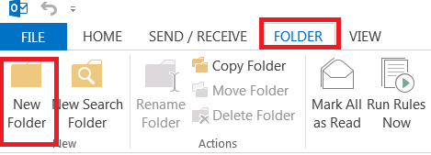

- On the Create New Folder screen, click on Inbox . Then, enter the Name of the new folder in the Name box. In this example, it is called BoilerConnect. You can leave the Folder contains box set at Mail and Post Items.

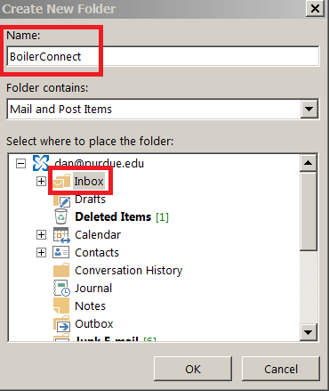

- Click OK, and the new folder will appear under your Inbox.

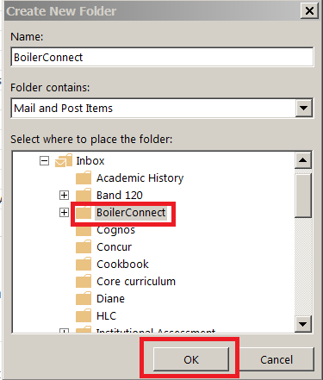

Routing Specific Types of BoilerConnect Appointment Emails by Subject
As mentioned earlier, you can also filter out only a specific category of emails from BoilerConnect based on their subject matter, but keep others. There are three kinds of emails related to student appointments. Notification (creation of the appointment), Reminder, and Cancelled. So, for example you could filter out both the Notification and Reminder emails and keep those emails for review that are notifying you of a cancelled appointment.

In this example we will filter out the Notification and Reminder emails, and keep the Cancellation emails from BoilerConnect in your Inbox. You could also create a folder in Outlook and route the Cancellation emails to that folder if you prefer.

Keeping the Cancellation Email Notifications in your Outlook Inbox and Filtering out the Others
This assumes that you have not created a specific folder to route your Cancellation emails to, and that you will be keeping the emails notifying you of a Cancelled appointment in you Inbox. The emails being filtered out can be routed to your Junk mail or Deleted Items folder, or even to a special folder you create in Outlook.

This process involves creating a rule to filter out the Appointment Notification and Appointment Reminder emails.

- Select Rules from the ribbon at the top of Outlook and click on Create Rule.

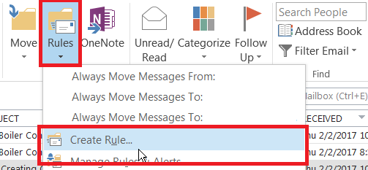

- On the Create Rule screen, click the checkbox alongside Subject contains, and then enter [Appointment Notification]. Make sure you include the brackets and capitalizations. Then click on the checkbox alongside Sent to and select me only from the drop down box.

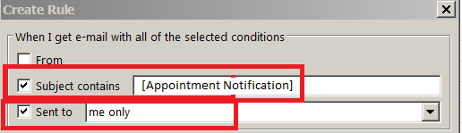

- While still on the Create Rule screen, under the Do the following section, click on the checkbox alongside Move the item to folder, and click on the Select Folder button. In this example, the email will be moved to the Junk E-mail folder. You could also select the Deleted Items folder.
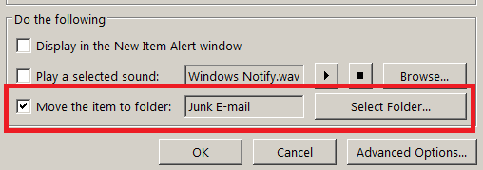

- You can run the role now. Click the checkbox and then click OK.

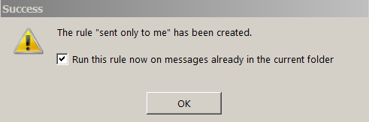

Once you have completed this rule you will need to follow the same process for routing the [Appointment Reminder] emails to junk mail or your Deleted Items folder.

