Last Updated May 5, 2017

Scheduling Appointments
- Using Your Assigned Student List to Schedule and Manage Appointments
  - Using Your Assigned Student List
  - Type of Appointment
  - Appointment Reason
  - Using the Comment Box
  - Your Office Grouping Location
  - Appointment Calendar
  - Reminder Appointment Messages
  - Adding Additional Attendees
  - Choosing an Appointment Time
  - Repeating an Appointment
- Using the Search Option to Schedule an Appointment
  - Editing an Existing Appointment
  - Cancelling an Appointment
  - Rescheduling an Appointment
  - Sending an Additional Appointment Reminder
  - Deleting an Appointment

Using Your Assigned Student List to Schedule and Manage Appointments
As an academic advisor, you can schedule appointments with students in different locations throughout the BoilerConnect platform. Your Advisor Dashboard page provides you with the list of students that you currently advise, as well as a menu of options on the right side of the dashboard.

Breadcrumb: Advisor Home>Assigned Students
- Using the list of My Assigned Students, click in the checkbox alongside the name of the student you would like to schedule an appointment for.

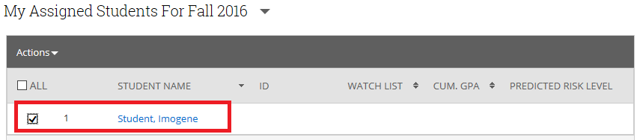

- Click on the down arrow alongside Actions on the toolbar to display a drop down menu of options, and select Schedule Appointment.

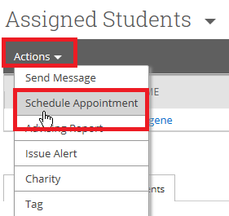

Breadcrumb: Advisor Home>Assigned Students>Schedule Appointment

On the Schedule Appointment page
- Under the Filters section, select the Type of appointment you are scheduling

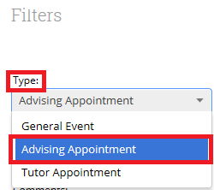

The General Event appointment type refers to events like football practice, honors meetings, etc.

In the Reasons checkbox, select what the purpose of the appointment will be. You can select more than one reason for an appointment. After selecting the first reason, just click in the Reasons box again, and scroll to select the second reason.

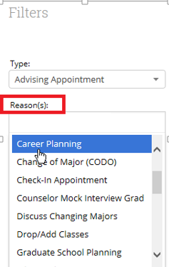

- Use the Comments box to provide any additional information to help the student prepare for the appointment. The comments you enter here will be seen by both the student and you when they look at their calendar and when they receive there appointment notification email.

- The Location box should be populated with your office grouping. Just click in the box and highlight the office grouping.

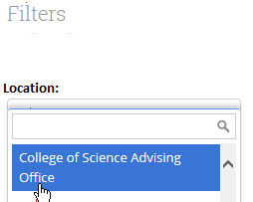

- From the Calendar, select the date you would like to schedule the appointment for:

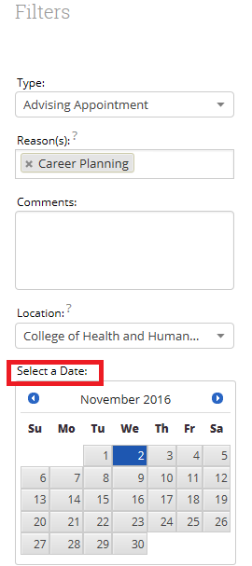

- A Reminder email is sent out automatically the morning of the appointment. The text message reminder is sent 1 hour before the appointment. If you are unsure of what the time frame for the reminder is, just roll over the question mark with your mouse. You can select only one reminder type, or both.

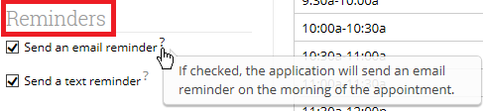

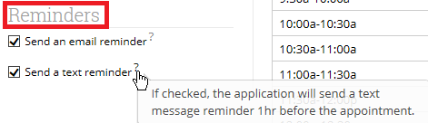

These Reminders are automatically sent out by the system. Once you have clicked these checkboxes, you will not need to send a separate reminder to the student for the appointment unless you opt to do so. Other advisors cannot see your Reminders
- The Add an Attendee link will let you add others that will be attending the appointment. You can select an attendee by typing their last name in the Add Attendee box, and then highlight them. After highlighting them their name should then appear under the People Attending section.

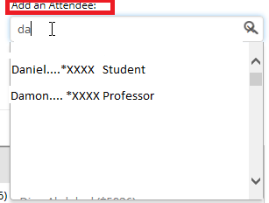

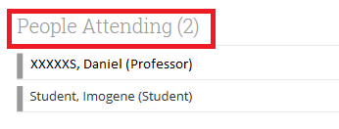

If you decide you want to remove an attendee at any time, just click the “X” to the far right side of the screen alongside the person’s name you want to remove.

- In the Select an Advisor section, your name should already be present. Just click on the radio button alongside your name. Once you do, your calendar will appear at the bottom of the screen. But you still need to Choose a Time to Meet by clicking in the Length box.

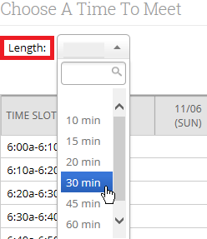

Your Calendar (also referred to as the scheduling grid), should now appear with the list of available times. If you already have something scheduled, you will see that notated on the calendar. Simply click in one of the checkboxes to select the time for the appointment:

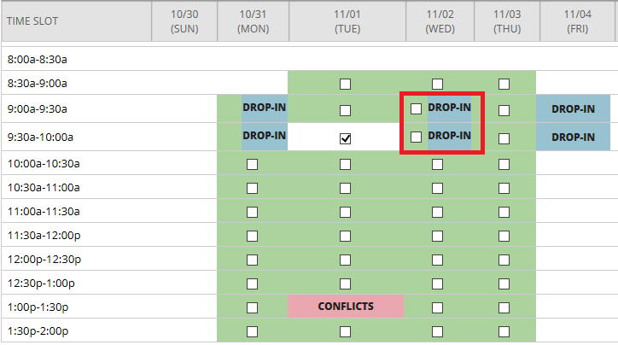

The white cells mean that there is no availability during that time. Drop-in appointments should only display as Drop-In. If there is a checkbox alongside any of your Drop-in times (as in the example above), then there is an overlapping appointment time showing in your availability. If this occurs, simply go to the available times and modify the overlapping time in the drop in or appointment time.

- If the appointment is to be repeated, you may select from the following list of options:

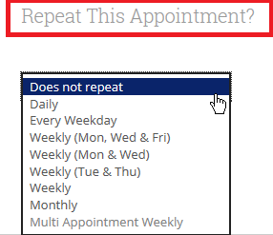
- Click on Save Appointment
- The appointment you just scheduled should now appear in the Upcoming Advising Appointments at the bottom half of your Advisor Home dashboard.

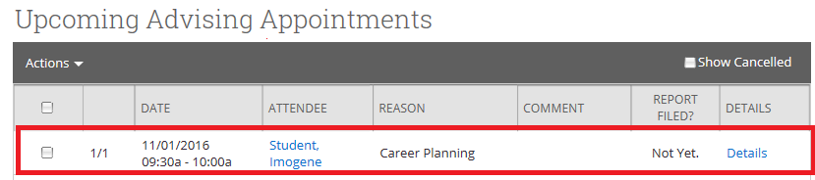

When you save this appointment, the system will immediately send the appointment notifications you selected to the student, along with any details you included. If any other attendees were selected to attend, their calendar will also be updated. The Reminder notices are sent out automatically as well. Email reminders go out at 6 am the morning of the appointment, and text notifications go out one hour prior to the scheduled appointment.

You can view the Details of the appointments you have appearing in your Upcoming Advising Appointments section, by clicking on the Details link to the far right side of the screen for the selected student:

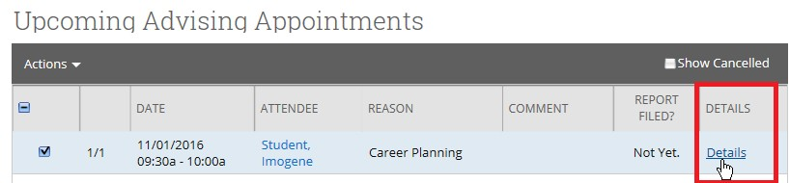

The Manage Appointment pop-up screen will display the details regarding the appointment scheduled for this student. It will also allow you to edit, cancel or even delete the appointment if needed.

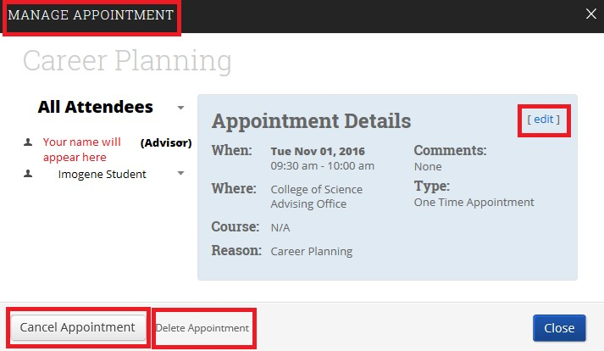

Breadcrumb: Advisor Home
Scheduling an Appointment Using the Search Student Option
You can also schedule appointments with students by using the Search box at the top of the Advisor dashboard.
Preferred names are not included in BoilerConnect. So if searching by student name, you must enter the student’s given name.

- On the Campus toolbar, click on the magnifying glass to the far right side of the screen:

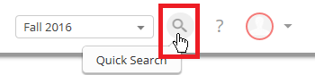

- Begin entering the name of the student you are wanting to schedule an appointment with. Note, this box will begin populating names based on the letters you are entering in the box. The letters you have entered will appear in red and will appear in a drop down box, and the results will include first names and last names that include the letters you have entered.

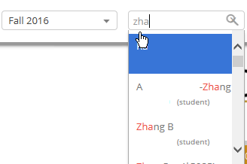

- Highlight the name of the student you were looking for, and you will be taken to your Advisor Home dashboard. On the right hand side of the screen, in the Staff Alerts box and click on the Schedule an Appointment link:

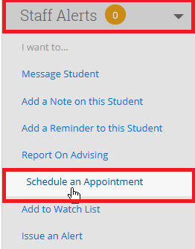

- You will be taken to the Schedule Appointment page, where you can follow the steps outlined above beginning with the third bulleted item of Using Your Assigned Student List to Schedule and Manage Appointments with Students to schedule an appointment with this student.

Breadcrumb: Advisor Home>Upcoming Advising Appointments
Editing an Existing Appointment
To edit an existing appointment:
- From the Advisor Home Dashboard screen, from the Upcoming Advising Appointments section, click the checkbox alongside the name of the student you are editing the appointment for:
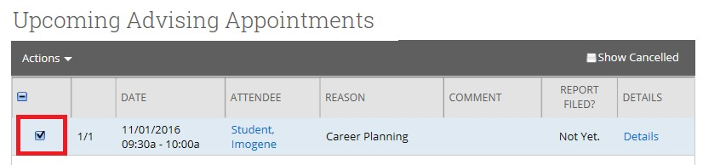

- On the far right side of the screen, click on the Details link:

- Select the Edit link:

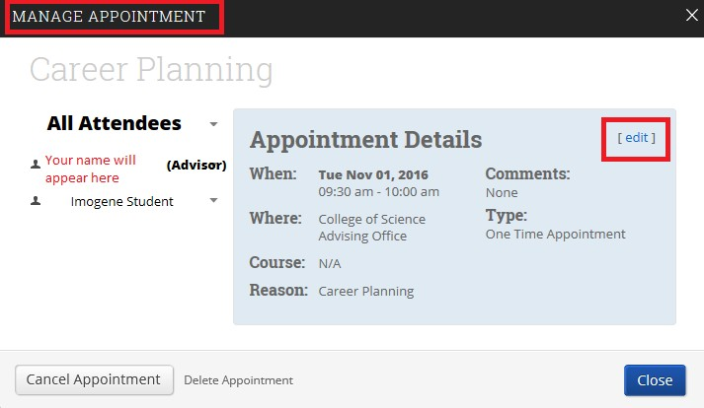

This will return you to the original screen you used to enter the appointment for this student. Make any changes needed. Click Save when completed.

Breadcrumb: Advisor Home>Upcoming Advising Appointments
Canceling an Existing Appointment
- From the Advisor Home Dashboard screen, in the Upcoming Advising Appointments section, click the checkbox alongside the name of the student you are canceling the appointment for:

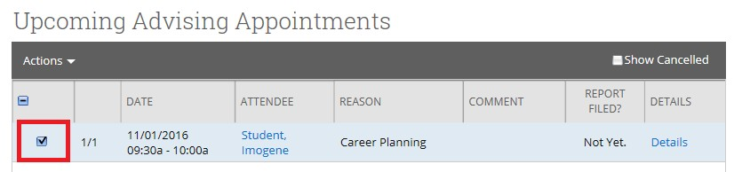
- Click the name of the student you wish to cancel the appointment with and a menu of options will appear. Click on the Cancel button below their name:

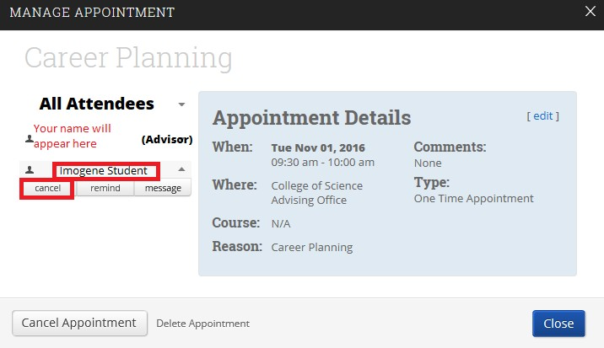
Note that there is also a Cancel Appointment link at the bottom of this same screen. Either link will take you to the same location for you to enter the information on canceling the appointment.

- Once you have selected the Cancel option, you will be asked to select a reason for canceling the appointment from a list of options in the drop down box.

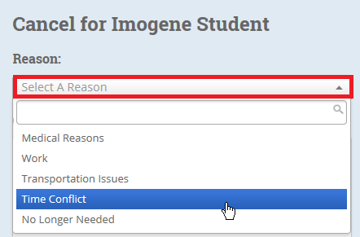

- In the Comments box, provide an explanation for the cancellation.

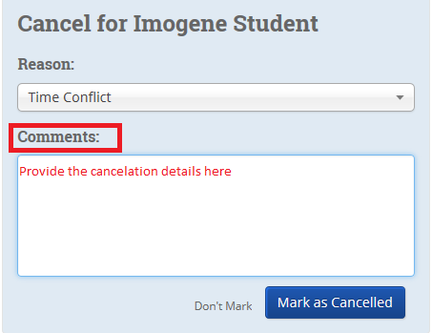

  - Click Mark as Cancelled and you will be taken to a screen where you can reschedule the appointment or delete it.

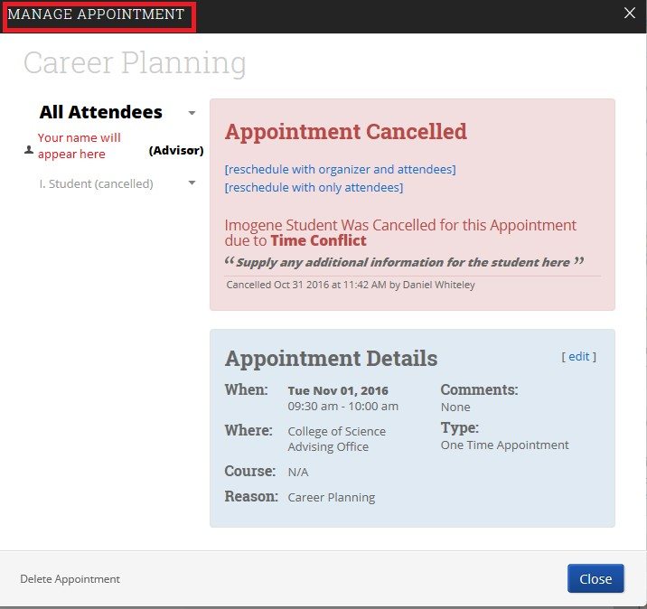

- If you do not want to reschedule the appointment, click Close.

If the student is the one cancelling the appointment, they can only do so three times before they are locked out of being able to schedule appointments. You will be able to unlock them once you have met with them regarding the reasons for the cancellations.

- If you want to Reschedule an Appointment, now is the time to do it. By doing it at this point in the process you will avoid having to go all the way back through the appointment process. Click on one of the Reschedule options

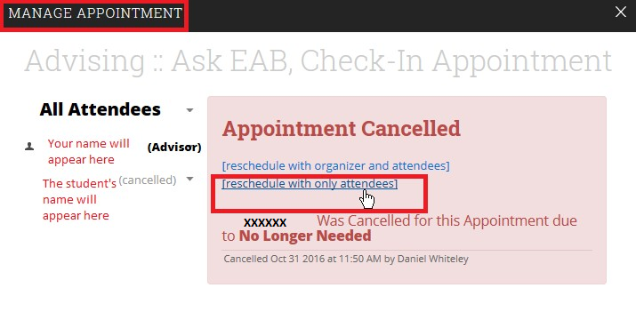

- You will be taken back to the Schedule Appointment screen, where you can select a new date for the appointment if needed.

Breadcrumb: Advisor Home>Upcoming Advising Appointments
Sending an Additional Appointment Reminder

The system automatically sends out email appointment reminders at 6:00 the morning of the appointment, or text appointment reminders one hour prior to the scheduled meeting. You would only want to use this option if you have determined a specific need for an additional reminder.

- From the Advisor Home Dashboard screen, from the Upcoming Advising Appointments section, click the checkbox alongside the name of the student you are sending the appointment reminder to:
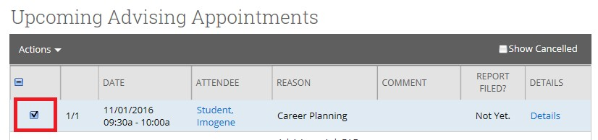

- Click the name of the student you wish to send the appointment reminder to and a menu of options will appear.

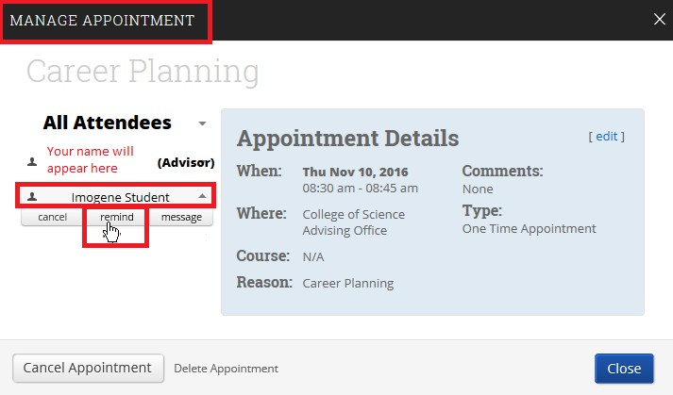

On the Reminder screen, select whether you want the reminder to go out via email or text message. You can select one or both options. Revise the message if needed, and click Send Message.

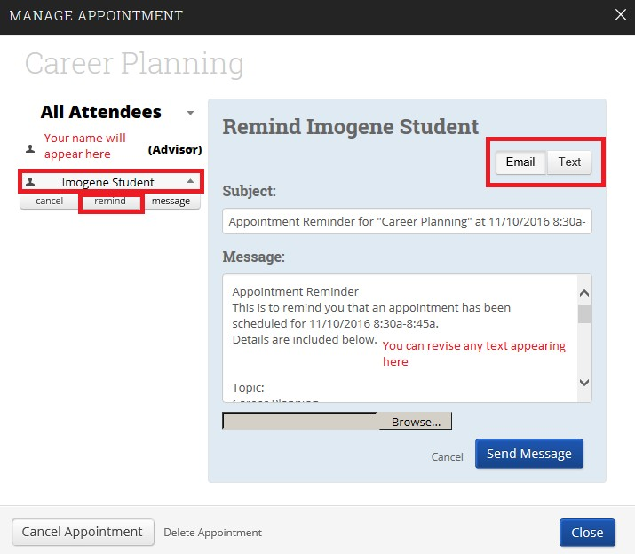

Deleting an Appointment
- From the Advisor Home Dashboard screen, from the Upcoming Advising Appointments section, click the checkbox alongside the name of the student you are deleting the appointment for:

- Click the name of the student you wish to delete the appointment for, and click on Delete Appointment

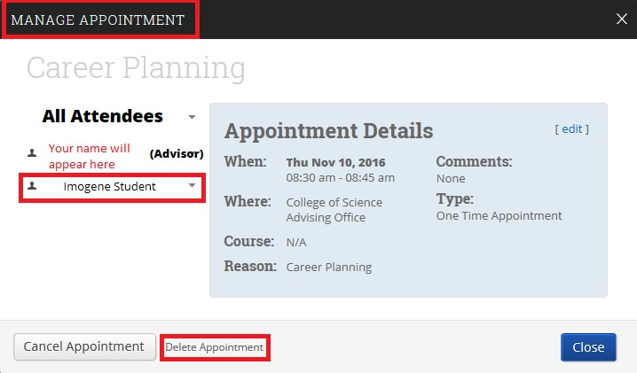
- You will be prompted to select Cancel or Delete Appointment

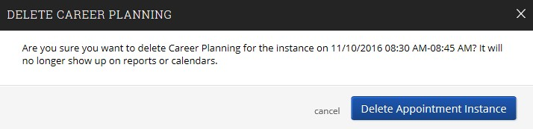
- Click on Delete Appointment

