Kiosk Check-In and Drop-In Instructions

Check in for a scheduled appointment using the kiosk
Creating a drop in appointment using the kiosk

Check-In for Scheduled Appointment
Step 1: Swipe PUID
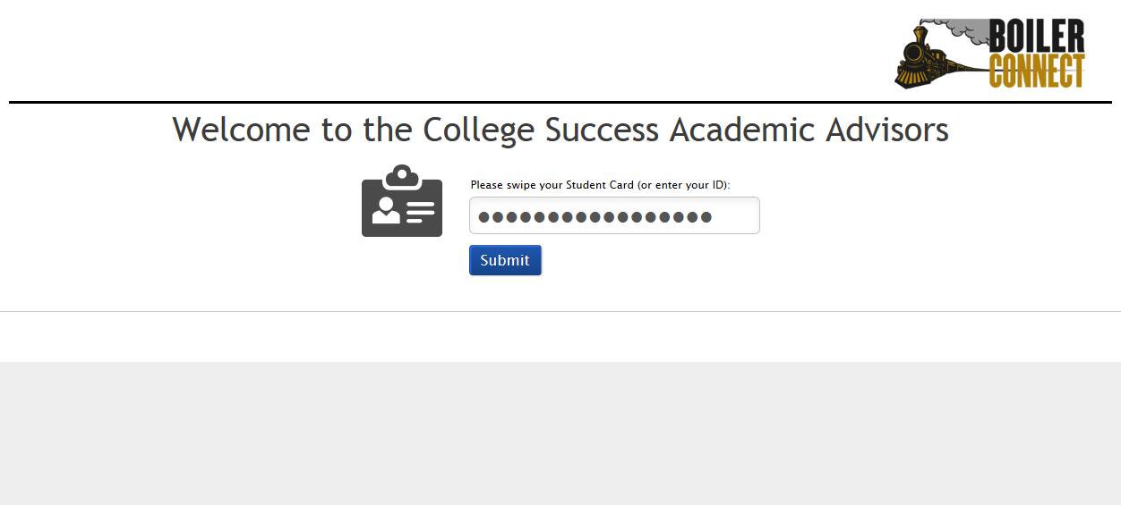

Step 2: Select “Check-In” for scheduled appointment
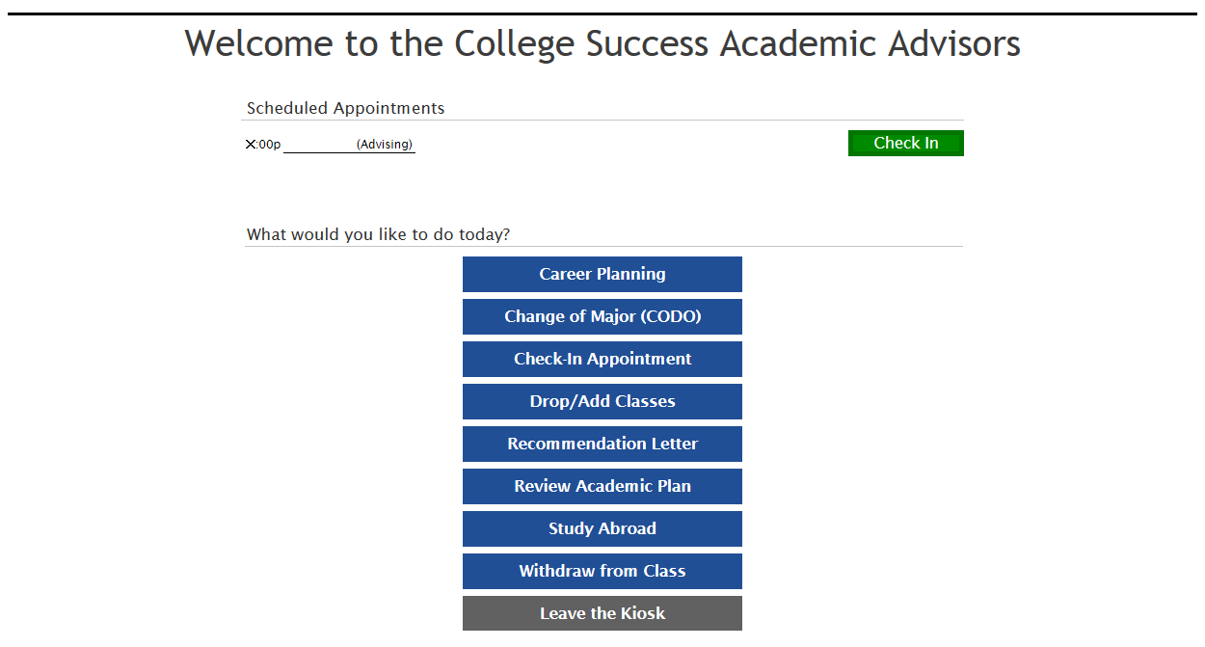

Step 3: Select “I’m Done. Exit the Kiosk.”
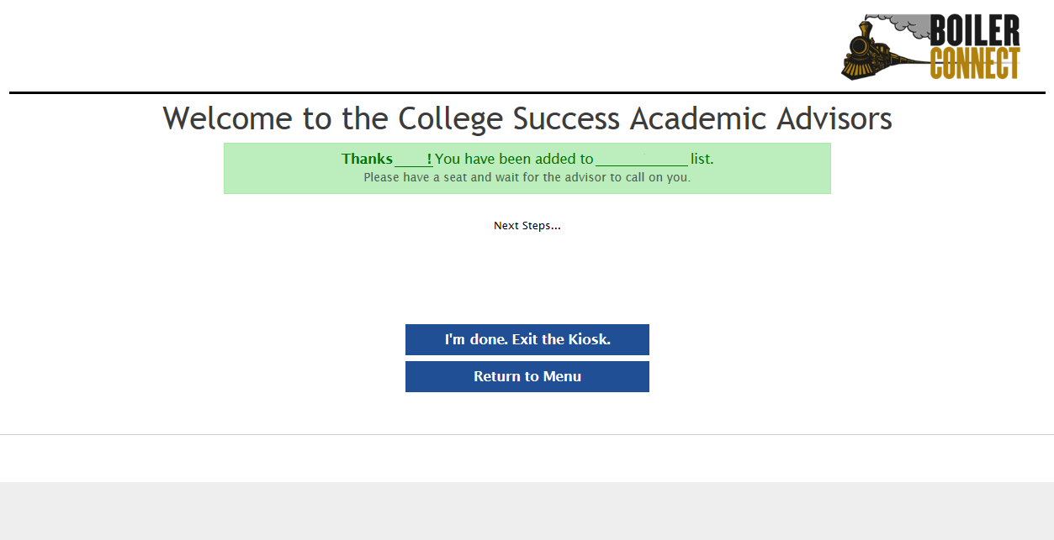

Create Drop-In Appointment
Step 1: Swipe PUID

Step 2: Select Reason
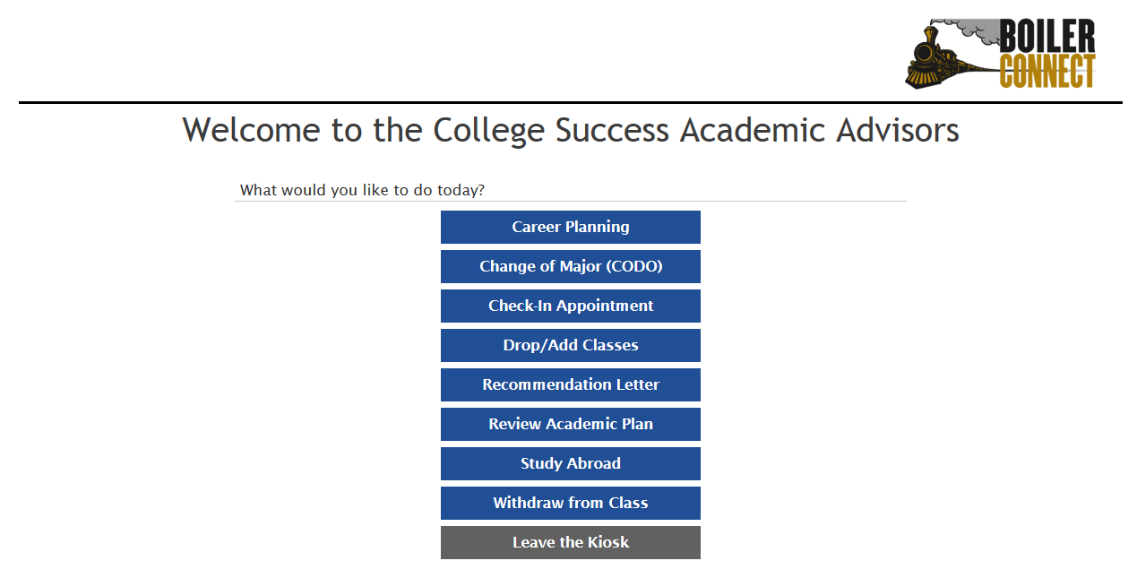

Step 3: Select Advisor
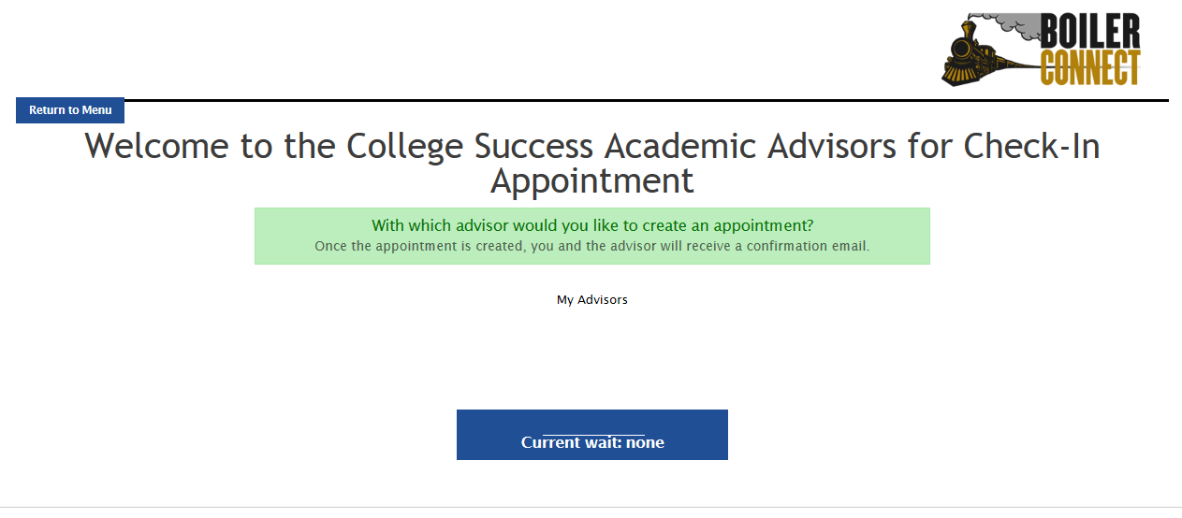

Step 4: Select Day
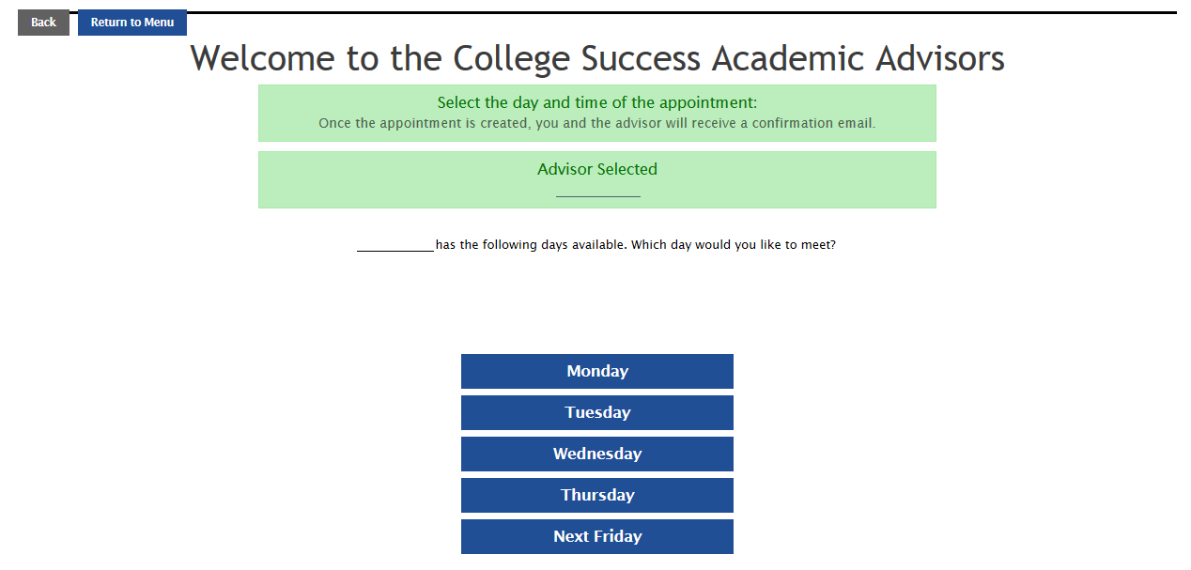

Step 5: Click “Back” (if no appointments are available that day)
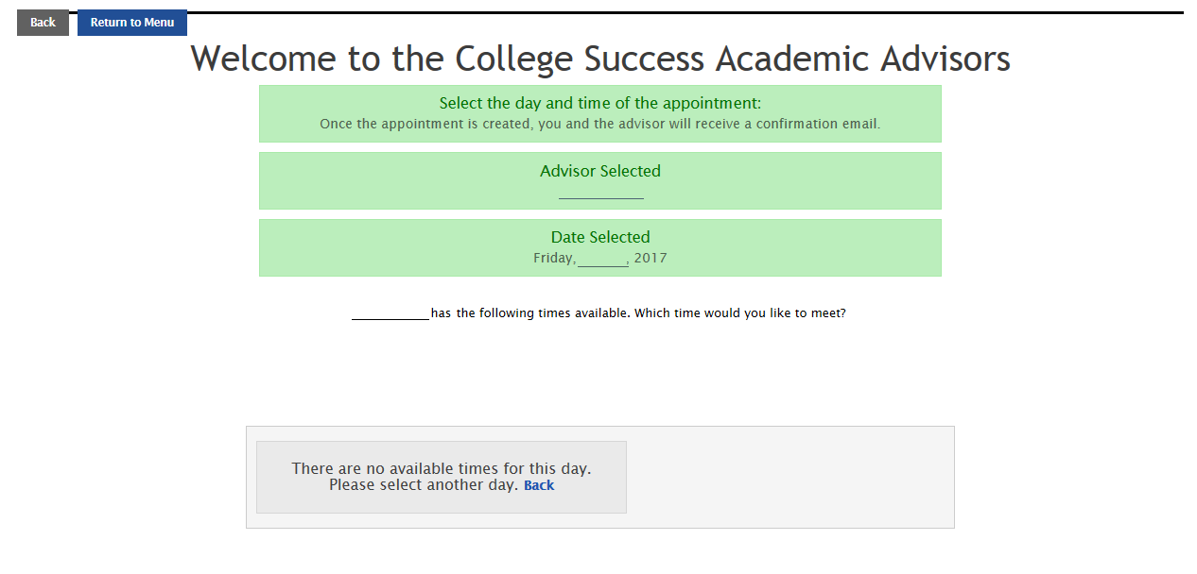

Step 6: Select Different Day

Step 7: Select Time
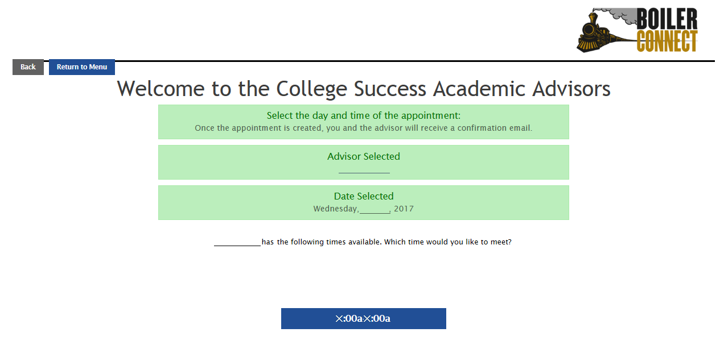

Step 7: Select “Save Appointment”
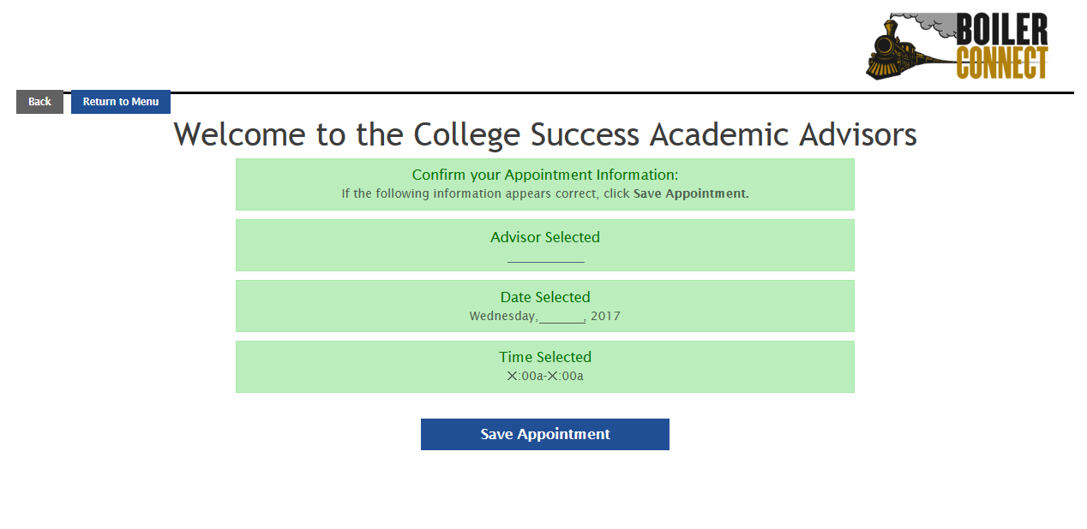

Step 8: Select “I’m Done. Exit the Kiosk.”
