FOR THE APPROVED ROLE REQUESTOR IN THE COLLEGE
Advisor Moves From one College to Another
-The role in the previous department needs to be removed before a new one can be added. If the previous role has not been removed, you will need to contact the role requester in the previous college to remove the role. You can use the following link to see all of the approved role requesters.
https://www.purdue.edu/em/esarolerequest/RoleRequesters

-Once the old role has been removed, you will need to request the new role assignment in the new college.

After the new role assignment has been assigned, the advisor will then need to go in to BoilerConnect and do the following:
-Update the change in availability. This includes updating the appointment constraints as well as the available times:

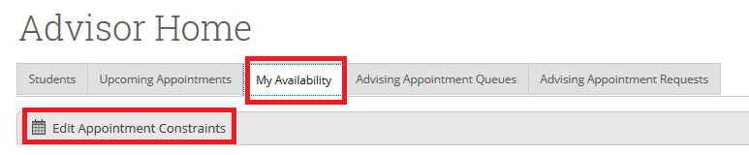

-Update the new location. Once you have updated the Location, update the Services you will be providing in the new College. You may also need to update any information you included in the Details box.

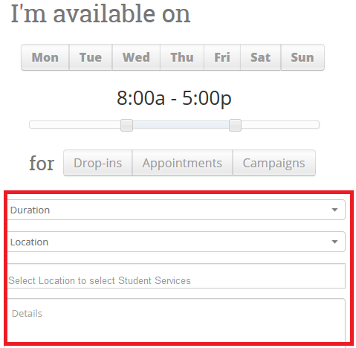

Advisor Moves From one Department to Another in the Same College

When an advisor moves to a new department within the same college, a new role will not need to be requested since the Advising role is the same across all Colleges and Departments.

In this case, the advisor will need to go in to BoilerConnect and do the following:

-Update the change in availability. This includes updating the appointment constraints as well as the available times:

-Update the new location. Once you have updated the Location, update the Services you will be providing in the new College. You may also need to update any information you included in the Details box.

