Generating a List of Current Fiscal Approvers
You can use this transaction code to generate the list of current fiscal approvers by fund center and business area.
- In SAP Financial run t-code ZFI_WF_APPROVERS
- If you get this message, click the green check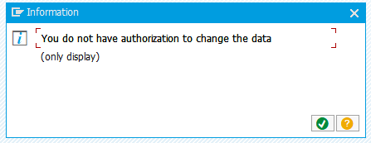
- Click on the print icon
- After the report regenerates, click on the Microsoft Excel File icon 
- The result is a list of fiscal approvers by business area and funds center.

