Corals, Biomimicry, and Microplastics
Designing Solutions for Coral Settlement and Reef Sustainability
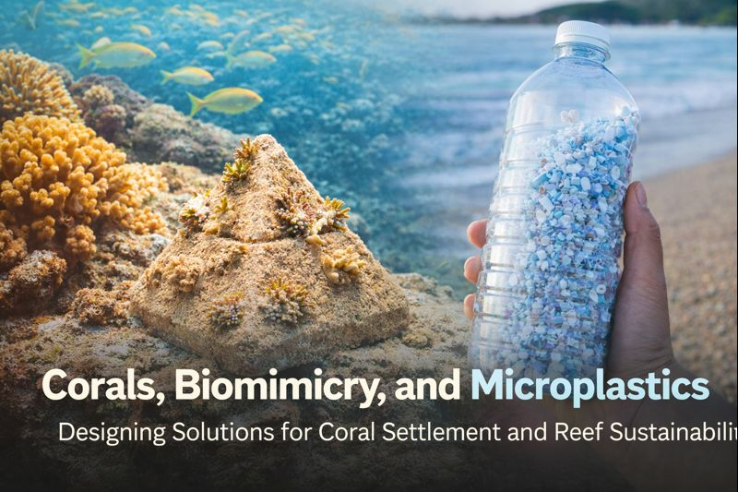

Project Information
- Teacher: Jenny Kuwahara
- School: Mililani High School
- Grades / Subjects: Grades 9–12
- Biology, Marine Science, Environmental Science, Engineering / STEM
Scenario: Coral reefs are among the most biologically, culturally, and economically important ecosystems in Hawaiʻi. They protect coastlines from high surf, support fisheries, sustain tourism, and are deeply embedded in Hawaiian history and worldview. Today, coral reefs face multiple threats, including warming ocean temperatures, sedimentation, runoff, ocean acidification, and microplastic pollution. These stressors reduce coral survival, especially during the early life stages when coral planulae (larvae) attempt to settle and grow. Students are challenged to investigate these threats and explore how biomimicry-inspired designs can support coral settlement and reef resilience, while also considering the cultural importance of corals and human responsibility to protect them.
Your Task: Your task is to design and create a coral settlement structure or model that helps address challenges faced by coral reefs in Hawaiʻi. Using principles of biomimicry (and geomimicry), you will:
- Study coral life cycles and settlement challenges
- Examine natural surfaces and structures that support coral survival
- Design and prototype a coral settlement substrate or model
- Communicate how your design supports coral health and reef sustainability
You will present your design and findings to peers and community members, explaining both the scientific and cultural significance of your solution.
Constraints: Your design must consider the following constraints:
- Safety – materials and processes must be safe for classroom and field use
- Cost – designs should be realistic and feasible
- Time – designs must be completed within the project timeline
- Environmental impact – materials and forms should not introduce new harm
Criteria: Your design will be evaluated based on the following criteria:

Cultural Content
- Incorporates Hawaiian perspectives on corals (koʻa)
- Includes moʻolelo, cultural references, or ʻike kupuna
- Reflects responsibility (kuleana) to care for the ocean and ʻāina

STEM & Biomimicry Content
- Demonstrates understanding of coral biology and settlement
- Applies biomimicry or geomimicry principles
- Integrates 3D printing and/or physical modeling
- Uses evidence and reasoning to justify design decisions

Learning Design
- Engages in active, hands-on learning
- Includes iteration, testing, and reflection
- Aligns with Nā Hopena Aʻo and relevant NGSS connections

Communication & Outreach
- Clearly communicates the problem and proposed solution
- Shares learning with peers, school community, or partners
- Reflects on human impacts and possible actions to protect reefs

