Fusion 360 Lure Mold Construction TRAILS 2.0
Before starting the project, you can make three new components before doing any sketches by right clicking on the top unsaved component and clicking on New Component. Name each new component as Lure, Bottom Mold and Top Mold. You can also save the whole project as Lure Project when the top component is active with the little black dot in the circle.

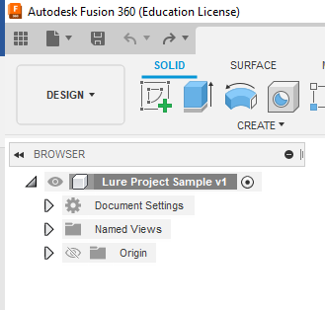
Right click, select new component , and give the component an appropriate name (such as “Lure”)

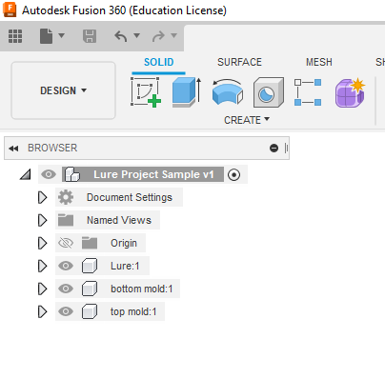
Once you have all three components you need to click on the circle to activate the Lure to begin the drawing.

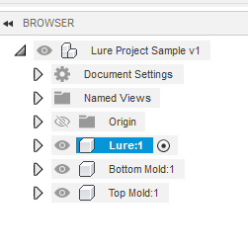
The following steps will start with a completed lure done in Fusion 360 and saved as the Lure component.
This is the completed lure drawn with a Revolve and filets. Now you will construct the bottom mold with one or mold lures in the mold.
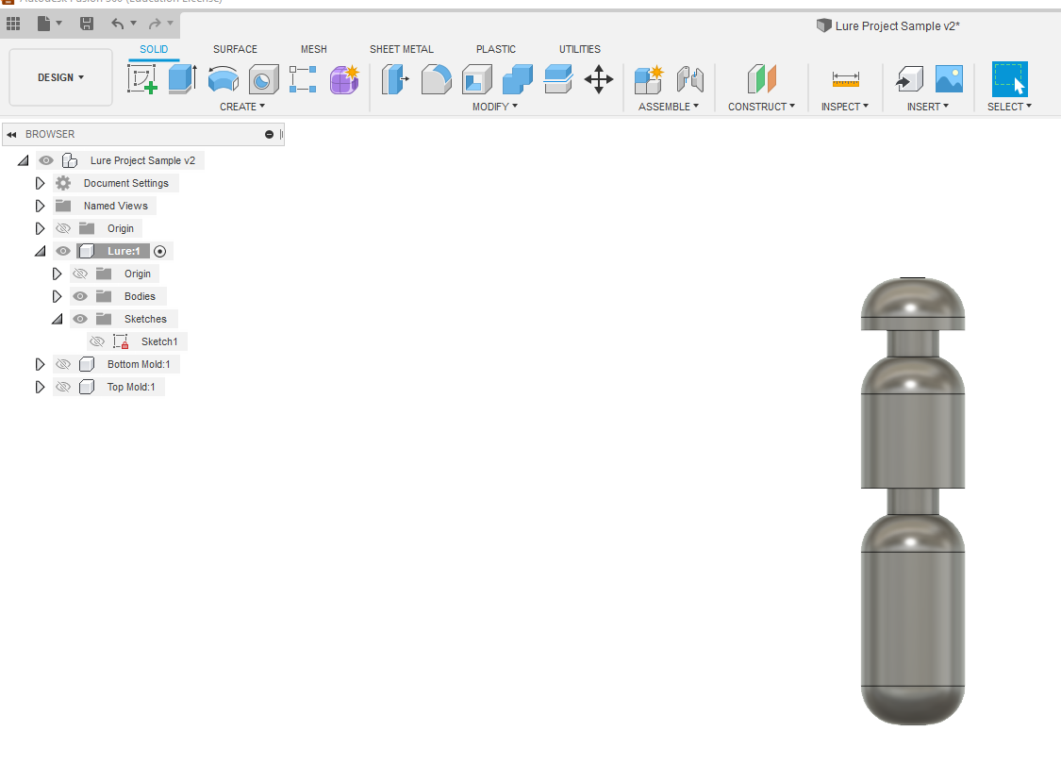

Activate the “Bottom Mold” component by hovering over its name and left-clicking on the radio button at the right.
Start a new sketch on the front plane. Draw a rectangle around the lure. The basic size is 3” x 4”. Dimension the rectangle to lock in the size. Dimension the distance from the Origin to the bottom line at .5” and the left line at .75” to lock in all dimensions. This will allow you to put three lures in this mold. Add a point near the upper right hand corner of the rectangle and then dimension the point as shown. You will then Click finish sketch.
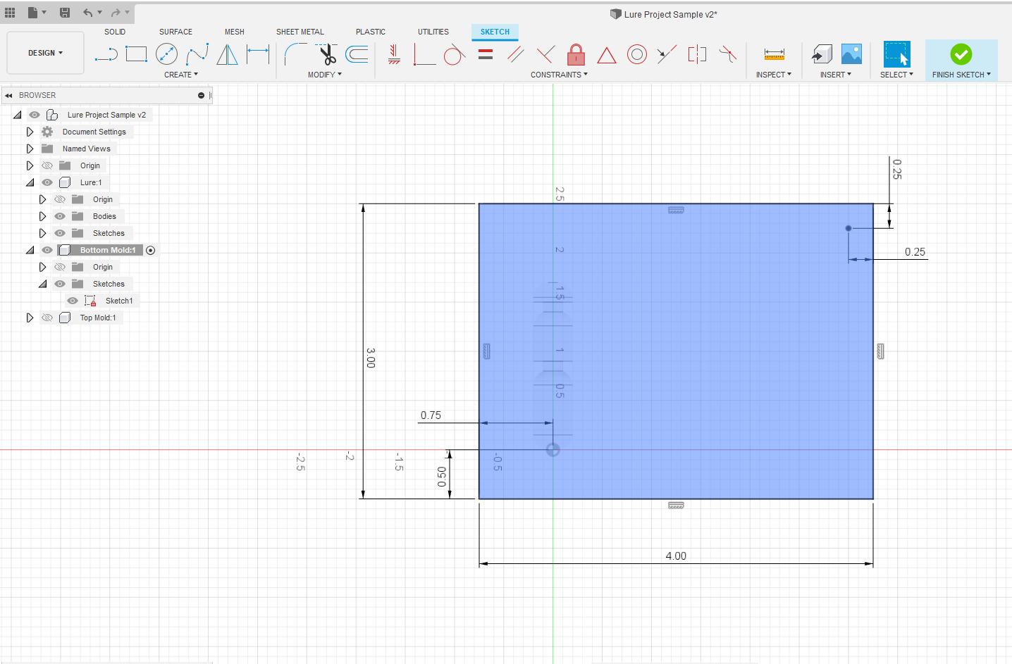

Extrude the mold -.5” so the lure is on the top surface as a new body. Click OK and the bottom mold will extrude .5” and the lure will be visible.
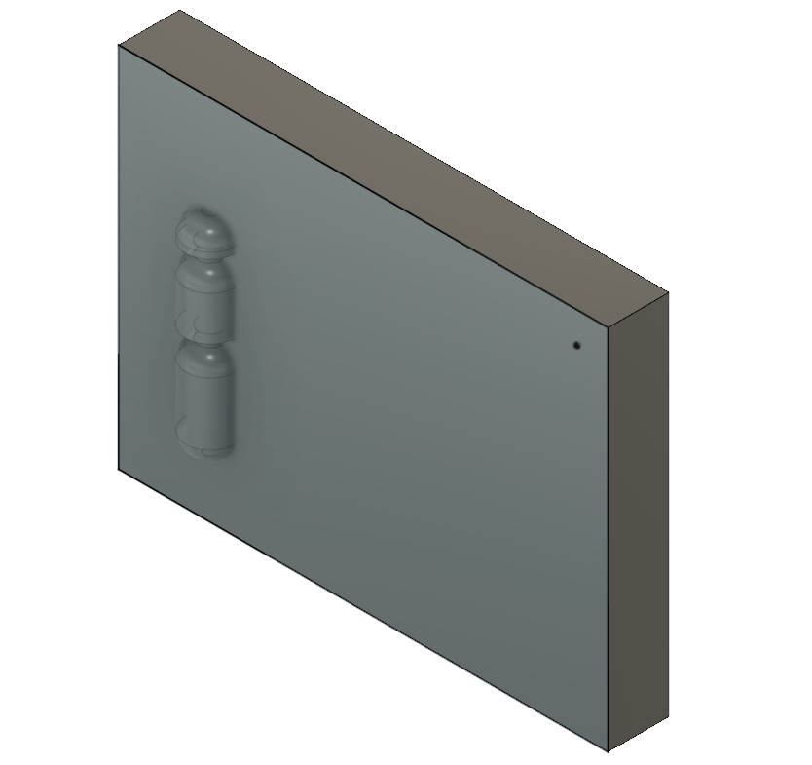

Expand the features for the Bottom Mold by clicking on the triangle to the left of its name in the browser, open the Sketch folder, and turn on its visibility by clicking on the eye to the left of “Sketch 1”.
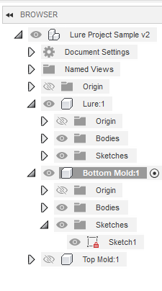

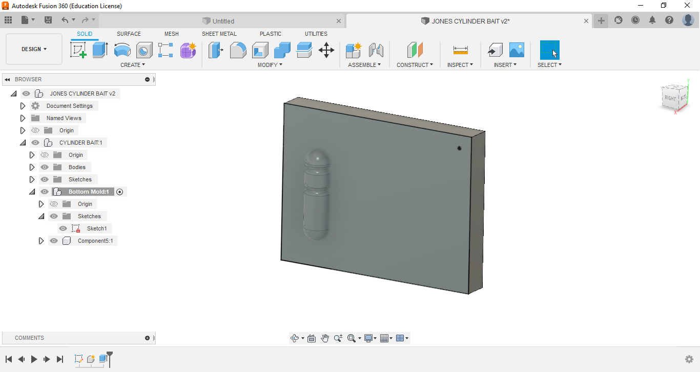
Click on the Hole feature and then click on the point that you created in Sketch 1. Set the hole information to match the menu below. When all the boxes match, click OK.
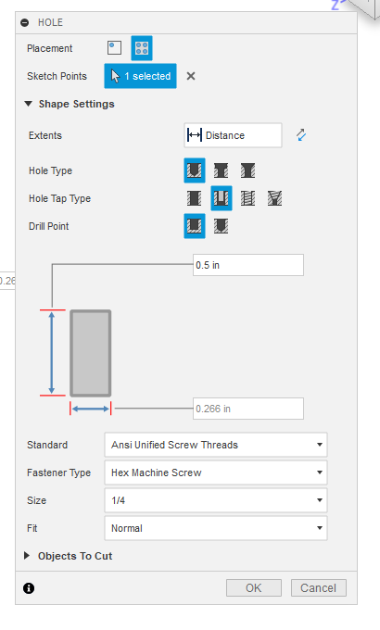
There will be one hole in the corner and now you will use Rectangular Pattern to add the other 3 holes.
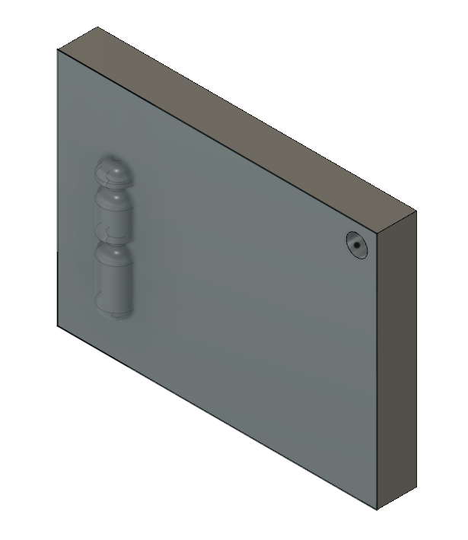

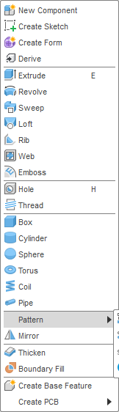
Rectangular

Fill in the hole information to match the picture. Select the top line to add the hole on the top left side and type in distance of 3.5” and then select the right line and type in the distance 2.5” for the bottom two holes. Click OK to set the new holes in the bottom mold.
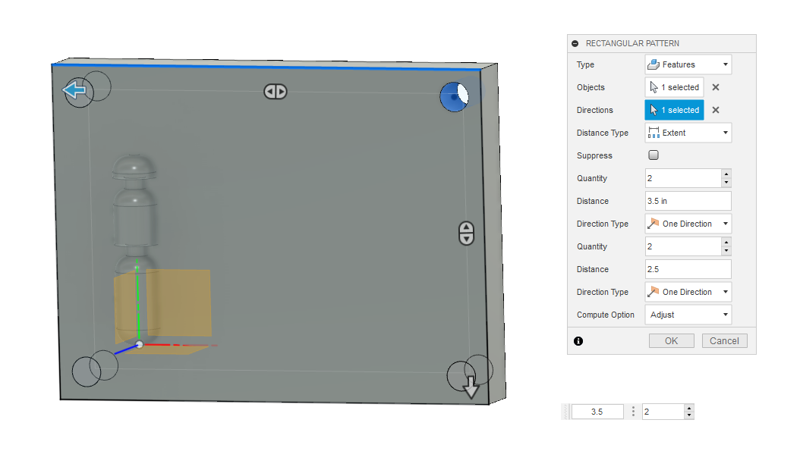
The above part is before clicking OK and the part below is after clicking OK.
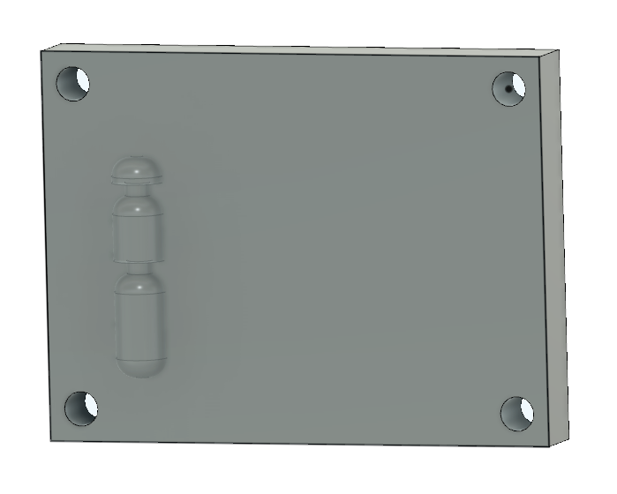

Now that the four holes are created you will use the same basic technique to create two more lures in the bottom mold for a total of three lures.
Right click on the bottom mold in the browser and then click on the Ground to make sure the bottom mold doesn’t move. After you click Ground, the Bottom Mold will have a PIN icon. This will anchor the bottom mold and make setting the lures in the bottom mold easier.
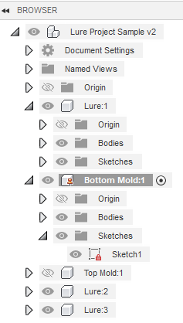
Activate the top-level component (“Lure Project Sample” in this example) and select Pattern, Rectangular. Select the lure as the component and the top edge of Bottom Mold as the direction. Fill in the Quantity, Distance Type as Spacing and use -1.25 for the spacing of the three lures. Click OK.
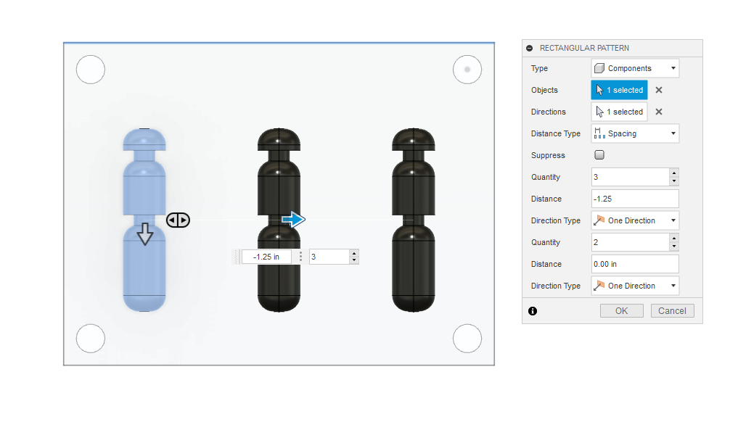
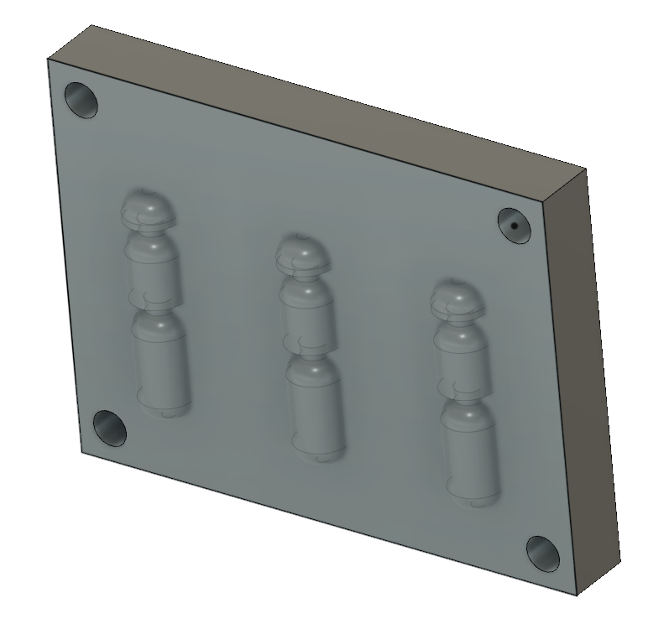
There are now three lures in the bottom mold and you will need to remove the lures to create the three cavities for the bottom mold.

