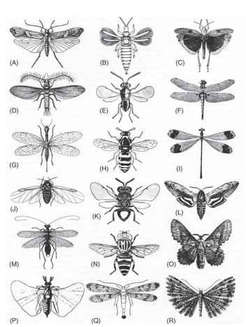
Design Activity - W.I.N.G.S.

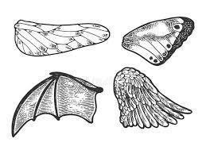

Scenario: You are working for a renewable energy company - W.I.N.G.S. and your job is to help the company design new blades for wind turbines. W.I.N.G.S. researchers have determined that wind turbine blades must be redesigned to reduce the harm to wildlife.
Your Task: Your team must design blades that mitigate the harmful effects on wildlife.
Constraints:
  - Turbine blades must fit on a Kid Wind turbine.
  - Use parametric modeling to create a design to be 3D printed.

Criteria:
  - Turbine blades must be designed based on animal appendages and/or nature.
  - Biomimicry designs will consider function as a design feature.

