

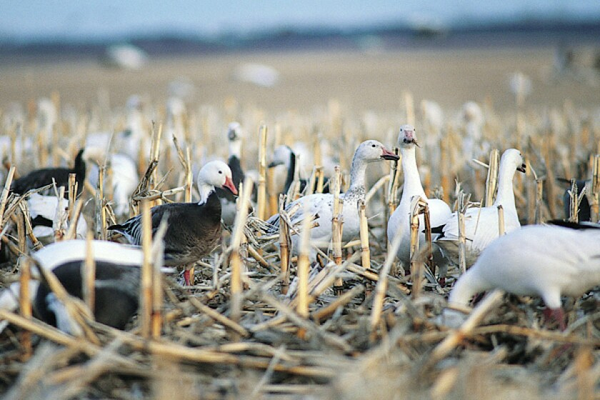
Light Goose Decoy
Scenario: Light geese populations have been increasing exponentially on the North American continent since the 1960s. Larger populations are causing habitat destruction in the Canadian arctic and crop destruction in migratory paths in the United States.
Your Task: Design and create a robotic decoy that mimics a light goose’s behavior well enough to encourage a flock of seasoned light geese to land.
Constraints:
  - Decoy must have one moveable joint with indirect attachment to one or more motors via gears, string, cables, chain or connecting rods.
  - At least one part of the joint or a decoy component must be designed using Fusion 360 and 3D printed.
  - Decoys containing robotic component must be no larger than a typical adult light goose and no smaller than a typical juvenile.

Criteria:
  - The decoy should mimic behavioral motion and the morphology of light geese, specifically focusing on realistic robotic movement of at least one selected joint containing computer designed and 3D printed components.
  - Field tests of designs will test durability and operational continuity in cold-weather outdoor field conditions and be redesigned accordingly.
  - Final designs will be presented to, evaluated, and ranked by experienced hunters and/or wildlife professionals from the community.

