Raptor Round Up
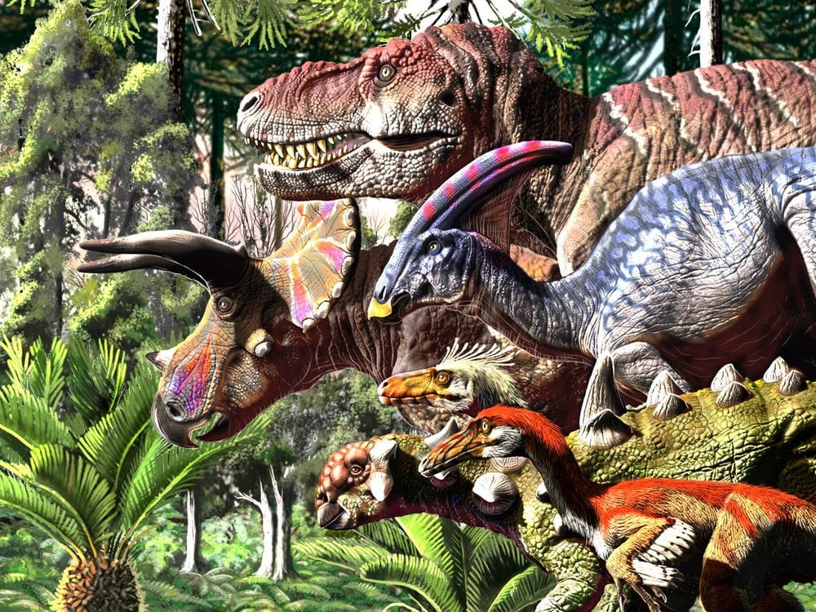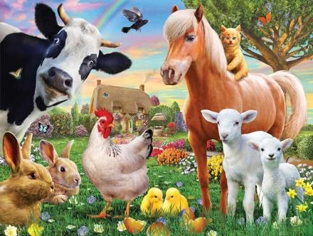

Scenario: Rusler Implement, a local agricultural equipment company, is looking to expand to agricultural and gardening hand tools. They are looking for concepts and designs to submit to their manufacturing staff. They want the products to reflect organism adaptations that have proven successful.
Your Task: Develop a gardening hand tool that is inspired by prehistoric or contemporary organism adaptations.
Constraints:
  - Final product will be created using a 3D printer and PLA filament.
  - You will work on a single component of the research, design, and production phase.
  - Each phase of the process will have time constraints.

Criteria:
  - The tool must work well in a gardening and farming setting.
  - The tool should fit comfortably in the hand.
  - The tool must relate to an adaptation found in a dinosaur or contemporary farm animal.

