The Impacts of Stormwater Runoff on the Campus of Delmar Middle and Senior High School (DMSHS), Delmar, DE
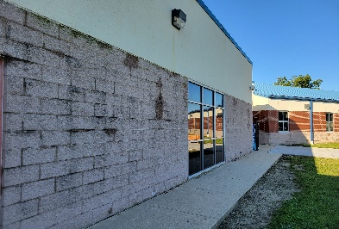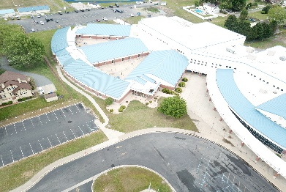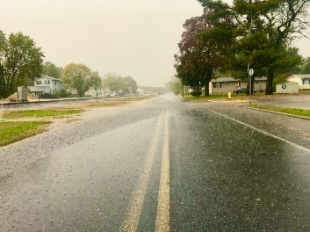
Image

Scenario: Delmar, Delaware like many other towns in Delaware is experiencing intermittent localized flooding from stormwater runoff. You have been selected to research these impacts, and to try to develop solutions
Your Task: Work with your group to create a STEM based audio-visual presentation (MP4 video required) that clearly identifies the effects of stormwater runoff as they relate specifically to our campus, create a scaled map that identifies the major surface water flows (location and direction), drainage locations (gutter down spouts and storm drains) and whether they drain the runoff effectively. Include the identifications of features currently in place to mitigate (reduce) the runoff. Your video may include a mix of stills and videos taken on site.
Constraints:
  - Video and still photography must be taken on-site
  - Video must be captured using the AVHDC format @ 720 PPI
  - Project must be between 1 and 3.5 minutes

Criteria:
  - Students must create a story board & shot list before capturing images

  - You must submit a properly named and executing mp4 file

  - All images and primary footage will be placed on student share drives, copies may be made to render and edited off site or afterschool

