Planting Roots
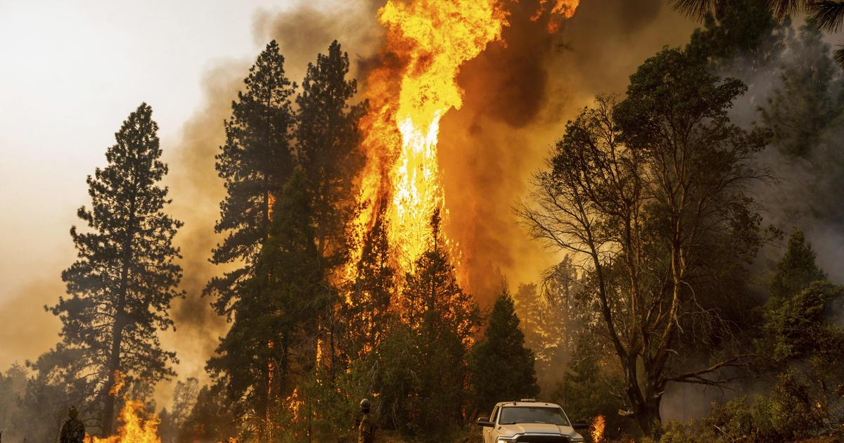

Image

Scenario: A wildfire has just destroyed Cimarron Canyon, Hermit’s Peak, Calf Canyon, and Sugarite Canyon and the monsoon rains are starting up. Due to the fire there is a high risk of soil erosion. With this erosion there is a risk to the highways with mud slides and a risk to the town water supply. Your team is brought in to mitigate erosion in the burn scar area.
Your Task: Your team will design and print a model root structure based off of native plants in your area to help slow down the erosion caused by the fire.
Constraints:
  - Must include native flora root systems
  - Must use 3D printer to print root systems
  - Must be portable and lightweight

Criteria:
  - Design must mimic natural root systems
  - Design should be 3-4 inches long and 2-4 inches tall

