Wing It
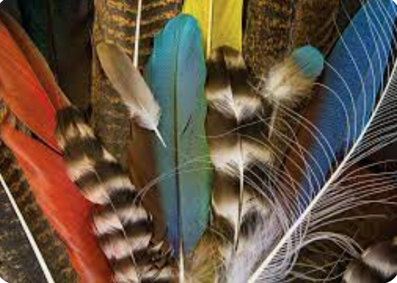
Scenario: You and your team are new engineers at CS Wind/Vestas, the wind turbine manufacturing company. They are looking to design new blades for the next generation of wind turbines. The company is requesting a design using biomimicry to optimize the efficiency of the design. Since the newly designed turbines will be used in our local area, CS Wind/Vestas wants you to base your design on winged organisms in the Pueblo area. Your ultimate goal will be to design a wind turbine blade that yields the greatest energy production.
Your Task: Your team must design and create a 3D printed wind turbine blade that mimics a winged organism to produce the most energy.
Constraints:
  - Use parametric modeling to create a design to be 3D printed.
  - Blades must fit on the prototype turbine and match the optimal turbine blade parameters (length, pitch, and blade count) as determined by in-class testing (KidWind Activity).
  - Your 3D model must print in ≤ 8 hours.

Criteria:
  - Blade design must mimic nature.
  - Biomimicry designs will consider form as a design feature (shape), as well as considering other functions of the wing.

