Blue Crab Challenge – Design Brief

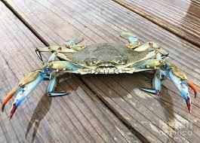
Scenario: The Crisfield Area Chamber of Commerce is preparing for the National Hard Crab Derby. The National Hard Crab Derby features the king arthropod of the Eastern Shore, the Blue Crab. Mr. Krabs is looking to modify the crab races, featuring the Maryland Blue Crab. He would like to see if any other predator has the ability to challenge the Blue Crab. He is looking for engineers to study the Maryland Blue Crab, and design a predator that will beat the Maryland Blue Crab in a closed obstacle course collecting. The challenge will see which designed predator can collect the most food in an obstacle course designed for a Blue Crab.
Your Task: Your robotics team has been tasked to design a predator to compete against the Maryland Blue Crab. Your team will study the Maryland Blue Crab and other predators in order to understand their functions. After research, you will need to use your knowledge of simple machines, robotics, and 3D printing in order to design and build a predator to compete in the competition. The designed creature should be able to collect food similar to the Blue Crab. This means picking up an object and expelling the “food” from the center.
Constraints:
  - Only 3D printed pieces and VEX Robotics Equipment available.
  - There is 2 weeks until the National Hard Crab Derby.
  - Cannot be bigger than 7” x 7’
Criteria:
  - Your design must be able to move forward/backward and left/right, as well as pick up food.
  - Your design should be able to crush food.
  - Your design should be able to protect itself from any damage.

