Bug RVs: Build a Better Bug Box
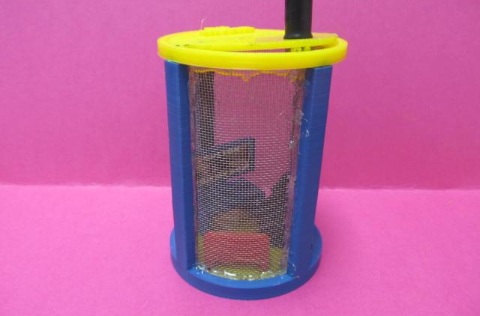
Student developed and 3D printed bug box

Lesson Overview:
Biology students study insects and design a box for collecting insects. This design is done in collaboration with engineering students who 3D print the final product.

Age Level or Subject:
- 9-12 Biology I or II, Introduction to Engineering & Design, or any Engineering Technology Class

Tags:
- Insect
- Design
- 3D Printing
- Bug Boxes

