Multiple Choice Questions for the Flight of the Bumblebee Test

Use the image and the blanks for questions 1 through 4.
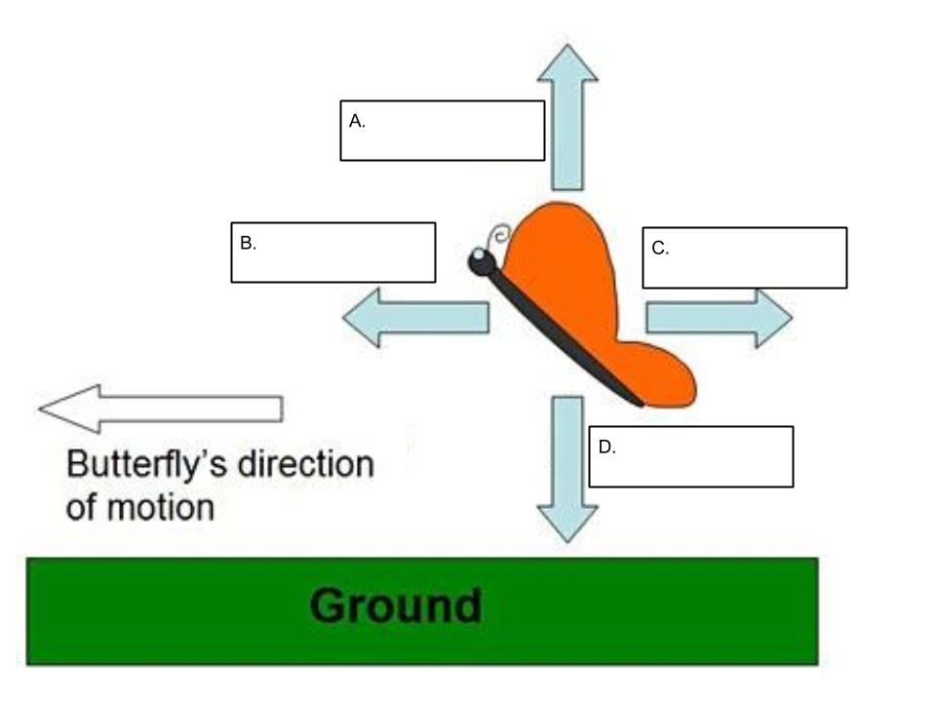
- Which force is A?
  - Thrust
  - Lift
  - Drag
  - Gravity

- Which force is B?
  - Thrust
  - Lift
  - Drag
  - Gravity

- Which force is C?
  - Thrust
  - Lift
  - Drag
  - Gravity

- Which force is D?
  - Thrust
  - Lift
  - Drag
  - Gravity

- Which direction does Lift force directed?
  - Down towards the ground.
  - Forward, in the direction of flight.
  - Up away from the ground.
  - Backwards, in the direction opposite of the flight.

- Which direction does Thrust force directed?
  - Down towards the ground.
  - Up away from the ground.
  - Forward, in the direction of flight.
  - Backwards, in the direction opposite of the flight.

- What is a “Fair Test” when developing an experiment involving variables?
  - When you change two variables and see which affects the dependent variable more.
  - When you keep all variables the same and see how it affects the dependent variable.
  - When you change all variables at once and see how it affects the dependent variable.
  - When you change one variable and see how it affects the dependent variable.

- What is an “Unfair Test” when developing an experiment involving variables?
  - When you change one variable and see how it affects the dependent variable.
  - When you change two variables and see which affects the dependent variable more.
  - When you keep all variables the same and see how it affects the dependent variable.
  - When you change all variables at once and see how it affects the dependent variable.
  - A, B, and C.
  - B, C, and D.

- Which describes a “Fair Test” when testing pipes for sound produced when being hit?
  - Having two pipes that are the same material, but different diameters and different lengths.
  - Having two pipes that are the same material, diameter, and the same lengths.
  - Having two pipes that are the same material, diameter, but with different lengths.
  - Having two pipes that are the different material, diameter, and lengths.

- What are the two main types of insect Flight?
  - Indirect Flight and Aerodynamic Flight
  - Fixed Wing and Direct Flight
  - Fixed Wing and Aerodynamic Flight
  - Indirect Flight and Direct Flight

- Which of these describes muscles attached directly to wings for control in insect flight?
  - Indirect Flight
  - Direct Flight
  - Fixed Wing Flight
  - Aerodynamic Flight

- Which of these describes how the muscles make the thorax oscillate and control wings for insect flight?
  - Indirect Flight
  - Direct Flight
  - Fixed Wing Flight
  - Aerodynamic Flight

- What type of flight do bees have?
  - Indirect Flight
  - Direct Flight
  - Fixed Wing Flight
  - Aerodynamic Flight

- How does a honeybee manipulate it’s wings to fly compared to other insects their size?
  - They are static and do not move, but the shape of the wings changes air pressure, causing flight.
  - Slow long arcs.
  - Fast short arcs.
  - Back and forth.

- What does an anemometer measure?
  - Air Pressure
  - Wind Speed
  - Wind Direction
  - Air Humidity

- When flying a kite, which would be the most important meteorological tool?
  - Thermometer
  - Barometer
  - Hygrometer
  - Anemometer

- Vane, Cup, Laser Doppler, and ultrasonic can all be types of:
  - Barometers
  - Rain Gauges
  - Anemometers
  - Hygrometers

- What is the purpose of a design brief?
  - To develop the results of the design, including audience, criteria, and constraints.
  - To develop the results of the design, including audience, aesthetics, and constraints.
  - To develop the results of the design, including budget, aesthetics, and constraints.
  - To develop the results of the design, including budget, criteria, and constraints.

- Which parts of the design brief are not needed?
  - Criteria and Constraints
  - Criteria and Aesthetics
  - Criteria and Budget
  - Constraints and Aesthetics
  - Constraints and Budget
  - Budget and Aesthetics

- Which parts of the design brief are absolutely needed?
  - Criteria and Aesthetics
  - Criteria and Budget
  - Criteria and Constraints
  - Constraints and Aesthetics
  - Constraints and Budget
  - Budget and Aesthetics

