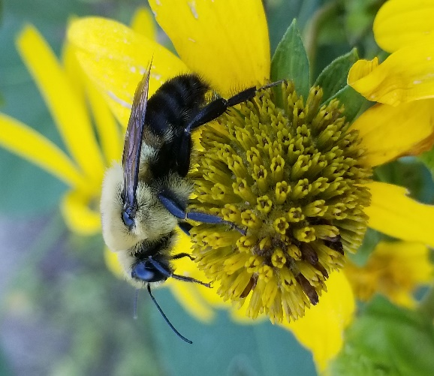
Age Levels:

Biology, Principals of Engineering (POE), & Engineering Design and Development (EDD) Students

Total Time Required:

Approximately 5 weeks for POE & EDD, approximately 3 weeks for Biology classes

Prepared by:
- Amanda Cox, Kyle Marsh, Zach McKeever, and Ben Modlin
- June 2016

Unit Objectives:
Students will be able to:
- Understand Biomimicry
- Review Ecology concepts in a real life setting
- Design, create, program/control a bumblebee inspired robot with a vital 3D printed part

Science Standards and Standards for Technology Literacy:
NGSS Standards

(NGSS) HS-LS1-5. "Use a model to illustrate how photosynthesis transforms light energy into stored chemical energy."

(NGSS) HS-LS2-5. Develop a model to illustrate the role of photosynthesis and cellular respiration in the cycling of carbon among the biosphere, atmosphere, hydrosphere, and geosphere.
(NGSS) HS-LS2-7. Design, evaluate, and refine a solution for reducing the impacts of human activities on the environment and biodiversity.* [Clarification Statement: Examples of human activities can include urbanization, building dams, and dissemination of invasive species.]
(NGSS) HS-LS2-8. Evaluate the evidence for the role of group behavior on individual and species’ chances to survive and reproduce.[Clarification Statement: Emphasis is on: (1) distinguishing between group and individual behavior, (2) identifying evidence supporting the outcomes of group behavior, and (3) developing logical and reasonable arguments based on evidence. Examples of group behaviors could include flocking, schooling, herding, and cooperative behaviors such as hunting, migrating, and swarming.]
(NGSS) HS-LS4-6. Create or revise a simulation to test a solution to mitigate adverse impacts of human activity on biodiversity.*[Clarification Statement: Emphasis is on designing solutions for a proposed problem related to threatened or endangered species, or to genetic variation of organisms for multiple species.]
(NGSS) LS2.C If a biological or physical disturbance to an ecosystem occurs, including one induced by human activity, the ecosystem may return to its more or less original state or become a very different ecosystem, depending on the complex set of interactions within the ecosystem.

Standards for Technology Literacy:
ITEEA Standards for Technological Literacy
Standard 1: Students will develop an understanding of the characteristics and scope of technology.
Standard 2: Students will develop an understanding of the core concepts of technology.
Standard 3: Students will develop an understanding of the relationship among technologies and the connections between technology and other fields of study.
Standard 5: Students will develop an understanding of the effects of technology on the environment.
Standard 6: Students will develop an understanding of the role of society in the development and use of technology.
Standard 8: Students will develop an understanding of the attributes of design.
Standard 9: Students will develop an understanding of engineering design.
Standard 10: Students will develop an understanding on the role of troubleshooting, research and design, invention and innovation, and experimentation during problem solving.
Standard 11: Students will develop the abilities to apply the design process
Standard 12: Student will develop the ability to use and maintain technological products and systems.
Standard 13: Students will develop the abilities to assess the impact of products and systems.
Standard 15: Students will develop an understanding of and be able to select and use agricultural and related biotechnologies.
Standard 16: Students will develop an understanding of and be able to select and use energy and power technologies.
Standard 19: Students will develop an understanding of and be able to select and use manufacturing technologies.

Recommended Instructor Preparation
- It works best if Biology & Engineering classes meet at the same time
- Pre-plan with both teachers together
- Make sure you set up groups evenly with kids from all classes and experience levels
- Talk to florists/grocery early to ensure you have flowers if needed- out of date inexpensive ones work just fine
- Biology students can continue class while engineering classes CAD and build, with periodic check in times
- Take time to look for new articles and videos of pollination and bee population

Student/Teacher Resources:
Articles
ARS Honey Bee Health and Colony Collapse Disorder - USDept of Ag.
Supporting pollinators could have big payoff for Texas cotton farmers- NSF
Attractiveness of Agricultural Crops to Pollinating Bees
Journey with Nature - Bees and Agriculture
What’s Behind Bee Decline and Colony Collaspse Disorder - Journalist’s Resource
Bee declines driven by combined stress from parasites, pesticides, and lack of flowers - Full Article
A Reason Millions of Bees are Dying - Washington Post
10 Amazzzzing Bee Facts - INFOGRAPHIC. Today I found Out.
Honeybee Die Offs Less Severe This Year - Purdue Ag News
Honey Bee Comb Size Chart - Bush Bee Farm
Indiana DNR Gardening for Honey Bees
Decline of bees forces China’s Apple Farmers to Pollinate by Hand
Videos
FlowHive - Honey on Tap
Slow Motion Flight and Facts
Dragonfly Flight - Smarter Every Day. At 2 min he talks about what makes wasps fly.
Dance of the Honey Bee - 6 min short film on Bees and Agriculture
Why are Honeybees Dying - It’s OK to Be Smart - PBS
How do Bees Make Honey - It’s Ok to Be Smart - PBS
Why are Bees Disappearing - TED Talk - Marla Spivak
Slow Motion Butterfly Flight - Monarch Butterfly

Lesson Plan 1: Engineering Design: How to Properly Document

Lesson Focus:
How to make an Engineering Notebook.

Total Time Required:
- Two 55 minute class period (For thorough explanation) or one 55 minute period (For concept of notebook)

SEE TRAILS WEBSITE FOR LESSON PLAN

Lesson Plan 2: Engineering Design: How are unique ideas created?

Lesson Focus:
Brainstorming.

Total Time Required:
- Two 55 minute class periods

SEE TRAILS WEBSITE FOR LESSON PLAN

Lesson Plan 3: Science Inquiry Investigation: Why is photosynthesis important?

Lesson Focus:
The importance of photosynthesis.

Total Time Required:
- One 50 min class period, finish as homework as needed

Lesson Objectives:
Students will be able to:
- Illustrate how photosynthesis transforms light energy into stored chemical energy
- Understand energy and matter input and outputs of photosynthesis
- Model the cyclic relationship of photosynthesis and respiration
- Illustrate the role of photosynthesis and cellular respiration in the cycling of carbon among the biosphere, specifically related to sugars (glucose) and CO₂

Lesson Procedures:

Set Induction: Humans need oxygen to survive, how did the O₂ that human’s breath get into the atmosphere? How do humans alter this process?

Procedures / Steps:
- Students sketch (either individually first, or in a group) the main ideas of what they know about how photosynthesis works. This can be as detailed as student knowledge permits. Have students with limited knowledge or memory on the subject draw anything about photosynthesis they can model, or as much of the main idea as possible. (Do not allow them to do research or have books/computers at this point).

- Teacher lesson on photosynthesis. Describe and model for students using 2D and 3D printed model without having them take notes. Discuss with students and build the equation of photosynthesis and respiration using student knowledge. Ask them to explain how they are related (reviewing respiration). After class discussion, have students complete the student worksheet answering in notebook.

2 a. (optional) Using the idea of what and how photosynthesis works, sketch a model that
helps students remember photosynthesis concepts with their own correlations. Ex: a baseball player may draw photosynthesis as a baseball field with electron transport as a base hit.

2 c. For extra modeling work: (computer photosynthesis model, NGSS@NSTA)
ttps://authoring.concord.org/activities/1008/single_page/8a3066ef-4ed5-49a8-9fa0-b74983abaca5

Closure/ Review:
Follow up with review of cycling matter and energy used in the in/outputs of photosynthesis, making sure carbon is a focus. Use this knowledge to model how photosynthesis and respiration are cyclic. Link this knowledge to the knowledge of how plants are involved in cycling matter and energy and the base of the trophic levels.

Note: Students should have already learned about ATP and cellular respiration prior to this lesson. This will aid in the connections students can draw about energy transfer and the cycle between photosynthesis and respiration. Students will probably be under the impression that plants cannot perform respiration, make sure they understand respiration can occur both day and night, as long as there is a source of sugar (carbon) and oxygen. Also make sure to address that plants do not intentionally make oxygen for humans to breath; it is a byproduct.

There are many more activities that can be incorporated with this series of three lessons. Dependent on when the engineering design part is to take place, this can be expanded to include many other activities, labs or modeling. 3D model files are on the TRAILS website.

Student Worksheets:
Using Models to Understand Photosynthesis [1]
During photosynthesis, plants use carbon dioxide, water, and the energy in sunlight to produce oxygen plus sugar molecules with high stored chemical energy. Thus, photosynthesis converts light energy to stored chemical energy.

A scientific model is a simplified representation of reality that highlights certain key features of a structure, process or system. A good model helps us to understand a process such as photosynthesis.
A chemical equation is one type of model of photosynthesis. In the box below, the first version of the chemical equation for photosynthesis shows the chemical formula for each type of molecule, and the second version shows diagrams of the structure of each type of molecule. Notice that the atoms in the CO₂ and H₂O molecules are reorganized as atoms in O₂ and C₆H₁₂O₆ (the sugar glucose). Although the atoms stay the same, the product glucose has multiple C-C and C-H bonds which have higher stored chemical energy than the C=O and O-H bonds in the input CO₂ and H₂O.

In words the equation of photosynthesis: six carbon dioxide molecules plus six water molecules with sunlight energy produces six oxygen gas molecules and one glucose molecule.

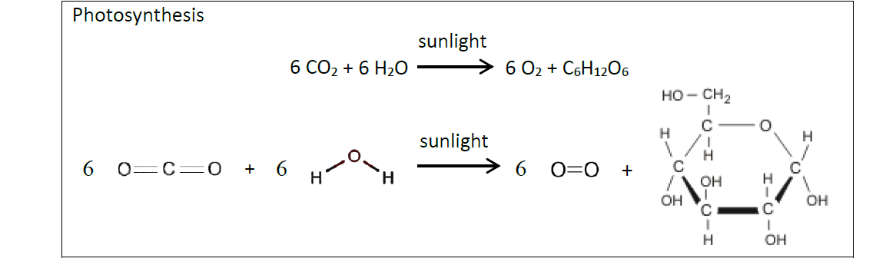
Figure 1: Equations of photosynthesis.

1. During biological processes, energy can be converted from one type to another, but energy is neither created nor destroyed. During photosynthesis, what happens to the energy in sunlight? Be specific.

2. The chart below shows another type of model of photosynthesis. This model emphasizes that:
· One type of energy is converted to another type of energy.
· Matter is converted to matter; i.e. atoms in the input molecules are reorganized as atoms in the output molecules.

Complete this chart to show the changes during photosynthesis in your Engineering notebook.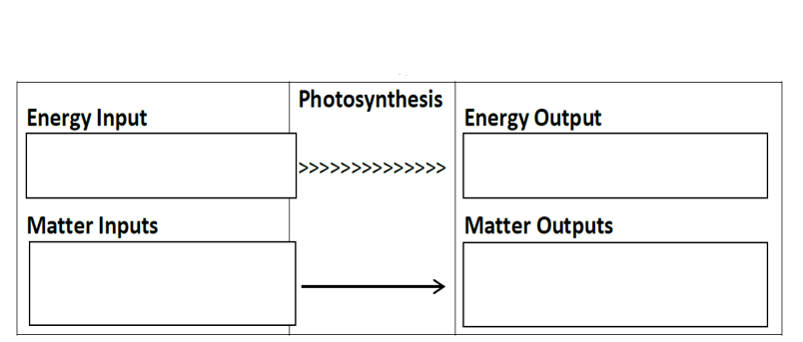
Figure 2: Chart to complete energy and matter inputs and outputs of photosynthesis.

Photosynthesis takes place in chloroplasts which are abundant in leaf cells. This diagram of a chloroplast provides another model of photosynthesis.

This model shows some of the multiple steps involved in synthesizing a single sugar molecule and a few of the many molecules needed for photosynthesis. Another important molecule is chlorophyll, a green pigment which absorbs light and begins the process of converting light energy to chemical energy.
In a real chloroplast, there are many repeats of each of the molecules and structures shown here.

3. Sketch in your engineering notebook and circle the part in the chloroplast where you would expect chlorophyll to be located.
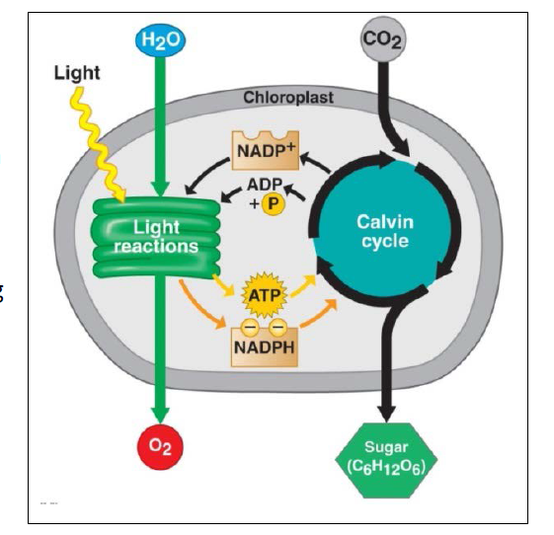
Figure 3: Diagram of photosynthesis in a chloroplast.
4. A typical leaf is flat and thin. Why is it useful for each leaf cell to be relatively near the surface of the leaf?

5. All three models of photosynthesis (the diagram above and the chemical equations and chart on page 1) show some of the same basic characteristics of photosynthesis. What are some basic characteristics of photosynthesis that are shown in all three of these models of photosynthesis?

6. Compare the three types of models – the diagram, the chemical equations and the chart. Describe one advantage and disadvantage of each type of model that helps you to better understand photosynthesis.

Advantage of Diagram (Figure 3) | Advantage of Chemical Equations (Figure 1) | Advantage of the Chart (Figure 2)
Disadvantage of Diagram | Disadvantage of Chemical Equations | Disadvantage of Chart
Figure 4: Chart of advantages and disadvantages of models of photosynthesis.

The sugar molecules produced by photosynthesis are useful for two reasons. As shown, the chemical energy stored in the sugar molecules can be transferred to ATP molecules which provide the energy for cellular processes. In addition, plant cells use some of the sugar molecules to synthesize other needed molecules such as cellulose and amino acids.
All biological organisms use ATP to provide energy for many of the molecular and cellular processes required for life. Cellular Respiration is the process that transfers some of the chemical energy in glucose or another organic molecule to chemical energy in ATP. This figure shows how photosynthesis and cellular respiration work together to produce the ATP that plants need.
Some of the glucose produced by photosynthesis is not used for cellular respiration, but instead is used by the plant to synthesize other molecules such as starch, cellulose and amino acids. Starch molecules can also be broken down to provide glucose for cellular respiration. Other molecules such as cellulose and amino acids are used for growth.
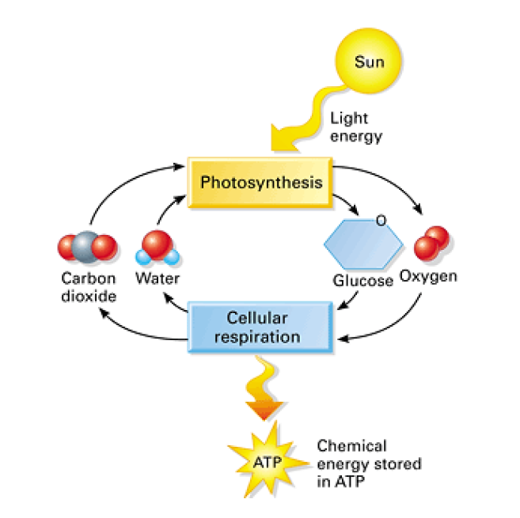
Figure 5: Diagram of relationship between photosynthesis and cellular respiration.

7. Complete the chart below to show a model of the relationships between photosynthesis, cellular respiration, and other processes in the plant.
· Write the chemical equation for photosynthesis in the box.
· Draw arrows to link the glucose produced by photosynthesis to the glucose used by cellular respiration and to the glucose used in the synthesis of other biological molecules (similar to the ATP arrow).
· Draw an arrow to show that starch can be broken down to provide glucose molecules for cellular respiration.

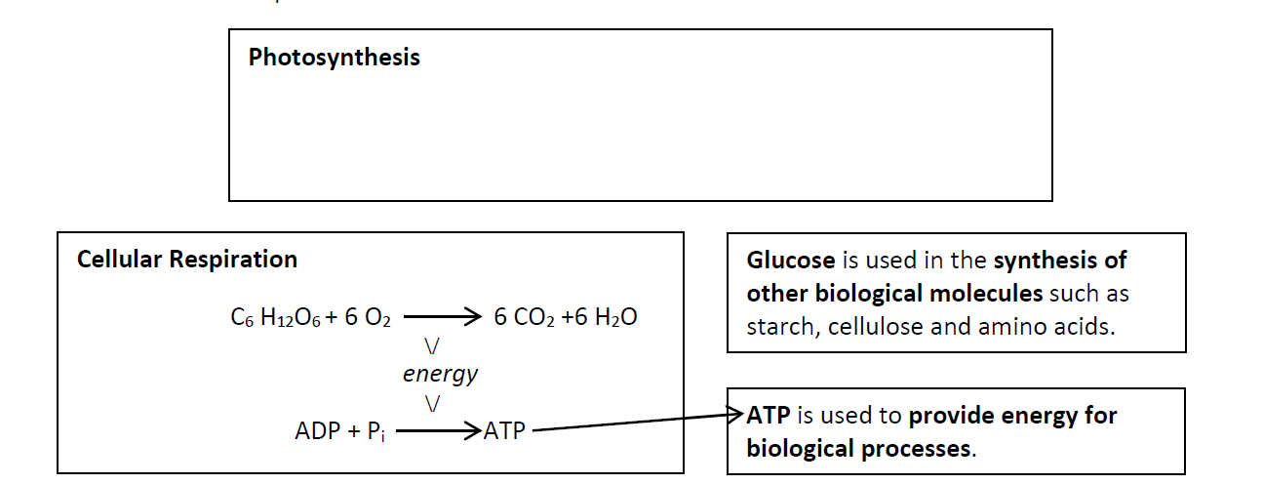
Figure 6: Chart linking photosynthesis and respiration.
8. In the dark, a plant produces more CO₂ than it takes in. Explain why.

9. In the light, a growing plant takes in more CO₂ than it produces. Explain why. Where do the carbon atoms from the CO₂ go?

[1] Adapted from: Dr. Ingrid Waldron, Dept. Biology, University of Pennsylvania, © 2014.

Lesson Plan 4: Science Inquiry Investigation: Explain the importance of plants in food chains and energy transfer

Lesson Focus:
Flower dissection

Total Time Required:
- One 50 minute class period

Lesson Objectives:
Students will be able to:
- Recognize reproductive parts of a plant with the aid of a 2D and 3D model, and recognize the parts’ role in reproduction.
- Explain that flowers undergo sexual reproduction and need aid in pollination, which must be carried out by insects, animals and/or nature (wind, rain, etc.) to reproduce since plants are not motile organisms
- Understand plants are needed for stable food webs and are an integral part of the carbon cycle

Equipment and Materials
Tools and Materials | Quantity Needed
Scissors or dissection tools | 1 tool per student
Flower with easily identifiable reproductive parts | 1 per group of 2-3 students
Clear tape, lab paper, and pencil | 1 per group

Special Notes on Materials:

Flower dissection will take one 50 minute class period or less. Please adapt as needed. This can be done as a model, or an actual dissection. If you speak to local florists (even Walmart or grocery stores) they will usually save flowers that are past their “sale date” for you. 3D model file on TRAILS website.

Lesson Procedures:
Set Induction: How do plants reproduce? How are plants connected in the food web and energy/carbon transfer?

Procedures / Steps:

- Brainstorm {previous lesson} (students may know a lot about this topic already) in Engineering Notebook how plants reproduce. Do not allow students to look up answers. There should be sketches and descriptions. You might have to direct students with questions such as: HOW are the seeds made and how do they get to a place to grow?
- On the next page introduce and define the word dispersal. Ask students to define pollination and give a correct definition of pollination. Students should record this in their notebook. Ask the students to build off and/or correct work to show how plants use dispersal methods (insects, animals, and natural events). Make sure to share correct information with the students after the second round of work. Have students take notes in the notebook:

Pollination is the act of transferring pollen grains from the male anther of a flower to the female stigma. One of the ways that plants can produce offspring is by making seeds. (USDA Forest Service)
In order for fertilization to occur, insects or other methods must transfer pollen. This causes the formation of seeds and fruit/nuts surrounding seeds. ⅓ of the foods that humans eat require pollination. Some examples are fruits, vegetables and nuts. Without these food, not only do humans lose food variety, they lose nutrients. Outside of the food crops, 80-95% of plant species need a form of animal to disperse seeds. Some plants like wheat rely on the wind as a dispersal method.

Flowers attract the animals and insects who pollinate. Fruits are then derived from the ovary of the plant. These contain the seeds. They can be dispersed by eating or otherwise moving the fruit.

Not only are plants important food for humans, they are also the lowest trophic level and provide food for all other trophic levels, oxygen for the entire biosphere, habitat, and protection.

Closure/ Review:

Review with students to make sure they understand pollinators (animals, insects and nature) are required for plants to reproduce, which are required for the base of the food chain, photosynthesis, food sources, habitat, etc. Introduce that humans can negatively or positively impact this process.

Note: If flowers are not available, students have allergies, etc. flowers could be reversed engineered and built with paper or other materials. There are also online dissections that could be performed instead.

Student Worksheets:
- Flower dissection. The following can be modified and printed for student use:

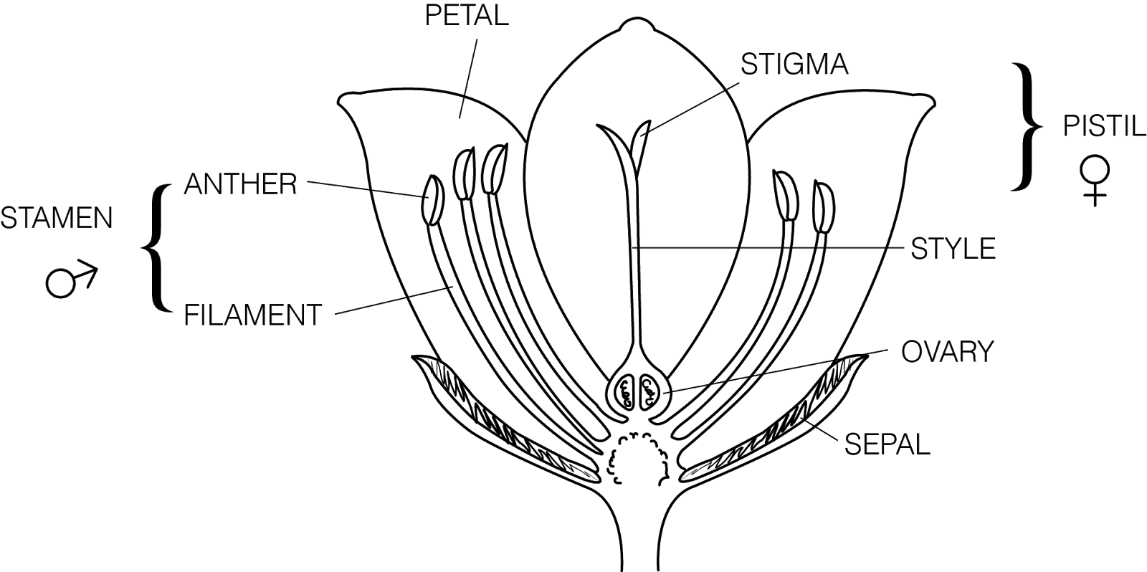
http://www.beeginnerbeekeeper.com
Fig 1. Labeled cross section of a flower.

Procedure
1. Obtain a single flower and observe reproductive parts carefully. Look at Fig 1. to help identify parts. Flower parts are arranged in a circular pattern. Each circle is called a whorl. The whorls are attached at the enlarged receptacle located at the base of the flower.

Please read this overview before you begin your flower dissection:
As you examine your flower, you will be carefully removing parts beginning with the outer whorl and working your way in towards the pistil. You will arrange each whorl in a circle on plain paper, beginning with the sepals as the largest outermost circle. As you proceed with your dissection, carefully tape each whorl of flower parts into position and label them. As each whorl is observed and removed, complete the appropriate information in your notebook.

2. The sepals form the outermost whorl of the flower. The sepals are leaf-like structures that are usually green in color. Sometimes, the sepals are the same color as the petals, or appear to be another set of petals of a different color. The function of the sepals is to protect the inner part of the flower before it blossoms. Gently remove the sepals, tape them into position onto the paper, and label them. In your notebook, record the following observations:
a) How many sepals does your flower have?
b) Describe/sketch the appearance of the sepals (color, markings, etc.).

3. The petals are found directly under the sepals. The color and odor of the petals help to attract birds and insects to the flower for pollination. Gently remove the petals, tape them into position onto the paper, and label them. In your notebook, record the following observations:
a) How many petals does your flower have?
b) Describe/sketch the appearance of the petals (color, markings, etc.).

4. The stalk-like structures inside the petals are the stamens, the male reproductive organs. Depending on the species, the stamens may be attached to the receptacle, to the petals, or to the pistil. The enlarged portion at the top of the stamen is the anther. Pollen sacs, inside the anther, produce the pollen grains. When the pollen grains mature, the pollen sacs split open, releasing dust like pollen grains. The filament is the thin structure that supports the anther. Gently remove the stamens, tape them into position onto the paper, and label them.
In your notebook, record the following observations:
a) How many stamens does your flower have?
b) To which structure(s) were the filaments attached?
c) Have the pollen sacs opened? How can you tell?
d) If pollen grains are visible, describe/sketch their appearance.

5. The central structure of the flower is the female reproductive organ, the pistil. The top of the pistil is the stigma. When mature the stigma is enlarged, and its surface is sticky. The style is the middle portion of the pistil which supports the sigma. The ovary is the enlarged structure at the bottom of the pistil containing the eggs. A fertilized egg becomes an embryo. The wall of the ovule thickens and forms a seed, thus enclosing and protecting the embryo. The ovary wall also thickens and develops into a fruit. In some plants such as apples, the ovary walls become fleshy and contain stored sugars and starches. In other plants such as walnuts, the ovary walls become dry and hard. Carefully remove the pistil by cutting it from the stem just under the ovary. Make a life-sized sketch of the entire pistil (just the outline) in the center of the paper and label it. Cut the style just at the top of the ovary, tape it next to your sketch, and label the stigma and style. Measure the length of the style in millimeters. Cut a thin crosswise section of the ovary and tape it under the stigma and style. Label the ovary wall and eggs.
In your notebook, record the following observations (letters match observations on the table):
a) What color is the pistil?
b) Describe/sketch the appearance of the stigma. Is the stigma mature? How can you tell?
c) How long is the style (in mm)?
d) Describe the appearance of the ovary.

Discussion - Please answer the following questions in complete sentences in your notebook.
- Which does your flower produce in greater numbers: eggs or pollen grains?
- Explain why this would be important in terms of reproductive success.
- What are some adaptations of flower petals to help attract pollinators?
- How is the stigma of your flower adapted to capture and hold pollen?
- There are a few different ways that pollen can be brought to the pistil: insects, wind, birds,
animals and water. Which do you think pollinates your flower and why?
- Sometimes, pollen from a different species lands on the stigma of a flower. Based on your
knowledge of cell communication, suggest a mechanism that would ensure that only the correct
species of pollen germinates on the stigma of a particular type of flower.
- Describe where pollination and fertilization occur.
- Explain the differences between pollination and fertilization.
- Which part of the flower becomes the seed?
- Which part becomes the fruit?
- Which part of the fruit contains the embryo?

Lesson Plan 5: Biomimicry (See TRAILS Website)

Lesson Focus:
Concept of Biomimicry as can be applied to pollination
Introduce biomimicry and define as how nature solves a problem: See Biomimicry lesson on the TRAILS website.

Biomimicry is an approach to innovation that seeks sustainable solutions to human challenges by emulating nature’s time-tested patterns and strategies. (Definition from Biomimicry Institute website: https://biomimicry.org/what-is-biomimicry/#.V2mD_vkrKM8 ; have students look at the website for more ideas.) There are a lot of neat ideas on this website which can lead to class discussions or other individual projects. This will help students with the next lesson.

Redirect work to focus on bees as the pollination mechanism. Students now need to research and sketch structures that allow bees to pollinate (new page in engineering notebook). Make sure students list conditions and environments that allow pollination. Flowers that use pollination by bees should also be investigated and a brief description recorded.

Closure/ Review:

Review with students to make sure they understand what biomimicry is.

Lesson Plan 6: Science Inquiry Investigation: How do humans impact an ecosystem, in both negative and positive way?

Lesson Focus:
Human impact on the honey bee population, discussion and presentation.

Total Time Required:
- 1-2 class periods for whole and small group instruction. Approximately 1 class period to present ideas.

Lesson Objectives:
Students will be able to:
Design, evaluate, and refine a model which shows how human activities can change the flow of matter and energy in an ecosystem and how those changes impact the environment and biodiversity of populations in ecosystems of different scales, as well as, how these human impacts can be reduced.

Special Notes on Materials:
https://www.purdue.edu/newsroom/releases/2015/Q2/honeybee-die-off-less-severe-this-year-.html (information on the Honey Bee population from Purdue)

We are not telling students at this point they will be making bee robots. We want to keep this purely in the brainstorm stage so we do not have design fixation prior to brainstorming. We think taking this approach will allow for more creative ideas and critical thinking toward a solution before an engineering design is created.

Lesson Procedures:

Set Induction: Human impact on the environment and on Honey Bee population

- Watch YouTube videos: (there are many more, preview a few to decide on level pertinent to your classroom)
https://www.youtube.com/watch?v=Zgc5w-xyQa0 (SciShow, what’s happening to Honey Bees) 4:23
https://www.youtube.com/watch?v=1ZlJbDshqD8 (Declining Honey Bee population, Good Morning America) 2:46

- Quickly talk to the students about how humans can impact the environment, remind them it can be both positive and negative. Have students break into groups to discuss how humans impact the Honey bee population and how this can have further impacts on the environment. Have the students come up with ideas on how we can correct the human impact issue on bees. Make sure to take notes in yhe notebook.

- Review biomimicry idea. Brainstorm (reference/review lesson) ideas on how Humans can create a way to artificially pollinate. Help keep students in the brainstorm stage here. You may want to start individually and come to a group discussion. Students will keep these in their notebooks to use as ideas in the engineering phase. Remember not to tell them they will be making a robot yet.

- Students will present their group’s best idea on how to correct the impact issue and the best biomimicry of pollination idea. Sketches should be projected and all group members should talk equally to the class. Groups should be graded on the 21st century collaboration and presentation rubrics. Talk briefly about how to present and look over the presenation rubric with the class before letting them present.

Closure/ Review:
Review the biomimicry concept, tie in careers related with biology (involve community members if you have resources). Review human impact on ecosystems/biosphere. Remember that the impact can be positive and we can help correct it, especially using the biomimicry concepts. You may need to review presentation standards, or ideas to help them present/ communicate better.

Note: there are many other types of disseminating ideas such as fish bowl, harkness, silent, and other types of presentations/ discussions that could be used as well as an essay answer depending on the learners.

Lesson Plan 7: Engineering Design: How can a robot be designed, using biomimicry, to pollinate flowers?

Lesson Focus:
Create a robot to simulate pollination and nectar collection.

Total Time Required:

Ten to fifteen 55 min class periods, dependent on student experience

Lesson Objectives:
Students will be able to:
  - Analyze the impacts of bees on pollination of our food supply
  - Design and build a robot that is capable of collecting and distributing liquids
  - Design and build a robot that is capable of collecting and distributing pollen (glitter)
  - Program a robot to work either autonomously or via remote control
  - Design a part for their robot using Autodesk Inventor
  - Print their part and integrate it into their final solution
  - Document the engineering design process
  - Reflect on the process at the end

Equipment and Materials
Tools and Materials | Quantity Needed
Computer with internet | One per group
CAD software | One per group
VEX Robotics (or similar system) with coding | One per group
3D Printer | One per group
Dial calipers, micrometers, and/or other precision measurement equipment | One per group
Flower/nectar storage device | Set for class

Special Notes on Materials:
Robots can be made with almost any materials, many types of modifications and CAD software can be replaced with other free online software.

Lesson Procedures:

- Have students read the article Decline of Bees forces China’s Apple Farmers to Pollinate by Hand and complete the design brief (see TRAILS website for examples)
  - Check the design brief once students have completed it before allowing them to continue
  - Discuss the deliverables as a class
  - Discuss criteria and constraints
    - 6 motors maximum
    - Must fit with a standard printer paper box
    - Must be either controllable via remote or automated programming
    - Must use VEX parts
    - Must include a custom 3D designed and printed part
    - Create ALL engineering documentation required in the notebook
- Hand out design brief and discuss with students
- Students will use VEX parts and 3D printed parts designed in Inventor to create a BumbleBot
  - The part must be integral to the design
  - If the part is removed from the robot, it should no longer function
- Using the BumbleBot, students will navigate a course to retrieve “nectar” from flowers placed around the room.
  - Students are required to create at least one custom 3D printed part to use on their BumbleBot
    - They cannot simply trace an existing part. It must be a completely new part that is integral to their end product
  - While collecting nectar, the BumbleBot will also collect “pollen” in the form of glitter
- Students will be graded on three factors:
- Amount of pollen spread (Count sequence)
- Amount of nectar collected (overall volume)
- Time taken to travel from home hive to all flowers and back to home hive
- The BumbleBot will be remote controlled, but students may create autonomous coding for the BumbleBot.

Remaining time of Day 1-Day 9
- Students will begin engineering design process, keeping a proper engineering notebook
  - Define Problem
  - Brainstorming
  - Research
  - Sketching
  - Choose Solution (Optional: Through Decision Matrix; see TRAILS website)
  - Build Prototype
  - Test
  - Evaluate
  - Refine
  - Final Test
  - Reflection

Closure/ Review
- Test and evaluate BumbleBots
- Have students write a ½ page reflection in engineering notebook that addresses:
  - What went well?
  - What didn’t work?
  - How could students adjust their design to increase efficiency?

- Note: This project will be very open ended and will be largely guided by the students. Their objectives are listed in the design brief, but are also as follows.
- Students will use VEX parts and 3D printed parts designed in Inventor to create a “bee”-bot.
- Using the BumbleBot, students will navigate a course to retrieve “nectar” from flowers placed around the room.
- While collecting nectar, the BumbleBot will also collect “pollen” in the form of glitter
- Students will be graded on three factors:
  - Amount of pollen spread (add sequence to container to count later)
  - Amount of nectar collected (overall volume)
  - Time taken to travel from home hive to all flowers and back to home hive
- As the instructor, you will need to create the flowers that students will use
  - The suggestion is to take artificial flowers and wrap them around a 30 mL vial and to fill the vial with “nectar”
    - The “nectar” will be a variety of liquids, either with naturally different colors or with food coloring
    - Ideally, each of the liquids will have different densities
      - Water, corn syrup, vegetable oil, rubbing alcohol, honey, maple syrup, etc.
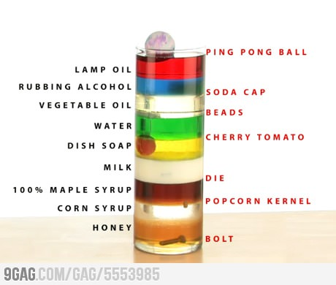
- Students should have a basic understanding of hydraulic systems
  - Prime movers, working lines, bleed lines, filters, and reservoirs
- For POE: use structured design brief
- For EDD: use blank design brief

This project is supported by the National Science Foundation, award # DRL – 1513248
Any opinions, and findings expressed in this material are the authors and do not necessarily reflect the views of NSF.

