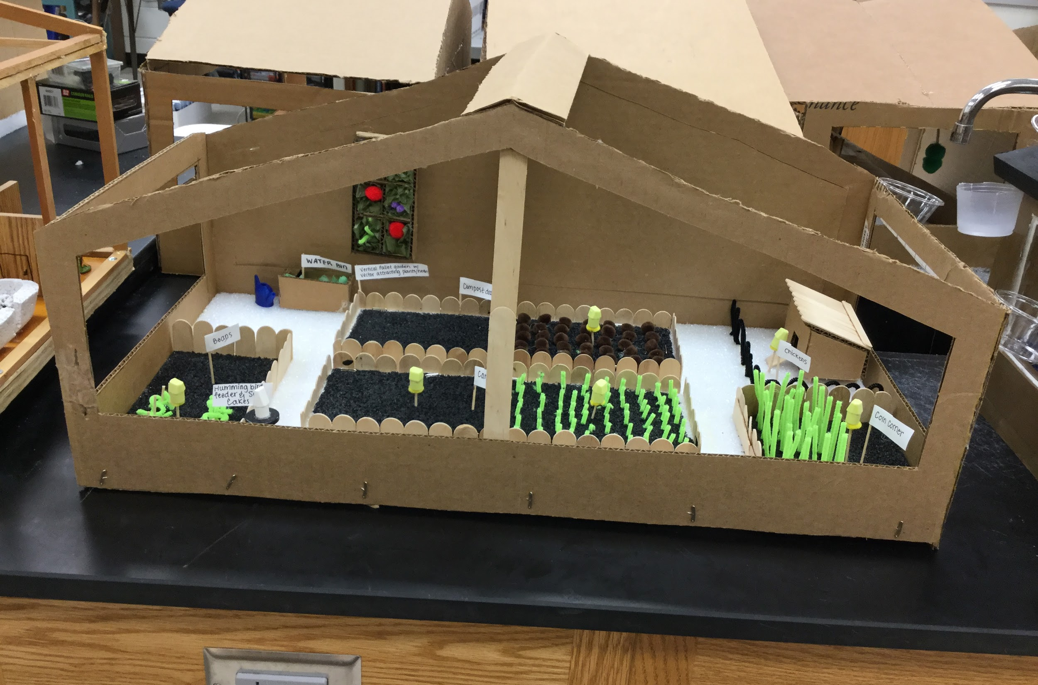

Age Levels:

9th-12th Biology or Biology II
- This lesson could easily be modified to collaborate with Engineering students by producing final the prototype in Revit or a 3D CAD program. They could even be 3D printed.

Total Time Required:

About 4 weeks

Prepared by:
- Amy Charlwood
- June 2019

Unit Objectives:
Students will be able to:
- Students will be able to develop a creative backstory for the zombie apocalypse
- Research various methods of providing for food and water needs
- Write a paper in MLA format justifying their decisions
- Keep a spreadsheet balanced to keep track of a $2000 budget
- Develop a 3D prototype of their room built to scale

Science Standards and Standards for Technology Literacy:
Below are standards in Biology and Engineering that this unit addresses.

Biology: The following are Student Learning Objective
- Differentiate between different types of gardening including pros and cons
- Describe aquaponics and hydroponics
- Determine what basic nutrients are needed in a healthy diet and where those can be found
- Describe the need for composting how to successfully compost

Biology: Math, Literacies, 21st Century Skills
- 9-10.RS.1/9-10.RT.1 Cite specific textual evidence
- 9-10.RS.3/9-10.RT.3 Follow precisely a complex multistep procedure
- 9-10.RS.5/9-10.RT.5 Analyze the structure of the relationships among concepts in a text, including relationships among key terms
- 9-10.WS.2/9-10.WT.2 Write informative/explanatory texts
- 9-10.WS.6/9-10.WT.6 Use technology, including the Internet, to produce, publish, and update individual or shared writing products
- 9-10.WS.8/9-10.WT.8 Gather relevant information
- Students will be able to collaborate, communicate, be creative, & think critically

Standards for Technology Literacy: IED State Standards
- IED-1.4 Apply and adapt the design loop as a guide to solving a problem or creating a solution
- IED-6.3 Evaluate a sketch and generate a model using appropriate modeling materials
- IED-7.14 Grade design solutions that use specific elements, principles, and functions to solve problems & communicate ideas.

Standards for Technology Literacy: IED Math, Literacies, 21st Century Skills
- 9-10.RS.3 Follow precisely a complex multistep procedure
- 9-10.RS.5 Analyze the structure of the relationships among content in text
- 9-10.RS.3/9-10.RT.3 Follow precisely a complex multistep procedure

Recommended Instructor Preparation

- Prior to this lesson teachers should be familiar with MLA format. Complete instructions for this are in the BIG packet linked in the Student Resources section of the lessons.
- This is designed to run in Google Classroom. It can be run on other formats, but may require some alteration.

Lesson Plan 1: Zombies Introduction

Lesson Focus:
Students are introduced to the project. All required products are discussed along with due dates. Students work in collaborative groups to decide how work will be split up.

Total Time Required:
- 1 class period

Lesson Objectives:
Students will be able to:
- Become familiar with the project and due dates
- Students will agree to how to divide up the work

Equipment and Materials
Tools and Materials | Quantity Needed
Engineering notebook | 1 / student
BIG Instruction packet | 1 / printed per group  Also posted on Google Classroom

Special Notes on Materials:
The Instruction Packet is intimidatingly big. This was intentional. Students have all instructions for the entire project in ONE place instead of several. This includes instructions on how to write a paper in MLA and how to use both spreadsheets. It is cludes a table of contents to help them find information. I do not expect students to memorize or even read the entire packet. They need to be able to use ir as a resource.
Obviously due dates will need to be changed each year. These were left in to give you an idea of how long each item took and how they assignments overlapped.
Lesson Procedures:
- The teacher will go over the Instruction Packet. Special attention should be paid to:
  - Products & due dates on the front page
  - Table of Contents on 2-3
  - Detailed instructions for each assignment on pages 28-30
- Students will collaborate in their cooperative groups of 3-4 to decide how to split up work.
- Students will write up a written agreement that they all sign and turn it in to the teacher.

Student Resources:
Zombie Instruction Packet

Student Worksheets:
None are needed

Lesson Plan 2: Research

Lesson Focus:
Students are given a list of approved websites to search for information on different types of gardening. They are allowed to use other sites with approval. This data needs to be recorded in their engineering notebooks. They are also encouraged to record data in their Excel Information Spreadsheet which will be discussed further in lesson 4. All sources will need to cited in the Information Spreadsheet in the works cited column and parenthetical citation column.

Total Time Required:
- 5-7 class periods

Lesson Objectives:
Students will be able to:
- Collect data on pros & cons of different types of gardening
- Cite sources from which information is gathered
- Share data with group members

Equipment and Materials
Tools and Materials | Quantity Needed
Engineering notebook | 1 / student
BIG Instruction packet | 1 / printed per group  Also posted on Google Classroom
Computer with internet access | 1 / student

Lesson Procedures:
- Students research assigned information. The information that must be researched is listed in the Instruction Packet on page 29 (this is linked to the Student Resources section of this lesson). The approved sources are linked to the Student Resources section of this lesson. They will be provided for the students on Google Classroom. Students should research topics that they agreed to in the previous lesson becoming “experts” on those topics.
- As students research, they should be recording their data in their engineering notebooks. They should also be recording at least the citations in their Information Excel Spreadsheets on Google Classroom (this is linked to the Student Resources section of this lesson and will be explained in detail in lesson 4).
- Students will share information with their cooperative groups and begin to make decisions about their prototype.

Student Resources:
- Zombie Instruction Packet
- Approved Sources
- Information Excel Spreadsheet

Lesson Plan 4: Information Excel

Lesson Focus:
Historically students did research on 3 x 5 cards that needed to be shuffled. This had several disadvantages. Student could not get feedback on them until they were done and turned in. Students also had to retype or rewrite the information from the cards into they formal paper. By using spreadsheet, teachers can go in and make comments in real time. They can let students know if paraphrases are too close to a quote or let them know if their citations are incorrect BEFORE they go in the paper. Students can sort the information in the spreadsheet just like they would with notecards. The data can them be copied & pasted into the paper with the parenthetical citations. This leave the paper needing topic sentences, closing sentences, and flow. Ta-da! The works cited information can also be copied and pasted from this document into the paper.
Detailed instructions on how to use the Information Excel Spreadsheet are in the Zombie Instruction Packet pages 5-10 (linked to the Student Resources section of this lesson).

Total Time Required:
- 5-7 class periods. This is done simultaneously with research (see lesson 3). Students may need an extra day to make corrections.

Lesson Objectives:
Students will be able to:
- Cite sources used for research
- Paraphrase information gathered
- Sort information in a spreadsheet

Equipment and Materials
Tools and Materials | Quantity Needed
Engineering notebook | 1 / student
BIG Instruction packet | 1 / printed per group  Also posted on Google Classroom
Computer with internet access | 1 / student

Lesson Procedures:
- As students find information, it is typed in the “Quote” column. Then cited in the Works Cited column. After the students type it once, it can simply be copied into other boxes instead of rewriting it on every note card.
- As students have time (I suggest this for homework), they should be paraphrasing the quotes and filling in the parenthetical citation. These citations can be copied as needed. Simple fill-in-the-black examples of a MLA citation are in the Zombie Instruction Packet on page 23.
- Using the Keyword column, students can sort data into paragraphs (using the A -> Z feature).
- Using the # column, students can put the sentences into order that they want them in the paragraph.
- Students copy & paste the paraphrase then the parenthetical citations into the paper.
- Students add introductory paragraphs, topic sentences, closing sentences, concluding paragraph, and make it flow.
- Extra parenthetical citations are removed (see Zombie Instruction Packet pages 14-16).

Note: When doing MLA papers, I require younger students to fill out the entire spreadsheet so I can check their paraphrasing. For Juniors and Seniors, I often only require them to fill in the Works Cited column and Parenthetical column as they are better at paraphrasing on their own.

Student Resources:
- Zombie Instruction Packet
- Information Excel Spreadsheet

Lesson Plan 5: Zombie Backstory

Lesson Focus:
Students have to develop a backstory explaining how the zombie apocalypse started. Most students choose to turn this in as a short essay, but I have accepted graphic novels, stop-motion animation, skits, and videos to fulfill this requirement.

Total Time Required:
- 3 class period. Students do this during the time they are finalizing their spreadsheets.

Lesson Objectives:
Students will be able to:
- Develop a creative backstory explaining the zombie apocalypse

Equipment and Materials
Tools and Materials | Quantity Needed
Engineering notebook | 1 / student
BIG Instruction packet | 1 / printed per group  Also posted on Google Classroom
Computer with internet access | 1 / student

Lesson Procedures:
- The steps students take will vary depending on the format they choose to use for this backstory. They all need to begin by choosing this format.
- The information Requirement for the backstory are at the end of the Zombie Instructions packet page 28. These are written assuming students will write an essay.
- Students need to complete the backstory.

Student Resources:
- Zombie Instruction Packet

Lesson Plan 6: Budget Excel Spreadsheet

Lesson Focus:
Students will use this spreadsheet to keep track of their budget. This sheet should include ALL needed supplies to convert a sunroom into a garden such as soil, lumber, chicken wire, screws, hinges, piping, and anything else needed.

Total Time Required:
- 5-7 class period. This is done simultaneously with the backstory and finalizing the Information Excel (but after research is complete).

Lesson Objectives:
Students will be able to:
- Keep track of spending to stay within a budget
- Prioritize needs based on costs and space

Equipment and Materials
Tools and Materials | Quantity Needed
Engineering notebook | 1 / student
BIG Instruction packet | 1 / printed per group  Also posted on Google Classroom
Computer with internet access | 1 / student

Lesson Procedures:
- As students make decisions about what to build and place in their sunroom, they need to find those items on the Internet. Most items will be available at Menard’s or Lowe’s.
- Students then document all “purchases” on the Spreadsheet to be sure they are staying within their $2000 budget. [Description of step number 2]

Note: I have found that students who spend less than $1000 usually are not prepared to survive. Most students spend around $1500, but some spend every penny. If you want to make the project more challenging, the budget could be dropped to $1500.

Student Resources:
- Zombie Instruction Packet
- Excel Budget Spreadsheet

Lesson Plan 7: Final Paper

Lesson Focus:
Students will compile all the data they have researched and the decisions they have made to write a formal paper justifying their choices. Students also verify that they have learned all the student learning objectives (standards) for the unit in this paper. Usually there are no wrong answers as long as they justify their choices.

Total Time Required:
- 5 class period.

Lesson Objectives:
Students will be able to:
- Write a formal paper in MLA format
- Clearly describe decisions they have made
- Justify all choices they have made
- Verify meeting all the student learning objectives for the unit.

Equipment and Materials
Tools and Materials | Quantity Needed
Engineering notebook | 1 / student
BIG Instruction packet | 1 / printed per group  Also posted on Google Classroom
Computer with internet access | 1 / student

Lesson Procedures:
- Usually each student writes part of the paper. Students were “experts” in different areas and did different research. each students puts in his or her information. Detailed instructions on how to write a formal paper in MLA are in the Zombie instruction packet. It includes the header, heading, paper, citations, and works cited page.
- After putting in their data, students indicate where student learning measures are met. In my class these “standards” are written in their engineering notebook and at the end of each unit students must indicate where in the notebook the teacher can find evidence of learning this standard. For this project, students indicate evidence in the final paper. Standards are indicated with a letter and a number (like C1). I have linked a sample student paper in the student Resources section of this lesson. I have also linked a sample of my unit standards and a sample “Trains” paper that students can access as an example.
- Usually one student takes over responsibility for the paper overall. this student makes sure the paper ‘flows,” is in logical order, and follow all MLA guidelines.

Student Resources:
- Zombie Instruction Packet
- Sample Zombie Student Paper
- Sample Trains Paper
- Student Unit Standards

Lesson Plan 8: Sunroom Prototype

Lesson Focus:
Students develop a 3D model to represent the decisions they have made through their research.

Total Time Required:
- 5 class periods

Lesson Objectives:
Students will be able to:
- Use the design process to develop a prototype
- Measure accurately
- Develop a prototype built to scale
- Represent their ideas in a visual, 3D model

Equipment and Materials
Tools and Materials | Quantity Needed
Engineering notebook | 1 / student
BIG Instruction packet | 1 / printed per group  Also posted on Google Classroom
1” thick styrofoam for the base | 1 sheet / group
Hot glue & glue gun | 1 gun with glue / group
Wide variety of craft items:  - cardboard  - popsicle sticks  - toothpicks  - beads  - pipe cleaners  - tissue paper  - straws  - cups  - T-pins  - duct tape  - other items on request | This will vary widely depending on decisions that groups make

Special Notes on Materials:
This prototype could easily be converted into collaborative project with Engineering students who make the prototype as a floor plan, Revit drawing, 3D CAD drawing, or 3D printed model.

Lesson Procedures:
- Students decide what structures are going in the prototype primarily during the research and discussion portion of the project. Students are encouraged to use the vertical space as well as the horizontal space in their prototypes.
- Students build structures to model their plan to scale.
  - As students build they often will redesign of modify their original plan. This is encouraged as a natural part of the design process.
  - However, this may also require then to make changes to their Budget Spreadsheet or their Final Papers.
- All items in the room must be clearly labelled or the prototype needs to come with a key.
- Requirements for the prototype are in the Zombie Instruction Packet on page 30.

Note: When the project is over, student evaluate themselves and their peers. These evaluations are averaged to get one score. I feel this is important to ensure that all students contribute as fairly as possible. A rubric for this is included in the Zombie Instruction Packet. However, this is not essential to the project’s learning objectives.

Student Resources:
Zombie Instruction Packet

This project is supported by the National Science Foundation, award # DRL – 1513248
Any opinions, and findings expressed in this material are the authors and do not necessarily reflect the views of NSF.

