Age Levels:

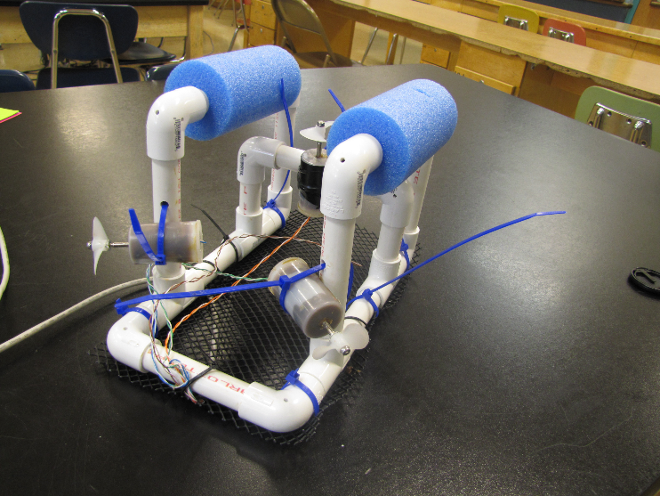
11th-12th Environmental Science & Engineering Design and Development

Total Time Required:
- (11) 90 minute periods
- (6) 50 minute periods

Prepared by:
- Katy Tincher and Craig Hughes
- 2017

Unit Objectives:
- Understand aquatic food webs
- Communicate environmental issues
- Predict buoyance using math
- Design and Build See Perch to Collect Plastic Pollution

Science Standards and Standards for Technology Literacy:
Below are the standards for Environmental Science and Technology
Environmental Science:

Env.5.5 Identify the indirect and direct threats to biodiversity (e.g. habitat loss and destruction, invasion by exotic species, commercial over fishing and hunting, pollution, climate change, and bioaccumulation and biomagnification of toxins)
Env.7.7 Describe and explain the product life cycle and waste stream and its implications to waste management. Explain the difference between reduce, reuse, and recycle.
Env.8.7 Understand and explain that waste management includes considerations of quantity, safety, degradability, and cost. Also understand that waste management requires social and technological innovations because waste-disposal problems are political and economic as well as technical.

Standards for Technology Literacy:
STL 5 Students will develop an understanding of the effects of technology on the environment.
STL 9 Students will develop an understanding of engineering design.
STL 10 Students will develop an understanding of the role of troubleshooting, research and development, invention and innovation, and experimentation in problem solving.

Recommended Instructor Preparation
- Plastic “pollution” can consist of various everyday objects or plastic delrin spheres that will float in the water.
- Each group may have 1 Sea Perch kit or may have just 1 kit to be purchased and other materials may be donated from local suppliers.
- Interchangeability of more expensive components in the Sea Perch may be used in order to keep cost of equipment to a minimum.

Student/ Teacher Resources:
Activity Extensions:
- Will it float: http://www.abc.net.au/science/surfingscientist/pdf/lesson_plan14.pdf
- Engineering Drawing and Sketching: http://www.me.umn.edu/courses/me2011/handouts/drawing/blanco-tutorial.html

Web Resources:
- Buoyancy: http://hyperphysics.phy-astr.gsu.edu/hbase/pbuoy.html
- Decision Matrix Analysis: https://www.mindtools.com/pages/article/newTED_03.htm

Whirligig beetle (Gyrinus substriatus): http://www.arkive.org/whirligig-beetle/gyrinus-substriatus/
- Aquatic Food Webs: https://serc.si.edu/research/research-topics/food-webs/aquatic-food-webs

OCEAN PLASTICS POLLUTION: A Global Tragedy for Our Oceans and Sea Life: http://www.biologicaldiversity.org/campaigns/ocean_plastics/

Lesson Plan 1: Science Inquiry Investigation: What are the roles of various species in freshwater aquatic food webs?

Lesson Focus:
The teacher should provide pictures of various animals with the common name as the only identifiable characteristic. Students will describe the relationship between the various animals and arrange them in a logical manner.

Total Time Required:

50 minute period

90 minute period

Lesson Objectives:
- Describe and illustrate the feeding relationships of aquatic food webs

Equipment and Materials

Tools and Materials | Quantity Needed
Set of laminated aquatic species cards (writer did not include an example) | 1 / group
Large sheet of poster paper | 1 / group
Set of markers or colored pencils | 1 / group
Scotch tape | 1 / group

Lesson Procedures:
- Provide each group with:
- Set of laminated aquatic species cards
- Large sheet of poster paper
- Markers or colored pencils
- Scotch tape
- Instruct students to utilize their own computers to conduct research pertaining to the feeding relationships with identifying labels between the aquatic species identified on the laminated cards.
- Using the information collected, students will create an aquatic food web using the provided materials including a legend or key and appropriate arrows.
- Conduct at least one peer review of another group’s food web, checking for accuracy and quality of appearance. Utilize the peer review tool within Canvas to assess and provide feedback to your assigned group.
- Bring the class together for a collaborative environment and with the teacher leading the teams, discuss the similarities and differences between the food webs. Use the following guiding questions to help with facilitating discussion:
- What research did you find to support the accuracy of your food web?
- If there are differences between group’s food webs, why? What research was done to confirm accuracy?
- Was the research reliable? Where did you collect information from?
- The teacher should close by summarizing:
- Most producers/autotrophs are photosynthetic while consumers/heterotrophs must consume other organisms for energy.
- In all food webs, several predator/prey relationships are present in order for those animals to survive.
- Consumers are described as primary, secondary, tertiary, or quaternary consumers based upon their feeding levels.

Student Resources:
What’s Eating You Activity

Lesson Plan 2: Science Inquiry Investigation: What impact does plastic pollution have in marine habitats?

Lesson Focus:
Students will investigate pollution in aquatic environments and create a PSA on the topic.

Total Time Required:

(2) 90 minute periods

(1) 50 minute period

Lesson Objectives:
- Determine impacts of plastic pollution on the environment, specifically, marine habitats and impacts on the animals that live there
- Create a PSA to disseminate feeling to the viewers

Equipment and Materials
Tools and Materials | Quantity Needed
Projector | 1 / class
Video or Phone Camera | 1 / class
Computer with Video Editing Software & Internet access | 1 / group

Lesson Procedures
- Show the ASPCA Animal Cruelty video: https://www.youtube.com/watch?v=9gspElv1yvc
- After the video is finished, have a discussion about the video and the impacts it has on the viewer. What information is learned about the issue at hand from the video?
- Have students research the facets of plastic pollution on the environment, specifically, marine habitats and impacts on the animals that live there.
- Using a camera and video-editing software, students will film a 2:00 minute (± 15 seconds) informational public service announcement (PSA) that will educate and inform viewers of the impacts of plastic pollution in marine habitats.
- Provide a discussion using guiding questions that will help students in the creation of their PSA.
- Guiding questions:
  - What information did you research that will be “eye-opening” or shocking to a viewer?
  - What images, visuals, and audio will help provide evidence to the information you researched?
  - What type of tone or feeling do you want the viewer to feel when they watch your PSA?
- Provide students with time to film, edit, and finalize their PSA. Videos will be shown in class and students will complete a peer review evaluation of the videos as they watch them in class.
- Teachers should close by summarizing:
- Large amounts of pollution that affect marine habitats are made from plastic materials which are not biodegradable.
- Many marine animals die from ingesting plastic objects left in marine habitats from human pollution.
- Marine habitats are collecting large amount of plastic materials in concentrated areas due to ocean currents.

Student Resources:
Ocean Pollution PSA Assignment

Lesson Plan 3: Science Inquiry Investigation: What characteristics of mass and volume have an effect on buoyancy?

Lesson Focus:
Students will explore Archimedes’ principle and buoyancy.

Total Time Required:
- (1) 50 minute period

Lesson Objectives:
Students will be able to:
- Predict buoyancy of an object using mathematics and predictive analysis.

Equipment and Materials
Tools and Materials | Quantity Needed
Projector | 1 / class
Sink or float quiz (printed) | 1 / group
Aluminum foil piece2 30” x 40” | 2 / group
30 golf balls | 1 / class (if they take turns)
Large tub of water | 1 / class (if they take turns)
Riff-Raft Activity Printed or available on Google | 1 / group

Lesson Procedures:

- With students, observe the shape of the following ships. Why do the ships have different shapes?
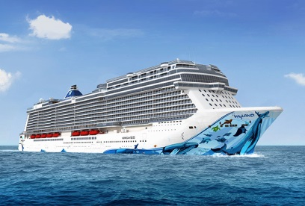 | 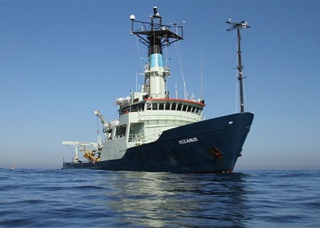
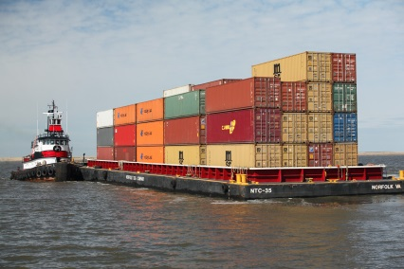 | 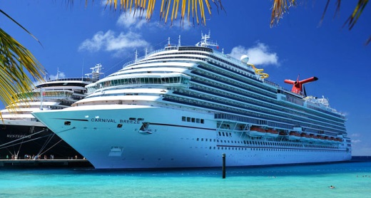

- Give each group of students the Sinking and Floating quiz. Which person will likely float?
Condition | Reason
Child versus Adult
Adult versus Elder
Man versus Woman
Fat guy versus Thin guy

- After giving them time to finish the Sinking and Floating quiz, discuss which person will likely float.
- Define Archimedes’ principle for the students to have them google it:
Archimedes’ principle indicates that the upward buoyant force that is exerted on a body immersed in a fluid, whether fully or partially submerged, is equal to the weight of the fluid that the body displaces
(http://en.wikipedia.org/wiki/Archimedes’_principle)

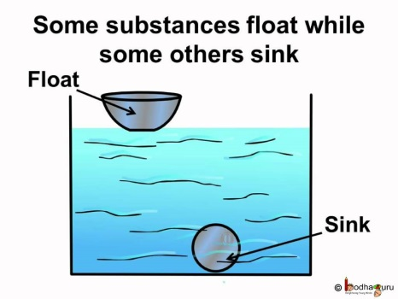

- Have the students complete the Riff-Raft Activity:

Riff-Raft Activity Procedures / Steps:

The manufacturing company Riff-Raft seeks to create a new line of emergency rafts that are portable for hikers. Your task is to create a prototype of the raft using given materials. As an engineer, you have to report out the anticipated capacity of the raft before testing it out.
Challenges
- Build a raft using a sheet of aluminum foil (40 x 30 cm)
- The raft should load at least 30 golf balls on water before submerging
- Predict critical load (total number of golf balls)
- Size: Less than 30 x 25 cm
- Time limit: 10 minutes
*Hint: Weight of golf ball: 46g
Results
Estimated capacity:
Number of golf balls | Total weight (N of golf balls * 46g)

Measured capacity:
Number of golf balls | Total weight (N of golf balls * 46g)

Redesign the Riff-Raft prototype
Challenges
- Rebuild a raft using the STEM knowledge and given materials.
- Sheet of aluminum foil (40 x 30 cm)
- Calculate the minimum volume of the raft to hold 30 golf balls.
- Time limit: 20 minutes
Your Design
- Calculate the volume of your raft that is capable to hold 30 golf balls.

- Draw your design:

Results
The volume of the raft | Number of golf balls

Reflection
- What knowledge did you use to build your raft design?

- In general, how does knowledge of STEM concepts benefit you in the design of a raft?

Student Resources:
Sink or Swim Activity

Lesson Plan 4: Science Inquiry Investigation: How do the whirligig beetle’s adaptations guide its specific feeding behaviors?

Lesson Focus:
- The biological adaptations of the whirligig beetle

Total Time Required:
- (2) 90 min. blocks

Lesson Objectives:
- Model, illustrate and annotate the biological processes of the whirligig beetle

Equipment and Materials
Tools and Materials | Quantity Needed
Computer with Internet access | 1 / group
Graph paper | 2 - 4 sheets / group
Various crafting materials (such as construction paper, pipe cleaners, beads, tissue paper, modeling clay, markers, colored pencils…)
Hot glue guns | 1 / group
Hot glue sticks | Several / group

Lesson Procedures

- Tell students to watch the video: https://www.youtube.com/watch?v=RIbzOeNcaxE and write down your observations. Think about what you are seeing and why that behavior may be happening.
- Research the anatomical structure of the whirligig beetle. Specific features to focus on include: eyes, body shape, and appendages. Draw out your design of a whirligig beetle on graph paper.
- Create a model of a whirligig beetle out of crafting materials. This model should be located in the same area of a body of water that a live whirligig beetle would reside.
- Research the Optimal Foraging Theory and draw out on graph paper using dashed lines the movements that a beetle would make. Shade areas of the graph paper with areas of no food, minimal food, and plentiful food. Then include a legend or key to identify food availability. Think about what other organisms might also use Optimal Foraging Theory.
- Showcase all of the models and their corresponding drawings. Have students observe and discuss the similarities and differences between the different groups’ designs.
- Student led discussion where students must articulate in their own terms what optimal foraging theory means and include examples of other species that can be used to describe the theory.

Student Resources:
Insecta Trifecta Activity

Lesson Plan 5: Science Inquiry Investigation: What are features of a design solution to reduce the amount of plastic pollution in marine habitats?

Lesson Focus:
- Design solution to reduce the amount of plastic pollution in marine habitats.

Total Time Required:
- (6) 90 minute periods
- (3) 50 minute periods

Lesson Objectives:
- Construct and test prototypes for the design problem
- Redesign and modify the solution
- Complete a final evaluation of their design
- Present design

Equipment and Materials
Tools and Materials | Quantity Needed
3D Printer | 1 / class
Computer with Parametric software | 1 / group
Sea Perch Kit | 1 / group
Large plastic tank | 1 / class
Various plastic pollution (can be marbles, clean trash, etc.)
Large sheet of paper | 1 / group
Set of markers | 1 / group
Isometric graphing paper | Several sheets / group

Lesson Procedures:

- After discussing the design brief, provide a list of criteria and constraints that the students will have for the project:
- The design must mimic the location and movement of a whirligig beetle in the environment
- Must have at least one 3D printed part in the final solution
- Must use materials that can be used in an aquatic environment (No VEX parts can be used)
- Must collect and store various plastic “pollution” from the marine habitat
- Have students review the design brief and complete the Define the Problem section on the Clean Sweep Submission Form to review the elements of the design brief.
- Without the aid of Internet searches, students will brainstorm possible concepts of possible design solutions. Provide students with a sheet of large paper and markers to sketch and provide ideas for brainstorming. Each group needs to compile at least 10 brainstormed ideas for an adequate session.
- Students will need to discuss and evaluate the brainstormed ideas and select three possibilities to explore. From the three ideas selected, students will complete a decision matrix using the criteria and constraints to provide an unbiased evaluation to determine the “best” solution.
- Students will document the initial design solution by sketching an isometric pictorial of the solution with annotations, signatures, and dates.
- Model the initial design using Autodesk Inventor and create working drawings of the parts required to build your solution.
- Students will begin constructing and testing their prototypes for the design problem, modifying and completing redesign as needed throughout the allotted time.
- Students will prepare a testable prototype for an initial round of testing and all groups will test to evaluate the performance of the design solution.
- Students will be given time to redesign and modify the solution in preparation for final testing.
- Students will test their revised solution and complete a final evaluation of their design solution. Students will complete a final design solution isometric sketch of the design with annotations, signatures, and dates.
- Update the initial design using Autodesk Inventor and create working drawings of the parts required to build your solution. Submit your completed working drawings in PDF format to Canvas.
- Students will present their solution and complete the Clean Sweep Submission Form for grading.
- Teachers should close by reviewing the following:
  - Engineering design is a systematic process that is used to develop design solutions to major societal problems.
  - Engineers must research and become experts in various areas that involve problems in order to design and develop successful solutions to problems.
  - Engineering sometimes contains a mix of various subject areas and fields of study such as sciences (biology and physics), engineering (constraints, optimization, and predictive analysis), technology, and mathematics.

Student Resources:
Design Brief

This project is supported by the National Science Foundation, award # DRL – 1513248
Any opinions, and findings expressed in this material are the authors and do not necessarily reflect the views of NSF.

