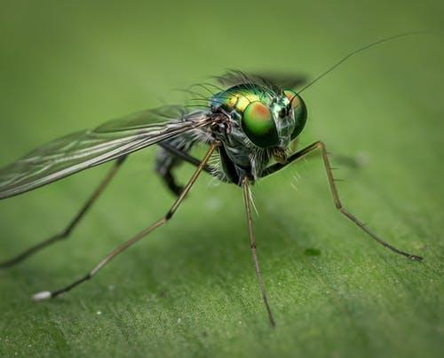

Age Level or Subject:
- Grades 9-12
- Engineering and/or Science courses

Total Time Required:

10 Classroom Hours

Prepared by:
- Tony Gonczarow, Alan Clifton, and Rob Clemence
- June 4, 2019

Unit Objectives:
Students will be able to:
- Observe biological processes and organism as a source of design inspiration.
- Form hypotheses about using predator insects to control undesirable insect populations.
- Create a decision matrix to select the best features that meet the need of the client.
- Predict rate of predator insect to undesirable insect eradication.
- Create a prototype using 3D printer displaying features of the designed predator insect.

Science Standards and Standards for Technology Literacy:
Content specific
Standards for Technological Literacy

9-I. Established design principles are used to evaluate existing designs, to collect data, and to guide the design process.

11-O. Refine a design by using prototypes and modeling to ensure quality, efficiency, and productivity of the final product.

11-P. Evaluate the design solution using conceptual, physical, and mathematical models at various intervals of the design process in order to check for proper design and to note areas where improvements are needed.

11-R. Evaluate final solutions and communicate observation, processes, and results of the entire design process, using verbal, graphic, quantitative, virtual, and written means, in addition to three dimensional models.

Science Standards

B.3.2 Design, evaluate, and refine a model which shows how human activities and natural phenomena can change the flow of matter and energy in an ecosystem and how those changes impact the environment and biodiversity of populations in ecosystems of different scales, as well as, how these human impacts can be reduced.

B.3.3 Evaluate the claims, evidence, and reasoning that the complex interactions in ecosystems maintain relatively consistent numbers and types of organisms in stable conditions, and identify the impact of changing conditions or introducing non-native species into that ecosystem.

B.5.3 Apply concepts of statistics and probability to support a claim that organisms with an advantageous heritable trait tend to increase in proportion to organisms lacking this trait.

B.5.4 Evaluate evidence to explain the role of natural selection as an evolutionary mechanism that leads to the adaptation of species, and to support claims that changes in environmental conditions may result in: (1) increases in the number of individuals of some species, (2) the emergence of new species over time, and/or (3) the extinction of other species.

Recommended Instructor Preparation
- VEX Robotics kits
- 3D Printer
- CAD Softare

Lesson Plan 1:

Science Inquiry Investigation: Guiding Question – What is makes a good predatory insect?

Lesson Focus:
The students will learn the functions and types of parts of many different insects.

Total Time Required:
- 1-2 hours

Lesson Objectives:
Students will be able to:
- Describe the general body structure of insects.
- Describe and state the function of four variations on insect mouthparts.
- Define biomimicry and list examples.
- Hypothesize which types of insects will make good predators.

Equipment and Materials:
Insect Collection and observation equipment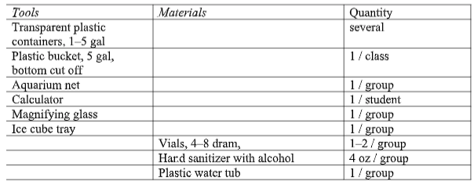

Special Notes on Materials:
Cut bottom out of 5 gal bucket before starting. Bottom and lid are not needed.
Fill vials approx. 80% full with hand sanitizer. Each group of student will have 1–2 vials to preserve insects.
Clear plastic containers are used to observe aquatic insects. They should be very transparent. Ice cube trays are for sorting insects.
During field observations, students may work in teams with one transparent container for observation per team.

Lesson Procedures:

Set Induction: What is the general body structure of an insect? Are all insects’ mouths, legs, and wings the same? Why have insects dominated the Earth?

1. Forty to fifty minute lecture over a general introduction to insects, insects as predators, and biomimicry. Focus on adaption in mouth parts, wing types, and limbs. View videos on predatory insects.
- Powerpoint 1 Introduction to Insects. http://www.ipm.iastate.edu/files/curriculum/06%20Introduction%20to%20Insects.pptx
- Powerpoint 2 Insects as Predators
http://web.csulb.edu/~dlunderw/entomology/16-Insectsaspredators.pdf
- Website on Biomimicry
https://biomimicry.org/what-is-biomimicry/#.V2qQJfkrLIU
- Video on Biomimicry in Design
https://www.youtube.com/watch?v=hqOjI9v_PO8
- Videos on Insect Predators Grasshopper Eating a Fly. https://www.youtube.com/watch?v=rwPaUma6R_k
- Dragonfly Larvae Eating Fish. https://www.youtube.com/watch?v=W557aSVdW_g
- Parasitoid Wasp https://www.youtube.com/watch?v=vMG-LWyNcAs
- Dragonfly Capturing Prey https://www.youtube.com/watch?v=6uFeo_fh3uA
- Mantid Fly https://www.youtube.com/watch?v=lZeR58qfx-8

2. Discuss and list some examples of predatory insects and their adaptations. (Images and Videos of Predatory Insects in Action.)

3. Field Observation: Observe Insects and their adaptions. (Optional)
a. Travel as a group outside and collect various sample insects to study in the laboratory setting.
b. Collection can include aquatic insects, flying insects or burrowing insects.
c. Distribute handout on insect mouthparts and mandibles (Trails D-Bait Packet)
d. Students will use dissecting microscopes to view various insects and their body parts. They will sketch body part adaptions and discuss how structure is related to function.

4. Optional Activities for #3.
a. The instructor may collect insect samples and bring them to the laboratory, preserved specimens, images or videos of insects may be used. Students can complete part c from above.
b. optional online lab on external insect anatomy. https://genent.cals.ncsu.edu/students/lab-schedule/1455-2/

5. Going Further: Insect Mouthpart Interactive Activity https://www.cals.ncsu.edu/course/ent425/library/labs/external_anatomy/anatomy_mouthparts.html

Note:
Closure/ Review
1. Insects all have the same basic body plan.
2. The shape of an insect’s body parts such as mouthparts and legs give clues to where they live and how they survive.
3. To be an effective predator and insect must be able to capture, kill and devour its prey in a very short time period.

Lesson Plan 2:

Science Inquiry Investigation: Guiding Question – What is the impact of insect pest in Indiana?

Lesson Focus:
The students will learn about pest insects and the problems associated with them.

Total Time Required:
- 2 Hours

Lesson Objectives:
Students will be able to:
- identify the specific problems caused by pest insects.
- select a pest insect for eradication by an engineered predatory insect.

Lesson Procedures:

Overview of Lesson – segment of unit designed to engage student into gaining knowledge of the specific problems caused by pest insects.

Discuss scientific inquiries. What are specific types of damage caused by pest insects?
What diseases are transmitted by pest insects? How does the pest insect execute its damage? Reference sample links below:

- Mosquito diseases http://www.in.gov/isdh/23592.htm

- Insects attacking Hardwoods http://www.inwoodlands.org/wood-boring-insects-threatenin/

- Vegetable insect pest in Indiana
http://university.uog.edu.172-31-22-36.previewmywsisite.com/cals/people/PUBS/InsAg/E-88.pdf

Discuss which types of insects are likely to damage crops, damage trees, and transmit disease.

Research pest insects and complete Pest Insect Fact Sheet. Select a pest insect for eradication by an engineered predatory insect.
https://docs.google.com/a/southmont.k12.in.us/viewer?a=v&pid=sites&srcid=c291dGhtb250LmsxMi5pbi51c3xlbnZpcm9ubWVudGFsLXNjaWVuY2UtYi10cmktMy0yMDE2fGd4OjYxMTRiOGQ3MjkyMDdlMmY

Using biomimicry, describe the biomechanical act or action that your insect performs to create its specific type of pest damage.

Closure/ Review

Indiana has several pest insects responsible for damage to crops and trees. They are also carriers and transmitters of disease.

Reinforce the economic, ecological, environmental and health impact of pest insect behavior and current deterrent practices to the pest insects.

Discuss the selection of particular pest insects for eradication by an engineered predatory insect.

Note: Students will ultimately select a pest insect for targeted eradication with the use of an engineered predatory insect.

Student Resources:
- Penn State Entomology PDF on Bagworms
- Penn State Entomology PDF on Insect Pests

Lesson Plan 3:

Guiding Question – What are the dynamics of the predator prey relationship?

Lesson Focus:
The students will understand the predator/prey relationship and how it can bring balance to an ecosystem.

Total Time Required:
- 1-2 Hours

Lesson Objectives:
Students will be able to:
- Students will investigate how insect populations are affected by predator-prey relationships over several generations.
- Examine the changes that populations undergo to keep a balance in an ecosystem 3. Create a graph illustrating population changes in a predator/prey relationship.

Lesson Procedures:

Set Induction:
What is a predator/prey relationship?
How do predator populations change?
How do prey populations change?
How are these population changes related?
Is there really such a thing as a true predator/prey relationship?

Procedures / Steps:
Ten minute lecture over predator/prey relationships. https://docs.google.com/a/southmont.k12.in.us/viewer?a=v&pid=sites&srcid=c291dGhtb250LmsxMi5pbi51c3xlbnZpcm9ubWVudGFsLXNjaWVuY2UtYi10cmktMy0yMDE2fGd4OmYwOGY1N2MyY2E0YWIwNg

Pre Lab Directions.
a. Distribute Insect Predator/Prey Game https://docs.google.com/a/southmont.k12.in.us/viewer?a=v&pid=sites&srcid=c291dGhtb250LmsxMi5pbi51c3xlbnZpcm9ubWVudGFsLXNjaWVuY2UtYi10cmktMy0yMDE2fGd4OjcwN2QwNmQ4NTgyNTgwNmY
b. Review directions and model one round of the game.

Students should complete the game, prepare the graph and answer the questions included on the lab handout.

Note:
Closure/ Review
1. Predator and prey numbers are directly proportional to each other.
2. Predator and prey relationships are more complicated and may involve more species and disease.
3. Both predators and prey have specific tactics to make them successful.

Student Resources:
- Going Further - The Insect Predation Game: Evolving Prey Defenses and Predator Responses. http://www.esa.org/tiee/vol/v4/experiments/insect_predation/description.html

Lesson Plan 4:

Guiding Question – How do we select the best features with developing predator insects?

Lesson Focus:
The students will design a predatory insect to eradicate their selected pest insect.

Total Time Required:
- 2 Hours

Lesson Objectives:
Students will be able to:
- Interpret characteristics and behaviors of Predatory and Parasitoid Insects.
- View and interpret actual examples of biological extermination of pest bugs.
- Develop ideas through individual and small group brainstorming.
- Generate rough sketch concept ideas and develop and score a Decision Matrix to determine constructs of the Design Activities.

Equipment and Materials
Tools and Materials | Quantity Needed
Engineers Notebook | 1 Per Student
Student Computers

Lesson Procedures:

Set Induction: Imagine yourself as a biomechanical engineer. Your challenge is to design a predatory insect to eradicate your selected pest insect. What constructs will you use to identify and assess the best attributes of predatory insects? How will you determine the predatory attributes that will be effective on your targeted pest insect?

Procedures / Steps:
1. Teacher provides the material detailing the design brief. The following link titled “Insects as Predators and Parasitoids” will provide foundational information:
http://www.csulb.edu/~dlunderw/entomology/16-Insectsaspredators.pdf
2. Teacher asks what context, criteria, and constraints of the design problem are.
3. Students will research and complete a Predatory Insect Fact Sheet.
4. Students will view examples of actual biological extermination of pest bugs:
https://www.youtube.com/watch?v=UzxD0K74Ryg
https://www.youtube.com/watch?v=6Y-YXuGmhx0
5. Students will begin the “Brainstorming” phase independently and use all resources to begin identifying and designing insect components of the head, thorax and abdomen structures of the proposed predatory insect.
6. Continue “Brainstorming” in a group fashion by sharing findings and discussing choices.
7. Student provides rough sketches of “idea concepts” of predatory insect to be designed.
8. Students will develop their own Decision Matrix that will weight decision criterion that will support subsequent design activities. Students will refer to Lesson #2 Pest Insect Fact Sheet and Lesson #4 Predatory Insect Fact Sheet in order to build the Decision Matrix.

Note:
Closure/Review
1. Teacher will guide student discussion reviewing brainstorming experience.
2. Teacher asks the student to revisit the design brief.
3. Students share the evaluation and results of the Decision Matrix.

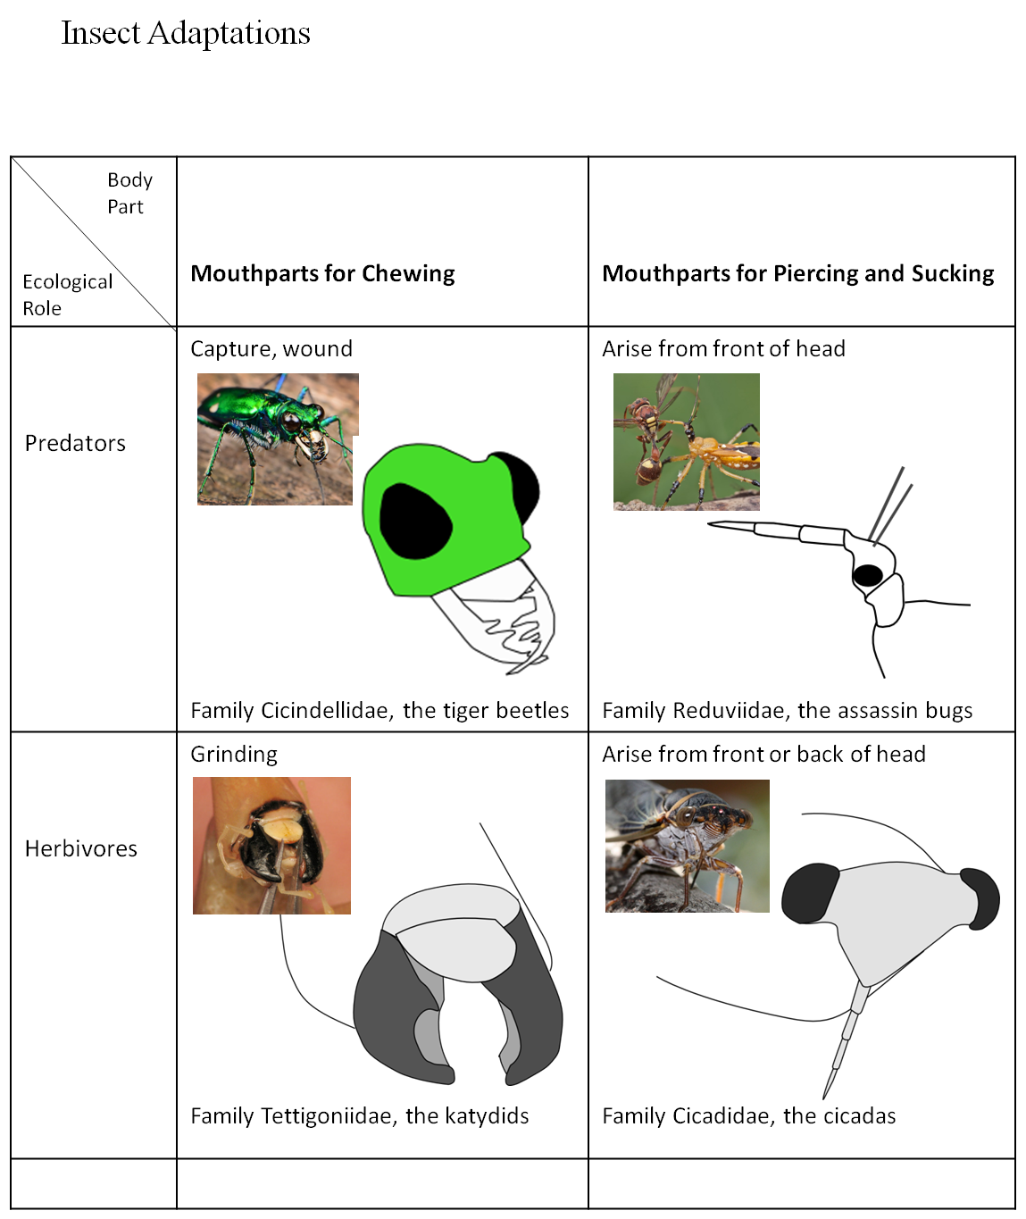
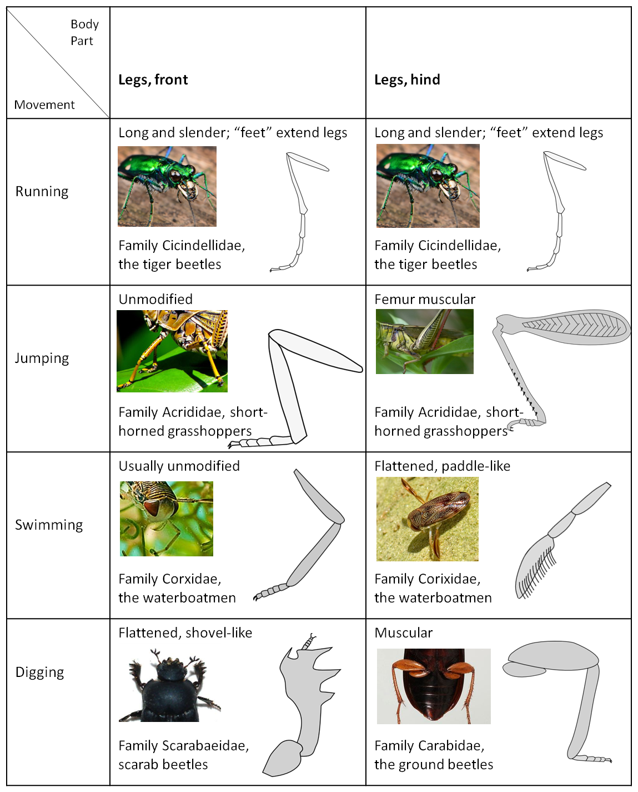

Student Resources:
- YouTube Video on the Emerald Ash Borer
- YouTube Video on the Spotted lady Beetle and the Soybean Aphid
- “Insects as Predators and Parasitoids” will provide foundational information

Student Worksheet - Design Brief:
Scenario:
You are working as an ENTOMOLOGICAL SCIENTIST for BUILDABUG, INC. BUILDABUG has locations at Southmont and North Montgomery High Schools. Mr. Goncarow and Mrs. Lewis are Directors of Entomological Engineering, while Mr. Clifton and Mr. Clemence are Directors of Biometrics and Biomimicry. BUILDABUG has been contracted by the Indiana Department of Natural Resources with the objective of identifying multiple pest insect species for the purpose of biological eradication. The state has cited economic, ecological, environmental and public health concerns as primary reasons for this pioneering initiative. Before BUILDABUG can develop its predatory insects, pest insects of Indiana must be studied and specific species targeted for biological eradication.

Your Task:
As a member of BUILDABUG, the Entomological Scientist Peer Group will be required to research pest insects of Indiana. Your collection of data will be valuable in selecting a pest insect species for the purpose of biological eradication. Upon selecting a pest insect for eradication, you will then research data that identifies the finest qualities of predatory insects and embark on a journey to design a SUPER PREDATOR INSECT prototype that will be produced into a 3D printed prototype.

Where Do You Begin?:
Develop a plan focusing on how you will proceed to the creation of your SUPER PREDATOR INSECT. Start with the KWHLAQ Report. This will help you to begin to consider what information you will need and what methods you will utilize to collect your information in this exciting SCIENTIFIC JOURNEY.

Lesson Plan 5:

Engineering Design: Guiding Question – How can we communicate and model the predatory insect solution?

Lesson Focus:
The students will design and create the parts of their predator insect.

Total Time Required:
- 3-4 hours

Lesson Objectives:
Students will be able to:
- Produce the designed predator insect prototype using CAD modeling and the 3D printer.
- Share the process of integration with science and technology to solve a real world problem.

Equipment and Materials
Tools and Materials | Quantity Needed
Student Computers | 1 Per Student
3D Printer | 1
Engineers Notebook | 1 Per Student
PowerPoint Software
CAD Software

Special Notes on Materials:
3D Printer time and materials will depend on the student’s design and time constraints

Lesson Procedures:
Set Induction:
What would be the best practice when communicating your design to people that have not followed you in your design processes.

Procedures / Steps:

- Using the final design sketch from the group create a CAD model of each body part for the designed insect. (head, thorax and abdomen)
- Assemble the individually designed insect body parts in the CAD model software.
- Using the slicer software, students will prepare the assembled CAD model for 3d printing, looking for best practices when using the printer.
- Students will create a powerpoint detailing and reflecting on their design process.
  - Including research of predator insect types and a single invasive insect type.
  - Including design steps that show brainstorming, rough designs and final designs.
  - Including the prototype model and explanation the final design.

How would it work? What are the design benefits and possible drawbacks from the design?

Note:
Closure/ Review
- Teacher will share the similarities and differences between the student groups.
- Teacher will lead class discussion over what students learned with integration with science and technology to solve a real world problem.

Student Resources - Decision Matrix
Criteria | Weight (%) | Product #1 | Product #2 | Product #3
 |  | 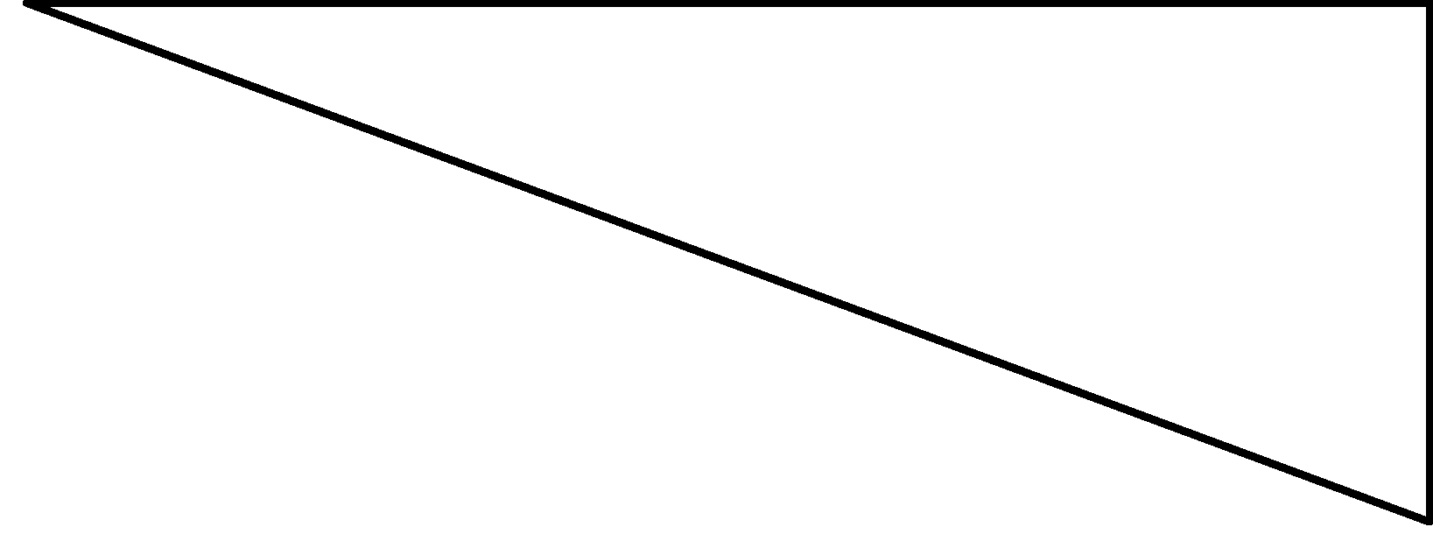 | 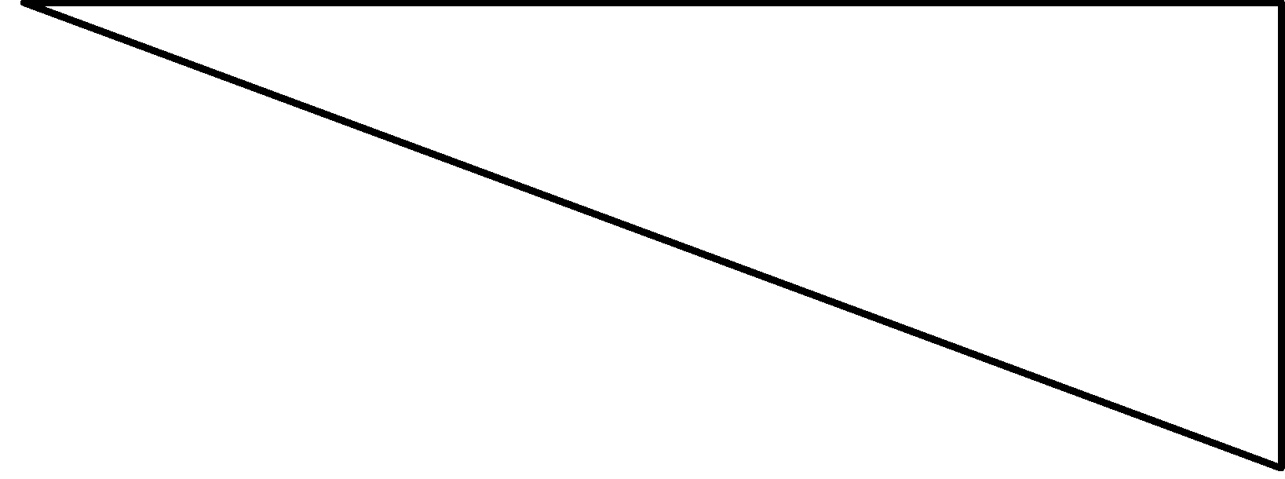
Constraints
Total | 100

Lesson Plan 6:

Engineering Design: Guiding Question – How do we simulate the model prototype?

Lesson Focus:
The students will assemble and animate their printed designs using robotics

Total Time Required:
- 4 – 6 hours

Lesson Objectives:
Students will be able to:
- Using the vex robotics platform, create a working model of one segment (head, thorax or abdomen) from the designed predatory insect.
- Incorporate bio-mimicry from the designed predatory insect to attack the simulated prey.
- Use CAD modeling and 3D printing to create specialized biomimicry.

Equipment and Materials
Tools and Materials | Quantity Needed
VEX Robotics | 1 set per class
Balloons to simulate prey
Student Computers | 1 Per Student
CAD Software
3D Printer | 1
Engineers Notebook | 1 Per Student

Special Notes on Materials:
The number of balloons and the amount of robotics will depend on the student’s designs

Lesson Procedures:

Set Induction:

Why do scientists and engineers create working models of subjects they study?

Procedures / Steps:

- Create one basic model robot using the step by step guide found on http://www.vexrobotics.com/wiki/images/c/cb/VEX_Machinations-071108.pdf page 8.

- Mount to the model robot balloons for a head, thorax and abdomen to simulate prey.

- Student groups create the basic model robot using the step by step guide found on http://www.vexrobotics.com/wiki/images/c/cb/VEX_Machinations-071108.pdf page 8.

- Student groups will design one segment from their Predatory insect design to add to the basic robot model for attacking the simulated pray and popping the balloons simulating the head thorax and abdomen.

- Student groups will develop CAD models, 3D print, and mount the adaptations to their model robot. Including remote activated or automated movements.

- Students groups will use their simulated predator insect robot and attack the simulated pray robot.

Note:
Closure/ Review:
Teacher discussion with the class going over what worked and did not work with the adaptations and how this type of testing could be beneficial in real world applications.

Student Worksheets:
BUILDABUG Pre and Post Tests
1. Generating a large quantity of ideas for a solution to a problem is called __________.
A. Constraining C. Ideation B. Brainstorming D. Implementation

2. What term best describes the list of items below?
• Must be made out of 4 to 6 pieces
• Must be “interlocking”
• Part cannot extend more than 3 units in any direction
• No two parts can be the same
Client C. Constraints B. Deliverables D. Problem statement

3. What type of document includes the following section headings?
• Client
• Problem statement
• Design statement
• Constraints
• Deliverables
Specification sheet C. Design brief B. Title block D. Parts list

4. Why Keep an Engineering Notebook?

5. What are the 4 best Practices for the Engineering Notebook?

6. Put into order the Design Process steps and define each step.
______ Define Problem
______ Construct and test Prototype
______ Present Solution
______ Evaluate Solution
______ Generate Concepts
______ Develop a Solution

Biomimicry Quiz
1. Biomimicry is ______________.
a. One species mimicking the call of a different species.
b. Nature creating a solution using human technology.
c. The act of technology mimicking nature.
d. a, b. and c are correct
2. Which of the following is an example of biomimicry?
a. Designing a building like a termite colony so it cools more efficiently.
b. Building the front of a train in the shape of a bird’s head so it encounters less friction.
c. Patterning a farm after a prairie to improve agricultural yields.
d. a, b, and c are correct
3. The discovery of Velcro was inspired by a(n)____________.
a. Slime mold
b. Cocklebur
c. Tree sap
d. Rubber
4. What part of a humpback whales body is helping improve wind turbine technology?
a. Whale tail
b. Whale nose
c. Whale blowhole
d. Whale fin

Insect Test
1. What are the three body parts of an insect?
a. Eye, tail, wing
b. Head, thorax, abdomen
c. Vein, artery, capillary
d. Head, arms, legs
2. Which is not an insect?
a. Butterfly
b. Ant
c. Beetle
d. Spider
3. How many legs do insects have?
a. 4
b. 6
c. 8
d. 10
4. Why have insects been so successful on planet earth?
a. Small size
b. Multigenerational’
c. Occupy a wide variety of habitats
d. a, b, and c are all correct
5. Is the insect mouth part pictured above an___________ mouthpart?
a. Piercing and sucking
b. Chewing
c. Siphoning
d. Sponging
6. Based on the appearance and structure of this insect forelimb describe the functions it serves for the insect that has it.

Predator/Prey Quiz
1. Animals that eat other animals are called_______.
a. Prey
b. Predators
c. Consumers
d. Mammals
2. A larvae that consumes the living tissue of a host is known as a(n)__________.
a. Prey
b. Sphenoid
c. Parasitoid
d. Altidore
3. A common predator of soy bean aphids are________?
a. Dragon Fly Larvae
b. Blood worms
c. Asian Lady Beetles
d. Emerald Ash Borers
4. All of the following statements concerning characteristics of predator-prey relationships are correct EXCEPT:
a. A rise in the population of prey is often followed by a rise in the population of predators.
b. A rise in the population of predators is followed by a decrease in the population of prey.
c. Camouflage is an adaptation that protects prey.
d. The population of predators most often completely eliminates the population of prey.
5. The relationship between a predator and prey is best characterized by__________.
a. Character displacement
b. Coevolution
c. Functional Niches
d. Realized Niches
6. Which Organism is the predator? ____________________________
Which Organism is the prey? ________________________________
Explain how these two populations impact each other?


This project is supported by the National Science Foundation, award # DRL – 1513248
Any opinions, and findings expressed in this material are the authors and do not necessarily reflect the views of NSF.

