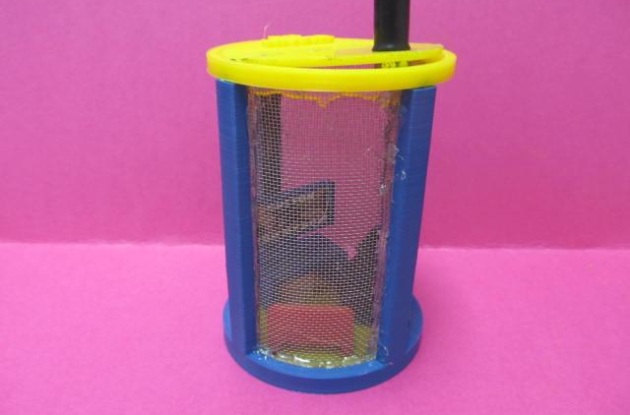

Lesson Overview:
Biology students study insects and design a box for collecting insects. This design is done in collaboration with engineering students who 3D print the final product. These bug boxes are later used by elementary students to collect insects in the school’s nature area.

Age Level or Subject:
- 9-12 Biology I or II, Introduction to Engineering & Design, or any Engineering Technology Class

Lesson or Unit Objectives:
Students will be able to:
- Biology students will be able to: Identify 20 common arthropods in Indiana, differentiate between different types of arthropods, list places you likely to find insects, and describe why insects are ecologically important, & present projects to students and adults.

- Engineering students will be able to: Complete the design process, optimize drawings of insect RVs, draw insect RVs with 3D CAD software, 3D print an insect RV, & present projects to students and adults.

This project is supported by the National Science Foundation, award # DRL – 1513248
Any opinions, and findings expressed in this material are the authors and do not necessarily reflect the views of NSF.

