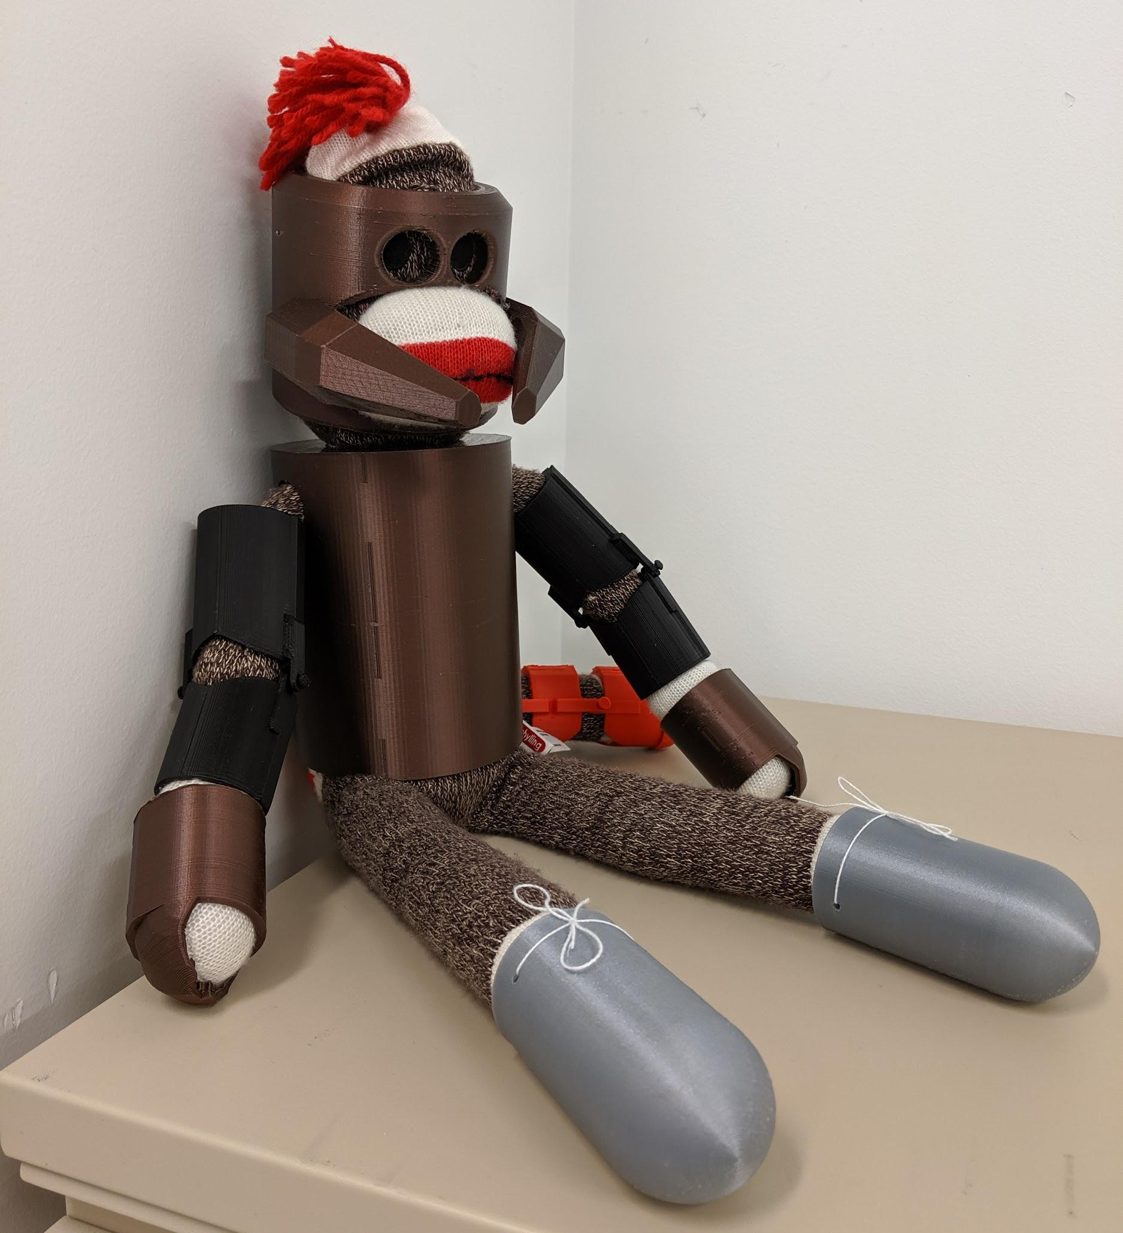

Age Levels:
- 9-12 Biology I or II, Introduction to Engineering & Design, or any Engineering Technology Class

Total Time Required:

We completed this as an ongoing project for a semester. The Engineering students spent two days a week on the project for about 12 weeks. Biology students spent about 5 weeks on an Invertebrate Unit. The Invertebrate Unit Notes are linked here if you are interested. The actual activities needed for collaboration take about a two weeks. Students also collaborated about one day a week during Student Resource Time (SRT). We feel that this project could be done with less time if consolidated.

Prepared by:
- Amy Charlwood, Jim Jones, & Dennis Schooley
- June 2018

Unit Objectives:
Students will be able to:
- Differentiate between different types of arthropods
- Describe insect exoskeleton
- Describe several adaptations that are unique to arthropods

Science Standards and Standards for Technology Literacy:
Below are standards in Biology and Engineering that this unit addresses.

Biology II: The following are Student Learning Objective
- Identify 20 common arthropods in Indiana
- Differentiate between different types of arthropods
- Describe adaptations that are unique to arthropods
- Describe why insects are ecologically important

Biology II: Math, Literacies, 21st Century Skills
- 9-10.RS.1/9-10.RT.1 Cite specific textual evidence
- 9-10.RS.3/9-10.RT.3 Follow precisely a complex multistep procedure
- 9-10.RS.5/9-10.RT.5 Analyze the structure of the relationships among concepts in a text, including relationships among key terms
- 9-10.WS.2/9-10.WT.2 Write informative/explanatory texts
- 9-10.WS.6/9-10.WT.6 Use technology, including the Internet, to produce, publish, and update individual or shared writing products
- 9-10.WS.8/9-10.WT.8 Gather relevant information
- Students will be able to collaborate, communicate, be creative, & think critically

Standards for Technology Literacy: IED State Standards
- IED-1.4 Apply and adapt the design loop as a guide to solving a problem or creating a solution
- IED-6.3 Evaluate a sketch and generate a model using appropriate modeling materials
- IED-7.14 Grade design solutions that use specific elements, principles, and functions to solve problems & communicate ideas.

Standards for Technology Literacy: IED Math, Literacies, 21st Century Skills
- 9-10.RS.3 Follow precisely a complex multistep procedure
- 9-10.RS.5 Analyze the structure of the relationships among content in text
- 9-10.RS.3/9-10.RT.3 Follow precisely a complex multistep procedure
- 9-10.RS.5/9-10.RT.5 Analyze the structure of the relationships among concepts in a text, including relationships among key terms
- Students will be able to collaborate, communicate, be creative, & think critically

Recommended Instructor Preparation
- Prior to this lesson, students must be taught the basics of 3D CAD modeling.
- Teachers need to be familiar with the types of arthropods present in their area and be able to differentiate between common arthropods.
- This is the second major collaborative project our students do, so this unit does not have an instructions of brainstorming, using a decision matrix, and collaborating. Instructions on this can be found at other lesson on this website.

Lesson Plan 1: Armor Design Brief and Exoskeletons

Lesson Focus:
Students will be given the design brief for the project and taught more about insect exoskeletons. This will be done with Biology and Engineering student groups working in collaboration during SRT.

Total Time Required:
- 45 minutes

Lesson Objectives:
Students will be able to:
- Become familiar with the Animal Armor project
- Describe the makeup of an exoskeleton

Equipment and Materials
Tools and Materials | Quantity Needed
Projector | 1 / class
Engineering Notebook | 1 / student
Animal Armor Design Brief | 1 / student

Lesson Procedures:
- Students will be given the Animal Armor Design Brief. The will become familiar with the design constraints. Design Brief will be taped into the student engineering notebooks.
- Teachers will present the PowerPoint on exoskeletons. Students will copy these notes into their engineering notebooks.

Student Resources:
- Animal Armor Design Brief
- Exoskeleton PowerPoint

Lesson Plan 2 : Arthropod PowerPoint

Lesson Focus:
Biology II students research different types of arthropods. They use their research to develop a PowerPoint that they will teach to their collaborative group of Engineering students.

Total Time Required:
- 3 class periods of about 40 minutes

Lesson Objectives:
Students will be able to:
- Research and gather relevant information
- Cite information using MLA
- Organize information into a clear, concise PowerPoint
- Explain/teach information on arthropods

Equipment and Materials
Tools and Materials | Quantity Needed
Computer with internet access | 1 / student
Engineering notebook | 1 / student

Lesson Procedures:
- Students are given the Arthropod PowerPoint Assignment. This is included in the Student Resource section on the next page.
- Students are given 3 days to research and build a PowerPoint.
- Students will present/teach the PowerPoint information at the next collaborative meeting with Engineering students in SRT.

Student Resources:
Arthropod PowerPoint Assignment

Lesson Plan 3: Armor Information

Lesson Focus:
The school’s Student Resource Officer (SRO) will present information on body armor. Most Schools have an officer who could give a similar presentation. In future years, we are trying to get a specialist in costuming.
Students will be given a presentation on adaptations that the arthropod exoskeleton allows.

Total Time Required:
- 45 minutes

Lesson Objectives:
Students will be able to:
- Discuss different types of body armor including pros and cons
- Identify several adaptations of arthropods

Equipment and Materials
Tools and Materials | Quantity Needed
Projector | 1 / class
Engineering Notebook | 1 / student

Lesson Procedures:
- The SRO will discuss body armor, they types of body armor, and pros & cons of body armor. This will include a question and answer segment. Students will be expected to take notes in their engineering notebooks.
- Teachers will present a PowerPoint on arthropod adaptations. This is included in the Student Resources section of this lesson. Students will be expected to take notes in their engineering notebooks.
- Students will be assigned to pick two adaptations that they like and record them in their engineering notebooks as homework for the next collaborative meeting.

Student Resources:
Arthropod Adaptations PowerPoint

Lesson Plan 4: Animal Armor & Brainstorming

Lesson Focus:
Using the information they learned about body armor, exoskeletons, and arthropod adaptations, students will develop a design for their animal armor.

Total Time Required:
- 40 min.

Lesson Objectives:
Students will be able to:
- Students will produce at least 3 unique ideas for Animal Armor per student
- Students will collaborate to develop one unique ideas for Animal Armor

Equipment and Materials
Tools and Materials | Quantity Needed
Engineering notebook | 1 / student
Animal Armor Design Brief | 1 / student
Large paper (24” x 24” or larger) | 1 / group

Lesson Procedures:
- Student will review with teachers what they previously learned about brainstorming and the project on the Animal Armor Design Brief.
- Each student working ALONE produces 3 unique ideas for Animal Armor. These will be sketched in their engineering notebook.
- Students will join with their collaborative groups and share their ideas. These may need to be sketched on the large paper.
- As a group, they agree on at least 5 possible ideas. These should be sketched into their engineering notebook. Groups will decide which is best based on a decision matrix. The decision matrix is included in the Animal Armor Design Brief in the Student Resource section of this lesson. Students previously learned to use a decision matrix. For an example of how a decision matrix works, see the Bug RV Unit lesson 3 in this website

Student Resources:
Animal Armor Design Brief

Lesson Plan 5 : Collecting Aquatic Macroinvertebrates

Lesson Focus:
Students will be collecting aquatic macroinvertebrates from our school pond and comparing it to a sampling taken from the Elkhart River by the teacher. Students will be doing basic identification and determining a basic level of water quality for the two bodies of water.

Total Time Required:
- 90 minutes This can be split up into two class periods. They can collect from the pond on one day & compare on another.

Lesson Objectives:
Students will be able to:
- Collect aquatic macroinvertebrates
- Identify common invertebrates
- Evaluate basic water quality

Equipment and Materials
Tools and Materials | Quantity Needed
Bottomless bucket | 1 / class
Small fish net | 1 / class
Small plastic container | 1 / group of 3-4 students
Ice cube trays | 1 / group of 3-4 students
Plastic spoons | 1 / student
OPTIONAL Materials:
Screen or sein | 1 / class
Clear plastic makeup cases or glass vials (see notes below) | 1 / every invertebrate collected
Hand sanitizer (needs high alcohol content) | 1 liter / class

Special Notes on Materials:
Insects can be collected to identify later by putting them in vials of alcohol or hand sanitizer. The hand sanitizer works well because it does not spill. I prefer to collect them in clear plastic makeup cases. These work well because of the flat lids as opposed to the cylindrical vials. Here is a link from amazon.com with the type of cases I am talking about. They come in many sizes.
Lesson Procedures:
- Take students to a body of water OR bring samples to the students to observe.
- Samples of macroinvertebrates can be easily done with a bottomless bucket and an aquarium fish net. Set the bucket firmly on the bottom of the pond or river bank with the top above the water. Stir thoroughly with the net (in the water column and the bottom. The bucket keeps the organisms from escaping. Scoop through the water column & across the bottom several times. Dump the net’s contents in small plastic containers with a little water in them. Details on this method can be found in this website in the D-Bait Unit lessons.
- Students should let the water settle in their plastic containers. They can then scoop out anything that wiggles with their spoons. These are sorted into ice cube trays by type.
- The organisms can be collected for later identification by placing the organisms in plastic cases or glass vials with alcohol or hand sanitizer. Details on this method can be found in this website in the D-Bait Unit lessons. Students are also encouraged to take videos of how the arthropods move to show Engineering students in collaborative meetings. Preserved specimens can also be brought to collaborative meetings.
- Students fill out the Hoosier RiverWatch Data Sheets. These are included in the Aquatic Macroinvertebrate Activity in the Student Resource section on the next page.

Student Resources:

Aquatic Macroinvertebrate Activity

Additional Supplemental Activities:
Build a Bodacious Bug Activity
Metamorphosis Online Activity

Lesson Plan 6 : Terrestrial Arthropod Collection

Lesson Focus:
Students collect and identify terrestrial arthropods.

Total Time Required:
- 2-3 class periods. One 45 minute class period to collect and then 1-2 class periods to identify organisms.

Lesson Objectives:
Students will be able to:
- Catch and collect terrestrial arthropods
- Identify common arthropods

Equipment and Materials
Tools and Materials | Quantity Needed
Butterfly nets | 1 / group
Clear plastic card case (see notes below) | 2-3 / group
Clear plastic makeup cases or glass vials (see notes below) | 1 / every invertebrate collected
Hand sanitizer (needs high alcohol content) | 1 liter / class
Insect and Arachnid identification books such Peterson’s or Golden Guide | 2 types per group
Computer with internet access | 1 / student or group
Engineering Notebook | 1 / student

Special Notes on Materials:
Insects can be collected to identify later by putting them in vials of alcohol or hand sanitizer. The hand sanitizer works well because it does not spill. I prefer to collect them in clear plastic makeup cases. These work well because of the flat lids as opposed to the cylindrical vials. Here is a link from amazon.com with the type of cases I am talking about. They come in many sizes.
My students collect with the butterfly nets and with hinged clear card cases. Many students prefer the card cases. Here is a link from amazon.com with the type of cases I am talking about.
Lesson Procedures:
- Students collect arthropods in their butterfly nets and card cases. Students should disturb shrubs, grasses, and even move rocks and logs if possible. Arthropods usually go up when disturbed so nets and cases should be placed to anticipate this.
- As each organism is caught, it needs to be placed in a case or vial of alcohol or hand sanitizer. These can then be identified at a later date. Students are also encouraged to take video of the insects moving to bring to their collaborative meetings with Engineering students. Preserved specimens can also be brought to these meetings.
- Students are given the Arthropod Classification Image (included in the Student Resources o the next page), the Arthropod Collecting Lab, and several insect identification books (such as Peterson’s Guides or Golden Guide). Students also found this insect identification website helpful.
- Students identify the arthropods they have collected and record the data in their engineering notebooks.

Student Resources:
- https://www.insectidentification.org/insect-key.asp
- Arthropod Classification Image
- Arthropod Collecting Lab

Lesson Plan 7: 3D CAD modeling

Lesson Focus:
Students will draw the animal armor using a 3D CAD modeling program.
Prior to this lesson, they must be taught the basics of 3D CAD modeling.

Total Time Required:
- Engineering students should be able to draw the animal armor in 10 class periods of 45 minutes.

Lesson Objectives:
Students will be able to:
- Sketch on the 3D CAD program
- Extrude, sweep or loft the animal armor parts
- Collaborate with group members to confirm accuracy of the drawing

Equipment and Materials
Tools and Materials | Quantity Needed
Engineering notebook with detailed dimensioned drawings of each piece of animal armor, copied from Biology student | 1/ student
Computer with 3D CAD program | 1 / student

Special Notes on Materials:
Engineering students will need to collaborate with the Biology students about the animal armor sketches. They must get all the information about the parts and then sketch of the armor with very detailed dimensions. The collaboration must continue throughout the whole project. As drawings are done, the biology students must look over the 3D CAD drawings and approve them for accuracy.

Lesson Procedures:
- Use the 3D CAD program to sketch the parts of the animal armor with as much detail as possible.
- Extrude, sweep or loft the sketch to .125” thickness

Student Resources:
Engineering notebook sketches

Student Worksheets:
None are needed

Lesson Plan 8: 3D Printing the Leaf

Lesson Focus:
Saving the file as an STL file for slicing and 3D printing. After the 3D CAD drawing is approved and the students exports the file as an STL file the animal armor needs to be printed. The teacher should slice the STL file with slicing software. Once sliced the part should be printed actual size as long as it fits on the printer. Use the 3D printing lesson for more details on printing the leaf.

Total Time Required:
- One 45 minute class period

Lesson Objectives:
Students will be able to:
- Save the 3D CAD file
- Export the 3D CAD file as an STL file
- Email the STL file to the teacher or save on a flashdrive
- 3D print the leaf

Equipment and Materials
Tools and Materials | Quantity Needed
Computer with 3D CAD software | 1 / student
Flash drive (if needed) | 1 / class
3D printer | 1 or more / class

Special Notes on Materials:
The teacher will be slicing the STL file to make a G-code of the animal armor. Students may slice the file if allowed by the teacher. Use the 3D printing lesson to complete this lesson.
Lesson Procedures:
Follow the steps in the lesson on 3D printing

Student Resources:
Student file of animal armor parts
Student STL file
Slicing software
3D printer

This project is supported by the National Science Foundation, award # DRL – 1513248
Any opinions, and findings expressed in this material are the authors and do not necessarily reflect the views of NSF.

