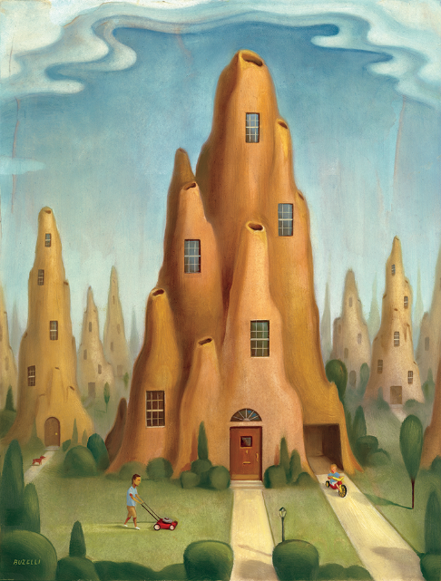

Age Levels:
- AP Biology (11-12)
- Construction Class (10-12)
- Civil Engineering Architecture (11-12)

Total Time Required:

5 to 6- 50 minute CONTENT lessons

4 to 5- 50 minute WORK TIME (project)

Prepared by:
- Abi Bymaster & Mike McKee
- June of 2018

Unit Objectives:
Students will be able to:
- Create a flow chart to explain the elements of typical residential cooling (HVAC).
- Create a flow chart to explain the process of transpiration (in plants); then use that concept to improve upon current residential cooling via functional landscape design.
- Graphically summarize how insects, birds and/or beavers create their residences based on an assigned reading from “Animal Architects.”
- Assess and use concepts from termite mound, bird nest, and beaver dam construction to promote the use of biological resources to build residential homes.
- Use the law of thermodynamics and mammalian mechanisms of homeostasis to create a more energy efficient cooling system.
- Assess variety of animal behavior while reading how individual species construct their homes.

Science Standards and Standards for Technology Literacy:
AP Biology
- Essential knowledge 2.A.1: All living systems require constant input of free energy.
  - a. Life requires a highly ordered system.
  - b. Living systems do not violate the second law of thermodynamics, which states that entropy increases over time.
    - Order is maintained by coupling cellular processes that increase entropy (and so have negative changes in free energy) with those that decrease entropy (and so have positive changes in free energy).
    - Energy input must exceed free energy lost to entropy to maintain order and power cellular processes.

Organisms use free energy to maintain organization, grow and reproduce. Evidence of student learning is a demonstrated understanding of each of the following:

Organisms use various strategies to regulate body temperature and metabolism. To foster student understanding of this concept, instructors can choose an illustrative example such as:

Endothermy (the use of thermal energy generated by metabolism to maintain homeostatic body temperatures) •

Ectothermy (the use of external thermal energy to help regulate and maintain body temperature)

Elevated floral temperatures in some plant species
- Essential knowledge 2.A.3: Organisms must exchange matter with the environment to grow, reproduce and maintain organization.
  - Molecules and atoms from the environment are necessary to build new molecules.
    - Living systems depend on properties of water that result from its polarity and hydrogen bonding.
    - High specific heat capacity
    - Heat of vaporization
    - Heat of fusion
    - Water’s thermal conductivity

Essential knowledge 2.C.2: Organisms respond to changes in their external environments.

Organisms respond to changes in their environment through behavioral and physiological mechanisms.

Taxis and Kinesis of animal/insect home construction

NGSS:
- HS-LS1 From Molecules to Organisms: Structures and Processes
- HS-LS2 Ecosystems: Interactions, Energy, and Dynamics
- HS-ESS3 Earth and Human Activity
- HS-ETS1 Engineering Design

Standards for Technology Literacy:

STL 4 Students will develop an understanding of the cultural, social, economic, and political effects of technology.
- STL 5 Students will develop an understanding of the effects of technology on the environment.
- STL 20 Students will develop an understanding of and be able to select and use construction technologies.
  - K. Structures are constructed using a variety of processes and procedures.
  - L. The design of structures includes a number of requirements.

Recommended Instructor Preparation/Knowledge
- Assign reading chapters 5-8 from “Animal Architecture” by Gould up o 1 week prior to Lesson 2
  - Note: Lesson 1 takes ~4 days
  - Teachers should read chapters 5-8 prior to assigning students.
- Prepare lecture/Mastering Activity and/or AP Biology Transpiration Lab.
- Line up an HVAC specialist to discuss:
  - Residential HVAC
  - Economic Cost of Residential HVAC
  - Environmental Cost of HVAC
- Constant communication between Construction/Engineer teacher is a must throughout the unit. Bio focused lessons will be summarized and ‘taught’ to non-bio students.
- IF this is the 1st Integreated STEM unit you have conducted in your class, please see TRAILS: Engineering Notebook, Brainstorming lessons.
- Prior knowledge for AP Bio students includes plant structure/function and animal behavior.
- **Optional: Line up Biomimicry.org (Gretchen Hooker) to SKYPE with class

Lesson Plan 1: Animal Architects_Plant Transpiration

Lesson 1 Focus:

Transpiration of Plants

Total Time Required:
- Three, 50-minute class period
  - Lab prep required

Lesson Objectives:
Students will be able to:
- The student is able to connect evolutionary changes in a population over time to a change in the environment (1A2 & SP 7.1).
- The student is able to use calculated surface area-to-volume ratios to predict which cell(s) might eliminate wastes or procure nutrients faster by diffusion (2A3 & SP 2.2). •
- The student is able to justify the selection of data regarding the type of molecules that an animal, plant, or bacterium will take up as necessary building blocks and excrete as waste products (2A3 & SP 4.1).
- The student is able to represent graphically or model quantitatively the exchange of molecules between an organism and its environment, and the subsequent use of these molecules to build new molecules that facilitate dynamic homeostasis, growth, and reproduction (2A3 & SP 1.1, SP 1.4).
- The student is able to predict the effects of change in a component(s) of a biological system on the functionality of an organism(s) (4A4 & SP 6.4).
- The student is able to apply mathematical routines to quantities that describe interactions among living systems and their environment that result in the movement of matter and energy (4A6 & SP 2.2).
- The student is able to use visual representation to analyze situations or solve problems qualitatively to illustrate how interactions among living systems and with their environment result in the movement of matter and energy (4A6 & SP 1.4)

Equipment and Materials
Tools and Materials | Quantity Needed
- Small plastic bags  - String  - Labeling tape and markers  - Spray bottle  - Fan  - flood light  - Balance  - Bedding plants (Impatiens or Petunias)  - Be sure plants have been watered. | - 1-2/group  - Multiple  - 1/group  - 1/lab bench  - 1/lab bench  - 1/lab bench  - 4  - 2/group
** Carolina Biology has a Kit

Special Notes on Materials:
** Special note: This is a College Board generated laboratory procedure. All teacher information is located here.

Lesson Procedures:

- Pre-lab homework: Read and take notes over sections of Chapter 8 of Urry, AP Biology text.
- Use this link to access lab.

- Summarized Version of Procedure is seen below: (does NOT include pre-lab exercise)
  - Select 4 plants.
  - Remove any blooms present! Any blooms or leaves that fall off during the week should be placed back in the center of the plant so as not to affect the mass.
  - Carefully wrap the root ball of each plant in a small plastic bag.
  - Tie the bag snuggly around the stems with the string.
  - Mist one plant well with water and cover with another plastic bag and secure string
    - Another suggestion is to mist the plants and then place an aquarium upside down over them.
    - A shallow pan of water inside the aquarium will provide additional humidity
    - Label as HIGH HUMIDITY
  - Label the others as: CONTROL, FAN, and LIGHT
  - Record the masses of each of the four plants.
  - Place each of the four plants in their appropriate conditions:
    - CONTROL - adequate light and no draft
    - FAN - adequate light and one meter from a fan kept on low for the entire
week
    - LIGHT - 1 meter from lamp
    - HIGH HUMIDITY - adequate light
  - Record the masses of the plants each day for one week.
  - Plot the change in mass for all plants on a single graph.
  - Cumulative percent change in mass may be more appropriate.
- ***Extensions might include varying the light intensity or color, removing a portion of the leaves, etc.

Student Resources:
Bozeman Science: Transpiration

Student Worksheets:
In a lab notebook, students will submit:
Calculations: Determining Surface Area and Transpiration Rates
1. In the first part of this lab, you were asked to investigate methods to calculate leaf surface area and the surface area of all the leaves on a plant or plant cutting (depending on your experimental setup). Determine the total surface area of the leaves in cm2 and record the value.
2. Calculate the rate of transpiration/surface area. If you are using a gas pressure sensor to collect data, you can express these rate values as kPa/min/cm2 , where kPa (kilopascal) is a unit of pressure. Record the rate.
3. After the entire class agrees on an appropriate control, subtract the control rate from the experimental value. Record this adjusted rate.
4. Record the adjusted rate for your experimental test on the board to share with other lab groups. Record the class results for each of the environmental variables investigated.
5. Graph the class results to show the effects of different environmental variables on the rate of transpiration. You may need to convert data to scientific notation with all numbers reported to the same power of 10 for graphing purposes.
6. Optional** Perform statistical analysis (e.g., a T-test) of your data, comparing results of experimental variable(s) to controls. ■
Analyze Results:
1. How was the rate of transpiration affected by your choice of experimental variable as compared to the control?
2. Think of a way you can effectively communicate your results to other lab groups. By comparing results and conclusions, explain how changes or variables in environmental conditions affect transpiration rates.
3. Based on data collected from different lab groups, which environmental variable(s) resulted in the greatest rate of water loss through transpiration? Explain why this factor might increase water loss when compared to other factors.
4. Why did you need to calculate leaf surface area to determine the rate(s) of transpiration?
HOMEWORK: Application: (I assigned this reading as homework). Students will need to take notes and be prepared to USE this information for their design product
This project is supported by the National Science Foundation, award # DRL – 1513248
Any opinions, and findings expressed in this material are the authors and do not necessarily reflect the views of NSF.

Lesson Plan 2: Animal Behavior & Biomimicry-Read, Pair & Share

Lesson 2 Focus:
Students will use their ‘reading role’ to discuss the various behaviors animals exhibit in order to create their homes.

Total Time Required:
- 2, 50-minute class periods
- **This can change based on teacher need.

Lesson Objectives:
Students will be able to:
- Demonstrate their knowledge of various ‘animal architects’ by comparing and sharing chapter summaries. They will create a Venn diagram to assess the similarities and differences b/w two species.
- Use Venn diagram to pick a ‘model’ animal by which they will mimic their own newly created, ‘better’ homes.
- Assess phylogeny of animal behavior of nest building based on assigned reading.

Equipment and Materials
Tools and Materials | Quantity Needed
“Animal Architects”, by James Gould | Class copy with chapter 6-8 photocopied
Student Notebook | 1/student

Special Notes on Materials:
Book can be purchased on Amazon

Day 1: Lesson Procedures:
- 1-week prior to this lesson, students will be given assigned reading.
- Each student will assume one of the following roles.

How to read book (to be assigned 1 week prior to actual discussion (THIS lesson)

Group Roles:
Each group member will play a role in the discussion process. Below, the roles are defined.

- Focus on Design This person will begin the discussion by stating…”This design was created b/c of _______ behavior.” –OR-The NEED for this design came from ______.”
  - This person is digging in the text to unveil WHY this animal/insect constructs it’s home. For example, the termite mound is designed for a very specific reason: temperature control.
- Discussion Director: This person will write up a list of questions that will lead/redirect the discussion if/when need be.
- Capable Connector: This person works with the biology content to find connections between class reading (text and this book) and outside reading and experience (e.g., podcasts, experiences outside, etc.). These connections could include personal experience but they need to be related to things discussed thus far and/or topics yet to come.
- Word Wizard: This person will create a list of technical vocab and big words; both lists should come from their individual reading AND those terms discussed by the group. Any term that is interesting, unusual or difficult to understand is fair game.
- Illuminated Illustrator: This person may not contribute much to the conversation rather, they will visually summarize the discussion as it’s happening. This can be a combo of sketchnotes, flowcharts, quotes, etc. It will be DUE @ the end of the class ON the day of discussion. Here is the rubric.

Points | 9 | 6 | 3
Accuracy | Summary is completely correct including main ideas and all details. Nothing significant is omitted. | Summary is correct but significant details have been omitted. | Summary has errors and significant details have been omitted.
Ease of Understanding | Information is conveyed with visuals and the content is comprehensible to other groups. | Information is conveyed visually but may not be completely comprehensible to other groups. | Summary is overly reliant on words and may not be “at a glance” comprehensible to other groups.
Balance | All three chapters are represented with similar weight in terms of ideas and details. | At least two of the chapters are represented fully. | Only one chapter is represented fully.
Day 2: Lesson Procedure ** #2- Optional **
- In their discussion groups, students will view the following video about animal behavior and biomimicry:
  - https://www.youtube.com/watch?v=7Sc2sOIXhOc
- After viewing this video, students will prepare 7-10 questions for a SKYPE interview with Gretchen Hooker, Biomimicry Institute.
  - ** Note: If this discussion cannot take place, you may move on to #
  - During the discussion, Gretchen will present the basics of biomimicry and emphasize the importance of using nature as a model for updating architecture.
  - Throughout the presentation, students will generate questions to ask during the Q/A.
  - 1 student from each group will ask a question.
- After the presentation, students will be given the “design brief.
- Students read brief and begin initial designs at this time. All designed should be recorded in their engineer’s notebooks:
- Questions to consider:
  - Is my design biomimicry OR biomorphism?
  - What are the BENEFITS of our design?
  - What FLAWS exist in our design?
  - How could we AMEND our current design?

Note: At this point, students will stop in the ‘design’ process and come back to it. There is more yet to learn!

Student Resources:
See YouTube video above.

Student Worksheets:
See Rubric inserted above
This project is supported by the National Science Foundation, award # DRL – 1513248
Any opinions, and findings expressed in this material are the authors and do not necessarily reflect the views of NSF.

Lesson Plan 3: HVAC vs. Thermoregulation: Which is the most cost effective?

Lesson Focus:
Students will learn how typical residential HVAC systems work to cool houses & compare that to their assigned animal/insect architect.

Total Time Required:
- 1 lesson

Lesson Objectives:
Students will be able to: (list 2-3 that apply directly to the lesson)
- Compare and contrast the current method of HVAC (in residential homes) to the method of HVAC in ‘animal architecture’ using a Venn diagram.
- Create a negative feedback mechanism demonstrating mammailian temperature regulation.
- Combine their knowledge of mammalian temperature regulation, the cost of HVAC and their knowledge of biomimicry to adjust their landscaping/housing design.

Equipment and Materials
Tools and Materials | Quantity Needed
Student Notebook | 1/student
Giant Post-it Note sheet | 1/group
Guest Lecturer: HVAC | 1/class

Special Notes on Materials:
Teacher should bring in a local HVAC installer to explain how the air conditioner in a home functions. Emphasis should be placed on hands on ‘typical’ HVAC and geothermal. The focus of the discussion is to explain how refrigeration (via air conditioning) works.

Lesson Procedures:
- Students will take notes over the guest lecturer: HVAC specialist. (30 minutes)
- In their groups, students will then take their knowledge of their ‘animal/insect’ and create a Venn diagram to compare and contrast ‘typical/geothermal HVAC” with ‘animal/insect architecture, HVAC.’
  - Have students create a rough draft on a piece of scrap paper.
  - Each group will then create a large ‘post-it’ to share with the class.
  - It is advised that teacher and guest lecturer walk around offering suggestions, observing and/or correcting while students work.
- Class discussion. Each group will go around and present what they consider the greatest difference and the greatest commonality between HVAC ‘types.’
- HOMEWORK: In preparation for the construction/engineering classes joining our team, you (bio students) must summarize your bio knowledge and be prepared to ‘teach it’ to your const./eng. Students. This is summary will be collected and graded similarly to your visual summary (see lesson 2).
  - ** This can be extended to include assessments; it will take longer.

Note: At the end of class, students are asked to take this ‘new found knowledge’ and think of ways to apply it to their ‘design.

Student Resources:
- How Does your Air Condition work?
- EPA: Refrigeration

This project is supported by the National Science Foundation, award # DRL – 1513248
Any opinions, and findings expressed in this material are the authors and do not necessarily reflect the views of NSF.

Lesson Plan 4: Using vegetation for energy efficiency

Lesson Focus:
Students will use their knowledge of plant transpiration, specific heat of water (how plants help cool areas) to create a blueprint of a ‘green home’ and accompanying landscape design (not genus, species) to be used to create an energy and economically efficient residential home.
* Critical Info: This lesson has the capability to taking several days. Each option listed below can be used as a final design product. Be sure to pick the option best suited for your class/school.
**Critical Info: It is advised that the cons./engineering teacher assigns some of the readings (in unit) to his/her students in preparation of initial briefing.

Age Levels

Construction –OR- Engineering class (10-12)

Total Time Required:
- Ranges in time from 5-10, 50 minute periods

Lesson Objectives:
Students will be able to:
- Option 1: Use Microsoft Excel to create a blueprint of housing/landscape design
- Option 2: Use laser cutter to create a rough-framed scale model.
  - Will need to collaborate with your engineering/construction teacher(s)
- Option 3: Use Revit/Inventor (or CAD of choice) to create and 3-D print a scaled model of your design.

Equipment and Materials
Tools and Materials | Quantity Needed
Option 1: | Computer
Option 2 | Laser cutter, wood product, platform (substance)
Option 3: | CAD software, 3D printer

Special Notes on Materials:

Lesson Procedures:

- Students will work with Construction/Engineering students
  - Teachers can create groups as best he/she sees fit
  - Experience tells me that students are more effective when teachers create the groups (especially since they are not usually in the same class).
- Once in their groups, students will read an article entitled :
  - Teaching engineering concepts through socially relevant contexts: Serving the homeless with smart tiny homes
  - Written by Scott Bartholomew, Engineering Technology Journal
- Students will use this short article as a discussion point and take their previous designs to make final modifications.
- Biology students must be sure to convey the importance of biological phenomenon to construction/engineering students. It is VITAL that each (or most) aspect of design is supported by biology.

Note:
Students return to their engineering notebook EACH time they modify their designs.

Student Resources:
- Fallingwater Architecture Website
- Joslyn Institute for Sustainable Living Website
- University of Worcester: A Functional Landscape Approach PDF
- EPA Website on Reducing Heat Islands

Student Assessment for final design:
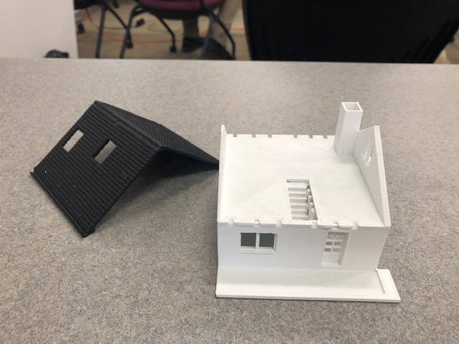
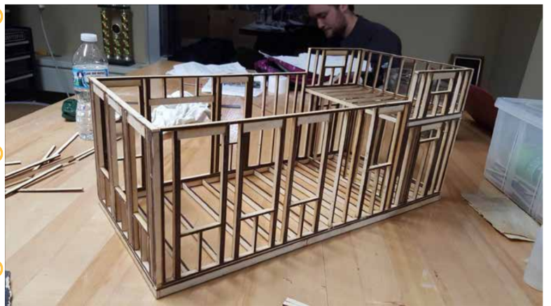

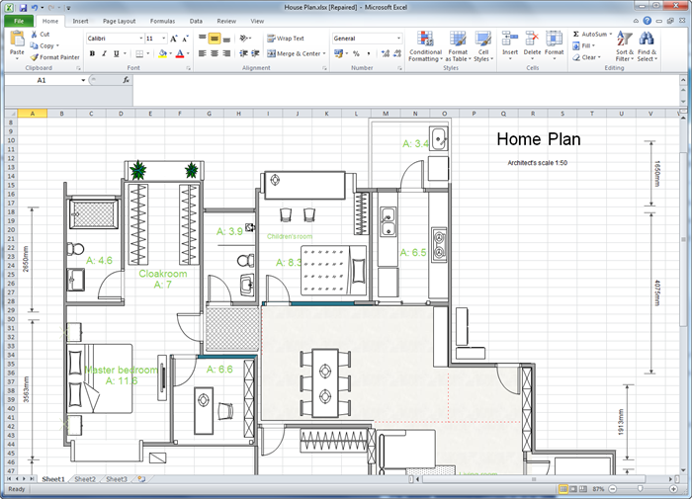

This project is supported by the National Science Foundation, award # DRL – 1513248
Any opinions, and findings expressed in this material are the authors and do not necessarily reflect the views of NSF.

