Introduction
While their wings can be very fragile and easily damaged when handled by humans, butterflies are actually excellent flyers. Some of them—like the Monarch butterfly, which is shown in Figure 1—migrate thousands of miles each year! That's quite an amazing feat for something so small.
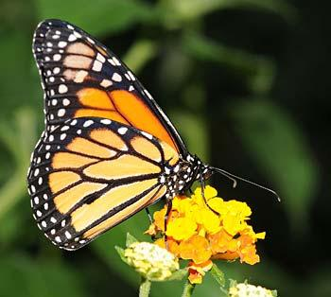
Figure 1. Monarch butterflies may seem delicate and fragile, but they can actually fly thousands of miles each year (Thomas Bresson, 2010).

Most flying animals that you are familiar with from everyday life, like insects and birds, flap their wings, but many also glide. Animals glide by sticking out their wings and coasting, like a paper airplane. Some large birds can glide on air currents for a long time, but butterflies usually only glide for relatively short periods in between flapping their wings. Gliding helps flying animals save energy. Even though butterflies only glide some of the time, this can still help them save a lot of energy over the course of a long migration, like the Monarch's. Watch this slow-motion video to see butterflies alternating between flapping and gliding flight:

https://www.youtube.com/watch?time_continue=2&v=_SbihKIoOPU

This slow-motion video, taken at the Boston Museum of Science by Dr. Mirko Kovac, shows a butterfly alternating between flapping and gliding flight.

Butterflies are such great flyers that a team of researchers at the Harvard University Microrobotics Lab wants to mimic their behavior in order to build a small flying robot that can glide for short periods of time. In order to build a robotic butterfly that can glide, they first had to study the behavior of real butterfly wings, and how air moves around them when butterflies glide. The study of how air moves around wings and other objects is called aerodynamics. The Harvard scientists measured the lift and drag exerted on butterfly wings by the air. Lift is the force that pushes up on the wings of a flying object (whether it is a butterfly, a bird, or an airplane). In order for a flying object to stay in the air, the lift must overcome the object's weight. Drag is what pulls back on flying objects to slow them down, and is caused by air resistance. In order to overcome drag, a flying object must generate thrust to push itself forward. Figure 2 shows lift, drag, weight, and thrust acting on a butterfly.
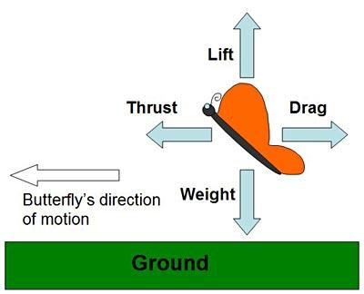
Figure 2. The butterfly in this diagram is moving to the left. Lift on the wings must support the butterfly's weight to keep it in the air. Thrust pushing the butterfly forward must overcome drag, which slows it down.

As you can probably imagine, it is very difficult to take measurements of real butterflies that are flying around! Instead, the scientists used artificial butterfly wings they made in a laboratory. They put those wings in a wind tunnel, which is a scientific instrument that lets scientists very accurately control the speed and smoothness of air flow. To simulate gliding (as opposed to flapping), the wings were held in a fixed position. The artificial butterfly wings were connected to a force sensor, which let them measure lift and drag in a carefully controlled environment so they could directly compare different butterfly species' wings. Imagine how hard it would be to do that outside on a gusty, windy day! Figure 3 shows a diagram of a typical wind tunnel. It consists of a fan that sucks air into a tunnel, where it flows past the butterfly wing in a test section before exiting through the tunnel's exhaust. For this experiment your wind tunnel will be much simple, just a fan, a kitchen scale, and a stand you make from popsicle sticks.
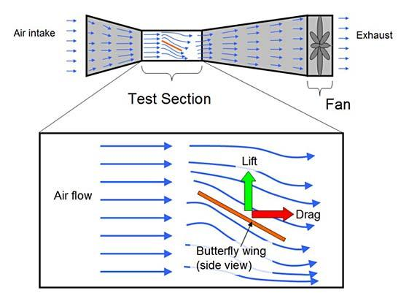
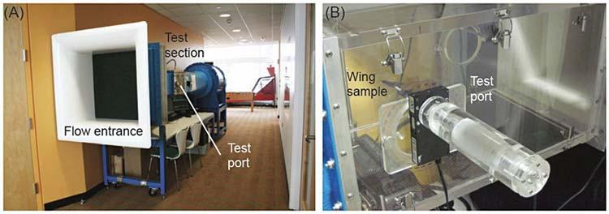
Figure 3. The top image shows a side-view diagram of a typical wind tunnel with a zoomed-in view of the test section, which contains the butterfly wing. A very powerful fan (much bigger than the window fan you will use in this experiment) sucks air through the tunnel. One end of the tunnel is a large opening, which gets narrower, causing the air to speed up (it works just like the nozzle on a garden hose, but with air instead of water). The air that enters the test is moving in very straight, smooth lines when it hits the butterfly wing, which is attached to a force sensor (not shown in the diagram). This allows the scientists to make controlled, accurate measurements of lift and drag. Finally, the air flows past the butterfly wing and out the "exhaust" end of the tunnel. The bottom image shows a picture of the actual wind tunnel used in the Harvard experiment—(A) the whole tunnel and (B) the test section (Harvard Microrobotics Lab, 2012).
In the Harvard study, one thing the scientists tested was the effect of angle of attack on how much lift is generated. Angle of attack is the angle between a wing (when viewed from the side) and the direction of the wind in the wind tunnel, as shown in Figure 4. Angle of attack is usually represented by the lowercase Greek letter α.
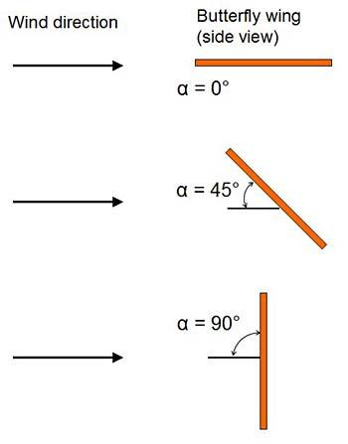
Figure 4. Angle of attack is the angle between the wing (when viewed from the side) and the direction of the wind. This diagram shows angles of attack of 0°, 45°, and 90°.

Changing the angle of attack can have a big impact on lift. More lift can make flying easier and require less energy. Looking at Figure 4, which angle of attack (0°, 45°, or 90°) do you think would generate the most lift for a butterfly? In this science project, you will do an experiment to measure how changing angle of attack changes the lift force on paper butterfly wings. The version of the experiment you can do at home is very simple compared to the real (and quite expensive) wind tunnel that the Harvard researchers used, but it will still allow you to investigate some fundamental principles of butterfly flight.

Terms and Concepts
- Glide
- Aerodynamics
- Lift
- Force
- Weight
- Drag
- Thrust
- Wind tunnel
- Force sensor
- Angle of attack

Questions
- What are the four forces that act on a flying object? Which ones cancel each other out?
- What do scientists use wind tunnels for?
- How do you think changing angle of attack changes lift and drag?
- Have you ever held your hand out the window of a moving car, or in front of a strong fan? How does rotating your hand affect the lift force that you feel (pretend your hand is a wing)?
- What angle of attack do you think real butterflies use when they glide during flight?

