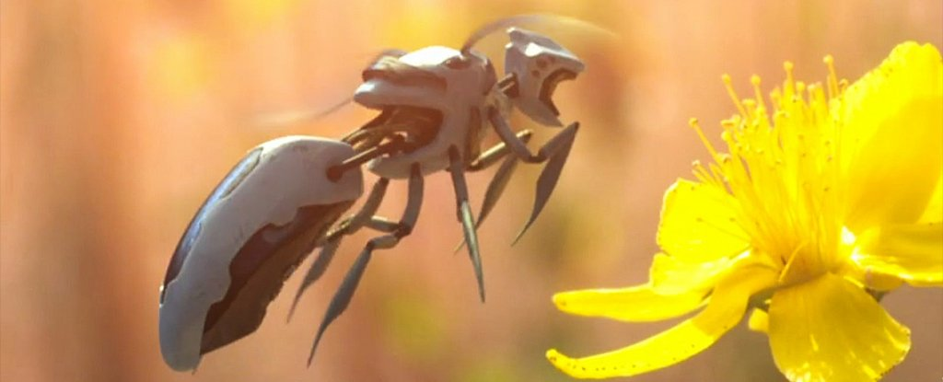
(Polynoid/Greenpeace/Vimeo)

A Giant US Retail Corporation Just Filed a Patent For Autonomous Robot Bees
LEANNA GARFIELD, BUSINESS INSIDER
15 MAR 2018
This is not scary at all. Nope.
Like an episode out of Black Mirror, Walmart has filed a patent for autonomous robotic bees, technically called pollination drones, that could potentially pollinate crops just like real bees.

The drones would carry pollen from one plant to another, using sensors and cameras to detect the locations of the crops.

First spotted by CB Insights, the robot bee patent appears along five other patents for farming drones, including one that would identify pests and another that would monitor crop health. Walmart did not immediately respond to Business Insider's request for comment.

While Walmart's exact goal for these patents is unclear, they may signal that the company hopes to venture into agriculture and gain more control over its food supply chain.

This would make sense, considering Walmart has recently focused on improving its grocery delivery business.

On Wednesday, the retailer announced that it will expand its grocery delivery this year to over 800 stores that reach 40 percent of US households.
In some locations, the service will offer same-day delivery in as little as three hours. In January, Walmart also filed a patent for an online grocery shopping service that would allow shoppers to accept or reject produce picked by Walmart employees.

Walmart is not the first organisation to create a robot bee.

In recent years, scientists have searched for solutions to the decline of honeybees, which pollinate nearly one-third of the food we eat and are dying at unprecedented rates largely because of a phenomenon called colony collapse disorder. (In 2017, however, these deaths declined from the year prior.)

Harvard University researchers introduced the first RoboBees in 2013. At the time, the bee-size robots could only fly and hover mid-air when tethered to a power source, but they have advanced since then.

Today, the RoboBees can also stick to surfaces, swim underwater, and dive in and out of water.

The researchers believe these RoboBees could soon artificially pollinate fields of crops – a development that would help offset the yearly bee losses over the past two decades.

Though Harvard's bees can do several tricks, they still can't be remotely controlled. The robotic bees described in Walmart's patent, however, would have this capability, along with the ability to automatically detect pollen.

That would mean that the bees could theoretically work on a farm one day, rather than just in a lab.

Article #2

This 'bee' drone is a robotic flower pollinator
by Parija Kavilanz @CNNTechFebruary 15, 2017: 12:25 PM ET
In our food chain, honeybees are tasked with a vital function: pollination.

In North America alone, honey bees' role in pollination enables the production of at least 90 commercially grown crops, including apples, blueberries, melons and broccoli.

One student wanted more people to understand the significance of bees to human life -- so she created what's essentially a "bee drone" to be a functional teaching tool that couples technology and design.

Plan Bee is a personal robotic bee (controlled by a smart device) designed to mimic how bees pollinate flowers and crops. Similar to how bees transfer pollen from one flower to another, the drone sucks in pollen from a plant and expels it onto other flowers to enable cross-pollination.
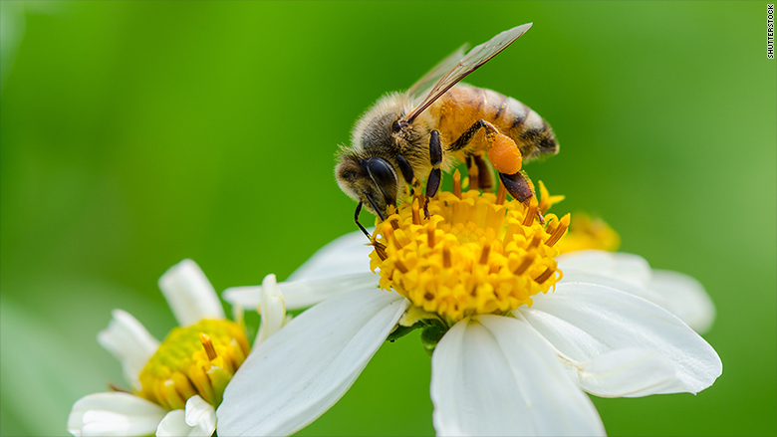

Industrial design major Anna Haldewang first developed the idea for Plan Bee in a product design class, after a professor challenged her to create a self-sustainable object that stimulates the growth of plants.

"You need sun, water, soil and cross-pollination for that to happen," said Haldewang, 24, a senior at Savannah College of Art and Design in Georgia.

Pollination made her think about bees, and in researching, Haldewang was struck by honeybees' struggles: "I had no idea about the danger to honeybee colonies and that bees were disappearing," she said. It prompted her to create an educational product that both addressed her class assignment and would help to spread awareness about a bee's role in the food system.

The bee drone prototype
So she developed the Plan Bee prototype, a hand-sized yellow-and-black device that looks nothing like a bee. She wanted to give it the essence of a bee without exactly replicating the insect, she said.
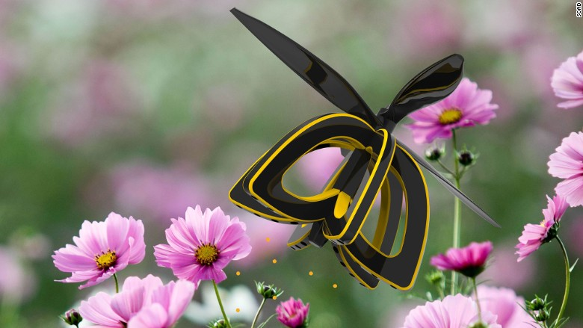Plan Bee at work

Haldewang worked through 50 design variations before settling on the final version. The device is made with a foam core (to keep it lightweight), plastic-shell body and a pair of propellers to keep it airborne. Each of the drone's six sections has tiny holes underneath through which the device sucks in pollen from a flower when it hovers over it. The pollen is stored in the body cavity before it's later expelled for cross-pollination.

"When you flip it upside down, it looks like a flower," she said, adding it was her way to honor a flower's role in pollination.

Plan Bee is in its early stages, and Haldewang is still fine-tuning the engineering. But she has already filed a patent application, and she hopes to have a marketable product in about two years.
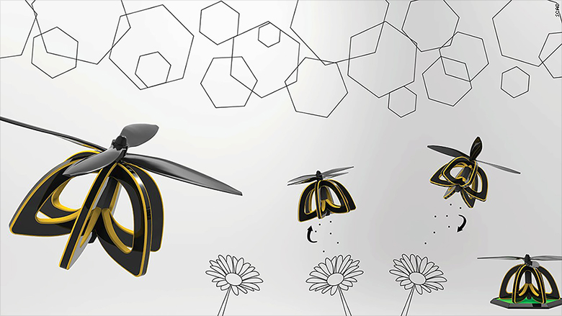
Her plan for the device, at first, is for it to be an educational tool. "I would love to see people use it in their backyards and even create custom gardens with it," she said. "With an actual bee, its so small you don't notice it and how it's pollinating flowers. With the drone you can see how the process works."
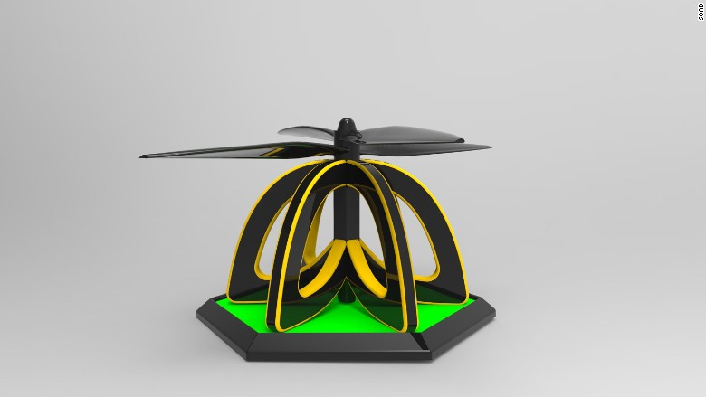Plan Bee drone
Plan Bee is one of 1,600 new concepts that SCAD's design students develop every quarter as part of their coursework. Victor Ermoli, dean of the school of design, and SCAD founder and president Paula Wallace review each project for its potential in marketability or industry collaboration. Separately, the school also works on 30 projects a year leveraging technology, in collaboration with companies like Microsoft (MSFT), HP (HPQ), AT&T (T), Dell and Mattel (MAT).

Haldewang's bee drone stood out, Ermoli said. "It is outstanding. The design is self-explanatory and it offers a very clever solution."

But is it viable? Its application in backyards as a teaching tool has potential, said Ermoli. And the drone could serve an even bigger purpose. "It could conceivably be used in large-scale farming, even in hydroponic farming."
CNNMoney (New York)First published February 15, 2017: 9:56 AM ET

