Arthropod Metamorphosis Google Classroom
90% or better = A1 AND A2
Use the following websites to answer the following questions. All answers should go in your engineering notebook. Any vocab. words you learn need to be defined in at the beginning of the invertebrate unit. Restate the questions so you know what you were answering.
- One unique trait of arthropods is their exoskeleton. Define exoskeleton.
The exoskeleton puts an unusual twist on arthropod growth. Go to the website below & use the information to answer questions about how insects grow.
http://www.insectidentification.org/process-of-molting.asp
- What do you call the process of insect growth?
- Why do insects need to do this in order to grow instead of growing like people do?
- When an insect sheds its old exoskeleton, what is underneath?
- How often do insects need to shed their skins.
- Name two other species that are not insects that do this process.

This is a video of cicada molting. https://www.youtube.com/watch?v=mArDqy8RkxM
Cicadas are the insects that are so loud in the fall. If the whole process does not fascinate you like it does me, at least watch from 45 seconds to 1:10 to watch it begin to molt and then from 2:10 to 2:35 to watch the wings expand.

Go to the following website on basic metamorphosis. You may need to enlarge the images.
https://pdfs.semanticscholar.org/presentation/e707/18f7edb88f95915d42d0f54e6efd4e6f4063.pdf
- How do some pesticides keep insects from molting?
- What are exoskeletons made of?
- This site covers metamorphosis deeper than we have before. It differentiates between 4 types of metamorphosis. In your engineering notebook, sketch each type of metamorphosis. Label each stage
- In your diagrams, indicate which stage(s) of metamorphosis are insects reproducing?
- In your diagrams stage(s) are insects primarily eating and growing?
- What is an instar?
- Name two organisms that go through complete metamorphosis.
- Name two organisms that go through incomplete (gradual) metamorphosis.
- Name an insect that does NOT go through metamorphosis.
- Name an insect that goes through modified metamorphosis.

- 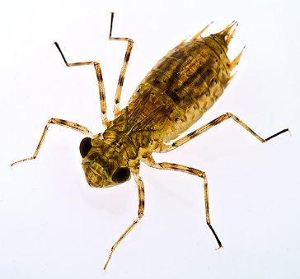This little guy is an immature dragonfly. He is one of the beasties we can find in our river water. Dragonflies go through incomplete metamorphosis. What stage of metamorphosis would this little guy be? How do you know?

- 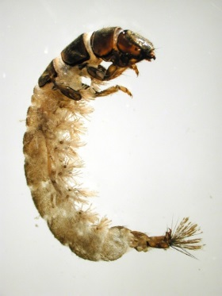This little guy is an immature caddisfly. He is another critter that can be found in river water. Caddisflies go through complete metamorphosis. What stage of metamorphosis would this little guy be? How do you know?

The following website gives a basic overview of what happens in the pupal stage. http://wonderopolis.org/wonder/what-goes-on-inside-a-cocoon/
- What is the difference between a chrysalis and a cocoon?
- What are imaginal cells?
- How do insects get out of their cocoons?

This website goes into more detail about what happens in a cocoon. It is written by an entomologist. That is a scientist who specializes in insects. While reading this website, you do NOT need to watch the video clips. https://askentomologists.com/2015/01/14/what-happens-inside-a-cocoon/
- Do insects decide to become a caterpillar or a cocoon?
- What triggers the larva to form a cocoon?
- Name two parts of the insect that do NOT turn into goo in the cocoon.
- Imaginal discs develop into structures that are not present in the caterpillar, but are in the adult. Name two of these structures.
- Can an insect remember something as an adult that it learned as a larva?
- What does this mean about their brain?

Go to this URL to watch a video on butterfly metamorphosis. https://www.youtube.com/watch?v=5XWFFTuX5gQ
- Does the chrysalis form under the skin or does the insect form it outside the skin?
- Name two body structures that the larva has that it sheds (they are not needed).

Go to this next website & read about apoptosis.
http://science.howstuffworks.com/life/cellular-microscopic/apoptosis.htm
- Define apoptosis (pronounced A-pup-toe-sis) and necrosis (pronounced neck-crow-sis).
- What advantage is there to apoptosis over necrosis?
- When do human cells perform apoptosis?
- Scientists think that understanding apoptosis could lead to treatments for diseases like cancer. How could understanding apoptosis help with cancer?
- Why would I include an article on apoptosis in with a lesson on metamorphosis?

