Biology II Zombie Project Instructions

The zombie apocalypse is coming! You have heard on the news that zombies have been spotted on the east and west coasts. As these are slow moving zombies, we have some time to plan before they hit Indiana. You and your partners will need to plan and prepare for this disaster. Warnings from the Emergency Broadcast System say that you will need to be prepared to stay indoors for at least three years to allow the zombies to die off. These are slow, stupid zombies who will not break into buildings, but will attack anyone outside. You need to plan & prepare!

Group Task Agreement 10 pt (Due 4/29)
- see pg. 28


Engineering Notebook Data 40 points (Due 5/7)
- see pgs. 25 & 28
  - Research on Required topics
  - Sketch of Sunroom design (at least one)

Backstory 50 Points (Due 5/13)
- see pgs. 4, 26 & 28

Excel Information Spreadsheet 30 points (Due 5/20)
- see pgs. 24 & 29

Excel Cost Spreadsheet 50 points (Due 5/20)
- see pgs. 25 & 29

Research Paper Requirements 100 points Due (5/23)
- see pgs. 4, 27 & 29

3D Room Prototype 50 points (Due 5/27)
- see pgs. 26 & 30

Teacher, Peer, and Self-Evaluation 40 points (Due 5/29)
- see pgs. 24 & 30



Table of Contents

Required Information Page . . . . . . . . . . . . . . . . . . . . . . . . . . . . . . . . . . . . . . . . . . . 4
Google Excel Spreadsheet . . . . . . . . . . . . . . . . . . . . . . . . . . . . . . . . . . . . . . . . . .5-10
Purpose . . . . . . . . . . . . . . . . . . . . . . . . . . . . . . . . . . . . . . . . . . . . . . . . . . . . .5
Columns . . . . . . . . . . . . . . . . . . . . . . . . . . . . . . . . . . . . . . . . . . . . . . . . . 5-6
A = Student Data . . . . . . . . . . . . . . . . . . . . . . . . . . . . . . . . . . 5
B = Section . . . . . . . . . . . . . . . . . . . . . . . . . . . . . . . . . . . . . . 5 and 9
C = Order . . . . . . . . . . . . . . . . . . . . . . . . . . . . . . . . . . . . . . . . 5 and 10
D = Direct Quote . . . . . . . . . . . . . . . . . . . . . . . . . . . . . . . . . . 6
E = Paraphrase. . . . . . . . . . . . . . . . . . . . . . . . . . . . . . . . . . . . .6
F = Page Number . . . . . . . . . . . . . . . . . . . . . . . . . . . . . . . . . .6
G = Works Cited Citation . . . . . . . . . . . . . . . . . . . . . . . . . . . .6
H = Parentheitical Citation . . . . . . . . . . . . . . . . . . . . . . . . . . .7
Tips & Tricks . . . . . . . . . . . . . . . . . . . . . . . . . . . . . . . . . . . . . . . . . . . . . . 7-10
A. What column to type first . . . . . . . . . . . . . . . . . . . . . . . . . 7
B. Copying the works cited citation . . . . . . . . . . . . . . . . . . . . 8
C. Grouping quotes together . . . . . . . . . . . . . . . . . . . . . . . . . .9
D. After Excel is complete . . . . . . . . . . . . . . . . . . . . . . . . . . . 9-10

Header, Heading, and Titles . . . . . . . . . . . . . . . . . . . . . . . . . . . . . . . . . . . . . . .11
Header. . . . . . . . . . . . . . . . . . . . . . . . . . . . . . . . . . . . . . . . . . . . . . . . . . . . 11
Insert header . . . . . . . . . . . . . . . . . . . . . . . . . . . . . . . . . . . . . 11
Insert Page number . . . . . . . . . . . . . . . . . . . . . . . . . . . . . . . . 11
Change alignment . . . . . . . . . . . . . . . . . . . . . . . . . . . . . . . . . 11
Change font type & size . . . . . . . . . . . . . . . . . . . . . . . . . . . . .11
Heading . . . . . . . . . . . . . . . . . . . . . . . . . . . . . . . . . . . . . . . . . . . . . . . . . . . 12
Military date. . . . . . . . . . . . . . . . . . . . . . . . . . . . . . . . . . . . . . 12
Title. . . . . . . . . . . . . . . . . . . . . . . . . . . . . . . . . . . . . . . . . . . . . . . . . . . . . . . 12

Final Paper & Backstory (General guidelines) . . . . . . . . . . . . . . . . . . . . . . . . . . . 13
Paper Format, Length, Font . . . . . . . . . . . . . . . . . . . . . . . . . . . . . . . . . . . 13
Proofreading . . . . . . . . . . . . . . . . . . . . . . . . . . . . . . . . . . . . . . . . . . . . . . . 13

Parenthetical Citations . . . . . . . . . . . . . . . . . . . . . . . . . . . . . . . . . . . . . . . . . . . . 14-16
Print Sources . . . . . . . . . . . . . . . . . . . . . . . . . . . . . . . . . . . . . . . . . . . .14
One author, two authors, or three authors. . . . . . . . . . . . . . . . 14
Over several pages. . . . . . . . . . . . . . . . . . . . . . . . . .14
One sentence, but the info. is on separate pages . . .14
Internet Sources . . . . . . . . . . . . . . . . . . . . . . . . . . . . . . . . . . . . . . . . . 14
Entire paragraph from one internet source . . . . . . . . . . . . . . . . . . . . .14
Entire paragraph from one printed source . . . . . . . . . . . . . . . . . . . . .14
Two sources with the same author . . . . . . . . . . . . . . . . . . . . . . . . . . .15
Two sources with the same article title . . . . . . . . . . . . . . . . . . . . . . . 15

Removing Citation Examples . . . . . . . . . . . . . . . . . . . . . . . . . . . . . . . . . . . . . . . . . 16

Scientific Names . . . . . . . . . . . . . . . . . . . . . . . . . . . . . . . . . . . . . . . . . . . . . . . . . . . . 17

Taxa . . . . . . . . . . . . . . . . . . . . . . . . . . . . . . . . . . . . . . . . . . . . . . . . . . . . . . . . . . . . . . 17

Monster Names . . . . . . . . . . . . . . . . . . . . . . . . . . . . . . . . . . . . . . . . . . . . . . . . . . . . . 17

Paraphrasing . . . . . . . . . . . . . . . . . . . . . . . . . . . . . . . . . . . . . . . . . . . . . . . . . . . . . . .18

Quoting . . . . . . . . . . . . . . . . . . . . . . . . . . . . . . . . . . . . . . . . . . . . . . . . . . . . . . . . . . . 19
Exact quote . . . . . . . . . . . . . . . . . . . . . . . . . . . . . . . . . . . . . . . . . . . . . 19
Adding info. to a quote . . . . . . . . . . . . . . . . . . . . . . . . . . . . . . . . . . . . 19
Removing info. from a quote . . . . . . . . . . . . . . . . . . . . . . . . . . . . . . . .19
Quotes with more than four lines . . . . . . . . . . . . . . . . . . . . . . . . . . . . 19

Works Cited Requirements . . . . . . . . . . . . . . . . . . . . . . . . . . . . . . . . . . . . . . . . 20-23
Sources . . . . . . . . . . . . . . . . . . . . . . . . . . . . . . . . . . . . . . . . . . . . . . . . 20
Format . . . . . . . . . . . . . . . . . . . . . . . . . . . . . . . . . . . . . . . . . . . . . . . . .20 Line spacing . . . . . . . . . . . . . . . . . . . . . . . . . . . . . .20
Hanging indent . . . . . . . . . . . . . . . . . . . . . . . . . . . 20
Alphabetize . . . . . . . . . . . . . . . . . . . . . . . . . . . . . . 20

Works Cited Examples . . . . . . . . . . . . . . . . . . . . . . . . . . . . . . . . . . . . . . . . . . . .21-23
Book with one author . . . . . . . . . . . . . . . . . . . . . . . . . . . . . . . . . . . . . .21
Book with two authors . . . . . . . . . . . . . . . . . . . . . . . . . . . . . . . . . . . . .21
Book with three or more authors . . . . . . . . . . . . . . . . . . . . . . . . . . 21-22
Reference book (encyclopedias) . . . . . . . . . . . . . . . . . . . . . . . . . . . . . 21
Magazine . . . . . . . . . . . . . . . . . . . . . . . . . . . . . . . . . . . . . . . . . . . . . . . .22
Online Sources . . . . . . . . . . . . . . . . . . . . . . . . . . . . . . . . . . . . . . . . . . . 23

Rubrics & Due Dates . . . . . . . . . . . . . . . . . . . . . . . . . . . . . . . . . . . . . . . . . . . . .24-27
Evaluation Rubrics . . . . . . . . . . . . . . . . . . . . . . . . . . . . . . . . . . . 24
Info. Excel Rubric . . . . . . . . . . . . . . . . . . . . . . . . . . . . . . . . . . . . 24
$$ Excel Rubric . . . . . . . . . . . . . . . . . . . . . . . . . . . . . . . . . . . . . .25
Engineering Notebook Rubric . . . . . . . . . . . . . . . . . . . . . . . . . . . 25
3D Prototype Rubric . . . . . . . . . . . . . . . . . . . . . . . . . . . . . . . . . . .26
Backstory Rubric . . . . . . . . . . . . . . . . . . . . . . . . . . . . . . . . . . . . . 26
Final Paper Rubric . . . . . . . . . . . . . . . . . . . . . . . . . . . . . . . . . . . . 27

Working Online . . . . . . . . . . . . . . . . . . . . . . . . . . . . . . . . . . . . . . . . . . . . . . . . . .28-30
Instruction Packet . . . . . . . . . . . . . . . . . . . . . . . . . . . . . . . . . . . . .28
Excels . . . . . . . . . . . . . . . . . . . . . . . . . . . . . . . . . . . . . . . . . . . . . . 28
Design Brief . . . . . . . . . . . . . . . . . . . . . . . . . . . . . . . . . . . . . . . . .28
Zombie Sources . . . . . . . . . . . . . . . . . . . . . . . . . . . . . . . . . . . . . 28
Final Paper . . . . . . . . . . . . . . . . . . . . . . . . . . . . . . . . . . . . . . . . . .28
Backstory . . . . . . . . . . . . . . . . . . . . . . . . . . . . . . . . . . . . . . . . . . .29

Required Information Page

Backstory
- The following is information you MUST have in your backstory.
- How did this start?
- Is this apocalypse viral, bacteria, or caused by magic?
- Where did it originate? How did it get to the US (if it did not originate here)?
- Is there hope for medical treatment of the infected?

Final Paper
- A plan for growing a majority of your dietary needs.
- A list of the types of vegetables/fruits you are growing and in what quantities.
- A plan for composting.
- A plan for water for your gardening needs (drinking & bathing water can be handled separately).
- A plan for pollination
- A detailed list of structures you will be building and their locations in the sunroom. Actual materials needed and what they are needed for, and actual costs will be recorded on a spreadsheet (not the final paper). You have $2000 to spend on your room.
- Choices your group made about small animals (fish, rabbits, chickens) & aquaponics
- Soil type
- Heirloom seeds vs. Hybrid seeds
- Choices on square foot gardening, vertical gardening, & elevated beds
- Standards should be indicated with comments to Mrs. C.

Google Excel

This document is where you will enter and compile useful information found on your assigned topic. This document will not only help you record your information, but will also help you organize it for your paper and keep track of accurate citations.

Columns
After opening up the Excel document, you will see a spreadsheet with eight columns. It should be set up with the headings listed below.

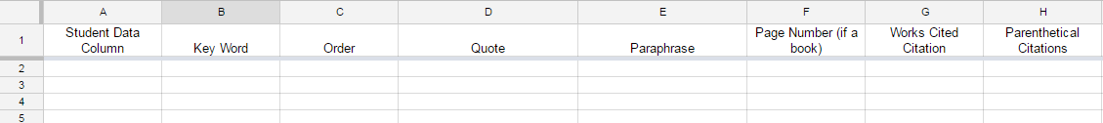

Column A: Student Data Column
This column is for the student to insert any comments or notes that they choose. In previous years students often chose to indicate what question they are answering from the Required Information Page and if that question is completely or only partially answered. This column will not be graded.

Column B: Key Word
This column will only be filled in after all or most of your information has been gathered. After a quote or paraphrase is entered, you can decide what part of the essay it will go in. Quotes and paraphrases grouped into the same section may form a paragraph or multiple paragraphs on that topic. These will probably be grouped by the five key questions from the required information. See page 9 for more examples.
Example: Kingdom, Phylum, History, Traits, or Existing

Column C: Order
Once you have organized your paper into sections, it must also be put into order according to what information you wish your reader to receive first. Numbers will be placed in this column according to what fact you want mentioned first (1), second (2), third (3), etc. See page 9 for more examples.

Column D: Direct Quote
While researching, if you find a piece of information that is useful, you can type it and/or copy (Cntrl C) and paste (Cntrl V) it into this column. Quotations marks must be used to avoid plagiarism. From this point, you may wish to use this quote directly in your essay, or only part of it. Until you know for sure, you must keep the quotation marks around all words in this column.
Example: “The number of locomotives and railroads multiplied rapidly in the 1330s”

If you are quoting a diagram or table, you need to type (Table) or (Diagram) after the quote so the teachers know why this is not a complete sentence.
Example: “No cell wall” (Table)

You may have a quote in column D without having a paraphrase in column E.

Column E: Paraphrase
Once a direct quote is in column D, you might decide that it should be paraphrased rather than placed directly into the essay. In this column, a paraphrase can be typed. A paraphrase should only include the main ideas of the original; it should not include any unique words from the original nor more than three consecutive words that are the same as the original. Double check your paraphrases to make sure they are distinct from the original and do not contain any accidental plagiarism. If you plan on using the quote in the final paper, column E should say Quote or Quoting. Do not leave this blank.

You may not have a paraphrase in column E without having the direct quote in column D. This is to ensure that both teachers and you can compare the original to your paraphrase to check for accidental plagiarism and comprehension of the original information.

Column F: Page Number (if a printed source)
Whether your information is from your textbook, an encyclopedia, or another library book, any print text will require you to cite the page number. Keep track of it here immediately after entering the direct quote in column D.

Column G: Works Cited Citation
To ensure accuracy of your citations, cite your source immediately after entering a quote in column D. Once you have typed it once in either a word document or in this column, you will never need to type the full citation again; simply copy and paste.

Column H: Parenthetical Citation
After typing the full works cited citation for your source, figuring out the parenthetical citation will be much easier. Use the information entered into columns F and G to determine the proper parenthetical citation. Be sure to consult your MLA Formatting Guide for additional help.

**Note: If you notice an error in Column F or G, be sure to correct Column H also, if necessary.

**Tip: Because the punctuation on parenthetical citations is one of the most difficult parts for students, use the proper punctuation and capitalization in this column and it will be ready for you to copy and paste directly into your essay later.
Instead of typing: Robbins 58 OR vampire
Use parenthesis followed by a period: (Robbins 58). OR (“Vampire”).

Tips, Tricks, and Shortcuts in Excel

A. What column do I type in first?

You probably will not fill in the columns from left to right. Instead, you will probably type information in the following order:
1. Column D: Direct Quote
2. Column F: Page Number (if a print source)
3. Column G: Works Cited Citation
4. Column A: Any info. that helps the student

5. Column H: Parenthetical Citation
6. Column E: Paraphrase

7. Column B: Key words
8. Column C: Order

If the bell is about to ring, make sure to fill in columns D, F, and G. Failure to fill in column G may result in information that either can not be used in the final paper or information that may become incorrectly cited, resulting in plagiarism and major points taken off.

Columns B and C might not be filled in at all until all of the other columns are completed.

B. Do I really have to type out the works cited citation every single time?

Yes. Although it takes time, it is required, and doing it right the first time will save you from point deductions, headaches, and confusion. However, once a works cited citation or parenthetical citation has been typed once, there’s an even quicker way to get it into another row without copying and pasting.

1. Click once on the cell with the information you wish to duplicate.
2. Locate the blue square in the bottom right hand corner of the cell.
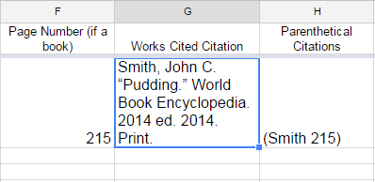

3. Hover your mouse over this blue square until it turns into a cross. Click the square and drag it directly downward to the bottom right corner of the cell below it.

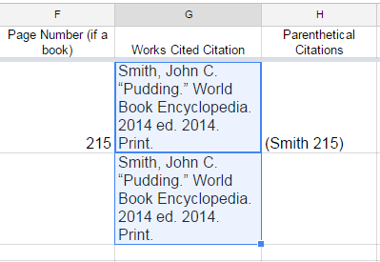

4. The information should now appear in both cells. You can drag the cross down to an unlimited amount of cells. If you have five consecutive quotes from the same source, you can drag the first citation down four cells to instantly copy the information into each one.

C. How do I get all of the quotes in the same section to group together so I can order them more easily?

- Hover your mouse over the top bar labeled “B” until a small square with an upside down triangle appears on the right side of the bar.

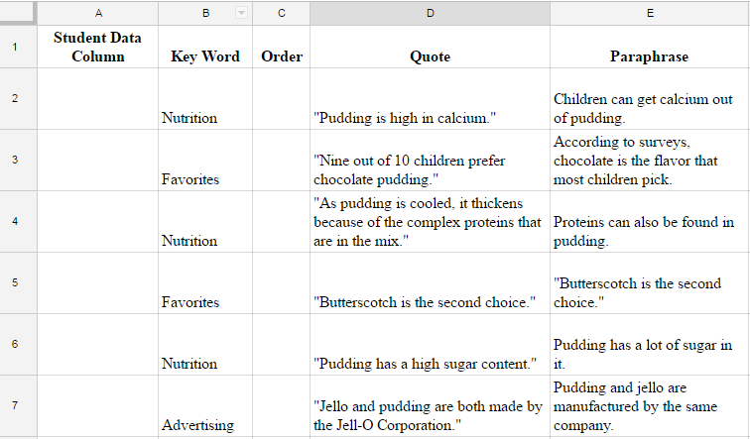

2 . Click on this square. A drop down menu will appear. Select “Sort Sheet A-Z.”
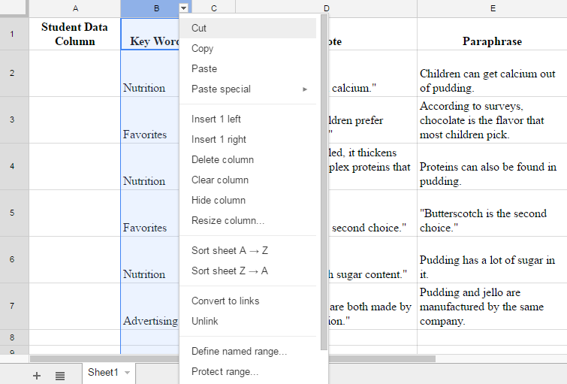

All of your cells will shift with their corresponding rows to be grouped by this column. Now all cells that are about the same topic (same paragraph) are together.

This process can be repeated after your Column C. Decide which paragraph (key word) will go first. Decide what order the cells in that topic will go in and number them starting with number one (ex. numbers 1-10). Decide which paragraph will go next and continue numbering those cells (ex. numbers 11-16). Continue until all cells are numbered.

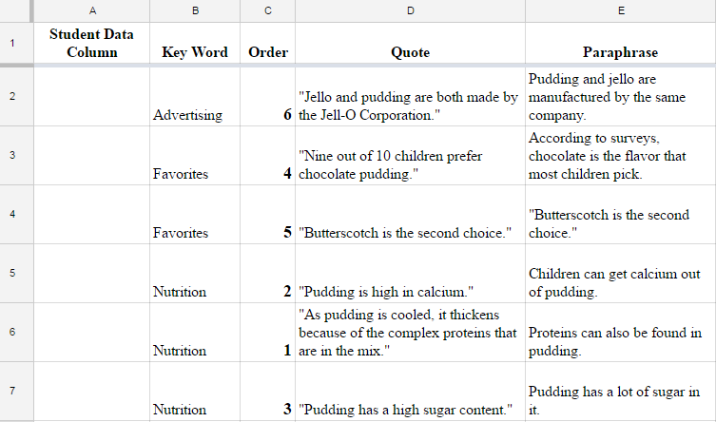

Then then sort Column C the same way you sorted Column B. Hover your mouse over the top bar labeled “C” until a small square with an upside down triangle appears on the right side of the bar. Click on this square. A drop down menu will appear. Select “Sort Sheet A-Z.” This will put the information into the order you use in the actual paper.

D. All of my quotes are cited and paraphrased, my sections have been grouped and all of my information is ordered. Now what?
You can begin copying and pasting direct quotes or paraphrases from Columns D or E into a Google word document. After you have pasted the information from one cell of the spreadsheet into the word document, type a space and paste the parenthetical citation from column H immediately after it. Repeat as needed.

Header

The purpose of the header is to identify the author of the paper. This ensures that if the paper becomes unstapled, that it will be credited to the correct person & restapled in the correct order.
Doe 1
John Doe
Mrs. Sprunger
Biology 1:1
26 January 2011
Trains
Trains have been around for hundreds of years. With many different types, they have developed significantly in this time. Although not always a success, trains rapidly gained popularity. Trains have been key to allowing the country to grow into the great nation that it is today. These machines still continue to shape the world.

1. In order to type in the header, click on “Insert” above
the tool bar.

- In the drop-down menu, click on “Header”.

3. Next to insert the page number, click again on “Insert”
above the tool bar.

4. In the drop-down menu, click on “Page Number.”
Choose the top, left choice.

5. This needs to be right aligned. Click on the right align
symbol on the toolbar (above the four inch mark).

6. Move your cursor to the left of the page number.
Hit enter (this makes the header fit on the page). Type
in your last name and then type a space.

7. You now need to change the font type and size.
Highlight your last name and page number. Click on the down arrow next to
“Arial” in the toolbar. Click on “Times New Roman.”

8. Click on the down arrow next to the 11 in the toolbar (to the left of the font type).
Click on 12.

Heading, & Title

The purpose of the heading is to identify the author of the paper, the teachers involved in the project, and the due date. This type of identification is much shorter than having an entire title page.
Doe 1
John Doe
Mrs. Sprunger
Biology 1:1
26 January 2011
Trains
Trains have been around for hundreds of years. With many different types, they have developed significantly in this time. Although not always a success, trains rapidly gained popularity. Trains have been key to allowing the country to grow into the great nation that it is today. These machines still continue to shape the world.

1. The heading should be at the top of the first page aligned
with the left margin.

2. The first line is the student’s first & last name.

3. Double space. To double space, either use the spacing
symbol in the tool bar (above the 5” mark) or click on
“Format” above the toolbar then on the “Line spacing”
choice.

4. The second line is the name of the English teacher.

5. The third line includes the name of the class (biology),
the period, and the group number. For third hour
biology in group 6, it would be Biology 3:6.

6. The fourth line is the date in military format. Note the day is first, the month is not
abbreviated, and no punctuation is needed.

7. Next is the Title. It should be centered.

8. ALL parts should be in Times New Roman, 12 point font (see instructions on pg.
10 for details).

9. Double check with the example to the right and the sample paper online.

Final Paper & Backstory

- Double space.

- This paper must be typed.

- Type in Times New Roman. Use a 12 point font (see instructions on pg. 10 for details).

- Margins should be one inch on all sides of the text. The margins are already set in Google Classroom.

- Number the pages. They may not be handwritten in after printing. This should have been set up as you start your header & heading (see instructions on pg. 10 for details).

6. Page numbers should be in the header on the top right corner of the page along
with your last name (see instructions on pg. 10 for details).

7. In this project, students should work in their groups to research information,
paraphrase, and organize the paper.

8. PROOFREAD YOUR FINAL PAPER! Use the formal writing style.
- There should be no contractions.
- There should be no commands (don’t tell the reader what to do).
- There normally should be no use of: I, me, my, mine, you, us, we, our, etc. However in this paper you will be allowed to use these.

9. PROOFREAD YOUR BACHSTORY! Use the narrative writing style.
- There may be contractions.
- There should be no commands (don’t tell the reader what to do).
- There may be: I, me, my, mine, you, us, we, our, etc.

Parenthetical Citations / In-Text Citations

The purpose of a parenthetical citation is to tell the reader where each piece of information was found as he or she read the paper. In a research paper, it is expected that students will need to use material from other sources. You are expected to give these other sources credit. This is done through parenthetical (parenthesis) citation. Check the example paper online for more examples.

Citing
- Note that the end of sentence punctuation goes AFTER the parenthesis.

- PRINT SOURCES: After the information, put the author’s last name in parenthesis with the page number from which the information was found.
- One author or an encyclopedia: Jellyfish do not have any organs, but they do have tissues (Johnson 124).
- Two authors: Despite the fact that they come in a tiny can, tuna are very large fish (Miller and Jones 56).
- Three or more authors: All fish have scales (DeWitt et al 234).
- Over several pages: Turtles and snakes are both type of reptiles (Krider 34-36).
- One sentence, but on separate pages that are not together: All types of plants must do photosynthesis (Dillinger 784, 787-789).

- INTERNET SOURCES: If the source is from the Internet (not print) you do not need the page numbers. If there is no author, use the first significant word in the title from the Works Cited page.
- Example: Squid are intelligent organisms (Smith).
- Example: Horns and antlers are not the same thing (“Deer”).

4. ENTIRE PARAGRAPH FROM ONE INTERNET SOURCE: Cite the
information once at the end of that information or paragraph.
- Example: Pandas are not really bears. They are actually more closely related to raccoons. Pandas eat bamboo almost exclusively. If the bamboo forests are destroyed, the pandas will have no food source (Williams).

5. ENTIRE PARAGRAPH FROM ONE PRINTED SOURCE: Cite the author
and page number the first time, and then just the page number if there is additional
information from the same source on another page.
- Example: Jellyfish do not have any organs, but they do have tissues (Johnson 124). All jellyfish have stinging cells, called nematocysts. These cells are barbed like fishing hooks. These barbs help the cells stay inside the prey (129). Some jellyfish stings cannot penetrate human skin. However, some jellyfish produce toxins that can be painful and paralyzing (134).

6. TWO SOURCES with the SAME AUTHOR: Use the author’s last
name, a comma, the first significant word of the title in italics, and the
page number in the citation. The first example is for your two textbook
versions.

- Water flows through tube-like cells just under the bark of a tree (Biggs et al, Biology 702). These cells together create a tissue called xylem (Biggs et al, Reading 333).

- Elephant tusks are not a type of teeth (Wilder, “Anatomy” 127). This is true of both African and Asian elephants (Wilder, “Elephants” 64).

- TWO INTERNET SOURCES with the SAME ARTICLE TITLE (no author): Use the article title AND the next significant word in the website name or company sponsor. Note the comma & quotation marks which are necessary.
- Panda bears only eat plants, especially bamboo (“Panda,” Discovery). Despite this vegetarian diet, they have sharp teeth like a carnivore (“Panda,” Zoology).

8. Each paragraph must have at least one citation (at the end of the information that
is not common knowledge) even if it is from the same source as the
previous paragraph.

- Most sentences in the paper should be cited. Exceptions would be topic sentence
or concluding sentences, opinions, and common knowledge (something 9 out of
10 average people would know).

Removing Citations Examples
BEFORE
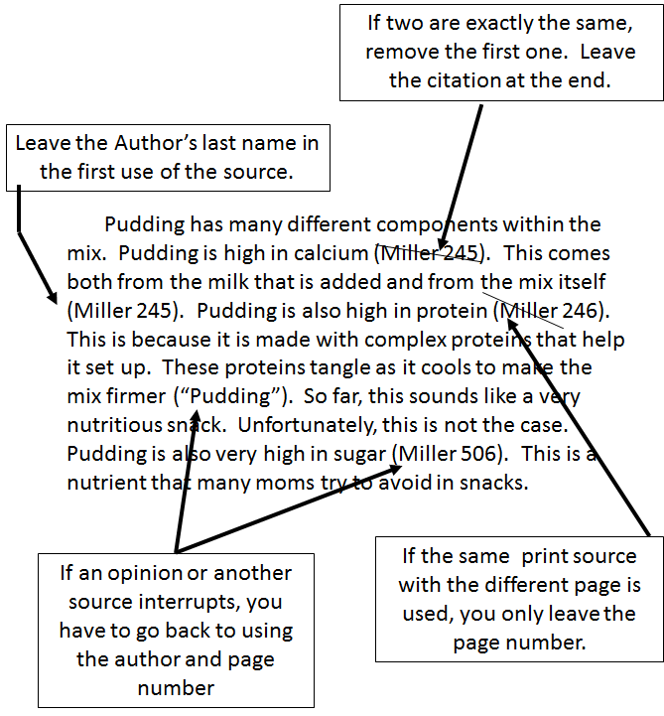
AFTER

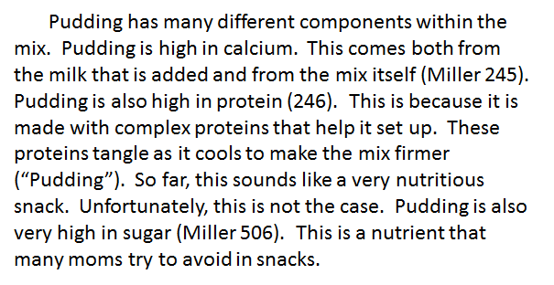

BEFORE
AFTER
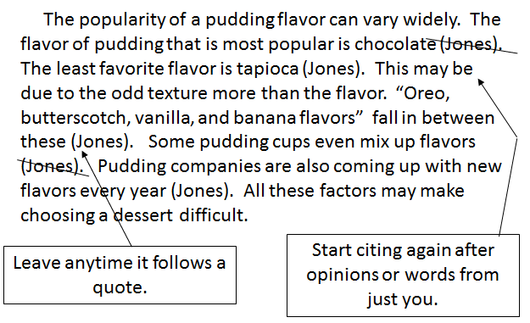
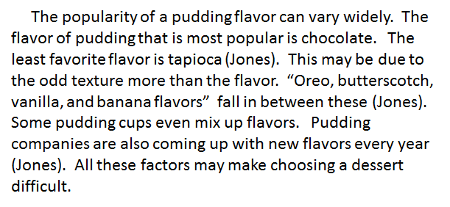

Scientific Names
Scientific names of organisms & taxa must be written in a specific way.

- To recognize scientific names in your research, they will be two word names in Latin.
- The first word must be capitalized, but the second is not.
- Both words must be in italics.
- The first word will sometimes be abbreviated to a single letter after writing it out the first time.
- Examples: Canus lupus or C. lupus
Escherichia coli or E. coli

Taxa
- Capitalize the other taxa only if the name and the taxa are BOTH together.
Capitalize: They are in the Phylum Chordata.
The Animal Kingdom includes the mammals.
Don’t capitalize: They are in the same phylum.
They are all chordates.
Both are in the same species.

- If the organism belongs to more than one category, it is in one phylum (singular). If it could be in two or more categories, it is in several phyla (plural).
Example: Because of its fur, Easter Bunny belongs to the mammal phylum.

Example: Because it has scales and hair, the naga could belong to the mammal and reptile phyla.

Capitalization of Monster Names
- Capitalize a monster’s name if there is only one of them. This makes it a proper name. An example of this would be the Tooth Fairy or Easter Bunny.
Example: Many children believe that if they leave their teeth under a
pillow the Tooth Fairy will leave them money or a gift.

- Do NOT capitalize if there are many of this monster.
Example: A unicorn is known for the single horn on its forehead.

- If there is disagreement in you sources about if there is one or many, you must be consistent in the paper. Either always capitalize the name or never capitalize the name.

Paraphrasing

Paraphrasing is putting information into your own words. If you are paraphrasing, the sentence should be significantly different from the original source (not just changing a word or two). Examples for citing sources that are paraphrased are below. Having three or more words in a row from the original text is plagiarism. Some things will need to be quoted. Remember, lists should almost always be quoted. Significantly less than half the paper should be quoted, so quote sparingly.

Quote: “Jellyfish have specialized cells that are organized into tissues, but this is the extent of their complexity. Unlike other more advanced invertebrates, no organs are found in jellyfish.”

BAD Paraphrase: Jellyfish contain specialized cells that are organized into
tissues, but this is the limit of their complexity. Unlike other more evolved
invertebrates, no organs are inside jellyfish (Johnson 124).
  - just changing a couple words or quoting entirely is plagiarism & will be a
major point deduction

BAD Paraphrase: No organs are found in jellyfish, unlike other more advanced
invertebrates (Johnson 124).
  - just changing the order of key phrases is plagiarism.

GOOD Paraphrase: Jellyfish do not have organs, but they do have tissues
(Johnson 124).

Quote: “Some scientists believe that the monera kingdoms should actually be divided into the two separate kingdoms; the archaebacteria and eubacteria kingdoms.”

BAD Paraphrase: Some scientists believe that the monera kingdoms should
actually be split into the two kingdoms; the archaebacteria and eubacteria
kingdoms (Kline 307).

GOOD Paraphrase: Scientists disagree about how to classify bacteria. They can
be classified as one kingdom or as two different kingdoms. If bacteria are all in
one kingdom, it is the monera kingdom. This can then be divided into the
archeabacteria and eubacteria (Kline 307).

Quoting
Quoting is using the exact words that were found in the original source. Quotes should always be written in quotation marks. Quoting should be done in moderation. Significantly less than half the paper should be quoted.

1. EXACT QUOTE : Cite the source right after the quote even if the rest of the
paragraph is from the same source.
- Example: “Free from the stresses of homework and ‘required’ reading, summer can be a great time for kids to read for sheer enjoyment” (Adkins 48).

- Example: “Now is the winter of our discontent” is a frequently used quotation
(Shakespeare 24).

2. ADDING OR REMOVING INFO: Quotes must be EXACTLY like the original
source or you must indicate what has changed.

Quote: “Jellyfish have specialized cells that are organized into tissues, but this is the extent of their complexity. Unlike other more advanced invertebrates, no organs are found in jellyfish.”

Removing info. : “Jellyfish have . . . tissues, but this is the extent of their complexity. Unlike other more advanced invertebrates, no organs are found in jellyfish” (Johnson 124).

Adding info. : “Jellyfish [also] have specialized cells that are organized into tissues, but this is the extent of their complexity. Unlike other more advanced invertebrates [like the octopus], no organs are found in jellyfish” (Johnson 124).

3. Note the quotation marks go before the parenthesis, but the end punctuation is still
AFTER the parenthesis.

4. QUOTE WITH MORE THAN FOUR LINES: It must be placed into a block
quote. A block quote has ALL the text indented one ½ inch from BOTH margins.
With a block quote, no quotation marks are needed. Google apps has a block quote
function under “format” that will do this for you. You may have no more than two
block quotes in the entire paper. Note the period is before the parenthesis in a block
quote.

Gerbils are members of the rodent family (“Rodents”). Gerbils are often kept as pets even though they normally do not live for very long (Howard 35).
Dogs and cats are still the most common pets in the United States,
but smaller pets are popular. Animals such as fish, hamsters, and
gerbils are often better suited to live in cities and apartments than
traditional pets. These pets do not require yards or extensive
walks for exercise. (“Popular”)
Smaller pets such as gerbils also have the advantage of being cheaper to purchase (Howard 35).
Works Cited Page

The purpose of a works cited page is to give a detailed description of the sources of information. This page gives enough detail on each source so a reader can find that exact source again.

- For this paper you need at least three sources. You must use your Reading Essentials textbook, the World Book Encyclopedia (in print form), and at least one source from the Internet. Your approved sources will be given to you by Mrs. Charlwood. You do not have to all the sources, but you may need to. Additional sources should not be used unless you get them approved by Mrs. C and your English teacher. You may also want to use the hardback version of your textbook.

- If you use a dictionary (aside from the textbook glossary) it must be http://dictionary.reference.com. This source must be cited (like all other sources).

- The works cited page should be after the last page of the research paper.

- It should still have your last name and the page number in the header like all other pages.

- Double space this page.

- Begin the first line of each entry aligned with the left margin, and indent lines that follow by one-half inch. This is called a hanging indent (reverse indent).
  - If you have already begun to input entries, you will need to highlight the existing text before setting up the indents.
  - To set up a hanging indent (reverse indent), find the blue rectangle and triangle used to set tabs below the tool bar. Click and drag this over to the ½” mark
  - Next click just on the top rectangle and drag it back to the left margin.

- Alphabetize the entries by the author’s last name (or the first significant word in the title of the source if there is no author listed).

- Nothing should be blue or underlined on this page (remove hyperlink).

- See the examples on the Works Cited Example Page (next pages) and in the example paper online.

- Before turning in your paper check that all the sources used in the paper are on the works cited page. Check that all the sources on the works cited page are still used in the paper.

Works Cited Examples
BOOKS
Example:
Welty, Eudora. One Writer’s Beginnings. Cambridge: Harvard UP, 1984. Print.

My Book Sources:

, . . :
^{(Author last name)} ^{(Author First Name)} ^{(Book Title Italicized)} ^{(Publishing Location)}
, . Print.
(Publishing Company Name) (Year of Publication)

BOOKS with 2 Authors
Example:
Jones, Bob R. and Sam S. Smith. One Writer’s Beginnings. Cambridge: Harvard UP, 1984. Print.

My Books with 2 Authors Sources:

, and .
^{(1st Author last name)} ^{(1st Author First Name)} ^{(2nd Author First Name)} ^{(2nd Author Last Name)} ^{(Book Title Italicized)}
. : , . Print.
(Book Title Italicized Continued) (Publishing Location) (Publishing Company Name) (Year of Publication)

BOOKS with 3 or more Authors
Example:
Biggs, Alton et al. Biology. Columbus: McGraw-Hill, 2012. Print.

My Books with 3 or more Authors Sources:

, et al. . :
^{(Author last name)} ^{(Author First Name)} ^{(Book Title Italicized)} ^{(Publishing Location)} , . Print.
(Publishing Company Name) (Year of Publication)

BOOKS with 3 or more Authors
Example:
Biggs, Alton et al. Reading Essentials for Biology. Columbus: McGraw-Hill, 2012. Print.

My Books with 3 or more Authors Sources:

, et al. . :
^{(Author last name)} ^{(Author First Name)} ^{(Book Title Italicized)} ^{(Publishing Location)} , . Print.
(Publishing Company Name) (Year of Publication)

REFERENCE BOOK
Example:
Chrisley, Ronald. “Freud, Sigmund.” World Book Encyclopedia. 2000 ed. 2000. Print.

My Reference Books:

, . “ .” .
^{(Author last name)} ^{(Author First Name)} ^{(Article Title)} ^{(Book Title Italicized)}

. . Print.
(Year or Edition) (Year of Publication)

MAGAZINE
Example:
Donalson, Abigail. “Fishing for Trout.” Field and Stream. 9 Jan. 2002: 27-34. Print.

My Magazines:

, . “ .” .
^{(Author last name)} ^{(Author First Name)} ^{(Article Title)} ^{(Magazine Title Italicized)}

: . Print.
(Day Mon. Year of ^{(Inclusive Pages)}
Magazine)

ONLINE SOURCES
Example:
Rimer, Sarah. “Retired Doctors Head Back to Work.” New York Times on the Web. New York Times, 4 Dec. 1999. Web. 6 Dec. 2009.

My Online Source 1:

, . “ .” .
^{(Author last name)} ^{(Author First Name)} ^{(Article Title)} ^{(Website: top left)}

, . Web. .
(Sponsor:Bottom by copyright) (Day/Month/Year info. (Day/Month/Year you got the info.)
posted or updates)

My Online Source 2:

, . “ .” .
^{(Author last name)} ^{(Author First Name)} ^{(Article Title)} ^{(Website: top left)}

, . Web. .
(Sponsor: Bottom by copyright) (Day/Month/Year info. (Day/Month/Year you got the info.)
posted or updates)

Dictionary.com as a Source:

“Word.” Dictionary.com. Dictionary.com, n.d. Web. Date found.

“ .” Dictionary.com. Dictionary.com, n.d. Web. .
^{(Word being defined)} (Day/Month/Year
you got the info.)

Teacher, Peer, & Self-Evaluations Requirements

All students will fill out an evaluation form for themselves and one for each group member at the end the project. Mrs. C will also complete an evaluation form for each student. These grades will be averaged together. These will be turned in confidentially, so others in the group do not need to know what grade you gave them.

Grading Rubric for Peer Evaluations (Average)

Name of Student being evaluated: |  |  | 
They allowed you to work.
They were consistently on task
They completed all agreed upon tasks
The work produced was accurate
The work produced was equivalent to the work others produced during the project
They were able to get along with others

Grading
All parts of the project that will be graded have a rubric. Those are posted below with due dates.

Grading Rubric for Info. Excel
Category | Comments | Points Possible | Points Earned
Works Cited (correct & complete) |  | 15
Parentheticals (correct & complete) |  | 15
TOTAL POINTS |  | 30

Grading Rubric for $$ Excel
Category | Comments | Points Possible | Points Earned
All Columns |  | 10
All Materials Needed Accounted for |  | 20
Did not Exceed Budget |  | 20
TOTAL POINTS |  | 50

Grading Rubric for Engineering Notebook
Category | Comments | Points Possible | Points Earned
Contents  Has required info:  *Water plan  *Compost plan  *What is grown  *Seed type  *Square foot garden  *Vertical garden  *Elevated garden  *Aquaponics  *Pollination  *Nutrition  *Materials |  | 30
Sketches  Room  Other structures |  | 10
TOTAL POINTS |  | 40

Grading Rubric for 3D Prototype
Category | Comments | Points Possible | Points Earned
Contents  Has all planned structures:  *Water  *Compost  *What is grown where  *Other structures |  | 35
Key  Written key for unclear structures or symbols |  | 5
3D & to Scale |  | 10
TOTAL POINTS |  | 50

Grading Rubric for Backstory
Category | Comments | Points Possible | Points Earned
Appearance  Heading  Margins  Font  Page #’s & last name  Double Space  Title |  | 5
Mechanics  Grammar  Punctuation  Spelling |  | 10
Contents  Has required info |  | 25
Organization  Logical order  Narrative format |  | 10
TOTAL POINTS |  | 50

Grading Rubric for Paper
Category | Comments | Points Possible | Points Earned
Appearance  Heading  Margins  Font  Page #’s & last name  Double Space  Title |  | 5
Mechanics  Grammar  Punctuation  Spelling  Parenthetical Citations |  | 20
Contents  Has required info.  Has All Standards in  Comments  Choices are justified  Sources:  - No plagiarism  - No libel  - Info. in cited sources |  | 50
Organization  Introduction Paragraph  Conclusion Paragraph  Logical order in  paper & paragraphs |  | 10
Works Cited  Correct format  Listed sources are cited  in paper  All sources are on W.C. |  | 15
TOTAL POINTS |  | 100

Assignments

- Information Online
- Instruction Packet online. This will be view only
- Zombie Sources Online. This document will have the suggested and required sources for this project. It will be on Google Classroom and view only.

- Group Task Agreement (10 pt)
- The group need to agree to who is researching what and who is “in charge” of certain tasks.
- Being “in charge” does not mean the others do not need to help.
- This can be written on normal paper or emailed to Mrs. C.

- Engineering Notebook (40 pt)
- A sketch or sketches of your sunroom are required in the Notebook.
- Some Research needs to be recorded in the Engineering Notebook. Every student needs to have this data in the Notebook.
- Required topics include: Composting, Heirloom seeds vs. Hybrid seeds, Square foot gardening, Vertical gardening, Elevated gardening bends, Aquaponics, Nutrition, & Pollination. (Materials and costs will be on a spreadsheet).
- Research needs to include more than definitions. You need pros & cons of different options.
- Other areas may need to be researched and other sources may be used on these topics as needed by your group.
- Required sources are listed on Google Classroom. Other sources may be used with permission.

- Backstory (50 pt)
- This needs to be opened by ONE member then shared with the group &Mrs. C.
- This is where you should write your backstory.
- The paper needs to answer the following questions: How did this start? Is this apocalypse viral, bacteria, or caused by magic? Where did it originate? How did it get to the US (if it did not originate here)? Is there hope for medical treatment of the infected?
- Your background story should be about a page long (assuming 12 pt font, double spaced) or longer.
- I recommend seeing the sources suggested on Google Classroom.
- This document will need to be printed and will be graded as the final paper.
- Students may choose an alternate format for this item if it is approved by Mrs. C.

- Google Info. Excel Spreadsheets (30 pt)
- This needs to be opened by ONE member then shared with the group & Mrs. C.
- This is where you will record your research, citations, and paraphrases.
- This is where you will organize your data into topics and paragraphs.
- This document will be graded, but primarily for completion. It is where you compile data

- Google $$ Excel Spreadsheets (50 pt) Rubric pg. 25
- This needs to be opened by ONE member then shared with the group & Mrs. C.
- This is where you will record all materials that must be purchased to complete the project.
- Websites used for pricing need to be cited at the end of the final paper, but do NOT need to be parenthetically cited in the paper.
- This document will be graded (rubric on pg 25). Be sure to include all materials for all structures and to stay in budget.

- Final Paper (100 pt)
- This needs to be opened by ONE member then shared with the group & Mrs. C.
- This is where you should turn the research into paragraph form. The information should all be cited using parenthetical documentation.
- This is where you will be identifying your standards. This should be done by inserting comments.
- After the data is organized in your Individual Excel, it will be copied to this document (in order) to create paragraphs. The required data is listed below:
  - A plan for growing a majority of your dietary needs (protein, carbohydrates, & vitamin C minimum).
  - A list of the types of vegetables/fruits you are growing and in what quantities.
  - A plan for composting.
  - A plan for water for your drinking & gardening needs (bathing & wash water can be handled separately).
  - Choices your group made about composting, heirloom seeds vs. hybrid seeds, square foot gardening, vertical gardening, Elevated gardening bends, aquaponics, nutrition, pollination, and small animals (fish, rabbits, chickens), soil type, and vegetation choices. All choices need to be justified (pros & cons).
- The Works Cited document will be typed in as the last page of the paper. It should include sources/sites for pricing (but these do not need to be parenthetically cited in the paper).
- This paper must be in MLA format. See this packet for details.
- This document will NOT need to be printed and will be graded as the final paper.
- Prototype Sunroom (50 pt)
- You need to design a sunporch to house your food needs for the next three years.
- The room is on the south side of your home. It is 300 ft² (12ft x 25 ft). The ceiling on the 12 ft. sides is at a standard 8 ft. The ceiling then peaks in the middle of the 25 ft. side at 12 feet. It has windows on three sides, starting at 32” from the floor and continuing to within 8” of the ceiling. This means that the windows on the south facing wall (the long side) are not square. All windows have screen. All window can be completely opened or closed in segments.
- A 3D prototype of your room is required. This should include all items you are planning on building in your room.
- All structures in the room should be made to scale (as much as possible).

- Peer Evaluations (40 pt)
- You will be completing self and peer evaluations.
- The scores will be averaged for evaluation grade at the end of the project.

