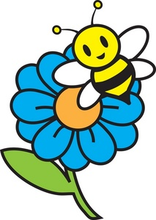

Client: Schlagel Ventures LLC

End User: Greenhouse owners

Designer: ___________________________

Design Problem: Bees, butterflies, and other insects are the main pollinators for many food plants, the ones that produce fruits and vegetables. For a variety of reasons, a greenhouse environment is not welcoming to most insect varieties. Also, the population of wild bees is in decline. In the near future, there may not be enough insects to pollinate our fruits and vegetables. So pollination must happen by other means. It happens that the design department has a supply of Blade Inductrix quadcopter drones.

Design Statement: Design, prototype, test, redesign, and present a quadcopter drone frame with a pollen collecting/distributing apparatus that can be flown through a greenhouse to move pollen from one flowered plant to another. Simulate this ability by flying the drone through a course of simulated flowering plants. Give a short sales pitch to a panel of potential investors highlighting why your group should be picked to further develop the technology.

Criteria:
- Collect pollen from the flowers in sufficient quantity to fertilize plants.
- Place pollen on the stigma of the pistil.
- Use the flying drone.
- Use an apparatus connected to the drone to collect and apply pollen.
- Use the 3D model for the body of the drone.
- Model and print a carrier for the pollen collector.

Constraints:
Drone: - Use Inductrix Quadcopter with standard battery
Collector: - 3D modeled and printed
- No tape or glue can be used
- Be lighter than the maximum capacity of drone
- Remain attached to the quadcopter
- Collect a quantifiable amount of pollen.
- Deliver a quantifiable amount of pollen.
Flight: -Fly through the course accurately in as short a time as possible
- Return to the starting point and land safely.

