Design Brief

The Bumble Bee Drone

Scenario - The US Military is investing even more and more money in drone technology. Much of the current military drone technology is on the larger scale (~10m) with robots that can be used for reconnaissance and delivering weapons into hostile zones. There are also smaller (~1m) sized robots that can be used for surveying smaller areas around 10 miles. The next stage is for deploying micro-sized robots (~1 cm) into areas for surveillance and spying. Breakthroughs in audio/visual technology have enabled a camera that can record in HD for 30 minutes with a weight of 0.5 grams and a size of 20mm. This is the approximate size of the humble bumble bee. Everyone knows that it is impossible for the bumble bee to fly so you have been tasked with creating a wing design that can enable the bee drone to actually fly.

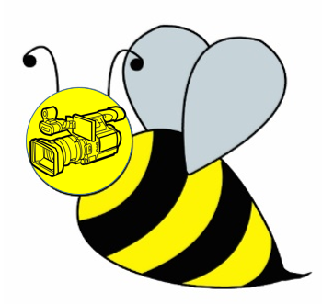

Your Task: You need to collect information about the area of science known as entomology - the study of insects. The wing shape must be similar in design to an actual insect to provide authenticity to the spy Bumble Bee drone. As a class we will learn about the forces involved in flying. Your group will need to design a wing that can generate the most force with the least amount of mass. We will use a 3-d printer to print scaled up wings out of plastic and actually test them in the next few weeks.

Where to Begin: Over the next two weeks we will begin to understand the forces involved in flying and we begin with the concept of lift.

