Design Brief

Clean Sweep
Introduction: View the introductory videos:
- Message in the Waves: https://www.youtube.com/watch?v=iVjue0R5tHQ
- The Great Pacific Garbage Patch: https://www.youtube.com/watch?v=Nh6lkv1udb0
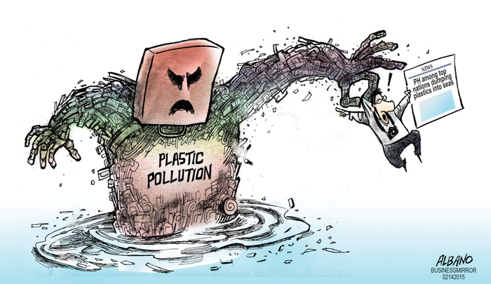
Scenario: The whirligig beetle is an aquatic insect that occurs in many types of aquatic habitats, including ponds, lakes and streams. Whirligigs employ a simple form of radar when they use water ripples to detect food or other whirligigs on the surface. Like bats, which use a kind of sonar, they pioneered “technologies” that humans have only fairly recently developed. These small predators and scavengers clean the water of dead or dying insects and help control the populations of other aquatic invertebrates. In turn, they and the larvae are eaten by fish and other predators.
Aquatic habitats are being threatened by plastic pollution due to plastic particles floating on the surface of the water which many animals such as fish, birds, and turtles mistake for the food they eat. This results in many of the animals becoming sick or dying due to malnutrition, suffocation, or strangulation.
Your Task: You and your team are required to research all about how plastic pollution in aquatic habitats creates issues for the creatures that live there. Additionally, you need to collect information on the whirligig beetle and its niche (role and function) in aquatic habitats.
Where do you begin? In your team, build a plan focusing on how you would proceed to provide the Environmental Protection Agency (EPA) with a report collecting relevant information about a design that will mimic the actions of the whirligig beetle and collect plastic pollution from the aquatic habitats. Start with the KWHLAQ report. This handout will help you begin to consider what information to collect and how you will collect the information.

