Balanced Force Model Reading 2:
Forces and Force Diagrams
Forces can intuitively be thought of as pushes and pulls. For example, you exert a force (a push or a pull) on a door to open it. Gravity exerts a force on you (a pull) which holds you to the surface of the earth. Friction with the surface of a hill exerts a force on your car that keeps it from sliding when parked. Note that in every situation, forces are an interaction between two objects--you can't touch without being touched. The door also pushes back on your hand, the earth is also gravitationally attracted to you, and the car exerts a frictional force on the road.

There are many types of forces between objects that are differentiated by the way in which two objects interact. Here are some of the ones we will use in class:

When two surfaces touch each other, forces perpendicular to the surfaces are called normal forces (here "normal" is a mathematical term meaning perpendicular) and forces parallel to the surfaces in contact are frictional. The Friction force that allows us to step forward or keeps car wheels from spinning can be called traction. When we touch things a combination of both normal and frictional forces are present. For simplicity, we can call a combination force a push or a pull.

Extended or linked materials such as a string or chain exert tension forces on an object.
When an object interacts with a fluid, such as water or air, propelling forces are called thrust, resistive forces are called drag, floating forces are called buoyant, and steering (or Bernoulli's) forces are called lift.

When two objects interact without touching, they exert forces through a force field. Earth, for example, exerts a gravitational force on the Moon even though the Earth and Moon do not touch. Other non-contact forces include electric and magnetic forces.

When we label forces, we want to indicate the type of interaction between the objects, what object the force is acting on and what object the force is by. Therefore, we will use the following notation:
Fkind, by agent, on victim

For example, the gravitational force on you would be written: Fgravity, by earth, on you,.
The analysis of a problem in dynamics usually involves the selection and analysis of the relevant forces acting on some object under consideration. An important first step in this analysis process is to carefully select the object of interest that will be the focus of our analysis. For purposes of this analysis, we will refer to the object under consideration as the system, and everything else in the environment that might in any significant way affect the system as the surroundings. This analysis process can often times be greatly simplified by utilizing a technique of constructing force diagrams to assist you in selecting the relevant forces and appropriately representing these forces with vector notations.

In general, we will follow the following steps when creating force diagrams.
1. Sketch the system and its surroundings.
2. Enclose the system within a system boundary.
3. Shrink the system to a point at the center of coordinate axes with one axis parallel to the direction of motion.
4. Represent all relevant forces (across the system boundary) with a labeled vector.
5. Indicate which forces (if any) are equal in magnitude to other forces.

Consider the analysis of forces acting on a log as a tractor pulls it at a constant speed. The analysis proceeds as follows:
Step 1. Sketch a diagram of the system and its surroundings.
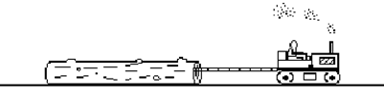
Step 2. In order to assist in the identification of the relevant forces acting on the system, enclose the system (log) within a closed boundary line.
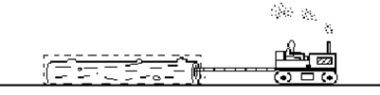
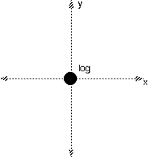
A broken line was used for emphasis in this sample problem; however, the line need not be broken.

Step 3. Since the shape of the object is unimportant, shrink it to a point. Place it at the intersection of a set of coordinate axes with one of the axes parallel to the direction of motion as shown in figure 4.

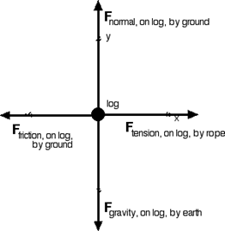

Step 4. Proceed around the system boundary line and identify all points at which there is contact between the system (log) and its surroundings. Construct qualitative vectors (indicate directions and relative magnitudes) to represent these forces.

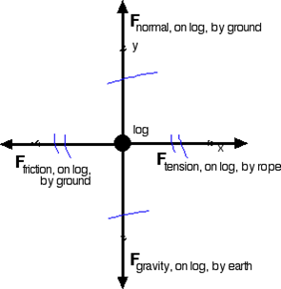
Step 5: Indicate which forces (if any) are equal in magnitude to other forces. The problem states that the tractor pulls the log at constant velocity, so we know that the net force has to be zero. In other words, the forces up must equal the forces down, and the forces left must equal the forces right. In the diagram below these equalities have been marked with hashes like those used to indicate
congruences in geometry.

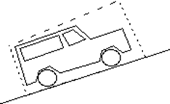
Let us now look at a more complicated example: A car parked on a hill.

Step 1. Sketch the system and its surroundings.

Step 2. Enclose the system within a system boundary.

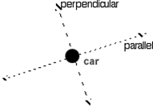
Step 3. Shrink the system to a point at the center of coordinate axes with one axis parallel to the direction of motion. Although the car isn't moving, if it did, it would slide down the hill. Therefore, the coordinate axes have been aligned parallel and perpendicular to the hill. Although it may seem strange, rotating the coordinate axis will make the rest of the analysis easier.
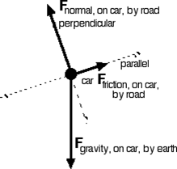
Step 4. Represent all relevant forces (across the system boundary) with a labeled vector. Gravity always points toward the center of the earth (down). The normal force is perpendicular to the road/tire surface and the friction force is parallel to the road/tire surface. Friction exerts a force up the hill to resist the tendency of the car to slide down the hill due to gravity.
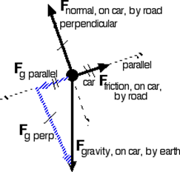
Step 5. Indicate which forces (if any) are equal in magnitude to other forces. Here's where the parallel/perpendicular coordinate axis helps. Since the car is motionless, the forces must be balanced along each coordinate axis. Gravity isn't along either coordinate axis, but we can represent gravity with two component vectors. Fg parallel is how much of the gravitational force tends to pull the car along the slope and Fg perpendicular is how much of the gravitational force tends to pull the car to the road. For the forces to be balanced, Fg parallel must be equal in size to Ffriction and Fg perpendicular must be equal in size to Fnormal, as indicated by the hash marks. Note that no hash marks are placed on Fg since we have replaced it with its equivalent component vectors.

Hints . . .
1. Seeing the components in the previous problem is often difficult for students. It may be helpful to physically rotate your paper so that the parallel/perpendicular components become aligned left/right and up/down. The result is a force diagram that looks like the one on the right.

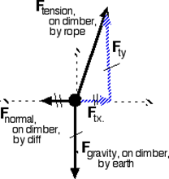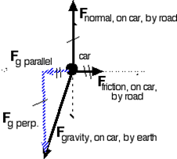

2. Here's a very different looking situation, but the analysis is very similar. In fact, turning the previous force diagram 180 degrees results in the force diagram shown. Realizing that all force diagrams have many similarities can be a relief. You don't need to memorize a bunch of different approaches to be able to draw a wide variety of force diagrams.

A rock climber on a cliff:

