Activity 2.4 Clean Sweep: Sink or Swim
Introduction
Scientific Inquiry: Guiding Question – What characteristics of mass and volume have an effect on buoyancy?

Lesson Objectives:
At the end of this lesson, you will be able to:
- Predict buoyancy of an object using mathematics and predictive analysis.

Equipment
- Large plastic tub
- Golf balls
- Aluminum foil

Procedure
Working with your Clean Sweep group, complete the following steps to complete the design challenge concerning buoyancy of objects.

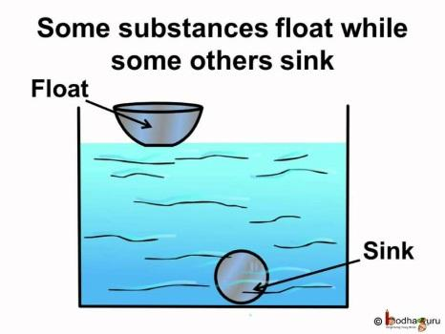

- Observe the shape of the following ships. Why do the ships have different shapes?
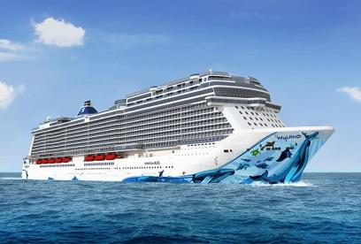 | 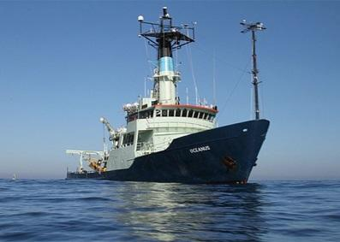
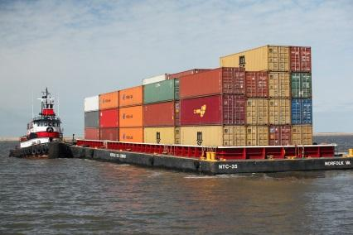 | 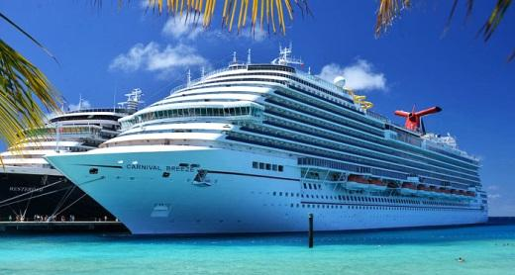

- Sinking and Floating quiz. Which person will likely float?
Condition | Reason
Child versus Adult
Adult versus Elder
Man versus Woman
Fat guy versus Thin guy

Raft Design Challenge
Preface: The manufacturing company Riff-Raft seeks to create a new line of emergency rafts that are portable for hikers. Your task is to create a prototype of the raft using given materials. As an engineer, you have to report out the anticipated capacity of the raft before testing it out.

Challenges
- Build a raft using a sheet of aluminum foil (40 x 30 cm)
- The raft should load at least 30 golf balls on water before submerging
- Predict critical load (total number of golf balls)
- Size: Less than 30 x 25 cm
- Time limit: 10 minutes
*Hint: Weight of golf ball: 46g

Results

Estimated capacity:

Number of golf balls | Total weight (N of golf balls * 46g)

Measured capacity:

Number of golf balls | Total weight (N of golf balls * 46g)

Redesign the Riff-Raft prototype

Challenges
- Rebuild a raft using the STEM knowledge and given materials.
- Sheet of aluminum foil (40 x 30 cm)
- Calculate the minimum volume of the raft to hold 30 golf balls.
- Time limit: 20 minutes
Your Design

- Calculate the volume of your raft that is capable to hold 30 golf balls.

- Draw your design:

Results

The volume of the raft | Number of golf balls

Reflection

- What knowledge did you use to build your raft design?

- In general, how does knowledge of STEM concepts benefit you in the design of a raft?

