Smart Plan (formerly EduNav)

How to Create a “What-If” Plan
Contents
How to Create a “What-If” Plan 1
Overview 1
Why create a “What-If” plan? 1
Creating a “What-If” plan 1
Modify Goals 1
What if: Changing my Major 2
What If: Adding a Double Major 4
What If: Adding a Minor 4

Overview
"What-if" Plans are used to visualize paths to degree and requirements for various educational goals. There can be an unlimited number of saved plans for each student, so this is your opportunity to explore.

Why create a “What-If” plan?
Create a “What-If” plan if you want to see how changing a major, adding a major, adding a minor, or adding a certificate could impact your time to degree, as well as visualize what courses are needed for your “what-if” scenario.
Please note that changing your goal in Smart Plan does NOT change your declared goal.

Creating a “What-If” plan

Modify Goals
- Make sure your plan status is Valid to ensure the most accurate version of your degree plan

- Scroll to the end of the planned terms. You will see a gray section titled Goal(s) that shows your declared goal
- Click on the Change button
- A Modify Goals panel will appear
  - From the Modify Goal tab, you can:
    - Edit the current concentration
    - Change the current major
    - Remove the current major
    - Add a second major
    - Add a minor
    - Add another program
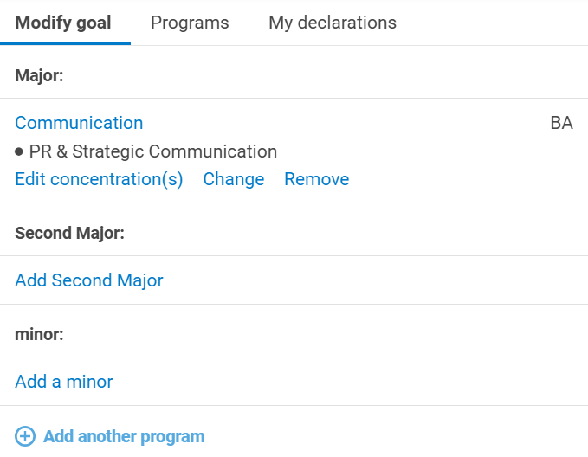
  - From the Programs tab, you will find all eligible programs at Purdue that can be added or changed to the current goal
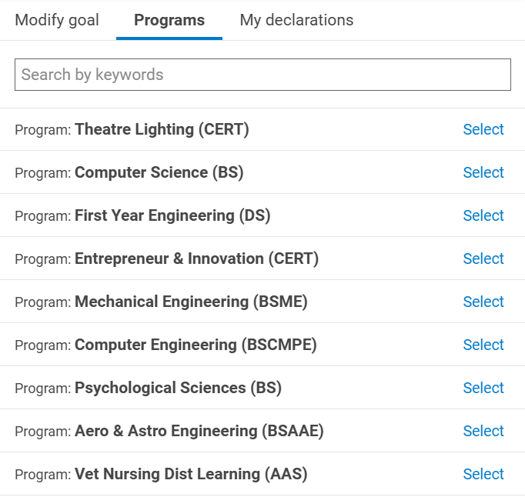
  - From the My declarations tab, you will see your declared program

What if: Changing my Major
- If you want to see what changing your major would look like, click the Change link under the current major
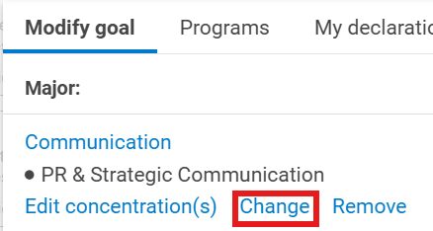
- Find the major you would want to change to and click Select
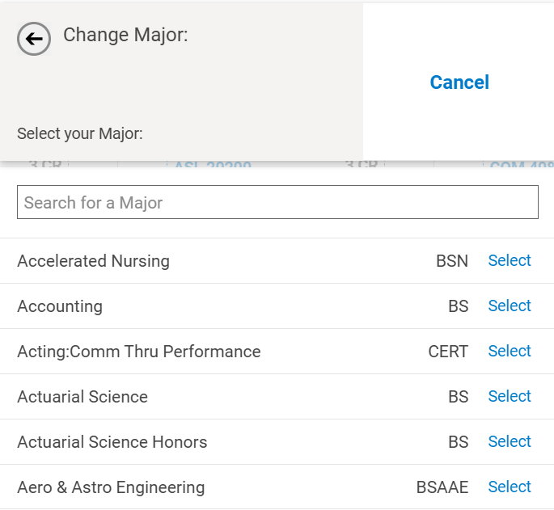
- Click the Apply button to apply the changes to your Smart Plan planner view. It might take a bit for Smart Plan to generate the new “what-if” plan because it is taking into account the courses you have already taken and the courses that are required by the new major to generate a plan specifically for you
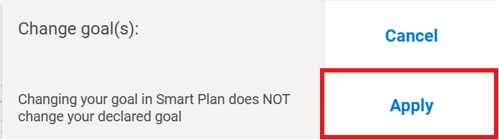
- After the new plan is generated, you can view the new plan and requirements
- If you scroll over to the Goal(s) section, you’ll see that the plan that you’re seeing is a “What-If” plan
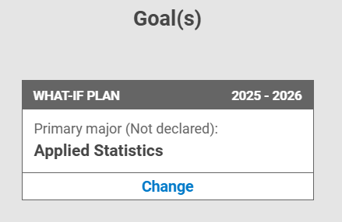

What If: Adding a Double Major
- Click Add Second Major
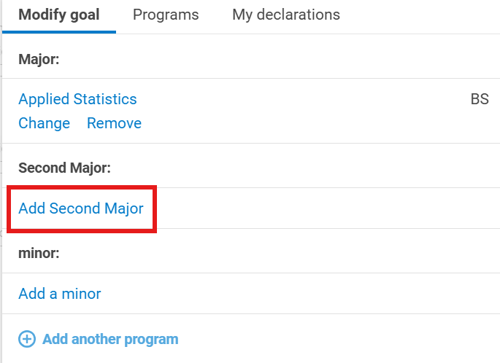
- Majors in the current department will appear
- If the major is in a different department, add the major under Add another program
- A list of Purdue programs will appear. Select the program
- Once the program is selected, you will see a Program 2 section under Modify Goal
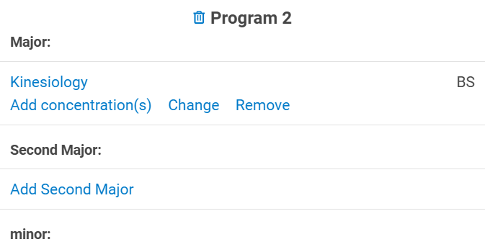
- Click the Apply button to apply the changes you made

What If: Adding a Minor
- Click Add a minor
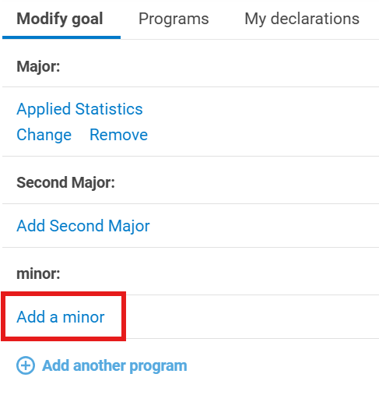
- A list of minors will appear
- Select or search for the minor to add
- Click the Apply button to apply the changes you made
Start planning with Smart Plan!

