Smart Plan (formerly EduNav)

Adding and Deleting Terms

Overview
When an advisor or student initially builds a plan, only fall and spring terms will be planned. This means that if you want to take a summer or winter term course, your initial plan does not incorporate the additional terms.
The only exception to this rule is if a degree program requires a summer or winter term course. If this is the case, the plan will include that term in the initial plan.
When individualizing plans, it may be necessary to add or delete terms.

Adding a Term
Terms can be added within the Planner View. Simply click the + icon between two existing terms to add a new term.
Courses can then either be added manually to the new term or the target credit hours can be increased so that Smart Plan will try to plan a course(s) in the new term when the Validate Plan button is clicked.
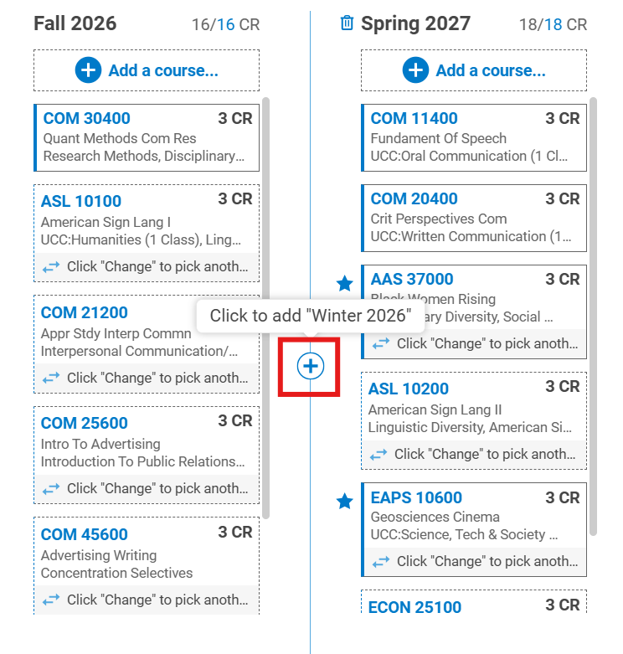

Deleting Terms
Terms can also be deleted within the Planner View. Hover over the term until a trash can icon appears to the left of the term header (example: Spring 2027).
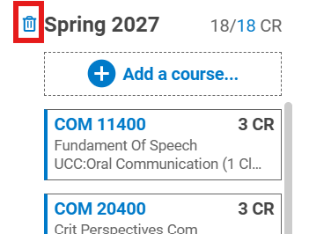
Click the trash can and confirm that you want to delete the term.
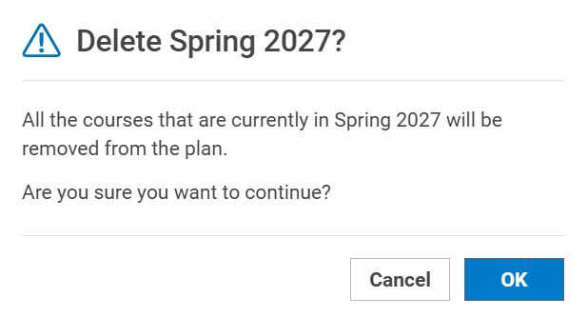
Start planning with Smart Plan!

