Shovel

What is Shovel?

Overview
Offered free to all Purdue students, Shovel is an intelligent study planner designed to help students master their demanding schedule. This smart time-blocking app allows you to:
- Import coursework from Brightspace
- Estimate study time for each task
- See if you realistically have enough time to get everything done
By visualizing all academic and personal commitments in one place, you can proactively manage your workload, avoid last-minute cramming, and maintain a balanced schedule.

How to Use
- Sign in through this link! (You must use this link (or the link at the bottom of this page) to create your free account. Setup MUST occur on a computer!)
- Connect Brightspace to Shovel to import your assignments and deadlines
- Share your external Calendar (Google, Apple, Outlook) with Shovel
- Create your schedule by dragging and dropping a Course, Activity, or Custom Event onto the calendar
- In addition to courses and coursework, consider:
  - Work schedule
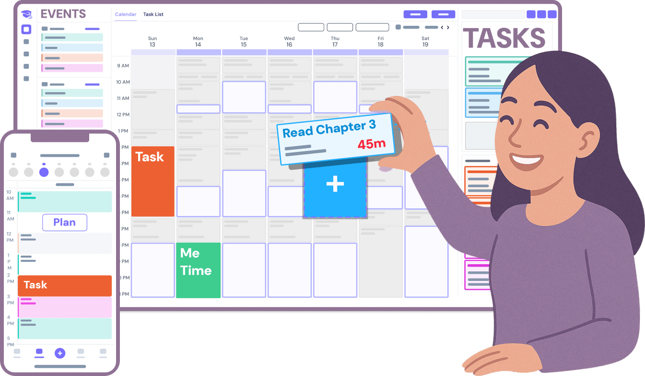
  - Family obligations
  - Commute time
  - To do tasks
  - Sleep schedule
  - Study blocks
  - Fun things!
- Adjust your calendar as needed
- Start managing your time!

Create your account now.

