Faculty Guide to Submitting BoilerConnect Progress Reports
Contents
What is a Progress Report? 2
You received a Progress Report Feedback Request. What should you do next? 3
Intervention Specifics: Instructor Recommends Student Seek Academic Resources 5
Intervention Specifics: Instructor Recommends Student Withdraw from Course 6
Progress Report Workflows 7
Round 1 7
Round 2 8

What is a Progress Report?
Progress Reports are used to assess a student’s academic performance or progress in your course. Progress Reports are submitted through a Progress Report Campaign during designated points throughout the semester.
A Progress Report can highlight areas where a student may be struggling in your course. Progress Reports should NOT be used to replace the Student of Concern Report process.

If you mark a student as experiencing challenges in your course on the Progress Report feedback form, you must select at least one alert reason (can select multiple):
- Instructor Recommends Student Seek Academic Resources
- Instructor Recommends Student Withdraw from Course
When a student is marked as experiencing challenges in your course, BoilerConnect will create an alert with the information submitted, including your comments, that will be available for students to view. In addition, an email will be sent to the student with the alert reason listed.
- If you indicated you recommend resources, the Academic Success Center (ASC) will use this information to conduct personalized outreach to follow up with the student.
- If you indicated the student should consider withdrawing from the course, their Academic Advisor will receive an email with the alert reason and recommendation listed.
If the student is not experiencing challenges in the course but still showing some academic concerns, you can still select these alert reasons (for instance, the student has missing assignments, but it is not negatively impacting their grade enough).
We highly encourage adding comments to provide additional context. Comments allow you to offer feedback and advice to students on how to improve their performance while allowing staff to assess the student’s risk of failing and engage in appropriate institutional outreach.

You received a Progress Report Feedback Request. What should you do next?
- Click on the link in the email to begin entering student feedback.
If there are multiple instructors listed for your course section, you can forward the email to any of the other listed instructors. However, please ensure that each student only receives ONE submission for your course. For example, if there are two instructors for ABC-10000, only one instructor should submit for the same student.

- Under the Experiencing challenges with this course? column, select Yes for any student this applies to.
  - Choosing an option from the Alert Reason(s) dropdown and inputting comments are OPTIONAL for students who are not at-risk to fail your course.

- If you marked that a student is at-risk to fail your course, you must choose a reason from the Alert Reason(s) dropdown that best describes your concern.
  - You may choose more than one Alert Reason. Keep in mind that each Alert Reason will open an individual “Case.” All Alerts send a separate email to the student. See the pages below for more information about the next steps after a Progress Report is submitted.
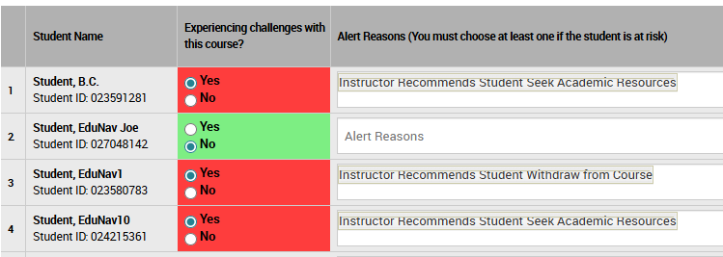
- If the student has poor attendance, please enter “Y” in the column accordingly. You can add more information in the Comments field.
- Add comments to provide context to the student’s status in your course. Comments help the student, advisor, and support staff identify the best steps for success.
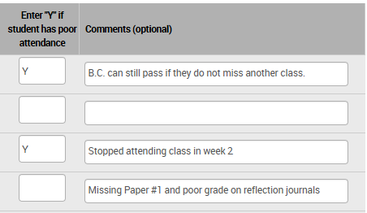
- At the bottom, select the Submit only marked students (but I’m not done) button if you are ready to submit reports for some students, but plan to revisit this page to complete feedback for additional students later.

- Select the Submit unmarked students as not At-Risk (I’m all done) if you are finished identifying students you are academically concerned about.
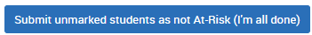
IMPORTANT: Both Submit buttons will submit information about marked students. You cannot mark a student, save, and edit later.

Intervention Specifics: Instructor Recommends Student Seek Academic Resources
Who & When | Who is notified of the alert and how?
Who uses the alert: Instructors  When to use the alert: You are concerned about the student’s academic progress in your course and recommend they seek academic or tutoring support. | Alert Triggers an Email?  - No email  - Assigned Advisor  - Student  Alert Creates a Case?  - No Case  - Case assigned to Academic Advisor  - Case assigned to Academic Success Center (ASC)
Intervention Expectations
- Case and formal intervention required.  - Advisors are notified of alert.  - Academic Success Center (ASC): provide outreach to student based on information included in the progress report alert. Refer students to additional campus resources as applicable.  - Advisors: in Round 2 (Weeks 10-12), advisors are expected to follow up with students who receive 2 or more Progress Reports submitted. | - Case closed: after two outreaches within two weeks since case creation, or made contact with the student. This is regardless of outcome.  - Document outcome and comments in BoilerConnect Case.  - Instructor is not notified of outcome.  - If there are non-academic related concerns, submit a Student of Concern report.
Email Sent to Student
Subject: Your Instructor has Feedback

Hi {$student_first_name},

Your instructor, {$completer_name}, has provided feedback about your academic progress in {$course_name}{$course_number}.

Are there academic resources you would like to know more about? A staff member from the Academic Success Center (ASC) will be reaching out to discuss the academic support resources available for you. In the meantime, here are some things you can do right now about your performance in this course:
- Speak with your professor to discuss your status in the class as soon as possible. You should be able to find their contact information in the course syllabus or in myPurdue.
- Talk to your academic advisor about your options. Schedule an appointment here.
- Having personal issues that are keeping you from doing your best? Any of these offices might be able to help!

Many students at Purdue have challenges at some point in their studies, you are not alone! Reach out and get the support you need to make the best decision for yourself about how to improve in this course.

Intervention Specifics: Instructor Recommends Student Withdraw from Course
Who & When | Who is notified of the alert and how?
Who uses the alert: Instructors  When to use the alert: You are concerned about the student’s academic progress in your course and recommend they withdraw from the course. | Alert Triggers an Email?  - No email  - Assigned Advisor  - Student  Alert Creates a Case?  - No Case  - Case assigned to Academic Advisor  - Case assigned to Academic Success Center (ASC)
Intervention Expectations
- No case or formal intervention required.  - Advisors are notified to follow up with student.  - Advisor: reach out to student and incorporate concern into discussion. Help student understand implications of course withdrawal and assist them with the process. | - Document as Note or Appointment Summary in BoilerConnect.  - Instructor is not notified of outcome.  - If there are non-academic related concerns, submit a Student of Concern report.
Email Sent to Student
Subject: Your Instructor has Feedback

Hi {$student_first_name},

Your instructor, {$completer_name}, has provided feedback about your academic progress in {$course_name}{$course_number}.

Here are some things you can do right now about your performance in this course:
- Speak with your professor to discuss your status in the class as soon as possible. You should be able to find their contact information in the course syllabus or in myPurdue.
- Check out what academic support resources the Academic Success Center (ASC) has to offer.
- Talk to your academic advisor about your options. Schedule an appointment here.
- Having personal issues that are keeping you from doing your best? Any of these offices might be able to help!

Many students at Purdue have challenges at some point in their studies, you are not alone! Reach out and get the support you need to make the best decision for yourself about how in improve in this course.

Progress Report Workflows

Round 1
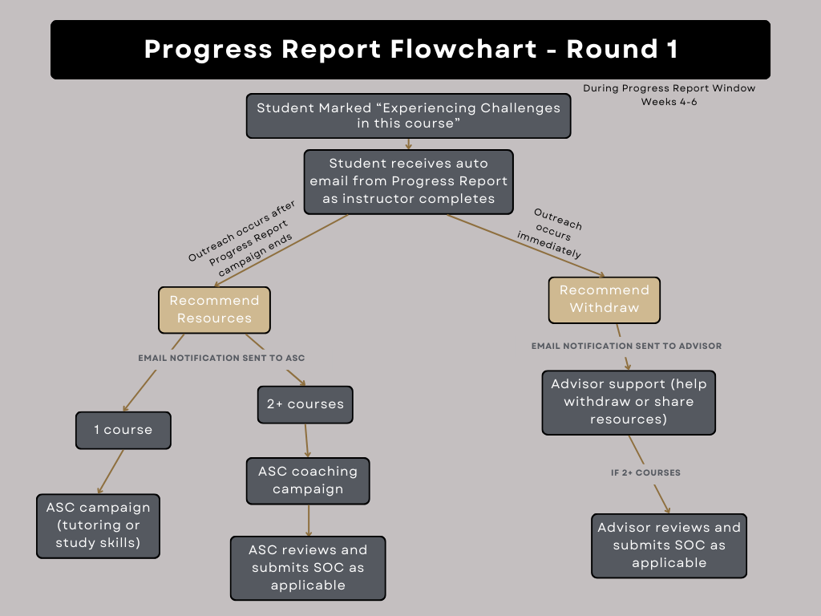

Round 2
