Faculty Guide to Submitting Academic Alerts in Brightspace
Contents
What is an Academic Alert? 2
Overview 2
When to Submit an Academic Alert 2
Notification 2
Options for submissions 3
Academic Early Alert 3
Kudos 3
Comments 3
Before you submit 3
How to Submit an Academic Alert in Brightspace 4
Intervention Specifics: Instructor Recommends Student Seek Academic Resources 7
Intervention Specifics: Instructor Recommends Student Withdraw from Course 8
Intervention Specifics: Kudos 9

What is an Academic Alert?
An Academic Alert is used to assess a student’s academic performance or progress in your course at any point during the semester. The primary method to submit an Academic Alert is through Brightspace under Course Tools.
An academic alert can be submitted for any of the following reasons:
- Instructor Recommends Student Seek Academic Resources to connect students to academic support, such as peer tutoring, Supplemental Instruction, study skills consultations, etc.
- Instructor Recommends Student Withdraw from Course to inform students that they may not be able to succeed in the course – this reason should only be selected if the chance of success is extremely unlikely.
- Share Kudos to recognize strong performance or improvement.
An academic alert should NOT be used to replace the Student of Concern Report process.

Overview

When to Submit an Academic Alert
An academic alert can be submitted at any point during the semester. To best support your students, consider important points in your class schedule, such as the first few weeks of the semester, midterm, and/or major exam or project dates.

Notification
After an alert is submitted, any of the following may be notified by email of the alert.
- Student – all academic alerts with comments included
- Academic Success Center – all alerts for Instructor Recommends Student Seek Academic Resources
- Student’s academic advisor – all alerts for Instructor Recommends Student Withdraw from Course
  - An academic advisor can view all alerts submitted, even if they are not notified by email.
These alerts route directly to BoilerConnect (Purdue’s student success platform) and individuals/units set up to help students navigate your recommendations.

Options for submissions

Academic Early Alert
An academic early alert is used when you have concerns about a student’s academic progress. You will select one recommendation:
- Recommend academic resources (e.g., tutoring, academic support)
- Recommend course withdrawal

Kudos
Kudos is used to recognize strong performance or improvement in your course. This option allows you to share positive, encouraging feedback or reinforce behaviors you’d like the student to continue.

Comments
Comments are required when submitting an academic alert. They do not need to be lengthy, but should provide helpful context for your submission.
Comments allow you to offer feedback and advice to students on how to improve their performance while allowing staff to assess the student’s risk of failing and engage in appropriate institutional outreach.
Reminder: students can view your comments from the alert after it is submitted. When providing comments, please ensure that the language used is appropriate for the students’ context on their course progress.

Before you submit
- Verify student name and PUID
- Review your selection and comments carefully
- Submissions are sent immediately and cannot be edited

If you have questions about academic alerts, please contact the Student Success Technologies team at sst@purdue.edu.

How to Submit an Academic Alert in Brightspace
- Login to Brightspace and select your course.
- Navigate to Course Tools and click Academic Alerts.
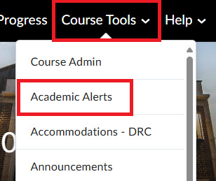
- On the Academic Alerts page, you should see your course roster.
- Find the student you wish to submit for.
- Select either the Manage Alerts button or Manage Kudos button for your submission.
  - Manage Alerts: if you have concerns about the student’s academic progress in your course
  - Manage Kudos: if you want to recognize strong performance or improvement in your course
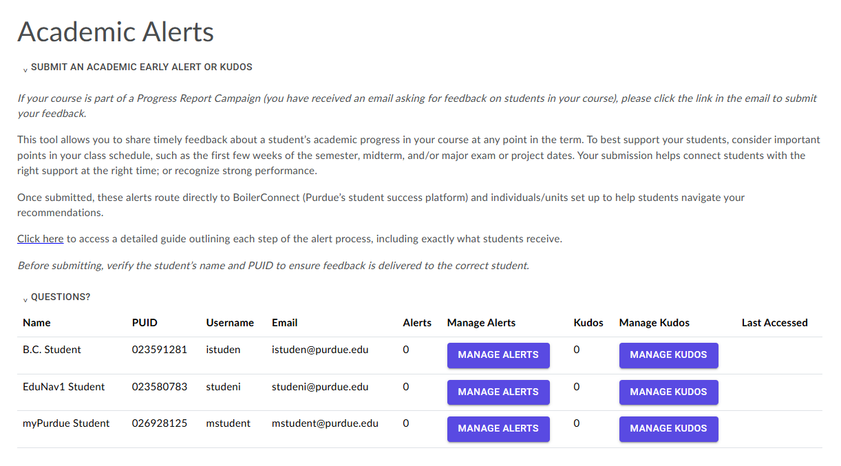
- For Manage Alerts: click the Manage Alerts button in the row for your intended student.
  - Select one of the recommendations.
  - Enter your comments in the Comments box.
  - Once completed, click the Submit Alert button.
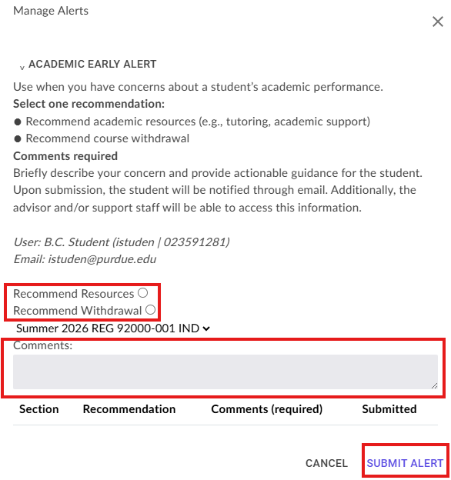
  - Note: If you are recommending withdrawal, you will be prompted to confirm that you have selected the correct student.
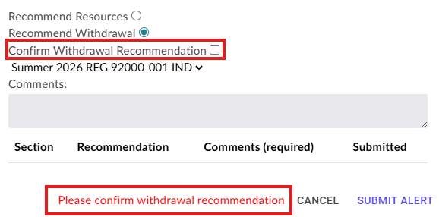
- For Kudos: click the Manage Kudos button in the row for your intended student.
  - Enter your comments in the Comments box.
  - Once completed, click the Submit Kudos button.
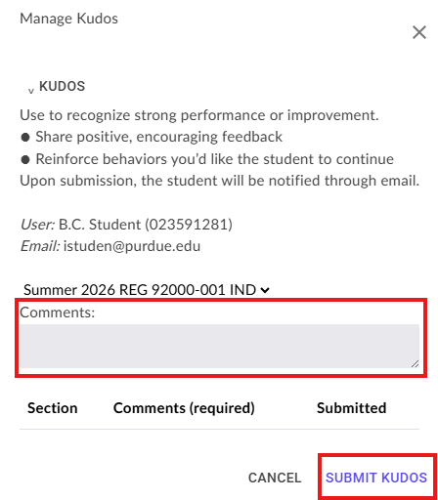
- You will receive a confirmation box indicating successful submission.
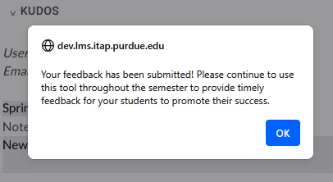
- Repeat this process for additional students at various points during the semester.

Intervention Specifics: Instructor Recommends Student Seek Academic Resources
Who & When | Who is notified of the alert and how?
Who uses the alert: Instructors  When to use the alert: You are concerned about the student’s academic progress in your course and recommend they seek academic or tutoring support. | Alert Triggers an Email?  - No email  - Assigned Advisor  - Student  Alert Creates a Case?  - No Case  - Case assigned to Academic Advisor  - Case assigned to Academic Success Center (ASC)
Intervention Expectations
- Case and formal intervention required.  - Advisors are notified of alert.  - Academic Success Center (ASC): provide outreach to student based on information included in the progress report alert. Refer students to additional campus resources as applicable.  - Advisors: can view this alert at any time and may follow up with students as necessary. | - Case closed: after two outreaches within two weeks since case creation, or made contact with the student. This is regardless of outcome.  - Document outcome and comments in BoilerConnect Case.  - Instructor is not notified of outcome.  - If there are non-academic related concerns, submit a Student of Concern report.
Email Sent to Student
Subject: Your Instructor has Feedback

Hi {$student_first_name},

Your instructor, {$completer_name}, has provided feedback about your academic progress in {$course_name}{$course_number}.

Are there academic resources you would like to know more about? A staff member from the Academic Success Center (ASC) will be reaching out to discuss the academic support resources available for you. In the meantime, here are some things you can do right now about your performance in this course:
- Speak with your professor to discuss your status in the class as soon as possible. You should be able to find their contact information in the course syllabus or in myPurdue.
- Talk to your academic advisor about your options. Schedule an appointment here.
- Having personal issues that are keeping you from doing your best? Any of these offices might be able to help!

Many students at Purdue have challenges at some point in their studies, you are not alone! Reach out and get the support you need to make the best decision for yourself about how to improve in this course.

Intervention Specifics: Instructor Recommends Student Withdraw from Course
Who & When | Who is notified of the alert and how?
Who uses the alert: Instructors  When to use the alert: You are concerned about the student’s academic progress in your course and recommend they withdraw from the course. | Alert Triggers an Email?  - No email  - Assigned Advisor  - Student  Alert Creates a Case?  - No Case  - Case assigned to Academic Advisor  - Case assigned to Academic Success Center (ASC)
Intervention Expectations
- No case or formal intervention required.  - Advisors are notified to follow up with student.  - Advisor: reach out to student and incorporate concern into discussion. Help student understand implications of course withdrawal and assist them with the process. | - Document as Note or Appointment Summary in BoilerConnect.  - Instructor is not notified of outcome.  - If there are non-academic related concerns, submit a Student of Concern report.
Email Sent to Student
Subject: Your Instructor has Feedback

Hi {$student_first_name},

Your instructor, {$completer_name}, has provided feedback about your academic progress in {$course_name}{$course_number}.

Here are some things you can do right now about your performance in this course:
- Speak with your professor to discuss your status in the class as soon as possible. You should be able to find their contact information in the course syllabus or in myPurdue.
- Check out what academic support resources the Academic Success Center (ASC) has to offer.
- Talk to your academic advisor about your options. Schedule an appointment here.
- Having personal issues that are keeping you from doing your best? Any of these offices might be able to help!

Many students at Purdue have challenges at some point in their studies, you are not alone! Reach out and get the support you need to make the best decision for yourself about how in improve in this course.

Intervention Specifics: Kudos
Who & When | Who is notified of the alert and how?
Who uses the alert: Instructors  When to use the alert: Encouragement for the student to keep up the hard work. | Alert Triggers an Email?  - No email  - Assigned Advisor  - Student  Alert Creates a Case?  - No Case  - Case assigned to Academic Advisor  - Case assigned to Academic Success Center (ASC)
Intervention Expectations
- No case or formal intervention required.

- Automated email to student letting them know their professor noticed their hard work in class and encouraging them to keep it up!

Email Sent to Student
Subject: Keep up the hard work!

Hi {$student_first_name},

Purdue cares about your success and professors are sometimes asked to provide feedback on your academic progress.

Your instructor, {$completer_name}, in {$course_name}{$course_number} has reported that you have shown hard work in their course, learning concepts and developing skills. Keep up the hard work!

