
Indiana Commission for Higher Education
New Degree Program Proposal for Public Institutions

2025-2026
[ Name]
To Be Offered by [Institution] at [Campus]

Program Details
Degree Award Level:
Mode of Delivery (On-Campus Only, Online Only, or Blended ):
Nature of Distance Education (100% Online, Blended, or None) :
Academic Unit(s) Offering Program: College, School, Department(s):
Credit Hours:
Suggested CIP Code:

1. Program Description & Developmental Timeline 3
2. Rationale for the Program 4
3. Career Relevance and Evidence of Market/Societal Need 5
4. Evidence of Positive Student Outcomes: Job Placement, Wages, and Student Debt 7
5. Market Intelligence: Student Demand, Provider Competition, and Projected Enrollment 9
6. Program of Study: Curriculum, Quality, and High-Impact Practices 15
7. Programmatic Costs 19
8. External Letters of Support (Minimum of 5) 21

- Program Description & Developmental Timeline
- Program Description
- Provide a short, comprehensive description of the proposed degree program that would be available to prospective students and other interested stakeholders. This description, or a slightly altered version, would be included on the institution’s web site upon launch and relevant promotional materials.

- Development Timeline
- Provide a timeline of key milestones in the development of this proposal and its progress through the institutional approval process before submission to the Commission, e.g., discussions at the department level, employer/industry engagement, discussions with non-HLC programmatic accreditors, examination of program exemplars, campus curriculum committee approvals, and Board of Trustees approval. Briefly explain any notable delays or pauses in the degree program’s development.

- Rationale for the Program
- Rationale: General
- What problem is this proposed degree program trying to solve? The rationale must make a compelling, thorough justification why establishing a new program of study is responsive to current and future talent needs.

- Institutional Rationale: Mission and Strategic Alignment
- Categorize this proposed degree program as one of the following:

Mission Critical | ☐
Mission Aligned | ☐
Discretionary | ☐

- If the proposed degree program is Misson Critical or Mission Aligned, explain how the program will harness and complement institutional strengths? How is it consistent with the mission of the institution and the institution’s strategic plan to wisely allocate limited resources to maximum effect? (Provide a link to the strategic plan and refer to the relevant section(s).)

- If the proposed degree program is Discretionary, provide a compelling rationale to expand the scope of the institution that would add rather than detract (or distract) from other academic programming and the institution’s strategic plan to wisely allocate limited resources to maximum effect. (Provide a link to the strategic plan and refer to the relevant section(s).)

- State Rationale: Postsecondary Educational Attainment
- Briefly explain how the proposed degree program will address the State of Indiana’s priorities of advancing affordability, accessibility, and attainment, as well as alignment with labor market demand.

- National Rationale: Economic Competitiveness, National Security, and/or National Interest
- Briefly explain how this proposed degree program will help advance national economic competitiveness, national security, and/or a key national interest.

- Career Relevance and Evidence of Market/Societal Need
- External Input on Program Design.
- Elaborating on the information provided in the degree program’s developmental timeline under (1.b.), briefly describe external input on program design. Potential examples include employer advisory boards or surveys, industry forums, evolving trends in the academic/disciplinary field, and accreditation/licensure standards. Clarify if this is an outgrowth of a current certificate, minor, and/or degree’s concentration/track. (Link to any relevant entities.)

- Program Learning Outcomes: Competencies, Skills, Knowledge, and Experiences
- List the significant learning outcomes that students completing this degree program are expected to master, which would be public. If applicable, specify usage of any non-HLC programmatic accreditation standards, industry qualification frameworks, or certification/licensure standards. (Link to any specified standards.)

- Indiana-Specific Talent Needs: Strategic Plans, Studies, and Reports
- Explain how this proposed degree program would help address Indiana’s talent priorities as reflected in the most recent strategic plans, studies, and/or reports of relevant local, regional, or state authoritative entities, such as regional workforce boards, the Bowen Center for Health Workforce Research and Policy, the Indiana Economic Development Corporation, the Indiana Early Learning Advisory Committee, the Indiana Health Workforce Council, the Indiana Institute for Workforce Excellence, Ascend Indiana, AgriNovus Indiana, BioCrossroads, Conexus Indiana, and TechPoint. (Link to cited sources.)

- Summarize any additional regional, state, or national studies that address current and future talent needs served by this proposed degree program. (Link to cited sources.)

- Identify the Most Relevant Occupations and Industries
- Specify the specific occupations, general occupational classifications, and industry sectors that are the most relevant to the proposed degree program in terms of competencies, knowledge, skills, and experiences, including any accreditation/licensure standards, if applicable, acknowledging not all postsecondary degrees are direct preparation for a narrow list of occupations or industries.
  - Cite authoritative sources that connect learning outcomes with employment opportunities, such as the Classification of Instructional Program (CIP) – Standard Occupational Code (SOC) mapping of the U.S Department of Labor’s (USDOL) Occupational Information Network (O*NET), the Bureau of Labor Statistic’s (BLS) Occupational Outlook Handbook, the State of Indiana’s ‘Credentials of Value List,’ the graduate to industry sector employment flows of similar programs of study (4-digit CIP Code Level) from the U.S. Census Bureau’s Post-Secondary Employment Outcomes (PSEO) data, or proprietary CIP-SOC tools, e.g., Lightcast and Gray DI.
  - Summarize the most prevalent job titles as well as credentials, knowledge, skills, and competencies included in recent regional/Indiana job postings that are most relevant to the proposed degree program. The proposal must demonstrate employers are regularly searching for graduates of this proposed program.

Appendix 1: Provide the list of occupations and occupational classifications relevant to the proposed degree program. Provide analyses of the most recent regional/Indiana job posting analytics. (This appendix should contain the detailed tables and/or relevant pages from the analyses.)

- Occupational Outlook: Projected Employment Trends
- As required under IC 21-18-9-5(b), summarize the current and projected labor market supply and demand for the occupations, occupational classifications, and industries identified as most relevant to the proposed degree program under (3.d.). Provide evidence in regional (if available), state, and national terms. The proposal must demonstrate graduates of the proposed degree program should have promising career opportunities.

In statewide and/or regional terms, are any of the most relevant occupations identified under (3.d.) listed among the top-three categories under the Indiana Department of Workforce Development’s (DWD) ‘Top Jobs’:

5- Star ‘Top Jobs’ | Yes ☐ | No ☐
List:
4-Star ‘Top Jobs’ | Yes ☐ | No ☐
List:
3-Star ‘Top Jobs’ | Yes ☐ | No ☐
List:

In statewide, regional, and/or national terms, are any of the most relevant occupations or occupational classifications identified under (3.d.) categorized by the USDOL’s Bureau of Labor Statistics as the ‘Fastest Growing (Projected)’ or ‘Most New Jobs/Occupations with the Most Job Growth (Projected)’ or by USDOL’s O*Net as a ‘Bright Outlook’ occupation:

Yes ☐ | No ☐

List, specifying the geography, respective designation(s), and any applicable growth rate category:

Appendix 2: In addition to the narrative and questions above for (3.f.), provide a summary of Indiana DWD data and ‘Top Jobs’ occupational rankings, U.S. BLS data, O*NET data, proprietary tools like Lightcast or Gray DI, etc. (This appendix should contain the detailed tables addressing occupation/occupational-specific details as well as applicable industry sector(s) projections on percentage growth, relative growth to average occupational growth, and the absolute employment change, upon which the narrative summary of future labor market demand is based including Indiana-specific information and/or relevant pages from the analyses.)
- Evidence of Positive Student Outcomes: Job Placement, Wages, and Student Debt
- Student Career Exploration and Planning
- As required under IC 21-18-9-5(b), explain how the proposed program will advise students on career exploration and planning that includes timely information about the labor market and career pathways?

- Connecting Students with Employment Opportunities
- As required under IC 21-18-9-5(b), explain how the proposed program will facilitate direct connections between students and employment opportunities?

- Job Placement
- As required under IC 21-18-9-5(b), provide the projected job placement rate for program graduates, including the projected job placement rate related to a graduate’s level of education or training, including estimates of underemployment. (Link to cited sources and authoritative proxies used as the basis for the projection, e.g., The New York Federal Reserve’s ‘Labor Market Outcomes for Recent College Graduates’ by major.)

- If the program is primarily a feeder for graduate/professional programs, please describe the programs most graduates are expected to attend. (Link to examples of relevant programs.)

- Graduate Retention
- In reference to facilitating direct connections between students and employers under (4.b.) and the regional/state workforce demand data under (3.e.), describe how this program will improve the institution’s in-state graduate retention rate.

- As required under IC 21-18-9-5(b), provide the program’s projected graduate retention rate upon graduation and after five years. (Link to cited sources as a basis for the projection.)

- Special Fees above Baseline Tuition
- Summarize any special fees above baseline tuition that are needed to support this program.

- Student Return-on-Investment (ROI): Wages and Student Debt
- As required under IC 21-18-9-5(b), provide the estimated wages for graduates at the following career milestones, if available:

Starting:
Three years after graduation:
Five years after graduation:
10 years after graduation:
20 years after graduation:
30 years after graduation:

- Compare the estimated wages (above) to the most recent authoritative median wage of the region/state, living wage of the region/state (e.g., MIT Living Wage Calculator), and median wage for individuals with the same or similar postsecondary credential in the region/state (e.g., PSEO and PSEO Coalition).

Appendix 3: Provide a summary of wage data for graduates from similar programs at peer institutions and/or wages by experience level for the relevant occupations identified under (3.e.), citing authoritative sources such as the U.S. Census Bureau’s Post-Secondary Employment Outcomes (PSEO) data, the PSEO Coalition’s ‘Living Wage vs. Postsecondary Graduate Earnings’ by certificate level, Indiana DWD and ‘Top Jobs’, the MIT ‘Living Wage Calculator’ for Indiana and region, U.S. Department of Education’s College Scorecard, the New York Federal Reserve’s labor market data for recent college graduates, Indiana DWD, U.S. BLS, Lightcast, other proprietary tools, etc. (This appendix should contain tables upon which the above estimates are based upon and/or relevant pages from the analyses.)

- As required under IC 21-18-9-5(b), provide the estimated average total student debt and average monthly student debt payment of in-state graduates. Explain the basis for the calculations. Compare the estimated student debt to in-state and regional benchmarks and the estimated wages for the proposed degree program’s graduates above. If applicable, confirm these estimates incorporated any special fees above baseline tuition under (5.e.). (Link to any cited sources. Cost comparisons to other state educational institutions with similar programs should draw from the Commission’s ‘Data Accountability and Transparency Dashboard’ under IC 21-14-15-1.))

- Explain how graduates will realize a positive return-on-investment in terms of completion rate, time to completion, net cost, job placement, and upward mobility. (Link to any cited sources.)

- Market Intelligence: Student Demand, Provider Competition, and Projected Enrollment

- Evidence of Student Demand and Interest
- The proposal must provide evidence of strong interest and demand amongst prospective students, describing how the institution investigated and assessed authoritative data. Briefly describe the proposed program’s recruitment and enrollment strategy.

Appendix 4: In addition to the above narrative analysis, include authoritative data tables demonstrating student interest and demand, such as web traffic and search engine analytics and student surveys. Save the details for specific enrollment projections for (5.c.). (This appendix should contain graphs/tables, relevant pages from analyses, and/or links to cited sources.)

- Provider Market Inventory: Details on Similar Programs at Other Institutions
The proposal must demonstrate the institution has carefully investigated the current provider landscape for similar programs within the state, Midwest geographic region, and, depending upon the nature of the program, across the nation.

List and Describe Similar Programs at Indiana Institutions
- Indiana institutions offering similar programs (on-campus and/or distance education). Include information on pertinent details, such as institutional Carnegie Classification; public/private; CIP Code; credit hours; on-campus/on-line/blended; any program specializations, concentrations, or tracks; any non-HLC programmatic accreditation/certification, if applicable; and, briefly identify what distinguishes these programs. Identify primary competitors, if applicable. (Provide a link to each program’s primary webpage.)

List and Describe Similar Programs at Regional and Peer Institutions Outside Indiana
- Institutions in contiguous states, MHEC states, or the nation, depending upon the nature of the proposed program, offering similar programs (on-campus and/or distance education). Include information on pertinent details, such as institutional Carnegie Classification; public/private; credit hours; on-campus/on-line/blended; any program specializations, concentrations, or tracks; any non-HLC programmatic accreditation/certification, if applicable; and, briefly identify what distinguishes these programs. Identify primary competitors, if applicable. (Provide a link to each program’s primary webpage.)

- Provider Market Analysis: Similar Programs’ Output, Growth, and Market Share
- In relation to the student interest and demand information under (5.a.), cite the most recent authoritative completion data of the programs identified under (5.b.) to assess the maturity of the market and demonstrate whether it is trending upward, downward, or stable. Why does the institution believe it can enter the market to reach viable enrollment/completions under (5.d.)?

Appendix 5: In addition to a narrative analysis above, include the most recent data for the applicable programs’ completions, growth trends, and market share data, such as the most recent IPEDS or Lightcast data. (This appendix should contain graphs/tables, relevant pages from the analyses, and/or links to cited sources.)

- Projected Enrollment/Completions and Threshold Viability
- The proposal must demonstrate a realistic pathway for the degree program to reach viability in terms of the three-year rolling average for degree conferrals required under IC 21-18-9-10.7 after the program exits its corresponding ‘Ramp Up Period’ by degree type.
- As required under IC 21-18-9-5(b), explain the basis for the projected enrollment and degree conferral figures; the projected completion rate must be provided.
- Replicating the corresponding degree type-specific table template below, insert a completed table with multi-year projections for headcount, FTE enrollment (rounded to the nearest whole number), and degrees conferred in a manner consistent with the Commission’s student data reporting and collection procedures. Specify the rolling average of degree conferrals for the final three-year period under analysis.

  - If applicable, provide a table for each campus at which the program will be offered

  - If the program is offered at more than one campus, e.g., an online multicampus collaborative, a summary table, which reports the total headcount and FTE enrollments and degrees conferred across all locations, must be provided.

- Delete the five example templates.

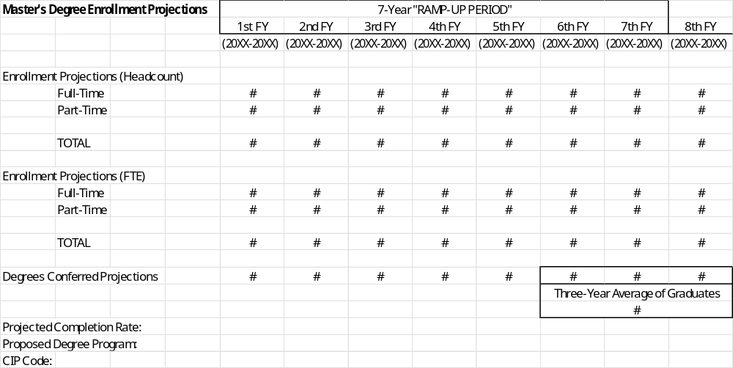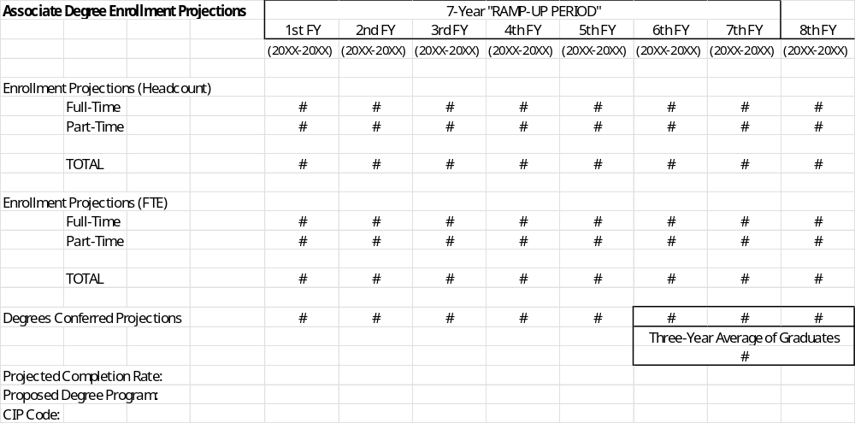
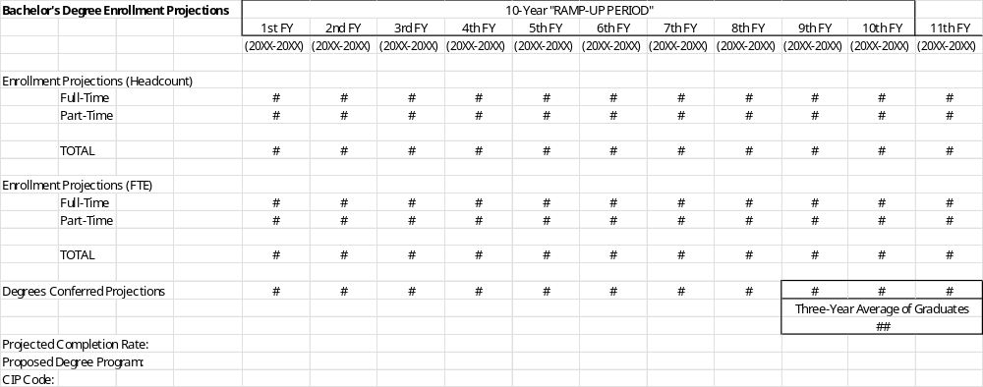

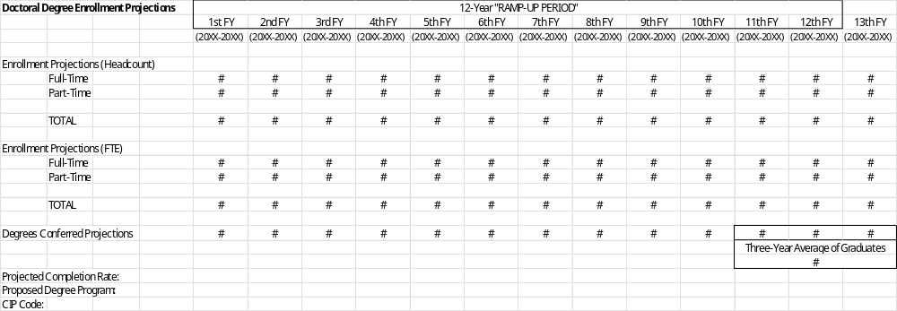

- Program of Study: Curriculum, Quality, and High-Impact Practices
- Required Credit Hours and Coursework
- Specify the credit hours required for the proposed program.
  - If the associate or baccalaureate degree program exceeds 60 or 120 semester credit hours, respectively, the institution must summarize the reason for exceeding this standard expectation under IC 21-18-9-8(d).

Appendix 6: Exceeding the Standard Expectation of Credit Hours, Detail (This appendix, if necessary, should contain detailed information on why it is necessary to exceed the standard credit hour expectation, such as links to relevant licensure and/or accreditation standards.)

- Provide an overview of the degree’s course requirements, including a list of required core courses and prescribed/restricted electives by area, if applicable. Include short course descriptions and, if necessary, notations for new courses or courses needing to be developed.

- Civic Responsibility and Commitment
- How does the proposed program cultivate civic responsibility and commitment to the core values of American society? For example, how does the curriculum include components that emphasize civic engagement and the duties of citizenship in a free society?

- Accelerated Delivery Options
- As required under IC 21-18-9-5(b), specify and describe whether the proposed course of study provides options for accelerated delivery, if applicable, such as a structured ‘Degree-in-3’ baccalaureate, dual degrees, or an accelerated master’s program (3+2 or 4+1).

- Opportunities for Credit for Prior Learning
- As required under IC 21-18-9-5(b), list and describe all opportunities to earn credit for prior learning (CPL) at a college-level through military experience and prior workforce/professional experience. Briefly explain how prospective and entering students will be informed of these opportunities. (Insert or link to the proposing institutions’ applicable certification CPL crosswalks, Joint Service Transcript CPL crosswalks, Indiana Collegiate Purple Star information, if applicable, and/or policies on CPL individual assessments or CPL portfolio reviews.)

- Opportunities for Embedded, Stackable Credentials and Degrees
- As required under IC 21-18-9-5(b), list and describe all embedded, stackable credentials or degrees a student can readily earn within the course of study, including microcredentials, credit-bearing certificates, and industry-recognized credentials. Briefly describe their learning outcomes and currency. (Link to any applicable websites for these credentials/degrees.)

- Work-Based Learning and/or Experiential Learning Requirement
- As required under IC 21-18-9-5(b), specify whether the proposed program of study requires a work-based learning or experiential learning experience, yes or no?

Work-Based Learning Requirement | Yes ☐ | No ☐
Experiential Learning Requirement | Yes ☐ | No ☐

- If applicable, describe the necessary course(s), credit hours, work/practica/clinical hours, and other requirements. Specify how these opportunities will connect students with employment opportunities and/or further education (graduate/professional school).

- If there are no such requirements, briefly explain why not and how students will still have opportunities to engage in work-based or experiential learning.

- Capstone Course(s) and High-Impact Practices
- Does the proposed program require students to complete a capstone course or capstone sequence which provides a structured, culminating experience for their learning, such as a major project or thesis?

Yes ☐ | No ☐ | Not Applicable (N/A) ☐

- Identify and briefly describe any evidence-based ‘High-Impact Practices’ incorporated into the curriculum of the proposed degree program, such as a first-year experience, capstone course or capstone sequence, seminars, and undergraduate research.

- Career Readiness and In-Demand Transferrable Skills
- Describe student engagement and instructional experiences with career relevance that place an emphasis on developing multiple career readiness competencies and in-demand transferable skills. For example, does the curriculum incorporate career exploration and preparation courses?

- Assessment
- Summarize how the institution intends to assess students with respect to mastery of proposed program’s learning outcomes (competencies, skills, knowledge, and experiences) listed under (3.b.).

- Accreditation/Certification
- Other than the Higher Learning Commission, is there an applicable programmatic accrediting/certifying body (or bodies) for this course of study? (If yes, link to the relevant curricular and programmatic standards of the accreditor(s).)

Yes ☐ | No ☐ | If yes, specify:
- In reference to external input on program design under (3.a.), was the program of study developed in alignment with the standards of an applicable programmatic accrediting/certifying body (or bodies) specified above? If yes, specify the body and corresponding standards.

Yes ☐ | No ☐ | Not Applicable (N/A) ☐
If yes, specify:

- Will the program be seeking programmatic accreditation/certification, if applicable? If yes, specify the accrediting body and anticipated timetable. If not, explain why.

Yes ☐ | No ☐ | Not Applicable (N/A) ☐

- Artificial Intelligence (AI) Fluency and Competency
- Explain how the program of study intentionally incorporates Artificial Intelligence (AI) to optimize the learning experience as well as prepare graduates for the shifting nature of work.

- Licensure and Certification
Graduates of this program will be prepared to earn the following:
State License:
National Professional Certifications (including the bodies issuing the certification):
Third-Party Industry Certifications (including the bodies issuing the certification):

- Defined Pathways for Certain Student Populations

- As required under IC 21-18-9-5(b), provide defined degree map pathways for the following student populations, contemplating how long a full-time and part-time student, as applicable, will need to complete the program:
  - High School
  - Returning
  - Adult (assume part-time)

Appendix 7: Degree Maps by Each of the Specified Student Populations, Detail (This appendix should contain the semester-by-semester, course-level detail on the program curriculum, including how long it will take to complete the program, assuming full-time or part-time study, as applicable.)

- Transfers from Two-year Institutions: Articulation Agreements
- **All institutions proposing baccalaureate degrees must address program articulation pathways, such as the Indiana College Core and/or a Transfer Single Articulation Pathway (TSAP).**
- For each articulation agreement, indicate how many of the associate degree credits will transfer and apply toward the baccalaureate program.

Appendix 8: Articulation of Associate/Baccalaureate Programs, Detail (This appendix should contain the actual articulation agreements relevant to the proposed program. Prior to submitting the program proposal to the Commission, universities should work directly with Ivy Tech Community College and Vincennes University to develop articulation agreements that maximize transfer opportunities for students.)

- Programmatic Costs
- Fiscal Support
- Characterize the budgeting source to launch and sustain this program followed by a brief explanation of the context:
New ☐ | Existing ☐ | Reallocated ☐

- Summarize any recent reallocation of resources to support this program, including any eliminated or downsized programs to provide resources for this program?

- Elaborate on any innovative fiscal strategies to sustain this program.

- Cost to Operate and Per Student Cost
- As required under IC 21-18-9-5(b), provide the projected cost to operate the proposed degree program, including the estimated cost per FTE student in the program. How does this compare to similar programs at other state educational institutions?

Appendix 9: Operating Cost Budgeting Estimates (This appendix should contain budgeting estimates and the per student cost. Comparisons to similar degree programs at other state educational institutions should draw from the Commission’s ‘Data Accountability and Transparency Dashboard’ under IC 21-14-15-1.)

- Faculty and Staff
- Of the faculty and staff required to offer this proposed program, how many are preexistent and how many will need to be added (express both in terms of number of full- and part-time faculty, including title and status, such as non-tenure track)? Specify whether the proposed program will utilize adjunct or clinical faculty, such as industry experts and practitioners.

Appendix 10: Faculty and Staff, Detail (This appendix should contain a list of faculty with appointments to teach in the program and a brief description of new faculty positions yet to be filled.)
- Physical Plant and Capital Equipment Costs
- Summarize physical plant and capital equipment cost requirements to successfully launch and deliver the proposed program, such as renovations to existing facilities, requests for new capital projects (including a reference to the institution’s capital plan, if applicable), the leasing of new space, and/or the purchase of needed equipment.

Appendix 11: Capital Costs, Detail. (If necessary, this appendix should contain additional information on capital costs to successfully launch and deliver the proposed program.)

- Collaborative Support and Curricular Synergies
- Identify programs at the proposing institution that overlap, complement, strengthen, or otherwise would be impacted by the proposed program, such as potentially cannibalizing enrollment or, conversely, providing opportunities to leverage interdisciplinary assets, curricular synergies, and the pooling of resources.

- Indicate any collaborative arrangements in place or planned to support the program, such as multicampus arrangements or inter-institutional agreements. Please provide details on estimated cost savings and/or other benefits in relation to (7.b.) above.

- External Letters of Support (Minimum of 5)
- List, by source, the five or more external letters received in support of the proposed degree program.

The letters should address the strong workforce and/or societal need for graduates in this field of study, how the proposed curriculum aligns with current and future talent needs, and the various career opportunities for graduates, especially in Indiana. The Commission particularly values original letters from external stakeholders that were directly involved in the genesis and/or development of the proposed program, including those with formalized relationships with the institution, e.g., an employer advisory board or regular employer of interns or graduates. Ideal submitters will be impacted by the program’s graduates, such as in-state employers (including local, state, or federal government), business and industry organizations, economic development entities, non-profit organizations, philanthropies, professional organizations, and graduate/professional schools.

Appendix 12: Letters of Support, Detail (This appendix should contain a minimum of five letters of support for the program.)

