

Seventh Meeting Monday, 21 April 2025, 2:30 p.m.
Zoom Meeting

AGENDA (As amended)

1. Call to order | Professor Susan South
2. Statement of Land Use Acknowledgement | Professor Susan South
3. Approval of Minutes of 24 March 2025
4. Acceptance of Agenda
5. Remarks of the Senate Chair | Professor Susan South
6. Remarks of the President | President Mung Chiang
- Question Time

- Memorial Resolutions
- Résumé of Items Under Consideration by Various Committees  - Consent Agenda  - Senate Document 24-15 Nominees for the Educational Policy Committee  - Senate Document 24-16 Nominees for the Equity, Diversity, and Inclusion Committee  - Senate Document 24-17 Nominees for the Faculty Affairs Committee  - Senate Document 24-18 Nominees for the Nominating Committee  - Senate Document 24-19 Nominees for the Steering Committee  - Senate Document 24-20 Nominees for the Student Affairs Committee  - Senate Document 24-21 Nominee for the University Resources Policy Committee  - Senate Document 24-13 Bylaws Revision Re CSSAC and MaPSAC Senate Members | For Information Professor Elizabeth A. Richards  For Action Nominating Committee  For Action Senator Libby Richards

12. Senate Document 24-14 Resolution Concerning the Big Ten Senate Leadership Statement | For Discussion Senator Susan South
- Senate Document 24-23 Mutual Academic Defense Compact (MADC)  - Purdue Indianapolis Report | For Discussion Senator Julia Chester  For Information David Umulis and Dan Hasler
- New Business

- Adjournment

Seventh Meeting Monday, 21 April 2025, 2:30 p.m.
Zoom Meeting

Present: Joseph W. Camp Jr. (Secretary of Faculties and Parliamentarian), President Mung Chiang, Susan South (Chair of the Senate), Mark Zimpfer (Vice-Chair of the Senate), Patrick Wolfe (Provost), Se’Andra Johnson (Sergeant-at-Arms), Dulcy Abraham, Ryan Alan Altman, Arezoo Ardekani, Santokh Badesha, Andy Baker, Jonathan Bauchet, Afsan Bhadelia, David Blon, Ali Bramson, Françoise Brosseau-Lapré, Tom Brush, Stephen Cameron, Julia Chester, Joseph Coates, Xingshan (Shawn) Cui, Eugenio Culurciello, Alejandro Cuza, Dan Cziczo, Brian Dilkes, Vince Duffy, Ulrike Dydak, Abigail Engelberth, Mara Faccio, Alex Francis, Yi Gao, Abrar Hammoud, Lori Hoagland, Sarah Huber, Whitney (Yu) Huidan, Katie Jarriel, Hyunyoung (Young) Jeong, Brent Jesiek, Alice Johnson, Nastasha Johnson, Rick Johnson-Sheehan, Bhagyashree Katare, Kee-Hong Kim, Cheng-kok Koh, Sarah LaRose, Seungyoon Lee , Kiseop Lee , Brian Leung, Stacy Lindshield, Damon Lisch, David Liu, Ryan Manuel, Stephen Martin, Stephanie Masta, Byung-Cheol (BC) Min , Patricia (Trish) Morita-Mullaney, Paul Mort, Abdelfattah Nour, Tae Hong Park, Darryl Ragland, Padinjaremadhom (PV) Ramachandran, Julio Ramirez, Sebastian Murgueitio Ramirez, Elizabeth Richards, Torbert Rocheford, Gustavo Rodriguez-Rivera, Chris Rogers, Leonid Rokinson, Chris Ruhl, Antônio Sá Barreto, Dennis Savaiano, Jennifer Scheuer, Steven Scott, Greg Shaver, John Sheffield, Michael Smith, Kevin Stainback, John Sundquist, Rusi Taleyarkhan, Mohit Tawarmalani, Monica Torres, Sasha Tsymbaliuk, Kim Updegraff, Anish Vanaik, Rua Williams, Christina Wilson-Frank, Bowei Xi, Howard (Howie) Zelaznik. Advisors: Eric Adams, Heather Beasley, Michael Cline, Melissa Franks, Sheila Hurt, Lowell Kane, Carl Krieger, Lisa Mauer, Sunil Prabhakar, Jenna Rickus, Alysa Rollock, Katherine Sermersheim. Guests: John Gipson, Ian Hyatt, Jamie Mohler, Km Pearson, Dimitrios Peroulis, Karen Plaut, Steven Schultz, David Umulis.

Absent: Saurabh Bagchi, Ximena Bernal, Lisa Bosman, Charles Bouman, Sabine Brunswicker, Letian Dou, Ben Dunford, Jim Dworkin, Morgan Hynes, Yuli Lyanda-Geller, Seema Mattoo, Somosmita Mitra, Robert Nawrocki, Loring (Larry) Nies, Jason Packard, Li Qiao, Brian Richert, Joseph (Paul) Robinson, Marisol Sepulveda, Ganesh Subbarayan-Shastri, Dengfeng Sun, Patrick Zollner. Advisors: Chad Cahoon, Cherise Hall, Beth McCuskey.
- Quorum being established; the meeting was called to order at 2:31 p.m.

- Chair Susan South read the following Statement of Land Use Acknowledgement, as required by Senate Document 20-55:
The Purdue University Senate acknowledges the traditional homelands of the Indigenous People which Purdue University is built upon. We honor and appreciate the Bodéwadmik (Potawatomi), Lenape (Delaware), Myaamia (Miami), and Shawnee People who are the original Indigenous caretakers.

- The minutes of the 24 March 2025 Senate meeting were entered as read.

- Senator Julia Chester made a motion to add Senate Document 24-23, which is a resolution to establish a mutual academic defense compact for the universities of the Big Ten Academic Alliance in defense of academic freedom and institutional integrity in the research enterprise. Senator Dilkes seconded her motion. There was a brief discussion to clarify that this document is different than Senate Document 24-14 which is already on the Agenda. Additional discussion clarified that the document would be discussed and voted on at the current meeting after suspension of the rules. The amended Agenda was accepted by general consent and SD 24-23 became Item 13 on the amended Agenda.

- Chair South began her remarks [Appendix A].

“This is the last time I will be addressing this group as Chair of the Purdue University Senate. I want to thank Immediate Past Chair Leong, vice chair and incoming Chair, Mark Zimpfer, Secretary of Faculties, Joe Camp, Sergeant-at-Arms, Se’Andra Johnson, and all the Senate committee chairs for their excellent work this year, particularly in helping me navigate the complexities of this position. I also congratulate incoming Vice Chair Ramirez and welcome him to Senate Leadership.
I want to take just a few minutes in my last remarks to speak on the current state of our community and the larger context of difficult and challenging recent events in our country. As I told the Board of Trustees just a few weeks ago, the current federal government has offended higher education. Prior to the Trump administration, higher education had already been battling a loss of public trust, as shown in the figure on this slide [Slide #4]. In the last three months, the attacks on higher education have intensified to the point where those of us who have dedicated our lives to the mission of teaching, learning, and engagement question our value and fear for the future. I disagree, however, with those who think higher education is something to atone for.

Faculty at institutions of higher education are not woke liberal ideologues who are out to convert college students while loading them with debt. We should in fact be proud of higher education in the U.S. It is routinely regarded as the best in the world, which is why there are currently over 1.1 million international students in the U.S., here to learn from our best thinkers and researchers. We send these students back to their countries with new knowledge and abilities, but also an awareness that the
U.S. is a place where people of all places and backgrounds come together to learn and achieve great things, diversity of backgrounds and opportunities for those who might not otherwise get a chance that education should be celebrated, lest we fall into a trap of conformity, inequity, and exclusion. I will note that my own alma mater, the University of Virginia, a public institution supported by state dollars, did not admit its fully coed class until 1970. We can never go back to the days when half of our population was excluded from the pursuit of education.
Higher education has lifted millions of people into better living conditions for the last one hundred years. My own mother was the first in her family to go to college. Her father worked at Goodyear Tire in Ohio and she and her siblings were born at home. She earned a bachelor's and a master's degree in five years from Kent State University, went to Washington D.C., and worked for the federal government for

almost 50 years and because of that job security was able to put a daughter through college as a single parent. That is what higher education in this country can do. Every time I go to commencement here at Purdue, I feel immense pride for the parents of our graduates. You can feel the joy from every single mother and father in Elliott Hall who celebrate with their children on that day. Our graduates have accomplished something truly life-changing. No matter what the current occupant of the White House might say, every single faculty member, staff member and graduate student working in higher education today, to remember what they do every single day is no less than amazing. We change peoples’ lives for the better.

If I were giving these remarks a year ago, I would have said Purdue is doing well, we are sending thousands of educated young people off into the world every year. I would have focused my remarks on the work that still needs to be done here at Purdue, improving the numbers of women among our students and faculty and retaining and developing our senior female faculty administrators, and I still strongly stress that we must do this, full stop.
Now my remarks must end by offering solace in a time when research dollars are being ripped away from scientists, when the education of our graduate students here is ended by revocation of visas, when the very right to govern our own academic institutions is threatened. How can we stand before our students as educators if we do not educate those in power as to the wrongness of their action? I end my remarks today by insisting that those working in higher education and institutions devoted to truth, facts, knowledge and developing leaders of tomorrow, must call out lies when they are spread, call out hate when we hear it, call out wrongs when we see them, for if not us, then who?

Thank you. I will move on to the remarks of the President. President Chiang you are recognized for your remarks.”
- President Chiang presented his remarks [Appendix B].

“Thank you, Chair South for your prepared remarks. As is standard practice, my prepared remarks are provided in two parts, one by myself and the other by colleagues rotating each month across different key units at the university. This month that will be Indianapolis by Dan Hasler and David Umulis. But I would like to start by thanking Chair Susan South for her outstanding leadership and trusted partnership. The collaborations, especially between her and Provost Wolfe over the past academic year have proven to be a cornerstone to the stability and success of our university. As this semester wraps up next week and makes way for finals and commencement, we again express our appreciation for all members of the Senate, and we look forward to Professor Mark Zimpfer's leadership starting June 1.
Now, as has been stated in the campuswide email on April 10, not all the top universities in the United States are the same. Purdue is a public university in America and the state land-grant institution in Indiana.

Topic 1: Successes and positive impact items

This university continues to expand its support for colleagues and positive impact, with collective accomplishments across faculty hirings, research funding, student interests and financial resilience, and academic facility improvements — underlining our unique strength serving more than 70,000 students and colleagues on the main campus alone.

  - Faculty and staff hiring and retention. Unlike peer institutions in a long and increasing list, Purdue is not freezing hiring or salaries. For example, in the ongoing recruiting season, 61 signed offers in the past two months alone. Last month, the Board of Trustees approved the tenure and promotion of 163 faculty systemwide. In the meantime, staff turnover at our West Lafayette location dropped from 3.7% to 2.8% in the last three years. Faculty turnover decreased from 2.2% to 1.7%.

  - Research funding and opportunities. In past two months alone, Purdue faculty have been awarded over 500 grants totaling over $140 million from the U.S. Department of Energy, the National Science Foundation, NASA, the National Institutes of Health, the U.S. Department of Defense, and the U.S. Department of Agriculture, including $26.4 million from industry partners. The Office of Industry Partnerships continues to work closely with college deans, department heads and all faculty to attract more corporate support for new research centers/consortia and strengthen our existing centers.
  - Investment in the latest facilities. Recent examples include:
    - Nursing and Pharmacy Education building
    - Mitch Daniels School of Business building
    - Academic Success Building
    - The modernization of Birck Nanotechnology Center and Zucrow High-Speed Propulsion Lab
    - As part of the One Health initiative alongside investment in faculty and students, a planned Life Science Research Building, and a facility for four departments involving chemistry are seeking faculty input across many departments throughout multiple colleges.
    - Enhanced commercial air service is coming to Purdue University Airport. Flights are expected to begin Aug. 5 — the same day the Amelia Earhart Terminal opens at the airport.
    - And a 1,000-bed student housing facility is on track to open this summer at Third Street and McCormick Road, with another new residence hall expected next year.

Topic 2: Bridge Funding Program to Support Faculty, Staff, Students

We remain committed to supporting the vital research and scholarly efforts happening every day at Purdue by our tremendous faculty, students, and staff. Last week, we launched the 2025 Bridge Funding Program. With this effort, we support our researchers and scholars to maintain continuity following any unanticipated terminations or interruptions of external funding.

You can find the link to the Bridge Funding Program with additional information and an FAQ at Purdue’s Federal Funding Updates website.

Topic 3: International student visas
There are resources available to Purdue community members with visa questions.
We all recognize this is an anxious time for our international community, and we are providing both overarching and tailored support to those
impacted, consistent with our responsibilities as a public, land-grant host institution in an evolving context of current federal actions and court cases.

Purdue has been in contact with anyone who has become aware of a change in their visa status according to government databases. Student visa inquiries should be directed to Chris Collins, Director of International Student Services (ccollins@purdue.edu). Faculty, staff, and postdocs with visa-related questions should contact Amanda Thompson, Director of International Scholar Services (thomp557@purdue.edu). Additional details have been communicated in Purdue Today.

Today, Purdue’s Action Council on Student Housing and Well-Being is also hosting a special meeting to gather additional ideas from representatives of the community.

Topic 4: Learning AI
AI literacy will clearly be a crucial foundational requirement for all our students, now and into the future as we had a glimpse at the last meeting through demos. We are hopeful for the Senate’s input on some kind of AI literacy expectation. Knowing that there are multiple ways of accomplishing this, we are eager to ensure that Purdue maintains clear educational leadership in this area. I will turn it over to Provost Wolfe to cover this topic in more detail.

Wrapping up these four topics, we again highlight how the community at our university appreciates the efforts of each of us as we continue Purdue’s trajectory of stability and success.

Now I turn it to Provost Wolfe and then back to Chair South.” Chair South recognized Provost Wolfe for his comments.
Provost Patrick Wolfe: “Thank you Mung. We have all recognized over the past two and a half years just how quickly AI has influenced our daily lives and our working lives. I was just reading an article yesterday in a major newspaper about the use of AI in law firms to help in document drafting and it is clearly having an enormous impact across sectors. So I think, and I very much hope that a topic of mutual collaboration with the Senate for the fall semester. It will be here before we know it. I know we all feel that we would be looking at whether we should have, or in a way how we should implement some kind of literacy requirement for graduation that gets at AI. I mean, AI

data, data science, I mean these are all similar ideas that have been aired over the past several years at Purdue and it certainly feels to us like it is time for these ideas to coalesce.

I know there are a few different mechanisms by which we could explore this idea, this type of requirement, and so I think we are anticipating that as we get toward the fall and anything I can do to help support getting any appropriate committees, ad hoc or otherwise, organized in advance of the fall to be ready to hit the ground running for the fall semester, I think there is an enormous opportunity for Purdue to show leadership here. We have the intellectual goods to be out in front leading in terms of AI literacy for our student population and I just think it will be a good opportunity to work with the Senate and explore the best opportunities for how to look at that, how to investigate it, and ultimately how to implement it here at Purdue. So of course questions welcome about this, but we are feeling our way a little bit and I am looking forward to working with everybody on it. So thank you.”
- The answers to pre-submitted questions were posted to the Senate website [Appendix C]. Chair South opened Question Time.

Chair South: “Thank you both. We now move to question time. The answers to questions that were pre-submitted have been posted to the Senate's website. We also have some time for questions from the floor, so I open it up to additional questions from the floor. Yes, Senator Francis, you are recognized.”

Senator Alex Francis: “I am on sabbatical this semester, so this is a bit unusual for me. My name is Alex Francis. I am a full professor in speech language and hearing sciences in the College of HHS, and I have been at Purdue since 2002. I have a simple question, urgent. Following what appear to have been significant irregularities in the promotion and tenure process there is a growing sense of insecurity and loss of confidence among faculty, especially among tenure track faculty who are already operating under rapidly changing expectations. Provost Wolfe, could you please comment on whether and if so, how, and why the promotion and tenure process was changed this year, and can you give us faculty any assurance that established rules will be applied consistently in the future?”
Provost Wolfe: “I can assure you and everyone that there are no changes to our procedures. Of course, we never comment on confidential personnel matters, but I think everyone at Purdue understands that requirements for promotion and tenure are clearly outlined and there is a clear process and every year we go through that process, and we will be going through it again next year. And that is about all there is to say about that.”

Senator Francis: “So you are saying that that process as written was followed exactly as written this year?”

Patrick Wolfe: “I am saying that that process is written is followed exactly every year.” Senator Francis: “Thank you. That is very reassuring.”

Chair South: “A question that came in to me to ask; ‘Is university leadership aware of the level of concern and growing lack of confidence among the faculty about the tenure process due to certain unusual or regular steps taken this year, instances where faculty were recommended to withdraw from tenure consideration without sufficient explanation?’”

Provost Wolfe: “I appreciate the question, but I would give you the same answer. And I mean, of course no one in a university setting is going to make a comment on an individual personnel matter, but we categorically reject the basis of the question. So thank you.”

Senator Ulrike Dydac: “My question is related to the international students, and I am extremely glad and thankful to see in Purdue today that there was additional communication because that was one of my concerns. There was very little communication to the overall campus community, and I am very concerned about the fear and the anxiety that has risen amongst our international students and even amongst international colleagues and in order to also continue to recruit and so on, one question that I still have that is not answered here is, will Purdue support students that are affected to finish up their degrees from off campus if it is reasonable and feasible?”
Provost Wolfe: “The first thing to say is I completely understand, and as somebody who has lived and worked in multiple different countries under different types of visas, I understand just how difficult it is when you feel like you thought you were standing on terra firma, and it turns out not to feel quite that way, so we are certainly working hard to give support. If you look across the country, you will see different universities writing and talking about this in slightly different ways. But it is fair to say that many are taking a remarkably similar approach. We are exploring with anybody who has been impacted with tailored solutions that would help them continue, consistent with our responsibilities as the host institution. What is behind that is the notion that the visa is a responsibility of an individual and a government, and we happen to be a host institution, but there are certain constraints of what we can and cannot do.

Certainly, we are exploring that in every instance possible. And again, if you look around a little bit, you will see different universities have talked about it a little bit in different ways. Duke was explicit about this. Illinois talked about it in some ways, and certainly there have been lots of internal conversations about that with our colleague universities. So as you said, we do really know how to do this. We were able to manage through things like Covid where students could not get visas on time because consulates and embassies were closed. So it is certainly safe to say and to assume that we are doing everything possible we can to make sure that every individual who is impacted has all the options available to them to decide exactly how they want to continue. And that is an important part of making sure that everybody feels reassured and supported.

I would encourage anyone who knows someone who was impacted or others who are worried about this to just listen. It is not necessary to try to offer even informal advice. It is enough, I think, in these difficult times just to be able to listen. And you saw in Purdue today for any student, Chris Collins is the right person to talk to. She is our official designated student visa officer in ISS. That is a governmental responsibility as well as a Purdue responsibility. And she can then fan out needed support to office of the Dean of Students or CAPS or anybody like that. We do deal with difficult student situations, tragedies, interruptions, other unexpected events all the time. And so we really, really do feel like we have confident ways in which we can manage all this. For anybody who holds a visa or is concerned about visa issues who does not have student status, the corresponding point of contact is Amanda Thompson and both of those individuals, and their emails are listed in the Purdue Today release from earlier this morning.
So everything flows through them and then they can fan out to support that is appropriate. So we are doing everything we can, Ulrike, and I certainly understand personally just how challenging this feels for members of our community. I did meet, as Mung mentioned, I met earlier today with our action council on student housing and wellbeing. We took some more input from our student trustee who is a graduate student, but also our president and president-elect, graduate student government and others. So we are working 24/7 on this, I promise you. And certainly it will be the case that students who are impacted will have options and we are helping them work through those options on a very, very individualized, customized basis. I hope that helps, but if I missed anything, please ask.”
Chair South: “There are a few more questions coming in on the tenure and promotion cases, the question is; ‘How can departments evaluate cases to be put forward when we do not know the criteria being used to make decisions when they reach the office of university leaders?’ We are talking about Panel A here, so cases that have strong endorsement at the lower levels are then being denied at the highest levels. So what reassurance is being provided that university bylaws and overall values of the institution are being followed? Keeping confidential specific cases, what can you tell us about the overall procedural integrity of the tenure process?”

Provost Wolfe: “That is a very straightforward question. The procedural integrity of the process is 100% complete. I think all of us have gone through our academic careers. We know what it is like to be involved in hiring and mentoring and in evaluating our colleagues, whether it is writing letters for colleagues at other institutions in response to requests or working through primary committees, area committees or Panel A. Again, it is very straightforward. I have said it, this will be the third time now, we have very clearly defined policies and procedures and they are posted online, and everybody is welcome to browse through them at their leisure.”
Immediate Past Chair Brian Leung: “This might be helpful for our later conversations. I am curious to hear what the President and Provost think about what is different about how Purdue has been operating that, unlike some of our Big Ten peers, has kept us out of some of the more severe attention, let us say? And well, you know what I mean, I do not want to go too far, but what have we been doing differently that

has set us up for the position that we are in that the President outlined in his remarks? Because that will be instructive, I think, to the kind of conversation we have with the two proposed Senate documents.”

President Chiang: “Well, thank you Past Chair Leung for the question. I think it is meant to be a very soft and encouraging question, but it also requires a very long-winded answer to perhaps fully go through all the nuances because we have a great team, and it is a large team working 24/7 as Provost Wolfe alluded to just now on another question. It would be hard for me to think on the fly and crystallize that in a short answer. I would simply say that Purdue University, not just now, but throughout its entire history, we always like to do the right thing in the right way, and we are here to support our faculty, staff, and students.”
Provost Wolfe: “I think all of us talk to our counterparts in different organizations, whether it is the APLU, the Big Ten, the AAU, there are a few others. I think the hard part for any organization that is subject to so many buffeting forces from outside, that has been true for all or much of the academy recently. It is always extremely hard to set a course and steer toward it and keep a north star. I am not saying that we have done it better or differently than others, but I can tell you the thing that we try hard to keep in mind every day is just to focus on the long term and to trust that, if we do what we know is right every single day, that we will be making progress toward those long-term goals. And we cannot always impact some of the externalities, whether it is that we cannot change the course of a decision to halt or pause some federal funding, but we can work quickly behind the scenes to figure out what bridge funding needs to look like, for example.

So I do not know if it is really that different from any place else, but I can tell you internally, Brian, the focus has been very strongly on just trying to chart the right course and steady as she goes. Also hoping that that provides reassurance and solidity for those of us who are here. And again, looking back to COVID when we, similarly, tried so hard to just stick to the course that we knew it was right and just not be distracted from that, even with some changing externalities. So we are all 100% aligned and pulling in the same direction on that. And just as we talked about with disruptions to international students, we are really, eager to help in any and every way that we can. And we, of course, welcome everybody on this Zoom's feedback on those various points. Thank you.”
Chair South: “Provost Wolfe, I am going to ask you to bear with me. There have been more follow-up questions, and I want to present these to you just because it represents the concern of our Senators on behalf of the constituents right now. So I am just trying to express the sentiments that are coming in. So the follow-up questions are revolving around, again, promotion and tenure cases where cases are getting through both at the department, at the college and Panel A, but then are not being endorsed to move on. So I think the questions in general, if I can summarize them, are what are the conditions in which that would occur?”
Provost Wolfe: “Well, again, I do not think there is any basis to get into hypotheticals of any kind. Again, anybody can look at the policies, procedures, and regulations

online. I would remind everyone that we are governed by a Board of Trustees, which is why promotion and tenure decisions are finalized at a public board meeting that occurs every year, typically in October. And I do not have the exact number in front of me, but there were certainly many cases of promotions and tenure dossiers that went through and cases that were granted at the last board meeting in April, and we are incredibly proud of that.”

Chair South: “There is another question that has come in to me that might be more for President Chiang, a longer question. Bear with me. So this one is about SK Hynix. While the Purdue community is very much in favor of the collaboration with SK Hynix, there is strong concern about the impact of the plant on the neighborhood, including traffic, real estate values, long-term environmental and safety concerns. Many Purdue faculty, staff and students live in communities remarkably close to proposed sites. Given that there is an abundance of land around Purdue, why is PRF pursuing this specific location, considering the density of the homes, offices, public school, and why is PRF opposed to offering zoned land that is not in the heart of residential West Lafayette?”

President Chiang: “I appreciate the question. As the question highlighted, this is a topic for Purdue Research Foundation, a separate nonprofit entity, and it should be brought up and discussed with PRF on site in a discussion. All I can say, within the Purdue University Senate now, is that much of the misunderstanding and misinformation I was told has been clarified by many other faculty and students.”
Chair South: “Thank you. So, many questions today. Another question that has come in for the Provost, and I am thinking this is for offer letters; ‘Is there a timeline for offer letters to be signed and approved?’ There have been concerns that those letters are taking long enough that there is a risk of losing candidates.”

Provost Wolfe: “Oh, that is a great question. I am excited about precisely the opposite, which is to say that, in a year when many places have canceled hiring or in some cases even retracted offers to graduate students, we are out there aggressively pursuing the top, top candidates. We have even had discussions about going back to the market in some cases where, if you could imagine in a year where we could lose a candidate to a number one ranked institution, if the top two institutions in the field have frozen hiring, then that might give us another chance to go out and find people. So I think everyone across campus will find that, when top drawer candidates come in the door and all the paperwork is in order, that we move incredibly fast to get offers on the table. And I can think of more than a few instances where that is been very much the case.”

Chair South: “So I have had a few more follow-up questions on SK Hynix. I just wanted to give the President a chance. Again, the comment is, a lot of Purdue folks are concerned. So if there is any additional comment.”

President Chiang: “As I mentioned, many supportive faculty, students and neighbors have been working with PRF and the mayor in particular along with many other stakeholders to clarify any misunderstanding and misinformation.”

Chair South: “And finally, I have one more question. I think this might be for the Provost. Are there any numbers that can be provided on how many students at Purdue have been impacted by visa revocations?”
Provost Wolfe: “Unsurprisingly, universities are not providing numbers in public, and that would be the same situation here. I would point out that any/all students who have been impacted have been contacted and are being looked after in the ways that I described before. There is not a ton more to say than that. I do not want to underemphasize the significance of what has happened, but I do not want to overemphasize it either. So I do not think it is appropriate to give numbers in public, but I would just, again, give reassurance that we are managing it in every single situation of which we are aware. And I am in contact with that team usually two or three times a day, five or six days a week. So it is best if we leave it there. But I do appreciate the question, and I understand the rationale.

There is at least one trade publication that is tracking statements about visas from across the country. Also, if you follow the news, you will see various court cases. The first have started, I am sure not the last, and so I would encourage anyone who is interested in this to just really keep an eye on the news. You can often get a particularly good contemporary read on what is happening by reading and following closely what is happening across the country. Some of the lawsuits that have been filed bring together students from various institutions like the one you might have read about last week that was filed in Indiana. So again, I will leave it there, but I do very much appreciate the question and the spirit of the question. And again, in the students' best interest, I am limited in what I want to say in public, but please rest assured, we are putting in a lot of time on making sure that we do right by our students. Thanks.”

Provost South: “Thank you for that. I will just have a last call for questions. Any final questions during question time? Last chance. I do not want to miss anyone. Thank you so much everyone.”

- Memorial Resolutions
Chair South asked for a moment of silence in remembrance of Dr. Carolyn E. Johnson, Associate Vice Provost for Diversity and Inclusion Emerita

- Senator Elizabeth Richards, Chair of the Steering Committee, presented the Résumé of Items (ROI) under consideration by the various Senate Standing Committees [Appendix D].
No updates were made to the ROI.

- Consent Agenda was presented to the Senate consisting of:

- Senate Document 24-15 Nominees for the Educational Policy Committee
- Senate Document 24-16 Nominees for the Equity, Diversity, and Inclusion Committee
- Senate Document 24-17 Nominees for the Faculty Affairs Committee
- Senate Document 24-18 Nominees for the Nominating Committee
- Senate Document 24-19 Nominees for the Steering Committee
- Senate Document 24-20 Nominees for the Student Affairs Committee
- Senate Document 24-21 Nominees for the University Resources Policy Committee

Chair South reminded the Senators that a Consent Agenda allows a body to group items together that are likely to be uncontroversial or to require little discussion and decide them all at once. If any member requests that an item from the Consent Agenda be pulled out for individual discussion, that request is granted without debate. There were no nominations from the floor and no requests to pull an item from the Consent Agenda. The Consent Agenda was approved by general consent.
- Chair South Recognized Senator Libby Richards to introduce Senate Document 24-13, Bylaws Revision Re CSSAC and MaPSAC Senate Members, for Action. Senator Richards made a motion to approve Senate Document 24-13. Senator Brian Dilkes seconded the motion.

Senator Richards: “MaPSAC Advisor Eric Adams can also join this discussion if there is any. We presented this last meeting recognizing the importance of giving CSSAC and MaPSAC members full voice and vote on the Senate.

Chair South: “Are there any questions or discussion on the document?”

Past Chair Leung: “It is my last Senate meeting. I am going to come on everything. I just want to speak in favor of this amendment, even though I do not think it is controversial because we are Purdue University Senate, and if we pass this document, I think it really underscores the reality of that faculty representing faculty, staff and students, and we are enshrining, not just the title University Senate. We are making it, I feel like, a better reality.”
Senator Anish Vanaik: “I would also like to speak in favor of this motion, but from the opposite framing in a certain sense. What was spoken of at the last meeting was the importance and significance of MaPSAC and CSSAC in the academic mission of the University Senate. Academic centering of the Senate is more important than ever to stand by and emphasize.”

Senator Julio Ramirez: “I received feedback from our faculty and staff, and it was total support for this. They thought the time was past due where something like this should have been done. There were comments and questions regarding whether one member of each of the groups was enough representation in a University Senate. So I am just passing along that question.”

Senator Howie Zelaznik: “I think a vote would be appropriate to make it clear what the level of support is rather than a passive ‘We all consent to this.’”

Chair South: “We have a poll ready. Does everyone see the poll? Votes are coming in.”
The votes were tallied and Senate Document 24-13 passed with 63 votes in favor and 5 votes in opposition. There were also four abstentions.
In answer to a question from Chair South, Secretary of Faculties Camp stated that the newly approved CSSAC and MaPSAC Senators were eligible to vote at the current University Senate meeting. Chair South welcomed the new Senators to the University Senate.

- Chair South “We now move to Senate Document 24-14. I will now step aside from my role as presiding officer, and Vice-Chair Mark Zimpfer will take over so that I can introduce Senate Document 24-14, Resolution Concerning Big Ten Faculty Leadership Statements.”

Vice-Chair Zimpfer “Thank you, Senator South. I will take on the temporary role of presiding officer and now recognize Senator South to introduce SD 24-14 for discussion.”

Senator South: “Thank you, Vice-Chair Zimpfer. To briefly introduce this, our next discussion item is SD 24-14. I do want to note our Sergeant-at-Arms has sent out a revised version. Let me be clear about the wording and the subject reference, and rationale lines to clarify that this document represents a statement that came out of leadership of the Senates of the universities in the Big Ten. This statement does not represent the views of Purdue's administration or the Big Ten Academic Alliance. No changes were made to the actual statement itself from the first version to the second version that you received.
The general question before us, which I need your help answering with input to this document is, does this statement, as it stands, represent a broad consensus of the Purdue Senate, which represents the Purdue community, faculty, students, and staff? I am asking you to vote today because this document is now moving through the Senate bodies of universities within the Big Ten. And therefore, if this document is to be passed, I would like to do so now instead of waiting until the next Purdue Senate meeting, which would be in the fall. And I will pass back to Vice-Chair Zimpfer.”

Vice-Chair Zimpfer: “Thank you, Senator South. Is there a second?”
Senators Afsan Bhadelia and Howard Zelaznik simultaneously seconded the motion.

Vice-Chair Zimpfer: “We have a motion and a second. It has been moved and seconded to suspend the rules and adopt SD 24-14 today. A two-thirds vote in favor

is required to suspend the rules. Are there any objections to suspending the rules and voting today?”

A Zoom poll was initiated to vote on suspending the rules. The vote to suspend the rules passed with 86% in favor. Vice-Chair Zimpfer reminded the Senators that any vote to amend or adopt this document would also require a two-thirds majority vote.

Senator South: “Thank you. I want to give you just some brief additional background on how this statement arose. Every year, the Big Ten Academic Alliance hosts a meeting for the leadership of the Senates of its member universities. The last meeting was held at the University of Maryland in November of 2024. I attended as the current Purdue Senate Chair and had an opportunity to meet the current leadership of many other member universities.
A few months ago, the Senate leadership of universities within the Big Ten started meeting on Zoom to discuss how recent events, particularly from the federal government, were impacting our universities. The document before you today was drafted collaboratively with these other Senate leaders of universities within the Big Ten. Our goal was to create a statement of elevated level and abstract commitment that was broadly representative of what faculty in higher education feel is the value of our mission and our shared values.
Our hope is that the endorsement of this document from our respective Senate bodies, and to give you additional background, the goal was to identify areas of broad consensus across institutions, across disciplines, across political affiliations on the value of higher education to the public. Statements of value are more important during times when those values are threatened. There is power in naming what is being threatened. It provides a collective voice to express solidarity and a reminder of our shared mission.
This document was created by faculty who are leaders in their respective Senates, but we anticipate it will be read by a broader public. And as such, it may serve as a public declaration of commitment to values and mission and help raise awareness of the importance of protecting higher education from political interference. And a statement endorsed by multiple university Senate bodies shows strength in numbers. And as of this morning, to the best of my knowledge, this statement, as written, has been endorsed by the Senates, voted on and passed, by the Senate of Michigan State University, the University of Michigan, the University of Nebraska, Northwestern, Ohio State University, and Oregon, and it is on the docket for eight other Senate bodies. And I will stop there.”

Vice-Chair Zimpfer: “Thank you, Senator South. Any discussion, questions, comments?”
Senator Dilkes: “I just want to say that I see a number of these documents coming out of the faculty of many the most research intensive and excellent universities in the United States. And I would like to admonish our administration to listen to us about this. It is not just the faculty of Purdue University or a small number of

disgruntled faculty who are calling for full-throated action and put your back in it elbow grease time defense of intellectual freedom, inquiry, and education. We are going to fall individually if we do not work together with that. That is my comment.”

Past Chair Leung: “I want to endorse this document through the lens of sharing that I have personal knowledge that Chair South was bombarded with options that might have been in place of this. And the wisdom of this document is that it says the most in the least amount of space and other versions of such statements I have seen have wanted to say everything. And rhetorically, that is unwise. It is just an unwise strategy. So the conciseness of this statement contributes to its merit, and I appreciate that Chair South landed on this, and contributed obviously, and brought it forth to the Senate. So while I do not have a vote, I really endorse this Senate document.”
Senator Julio Ramirez: “We heard the message from Professor South and reached out to the head leadership of the Lyles School of Civil and Construction Engineering, which was kind enough to set up an anonymous survey. And this was one of the questions regarding this document 24-14. I would like to share that we received healthy response such as in these kinds of surveys and times, and it was a hundred percent in favor of this document. It was also commended, the language, for its balance. And while we did get some comments regarding the strength of it, meaning that it was on the polite side, that it require a much stronger language to communicate the message. Both myself and Professor Abraham, the other Senator, were directed to support and sign this document. Thank you.”

Thank you. Further discussion? Hearing no further discussion. It is time to put the question, are there any objections to adopting SD 24-14 as presented? Secretary Camp, will we launch a poll?”

Secretary Camp: “If there are no objections, it passes by consent.”
Vice-Chair Zimpfer: “Hearing no objections, SD 24-14 has now passed by consent. I now step aside as presiding officer and welcome Chair South back into the role.”

- Senator Julia Chester introduced Senate Document 24-23 for discussion and approval by the Senate. Senator Chester provided a brief introduction to the document.
Senator Chester: “The proposal, as you can see on the screen is that we, the Purdue University Faculty Senate, to urge the president of Purdue University to formally propose and help establish a mutual academic defense compact among all members of the Big Ten Academic Alliance. I would like to propose that we suspend the rules and vote to adopt this at this meeting rather than waiting for September. And it ties very nicely with the previous document that we just voted on, 24-14. This idea was brought to me by a constituent. You may have heard about it in the news. I can tell you that so far Rutgers University, University of Nebraska, University of Michigan, Indiana University, and University of Massachusetts at Amherst have all adopted similar or identically worded documents. The documents from Michigan and Rutgers are identically worded resolutions.

We are asking, essentially, that our leadership and the President of Purdue University take a leading role in participating in convening this summit, joining this summit of the Big Ten academic group in order for us to have greater strength in numbers, including financial resources that might be necessary for various things like legal representation, public communications, expert testimony, legislative advocacy, coalition building, et cetera. I make a motion to suspend the rules.”

Senator Chester’s motion to suspend the rules was seconded by Senator Zelaznik.

A Zoom poll was initiated to vote on suspending the rules. The vote to suspend the rules passed with 86% in favor. Again, any vote to amend or adopt this document would also require a two-thirds majority vote.
Senator Chester was recognized to begin the discussion of SD 24-23.

Senator Chester: “I already really gave everything I wanted to say about this in terms of the introduction. I endorse this because one of the main potential impacts at our university is that the mission of the university will be compromised. So it is about all the things that we do at our university. And I think we should be on board as being a member of the Big Ten Academic Alliance. We need to protect the integrity of everything we do at the university, protect our ability for free speech, and protect the principles of higher education.”

Past Chair Leung: “I want to ask Senator Chester: So, the President and Provost, I believe, meet, and participate in the BTAA at distinct levels. I am not speaking for or against at this moment. I am just asking what in here that I have read so far is different than what the President and Provost are already doing. Is it the legal counsel and the fund? Is that the focus? Because it sounds like much of the rest of it is something they already do when they meet with their BTAA colleagues from different universities.”

Senator Chester: “I am not sure if I can answer this question, but that would be my understanding. Is it a potential commitment of resources if needed as well as us communicating in the same way? And in this document, it makes a statement that if any one of the Big Ten universities were to have some sort of implications of being targeted, that we would participate in that addressing of that issue of any university, not just ourselves.”

Vice-Chair Zimpfer: “Thank you, Chair South. I took part in some of the meetings that Chair South mentioned earlier with Senate leadership from across the Big Ten as recently as last week and dozens of emails this morning as well. Chair South, you can correct me if I am wrong, but I believe as of about 11 o'clock this morning, 7 of our Big Ten members have voted to not, or have decided not to bring this forward to their respective Senates and that they are not going to consider this document as drafted by Rutgers.

There was a lot of concern in the discussions we have had raised by other institutions. Some of the ones that float to the top are shared funding, shared legal services, legal counsel. There are many universities across the Big Ten right now that are concerned that they would be breaking the law in their respective states by signing this document. It was quite a lengthy discussion amongst those in attendance. And we had all the schools in attendance. Again, Chair South, you can correct me if I am wrong, but if I take my count, we had everyone present in that meeting as far as Senate leadership. So just providing some additional context to some of the discussions that have been had to date. Thank you.”

Chair South: “Thank you for bringing that up, Vice-Chair. And I will add to that some up-to-the-minute updates. I do think it is important to know someone passed on to me that the Big Ten Academic Alliance has put out a statement to media outlets saying, quote, "The Big Ten Academic Alliance did not contribute to and has not endorsed the Rutgers University Senate's recent resolution, or similar resolutions, calling for a mutual defense compact across Big Ten Academic Alliance universities. None of the Big Ten Academic Alliance's board of directors, its elected officers, or its staff participated in, contributed to, or were consulted about the creation, formulation, or passage of the resolution by the Rutgers University Senate. While Rutgers University is a member of the Big Ten Academic Alliance, the resolution does not represent the position of the Big Ten Academic Alliance, nor is it binding on the Big Ten Academic Alliance or any of its member institutions."

Senator Dilkes: “I realize we are sort of all circling a similar area of discussion, but I wanted to come back to the question that Brian Leung asked, and I think that the fundamental lever of this is to not allow single institutions to be picked off as has been occurring over the last few weeks where first one and then a small number of institutions are targeted for or proposed complete defunding by the federal government. And the idea is that were that to happen to any member institution, all member institutions would work to oppose such an effort. And I think that it would be extremely valuable, because I do see that working together as a sector and working together as in fact champions of the world of ideas and diversity of thought and expertise and education and research and truth and beauty and all the things that we spend so much time on is in fact valuable use of the institution.
Senator Tawarmalani: “As I was reading through this document, one of the questions that came up to me was this does not actually say if there was such a fund or if there was such a legal piece together that there would be a mechanism for the universities to decide whether this particular instance requires the use of such things or what would be the mechanism to decide whether this legal support or financial support should be provided in this instance? Because I am guessing there might be some disagreements on what is and is not an appropriate use of such funds.”
Chair South: “A question came to me that I wanted to pose. The question is: "I am not certain any university administrator," and this goes along with what Mohit was saying, "any university administrator has the authority to create a fund for the purposes in this document. It would make more sense for a mutual defense compact where none of those in the Alliance would capitulate to illegal orders from the administration."

Vice-Chair Zimpfer: “Addressing Senator Dilkes, and the other comment, the overriding discussion last week was that while the heart behind this defense compact made a lot of sense to the universities, the language did not. And there was a lot of discussion about changing the language to make it more acceptable to a wider representation of the Big Ten. And that was closed quickly by the members from Rutgers University. They want the language held as you see in front of you. That caused a lot of pushback by several universities. And that is why we see seven are not considering this, again, for all sorts of reasons. As mentioned, how would this even work? Is it lawful? Two universities to go unnamed both said that this would not be allowed in the states they operate in as far as setting up a funding mechanism and some of the other things that are listed here. And those are two of the seven that have rejected this document. So again, I am just trying to provide comments where we can Thank you.”

Past Chair Leung: “I feel like we see the usual suspects. So I was just recently at Rutgers at a Big Ten Academic Alliance conference in the academic leadership program, one of six of your representatives from this university. And it was not a Rutgers-focused conference. It was a Big Ten thing. But you are talking to a lot of colleagues in that environment. And right now, just because this is all new to me, my instinct is to advise this body not to vote in favor of this with no disparaging comments for anything to do with anyone who brought it forward. It is noble. But I think that as it is written, we are asking to be in a situation where the tail is wagging the dog. And there are a few institutions who are digging more into a hole than they are digging themselves out. And I do not recommend that we tie ourselves to that.
We can still be and insist that our administration and our Board of Trustees be staunch advocates of all higher education, but particularly the Big Ten. I think putting our eggs in this basket at this moment is not the wisest move. And again, this document is new to me, but I am also just giving you the benefit of my recent experience and all the conversations I have had with almost, I think, all but one of people from the Big Ten Academic Alliance, let us not let the tail wag the dog.”

Senator Dilkes: “I just wanted to say, who is the tail and who is the dog here? The filing of an amicus brief in support of it is exactly the kind of thing that provides the demonstration of greater support for higher education, the continuation of freedom of inquiry, academic freedom, and economic development through the university system. That will not happen in the absence of this, as evidenced by the fact that it has not happened, despite multiple opportunities to do so in a way that would provide mutual support and foster true sentiment among the public. That in fact, these actions that have been targeting the research and teaching enterprises of the United States are in fact broadly not supported, not only by the people who do it, but by the people who benefit from it. And so, I do not see evidence that we will accomplish what we need to accomplish as tails or dogs or whatever it is that we are in the absence of such a document.”
Chair South: “A question came into me that I want to pose to this group. The question was, ‘Let us assume Purdue was to vote for this document, but only a handful of

other Big Ten universities vote for it, what does that mean for the compact? Does it not require all or many universities in the Big Ten to be on board?’ I will just take this one because I have been in these meetings. Vice Chair Zimpfer I think summarized it very, very well. It looks like at this point, most, if not all, of universities of Big Ten are moving on the shared governance statement. One is most likely to get close to all of them. There were many concerns among the group meeting about this mutual defense compact, which Vice Chair Zimpfer has already summarized very well, so I will not belabor. Senator Mort, I will go to you.”
Senator Paul Mort: “To Chair South. I guess I did not want to appear to be too cynical here, but if I watch the news as Provost Wolfe suggested, my take on this is that it would be a way for the current administration to lump all of us together into a common target and then try to pick us apart and turn us against each other. I know that is a cynical perspective and it is very tactical, but I watched the news, what can I say? So from that point of view, I would say it would be tactically a mistake to pass this without having full commitment from all the leadership to provide a fund and the resources in a way that was clearly set apart with a set of principle triggers, which is lacking in this.”

Senator Dennis Savaiano: “Thank you. It would seem prudent to get a legal reading on such a statement prior to any consideration of a vote, in my view. If this is something our President cannot do because of legal limitations in Indiana relative to the way his funding, whether it be funding from the state or other funding, then it becomes moot. So I am wondering if it is not a little premature that we need to explore this a little further before we vote.”

Chair South: “Thank you for that comment. And Vice Chair Zimpfer said this too, that the financial commitment aspect, it was a concern when being discussed among the leadership of the respective Senate bodies.”
Senator Stephanie Masta: “I think in listening to folks, and it is the end of the semester, so I am just going to be a little blunt here. But Senate Resolutions only take effect when we decide to push for them. And sometimes Senate Resolutions are more about making a statement and less like commitment to action, because the only way that a Senate Resolution comes to fruition is if we do that work. So setting that aside, I do want to point out that the desire not to be a target or to somehow fly under the radar is exactly how institutions of higher education got themselves into this mess in which they are often, in the last six months, four months, whatever, capitulating to a very unpredictable government and moving very, very far away from their state admissions, particularly the land-grant institutions.

So people can vote how they want to vote, but if you think that not voting on this resolution is somehow going to not make us a target, then that is silly. And if you do not think that our administrations should be at the forefront of calling for an end to the repeated and unconstitutional and incredibly problematic attacks on higher education, then that is a choice, too. But we are in a critical moment where something must be said, and if faculty are not willing to do that, then who is?”

Senator Chester: “I just wanted to comment that this came about quickly, and this document is identical wording to Michigan and Rutgers and so I appreciate the intel that people are sharing who have been on these calls and what has been expressed as concerns. And I agree that this is the intent, we all agree with the intent. We just passed the previous document, which is a similar intent, but the devil is in the details. I just wanted to point out that the proposal is a little bit vague. It is asking the President of Purdue to formally propose and help establish a mutual academic defense compact. And being new to this entire process, I do not actually know what happens next If we were to vote yes on this and the administration can either take it or leave it, I suppose, or the details would be changed. I do not know if that means that the details of the funding and the legal aspects of this, could we work that out later? This is more of a question, can we work this out later? Is it better to get this done now rather than keep pushing it off to the future? So this, a question/comment.”

Chair South: “I will recognize myself for a quick comment. This document came out of Rutgers, and it has been very quick coming out of Rutgers. Then other folks moving to adopt it for their own Senates has been very quick. I would say the difference would be the document that we just passed, our group of Senate leaders of the institutions of the Big Ten did spend a bit of time, a bit, quite a bit of time working through what that document would be and what its purpose was. This current document was led by one Senate body of universities in the Big Ten.
Just for the sake of time, I am going to call a final wrap up on discussion. Is there any more discussion on this document?”
Senator Vanaik: “A lot of the discussion, I think, has conveyed the sense that we are looking for something like a strategy, something like a strategic perspective on what we should be doing. I feel like the Board of Trustees has outlined what it thinks its strategy is. I feel like the administration has outlined its set of strategies. We are hearing that there are all these other conversations going on. It is worth us asking Senate leadership to come back to us regularly or in some capacity and speak to us about a strategy around this. What is a faculty strategy that is not simply tailing whatever university administration is doing? I think that would serve some of these purposes. I think that would share the sense of the room as it were, the virtual room that we are in."

Chair South: “Thank you for that. So to your point, the motion on the floor is to vote on the document as it is so the vote could move forward and if it passed, and Secretary Camp can correct me on any of this, if it passed, there would be work that the Senate could do in asking the administration on how to implement these things. The other choice would be Senator Chester could withdraw at this point. We spend more time, for instance, in a Senate committee working on this document and it could come back for a vote in the normal course of things at a later meeting.“

Secretary Camp: “That is a particularly good summation. If the vote occurs now, remember it requires two-thirds in approval because the rules were suspended. It is not a simple majority.”

Senator Sarah LaRose: “So just to clarify my understanding of the proposal on the floor, we are voting to recommend to Purdue President Mung Chiang to form this defense compact regardless of what we recommend, he could choose to do whatever he wants as a result, and this body does not necessarily have legislative power beyond that. Is that correct?”
Chair South: “I think that is a fair statement.”

Senator Trish Morita: “I will just add to what Senator Masta shared. I remain concerned because I have written to my federal senators and representatives about the dissolution of research funding, specifically in my arena of education, and the deleterious effects of dismantling components of the Department of Education that directly impact Purdue University. There are concerns that have been expressed that this is duplicative. Another university has sent it. Why is ours a duplication of that?
And it is more an amplification of what others in the alliance are doing. But more importantly, I am concerned about the ways in which my federal representatives are getting back to me and saying that they do support the dissolution of research funding. And so it is especially important that our administration make a statement in collaboration and solidarity with others because if we are to rely on what is happening among our state representatives and federal representatives for the State of Indiana, I have deep concerns if we do not make this statement. So I am in support of this statement as articulated here.”

Senator Zelaznik: “I would just like to make a comment about the Senate not having any power. That might seem technically true, but when I was chair of the Senate a lifetime ago, there was a move to have a vote of no confidence in our current President, which did not end up coming out. But there are things that the Senate can do to put pressure on upper administration. So although we are technically powerless, we still do have the bully pulpit, which could work quite well.”
Chair South: “Thank you, Senator Zelaznik, and I am old enough to remember when you were Chair of the Purdue Senate. We now will move to vote unless Senator Chester would like to remove the document for now.”

Senator Chester: “I will keep the document.”

In answer to a question from Past Chair Leung, Secretary Camp stated that a two-thirds majority vote in favor is necessary to pass SD 24-23 at the current meeting.

A Zoom poll was initiated. The vote on SD 24-23 was 37 votes in favor, 22 votes in opposition with 15 abstentions. Thus, SD 24-23 did not reach the two-thirds majority vote in favor, so this document was not passed by the Senate. Chair South thanked the Senators for the spirited discussion.

Following defeat of the document, Chair South recognized Senior Vice Provost David Umulis and Chief Operating Officer Dan Hasler for a report about Purdue Indianapolis.

- Senior Vice Provost David Umulis and Chief Operating Officer Dan Hasler, Purdue Indianapolis Report [Appendix E].

COO Hasler: “Thank you, Chair South. And thank you all for giving us a little time today to share progress on your extension campus in Indianapolis.
I am joined by my much smarter partner, Senior Vice Provost David Umulis. It is hard to believe that it was only 20 months ago when we dried the ink on the documents that established Purdue University in Indianapolis. It is very much a startup; it continues to be a startup that does a lot of things for the first time. Which makes a requirement to be very nimble, very quick. We were very intentional as we created the campus here in Indianapolis to set it up as an expansion of West Lafayette [Slide #2]. It is not a regional campus; it is your campus expansion from West Lafayette. We did this, of course it has the same curriculum, it has the same faculty, it has the same admissions process, the same diploma, and we did this so that it would be easily moved and transferable between students and faculty in West Lafayette and Indianapolis and so that at the very beginning, the Indianapolis community would see the full power of Purdue University in Indianapolis. We wanted to share with you some of our early wins and David, I will pass it to you.”

Vice Provost David Umulis: “Well, thank you. Thank you very much to the Senate and for our opportunity to give you an update. And thank you to the faculty who are out there who are working in many different capacities on this call right now for what we are doing in Indianapolis. So at the start [Slide #3], which was this past fall with 13 undergraduate programs at launch, we have several new programs that are coming in '25 fall that we are recruiting for now in '26, and others that are in development throughout the colleges of Purdue University. I will show more details about those programs on a later slide. There were 10 Master's programs that launched and there will be 6+ new Master's programs launching in the upcoming year. So it is really a fun opportunity and space to think about growing what Purdue University offers as part of its overall portfolio taking advantage of Indianapolis. And we are continuing to be happy to field questions and support those programs and ideas that are launching.
Now, if you think about what we are doing in Indianapolis, it is a little bit different. If you think about universities and urban centers, you have some models that are campuses on the edge of a town, and you have campuses like New York University that are woven throughout the city. So we are working a lot with our partners and are supporting things more along the ladder, including the Purdue and Dallara program in location for the Motorsports engineering program with ribbon cutting coming up on May 24th during the Indianapolis 500. A weekend to see what that lab location looks like for that Purdue program for undergraduates to graduate students in the lab and other opportunities there.

Doing the same thing with Purdue and SpectronRx for a new radiopharmaceuticals program. Radiopharmaceuticals is an industry that has taken root in Indianapolis because of the supply chain logistics and the expertise in life sciences. We provide the only place for training, and it is being done with one of our partners on location

for the handling and development of radiopharmaceuticals such as PLUVICTO. We have 50 Lilly Scholars right now in Indianapolis and doing internship portion, and more on that in a minute. We have had a successful launch. It has taken a lot of effort from faculty and staff, students full-time in Indianapolis, as well as those that are serving in both locations.
To give you a little bit more of a snapshot of where we are at [Slide #4], at the start here, we have started with 809 students in housing in Indianapolis, not inclusive, but now we have more with the 50 Lilly interns who are staying in university housing in Indianapolis while doing the internship component of their training program. We are currently in 12 buildings across campus. Primary homes are on the 28 acres, and we will have Daniel show you in a little bit what that looks like. But the others I mentioned earlier are part of that portfolio of where students can engage, learn, and get experiences that really give them a leg up and get a high return on investment in their degree.

There were 2912 students at launch. We had winter commencement where we had students walking across the graduating stage in West Lafayette. Those are continuing students that were taking care of that were transferred from IUPUI into our care in Indianapolis. We have well over 80 Indy-based faculty, several more started up in the winter, including those for physics, mathematics, and chemistry. And we have faculty in the full cornerstone program, political science, psychology, really building the depth and breadth both in the programs that have degrees and then the rest of their courses that support students as they advance through those programs.
Over 34,000, now, bus rides between the location. So we have eight round trip bus trips per day, starting a little bit before 7 in the morning at each location. And it is easy to remember it is every two hours starting at 7, 9, 11, 1, 3, 5, 7, and then the last one is a little later at 9:30 to make sure that that students can finish what they are doing at either location. We have launched over 60 new student clubs, disciplinary clubs, social clubs, music clubs, and other types of activities in Indianapolis, as well as had over 450 courses per semester, developed a full academic success center that provides tutoring for all of the students in Indianapolis, whether or not they are just starting or continuing on and providing levels of support and tutoring for classes that were not available before the transition. We have the data mine, which has taken off and become extremely popular program and led to a lot of opportunities and open doors for our students as well as a Purdue team store that is open and doing business every day in Indianapolis.

What we are keen on and colleges and leadership across the institution are working on right now are the future years. It takes a couple of years for programs to go from idea to launch, and we are seeking program ideas through your departments that then go up to the colleges for review, and then in partnership with the Provost's office to identify the needs to get them to be launched and be successful. But the requirement for these programs follows these four principles:
They are mission driven [Slide #5]. The programs must advance the mission of Purdue University and align with strategic goals.

The programs are focused on individualized student success. They give students a competitive advantage in the market, which is what you have seen in Indianapolis thus far with things like the data mine, vertically integrated projects, epics, and other types of bespoke programs that are extremely high touch.

World readiness. So programming prepares students for work and life through career relevant experiences, internships, work-based learning, and experiential education.
And really, we want to add value and to the overall portfolio by leveraging programs that are unique to Indianapolis and not just duplications of programs. So we can add more programs to highlight future opportunities in Indiana, give students opportunities so that they come here and they choose to stay here after they graduate.”

COO Hasler: “So some of the tactics on the agreements with IU and what we are doing beyond that. If you look at the left side, the Purdue campus, we negotiated with IU for 100-year lease for 28 acres [Slide #6]. That represents the beating heart of our presence in Indianapolis. We also leased from IU 150,000 square feet of classroom, lab, and office space in the five buildings below that dotted line, ETSL, IO, et cetera. These are 40-year leases, all renewable. But while this is the beating heart, we have also been very intentional about what we call marbling into the community. When we looked at some of the best practices from other universities that were moving in or had moved into urban environments, we saw an interesting phenom. It was hard to tell where the university stopped and where the community began. You also see people taking the learning to where the practice is happening and that is why you saw the things that David mentioned earlier about the Dallara facility, which being the site for our motorsports program. SpectronRx and that is the site for our nuclear pharma.
At 16 tech in the upper left-hand corner, our advanced manufacturing center going in there, aviation out at the airport, et cetera. So look for more of these types of things to happen when we have significant partners that can help with the teaching and the experiential side of our students. We are going to try to take Purdue next to them and take advantage of their facilities.”

Vice Provost Umulis: “I mentioned earlier some of the new programs that are coming in '25 and '26 [Slide #7], and I also wanted to make sure that you worked with your colleges, if you have ideas, to work with your deans and heads to get those. We have had two rounds now. We have been pushing through feedback to the colleges that submitted programs and new proposals, and right now colleges working on a strategic plan that will be coming in on May 15th. So please continue to source some of those and do your own. We have SWOT analysis in order things to contribute. This fall, we have a BS in Actuarial Sciences, Integrated Business and Engineering, which are new to Indianapolis, a new MS in Sport Management that will be at two locations in West Lafayette and Indianapolis. We have the MS in Radiopharmaceutical Manufacturing that I mentioned, healthy enrollment in the MS and chemical engineering with a pharmaceutical engineering concentration. So think the workforce

needs for Lilly. The Cornerstone Certificate Program is now live in certificate in entrepreneurship and innovation.

Other upcoming programs with dates to be determined of exactly when they are going to be launching or collaborating with the individual units right now. The redesigned BS and construction management technology, which is something that the local industry has been really asking for, and we were working with Polytechnic to leadership to identify the ways to take advantage of Indianapolis for that program. BS in Mathematics, BS in Industrial Engineering, Robotics Engineering Technology, a Master's of Business and Technology, and an MS in organizational leadership, which was just approved at the most recent board of trustees meeting earlier this month.”

COO Hasler: “All of these programs and the programs that we already inherited in Indianapolis all have something in common [Slide #8]. We look for corporate partners for all of them, for our students, for our faculty. This is a sampling of some of the new partnerships or expanded partnerships that we have entered just since opening the campus up just last fall. Some of them are data mine, some of them are for co-op internships, some of them are research programs with Purdue faculty, both in Indianapolis and in West Lafayette. So look for this to grow. This is a cornerstone of why we are in Indianapolis.
And finally, you hopefully saw the groundbreaking for our first building, the Academic Success Building here in Indianapolis [Slide #9]. It will sit on West Street near Michigan, well actually on Michigan near West Street. It is about a 250,000 square foot facility. As you can see, dining, instructional space, retail housing. It will be tall, about 15 stories tall. So we are excited to be able to show the rest of the city exactly where they can find the heartbeat of Purdue University in Indianapolis, your extension campus.”

Following the presentation, Chair South thanked Vice Provost Umulis and COO Hasler for the presentation and they entertained questions from the virtual floor.

Vice-Chair Zimpfer: “Thank you, Chair South. So full disclosure, I am a professor in Construction Management Technology at West Lafayette. I have talked with our colleagues in Indianapolis and heard from others in my role as vice chair. Can you talk on some of the granular level? I have heard some wonderful things about Indianapolis, but I have also heard things like lack of support, from things like in the classroom, video boards and projection, that they have had to request from ITaP. I have heard complaints about the fact that students in Indianapolis had lost access to Adobe and now had to pay for that. How are we doing on the day-to-day operations? If you could speak to that, that would be great. Space considerations for programs, things like that, as we continue to grow.”
Vice Provost Umulis: “Last fall, in August when everybody started, every faculty, every student, every person was doing something for the very first time at scale and so there are undoubtedly some areas at which there was a need for a quick response, and the team did that response very swiftly, and I believe that there are Senators on the call in Polytech who oversee some of those types of questions regarding access

to technology. I can say that in response to the evolution, I appreciate your investment in CMT, to reimagine and to put that new plan forward. I think that has come a long way from being something that needed to be done, and now there is more clarity about the direction in which it is headed, and I think having a new head in that department will help a great deal to keep it going.
Regarding technology, there were a couple of little bumps here and there with technology and getting it all synchronized with Purdue systems and things, but we just polled everybody this morning with the IT staff, about bandwidth and other types of questions, and those things have all been resolved for some time now.

Access to software, I know that that and the evolution of those programs has been updated to take advantage of other software opportunities, and keeping the students that need access to that software apprised of what those evolutions are in those programs in Polytech.”

COO Hasler: “Can I just add to that? I mean, this is very much a startup, and we talked to ourselves about first time-itis. All these things that we were doing were the first time. Most of them went well. Some things glitched, and it is not only that. We are highly articulated with IU. A lot of what we do is dependent on agreements with IU, and it was first time for them in a lot of things too. Everyone has the right intent. Because it was new, sometimes the challenges were in the coordination between the two universities, at the site of the classroom. I think we have learned quickly, and our other mantra has been to make sure that bad news travels faster than good, so when we do have an issue, we get on it fast and we fix it fast.”

Vice Provost Umulis: “As an example of getting everybody ready for first time types of things, here is an example of the faculty pocketbook, and inside of it, on the first page, if there is any type of thing, there is an immediate list, a QR code that gets you to the right resource on the web for the most recent information, as well as the phone list for every single person. You may imagine, this might have been especially useful for me as an assistant professor starting in West Lafayette, I tell you, and these little things are carried around. We are going to do one more round of these in the upcoming year because they have been so popular. Make sure that it is resources at your fingertips, regardless of whether your phone is working.”

Vice-Chair Zimpfer: “I appreciate the response. We understand it is a monumental task, but there are so many tremendous opportunities in Indianapolis, so thanks for what you are doing. Understand that when we pass on the concerns, this is what Senate leadership hears about, so we just want to make sure that we forward those on. Thank you for the response.”
Past Chair Leung: “Hello. I am a little bit embarrassed because this is, as I said before, my last Senate meeting, and this is the least consequential question I am going to ask in my tenure. First, I want to say that the presentation was perfect for the Senate, and it is a model for other presenters to come to the Senate. It was zippy, but informative, so I recommend to Chair Zimpfer, if people ask, ‘Well, how do you want me to do this?’ Now that I have buttered up our presenters: So this is the least

consequential question, but will you help us with just one simple thing about vocabulary? We are Purdue West Lafayette. That includes the Indianapolis campus. I get that, but I get seven different versions of what we call ourselves as a whole unit. What is the official university expression, in its fullness and in its acronym, for what this wonderful combination is?”
COO Hasler: “It is a good question, and it is fundamental to a mind shift that we are in the middle of. It is Purdue University in Indianapolis. The challenge we have, and continue to have, is to make sure people understand this is not what they expect. They expect it to be a regional campus with its own Chancellor, its own Trustees, its own calendar, like IU Indianapolis is. When people are here, we do not say Purdue University, Indianapolis. It is Purdue University, but if they are not here to differentiate, it is Purdue University, the Indianapolis campus. We are going to continue to have to repeat and repeat and repeat that this is an extension of West Lafayette. It is the same. It is the same everything because people expect it to be the regional model.”
Vice Provost Umulis: “I think a couple of examples, as well, talking about students and faculty and staff here. It is Purdue University students that are in Indianapolis, Purdue University faculty in Indianapolis, Purdue College of Engineering programs in Indianapolis. Notice I do not say Purdue University in Indianapolis programs, Purdue University in Indianapolis students. It is Purdue University holistically, one Purdue, two locations, and this is an expansion of what we are doing in West Lafayette.”

Past Chair Leung: “I can say Purdue University in Indianapolis, and in an email I can write P-U-I, and that will communicate the same thing?”

Vice Provost Umulis: “I think if it is coming from you, Brian, as a Purdue faculty, just say Indianapolis. That is enough. Okay. Well, there is some confusion on that point.”
Vice Provost Umulis: “Understood. Well, this is something that is going to take some time, effort, and intentionality. I appreciate you mentioning that here because it is great for everybody to hear this.”

Past Chair Leung: “I told you that it was the least important question to ask today.”

Senator LaRose: “Ever since we heard about the rollout of this, I do not want to say branch campus, but regional, another campus of Purdue, I have been wondering what type of resources may be available for programs who are looking to expand their programming in Indianapolis. Are there financial resources available so that West Lafayette programs can expand their reach in the Indianapolis campus?”
Vice Provost Umulis: “Thank you very much for that question. With these calls for new programs, which is a big part of the process, and so we are growing a lot, you saw, in both undergraduate degrees and programs that are offered as well as graduate degrees and programs that are offered. Once a program gets the support of the Dean and it comes to our office, we collaborate closely with them. The next step is to identify the budget in terms of startup costs and what the needs are, and then

understand, at the same time, at that point, we talk about physical location and then a period to phase it in, as well as the triggers for certain types of resource needs or activation. We work closely in partnership to make sure that programs that are supported by the dean get the support that they need to be successful.”

Senator Zelaznik: “A very trivial question, but parking passes are completely transparent across both campuses, I presume?”

Vice Provost Umulis: “It is a great question. We have an agreement with IU regarding parking so that the parking pass from West Lafayette can be used without ticket in certain lots on the campus in Indianapolis. For permanent positions, we have the pass-through parking with IU, since it is a service that IU still controls. It depends on the specific role that you have and the time that you spend in Indianapolis.”
Senator Torbert Rocheford: “I have a question for Dan Hasler, too. Specifically, I would like to know, what are you the most excited about in terms of Purdue and Indianapolis, and what is the greatest challenge and concern you have for moving this enterprise forward?”

COO Hasler: “All I want to talk about right now is orange corn, Torbert. The reason I am doing this; I was Secretary of Commerce for a while. I love economic development. I saw this as a transformational event, not just for Purdue, but for central Indiana. We know we have a challenge keeping students in our state when they graduate. We punch above our weight in drawing them to Indiana for an education, and we punch far below our weight when we lose them. The whole point of having this extension campus is so not only a student who might be here for four years, but a West Lafayette student who might come down and study for a semester or a year, can be engaged with a company while they are here, either in a co-op, a data mine, or internship. We believe that if we can have more students have experiences with central Indiana companies while they are studying with us, it is going to be harder for them to leave at graduation. They are going to have relationships. The companies are going to know them, they are going to know the companies, and we believe it is a major weapon in trying to solve the issue of brain drain for the center part of our state as well. Getting them exposed to these companies while they are here in a way that they just cannot do in West Lafayette, which is what floats my boat, Torbert.”

Senator Rocheford: “The co-op is a great point, and I point you to Northeastern University in Boston. They have a great co-op program, and they have had that for 50 years, so that is great, Dan. What is your greatest concern and challenge?”

COO Hasler: “We talked about it a little bit earlier. It is a new model for not just other universities, but also Purdue University, and having the West Lafayette faculty and staff owning this place like they own West Lafayette in their hearts and their minds is the absolute requirement for having this work long-term. There is a tendency to keep focused on West Lafayette, and to the question earlier, what programs can we bring down? What classes might faculty come down and teach by taking the buses? Being able to get the integration and the fluidity between these two campuses requires that

West Lafayette based faculty and staff feel like this is as much theirs as West Lafayette and behave that way long-term. It is a new behavior; it is going to take time but letting us present this to Senate is just one part of that puzzle. We are looking to all of you to help us send that message out.”

Senator Julio Ramirez: “I must commend again the presenters for the clarity of the material, and I hope that it will be part of the minutes of the meeting. I had several questions from my colleagues, and I wish they could see this presentation, and they would go away, or happy to be answered. I do have one remaining one, which, now that you made the explanation today, it is even clearer to me how this is supposed to function. My question is this. Are the priorities of the Indy, Purdue University in Indy and Purdue University in West Lafayette, are they going to be aligned, and how is the budget going to function? Are there separate budgets and then they get commingled to manage the priorities? How do you envision this working in the future?”

Vice Provost Umulis: “Thank you very much for that question. First, about strategic alignment. You look at Purdue's pillars and strategic priorities. We have Daniels School of Business, One Health, we have Purdue University in Indianapolis, and we have Purdue Computes. Those programs are some of the starting points, the synergies that exist early, and so that is why we have more programs in the Daniels School of Business, the integrated business and engineering program launching, Purdue Computes as core to computer science, electrical engineering, computer engineering, and I expect other programs will embrace that as well. Regarding the budget models, we work very well and closely with the Treasurer and the financial affairs advisors, who work with the Colleges so that they submit budgets inclusive of both locations. It is not this, and then a separate thing. It is all part of that process, so it is integrated in that capacity.”

Senator Joseph Coates: “Thank you for recognizing me. I did have a question. I was down a few weeks ago for the Society of Indiana Archivists annual meeting at Luddy across the street, and part of the conversation was, how are things like library services and things like that going to run? Are those still going to be administered through Indiana University Indianapolis, or are there plans down the line to build something like that on that campus?”
Vice Provost Umulis: “Thank you. Every year we review the services, and we do see a greater role for Purdue University Libraries as part of that. It is part of making it more seamless and continue to improve one Purdue, and that means integration of systems, such as students can get dining in West Lafayette when students are up in West Lafayette, and the libraries is another area that we are bringing Purdue more into it.”

COO Hasler: “For example, right now we pay for access for our students to the IU library. We do not want to do that long-term, any more than we must, so that makes this first building especially important. A lot of the services we are currently buying, we can begin to bring online and inside. That is a key strategy.”

Senator Savaiano: “So I have an opposite question. Purdue has had a long and productive relationship with the medical school at Indianapolis. We have significant funding that comes to Biomedical Engineering and Nutrition, and those two areas are areas where Purdue has unique strengths that can support and have supported the medical school's activities, and continue to do so through the CTSI, the Indiana CTSI. How does the new arrangement work in terms of either facilitating additional coursework and opportunities in One Health, and have you had any experience in facilitating the work with the medical school, given the new model?”
Vice Provost Umulis: “Thank you very much for that question. This has been an especially important relationship for Purdue University overall and Purdue Engineering, as you mentioned. I was the former head of Biomedical Engineering at Purdue University before taking this on and have cultivated those relationships for many years, and they are stronger now than ever, and leading to real outcomes. For instance, we have had two years already of the joint grant proposals between College of Engineering and School of Medicine. Over 11 of those have been funded, they yield actual results in terms of cooperative grants, joint papers, co-advised students, and the like. Also, I would like to say, this past week, on Friday of last week, we had an inaugural distinguished seminar speaker in Indianapolis who is a biomedical engineer who develops bedside MRIs, micro-Tesla types of magnets. The room was packed with Purdue faculty, and it was packed with our colleagues from the school of medicine who wanted to see the speaker together and then have conversations afterwards to spur on more research discussions to cultivate these relationships. In fact, it is easier than it ever was.”

Senator Savaiano: “Have you had any other examples of curricular involvement or curricular development with the new model with the medical school? We are particularly interested in this regarding nutrition, because like you, we have had long-term research and graduate training relationships, but our educational opportunities have been less significant.”

Chair South: “I am going to move on to this next question. What are future outlooks for student growth in Indy? The implication of the question is are they where you expected them to be?”
Vice Provost Umulis: “I think in the fall, after a full outcome of this year's enrollment cycle and the numbers there, we are seeing healthy increasing interest in the programs that we have in Indianapolis as well as support for the new programs. I think our students have been entrepreneurial, very mature, 60 new student clubs. We have this Thursday a student innovation and excellence highlight for four hours in the afternoon. Anybody on the call is welcome to come down, and then a student recognition event is taking place in the old, converted train station in downtown Indianapolis called the Golden Hammers. The Golden Hammers Awards for Student Recognition, and these are awards for both the students that we took on that were started with IU/PUI, and the new students that started this past fall. The best way to see what these students are like is to come down and experience it for yourself, and I extend that invitation.”

Chair South: “Right now, how many students are on campus? How much room do you have for students? How much growth can you manage right now in terms of space and dorms, et cetera?”

Vice Provost Umulis: “Thank you. We have room for just over 1100 beds this fall. We have 2912 minus 210, give or take, the graduation number. We are looking at between the high 300s to low 400s graduating this spring term, and like I said, a healthy incoming fall class. We have ample housing and housing for these students in Indianapolis in the fall term, but also over the summer, for students that want to do internships over the summer. We have Purdue housing in Indianapolis that can be in the Purdue community while they are doing their internships in the companies.
There is also the scale that the infrastructure around Indianapolis brings. It gives us ability to pivot and grow to meet that increasing demand, and the academic success building will meet the demand that we need for more instructional lab space.”

Chair South: “I am going to take the liberty of asking you one more question. On your slide, you said you have 80 faculty right now based in Indianapolis. Is that correct?”
Vice Provost Umulis: “That number, it is 80 plus, but with the new hires in math and physics and things, we are over 100 faculty. We have well over 30 this semester and a lot more in the fall semester that do dual location teaching.”
Chair South: “I know of a fellow faculty member who just happened to live in Indianapolis, as I am sure many of our fellow faculty did and jumped right on board with wanting to teach courses in Indianapolis. His research lab is based out of West Lafayette campus, so how much research space is available in Indianapolis? If a faculty member wants to be completely based in Indianapolis, is that available?”

Vice Provost Umulis: “We have gone through the process of several research moves. We launched, when we did not have the space, earlier on, before these moves, the new audiology research clinic over in 16 Tech. We entered on good terms for a five-year lease, and they have clinical patients come in every day. Then, we have over 6000 square feet of space that we are upgrading and consolidating right now for future research activities.”
COO Hasler: “It is a rate limiter for us now, and that is some of the reason why the marbling strategy allows us to take advantage of other people's space rather than feeling like we must build it to control it.”

Chair South: “Thank you for answering those questions. I am going to do a final wrap-up just because I am cognizant of the time. Any final questions for David or Dan? Well, thank you so much. Really, as Immediate Past Chair Leung said, this was a wonderful presentation, and we appreciate you taking the time to come and talk to the Senate. Thank you very much.”
COO Hasler: “Please help us share the word.” Chair South: “Of course.”

COO Hasler: “At Purdue University in Indianapolis, and we are always looking at new curricula.”

Chair South: “I believe these slides will go up on the Purdue Senate website, so they'll be shared.”

Vice Provost Umulis: “Excellent. Thank you very much.”
Chair South: “We are rapidly approaching 5:00 PM. I am going to call for any New Business. Is there New Business? Immediate Past Chair Leung, you are bringing us New Business.”

- New Business

Past Chair Leung: “My new business is old business. Thank you for leading us through an extraordinarily tumultuous year, not caused by anything of our own doing. You have been so steady, and you have given me so much confidence in not only the Senate, but in the way that Purdue can stand steady, and Chair South, I genuinely appreciate everything you have done for us this semester. It is old business, if you think about it, but thank you so much.”
Chair South: “Thank you. Thank you so much. It has truly been an experience that I am so glad I did, and I would not trade it for anything else, as I am sure Immediate Past Chair Leung knows very well. Thank you to all of you for your amazing service as Senators and Advisors, and I hope everyone has a wonderful end of the semester.”

- There being no further business, the meeting adjourned at 5:00 p.m.

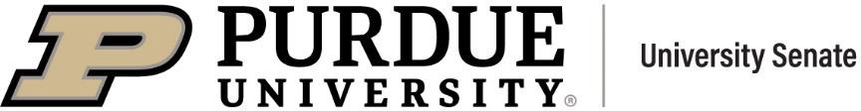 | University Senate Questions and Administrative Responses  21 April 2025

Questions

Continued Support.………..……………………………………………………………………………………… In light of the recent reduction or suspension of financial support for university research, and a subsequent announcement from multiple universities of their plans of budget freezes, hiring freezes, PhD admissions, etc., are there any similar plans at Purdue?
  - Purdue has no plans to implement hiring or admissions freezes, nor salary freeze. Please see the recent communication shared with faculty and staff on April 10 for additional information.

ICE/International Students at Purdue.…………………………………………………………………………. In light of what happened this past week at Columbia University, could the university please offer clear institutional guidance about what faculty, staff, and RA students should do if ICE comes to campus to detain a student and/or demands information about international students?
  - All warrants and government subpoenas should first be reviewed by the Office of Legal Counsel. If you have questions about what to do in the scenario of being presented with a warrant or government subpoena, standard protocol has always been posted on the Office of Legal Counsel website.

Free Speech…………….………………………………………...……………………………………………… Is the University committed to protecting the free speech and right to assembly for all University students, staff, and faculty, despite illegal threats to federal funding levied by the President of the United States? Or will the University capitulate to these threats, suppressing student and faculty rights in the hopes that the University will be spared from the whims of a capricious tyrant?
  - Purdue University has long been consistently committed to free and open inquiry. More information can be found on the Freedom of Expression and Use of University Facilities website.

Easter at Westwood.……………………………………………………………………………………………… Given that the Purdue President is hosting an Easter event, what are his plans to host events for other major religious holidays such as Ramadan?
  - The egg hunt is not a religious event. It’s part of the annual Spring Fest family weekend activities throughout campus.

Gender Inclusive Housing.……………………………………………………………………………………… Attendees of "Purdue's for me" are being informed that someone in upper administration has decided to end gender inclusive housing for fall 2025. Has Purdue decided to discriminate against transgender students and deny them equal access to safe on campus housing? Will students who have already committed be issued full refunds? This is outrageous.
  - Fall 2025 housing assignments for continuing students, made in December, remain unchanged.

Purdue University Regulations...………..…………………………………………………………………… Professor Xiaofeng Wang from IU was fired by IU administrators on Friday March 28 on the same day as an FBI and DHS raid on his home. Both he and his wife’s names were removed from IU’s Websites on March 30. No charges have been filed against Wang or his wife. Wang was fired without identifying any cause and without following the IU policy ACA-52, Section D.
My question is: Will Purdue administration follow Purdue University regulations if such an event were to happen at Purdue or cave in to what gives the appearance of political pressure as in the case of IU administration?
References material:
Media link: https://indianapublicmedia.org/news/fired-prof-accused-of-research-misconduct-fbi-involvement-unclear.php
https://indianapublicmedia.org/news/faculty-group-says-iu-violated-policy-when-firing-professor.php
Letter from Provost firing: https://www.documentcloud.org/documents/25874530-wangx-terminationmarch282029-1/?mode=document
Letter from IU Computer Science faculty to Provost Rahul Shrivastav)
Wikipedia page: https://en.wikipedia.org/wiki/Xiaofeng_Wang_(computer_scientist)
  - Purdue is not IU. Situations at IU can be explained by IU.

Campus Transportation.………….……………………………………………………………………………… We are voicing concerns about the changes to campus transportation as Purdue shifts from CityBus to Sp+. Will Purdue commit to providing a means for public transportation between Lafayette, where many students, staff, and faculty in the Purdue community live, and campus? At present there are two buses, the 4B and the connector, that provide this service.
  - Final details are still in progress, but the online FAQs offer the most current guidance. We will continue to provide updates as summer and fall transportation plans are confirmed.

Public Engagement..……………………………………………………………………………………………… In light of Trustee Gary Lehman's suggestion that Purdue stay "under the radar" such that "We don't want to stick our heads up too high, because when you do that, you're a target" - how will Purdue continue to put forward public engagement as a key priority for our scholarship and research agendas while navigating a federal landscape that actively destabilizes scientific consensus and public scientific institutions? Another way to ask this question is: How will Purdue researchers contribute to the land grant mission of scientific inquiry in the public interest without taking stands on public issues, drawing attention to Purdue, or relegating our focus to narrow technical questions?
  - Please address questions regarding comments by Trustees to the Board of Trustees.

Issues Related to Low Merit Increase.…………………………………………………………………………. While the university touts 14 years of flat tuition, faculty and staff have faced substantial financial challenges including, but not limited to, raises that do not come close to keeping up with the cost of living, medical plans with rising deductibles and now worsening prescription coverage (see email received from HR 3.31.25). AffirmedRx is not providing coverage for preventive medications which were previously covered by Caremark. None of this was clearly communicated with employees previously. Employees are now, not only facing less money in their pockets due to inflation and subpar raises but are also paying more for medical and prescription drug costs.
Employees feel like they are being hit with rising prescription costs while they are already down financially. Importantly, faculty and staff have performed their jobs admirably to get past COVID and to deal with ever-increasing size of students in our classes, and they are responsible for the excellent metrics the administration touts (e.g., most innovative lists, public ivy, etc.). What is the

rationale for not imposing even a small increase in tuition to help provide more financial support for employees?
  - At a time when many universities have chosen 0% salary raise and 0 staff hiring, Purdue is in a strong position financially to make salary investments even this year. The university’s composite merit increase from FY22-26 is the highest over a five-year period in at least the last quarter century and the three-year compounded increase for FY23-25 was 11.4%.

SuccessFactors………..……………………..…………………………………………………………….............
On January 31, I received a notice from SuccessFactors that I needed to complete 2025 Cybersecurity Awareness Employee Training.
I completed the training on February 1.
I observed that the training did not show as completed, and sent an e-mail the same day to the contact address listed in the original e-mail, oecomm@purdue.edu.
I never received a response.
On March 2, I received an e-mail from SuccessFactors telling me that I was overdue on the training.
I sent them an e-mail explaining the situation. I received no response.
On March 31, I received another Overdue Learning notice. On April 1, I sent them an e-mail explaining the situation. I received no response.
Despite considerable effort, I have been unable to find a telephone number for this office. I have discovered that at least one colleague in the Daniels School is in the same situation as I am.
My question is, is there some way to get these people to respond to e-mails to the contact address they list in their communications?
  - High volume has caused some delay in response to emails coming into the oecomm@purdue.edu inbox. To better serve our employees, Organizational Effectiveness has created the following emails and has assigned multiple subject matter experts to each email address.
    - OElearning@purdue.edu will handle questions related to learning/LMS assignments.
    - OESTAR@purdue.edu will handle any questions related to the STAR program.
    - OEcomm@purdue.edu will handle general questions and those related to the web and communications.




A MEMORIAL RESOLUTION
Honoring Dr. Carolyn E. Johnson
Associate Vice Provost for Diversity and Inclusion Emerita

CAROLYN ELAINE JOHNSON, Ph.D., born on October 6th, 1947, in Indianapolis, Indiana to Retha Scott and William Johnson, was a light to all who knew her. A woman of profound faith, wisdom, and boundless love, she lived a life dedicated to her family, her community, and her
calling to make the world a better place. Following her passing on November 17th, 2024, Carolyn’s life was celebrated on November 30th in Indianapolis and March 29th in West Lafayette.
From an early age, Carolyn dreamed of becoming a teacher—a dream she fulfilled with great distinction. She began her education at James Whitcomb Riley Public School #43, where she cultivated a lifelong love of poetry and literature, and graduated from Shortridge High School, known for its academic excellence. Carolyn went on to earn her bachelor’s and master’s degrees from Indiana University, participating in a trailblazing teacher education program that integrated liberal arts into elementary education. Her passion for learning led her to Purdue University, where she earned her Ph.D. and launched a career dedicated to empowering others.
Carolyn began her work at Purdue in 1985 as a senior research associate in the African American Studies and Research Center (AASRC) in the College of Liberal Arts, where she regularly taught a course titled “Black Women Rising,” coordinated an annual symposium on African American Culture and Philosophy in addition to numerous other programs and events, and served as chief editor of the academic newsletter “Nommo: Power of the Word” and as interim director of AASRC several times.
Throughout her career, Carolyn’s expertise in planning and guiding discussions enabled countless people to push past their own anxieties toward meaningful dialogue. Having worked in 115 countries around the globe, she was guided by a deep appreciation for the complexities of the human experience and a strong conviction that it is by voicing the things that make us uncomfortable that we truly learn about ourselves and each other.
In 2006, Carolyn was named director of Purdue’s Diversity Resource Office, where she was instrumental in building out numerous programs and initiatives that supported the professional development of students, faculty and staff. From 2008 to 2009, she served as interim chief diversity officer and, from 2017 to 2019, as special advisor to the provost. In 2019, she was appointed associate vice provost for diversity and inclusion, a position from which she retired in 2021.
Carolyn joined Alpha Kappa Alpha Sorority, Inc.–Tau Chapter in the fall of 1966 and later joined the Chi Phi Omega Chapter, where she served in a variety of positions over the course of her 58 years of dedicated sisterhood. In the local community and beyond, Carolyn was an engaged advocate for positive change through her service as executive director of the Hanna Community Center, a member of the President's Council of DePauw University and as a board member for numerous organizations including Bennett College, the Urban League, the American Red Cross, the NAACP, Girl Scouts of America, United Way, YWCA and L’Institut œcuménique de Bossey at the University of Geneva, Switzerland. An active member of the United Methodist Church, she held numerous leadership roles related to her church life, including service as president of the global organization, United Women in Faith.
Carolyn’s compassion, intellect, and determination touched countless lives, creating ripples of kindness that will endure for generations. For her family and friends, she will always be remembered not just as a transformative leader and educator, but as a woman of extraordinary heart. She taught us all to see the beauty in our differences, to lift others up, and to meet life’s challenges with grace and resilience. Carolyn’s presence will be deeply missed, but her spirit will remain in the hearts of all who knew her and honor her legacy of love, hope, and an unwavering belief in the goodness of humanity.

Respectfully submitted, Christopher D. Munt, PhD
Senior Director, Office of Diversity, Inclusion and Belonging

Hovde Hall of Administration, Room 136
610 Purdue Mall, West Lafayette, IN 47907-2040 Office: 765-494-6969 Fax: 765-496-2031


Résumé of Items 21 April 2025

To: | The University Senate
From: | Libby Richards, Chairperson of the Steering Committee
Subject: | Résumé of Items under Consideration by the Various Standing Committees

Steering Committee
Libby Richards, erichards@purdue.edu
- Soliciting reports and informational sessions in response to faculty and committee requests
- Collaborating with PSG and PGSG to facilitate resolution review

Advisory Committee
Susan South, senate-chair@purdue.edu

Nominating Committee
Damon Lisch, dlisch@purdue.edu and Seema Mattoo, smattoo@purdue.edu
- Managing committee vacancies
- Evaluating and balancing numbers, disposition and experience of Senators for equitable representation and task assignments

Educational Policy Committee
Vincent Duffy, duffy@purdue.edu
- Updating academic withdrawal language in academic regulations
- Assessing the need for AI regulations, the nature of AI use, available training
- PSG PGSG Joint Resolution: Purdue University Voter Accessibility Policy
- Well-being and stress management; including PSG Mental Health Days Initiative
- Practices of departments requiring certain grades in specific courses, academic notice
- Student success
- Team teaching & Purdue Online; how it is evaluated, counted in teaching load
- Communication with Faculty Committees reporting to EPC

Equity, Diversity, and Inclusion Committee
Brian Dilkes, bdilkes@purdue.edu
- Possible committee name change
- Compliance

Faculty Affairs Committee
Françoise Brosseau-Lapré, fbrossea@purdue.edu / Anish Vanaik, avanaik@purdue.edu
- SD 24-07 (Follow up)
- Impact and responses to SEA 202
- Follow up with concerned parents regarding ECEC
- Lecturers Advisory Committee
- Assessment of recent changes in P and T process
- University Innovation and Entrepreneurship framework

Student Affairs Committee
Abigail S. Engelberth, aengelbe@purdue.edu
- Class Size
- Equitable Parking
- Move-in Package
- Professional Excused Absences

University Resources Policy Committee
Lori Hoagland, lhoaglan@purdue.edu
- Parking regulations and appeals process
- Issues around parking at bicycle racks
- PSG/PGSG resolutions around voting, move-in packages and equitable parking

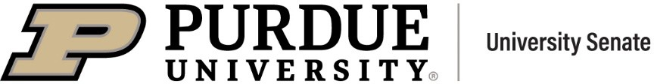
Senate Document 24-13
24 March 2025

To: | The University Senate
From: | Senator Libby Richards
Subject: | Bylaws Revision re: CSSAC and MaPSAC Senate Members
Reference: | Bylaw 2.00
Disposition: | University Senate for Discussion and Adoption
Rationale: | It is proposed that the Senate Bylaws be revised to grant CSSAC and MaPSAC members full voice and vote on the University Senate, i.e. they will become full Senators as are the other members listed below. Currently, these members serve as Advisors to the Senate with voice only on the Senate floor.
Proposal: | Bylaw 2.00 is revised as follows:

Current | Proposed
- oo Composition  - The Senate is composed of 104 members.  - The representation of the Senate is apportioned as follows:  - The President of the University.  - The Chief Academic Officer and the Chief Fiscal Officer of the University.  - The Chairperson and Vice Chairperson of the Senate.  - Two members elected by and representing the faculties of the regional campuses: one each from Purdue Northwest and Purdue Fort Wayne.  - Two members elected by and representing the faculty who hold University Tenure.  - One undergraduate student  member selected annually by the Purdue Student Government | - oo Composition  - The Senate is composed of 106 members.  - The representation of the Senate is apportioned as follows:  - The President of the University.  - The Chief Academic Officer and the Chief Fiscal Officer of the University.  - The Chairperson and Vice Chairperson of the Senate.  - Two members elected by and representing the faculties of the regional campuses: one each from Purdue Northwest and Purdue Fort Wayne.  - Two members elected by and representing the faculty who hold University Tenure.  - One member representing the  Campus Support Staff Advisory Committee (CSSAC).

(PSG) and one graduate student member selected annually by the Purdue Graduate Student Government (PGSG), with terms of office to begin on June 1.  7. The remaining ninety-three members are apportioned among the faculty units according to the number of faculty members attached to the respective faculty unit. This includes those the President assigns to participate in faculty government procedures, with the provision that no faculty unit has fewer than two members. Where a Dean is administratively responsible for more than one school, the faculties of these schools are considered a single faculty unit. | - One member representing the Management and Professional Staff Advisory Committee MaPSAC).  - One undergraduate student member selected annually by the Purdue Student Government (PSG) and one graduate student member selected annually by the Purdue Graduate Student Government (PGSG), with terms of office to begin on June 1.  - The remaining ninety-three members are apportioned among the faculty units according to the number of faculty members attached to the respective faculty unit. This includes those the President assigns to participate in faculty government procedures, with the provision that no faculty unit has fewer than two members. Where a Dean is administratively responsible for more than one school, the faculties of these schools are considered a single faculty unit.

Senate Document 24-14
21 April 2025

To: | Purdue University Senate
From: | Senator Susan South
Subject: | Resolution Concerning the Big Ten Senate Leadership Statement
Reference: | Big Ten Senate Leadership Joint Statement
Disposition: | University Senate for Discussion and Adoption
Rationale: | Following a series of conversations, the Big Ten Senate Leadership recommended a Joint Statement in support of the core mission and values of Higher Education in the United States of America. These members of The Big Ten Senate Leadership requested that the Faculty Senates of the Big Ten institutions endorse the Joint Statement.
Proposal: | The Purdue University Senate endorses the following statement:

Statement in Support of the Core Mission and Values of Higher Education in the United States of America

Private and public higher education institutions in the United States have for over three centuries contributed to the public good, and the nation’s global leadership position, through the advancement and sharing of knowledge, and by providing pathways for workforce development.

Research funding in universities is judiciously used to drive innovation, providing an exceptional return on investment that advances economic growth, health and well-being, scientific breakthroughs, national security, and cultural and civic development. Academic research and scholarly expertise are also vital to excellent teaching and training, ensuring that the U.S. workforce of the future remains globally competitive. Higher education in the United States continuously sets standards for international excellence and attracts students and colleagues from all over the world. The contributions of international scholars, staff, and students to U.S. higher education are integral to its leadership position.
U.S. higher education’s global excellence and public impact require working and learning environments that ensure opportunities for all. Initiatives that reduce discrimination are part of that imperative.

As recent challenges to funding and programming threaten to dismantle the core values and mission of higher education, at great detriment to the public at large and the U.S.’s international reputation, the undersigned faculty governance bodies affirm the following1:

- Public and private universities serve the public good and contribute to the U.S.’s national and global excellence, through teaching, research, and service.

- Cuts to research funding in higher education will undermine scientific innovation, health, societal progress, and the U.S.’s leadership position, with long-lasting detrimental impacts.
- Academic scholarship and research, through peer review and professional accreditation, lead to evidence-based expertise, not partisan viewpoints.

- We support academic freedom and free speech, and those who exercise their rights thereto, citizens and non-citizens alike.

- We oppose the targeted harassment of faculty members for their expertise.
- We support the First Amendment of the U.S. Constitution which guarantees the right of people to peaceably assemble. All community members who engage in peaceful assembly, regardless of viewpoint or citizenship status, should have the opportunity to do so without retaliation.
- We agree with the Department of Education that discrimination based on race, color, or national origin (Title VI), sex (Title IX), and disability (ADA) is reprehensible, affirming our legal and moral obligation as educational institutions not to discriminate based on these or other identifying characteristics. Initiatives that help to reduce such discrimination, when grounded in best practice, increase opportunities and ensure real meritocracy for all.

- We affirm the essential role of transparent and collaborative shared governance in maintaining the integrity of our universities, and commit to its continued strengthening.
- Lastly, we call upon faculty, students, staff, alumni, and community partners of our universities to unite in support of the core mission, values, and academic freedoms of higher education in the U.S.

  - This resolution was inspired by the 2/19/25 resolution passed by the Faculty Senate of the University of Virginia, “Resolution on External Challenges to Faculty Roles and Responsibilities.” It was drafted collaboratively by governance leaders at universities in the Big Ten Academic Alliance.

Committee Votes:
To: | The University Senate
From: | University Senate Nominating Committee
Subject: | Nominees for the Educational Policy Committee
Reference: | Bylaws of the University Senate
Disposition: | Election by the University Senate
Proposal: | For the two openings on the Educational Policy Committee, the Nominating Committee proposes the following slate of nominees. The faculty members elected will serve for the number of years  specified.

Name | Years | Department/School
Abdelfattah Nour | 3 | Basic Medical Sciences
Casey Krusemark | 3 | Medicinal Chem./Mol. Pharmacology

Senate Document 24-15
21 April 2025

For: | Against: | Abstained: | Absent:
Dulcy Abraham Damon Lisch (Co-  Chair)  Seema Mattoo (Co-Chair)  Byung-Cheol Min Sebastián Murgueitio  Ramírez Abdelfattah Nour Mohit Tawarmalani  Christina Wilson-Frank | N/A | N/A | Sabine Brunswicker

Committee Votes:
To: | The University Senate
From: | University Senate Nominating Committee
Subject: | Nominees for the Equity, Diversity, and Inclusion Committee
Reference: | Bylaws of the University Senate
Disposition: | Election by the University Senate
Proposal: | For the four openings on the Equity, Diversity, and Inclusion Committee, the Nominating Committee proposes the following slate of nominees. The faculty members elected will serve for the number  of years specified.

Name | Years | Department/School
Ashley Bellet | 3 | Visual and Performing Arts
Brian Dilkes | 3 | Biochemistry
Ryan Manuel | 1 | Construction Management Technology
Marisol Sepulveda | 1 | Forestry and Natural Resources

Senate Document 24-16
21 April 2025

For: | Against: | Abstained: | Absent:
Dulcy Abraham Damon Lisch (Co-  Chair)  Seema Mattoo (Co-Chair)  Byung-Cheol Min Sebastián Murgueitio  Ramírez Abdelfattah Nour Mohit Tawarmalani  Christina Wilson-Frank | N/A | N/A | Sabine Brunswicker

Committee Votes:
To: | The University Senate
From: | University Senate Nominating Committee
Subject: | Nominees for the Faculty Affairs Committee
Reference: | Bylaws of the University Senate
Disposition: | Election by the University Senate
Proposal: | For the five openings on the Faculty Affairs Committee, the Nominating Committee proposes the following slate of nominees. The faculty members elected will serve for the number of years  specified.

Name | Years | Department/School
Janet Alsup | 3 | Curriculum and Instruction
Stephen Cameron | 3 | Entomology
Nastasha Johnson | 3 | Libraries
Severin Schneebeli  Lindsay Weinberg | 3  3 | Industrial & Molecular Pharmaceutics  Honors College

Senate Document 24-17
21 April 2025

For:  Dulcy Abraham Damon Lisch (Co-  Chair)  Seema Mattoo (Co-Chair)  Byung-Cheol Min Sebastián Murgueitio  Ramírez Abdelfattah Nour Mohit Tawarmalani  Christina Wilson-Frank | Against:  N/A | Abstained:  N/A | Absent:  Sabine Brunswicker

Committee Votes:
To: | The University Senate
From: | University Senate Nominating Committee
Subject: | Nominees for the Nominating Committee
Reference: | Bylaws of the University Senate
Disposition: | Election by the University Senate
Proposal: | For the three openings on the Nominating Committee, the Nominating Committee proposes the following slate of nominees. The faculty members elected will serve for the number of years  specified.

Name | Years | Department/School
Damon Lisch | 3 | Botany and Plant Pathology
Abdelfattah Nour | 3 | Basic Medical Sciences
Darryl Ragland | 2 | Veterinary Clinical Sciences

Senate Document 24-18
21 April 2025

For: | Against: | Abstained: | Absent:
Dulcy Abraham Damon Lisch (Co-  Chair)  Seema Mattoo (Co-Chair)  Byung-Cheol Min Sebastián Murgueitio  Ramírez Abdelfattah Nour Mohit Tawarmalani  Christina Wilson-Frank | N/A | N/A | Sabine Brunswicker

Committee Votes:
To: | The University Senate
From: | University Senate Nominating Committee
Subject: | Nominees for the Steering Committee
Reference: | Bylaws of the University Senate
Disposition: | Election by the University Senate
Proposal: | For the two openings on the Steering Committee, the Nominating Committee proposes the following slate of nominees. The faculty  members elected will serve for the number of years specified.

Name | Years | Department/School
Amanda Darbyshire | 3 | Comparative Pathobiology
Katherine Jarriel | 3 | Honors College

Senate Document 24-19
21 April 2025

For: | Against: | Abstained: | Absent:
Dulcy Abraham Damon Lisch (Co-  Chair)  Seema Mattoo (Co-Chair)  Byung-Cheol Min Sebastián Murgueitio  Ramírez Abdelfattah Nour Mohit Tawarmalani  Christina Wilson-Frank | N/A | N/A | Sabine Brunswicker

Committee Votes:
To: | The University Senate
From: | University Senate Nominating Committee
Subject: | Nominees for the Student Affairs Committee
Reference: | Bylaws of the University Senate
Disposition: | Election by the University Senate
Proposal: | For the four openings on the Student Affairs Committee, the Nominating Committee proposes the following slate of nominees. The faculty members elected will serve for the number of years  specified.

Name | Years | Department/School
Joseph Coates | 3 | University Library- PNW
Seung Yoon Lee | 3 | Communication
Christian Rogers | 2 | Computer Graphics Technology- PIN
Michael Smith | 3 | History

Senate Document 24-20
21 April 2025

For: | Against: | Abstained: | Absent:
Dulcy Abraham Damon Lisch (Co-  Chair)  Seema Mattoo (Co-Chair)  Byung-Cheol Min Sebastián Murgueitio  Ramírez Abdelfattah Nour Mohit Tawarmalani  Christina Wilson-Frank | N/A | N/A | Sabine Brunswicker

Committee Votes:
To: | The University Senate
From: | University Senate Nominating Committee
Subject: | Nominees for the University Resources Policy Committee
Reference: | Bylaws of the University Senate
Disposition: | Election by the University Senate
Proposal: | For the one opening on the University Resources Policy Committee, the Nominating Committee proposes the following slate. The faculty  member elected will serve for the number of years specified.

Name | Years | Department/School
Richard Johnson-Sheehan | 3 | English

Senate Document 24-21
21 April 2025

For: | Against: | Abstained: | Absent:
Dulcy Abraham Damon Lisch (Co-  Chair)  Seema Mattoo (Co-Chair)  Byung-Cheol Min Sebastián Murgueitio  Ramírez Abdelfattah Nour Mohit Tawarmalani  Christina Wilson-Frank | N/A | N/A | Sabine Brunswicker

Senate Document 24-23
21 April 2025

To: | Purdue University Senate
From: | Senator Julia Chester
Subject: | Mutual Academic Defense Compact (MADC) among all members of the Big Ten Academic Alliance
Reference: | Resolution to Establish a Mutual Academic Defense Compact (MADC) for the Universities of the Big Ten Academic Alliance in Defense of Academic Freedom, Institutional Integrity, and the Research Enterprise
Disposition: | University Senate for Discussion and Adoption
Rationale: | Recent and escalating politically motivated actions by governmental bodies pose a significant threat to the foundational principles of American higher education, including the autonomy of university governance, the integrity of scientific research, and the protection of free speech
Proposal: | Purdue University Faculty Senate urges the President of Purdue University to formally propose and help establish a Mutual Academic Defense Compact (MADC) among all members of the Big  Ten Academic Alliance

Resolution to Establish a Mutual Academic Defense Compact (MADC) for the Universities of the Big Ten Academic Alliance in Defense of Academic Freedom, Institutional Integrity, and the Research Enterprise

Whereas, recent and escalating politically motivated actions by governmental bodies pose a significant threat to the foundational principles of American higher education, including the autonomy of university governance, the integrity of scientific research, and the protection of free speech;
Whereas, the Trump administration and aligned political actors have signaled a willingness to target individual institutions with legal, financial, and political incursion

designed to undermine their public mission, silence dissenting voices, and/or exert improper control over academic inquiry;
Whereas, the Big Ten Academic Alliance represents not only athletic competition but also a longstanding tradition of academic collaboration, research excellence, and commitment to democratic values and shared governance;

Whereas, the Big Ten Academic Alliance includes 18 universities with thousands of instructors serving over 600,000 students;
Whereas, the preservation of one institution’s integrity is the concern of all, and an infringement against one member university of the Big Ten shall be considered an infringement against all;

Be it resolved that, the Purdue University Faculty Senate urges the President of Purdue University to formally propose and help establish a Mutual Academic Defense Compact (MADC) among all members of the Big Ten Academic Alliance;
Be it further resolved that, under this compact, all participating institutions shall commit meaningful funding to a shared or distributed defense fund. This fund shall be used to provide immediate and strategic support to any member institution under direct political or legal infringement;

Be it further resolved that, participating institutions shall make available, at the request of the institution under direct political infringement, the services of their legal counsel, governance experts, and public affairs offices to coordinate a unified and vigorous response, including but not limited to: Legal representation and countersuit actions; strategic public communication; amicus briefs and expert testimony; legislative advocacy and coalition-building; related topical research as needed.

Be it finally resolved that, this resolution be transmitted to the leadership of all Big Ten universities and their respective governing boards and shared governance bodies, and that the President of Purdue University take a leading role in convening a summit of Big Ten academic and legal leadership to initiate the implementation of this Compact.

REMARKS OF THE SENATE CHAIR

21 April 2025

1

Disclaimer

- The following remarks are my opinion, and do not represent the views of Purdue University or the Purdue University Senate.

Thank you

Immediate past Chair Bria n Leung
Vice Cha ir and incoming Cha ir Ma rk Zimpfer Secreta ry of Faculties Joe Camp
Sergeant of Arms Se’Andra Johns on Senate committee chairs
Vice Cha ir Ramirez

Final Thoughts in a Trouble Time

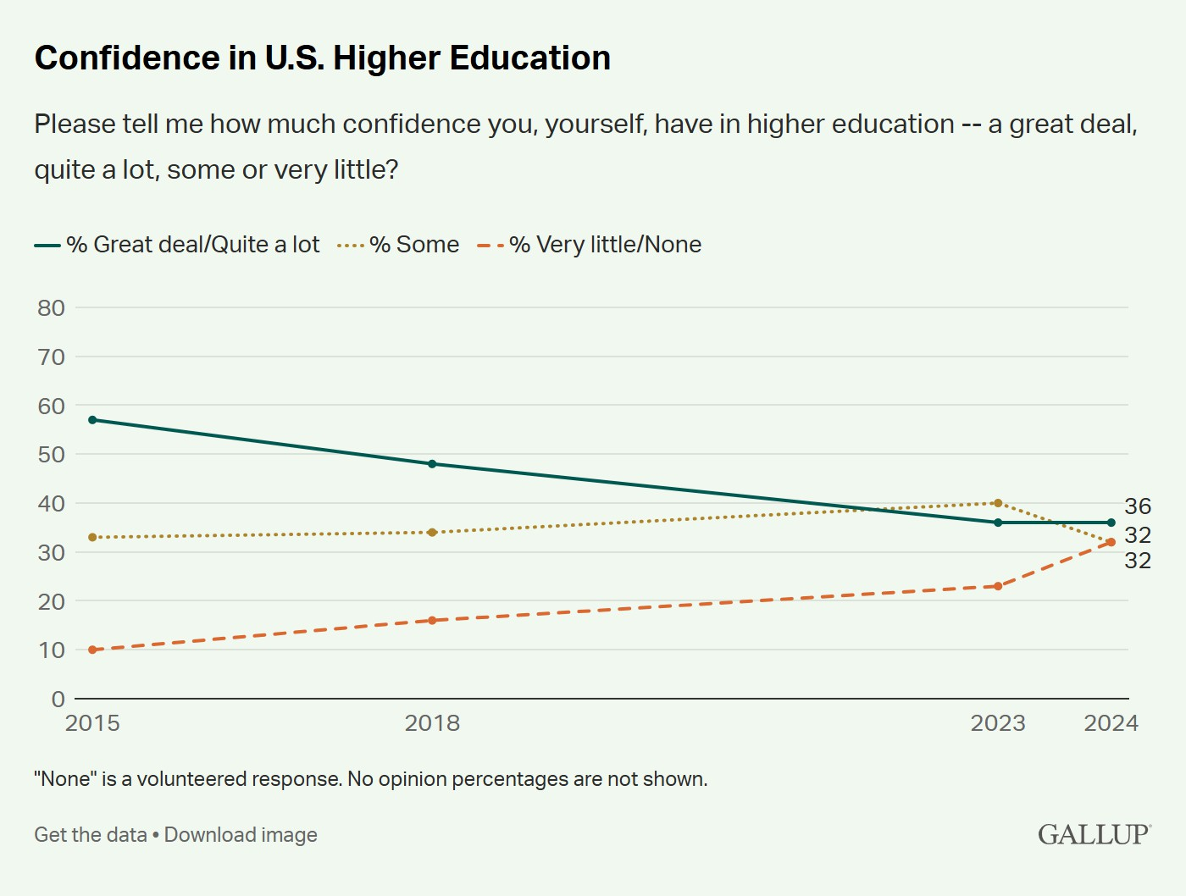
- In 2015, nearly 60% of Americans expressed trust in colleges and universities, according to a Gallup poll. By 2024, that figure had fallen to just one-third.

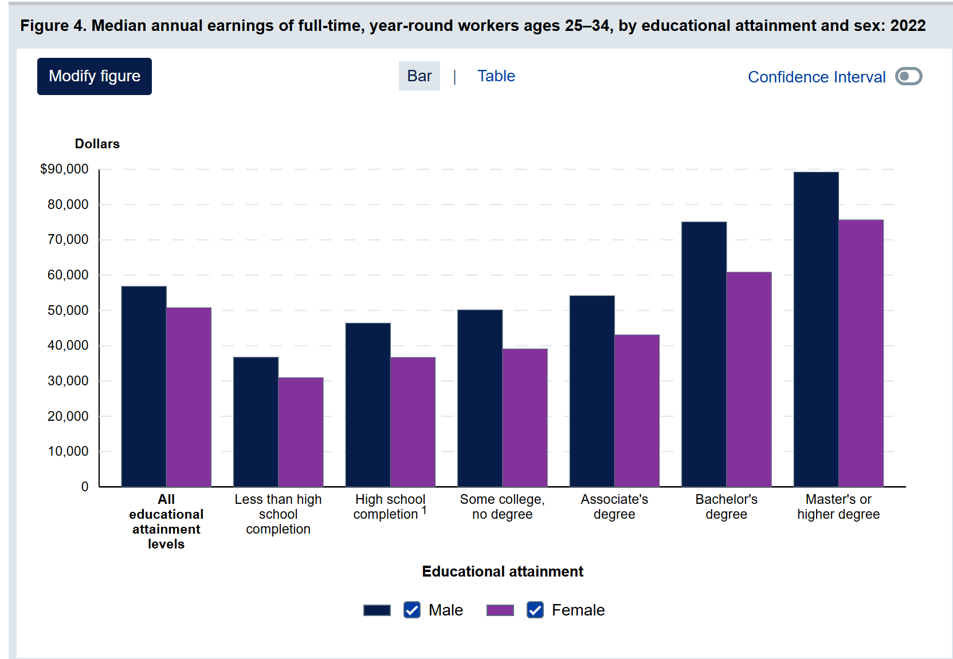
College Degree Attainment and Its Benefits

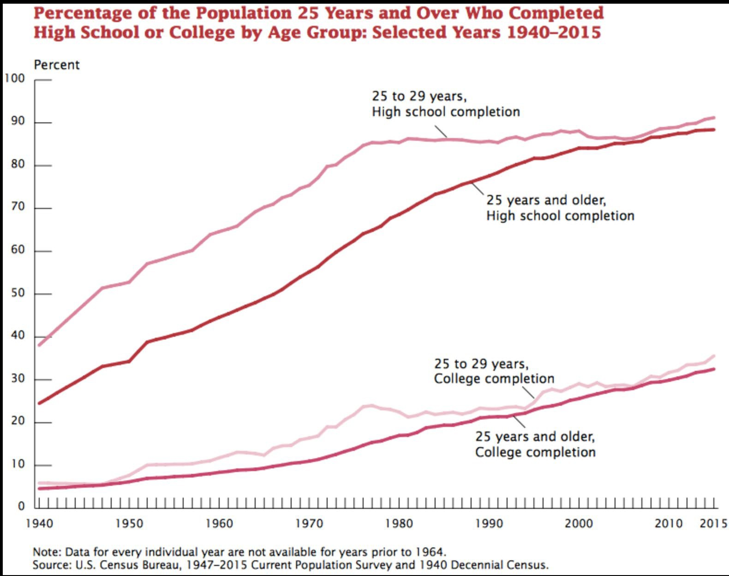

In my last few minutes….

- The mission of higher education is and always has been important
- Know that you are valued
- Know that you are changing lives

THANK YOU!
senate-chair@purdue.edu

7

Prepared Remarks by Mung Chiang for April 21, 2025, Purdue University Senate Public Meeting
Thank you Chair South for your prepared remarks. As is standard practice, my prepared remarks are provided in two parts: one by myself and the other by colleagues rotating each month across different key units at the university. This month, that’s Indianapolis by Dan Hasler and David Umulis.
But I would like to start out by thanking Chair Susan South for her outstanding leadership and trusted partnership. The collaborations, especially between her and Provost Wolfe, over the past academic year have proven to be a cornerstone to the stability and success of our university. As this semester wraps up next week and makes way for finals and Commencement, we again express our appreciation for all members of the Senate, and we look forward to Professor Mark Zimpfer’s leadership starting June 1.

Now, as has been stated in the campuswide email on April 10, not all the top universities in the United States are the same. Purdue is a public university in America and the state land-grant institution in Indiana.
Topic 1: Successes and positive impact items
This university continues to expand its support for colleagues and positive impact, with collective accomplishments across faculty hirings, research funding, student interests and financial resilience, and academic facility improvements — underlining our unique strength serving more than 70,000 students and colleagues on the main campus alone.

- Faculty and staff hiring and retention. Unlike peer institutions in a long and increasing list, Purdue is not freezing hiring or salaries. For example, in the ongoing recruiting season, 61 signed offers in the past two months alone. Last month, the Board of Trustees approved the tenure and promotion of 163 faculty systemwide. In the meantime, staff turnover at our West Lafayette location dropped from 3.7% to 2.8% in the last three years. Faculty turnover decreased from 2.2% to 1.7%.

- Research funding and opportunities. In past two months alone, Purdue faculty have been awarded over 500 grants totaling over $140 million from the U.S. Department of Energy, the National Science Foundation, NASA, the National Institutes of Health, the
U.S. Department of Defense and the U.S. Department of Agriculture, including $26.4 million from industry partners. The Office of Industry Partnerships continues to work closely with college deans, department heads and all faculty to attract more corporate support for new research centers/consortia and strengthen our existing centers.

- Investment in the latest facilities. Recent examples include:
  - Nursing and Pharmacy Education building
  - Mitch Daniels School of Business building
  - Academic Success Building
  - The modernization of Birck Nanotechnology Center and Zucrow High-Speed Propulsion Lab
  - As part of the One Health initiative alongside investment in faculty and students, a planned Life Science Research Building and a facility for four departments involving chemistry are seeking faculty input across many departments throughout multiple colleges.
  - Enhanced commercial air service is coming to Purdue University Airport. Flights are expected to begin Aug. 5 — the same day the Amelia Earhart Terminal opens at the airport.
  - And a nearly 1,000-bed student housing facility is on track to open this summer at Third Street and McCormick Road, with another new residence hall expected next year.
Topic 2: Bridge Funding Program to Support Faculty, Staff, Students

We remain committed to supporting the vital research and scholarly efforts happening every day at Purdue by our tremendous faculty, students and staff. Last week, we launched the 2025 Bridge Funding Program. With this effort, we support our researchers and scholars to maintain continuity following any unanticipated terminations or interruptions of external funding.

You can find the link to the Bridge Funding Program with additional information and an FAQ at Purdue’s Federal Funding Updates website.
Topic 3: International student visas
There are resources are available to Purdue community members with visa questions. We all recognize this is an anxious time for our international community, and
we are providing both overarching and tailored support to those impacted, consistent with our responsibilities as a public, land-grant host institution in an evolving context of current federal actions and court cases.
Purdue has been in contact with anyone who has become aware of a change in their visa status according to government databases. Student visa inquiries should be directed to Chris Collins, Director of International Student Services (ccollins@purdue.edu). Faculty, staff, and postdocs with visa-related questions should contact Amanda Thompson, Director of International Scholar Services (thomp557@purdue.edu). Additional details have been communicated in Purdue Today.
Today, Purdue’s Action Council on Student Housing and Well-Being is also hosting a special meeting to gather additional ideas from representatives of the community.

Topic 4: Learning AI

AI literacy will clearly be a crucial foundational requirement for all of our students, now and into the future as we had a glimpse at the last meeting through demos. We are hopeful for the Senate’s input on some kind of AI literacy expectation. Knowing that there are multiple ways of accomplishing this, we are eager to ensure that Purdue maintains clear educational leadership in this area. I will turn it over to Provost Wolfe to cover this topic in more detail.
Wrapping up these four topics, we again highlight how the community at our university appreciates the efforts of each of us as we continue Purdue’s trajectory of stability and success.



The next giant leap is HERE.

ONE PURDUE
West Lafayette Indianapolis

Our Indianapolis presence brings a new and fully integrated expansion of Purdue University to the capitol city.
- Indy talent pipeline
- Accessible excellence and student life
- Experiential education to accelerate an innovation-based economy

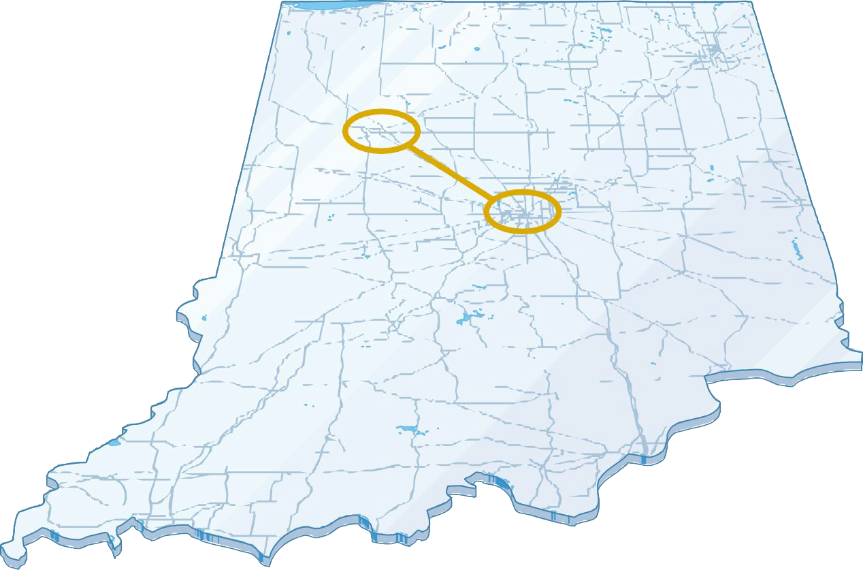
- An expansion of West Lafayette
- Future industry focused
- Built by Partnering w/ Tech businesses
- Integrated with Community

INDIANAPOLIS WINS
  - 13 undergraduate programs at launch
  - 6+ new undergraduate programs in ‘25, ‘26
  - 10 MS programs at launch
  - 6+ New MS programs launching in ’25
  - Purdue + Dallara program in location
  - Purdue + Spectron RX program in location
  - 50 Lilly Scholars in Indy
  - Successful launch! VIP; EPICS; The Data Mine.

INDY 1st YEAR BY THE NUMBERS

2024-25 Student Information

HOUSING/FACILITIES
STUDENTS
FACULTY & STAFF
CONNECTIONS
ACADEMICS LIFE
809
STUDENTS IN INDY HOUSING
- North Hall & LUX
- 50 Lilly interns at LUX in INDY
- 12 current buildings
- Several future locations approved for build or lease (ASB; 501, 520,401 )
2912
Students at launch
210
Winter graduates
80+
INDY-BASED FACULTY

85+
INDY-BASED STAFF

298+
Instructors per semester
clubs
NEW
Student
Over 60
WL-IND
Bus Rides
Over
30,000
450
Courses/semester
Academic Success Center
The Data Mine-15 projects
Purdue Team Store OPEN

TOTALITY TO TOTALITY


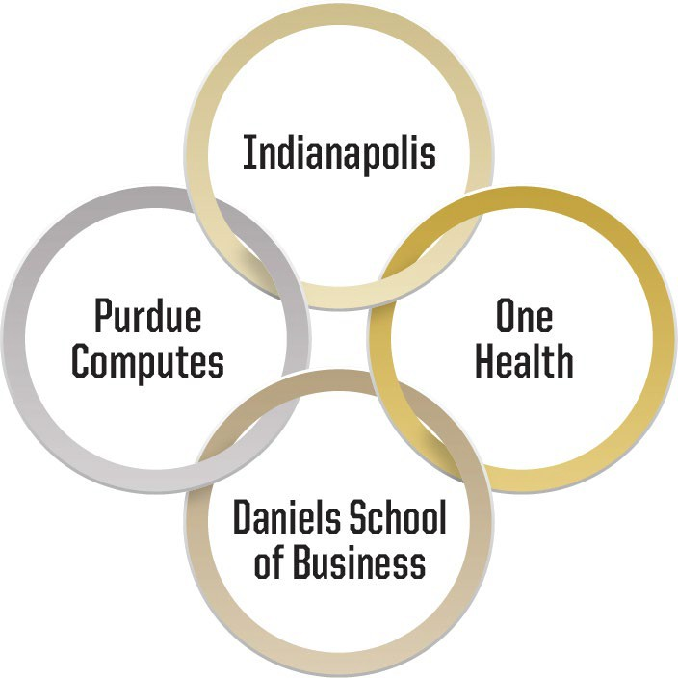
  - Mission-Driven. Programs must advance the mission of Purdue University and align with strategic goals.
  - Individualized Student Success. Programs give students a competitive advantage in the market.

  - World Readiness. Programming prepares students for work, life through career relevant experiences, internships, work-based learning, and experiential education.
  - Showcase Central Indiana. Programming leverages unique opportunities available in Indianapolis or the Central Indiana region to showcase future opportunities in Indiana

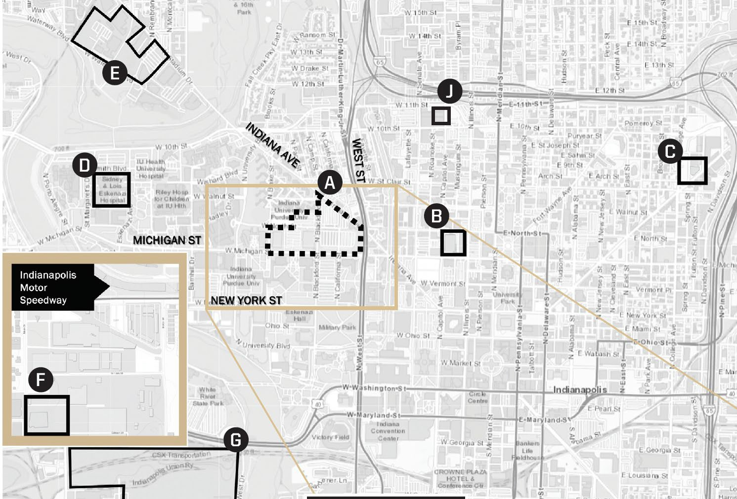
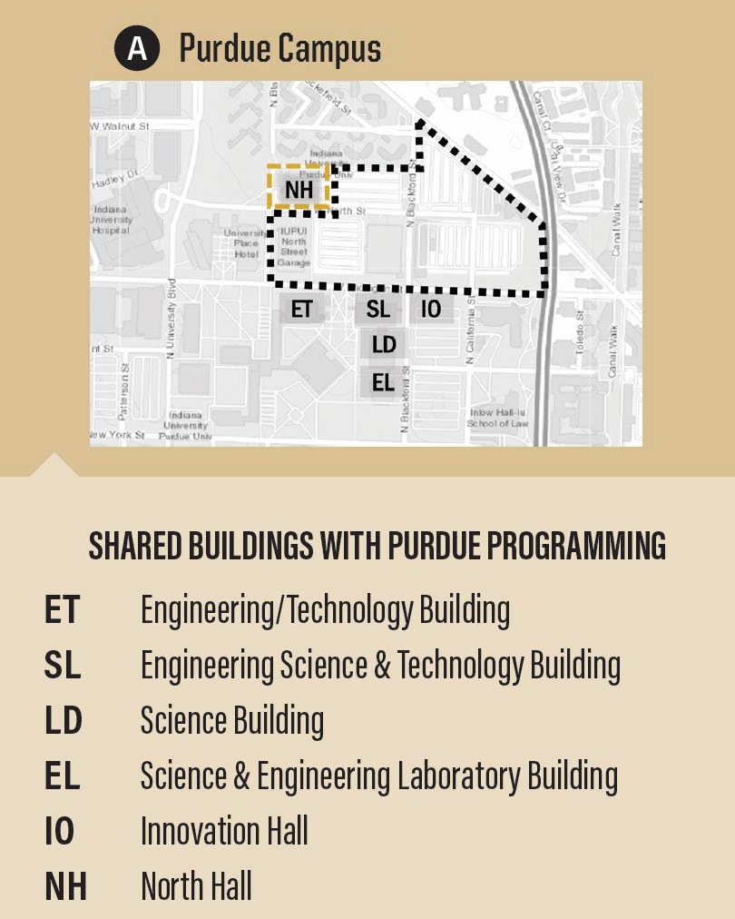
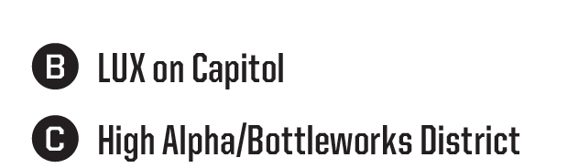
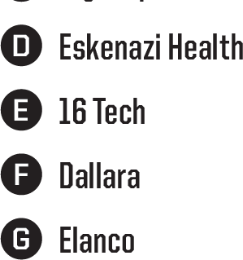
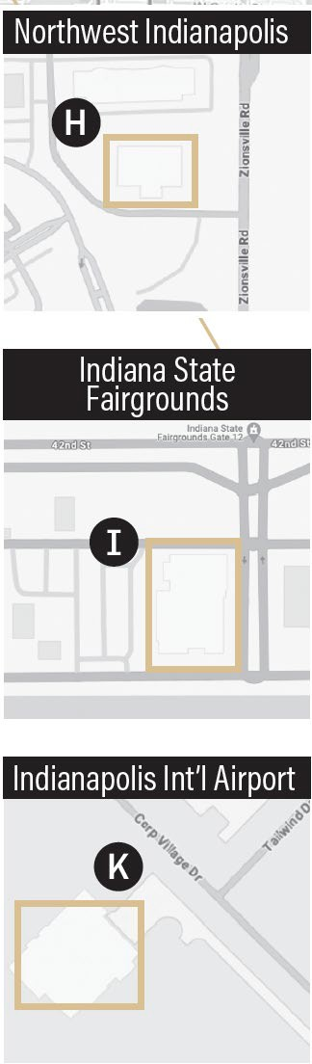






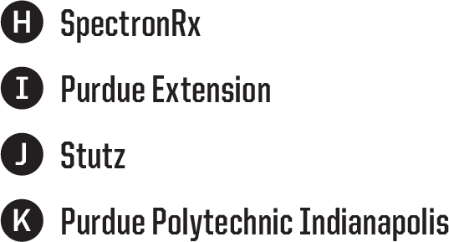
Purdue University throughout Indianapolis

THE FUTURE
- NEW PROGRAMS

Fall 2025
    - B.S. in Actuarial Sciences
    - B.S. in Integrated Business and

Engineering
    - M.S. in Sport Management (Dual location)
    - M.S. in Radiopharmaceutical Manufacturing (MS)
    - M.S. in Chemical Engineering-Pharmaceutical Eng. Conc.
    - Cornerstone Certificate Program
    - Certificate in Entrepreneurship and Innovation

Other upcoming programs
      - Redesigned B.S. in Construction Management Technology
      - B.S. in Mathematics
      - B.S. in Industrial Engineering
      - B.S. in Robotics Engineering Technology
      - Master of Business and Technology
      - M.S. in Organizational Leadership








A Platform for Partnerships











Internships, Co-Ops, Research, & Education

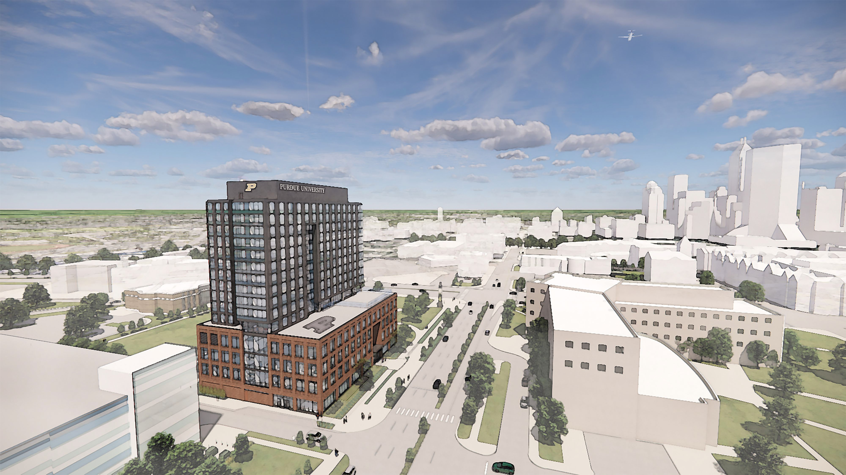
Indianapolis Growth: New Academic Success Building

- 248,000 gsf
- Dining, instructional space, labs, retail, housing
- Student activities
- Maker space
- Community engagement and more!


Questions


Status of Legislation
2024-25

Senate Document | Title | Origin | Senate Action | Implementation
24-01 | Senate Document 24-01 Nominees for Faculty Affairs Committee | Presented By Nominating Committee | *Nominees Elected 21 October 2024 | Elected
24-02 | Senate Document 24-02 Nominees for University Resources Policy Committee | Presented By Nominating Committee | *Nominees Elected 21 October 2024 | Elected
24-03 | Senate Document 24-03 Resolution for Voting Facilities and Time on Campus | Presented By University Resources Policy Committee | *Approved  21 October 2024 | Unknown
24-04 | Senate Document Reapportionment of the Senate for AY 2025-2026 | Presented By Steering Committee | *Approved  18 November 2024 | In Compliance
24-05 | Senate Document  Faculty Committee Name Change | Presented By Educational Policy Committee | *Approved 27 January 2025 | In Compliance
24-06 | Senate Document Modifications to Streamline and Clarify the Readmission Policy and  Add to Purdue University Academic Regulations | Presented By Educational Policy Committee | *Approved 27 January 2025 | In Compliance
24-07 | Senate Document Creating a University Senate Listserv | Presented By Senate Faculty Affairs  Committee | *Approved 24 March 2025 | Awaiting Administration’s Approval

24-08 | Senate Document Nominee for the Educational Policy Committee | Presented By Nominating Committee | *Nominee Elected 27 January 2025 | Elected
24-09 | Senate Document  Nominees for Vice Chairperson of the University Senate | Presented By Nominating Committee | *Election 24 March 2025 | Julio Ramirez Elected
24-10 | Senate Document Nominees for Advisors to the Senate | Presented By Nominating Committee | *Nominees Elected 17 February 2025 | Elected
24-11 | Senate Document Nominees for Advisors to the Senate Standing Committees | Presented By Nominating Committee | *Nominees Elected 17 February 2025 | Elected
24-12 | Senate Document Nominees for ex officio members of the Faculty Affairs Committee | Presented By Nominating Committee | *Nominees Elected 24 March 2025 | Elected
24-13 | Senate Document  Bylaws Revision re: CSSAC and MaPSAC Senate Members | Presented By Senator Libby Richards | *Approved 21 April 2025 | In Compliance
24-14 | Senate Document Resolution Concerning the Big Ten Senate Leadership  Statement | Presented By Senator Susan South | *Approved 21 April 2025 | In Compliance
24-15 | Senate Document Nominees for the Educational Policy Committee | Presented By Nominating Committee | *Nominees Elected 21 April 2025 | Elected
24-16 | Senate Document  Nominees for the Equity, Diversity, and Inclusion  Committee | Presented By Nominating Committee | * Nominees Elected 21 April 2025 | Elected

24-17 | Senate Document  Nominees for the Faculty Affairs Committee | Presented By Nominating Committee | * Nominees Elected 21 April 2025 | Elected
24-18 | Senate Document Nominees for the Nominating Committee | Presented By Nominating Committee | * Nominees Elected 21 April 2025 | Elected
24-19 | Senate Document Nominees for the Steering Committee | Presented By Nominating Committee | * Nominees Elected 21 April 2025 | Elected
24-20 | Senate Document  Nominees for the Student Affairs Committee | Presented By Nominating Committee | * Nominees Elected 21 April 2025 | Elected
24-21 | Senate Document Nominee for the University Resources Policy Committee | Presented By Nominating Committee | * Nominee Elected 21 April 2025 | Elected
24-23 | Senate Document Mutual Academic Defense Compact (MADC) among all members of the Big Ten  Academic Alliance | Presented By Senator Julia Chester | *Defeated 21 April 2025 | N/A

Student Affairs Committee
Annual Report
2024-25

Chair: Dr. Abigail Engelberth
Charge: The Student Affairs Committee is concerned with matters related to the general social, cultural, and practical welfare of all students of the University. Specific non-classroom matters of concern to this committee include, but are not be limited to, University Placement Service, intercollegiate athletics, counseling, scholarships, loans, conduct and discipline, health, living conditions, student political activities and organizations, Student Senate actions and recommendations, extracurricular activities, provision of equal rights and opportunities, and any other matters that would enhance students’ university environment for learning and living.

Membership: Heather Beasley, Ulrike Dydak, Abigail S. Engelberth, Melissa Franks, Praga Giri, Yara Hijaz, Hyunyoung (Young) Jeong, Beth McCuskey, Loring (Larry) Nies, Tae Hong Park, Sadie Poirier, Lynlee Rice, Dennis Savaiano, Michael G. Smith, Dengfeng Sun, Oleksandr Tsymbaliuk, Rua Williams

Chair 2024-2025: Dr. Abigail Engelberth
Meeting Schedule for Past Year: Once per month via Zoom

Committee work summary:
Resolution FA23-R002: Empowering Graduate Staff to Use or Be Compensated for Vacation Time
Summary:
- Objective: To empower graduate staff to use their vacation time for mental health reasons or be compensated for unused vacation hours.
- Proposal: Modify the graduate staff employment policy to include monetary compensation for unused vacation days and encourage a cultural shift towards using vacation time.
Committee Feedback:
- Concerns: The resolution's focus on compensation for unused vacation hours does not align with the stated goal of encouraging vacation use for mental health. The supporting points emphasize workload and the need for time off, suggesting a shift in culture towards balance.
- Compensation: The SAC discussed the lack of means for faculty to pay out students who do not take vacation. Compensation for unused vacation might encourage students to avoid taking time off, contrary to the resolution's intent.
- Policy Dependence: The current policy for taking and encouraging vacation is dependent on the PI and department. The SAC supports unifying the vacation policy for graduate students and encouraging its use.
Additional Feedback:

- Funding Source: The SAC is interested in knowing the proposed source of compensation for unused vacation time, as faculty and departments currently lack funds for this type of compensation.
- Comparison with Staff: Salaried Purdue staff have a 'use it or lose it' vacation time accrual policy, while Purdue faculty do not receive paid vacation.
Suggestions for Improvement:
- Clarify Compensation Source:
  - Specify the funding source for compensating unused vacation hours.
  - Example: "Identify potential funding sources for compensating unused vacation hours, such as departmental budgets or university-wide funds."
- Encourage Vacation Use:
  - Emphasize the importance of using vacation time for mental health and well-being.
  - Example: "Encourage a cultural shift towards using vacation time to support mental health and well-being, rather than seeking compensation for unused hours."
- Unify Vacation Policy:
  - Propose a unified vacation policy for graduate students across all departments.
  - Example: "Develop a unified vacation policy for graduate students to ensure consistency and support across all departments."
Resolution FA24-R002: Equitable Access to Type “A” Parking Permits for Graduate Students
Summary:
- Objective: To provide equitable access to type “A” parking permits for graduate students, enhancing their convenience and safety.
- Proposal: Allow all graduate students to purchase type “A” parking permits and lower the cost to that of type “C” permits.
Committee Feedback:
- Capacity Shortage: Solutions to address parking capacity shortages include creating 185 additional “C permit” spaces near Owen residence halls, Discovery Park lot, Convergence lot, restriping spaces in Ross Ade, and opening capacity in garages.
- Shuttle Service: A shuttle service has been launched at the airport (gravel lot) with a 10-15 minute route, providing 450 spaces. This shuttle is not operated by CityBus.
- Graduate Student Permits: Discussion on whether graduate students, who are mostly “C permit” holders, can access special types of permits.
- CityBus Pass: Need for a pass for off-campus routes on CityBus.
- Monitoring Improvements: Need to assess if there has been an improvement in parking and how pressing the issue remains. Faculty can also raise parking as an issue.
Resolution FA24-R003: Move-in Package for Incoming Graduate Staff
Summary:
- Objective: To provide a move-in package for incoming graduate staff to alleviate financial pressures upon arrival.
- Proposal: Deliver the first month's full salary as a zero-interest loan to incoming graduate staff, to be repaid within three months.
Committee Feedback:
- Funding Source: The resolution clarifies that the move-in package will be a zero-interest loan from the student's salary, addressing previous concerns about the source of funds.

- Repayment Term: The committee questioned the three-month repayment term and suggested that a longer repayment period within the student's contract might be more beneficial.
- Opt-in Policy: The committee inquired whether the move-in package would be an opt-in policy, allowing students to choose whether to participate.
Additional Feedback:
- Supportive Stance: The SAC is overall supportive of the resolution, appreciating the clarification on the funding source and the intent to alleviate financial pressures on incoming graduate students.
Suggestions for Improvement:
- Extend Repayment Term:
  - Consider extending the repayment period to provide more flexibility for students.
  - Example: "Extend the repayment term to six months or the duration of the student's contract to ease financial burden."
- Clarify Opt-in Policy:
  - Specify whether the move-in package will be optional for students.
  - Example: "Include a clause indicating that the move-in package is an opt-in policy, allowing students to choose whether to participate."
Bill 24-40: Expanding University Absence Policies
Summary:
- Objective: To expand Purdue University's excused absence policy to include professional leave for job or graduate school interviews and appointments.
- Proposal: Allow two excused absence days per semester for professional leave, provided the student submits evidence of attending an interview or professional event.
Committee Feedback:
- Logistics: There was significant discussion regarding which office would handle the absences or if it would be left to individual instructors. This is crucial for the implementation and consistency of the policy.
- Additional Feedback:
  - Support for the bill is contingent on the university creating a special office to manage these absences. Without dedicated personnel, it would be an unnecessary burden on faculty members to track all student absences and reasons. The bill should also ensure that these leaves do not conflict with exams or quizzes.
  - It is implied that professional leave would be handled similarly to other excused absences like grief or medical leave. Students have faced denial of leniency by professors, which is why they prefer not leaving it to individual discretion.
Suggestions for Improvement:
- Clarify Management of Absences:
  - Specify which office or department will handle the verification and tracking of professional leave absences. This could be the Office of the Dean of Students (ODOS) or a newly created office dedicated to managing professional leave.
  - Example: "The Office of the Dean of Students (ODOS) will be responsible for verifying and tracking professional leave absences to ensure consistency and reduce the burden on individual faculty members."
- Ensure No Conflict with Exams/Quizzes:

  - Add a clause to ensure that professional leave does not conflict with scheduled exams or quizzes.
  - Example: "Professional leave absences will not be granted during scheduled exams or quizzes unless alternative arrangements are made with the instructor."
- Provide Clear Guidelines for Evidence Submission:
  - Outline the types of evidence required to prove attendance at an interview or professional event.
  - Example: "Students must submit official documentation, such as an interview confirmation email or appointment letter, to the designated office for verification."
Bill 25-17: Encouraging Virtual Learning During Extreme Temperatures Summary:
- Objective: To recommend virtual learning when the average "Feels Like" temperature in West Lafayette is below -5°F for the health and safety of students and faculty.
- Proposal: Purdue Student Government recommends that Purdue University strongly encourages professors to conduct classes virtually under these conditions, with a 24-hour advance notice based on estimated temperatures.
Committee Feedback:
- Impact on Lab-Based or Clinical Courses: Consider the feasibility and impact of virtual learning for courses that require physical presence, such as lab-based or clinical courses.
- Preparedness for Cold Temperatures: Acknowledge that Indiana is in the Midwest and experiences cold winters; students should be prepared to handle these conditions. Here is a link to the most recent university statement regarding wintery conditions for reference.
- Additional Feedback:
  - -5°F is not considered cold enough to warrant canceling classes, and switching to online learning for large classes could significantly impact student learning. Additionally, the coldest days often occur in February, which may coincide with exams, potentially disrupting students' preparation and performance. Therefore, the bill in its current phrasing is not supported.
  - Encouraging virtual learning does not mean forcing clinical or lab courses into virtual formats. It could reduce missed days by moving classes online instead of canceling them.
  - The key to both bills is focusing on recommendations and consensus rather than obligatory policies. Students need to trust their professors rather than asking the university to dictate policies. Most faculty are already lenient for both interviews and cold weather.
Suggestions for Improvement:
- Address Impact on Lab-Based or Clinical Courses:
  - Clarify that the recommendation for virtual learning does not apply to lab-based or clinical courses that require physical presence.
  - Example: "This recommendation excludes lab-based or clinical courses that require physical presence. Instructors of such courses should use their discretion to ensure student safety."
- Reevaluate Temperature Threshold:

  - Consider raising the temperature threshold to a more extreme level that warrants virtual learning.
  - Example: "Recommend virtual learning when the average 'Feels Like' temperature in West Lafayette is below -20°F."
- Focus on Recommendations Rather Than Obligatory Policies:
  - Emphasize that the bill is a recommendation and not a mandatory policy, allowing professors to use their discretion.
  - Example: "Purdue Student Government recommends that Purdue University strongly encourages professors to conduct classes virtually under these conditions, while ultimately leaving the decision to the discretion of individual instructors."

Goals / Next Steps:
- Collaborate with the University Resources Policy Committee to draft a joint resolution for the senate concerning Resolution FA24-R003: Move-in Package for Incoming Graduate Staff.
- Continue working with PSG on Bills 25-17 and 24-40.
- Monitor changes in parking and transportation. Many students are concerned about the removal of the CityBus campus loops and the transition to a new contract with SP Plus.

 | Parking & Traffic Committee  Annual Report  2024-25

Chair 2024-2025: Josh Widhalm, Associate Professor of Horticulture and Deputy Director of the Center for Plant Biology

Charge: "The committee shall make a continuing systematic review of parking and traffic needs and possible solutions in the light of the University growth, faculty and student needs, and campus beautification, including regulations for the control of parked vehicles and traffic flow. It shall recommend policies for parking and traffic movement. It shall advise the president on plans and regulations for parking and traffic movement."
Membership: The committee included representation from faculty, staff, and undergraduate and graduate students (via PSG and PGSG). The committee was comprised of the following individuals:

  - Abidemi Mary Ajuwon – Nursing
  - Adam J. Keyster – Capital Program Management
  - Amanda Ward – Nursing
  - Anita Jane Lowery – Parking Facilities
  - Anthony Gillund – Energy Development & Sustainability
  - Anthony N. Standifer – Police Department
  - Ashleigh Briane Stingley – Parking Facilities
  - Bradley D. Anderson – Fire Department
  - Camille M. Shoaf – Campus Master Planning & Sustainability
  - Christa Pazera – University Residences / Resident Life
  - Diane M. Schrader – Infrastructure
  - Elizabeth A. Moore – Dean of Students
  - Emily Ryen Jones – Student Success (MaPSAC rep)
  - Eric W. Adams – Research Computing
  - Francis Willow Quinn Corvin – Student (Disability advocate)
  - Isaac Sean Grossman – Student (PSG rep)
  - Jacob Harlow Ehman – Student (PSG rep)
  - Jeffery P. Stefancic – Dean of Students
  - Jenna Bednarski – Nursing
  - Jennifer L. Schukraft – School of Management Admin & Instruction (MaPSAC rep)
  - Joshua R. Widhalm – Horticulture and Landscape Architecture
  - Kristi S. Brown – Capital Program Management
  - Larry E. Pherson – [Department not specified]
  - Lesley D. Wiete – Police Department
  - Marcus Drake Smith – Capital Program Management
  - Pamela Roxanne Yameogo – [Department not specified]
  - Peter Richard Celeste – Student Success
  - R.L. Walker – City of West Lafayette
  - Sofia K. Babcock – [Department not specified]
  - Steven T. Carn – Parking Facilities

  - Thomas R. B. Brown – Daniels School of Business (CSSAC rep)
  - Victor Anthony Gutierrez Schultz – Biochemistry (PGSG rep)
  - Vishal Shrivastav – Electrical & Computer Engineering

Meeting Schedule for Past Year:
  - October 11, 2024
  - November 15, 2024
  - December 9, 2024
  - February 7, 2025
  - March 12, 2025
  - April 22, 2025
Committee work summary:
While the committee is not a decision-making body, it serves as a vital communication link between the Purdue community and campus leadership. This year, the committee reviewed concerns and updates related to parking availability, ADA accessibility, graduate student permit access, VEO scooter program improvements, EV charging infrastructure, and pedestrian safety. These discussions were relayed to relevant decision-makers, with progress communicated back to stakeholders. Chair Josh Widhalm provided an update to University Resource Policy Committee Chair Lori Hoagland in March 2025 on these developments (see attachment: University Senate Parking and Traffic Update March 2025.pdf).

Key topics and developments:
- Graduate student parking & accessibility
  - Graduate students voiced concerns about limited access to A/B permits. Only those employed at 0.75+ FTE qualify.
  - Over 1,100 C-permit holders were offered garage permit swaps; ~300 accepted.
  - Additional A/B spaces secured at the Convergence Center and C-permit spaces opened along Arnold Drive, Trailway Boulevard, and the airport (500-space lot with shuttle service).
  - Ongoing feedback collection through PGSG surveys and committee discussions.
  - See attachment: PGSG listening session report transportation 2024.pdf

- ADA parking study & disability access
  - A third-party ADA parking audit initiated by Campus Parking was 95% complete by March.
  - The study revealed adequate overall space quantity, but many spaces are noncompliant.
  - The committee discussed hotspot identification and potential for reserved spaces for students with unique mobility needs.
  - Continued collaboration with the Disability Resource Center (DRC) and outreach to the Disability Student Union planned.
- Campus transit review and Bowen Lab access
  - A dedicated Bowen Lab shuttle is slated for Fall 2025 following advocacy from PGSG.
  - Committee participation in the campus transit RFP evaluation ensured representation of rider needs, including stop placement and access equity.
  - See attachment: PGSG Report Purdue Parking and Traffic Concerns 11_2024.pdf

- Infrastructure planning and future growth
  - Several parking lots were lost to construction (e.g., Krannert).
  - New lots (e.g., Cherry Lane, State Farm site) and shuttle expansions are being explored.
  - Discussions began around Purdue’s long-term goal for a car-free campus core.
- Pedestrian and bike/scooter safety
  - City of West Lafayette engaged regarding unsafe pedestrian crossings (e.g., University & 2nd St).
  - VEO scooter enforcement enhanced with AI-assisted geo-fencing and photo-verification.
  - Purdue is piloting accessible scooter solutions (e.g., three-wheeled models).
  - Safety measures (e.g., garage mirrors, mental health signage) were discussed.
- EV charging infrastructure
  - EV charger removed from Wood Street Garage due to infrastructure limitations.
  - However, total campus chargers increased to 10 across 5 garages.
  - Grant applications submitted to expand EV support, particularly for students with residential permits.

- Campus transit services
  - The Parking & Traffic Committee was invited to participate in evaluating proposals and presentations for Campus Transit services. Tom Brown volunteered to represent the committee and his name was submitted, but he was never contacted to participate.
  - On April 4th, 2025, the Purdue Board of Trustees approved a three-year, $7.8 million contract with SP Plus (SP+), a Metropolis company, to provide free transit services with expanded campus routes for students, staff and faculty at Purdue’s West Lafayette location. The contract begins July 1 and runs through June 30, 2028, with SP+ service scheduled to start Aug. 25, the first day of fall semester classes.

- Crosswalks on campus
  - At the April 22nd, 2025 meeting, the committee will review crosswalk improvement recommendations submitted by Purdue Student Government. Their proposal has identified 14 high-traffic pedestrian locations on or near campus that currently lack painted crosswalks. The committee will evaluate these suggestions to determine feasibility and potential for collaboration with Purdue administration and the City of West Lafayette to improve pedestrian safety.
  - See attachment: PSG_Crosswalks.pdf
Goals/Next Steps for 2025-2026:
- Monitor implementation of Campus Parking’s ADA study recommendations and communicate changes with the DRC and affected students.
- Ensure timely rollout of the Bowen Lab shuttle and review ridership once operational.
- Continue expanding parking options and shuttle service to meet student and staff needs during campus construction.
- Collaborate with the City of West Lafayette on pedestrian safety improvements, including follow-up on PSG crosswalk proposals and traffic lights (e.g., timing at NW and Fowler).
- Track progress on EV charging grant proposals and expansion plans.
- Explore discounted VEO access for students and promote VEO scooter parking awareness.

- Explore options for charging personal scooters in residence halls.
- Improve signage to distinguish sidewalks from bike lanes on campus.
- Identify opportunities to extend bike lanes, for example:
  - On McCormick Rd along the west side of the Intramural Fields, connecting Cherry Lane up to Lindberg (need to involve City of West Lafayette)
  - On Cherry Lane, connecting the path along 231 to McCormick Rd
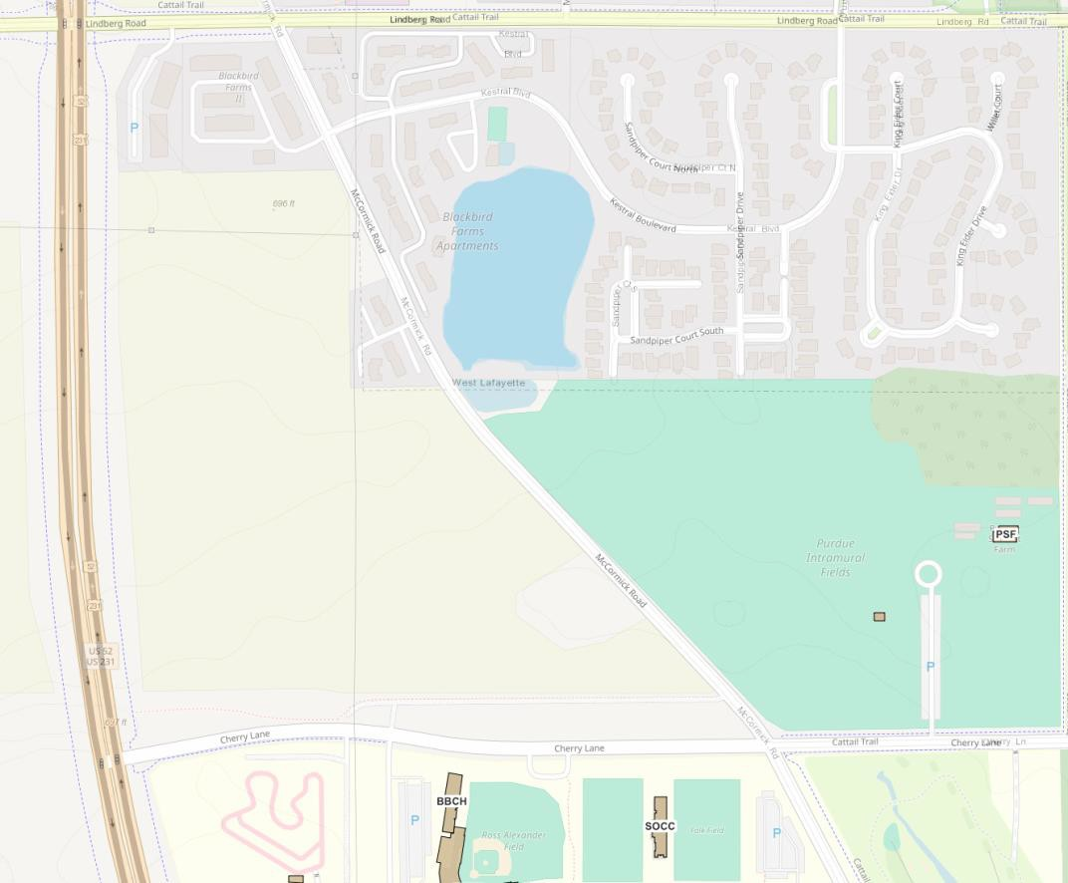

Staff Appeal Board for Traffic Regulation Annual Report
2024-25

Chair: Stephanie Winder

Charge: Members of the board should become thoroughly familiar with the Motor Vehicle, Bicycle, and Traffic Regulations at Purdue University. The board shall hear and determine all appeals made to it by staff members on charges of violations of the regulations cited.
Membership: Stephanie Winder, Bhagyashree Katare, Margaret Phillips, Matthew Stephens, Shankar Thangamani, Melissa Jasek, Melanie Beasley

Chair 2024-2025: Stephanie Winder

Meeting Schedule for Past Year: 10/17/24, 12/3/24, 2/10/25, 3/6/25, 4/24/25
Committee work summary: include any documents that were forwarded to Senate along with decision (passed, failed), as well as any information you have on the implementation of passed legislation.
- Adjudication of appeals sent to it by Parking Operations for staff citations that have already been upheld by Parking Operations.
- Provide consultation with Parking Operations concerning constituent interactions with vehicle registration/permitting system as well as other parking issues.

Goals / Next Steps: include any information that would be helpful to the committee members in the coming year
- Outside of standard adjudications, no goals or next steps are planned.

Athletic Affairs Committee
Annual Report
2024-25

Chair: Ernest R. Blatchley III
Charge: https://www.purdue.edu/senate/committees/standing-committees/studentAffairs/athleticAffairs.php

Membership: Ernest R. Blatchley III (Chair), Rachel Clark (Senate Appointee), Matthew Conaway (Senate Appointee), Kyle Haynes (Senate Appointee), Kathy Martin (Faculty Appointee), Marcy Towns (Faculty Athletic Representative), Phil Vanfossen (Faculty Athletic Representative), Tae Hong Park (Student Affairs Liaison), Mike Bobinski (VP/Athletics Director), Tiffini Grimes (Deputy Athletics Director, Senior Woman Administrator),Ken Halpin (Deputy Athletics Director, COO), Ed Howat (Senior Associate Athletics Director for Student Services and Sports), Beth McCuskey (Presidential Liaison, Vice Provost for Student Life), Tom Mitchell (Associate Athletics Director-Compliance), Peyton Stovall (Assistant Athletic Director-Student-Athlete Development), Calvin Williams (Associate Athletics Director-Sports), Tony Albrecht (Alumni Representative), Gary Henriott (Alumni Representative), Sue Holder Price (Community Liaison), Logan Sandlin (Student-Athlete Representative).

Meeting Schedule for Past Year:
August 22, 2024 3:30-5 PM
October 10, 2024 3:30-5 PM
January 29, 2025 3:30-5 PM
April 16, 2025 3:30-5 PM
Committee work summary: include any documents that were forwarded to Senate along with decision (passed, failed), as well as any information you have on the implementation of passed legislation.
- Annual presentation to the University Senate on student success
- Approval of competition schedules (and revisions) along with waivers for missed classes beyond the allowable limit
- Overview of student-athlete success initiatives in areas such as community service, civic engagement, DEI, resume building, networking, campus inclusion, and internships
- Ongoing discussions related to legislation/litigation affecting student-athletes and the overall health of the department (NIL, changes to NCAA and B1G governance, transfer rules, revenue sharing, and anti-trust legislation.) Though the financial impacts of the lawsuits will be significant, those numbers/terms will not be known until a settlement is reached.
- Discussion of financial standing of the athletics department with emphasis on student scholarships and support
- Review of a variety of compliance topics throughout the year, including sports wagering, transfer portal, NIL, and hazing prevention to ensure Purdue's policies

and practices in these areas are clear, consistent, and protect the student-athletes.
- Discussions of conference expansion and scheduling to ensure that student-athlete academic success and support remain consistent, and that missed class time is at the forefront of competition scheduling conversations.
- Overview of ongoing capital projects.
- Selection of recipients of Big 10 scholarships and awards.

Goals / Next Steps: include any information that would be helpful to the committee members in the coming year
- Continue discussion of legislation and governance changes that may affect student-athletes and the financial health of the department as it relates to NIL, revenue sharing, roster size limits, etc.
- Continue discussion about impact of conference expansion on competition schedules and how this might affect the current missed class time policies. The FARs and SWA remain engaged in these conversations and will be prepared to share feedback as the first year of the expanded conference is underway.

Budget Interpretation, Evaluation, and Review
Committee
Annual Report
2024-25

Chair:
George Zhou

Charge:
The Committee shall be charged with continuing to collect and analyze data about Purdue’s revenues and appropriations and to convey information about Purdue's budgetary policies to the Senate. Furthermore, with coordination and consultation with the University Resources Policy Committee, this Committee will work with the fiscal officers of the administration to examine and evaluate budgetary policies.

Membership:
John Morgan (Chemical Engineering) Cody James Mullen (Public Health) Howard Zelaznik (Health & Kinesiology) George Zhou (Civil Engineering)
Andrew Bean (Associate Vice President, Finance & Accounting) Eva Nodine (Vice President/Deputy CFO)
John Gipson (Provost's Chief of Staff and Assistant Vice Provost for Academic Operations)
Howard Zelaznik (URPC Liaison, Health and Kinesiology) Paul Mort (URPC Liaison, Materials Engineering)
Chair 2024-2025:
George Zhou
Meeting Schedule for Past Year:
3/25/2025

Committee work summary:
BIER discussed the challenges of recent federal policy changes, such as a significant reduction in indirect cost rates for research grant, and Indiana legislature's impact on Purdue’s student recruitment, including Senate Bill 448. We also discussed potential opportunities to address these challenges should be explored.

We are currently working evaluating the potential approaches to bolster university income and address financial challenges, effective strategies for engaging with the state legislature to secure support, such as in-state student scholarships, to promote in-state enrollment and state incentives for industry support of research programs aligned with regional economic growth. We are also exploring methods to enhance the transparency of the university budget for the university community, fostering improved productivity and efficiency. We are working on potential mechanisms for faculty and graduate students to sustain research activities during these uncertain times.
Goals / Next Steps: include any information that would be helpful to the committee members in the coming year

We are working with the Office of Financial Planning & Analysis Liaison and Provost Office at Purdue to discuss strategies to help Purdue to deal with financial challenges under the recent policy changes and funding cut. Our next meeting is expected to be held in April 2025.

Grade Appeals Committee
Annual Report
2024-25

Chair: Ryan Reeves

Charge: University Grade Appeals

Membership:
25 Faculty Members
7 Undergraduate Representatives
0 Graduate Representatives
Names and Contacts Provided on Following Pages

npa·anpmd@A6fiis ua\SJl)I pu61s '1au4ez
,,
npa·anpmd@�JIMZP
V P'""0 'kp1Mz -

npa·anpmd@!lNIAS -
1
00,d-nA uaAa1s 'nM �

npa·anp.md@fO!"ll"M (fi npa·anpmd@ra,aue:v0.
V 4"'"S 'i>oe11eM opemr "1"'-'e:l v,i "'"3UeA A

npa·anpmd@l•Uad"'I 1Jt npa·anpmd@U6
J tw41e;:i ·rnnads-P"''Jfi•as � • OAf!lSn9 'eJaAll:J-zan6upol:J
,,

npa·anpJnd@pue140 � npa·anpJnd@sa�= ...
�ea

eww
M Ma411ev,i 'pue140
OAeJB onag ei1nr euev,i W j
npa·anpmd@Jqo11aqwE
sum1-11 ·1n4qe11rnc)')ev,i
npa·anpmd@101fo o
·:, wei11w, ,,.,

•

n pa·anpJnd@4011a1s npa·anPJnd@a<nJ>µI ', o)
l:l ua4da1s '4�11"7 " l:J e,p.(7 'i>'lnJ)I '._I

npa·anpmd@xou�40�0 npasmPJnd@8('.8[U4ol (1
d e141llAJ •d.Je4s XOU)l-40)1 )I J e:,aaqal:J \Josu4or

npa·anPJnd@11a6uarp k)I npa·anPJr.d@ou,ue, �
H auieMQ ·Aa11afiuar �: ou,ue:,1ua:iu1A sawer 1 -:,:.,)

npa·anPJr.d@ue6eatl "I npa·anpmd@mxiar� ..:,. uefie3 Tf .,;, r U")I 1Paisua�3
npa·anPJr.d@a.{pw 'j-j npa·anpmd@'4"'1'"P@
)I 4emqaa 'ai\a \ auu,17 eiou1ed 'aJ14s1qrno

npa·anp,r.d@ddn4:,q
,,
)I ueue 'ddn4J
npa·anpJnd@n14:qM � 6u11-ueM •rn4J

npa·anpmd@"lJ•npq �' npa·anpJnd@ua,uuesq 6)
a:µena ·r uei\Je !;; epezano oiua,wrns epua,9 I



Chair 2022-2023: Rebbecca Johnson

Meeting Schedule for Past Year:

The Fall 2024 meeting was not held due to policy transition of the grade appeal process and all new membership. We learned the new policy and its application on our feet as the appeals season ramped up.

Spring Annual Meeting 4/17/2025

We conducted our annual meeting via Teams for one hour. The chair gave acknowledgments, committee activity overview, summer and fall planning, Chairperson election, and adjourned.

Committee work summary:
- The committee was aware of 275,000+ grades issued, 80 informal appeals, 12 of which rose to the University Grade Appeals Committee.
- 3 appeals closed at the end of the first vote, upholding the school’s decision.
- 9 appeals proceeded to a Full hearing.
- 4 appeals voted for a change of grade, and the Committee Chairperson completed Form 350 and submitted it for grade change.
- 2 grade appeals resulted in tied votes, and the Committee Chairperson cast votes to break the tie.
- The average life expectancy (OSRR release to final decision letter) was 19 days, not accounting for university days or breaks.
- Ryan Reeves was re-elected for another term as the University Grade Appeals Committee Chairperson.

Goals / Next Steps:
- Solicit availability from current committee members to see if we can build a cohort that could start to hear appeals from the Spring 2025 semester over the summer months. With the new grade appeal policy, it creates surges of appeals, and the committee has a protracted period of high demand and workload. Of our 12 appeals, 7 or 8 of them came to us in the same two-week window. The surge works against shortening of the average life of an appeal number.
- OSRR would like to commit more resources to the committee to streamline the process and add efficiencies.
- Working with OSRR and Student Government to increase our number of student representatives. With the volume of appeals that we expect, it is placing an undue burden on our student reps to hear as many appeals as they do. We would like to double or triple our student rep numbers. Committee Chair and OSRR will readdress this issue in late summer/early fall.
- Committee Chair is working with OSRR and the EPC to create a document or “one sheet” that can be passed out to school heads. It is an effort to pass along the trends and patterns that emerged from 12 grade appeals, but not have this committee infringe on any academic freedoms. More of a set of recommended practices that faculty may choose to implement.
- Make a change in committee chair position a longer-term process, instead of the more instant change. The current chair will begin cultivating for a successor in Spring 2026, vote them in April 2026. This will create a several month window for transition. This process and desire was announced in the April 2025 annual meeting. There are several members that could lead this committee as soon as their confidence grows to match the position.
- Overall, the current committee chair is satisfied with the current grade appeal policy. There is some good cause to believe that some efficiency gains can be made in the next appeals season.


Sustainability Committee
Annual Report AY 2024–25
Chair: Michael Johnston (mjohnst@purdue.edu)
Vice-Chair: Amanda Darbyshire (adarbysh@purdue.edu)
Charge: The purpose of the committee shall be to set five-year goals to advance the sustainability of the university, guided by Purdue University’s Sustainability Strategic Plan including but not limited to reducing overall energy consumption and transitioning to greater utilization of clean and renewable sources of energy, determine measurable objectives for achieving these goals, and evaluate progress in meeting the objectives.
Membership:
- Subhra Bansal
- Fabrício d'Almeida
- Amanda Darbyshire (Vice Chair)
- Sophia D’Isabella (PSG representative)
- Genell Ebbini
- Shawn Flora (CSSAC representative, resigned)
- Terri Griffin (CSSAC representative, replacing Shawn Flora)
- Bryan Hubbard
- Michael Johnston (Chair)
- Alexander Kildishev (resigned)
- Kevin Kircher
- Shuangting Li
- Aaron Lottes
- Ernesto Marinero
- Mark McNalley (MAPSAC representative, resigned)
- Tae Hong Park
- Rua Williams
- Olivia Williams (PSG representative)

Advisors (non-voting):
- Tony Gillund, Director of Sustainability
- Patrick Brown, Sustainability Coordinator

Chair 2024-2025: Michael Johnston
Vice-Chair 2024–25: Tae Hong Park
Meeting Schedule for Past Year: We met once this year (September 2024), at which point we divided into teams that collaborated with the Institute for a Sustainable Future (ISF) on

the projects described below. The chair regularly checked in with the committee via email for advice about future directions.
Committee work summary: include any documents that were forwarded to Senate along with decision (passed, failed), as well as any information you have on the implementation of passed legislation
We focused on these ways to bring about change:
- Collaborating with ISF on Campus Sustainability Self-Study
  - An eighteen-month project (to finish in Fall 2025), evaluating the knowledge of, and attitudes towards, sustainability among Purdue faculty, staff, and students.
    - We met once/month.
    - In April 2025, we launched a survey of the undergraduate student body, and in the Fall we will analyze the results.
    - Communicating to the entire Senate via email, we asked for help in advertising the survey
- Collaborating with the ISF on the role of sustainability in the undergraduate curriculum
  - We met once/month to discuss ways to centralize information about sustainability-focused courses
  - We met with the Undergraduate Curriculum Committee of the Senate to discuss the possibility of changing the academic calendar to allow for more days when the university could be closed down.
    - We decided this was not a fruitful avenue to pursue at this time
  - We participated in two workshops with the ISF about sustainability in higher education
- Oversight: We regularly submitted questions to the administration regarding SD 22-22, passed in AY 2022–23 and sponsored by this committee
- At the February Senate meeting, we provided an update on the activities of our committee

Goals / Next Steps: include any information that would be helpful to the committee members in the coming year

Goals for the next year include the following:

- Continue to collaborate with the ISF to advocate for a university-wide sustainability task force
- Review the ISF’s STARS report and determine areas of concern to focus on improving
- Continue to apply pressure to the administration to join the GLCAP and commit to decarbonization

University Resources Policy
Committee
Annual Report
2024-25
Chair: Lori Hoagland Charge:
The University Resources Policy Committee is concerned with, but not limited to consideration of the following matters: planning optimal utilization of the physical facilities of the University, including buildings, the library, scientific and other equipment and educational aids; studies of staff needs, utilization, and planning; interdepartmental cooperation of improved facilities and staff utilization; and nonacademic planning, including architecture, landscaping, parking, and traffic.
Membership:
Lori Hoagland (Chair) Horticulture and Landscape Architecture Yaseen Ali PSG Representative, Engineering
Andy Baker Political Science
Michael Cline Office of VP for Physical Facilities
Jonathan Bauchet School of Hospitality and Tourism Management Daniel Cziczo Earth, Atmospheric and Planetary Sciences Benjamin Dunford Management
Kee-Hong Kim Food Science (VAD committee liaison) Shalom Kpetsu PGSG Representative, PRO-SLC
Cara Kinnally Languages and Cultures
Carl Krieger Residential Education
Paul Mort Materials Engineering (BIER committee liaison) Gandolph Muscarella PSG Representative, Exploratory
Tae Hong Park Visual and Performing Arts (Sust. committee liaison) Julio Ramirez Civil Engineering (Library committee liaison)
Brian Richert Animal Sciences
John Sundquist School of Languages and Cultures Howard (Howie) Zelaznik Health and Kinesiology

Chair 2025-2026: Lori Hoagland (3rd term)

Meeting Schedule for Past Year:
UPRC committee meetings were arranged in August 2024, as following:
- Zoom meetings for all
- 4:00PM – 5:00PM om Mondays

- Each meeting was held at least 2 weeks prior to the next Steering Committee meeting so we could have time to discuss, draft, and submit documents to SC for their review and scheduling
- Meeting dates were: 08/26/24
09/23/24
11/04/24
01/13/25
02/10/25
03/10/25
4/7/25 - cancelled
Committee work summary: include any documents that were forwarded to Senate along with decision (passed, failed), as well as any information you have on the implementation of passed legislation
In 2024-25
- URPC submitted and passed one resolution:
  - Senate Document 24-03 Calling for more access and time for voting in national elections on campus
- URPC reviewed and offered guidance on two resolutions proposed by the PSG and PSGS on resolutions (FA24-R002 Equitable Parking and FA24-R003 Move-in Package)
- URPC discussed the following topics:
- Concerns around parking and how parking appeals are being handled
- Concerns around bicycle parking especially in light of the Veo scooters taking up too much space
- Concerns around campus child care facilities being closed when classes are in session
- Concerns arounds long lines at the Purdue dining courts; not enough dining options on or around campus
- Sustainability efforts on campus and how URPC can support them
Goals / Next Steps: include any information that would be helpful to the committee members in the coming year

The tentative goal, at URPC level, is to advance efforts around alleviating parking and transportation issues around campus (especially in light of upcoming changes to CityBus routes), support sustainability efforts across campus (especially with respect to infrastructure to support pedestrians and bicycles in light of increasing scooter traffic), and advocate for greater support and funding for open access journal costs.

Steering Committee
Annual Report
2024-25

Chair: Libby Richards
Charge: The Steering Committee proposes the agenda for every session of the Senate. It ensures distribution of the agenda to each member of the Senate at least five days before each regularly scheduled meeting. The Steering Committee, with the assistance of the Secretary of Faculties, provides for distribution along with the agenda, a report of items being brought to the University Senate by the Steering committees, along with the action taken on each item, by vote.

Membership: Ximena Bernal, David Blon, Lisa Bosman, Mung Chiang, Jim Dworkin, Katie Jarriel, David Liu, Stephen Martin, Libby Richards, Torbert Rocheford, Susan South, Mark Zimpfer, Joe, Camp*
Chair 2025-2026: Lisa Bosman
Meeting Schedule for Past Year: 1st Monday of the month at 4pm, Zoom

Committee work summary: include any documents that were forwarded to Senate along with decision (passed, failed), as well as any information you have on the implementation of passed legislation.
- Coordinated several speakers for informational presentations at the University Senate Meetings:
  - Athletic Affairs Committee
  - Name, Image, Likeness
  - Mental Health Resources on Campus
  - PERA and Research Partnerships
  - Faculty hiring and recruitment
  - Teaching and Learning Technology and AI Tools
  - Purdue Indianapolis Faculty Affairs
  - Purdue Global, Purdue Online, Purdue WL Graduate Programs
  - Administrative Operations
  - University Finances

- Facilitated cooperation between various Senate committees and/or university groups:
  - End of year meeting with PSG and PGSG leadership
  - Academic Organization Committee
    - Review of Daniels Restructuring
    - Review of CGT/CIT

  - Faculty Affairs Committee
    - Requested review of how faculty feedback is being solicited on grant support (both pre- and post-award)
    - Childcare facilities on campus
  - Student Affairs Committee
    - Sent PGSG document FA23-R002, FA24-R002, and FA24-R003 for review and feedback
  - Educational Policy Committee
    - Sent PGSG document FA23-R002, PSG PGSG Joint Resolution 24-01 for review and feedback
  - University Resources Policy Committee
    - Voting on campus
    - Sent PGSG document FA24-R002, and FA24-R003 for review and feedback
  - Equity, Diversity, Inclusion
    - Department of Education letter and BTAA resolution ii.

Goals / Next Steps: include any information that would be helpful to the committee members in the coming year

Consider meeting with PSG and PGSG leadership early in the AY to help facilitate their voices being heard

The following informational presentations were discussed as possibilities for the 2024-2025 AY but time did not allow. These can be considered for the 2025-2026 AY.
- Transformational Education 2.0
- Report from Enrollment Manager
- Graduate School update
- PSG/PGSG Priorities

Faculty Affairs Committee
Annual Report
2024-25

Chairs: Françoise Brosseau-Lapré & Anish Vanaik
Charge: The Faculty Affairs Committee is concerned with matters that pertain primarily to the responsibilities, rights, privileges, opportunities, and welfare of the faculty, collectively and as individuals. Topics in its area of responsibility include tenure, procedures for academic promotions, orientation of new faculty members, insurance and health program planning, academic responsibilities, and standards of appointment.

Membership:
- Arezoo Ardekani
- Ali Bramson
- Françoise Brosseau-Lapré (co-chair)
- Stephen Cameron
- Alexander Francis
- Alice Johnson
- Nastasha Johnson
- Bhagyashree Katare
- Lisa Mauer (Associate Vice Provost; Advisor)
- Angela Mills
- Robert Nawrocki
- Sunil Prabhakar (Vice Provost; Advisor)
- J. Paul Robinson
- Jennifer Scheuer
- Anish Vanaik (co-chair)

Chair 2023-2024: Eric Waltenburg (Aug – Feb); Françoise Brosseau-Lapré & Anish Vanaik (Feb – May 2024)

Meeting Schedule for Past Year:
All on Teams (except meeting on 04.28), 3.30-5 pm
9.16.2024
10.14.2024
11.11.2024
11.25.2024
2.3.2025
2.24.2025
3.31.2025
4.28.2025 (in person, Hovde Hall 119)

Committee work summary: include any documents that were forwarded to Senate along with decision (passed, failed), as well as any information you have on the implementation of passed legislation
Summary:
- September meeting:
  - Lecturers Advisory Committee discussions.
  - Updates on External Academic Program Reviews.
- October meeting:
  - SEA 202 discussions, formation of subcommittee to suggest edits to the three policy documents.
  - Ability of senate leadership to directly email faculty (listserv).
- Nov. 11 meeting:
  - SEA 202 discussions.
  - SD 22-08; Impact on healthcare practices.
  - Presentation and discussion regarding Elements.
- Nov. 25 meeting:
  - SEA 202 discussions.
  - Presentation and discussion regarding eAPR process.
- February 3 meeting:
  - Discussed increasing number of advisors to FAC; all in agreement to invite Candace Shaffer (benefits) and VPEC Alyssa Rollock.
  - Update on Elements rollout, discussion regarding implementation and variability across colleges this year.
  - Complaints by parents about ECEC; one member to serve as liaison with parents’ committee.
  - Revised SD-24-07.

- February 24 meeting:
  - Revisions to SD-24-07.
  - Presentation and discussion of Health benefits in view of recent legislation; discussion regarding Center for Healthy Living.
  - SEA 202; interim policies will become non-interim. Discussion of incorporating feedback from FAC/proposed amendments in the University Policies.
  - Update on COACHE survey.
- March 31 meeting:
  - SEA 202; revisions to document prepared from the ad-hoc committee.
  - Lecturers Advisory Committee – discussion of next steps in early fall 2025 now that it has finally be signed off by the Provost.
  - Discussion re: SUFIE and how to coordinate with them about entrepreneurship with regards to P&T.

  - Presentation and discussion regarding Post Tenure reviews.
  - FAC elections nominations

- April 28 meeting:
  - SEA 202 Ad Hoc committee: revised document for discussion
  - Report on Panel A and Panel B (from VPFAC); discussions regarding anomalies in the process for T&P this year (as per information shared by 2 candidates, and 3 department heads).

Faculty committee work summary: (if applicable) include any documents that were forwarded to Standing Committee and/or Senate along with decision (passed, failed)
- Suggestions on amendments regarding SEA 202 (forwarded to Senate Standing Committee).
- SD 24-07 Creating a University Senate Listserv to enable unmoderated communication between senate leadership and faculty (passed).

Goals / Next Steps: include any information that would be helpful to the committee members in the coming year

- Changes to Promotion and Tenure Procedures and Policies
  - Working with administration to clarify procedures and policies.
    - Whether or not someone can go up for tenure more than once.
    - Whether there are “standard procedures” for whom will give feedback to candidates at all steps of the process (when, and how).
    - Whether there are standard lengths of time between going up for promotion.
    - Incorporation of innovation practices.

- Hiring practices at Purdue
  - Dream hires program.
  - Proportion of TT faculty, clinical faculty, lecturers.
- Representation for Lecturers
  - Lecturers Advisory Board – proposal to FAC in early fall 2025.
- Implementation of PL113/SB202
  - Definition of Intellectual Diversity.
  - Clarifying “standard procedures” and timelines if there is a complaint.

- Implementation of provisions included in Senate Budget Bill (spring 2025)
  - Post-tenure reviews.
  - Minimum numbers of graduating students in degree programs.

Undergraduate Curriculum
Council
Annual Report
2024-25

Chair: Assistant Professor Andres Vargas, Department of Economics, Daniel School of Business

Charge: The Undergraduate Curriculum Council (UCC) is charged with the administration and oversight of the core curriculum. As a faculty-led structure, the UCC determines and oversees the operational guidelines associated with implementation elements of the core curriculum. The issues to be addressed by the UCC are limited to: the approval of foundational courses, establishment of guiding rules for meeting the foundational outcomes, regulating and monitoring approved courses that satisfy the foundational outcomes, review of the list of foundational and embedded outcomes, and resolution of issues related to transfer students satisfying foundational requirements.
The University Senate defines and limits the UCC’s duties, responsibilities and powers, and hears appeals to the UCC decisions; the UCC is directly responsible to the Senate via the Educational Policy Committee (EPC).

Four principles guide the working of the Undergraduate Curriculum Council:
- The curriculum is faculty governed.
- Learning outcomes within the outcomes-based curriculum are designed to prepare students for continuous learning and expertise within disciplines. The PWL curriculum will be outcomes-based.
- The curriculum maintains high academic standards within the disciplines.
- The goal of the curriculum is to design mechanisms to permit flexibility for both academic programs and students in meeting learning outcomes.

Membership:
Chair 2024-2025: Assistant Professor Andres Vargas, Department of Economics, Daniel School of Business

Voting Members
Name | Role | College/Unit
George Adams | Voting Faculty Member | Science
Jasmine Begeske | Voting Faculty Member | Education
Françoise Brosseau-Lapré | Voting Faculty Member | Health and Human Sciences
Steve Byrn | Voting Faculty Member | Pharmacy
Harry Denny | Voting Faculty Member | Liberal Arts
Jeneen Fields (Chair Elect) | Voting Faculty Member | Agriculture
Heather Howard | Voting Faculty Member | Libraries
John Howarter | Voting Faculty Member | Engineering
Chad Brown (Past -Chair) (July-Oct 2024) Jim Weisman (Nov 2024 -Feb 2025)  Deepti Pillai (March -May 2025) | Voting Faculty Member | Veterinary Medicine
Tawfiq Salem | Voting Faculty Member | Polytechnic
Andres Vargas (Chair) | Voting Faculty Member | Daniels School of Business
Lindsay Weinberg | Voting Faculty Member | Honors College
Non-Voting Members
Nurgul Aitalieva | Non-voting PFW Rep | PFW, Public Administration
Xinwan Hu | PSG Rep
Catherine Golden | Non-voting Provost Guest | Provost's Office
Britain Hamm | Non-Voting Rep | Liberal Arts Counseling &  Student Svcs - Advising
Pamela Jenkins | Non-voting Registrar Rep | Registrar's Office
Se'Andra Johnson (recorder) | Non-voting Provost  Admin | Office of the Provost  (Recorder)
Ryan C. Jones | Non-voting Registrar Rep | Registrar's Office
Jaime Keyster | Non-voting Academic Advisor Rep | Academic Advisor, Biology
Sharon Morphew | Non-voting Registrar  Rep | Credit Evaluation
Dani Parsons | Non-voting Academic Advisor Rep | Academic Advisor, Honors College
Bryan Price | Non-voting IDA+A Rep | Institutional Data Analytics and Assessment (IDA+A)
Heather Servaty-Seib | Non-voting Provost Rep | Provost's Office
Kim Watley | Non-voting Registrar  Rep | Registrar - Curriculum and  Catalog
Anne Weiss | Non-voting IDA+A Rep | Institutional Data Analytics and Assessment (IDA+A)
Daniel S. Wilbur | Non-voting PNW Rep | PNW, Communication and Creative Arts
Not assigned | Non-voting EPC Liaison  EPC Liaison | EPC Liaison

Meeting Schedule for Past Year: Monthly (usually the third Wednesday of the month). The UCC Leadership team continued meeting one week before the regular UCC meeting. This was helpful for addressing items and setting the agenda, and the leadership group will continue meeting monthly next year.

Committee work summary: include any documents that were forwarded to Senate along with decision (passed, failed), as well as any information you have on the implementation of passed legislation.
  - In 2024-25, the UCC reviewed 57 Purdue West Lafayette/Indianapolis course additions/changes and approved 53 of these courses for inclusion in the core curriculum as meeting one or more foundational learning outcomes (FLO). Please see the updated list of approved PWL core courses at: https://www.purdue.edu/senate/committees/standing-committees/educational/curr/courses.php
  - In 2024-25, the UCC reviewed 200 requests for transfer courses to be used to meet core FLO requirements and approved 117. The current list of Undistributed transfer credit from an institution other than a Purdue affiliated campus appears in the Transfer Credit Database.
  - In 2024-25, the UCC reviewed 54 requests for 10-year exceptions to be used to meet core FLO requirements and approved 47.

Summaries taken from all meeting minutes

- Structure and Approvals: Each meeting began with the approval of the agenda and previous meeting minutes, ensuring procedural consistency and transparency.
- Panel Assignments and Responsibilities: Significant panel reassignments and the establishment of responsibilities for assessing transfer courses and distributing decisions were regularly discussed.
- Course Proposal Reviews: Various course proposals were reviewed, with some approved and others requiring further information or revisions, highlighting the committee's rigorous evaluation process.
- FLO/ELO Assessment Updates: Regular updates on FLO (Foundational Learning Outcomes) and ELO (Embedded Learning Outcomes) assessment processes, including recruitment for testing phases and finalization of assessment documents.
- Transfer Requests Processing: Detailed discussions on handling transfer requests, with decisions typically communicated to advisors after a set review period and opportunities for objections.
- Migration of the UCC website: The UCC website migrated for the office of the Provost to the Faculty Senate.
- Departure of immediate past chair. In October of 2024, Chad Brown, the UCC past chair informed the committee that he was leaving Purdue University at the

end of the month. The UCC decided to continue for the rest of the year with a UCC leadership consisting of only two members, the chair and the chair elect.
- The college of Veterinary Medicine replaced Dr. Chad Brown temporality with Dr. Jim Weisman (Nov 2024 -Feb 2025), and selected Dr. Deepti Pillai as their new representative starting in March 2025.
- Chair Elect 2025-2026 Voting: Françoise Brosseau-Lapré was elected as the Chair Elect for the upcoming year, following a structured nomination and voting process.
- In December of 2024, the UCC met with Dr Jenna Rickus, SR VP for Teaching & Learning, to seek clarification regarding the status of the DEI ELO in light of current and pending legislation. It was determined that it was too early in the legislative process to assess how the pending legislation was going to affect the DEI ELO.
- In February 2025, the UCC resumed discussions regarding the DEI ELO. Two options were considered: to proactively revise the DEI ELO in anticipation of pending legislation, or to wait until the legislation was officially enacted to assess its impact. The committee ultimately decided to wait for the law to pass before making any changes.
- In May 2025, the UCC leadership met with Jenna Rickus, Senior Vice Provost for Teaching & Learning, and Heather L. Servaty-Seib, Senior Associate Vice Provost for Teaching & Learning. During this meeting, we were informed that, in order to comply with the newly enacted Indiana Senate Bill 289 (https://iga.in.gov/legislative/2025/bills/senate/289/details), the Diversity, Equity, and Inclusion (DEI) Embedded Learning Outcome (ELO) must be removed from the list of Embedded Learning Outcomes included in the University Core Curriculum. Website updates will take place in June 2025.
- Summer Assessment Volunteers and Stipends: Volunteers were sought for summer assessment tasks, with approved stipends for participation in evaluating core courses and foundational learning outcomes.
- Committee Involvement and Leadership: Discussions on future leadership roles within the committee and the benefits of participation, encouraging members to engage in committee work and leadership opportunities.
Summer PWL FLO and ELO Assessment

  - During Summer 2024, a group of UCC faculty and IDA+A staff reviewed evaluation materials for BSS, SCI, and OC courses to determine whether they met the associated FLOs, using a rubric developed the previous summer.

A summary of the evaluation results is provided below, with additional details available in Appendix A.

  - Syllabus
    - Acceptable - 82/300 27.3%
    - Needs Improvement - 64/300 21.3%
    - Unacceptable - 154/300 51.3%
  - Mapping

  - Acceptable - 231/300 77%
  - Needs Improvement - 45/300 15%
  - Unacceptable - 24/300 8%
- Measuring
  - Acceptable - 200/300 66.7%
  - Needs Improvement - 78/300 26%
  - Unacceptable - 22/300 7.3%
- Feedback
  - Acceptable - 230/300 76.7%
  - Needs Improvement - 41/300 13.7%
  - Unacceptable - 29/300 9.7%
- Total Evaluation Counts
  - Acceptable (Evaluated as Acceptable for all four evidence materials) – 56/300 courses
  - Needs Improvement (Evaluated as Needs Improvement for at least one evidence material) – 67/300 courses
  - Unacceptable (Evaluated as Unacceptable for at least one evidence material) – 177/300 courses
  - During Summer 2024, the ELO group and IDA+A staff collaborated to establish expectations for curriculum mapping across Purdue and to refine the process for evaluating curriculum maps. They created and revised rubrics and checklists, which were then used to assess three pilot curriculum maps submitted by various programs across the university.
  - In 2024-2025, the UCC worked closely with IDA+A to collect evaluation materials for courses that are part of the core curriculum that requested an extension in the previous rotations.

Goals / Next Steps: include any information that would be helpful to the committee members in the coming year.
  - With the removal of the Diversity, Equity, and Inclusion (DEI) Embedded Learning Outcome (ELO) from the Core Curriculum, the UCC will have to discuss a potential replacement of that outcome.
  - Assess the creation of a new outcomes related to Data/ Artificial Intelligence literacy.

2023-2024 FLO
Evaluation Overview
5/20/2025




Background Information
- HUM courses that submitted evidence in 2021-2022
  - Submission process was not as developed as it is now.
  - IDA+A did not have the experience that we have now (i.e. how to raise quality of submissions)
  - Rubric was developed based on submissions from this year (Instructors did not have access to rubric that all courses are evaluated by beforehand)
  - HUM is also the FLO with the largest amount of courses
- BSS, OC, SCI submitted evidence in 2023-2024
  - Quality of materials was higher with these groups as they had the rubric available

Evidence Analysis

- Syllabus
  - Acceptable - 82/300 27.3%
  - Needs Improvement - 64/300 21.3%
  - Unacceptable - 154/300 51.3%
- Mapping
  - Acceptable - 231/300 77%
  - Needs Improvement - 45/300 15%
  - Unacceptable - 24/300 8%
- Measuring
  - Acceptable - 200/300 66.7%
  - Needs Improvement - 78/300 26%
  - Unacceptable - 22/300 7.3%
- Feedback
  - Acceptable - 230/300 76.7%
  - Needs Improvement - 41/300 13.7%
  - Unacceptable - 29/300 9.7%
- Total Evaluation Counts
  - Acceptable – 56/300 courses 19%
    - Evaluated as Acceptable for all four evidence materials
  - Needs Improvement – 67/300 courses 22%
    - Evaluated as Needs Improvement for at least one evidence material
  - Unacceptable – 177/300 courses 59%
    - Evaluated as Unacceptable for at least one evidence material

Syllabus Breakdown
- High Performers
  - Daniels School of Business: 100% Acceptable
  - Honors College: 50% Acceptable, 50% Needs Improvement
- Attention Needed
  - College of Agriculture: 5.56% Acceptable, with a considerable Need for Improvement 72%
  - College of Science: 32.35% Acceptable, but 68% requires improvement.
  - College of Liberal Arts: 25.91% Acceptable, with a high of 58.18% Unacceptable
- Suggestions for Improvement
  - The Colleges of Agriculture and Liberal Arts should receive special attention because they have the greatest percentages of Needs Improvement and Not Available. Liberal arts also had the highest number of courses by a large margin.
  - Examine the materials and standards utilized in the Daniel School of Business curriculum to create a model/training for the rest of the colleges.
  - Break down best practices of how to integrate key skills of FLOs into syllabi.

Mapping Breakdown
- High Performers
  - College of Education: 100% acceptable.
  - College of Science: 91.18% Acceptable
  - Honors College: 100% acceptable.
- Attention Needed
  - College of Agriculture: 52.94% Acceptable, but 41.18% need improvement.
  - 72.73% is acceptable at the College of Health and Human Sciences, with opportunities to lower the 18.18% that need improvement.
- Suggestions for Improvement
  - Prioritize maintaining and enhancing acceptable results via decreasing the needs improvement results.

Measuring Breakdown
- High Performers
  - College of Education: 87.5% Acceptable
  - College of Liberal Arts: 70% Acceptable, with a 22.27% Needs Improvement rating indicating opportunity for improvement.
- Attention Needed
  - College Agriculture: Lower Acceptable (41.18%), with a large 52.94% Needs Improvement.
  - College of Health and Human Sciences: 45.45% Acceptable; 36.36% Needs Improvement.
- Suggestions for Improvement
  - To raise acceptable results, we may collaborate with CIE in order to get more information/materials to instructors.
  - Create seminars to enhance measurement techniques for all. This is the area where our time/training should go towards.

Feedback Breakdown
- High Performers
  - Daniels School of Business and Honors College: 100% Acceptable, indicating a very strong performance.
  - College of Science: 85.29% Acceptable with minimal Needs Improvement (14.71%).
- Attention Needed
  - College of Health and Human Sciences: 36.36% Acceptable, with the highest Needs Improvement (54.55%).
  - College of Liberal Arts: 79.55% Acceptable but also 9.55% Needs Improvement and 9.09% Not Available.
- Suggestions for Improvement
  - Simplify instructions. Focus on how instructors are providing feedback on attainment of the key skills, how students learn from the feedback, and ensure that formative and summative feedback are present.

Visual Art and Design
Committee
Annual Report
2024-25

Chair: Professor Laura Bittner
Assistant Professor of Practice (interior design)
Patti & Rusty Rueff School of Design, Art, and Performance bittnerl@purdue.edu
Charge: 1. Study and promote a heightened cultural atmosphere on campus through the visual arts in cooperation with appropriate academic departments and/or campus organizations. It shall plan and develop a program of acquisition, maintenance, and display of arts and artifacts for the University that will create an atmosphere in which students, staff, and citizenry can gain a heightened appreciation of the diversity of visual art forms and its creators.

  - Review general design criteria of proposed new structures; evaluate and suggest alternatives where appropriate. Advise the vice president for physical facilities on matters of building and landscape design concerns from the user’s viewpoint. Periodically review overall campus appearance and make recommendations for improvements relating to architectural and landscape design and planning.

Membership: | Julia Bello-Bravo, Agricultural Sciences Ed & Comm | 2025
 | Lucas Bergin, PSG Representative | 2025
 | Adam Bodony, Bands & Orchestras | 2025
 | Amy Deitrich, MaPSAC Representative | 2025
 | David Johnson, Industrial Engineering | 2026
 | Lowell Kane, LGBTQ + Center | 2025
 | Ralph Kaufman, Mathematics | 2027
 | Upinder Kaur, Agricultural and Biological Engineering | 2027
 | Kee-Hong Kim, Food Science, URPC Liaison | 2027
 | Shalom Kpetsu, PGSG Representative | 2025
 | Ashima Krishna, Honors College | 2026
 | Nathan Swanson, Honors College | 2025
 | Rua Williams, Computer Graphics Technology | 2025
 | Erika Kvam, Purdue Galleries Director | N/A
 | Advisors:  Angela Slocum, Physical Facilities Liaison | NA
Chair 2024-2026: | Professor Laura Bittner  Assistant Professor of Practice (interior design)
 | Patti & Rusty Rueff School of Design, Art, and  bittnerl@purdue.edu | Performance

Meeting Schedule for Past Year: Monthly small group meetings, September, October, November 2024. Monthly meetings February, March, and April 2025.
Committee work summary: include any documents that were forwarded to Senate along with decision (passed, failed), as well as any information you have on the implementation of passed legislation

We have been working on a few key ideas:
- Promote awareness of the VAD committee through an introduction letter to be sent to School and Department Heads, as well as college Deans.
- Promote the Process Guidelines for Discovered or Uncatalogued Art Items on Campus with the goal of adding more art to campus buildings and increasing exposure to art using the Lonsford gift and working with Purdue Galleries.
- Create a walking tour of art available on campus (working with the Purdue Alumni Center and Facilities)
- Create a call for an artist to create sculpture to display in Pickett Park, possibly a faculty member.
- Develop a way to promote art on campus by displaying top artwork from students the School of Design, Art, and Performance (identifying buildings, proposal, etc.) to hang for one school year. Artwork would rotate each year.
- Promote art and design, including Purdue Galleries and new Purdue building designs, via Boiler TV, exponent, social media, PU calendars

Goals / Next Steps: include any information that would be helpful to the committee members in the coming year

Our goal is to start implementing key ideas:
- Work with Purdue Facilities and Purdue Galleries to identify designated areas/building on campus appropriate for the placement of Art through the use of the Lonsford gift.
- Finalize a walking tour of art available on campus (working with the Purdue Alumni Center and Facilities)
- Finalize a call for an artist to create sculpture to display in Pickett Park, possibly a faculty member.
- Confirm a way to promote art on campus by displaying top artwork from students the School of Design, Art, and Performance (identifying buildings, proposal, etc.) to hang for one school year. Artwork would rotate each year.
- Confirm a way to promote art and design, including Purdue Galleries and new Purdue building designs, via Boiler TV, exponent, social media, PU calendars
- Identify designated areas/building on campus appropriate for the placement of Art using the Lonsford gift.

Academic Organization
Committee
Annual Report
2024-25

Chair:

Mark Wilson, Clinical Assistant Professor of Health Sciences
Charge:
The committee shall be concerned with changes in academic organization having a significant impact on the intellectual atmosphere and functioning of the university on all of its campuses, e.g., elimination or consolidation of existing departments and schools; and the establishment of interdepartmental institutes and centers. In performance of this task the committee shall, where appropriate, work with officers of the administration, ad hoc committees and faculty involved in contemplated changes.

Membership:
Ashley Bellet, Design, Art, and Performance Sally Bane, Aeronautics and Astronautics Nancy Edwards, Nursing
Krystal Hans, Entomology

Chair 2024-2025:

Mark Wilson, Clinical Assistant Professor of Health Sciences
Meeting Schedule for Past Year:
Committee work summary: include any documents that were forwarded to Senate along with decision (passed, failed), as well as any information you have on the implementation of passed legislation.

The Academic Organization Committee considered six proposals during the year beginning June 1, 2024 and ending May 31, 2025. A summary of the proposals are provided below.
- The college of Liberal Arts submitted two proposals together for name changes to units within the College. The AOC did not raise concerns with either proposal and recommended their approval.
  - Renaming the Division of Film and Video to the Department of Film and Video

  - Renaming the Department of Theater to the Department of Theater and Dance
- The Daniels School of Business submitted a request to restructure the unit. A major portion of this request was to convert the School from two departments into a nine department structure. This request required multiple meetings, along with conversations involving administrators of the Daniels School of Business. This proposal ultimately passed unanimously with no concerns.
- The College of Engineering submitted a proposal to convert the Division of Environmental and Ecological Engineering to the School of Sustainability and Environmental Engineering. This proposal passed without any concerns.
- Purdue University Ft. Wayne submitted two proposals at the same time. The AOC voted to support both proposals.
  - A name change for the Department of Criminal Justice and Public Administration to the Department of Criminal Justice.
  - A name change for the Department of English and Linguistics to the Department of English
- The Purdue Polytechnic Institute submitted a proposal to unify the Departments of Computer Graphics Technology (CGT) and Computer and Information Systems Technology (CIT) into a proposed School of Applied and Creative Computing. In addition to the proposal, the AOC received a letter from faculty of the CGT Department who raised a number of concerns about the proposal. The AOC sent a list of questions to the Polytechnic Institute for clarification. One issue which the AOC did not feel was adequately addressed involved faculty input in the process. After multiple meetings discussing the proposal, the committee decided it would be best to refer the matter to a higher administrative level. This proposal was brought to the attention of the Educational Policy Committee, for further consideration.

Goals / Next Steps: include any information that would be helpful to the committee members in the coming year

Mark Wilson will continue in the role of committee chair for the 2025-2026 academic year. Nancy Edwards will rotate off the committee. Timothy Reese and Esra Tepeli will join the committee.

Nominating Committee
Annual Report
2024-25

Co-Chairs: Seema Mattoo and Damon Lisch
Charge: The primary charge is to identify and recruit candidates to fill vacancies in standing and faculty committees of the University Senate, as well as the position of Vice Chair of the Senate. This involves evaluating and balancing numbers, disposition, and experience of Senators for equitable representation and task assignments. Candidates for the standing committees and the Vice Chair of the Senate are then voted on by the full Senate during regularly scheduled meetings. Non-voting advisors for each committee are also identified and recruited to serve on various committees.

Membership:
Dulcy Abraham | Senator
Darryl Ragland | Senator
Joseph Camp** | Ex-Officio (non-voting)
Damon R. Lisch | Senator (Co-Chair)
Seema Mattoo | Senator (Co-Chair)
Byung-Cheol Min | Senator
Sebastian Murgueitio Ramirez | Senator
Abdelfattah Nour | Senator
Mohit Tawarmalani | Senator
Christina Wilson-Frank | Senator

**Indicates Ex-Officio (non-voting)
Co-Chairs 2024-2025: Seema Mattoo and Damon Lisch

Meeting Schedule for Past Year:

The following meetings were held (via Zoom):
9/3/2024
10/28/2024
11/25/2025
1/13/2025
3/31/2025

Committee work summary: include any documents that were forwarded to Senate along with decision (passed, failed), as well as any information you have on the implementation of passed legislation.

Replacements were identified for all faculty and committees that required them, as well as advisors to those committees. Importantly, candidates for the position of vice-chair of the senate were identified and one of them, Julio Ramirez, was duly elected by the full Senate.

Goals / Next Steps: include any information that would be helpful to the committee members in the coming year

Given the number and variety of positions to be filled, the co-chairs will maintain a single, regularly updated document indicating current members of all committees, positions needing to be filled, candidates for those positions, recruitment of those candidates and their final status.

Readmission & Academic Renewal Committee Annual Report
2024-25

Chair: Janiah Downing, vice-chair; Dr Kathleen Ferrero

Charge: The primary charge is to hear appeals from students whose readmission application was denied by the academic college or school for which they were requesting readmission. This committee is also responsible for hearing requests for Academic Renewal.

Membership:
- Earl Coleman
- Temitope Folasade Adeoye Olenloa
- Kayce D Solari Williams
- Amber M. Neal-Stanley
- Terron Jermain Phillips
- Missy Casner
- Kathryn S Orvis

*Indicates advisor
**Indicates Ex-Officio (non-voting)
Chair 2024-2025: Megan Dorton (until March 2024), Janiah Downing (March-End of year)

Meeting Schedule for Past Year:
We do not meet in person. All conversations, voting, and decisions are made via email. In rare circumstances we will meet as a group. This did not occur this past calendar year.

Committee work summary: include any documents that were forwarded to Senate along with decision (passed, failed), as well as any information you have on the implementation of passed legislation
Due to recent staffing changes, Ja’Niah Downing has assumed the role of Committee Chair, while Dr. Kathi Ferrero has maintained the role of Vice Chair.

This subcommittee recently changed its name to more accurately reflect the work done by its members. The name changed from the Scholastic Delinquencies and Readmission

Committee to the Readmission and Academic Renewal Committee. Details of this request and its approval are documented in the Senate Committee meeting notes from January 27, 2025.
Additionally, the subcommittee recently made modifications to streamline and clarify the readmission policy and formally added it to the Purdue University Academic Regulations: Academic Notice and Separation. Details of this event and its approval are recorded in the Senate Committee meeting notes from January 27, 2025.
Reports are also attached to this report

PWL Readmit Data
This report summarizes data on PWL students who applied for readmission and were readmitted over the past five years.

Academic Separation

Table 1: Fall 2019 - Spring 2024 Students Academically Separated
Fall 2019 | Spring 2020 | Fall 2020 | Spring 2021 | Fall 2021 | Spring 2022 | Fall 2022 | Spring 2023 | Fall 2023 | Spring 2024
223 | 0 | 160 | 371 | 222 | 494 | 231 | 378 | 140 | 322

Readmission

Table 2: Spring 2020 - Fall 2024 Readmission Data
 | Spring 2020 | Fall 2020 | Spring 2021 | Fall 2021 | Spring 2022 | Fall 2022 | Spring 2023 | Fall 2023 | Spring 2024 | Fall 2024
Applied for Readmission | 151 | 171 | 38 | 68 | 73 | 121 | 155 | 181 | 131 | 143
Readmitted | 81 | 107 | 18 | 38 | 41 | 66 | 83 | 110 | 67 | 69
Enrolled | 71 | 92 | 15 | 31 | 36 | 58 | 74 | 100 | 62 | 57

Additional Data
- Of the 655 distinct students who were readmitted over the past 5 years, 236 students graduated, and 123 students were academically separated again.
- Over the last 5 years, 38 students were readmitted a second time and 28 of those students graduated.
- Over the last 5 years, 11 students were academically separated 3 or more times.

Goals / Next Steps: include any information that would be helpful to the committee members in the coming year

- Continuing to streamline efficiency in Academic Renewal and Readmission Appeal responses
- We anticipate no changes to the goals and expectations of the committee

