Entrepreneurship Education
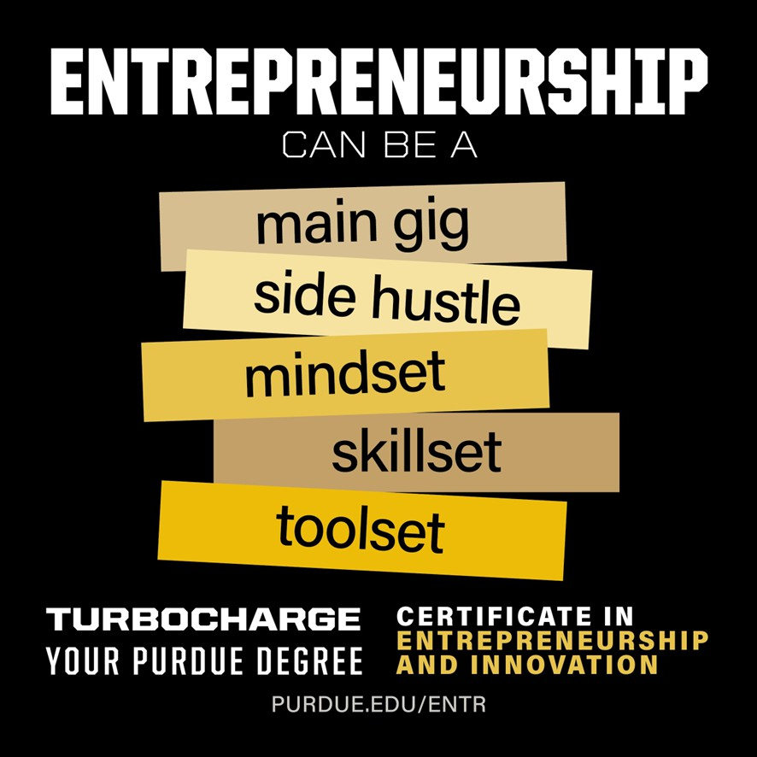

at Purdue

Nathalie Duval-Couetil, MBA, PhD
Director, University Entrepreneurship Education Initiatives Professor, Technology Leadership & Innovation natduval@purdue.edu

Program Overview
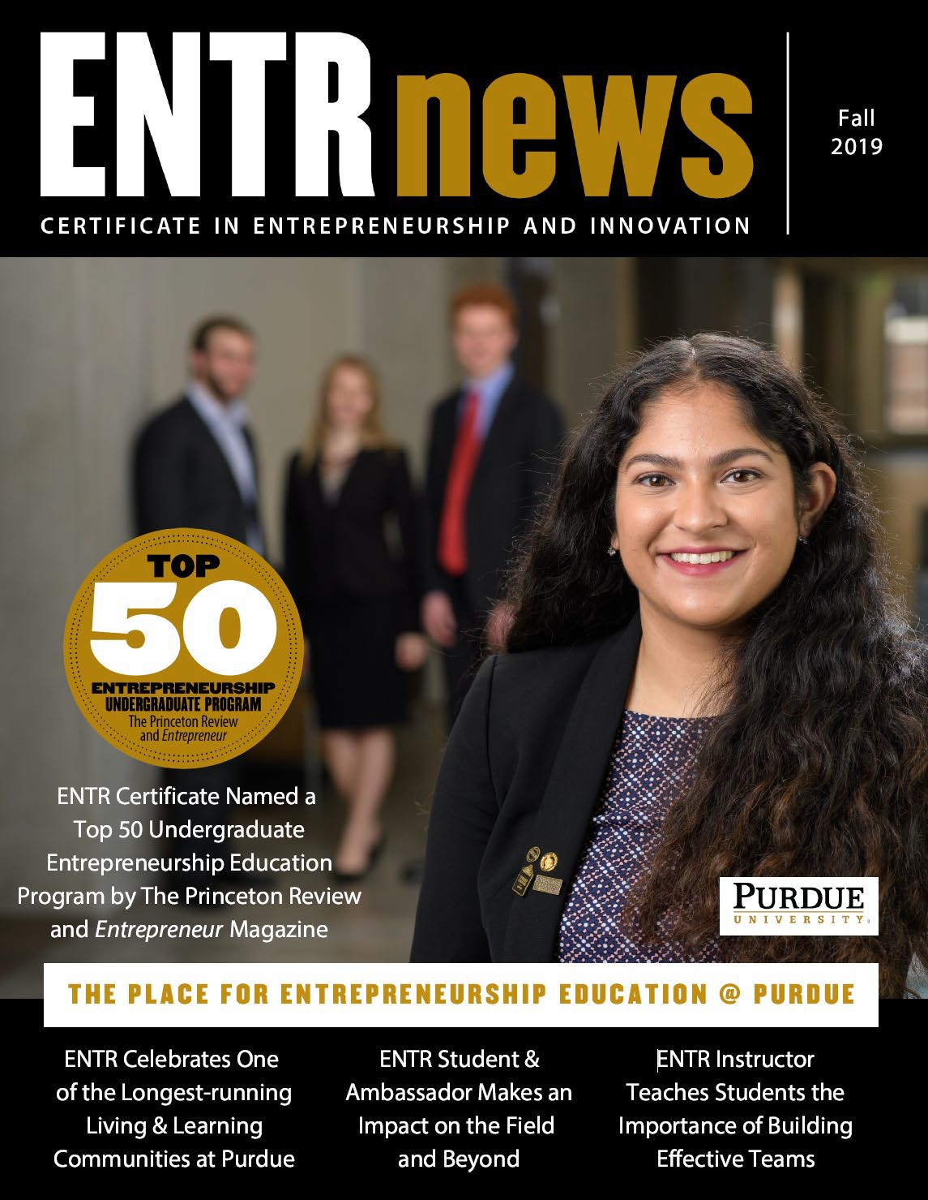

Similar to a minor, available to all majors 60+ entrepreneurship courses/year 2000 students from all majors
Among the largest programs in the country Administered through the Office of the Provost Work closely with all of Purdue’s colleges Launched in Indy in Spring 2025

Flexible Program Requirements

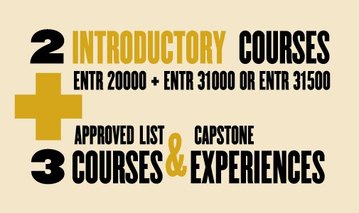
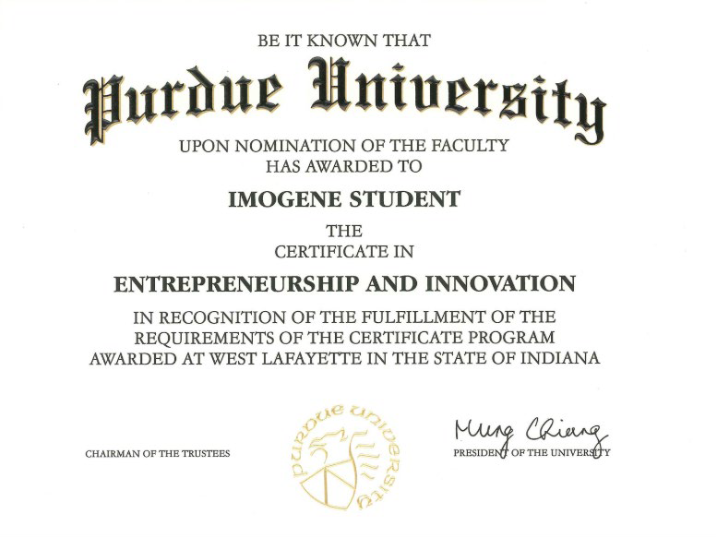

Experiential Interdisciplinary Courses

ENTR 20000 - Introduction to Entrepreneurship and Innovation* - 11 sections per semester ENTR 31000 - Marketing and Management for New Ventures* – 7 sections per semester ENTR 31500 - Business Planning for Social Entrepreneurship
ENTR 32500 - Global Entrepreneurship and Innovation ENTR 46000 - Internship and Career Preparation Seminar* ENTR 48000 - Entrepreneurial Leadership & Careers


ENTR 48100 - Consulting for Emerging Enterprises ENTR 48200 - Venture Planning Studio
ENTR 49000 – Discover Indy Entrepreneurship* 2 Entrepreneurial Learning Communities
* Offered at Indianapolis campus



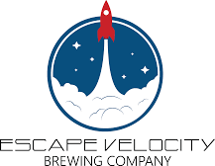

Community Engagement – Consulting Course




Example Client Companies

2022
- Charles F. Day and Associates
- KLD Alzheimers Association
- Premier Detailing and Wash
- YWCAEmpowerment Services
- Anu/Heloponix/Gropod
- Escape Velocity Brewing
- Rose Market
- United Way of Greater Lafayette

2023
- Goodstuff USA
- Lyn Treece Boys &Girls Club
- Lightstone Education Center
- Scout Lafayette
- Aimee Ness Realty
- Junobie
- Mental Health America
- Two Tulips
- Flora Candle Company
2024
- 21 Petals
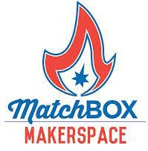





- Central Catholic Jr/Sr High


- Insignum AgTech


- North Side Machine &Tool
- Aerovy
- People’s Brewing Company



- Phoenix Paramedic Solutions

2025


- YWCAof Greater Lafayette
- Greater Lafayette Family Shelter
- Cars for Keeps


- Tricia's Hope
- Homestead Resources


- Dimension 7




- Essentially Aqua
- Millie's Thrift Store
- The Vegan Cheese Lady


- 21 Petals
- North Side Machine and Tool
- Lafayette Catholic Schools
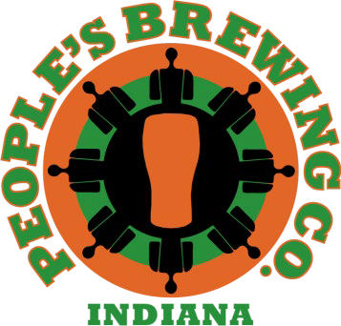





Graduate Level Course

Role of Education in the Ecosystem

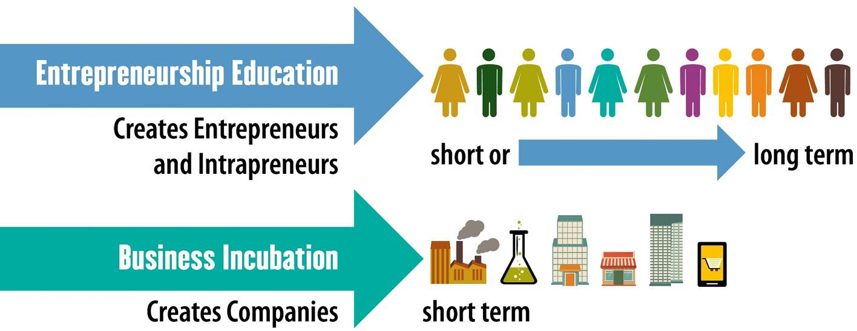


Entrepreneurship Program Impact

1000+
NEWSTUDENTS PARTICIPATE PERYEAR
2000+
STUDENTSENROLLED INENTRCLASSES PERYEAR
15,300+
STUDENTS ENROLLEDTO DATE
60+
ENTRCLASSES OFFEREDPER YEAR
550+
CERTIFICATES AWARDEDPER YEAR
200+
ACADEMIC MAJORS ENROLLED
96%
OFSTUDENTS BELIEVEITWILLBE USEFULTOTHEIR FUTURECAREERS
4OUT5
STUDENTSEXPECT TOWORKINA STARTUPINTHE FUTURE
800+
COMPANIES LAUNCHEDBY ALUMNI
�700M
INFUNDINGRAISED BYALUMNI VENTURES

Recognition

- Princeton Review Top 25 Program
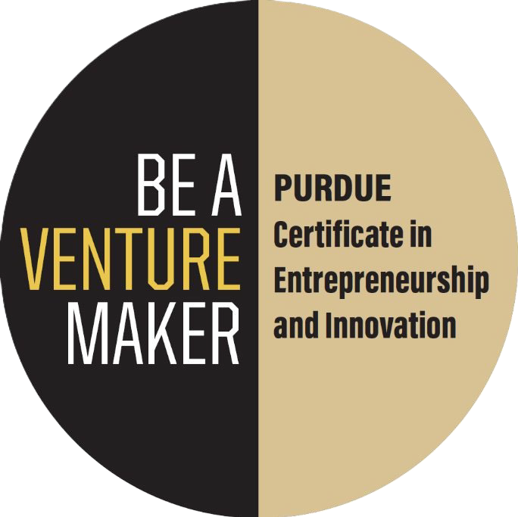

- Entrepreneurship Course/Program of the Year 2025 (ACEEU)
- Model Entrepreneurship Program Award ( USASBE)
- Top 5 Program (GCEC)
- Excellence in Curriculum Innovation (Deshpande Foundation)

Select Alumni Ventures in Indiana

Glassboard is a hardware product development firm for clients that range from startups to fortune 500 companies.
“We're alreadyengaged with students, hiring interns, and sponsoring the Purdue Indianapolis Motorsports club.”
Grant Chapman, CEO
Multiply Technologies provides ITasset management solutions to organizations.
“Some of my biggest career decisions have been impacted by relationships I built through the program.”
Doug Booth, Founder and CEO

Plum and Poppy is a wedding planning company &The Barn in Zionsville is an event
venue in Zionsville.
“The entrepreneurship program showed me how to bring a concept to life and use my creativity to solve problems.”
Sarah Bennett, Founder

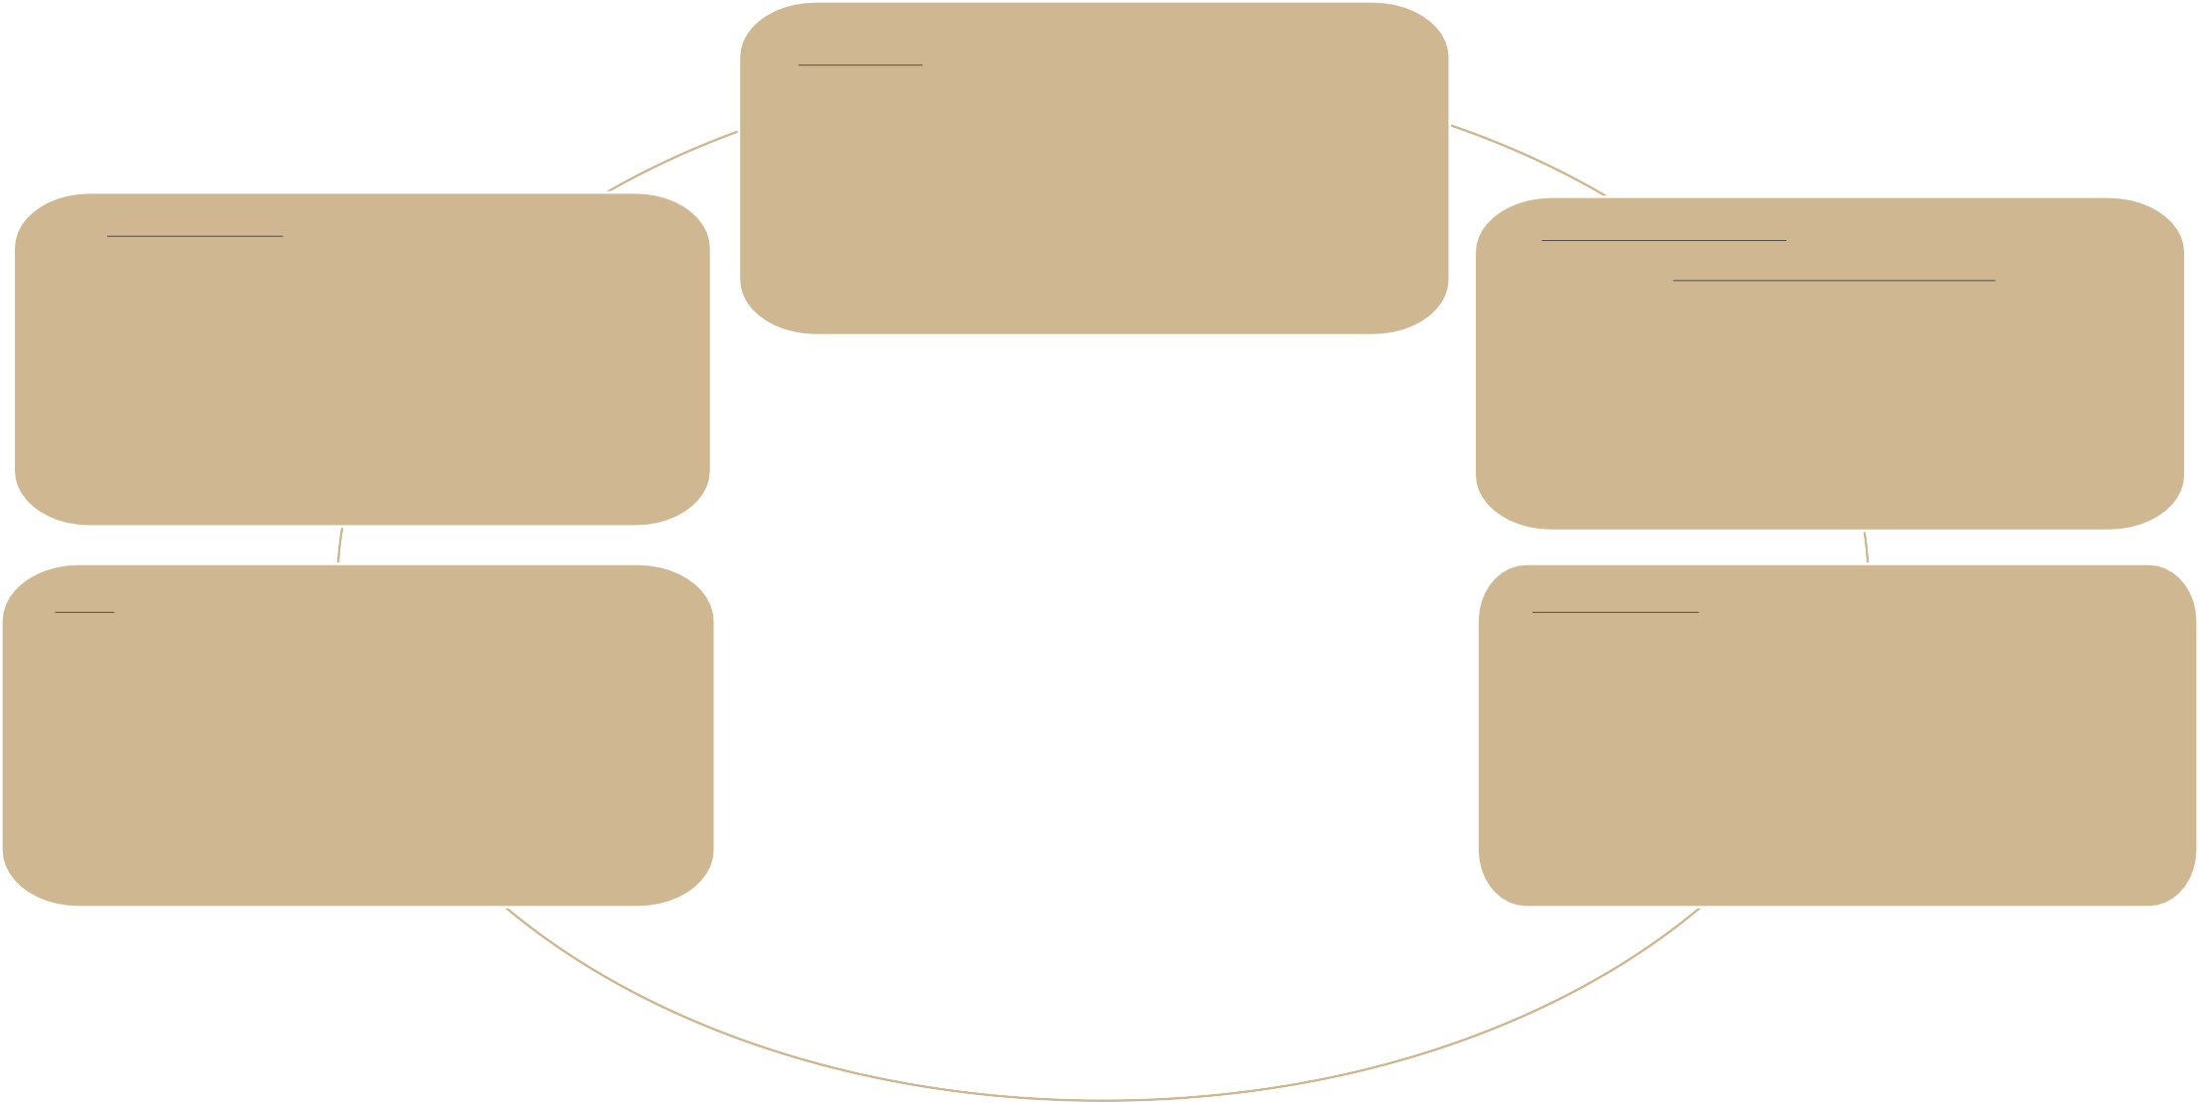
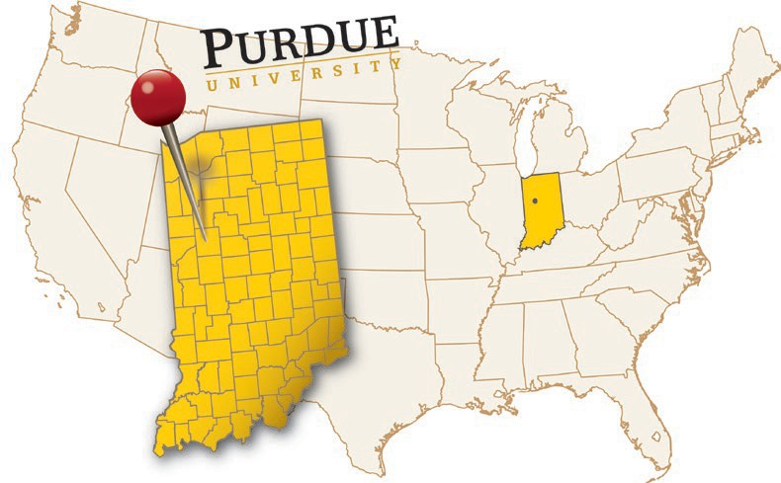







Anu is an Ag-Tech company empowering people to grow their produce at home.
“The program is the lowest-risk, highest-reward opportunitythat complements any degree. It enriched my classroom experience and inspired me to found my company”
Scott Massey, Founder and CEO

KODAis a mural artist commissioned by Fortune 500 clients and communities.
“The program paved my wayto creating a
$1M+ business in my 20s. The hands-on approach and mentorship is why I had the confidence to pursue my artistic dream.”
Koda Witsken, Owner and Lead Artist
Azzip Pizza operates 13 locations across Indiana and Kentucky over 300 employees.
“The ENTR program, where Azzip was born, gave me the confidence and tools to turn my idea into reality. The mentorship I received was critical to launching and growing my business.”
Brad Neimeier, Founder and CEO

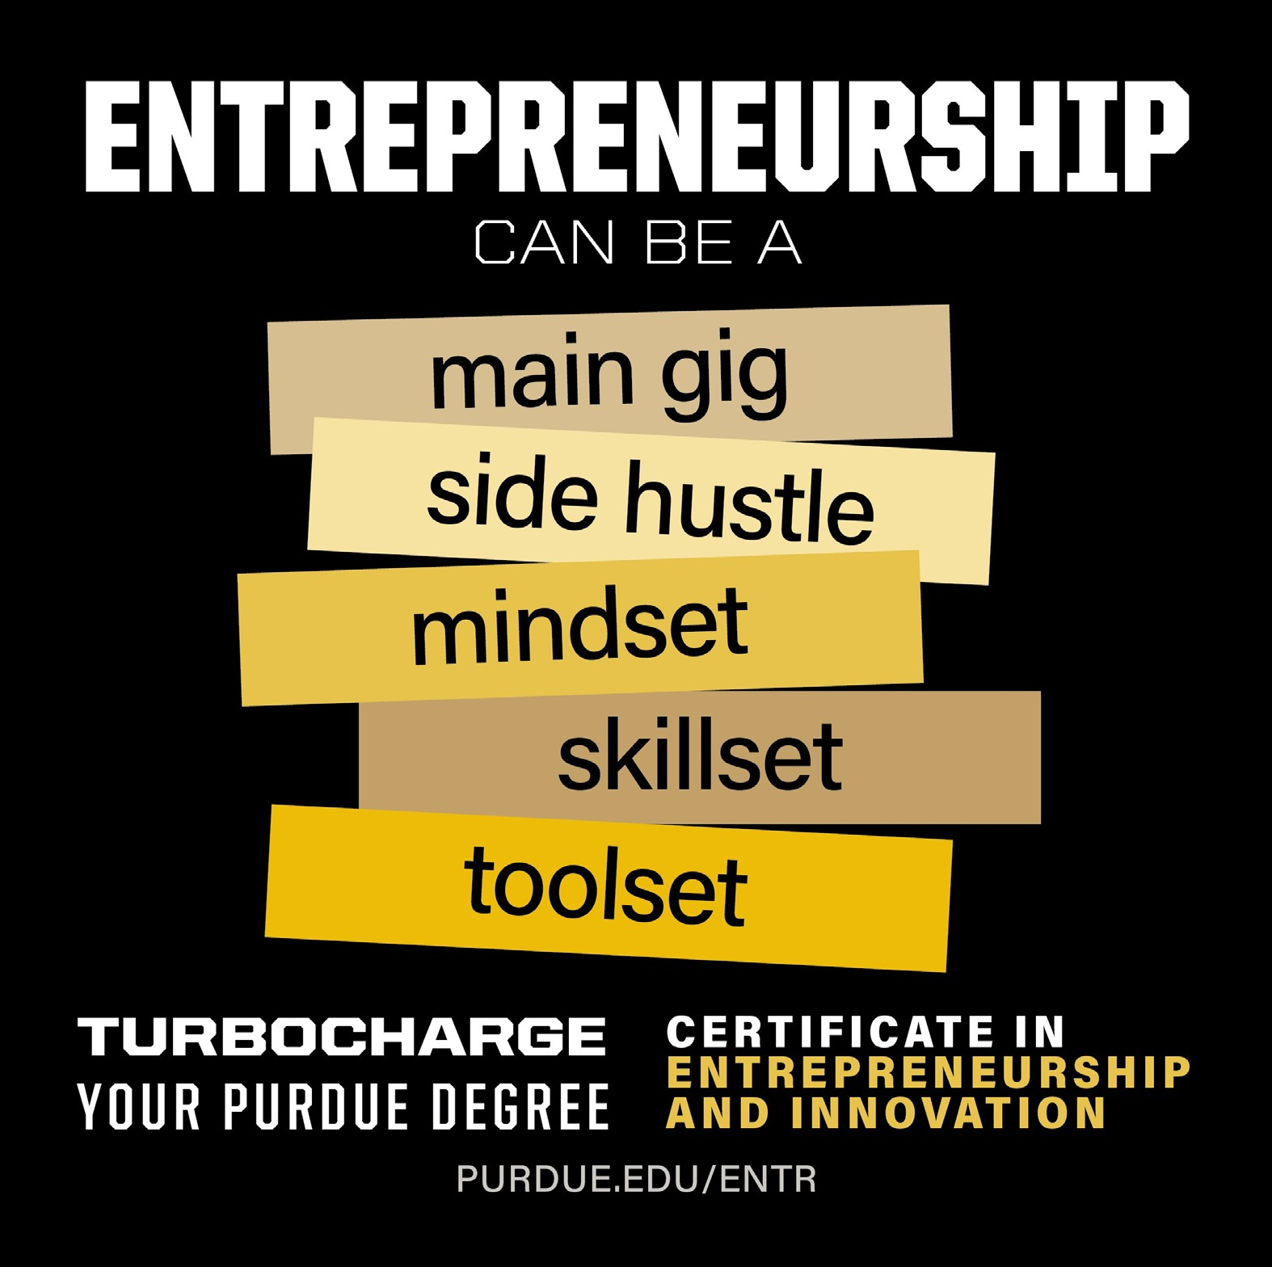
Thanks!

Questions?

