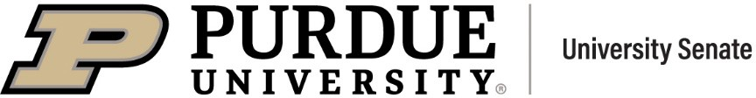
Senate Document 24-03
Amended 21 October 2024

To: | The University Senate
From: | The University Resources and Policy Committee (URPC)
Subject: | Access and time for voting in national elections
Reference: | Declarations from Brown and George Washington Universities to support voting by canceling classes, and link to site mapping class  cancelation efforts by universities across the U.S.
Disposition: | University Senate for Discussion and Adoption
Rationale: | Public institutions are intended to educate citizens. Toward that end, Purdue University has long-supported civic engagement. In 2021, the Purdue University Board of Trustees adopted a civics literacy requirement for all undergraduate students, with the aim of preparing a more knowledgeable and engaged citizenry. The most important aspect of citizenry is the casting of a ballot. Denying students, faculty and staff access to adequate voting facilities on a national election day is in direct opposition to these goals.
Proposal: | The university will work with county boards of election to provide facilities support for voter registration and both early and election day voting in national elections held every other year. On voting day, no quizzes or exams will be held, so if a student misses class due to long lines, they will only need notes for the day. If the university is unable to secure an adequate number of sites to provide all students, faculty and staff the opportunity to exercise their civic rights and vote in national elections on campus, then classes will be  cancelled so they can go off campus to vote.

Committee Votes:

For (11):  Andy Baker Jonathan Bauchet Daniel Cziczo  Benjamin Dunford | Against (0): | Abstained (0): | Absent (1):  Min Chen

Lori Hoagland Kee-Hong Kim Paul Mort Julio Ramirez Brian Richert
John Sundquist Howard Zelaznik

References:
After faculty vote, federal Election Days designated University holidays at Brown https://www.brown.edu/news/2020-09-09/election
Announcing a University Holiday on Election Day 2021 https://president.gwu.edu/announcing-university-holiday-election-day-2024 Mapping Election Day Across the U.S. Mapping Class Cancelation https://www.dayondemocracy.org/map

