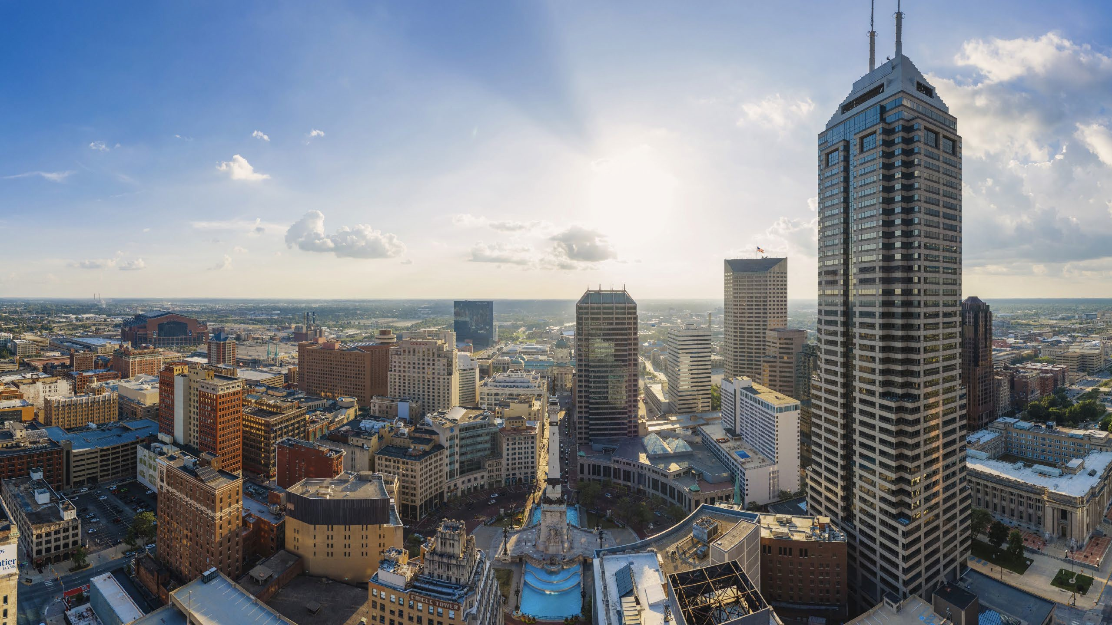

The next giant leap is HERE.

ONE PURDUE
West Lafayette Indianapolis

Our Indianapolis presence brings a new and fully integrated expansion of Purdue University to the capitol city.
- Indy talent pipeline
- Accessible excellence and student life
- Experiential education to accelerate an innovation-based economy

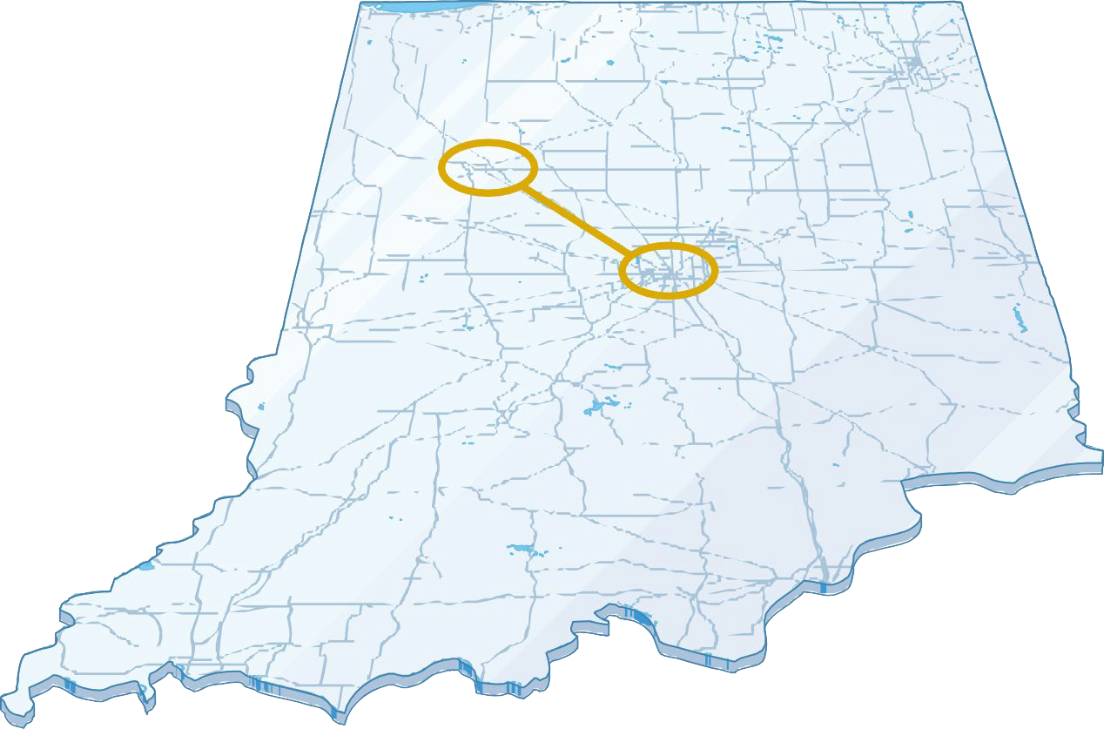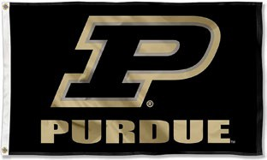
- An expansion of West Lafayette
- Future industry focused
- Built by Partnering w/ Tech businesses
- Integrated with Community

INDIANAPOLIS WINS
  - 13 undergraduate programs at launch
  - 6+ new undergraduate programs in ‘25, ‘26
  - 10 MS programs at launch
  - 6+ New MS programs launching in ’25
  - Purdue + Dallara program in location
  - Purdue + Spectron RX program in location
  - 50 Lilly Scholars in Indy
  - Successful launch! VIP; EPICS; The Data Mine.

INDY 1st YEAR BY THE NUMBERS

2024-25 Student Information

HOUSING/FACILITIES
STUDENTS
FACULTY & STAFF
CONNECTIONS
ACADEMICS LIFE
809
STUDENTS IN INDY HOUSING
- North Hall & LUX
- 50 Lilly interns at LUX in INDY
- 12 current buildings
- Several future locations approved for build or lease (ASB; 501, 520,401 )
2912
Students at launch
210
Winter graduates
80+
INDY-BASED FACULTY

85+
INDY-BASED STAFF

298+
Instructors per semester
clubs
NEW
Student
Over 60
WL-IND
Bus Rides
Over
30,000
450
Courses/semester
Academic Success Center
The Data Mine-15 projects
Purdue Team Store OPEN

TOTALITY TO TOTALITY

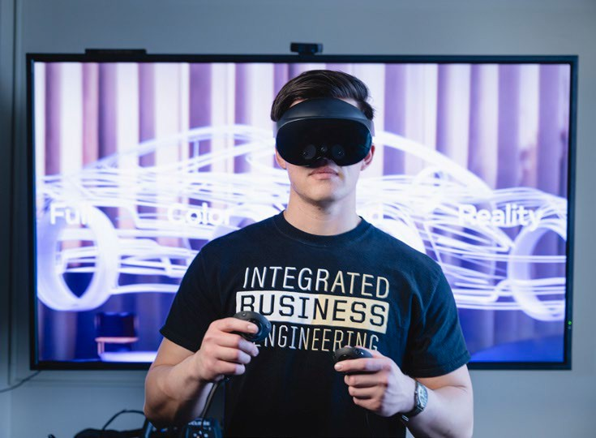
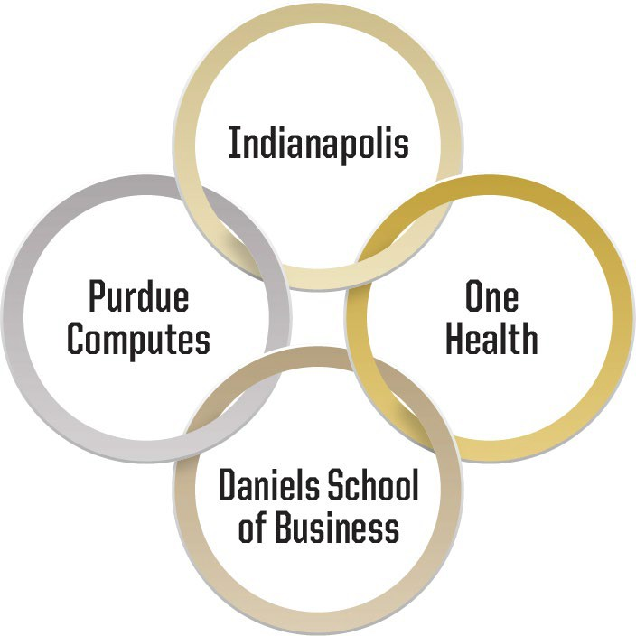
  - Mission-Driven. Programs must advance the mission of Purdue University and align with strategic goals.
  - Individualized Student Success. Programs give students a competitive advantage in the market.
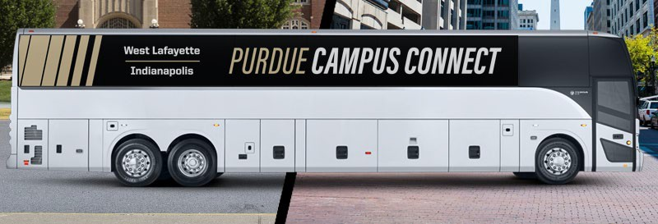
  - World Readiness. Programming prepares students for work, life through career relevant experiences, internships, work-based learning, and experiential education.
  - Showcase Central Indiana. Programming leverages unique opportunities available in Indianapolis or the Central Indiana region to showcase future opportunities in Indiana

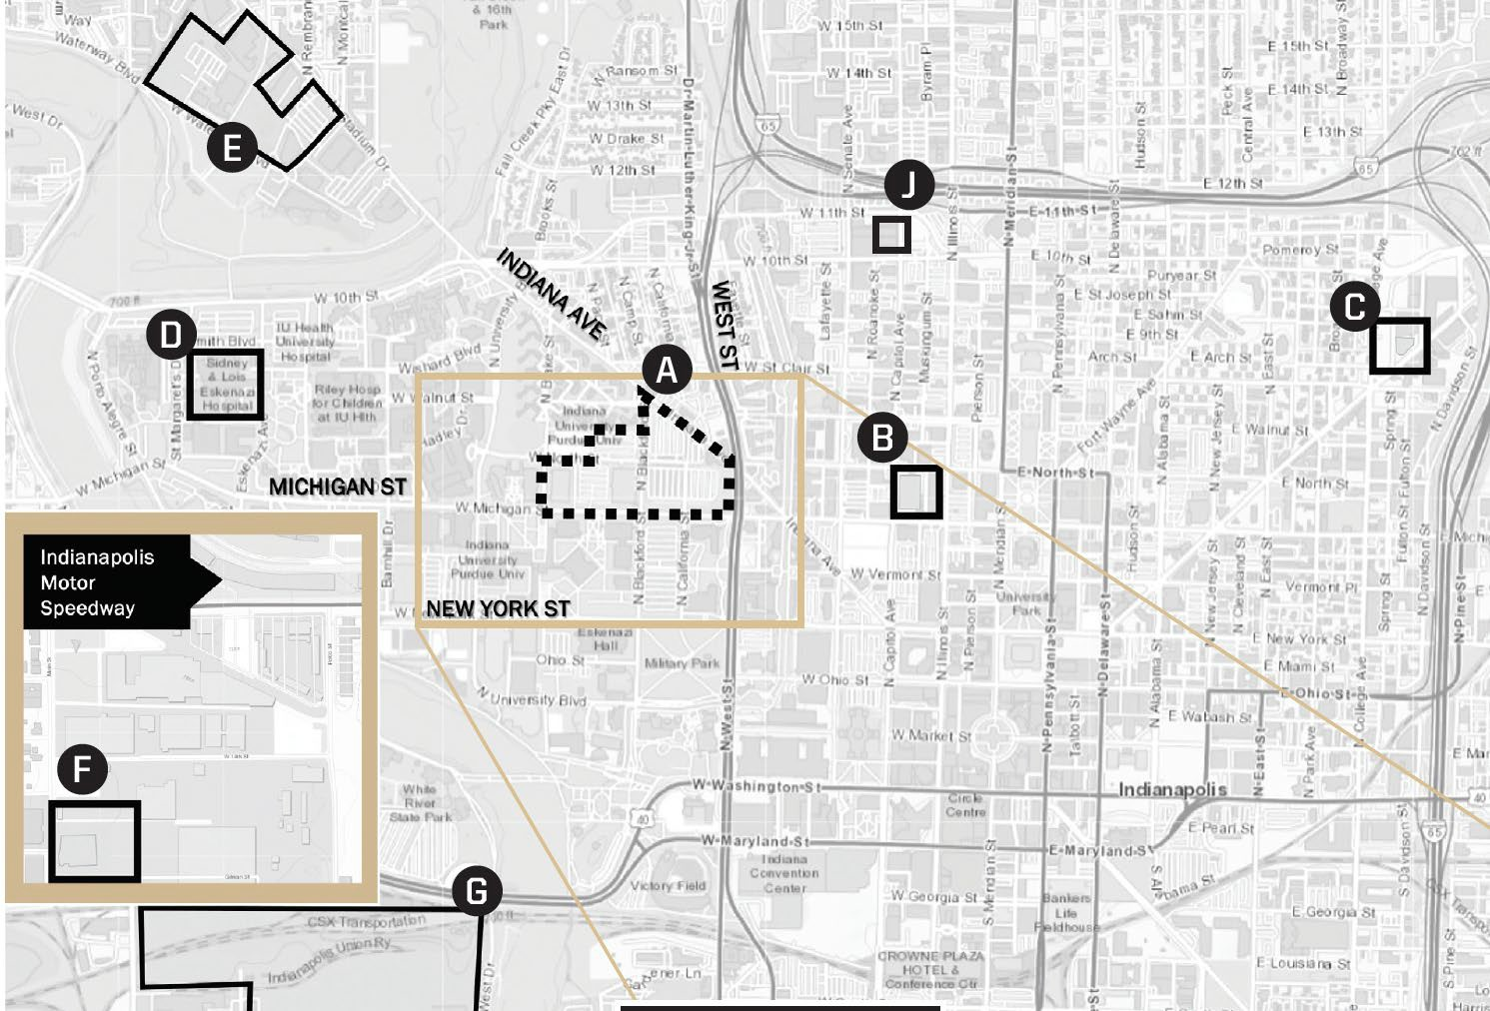
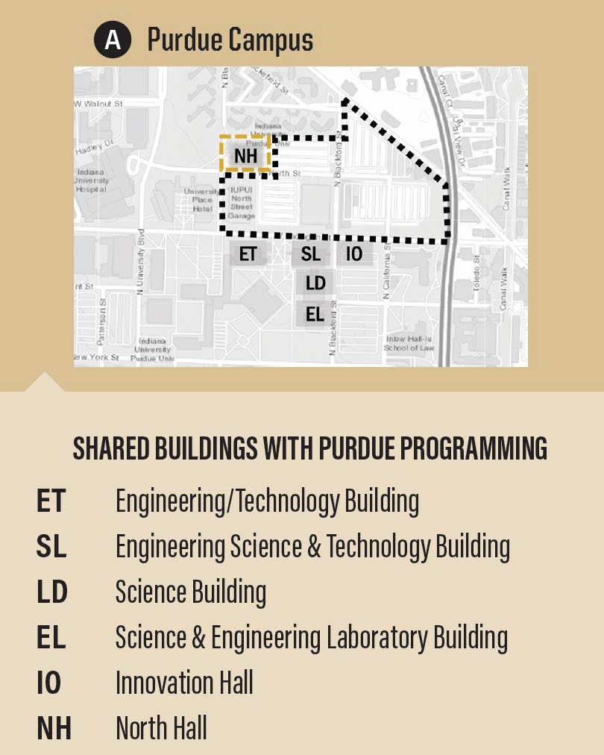
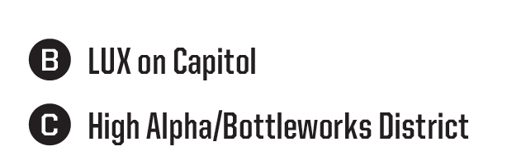
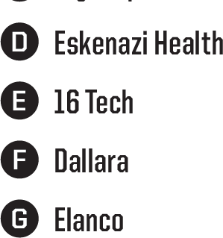
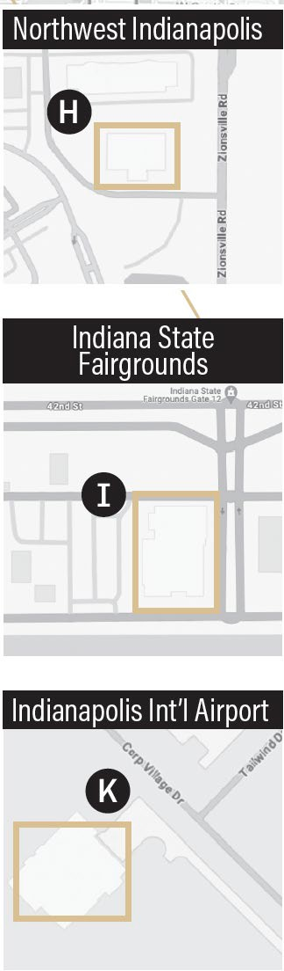





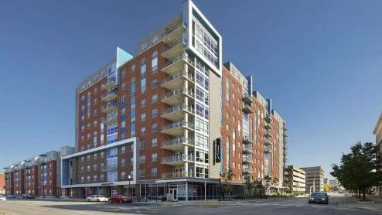
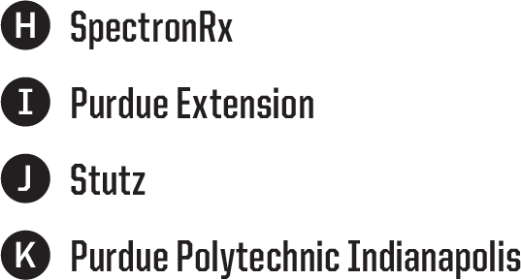
Purdue University throughout Indianapolis

THE FUTURE
- NEW PROGRAMS

Fall 2025
    - B.S. in Actuarial Sciences
    - B.S. in Integrated Business and

Engineering
    - M.S. in Sport Management (Dual location)
    - M.S. in Radiopharmaceutical Manufacturing (MS)
    - M.S. in Chemical Engineering-Pharmaceutical Eng. Conc.
    - Cornerstone Certificate Program
    - Certificate in Entrepreneurship and Innovation

Other upcoming programs
      - Redesigned B.S. in Construction Management Technology
      - B.S. in Mathematics
      - B.S. in Industrial Engineering
      - B.S. in Robotics Engineering Technology
      - Master of Business and Technology
      - M.S. in Organizational Leadership


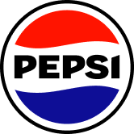
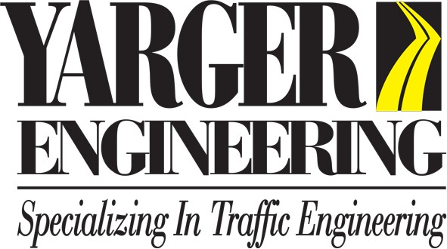

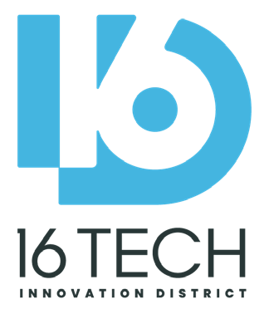


A Platform for Partnerships

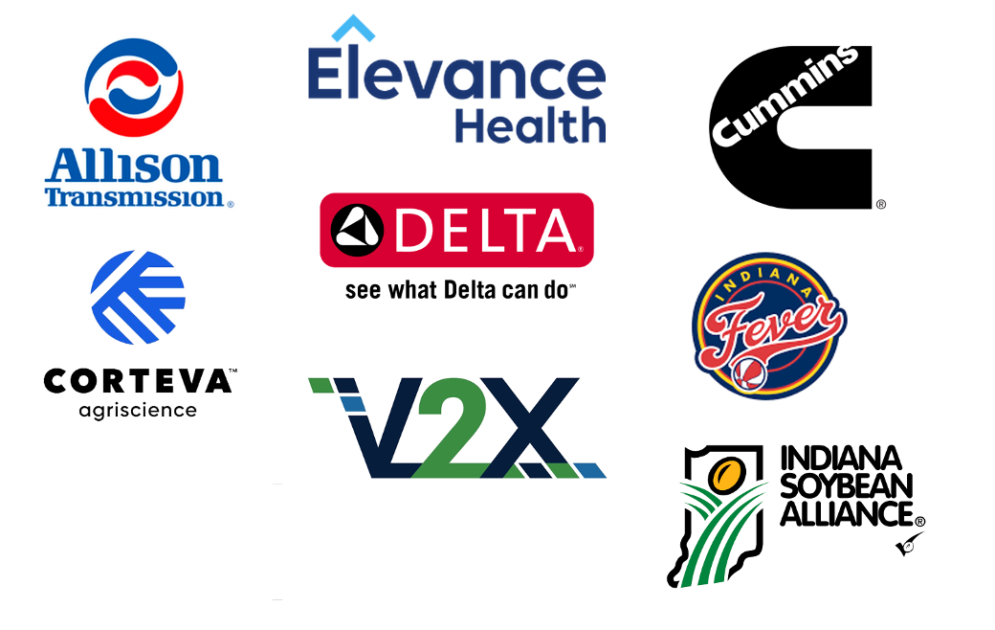


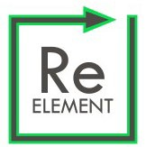
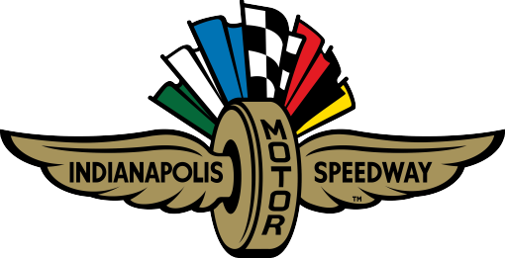
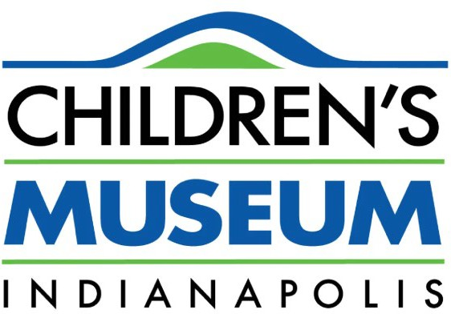

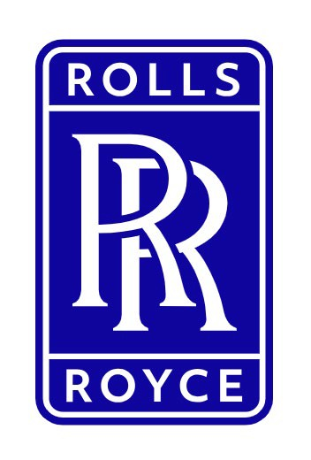


Internships, Co-Ops, Research, & Education

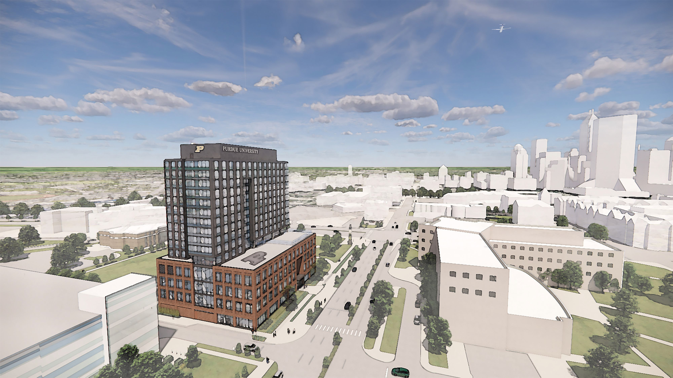
Indianapolis Growth: New Academic Success Building

- 248,000 gsf
- Dining, instructional space, labs, retail, housing
- Student activities
- Maker space
- Community engagement and more!


Questions

