

Second Meeting
Monday, 20 October 2025, 2:30 p.m.
Zoom Meeting

AGENDA

1. Call to order | Professor Mark Zimpfer
2. Statement of Land Use Acknowledgement | Professor Mark Zimpfer
3. Approval of Minutes of 8 September 2025
4. Acceptance of Agenda
5. Remarks of the Senate Chair | Professor Mark Zimpfer
6. Remarks of the President | President Mung Chiang
7. Question Time
8. Résumé of Items Under Consideration by Various Committees | For Information Professor Lisa Bosman
- Consent Agenda  - Senate Document 25-04 Nominee Advisor to the Educational Policy Committee  - Senate Document 25-05 Nominees for the Faculty Affairs Committee  - Senate Document 25-06 Nominees for the Nominating Committee  - Senate Document 25-07 Nominees for the University Resources Policy Committee  - Senate Document 25-08 Proposal for Faculty Mid-Semester Grade Reports  - Presentation on the Cornerstone Integrated Liberal Arts | For Action Nominating Committee  For Discussion Educational Policy Committee
For Information Professor Melinda Zook, Director
Cornerstone Integrated Liberal Arts

12. New Business
13. Adjournment

Second Meeting
Monday, 20 October 2025, 2:30 p.m.
Zoom Meeting

Present: Joseph W. Camp Jr. (Secretary of Faculties and Parliamentarian), President Mung Chiang, Mark Zimpfer (Chair of the Senate), Julio Ramirez (Vice-Chair of the Senate), Patrick Wolfe (Provost), Se’Andra Johnson (Sergeant-at-Arms), Shalom Ablavi Kpetsu, Dulcy Abraham, Eric Adams, Janet Alsup, Arezoo Ardekani, Santokh Badesha, Ashley Bellet, Ximena Bernal, Afsan Bhadelia, David Blon, Lisa Bosman, Ali Bramson, Françoise Brosseau-Lapré, Tom Brush, Stephanie Butram, Stephen Cameron, Wayne Campbell, Chan Choi, Joseph Coates, Dan Cziczo, Dan Degnan, Vince Duffy, Ben Dunford, Jim Dworkin, Ulrike Dydak, Mara Faccio, Julian Gallegos, Jing Gao, Yi Gao, Barb Golden, Tom Hacker, Kyle Haynes, Lori Hoagland, Sarah Huber, Whitney (Yu) Huidan, Morgan Hynes, Katie Jarriel, Alice Johnson, Nastasha Johnson, Bridgette Kelleher, Kee-Hong Kim, Yonsoo Kim, Casey Krusemark, Sarah LaRose, Scott Lawrance, Kiseop Lee, Seungyoon Lee, Leifur Leifsson , Brian Leung, Stacy Lindshield, Damon Lisch, Dianne Little, David Liu, Corey Maley, Ryan Manuel, Stephen Martin, Seema Mattoo, Patricia (Trish) Morita-Mullaney, Paul Mort, Annmarie Nicely, Loring (Larry) Nies, Suranjan Panigrahi, Tae Hong Park, Arun Prakash, Darryl Ragland, Padinjaremadhom (PV) Ramachandran, Brian Richert, Torbert Rocheford, Gustavo Rodriguez-Rivera, Chris Ruhl, Severin Schneebeli, Marisol Sepulveda, Rebecca Jean Siener, Michael Smith, Kevin Stainback, Mohit Tawarmalani, Monica Torres, Sasha Tsymbaliuk, Kim Updegraff, Changyou Wang, Lindsay Weinberg, Rua Williams, Howard (Howie) Zelaznik, David Ziviani. Advisors: Heather Beasley, Michael Cline, Melissa Franks, Cherise Hall, Sheila Hurt, Carl Krieger, Lisa Mauer, Sunil Prabhakar, Haley Oliver, Alysa Rollock, Katherine Sermersheim. Guests: Stephanie Ayala-Chittick, Dave Bangert, Amy Boyle, Dan DeLaurentis, A.J. Frigo, Jamie Mohler, Kim Pearson, Dimitrios Peroulis, Steven Schultz, Heather Servaty-Seib, Tulin Tosun, Melinda Zook.

Absent: Charles Bouman, Xingshan (Shawn) Cui, Eugenio Culurciello, Alejandro Cuza, Amanda Darbyshire, Letian Dou, Abigail Engelberth, Rick Johnson-Sheehan, Bhagyashree Katare, Cheng-kok Koh, Yuli Lyanda-Geller, Abdelfattah Nour, Chris Rogers, Antônio Sá Barreto, John Sheffield, Anthony (Tony) Smith , Ganesh Subbarayan-Shastri, Degfeng Sun, Bowei Xi. Advisors: Lowell Kane, Beth McCuskey.

- Quorum being established, the meeting was called to order at 2:30 p.m.
- Chair Mark Zimpfer read the following Statement of Land Use Acknowledgement, as required by Senate Document 20-55:

The Purdue University Senate acknowledges the traditional homelands of the Indigenous People which Purdue University is built upon. We honor and appreciate the Bodéwadmik (Potawatomi), Lenape (Delaware), Myaamia (Miami), and Shawnee People who are the original Indigenous caretakers.
- The minutes of the 8 September 2025 Senate meeting were entered as read.

- The agenda was accepted by general consent.

- Chair Zimpfer began his remarks, which were as follows:

“And now to keep good on my promise, to keep my remarks brief, I only have two short comments to make before we get started in earnest. First, I would like to say how thrilled and pleased I am with the Senate committees' performance. This is on AI literacy, a shout-out to EPC and UCC for jumping in and doing a lot of work quickly with more work to come, but great job so far. And as well as various Senators, as well as committees participating in the health benefits discussion. These are great examples of leadership and work ethic to solve problems and issues that are facing us here at Purdue. I really appreciate everyone's quick turnaround to request, and it makes this job a little bit easier. So, thank you so much.

And then my second comment, as a reminder, during any live Q&A with guest presenters attending a Senate meeting, please refrain from reading an editorial statement. Simply ask your question and await the response. This follows proper decorum and allows more questions to be asked. I will listen to the question, if we are getting into a two-minute plus statement, I will be stepping in as Senate Chair to ask you to direct the question towards our guest. I want to make sure we can recognize as many senators as possible during the open Q&A time. Thank you very much. President Chiang, you are recognized to begin your remarks, please.”
- President Chiang presented his remarks [Appendix A].

“Thank you very much. Can I have the slide up please? Thank you. Good afternoon, everyone. Thank you, Chair Zimpfer. I would like to focus the next 10 minutes or so with three follow-ups from the last meeting that we had. Again, all in the spirit of solving problems together. Each of the three topics will be summarized by one of the university's EVPs and a core member of this team. So, Chris Ruhl, CFO and Treasurer, and Amy Boyle, Vice President for Human Resources, will provide an update on prescription medication plan. Dan DeLaurentis, EVP for Research, and Ken Sandel, Associate Vice President for Sponsored Research Services will provide an update on the IRB protocols in PERA. And third, Patrick Wolfe, the Provost, and Haley Oliver, the Vice Provost for Grad Students and Interim Senior Vice Provost for Teaching and Learning, will provide an update on AI competency across different disciplines. In consultation with Senate and its committees, I want to echo again another message that Chair Zimpfer just provided and thanking our colleagues and Senate for this collaboration. The team will then answer any further questions on these topics. If you have some questions outside of these topics, of course you are free to ask those as well, and I or some other colleague will try to answer those.
So first on prescription plan, as Chairman of the board of Trustees, Gary Lehman said last week, the Board of Trustees and the HR team have been meeting with colleagues and will continue to explore options for the most impacted colleagues, while working to minimize the average employee cost of the 26,000 colleagues.
Going forward, they will also lean further on discussion with CSSAC and MaPSAC. Turning to Chris and Amy.”

CFO and Treasurer Chris Ruhl: ”Thank you Mung. I will flip this to Amy in a second but just want to express on behalf of the leadership team and the board and folks on the HR side, for your engagement and feedback to date and expect we will be getting

more of that along the journey. I will yield to Amy, her team has been gathering specific feedback working with the various advisory groups, meeting with individuals daily up to over a couple hundred right now on tailored solutions for what are very personalized decisions on healthcare in general. She will give you just a general update.
I would just note, there were questions both last month and this month, for which there are written responses that I believe get posted and then also refer you to a Purdue today update. That was a week ago, Wednesday the 15th, that provided, again, a little bit of background and oversight on this. But I will yield to Amy and then I will be around to help supplement and answer questions if we have
them.”

Vice President for HR Amy Boyle: “Great, thanks, Mark. As Chris mentioned, I want to make sure that we give a big thank you to everybody because we received a lot of thoughtful feedback over the past few weeks. We did meet with the board, we met with a variety of faculty and staff, and we really appreciate hearing directly from you about how these changes have impacted all of you. And we will continue to meet regularly with the advisory groups, particularly CSSAC, MaPSAC. And then obviously continuing to work closely with Mark and do appreciate the partnerships and we have seen some great help there and insight as we have worked together and will continue to look for possible solutions and new ideas.

It has been helpful too; to have these individuals and these groups share information and bring information back to us so we can produce solutions together. As questions have been received, they have been bringing them to us and that has been extremely helpful. And so, we hear people and we do understand the concerns. Our goal has always been, as Chris mentioned, to provide a benefits that support the health and well-being of everyone, faculty, and staff, while remaining financially
sustainable for the university long-term. So, and you saw some of this in the Purdue Today article, we do cover about 26,000 employee lives, that includes spouses, employees, dependents, and we continue to pay about 90% of the premium cost, which is about 75% of the total cost of care. Both are higher than local market and Big 10 averages. As some of you know, our premiums are tiered based on salary, balancing affordability and coverage for all members. While we do still have to prepare for worst case scenarios which can be extremely complex. Many of you who have collaborated with our team over the past few months understand how complex healthcare is, particularly prescriptions. In any given year, when we look at our tier two, where medication's hit, about 30% of members reach their deductible, about 4% reach their out-of-pocket max, which is a combination of healthcare and prescription utilization. Our plan design is grounded in, and will continue to be, in the collective goals of accessibility, quality, transparency, consumerism, and financial sustainability. The formulary change was made with those principles in mind.
While we took steps to ease the transition, we did a phased approach, provided some financial support, communication, and personalized assistance. Obviously, change is never easy, and so we do remain committed to continuing to review and monitor the impact of those changes. We are going to continue to enhance outreach, particularly to those most affected. We are having conversations now with Affirmed and our PCAs

to find those individuals that do have the most significant impact, so we can take more of a concierge approach to help those individuals find the most affordable solutions.

Finally, I do want to really continue to encourage people to reach out to human resources. We have seen a big increase in faculty and staff reaching out just in the past week, which is exactly what we had hoped for. The response from many who did join those conversations has been positive. The openness and engagement we are seeing is something that we appreciate, because the more we hear from you, the better we can help you navigate the transition and continue to try to find affordable options that meet your needs. That is something that we will
continue to do, we will continue to increase outreach, but then please do take those opportunities to meet with someone in our benefit service center. We are happy to do that in person. We have a lot of different options for collaboration with open enrollment occurring right now. So, please do reach out and let us try to help
you work through this. Thanks.” Chair Zimpfer: “Thank you, Amy.”
Chair Zimpfer recognized Executive Vice President for Research Dan DeLaurentis.

Vice President Dan DeLaurentis: “I have my colleague Jamie Mohler here from my office, who is most directly involved in the IRB module and all activities related to IRB. Jamie is here as normal with the University Senate. So, big picture, I am not going to surprise anyone here. We have been working with the PERA system across several different modules, starting with our sponsored programs and such. The IRB module is the last module, as I understand it, to migrate into the PERA system. I am also not going to surprise anyone by saying, of course, that no software is perfect and no processes are perfect, but we have certainly tried to hone our skills at assisting folks with the migration and the navigation through the various modules as we have deployed them. I have come to appreciate the flow charts and visuals that allow you to track the various activities regardless of what module you are in and the visibility and the transparency therein. I think none of us, either the actual teams doing all these functions or faculty enjoy the various emails back and forth and lack of transparency in some of the previous systems that we had. So, that is something we are paying attention to. With the IRB module becoming live, we have provided answers to the specific questions you have asked in a Purdue news article that came out today. We hope, as everyone gets used to this, that we have a comprehensive approach to the migration. Some things are migrating automatically. For those things that are not migrating automatically, we can provide assistance. We still have access, for several years, to the Cayuse system, and so we hope that the processes we have in place in the migration and the ability to help people navigate the process will be helpful. I will leave it at that and see if we have any questions for me or Jamie.”

President Chiang: “Chair Zimpfer, if we may move on to the third update on the academic side and then, with your permission, open the floor for general questions.” President Chiang called on Provost Wolfe and Vice Provost Oliver.”

Provost Patrick Wolfe: “Briefly, Chair Zimpfer alluded to this earlier, I do not know if you could see me on the screen or not, but I gave a sort of two thumbs up when he thanked everybody. I think we have moved quickly to address AI competency. There was a lot of work over the summer with a small group of faculty and Susan South and again, Senate leadership. And then moving in, as we started the new year,
to really start to dig in to understand, what it would look like to have a fundamental learning outcome across Purdue that involved AI literacy? Understanding that of course, we cannot just add curriculum and credits and content, we must figure out how to judiciously balance.

Number two, how do we manage the cycle of change? If you think about ChatGPT emerging about three years ago, how rapidly it leapfrogged itself within a matter of months. And universities, we tend to be tuned for the long term, so how do we manage the cycle of rapid change and development in AI? And recognizing again that our high school and college students are a major market for AI innovation. And so, many of you may find yourselves with less aptitude with AI tools than some of our students.
Thirdly, is how we take input from employers. So not just the push, but also the pull to make sure that we are teaching competencies and fundamentals that are going to stand our students in good stead for a long time. I am a little worried that my FORTRAN programming expertise is not going to have the same relevance in the job market today that I thought it might when I was being taught it, because you will all mostly know a lot of coding now is focused on having large language models do it for you.
So without further ado, let me hand it over to Haley. But those are the three things about which I have been thinking. Mark has talked about helping the Senate to move, act, and operate at the speed of business, and I think Haley has particularly good news again to report on that aspect. So, Haley, if I may, over to you.”

Vice Provost Haley Oliver: “Thank you, Patrick. Thank you Chairman Zimpfer, one, for welcoming me to this process. I am quite new to this role, but there has been work and thought around AI literacy certainly predating me. And I will echo you there too, Patrick. I am glad I did not learn completely how to assemble a genome since the internet will do it for me now. So, thankful for that.
In the summer of '25, a group of faculty subject matter experts from College of Liberal Arts, Science, Libraries, Daniel School of Business, HHS, and Engineering came together to consider how we might innovate the undergraduate curricula to respond to this systematic and system-wide demand of AI literate graduates. And obviously, Purdue is not the only one thinking about this, but I think with the support of the Senate, we are among the leaders and certainly are going to be among the leaders in having this built into the curricula.

Major outcomes from this group of faculty-led experts was, it was that they investigated and dialogued around specific skills, feasibility of addition of this to the core, whether it was possible as a foundational learning outcome versus an

embedded learning outcome. What facets of AI literacy, what do we mean by that? Is it just the tool or is it being able to really, the way I guess I like to think about it and to recycle their words, mastering AI working competency. Can you truly use this tool?
And we know as Patrick said, and to reiterate that employers are demanding this. It is a part of the job description, and it is part of our commitment to our students to be able to deliver against that.

The draft summary from the subject matter experts has been given to the UCC and EPC to aid in their discussions towards our universal goal of AI literacy in the curricula. And we recognize that this could require new courses, retooling of some courses, and helping build some of that capacity. Those are some of the discussions that are happening here in the Office of Teaching and Learning is how we might support those, because we know that this will demand some speed, and we know it is a changing environment.

Using a data-driven approach, we are still working with the data now, but we are looking at the core curricula and how we can best implement this into the core, should that be, and we expect it to be the true wish, but to be the least disruptive to our plans of studies. We know that we have high demands and high expectations for our students. This is important. Where can we best integrate it without being the least disruptive? And so, I know we have had great conversations with the UCC and EPC to help consider what this might look like and just know that the Office for Teaching and Learning is standing by to support. Anything further you need from me, Patrick?”
Provost Wolfe: “I think that is perfect, and I know we will have a chance to get into questions very shortly.”

Chair Zimpfer: “Thank you very much, Chris, Amy, Dan, Patrick, and Haley.”
- The answers to pre-submitted questions were posted to the Senate website [Appendix B]. Chair Zimpfer opened Question Time.

Professor Sara LaRose: “Thank you, Chair Zimpfer. Some of my faculty and staff have requested that I ask about the changing requirements for the civics literacy fulfillment. They recently told me that no longer will courses be something that fulfills that requirement, and instead all students are to complete 12 hours of podcast listening. So, they were wondering what the rationale was for that change. Thank you.”
Provost Wolfe: “I am happy to speak to that and happy to follow up offline. Every year we look at civics literacy, we look at completion rates, and we also look at what value looks to be added by what activities, depending on how many students are doing what. We are also working to try to make it a little more uniform across the whole system, including all our campuses. I think based on some earlier discussions this year, it seemed clear from the data that the podcasts were looking to be the vastly preferred method, but from and by many of the students. So I am happy to follow up more offline, it is not meant to be a jarring decision or change. It is more meant to

make sure that we are making the civics literacy work as efficacious as we can be. I would be happy to follow up with that one offline and I think open to continued suggestions and refinements about how we might further modify it. It continues to be a work in progress.”

Chair Zimpfer: ”Thank you, Provost Wolfe. Seeing no other questions, the chair recognizes Senator Bosman to deliver the Résumé of Items under consideration.”

- Professor Bosman, Chair of the Steering Committee presented the Résumé of Items under consideration by the various Senate Standing Committees [Appendix C]. It was noted that the changes to medical coverage were to be added to the FAC Résumé of Items under consideration.

- Consent Agenda
  - Senate Document 25-04 Nominee for Advisor to the Educational Policy Committee
  - Senate Document 25-05 Nominees for the Faculty Affairs Committee
  - Senate Document 25-06 Nominees for the Nominating Committee
  - Senate Document 25-07 Nominees for the University Resources Policy Committee
Chair Zimpfer reminded the Senate that a Consent Agenda allows a body to group items that are likely to be uncontroversial or to require little discussion and decide them all at once. If any member requests that an item from the Consent Agenda be pulled out for individual discussion, that request is granted without debate. There were no nominations from the floor and no request to pull an item from the Consent Agenda. The consent agenda was approved by general consent.

- Professor Vincent Duffy, Chair of the Senate Educational Policy Committee presented Senate Document 25-08 Proposal for Faculty Mid-Semester Grade Reports, For Discussion.

“Thank you, Chair Zimpfer. I would like to introduce the Mid-semester Academic Progress Document 25-08 for first reading. This document was originally a policy to help provide students with information before withdrawal dates. And as the implementation of this continued, there was a change to the time at which students could withdraw. The intention was to give the students more information before they had to make decision about withdrawing. So the faculty were providing
information about grades by the midpoint of semester when the withdrawal date was at the midpoint of semester.
There was a change that made the withdrawal date later and the implementation of that needed to be clarified. The Educational Policy Committee worked with the original document when it came to our attention in cooperation with Lesa Beals from the Registrar's office. The expectation was that the faculty would continue to give the information to the students by mid-semester, even though the students had additional information. And so the document that is presented here is one in which we just clarified that it was information provided to the students at the midpoint of

semester, and it was without change. That part that was in the original language, and it is toward the bottom of first paragraph on the left, on the second page. It says that originally to be provided before the withdraw date, and it has changed now to be provided at the midpoint.

There is a table that is in there, and this is a version of the document that includes some information about non-standard semesters, in terms of what that would mean for midpoint. But then we removed that information and we wanted the faculty just to see that that was there. But there is a table that the Registrar uses for information about the dates for when mid-semester grades could be reported and when withdraw takes place for students in non-standard semesters. So, that table is not intended to be in the policy document, but it is added and then shown because it was in first reading and second reading when the changes were made. We have an alternate version between us in cooperation with Secretary of Faculties and we can decide which document you want to bring to the second reading for the vote in November, and we can fold in any questions or any need for revisions into that.
There is some language that was removed, and it is in the second column there on the second page to help clarify what is the instructor's responsibility in the process for reporting mid-semester grades. We think it gives some flexibility back to the faculty but still maintains the intention to give information to the students at the mid-semester. And the original change to policy, which was to change the date of withdrawal still gives discretion back to the students in terms of when to withdraw with the additional information still provided at mid-semester.

One thing that is changed also in that second column is a clarification on how the reporting can take place. And we have seen that that information can be reported in MyPurdue easily. Most are reporting in the university learning management system and there's discretion left to the faculty in terms of how to provide information back to the students. In smaller classes, we tend to discover, and EPC said this, students are getting the information from the faculty, but it is in a small number of classes where they are still coming up as an issue and being reported back to the provost's office. So here, EPC is trying to provide the clarification and support both students and the faculty in terms of expectations.

I can see a question has come up there and I do not have anything further. And I have Lesa Beals here with us as Associate Registrar.”
Chair Zimpfer: “Thank you, Senator Duffy.”

In answer to a question from Professor Zelaznik, Professor Duffy clarified that the voting tally was based on a majority of the voting members of the EPC. Only those members with full voice and vote on the EPC, voted on the document. The ex-officio members with voice only were not included in the final vote tally.

- Professor Melinda Zook made a presentation on the Cornerstone Integrated Liberal Arts Program [Appendix D].

“Hello, I am Melinda Zook, and I am the director of Cornerstone Integrated Liberal Arts. This program is now in its ninth year here at Purdue. It is a good time to bring everyone up to date.

Our program has grown. The opening sequence, Transformative Texts, which I will introduce in a moment, has scaled up since its pilot year in 2017 [Slide #2]. That year we taught around 150 students, and last year we taught over
10,000, and we are on course to teach another 10,000 this year.
The student composition in Transformative Text reflects the university as a whole. This slide shows you the number of incoming students by college this fall [Slide #3]. We are currently teaching 5,000 of them. We have students from every college in our opening sequence, but the largest numbers are in the College of Education, Science, Purdue Polytechnic, and the Daniels Business School.

Of the 5,000 students in Transformative Text this fall, 4,000 are enrolled here in West Lafayette [Slide #4]. Another 500 are on our Indianapolis campus, and 750 are in the Daniels Business School, where we have a focused program, Cornerstone for Business, teaching the fundamentals of political economy. Speaking of Mitch Daniels, Cornerstone was launched under the direction of then-President Daniels, who wanted all our undergraduates to attain a more holistic education, including an encounter with humanist learning.

Our response to his challenge was to integrate humanistic inquiry into every degree program on campus by offering a new first-year sequence [Slide #5]. Transformative Texts, Critical Thinking, and Communication fulfills our students' written and oral communication requirements. So for a full year, we teach the fundamentals of the learning process, reading, writing, speaking, listening, and understanding. All through the close reading and discussion of great works of philosophy and literature drawn from a common core of 220 authors. Students need to be inspired to learn communication and critical thinking skills. Cornerstone faculty use a variety of genres, including fiction and nonfiction. So at any one time, your students might be reading and discussing famous speeches, drama, scientific texts, philosophical treatises, or science fiction. It might be Aristotle or John Locke, Jane Austen, or Frederick Douglass.

All Cornerstone faculty hold Ph.D.’s in the liberal arts, whether it is in the social sciences, the humanities, or the arts. We have distinguished professors teaching in the program, as well as three heads of departments. Most of the faculty, 86, hold tenure-track positions, and the program also has 23 clinical faculty members, both assistant and associate professors. All our faculty are trained to teach writing and speaking, and our program has passed every assessment by the university core.
Transformative Texts are small classes, 30 students each, all active learning debate, discussion, case studies, group work, project learning. Professor Dave Reisbeck’s class shows a typical day in Transformative Texts with students discussing the day's lesson in small groups [Slide #6].

We also use a lot of different pedagogical techniques, including experiential learning. This is Professor Sarah Robins’ class [Slide #7]. She is a philosopher of science, and throughout her class, students discussed animal welfare. One of their readings was by Charles Darwin with the curious title, now hold onto your seats, the Formation of Vegetable Mold through the Action of Worms. Now, there is an unappreciated classic to be sure. To go with it, we bought worms and habitats for her students. The students acclimate the worms, conduct a series of tests and observations, closely following Darwin's methods, and finally draft a lab report and present it.
We also take our students out of the classroom to the theater, museums, and the galleries [Slide #8]. We give them the opportunity to collaborate with other experts, such as in this case, where you see our students hamming it up with a professional troupe of actors. These are the actors from the London stage.

Now you heard me mention Professor Robins’ animal welfare topic. Faculty will sometimes pick a topic around which to select their readings. This slide shows you some of the topics your students are grappling with right now in Transformative Texts [Slide #9].

Cornerstone also offers a 15-hour liberal arts certificate to help stem, ag, and business students further hone their ability to communicate with precision, think critically, and adapt to new challenges [Slide #10]. Your students choose advanced liberal arts courses in these themes. Our goal is to prepare Purdue students for success as future employees, as citizens, and as human beings. The Cornerstone Certificate is now the second most popular certificate program on campus, following entrepreneurship.
This graph shows you the uptick in STEM and business students completing a second major in the liberal arts since the launch of Cornerstone [Slide #11]. The hope here is that this number will continue to grow, so that our students may be broad-minded, agile thinkers, able to prosper in whatever profession they should choose.

Cornerstone has also adapted to the new learning environment following the launch of AI tools in November 2022 [Slide #12]. We were one of the very first programs on campus to develop syllabus policies and guidelines for faculty that were published two months later. These guidelines, which we update all the time, instruct faculty on how to talk to students about the ethical use of AI, and how to create assignments that focus on student creativity and originality. We use a combination of teaching methods in our classes. They are often technology-free, since we want students to read, write, and speak without recourse to anything other than their readings and their own thinking. We also use classes like this one, where the students have monitored computer use. What we have found is that teaching students to exercise their voice and their agency over their education, getting them excited about the work, and inspired by the readings, is the best approach to teaching them reading, writing, and presenting.
Allow me to end by saying that Cornerstone has won awards from outside organizations, external and internal grants, funding from alumni, along with

considerable media attention [Slide #13]. In 2020, the NEH and the Teagle Foundation initiated a replication grant program for other colleges and universities seeking to adopt Purdue's model and establish their own Cornerstones.

This slide lists 85 campuses currently replicating Cornerstone, and they include community colleges, small liberal arts colleges, historically Black colleges, and institutions such as Stanford, Vanderbilt, and Georgetown [Slide 14]. So, for all these Cornerstones throughout the nation, Purdue was their inspiration. I thank you, and Hail Purdue.”
Chair Zimpfer: “Well, I will just take a moment to say, Professor Zook, congratulations. Wonderful presentation. Please extend congratulations to you and the rest of your team. It is fantastic work.”
Professor Zook “Thank you, Chair Zimpfer. It is a labor of love. You can switch to the next slide, it is just for the notes [Slide #15]. This is the learning process that we teach, reading, writing, speaking, listening, and understanding. This will be in the notes, you can look at another time. This next slide after that shows you what else we do [Slide #16]. It is a very robust program, highly active program. I could not fit everything in, but there is some more information for you.”

Chair Zimpfer opened the floor for questions.

There was a question in the Zoom chat from an unidentified Senator: “How do students become enrolled in the program?”

Professor Zook: “That is quite easy, I love this question. Because we are fulfilling their written and oral communication requirements, they are enrolled in the program by their advisors. Batch scheduling over the summer does it. Of course, they might have AP credit, so that is why we are only teaching 5,000 instead of 10,000 this semester. The thing that is optional is the certificate. They will do the first sequence, Transformative Text, and we hope that they will do the certificate, and many do. But that is completely optional, and this is because some programs are tighter than others. It is extremely hard for students to do additional work. Now, all the classes in the certificate are in the UCC, but still, many of them find it difficult.”

Professor Vincent Duffy: “I just wanted to make mention of the fact that in the EPC we are working with issues related to AI literacy and AI competency. I wanted to thank Professor Zook for the comments and for leading that team, because I was fortunate to participate in that AI related program over the summer. In that program, there were colleagues of Professor Zook that were sharing interesting, and I think transformative examples that were positive regarding picking up this idea and FLO (Foundational Learning Outcomes) of AI related competencies in the future. I think we may be able to check back with Professor Zook in the future as we continue to deliberate on the AI literacy and AI competency related documents that the UCC is looking at and reporting to EPC, this month and next month. Professor Zook, if you would not mind, we may check back with you. Chair Zimpfer, I would offer to you potentially as a resource as we deliberate on this in EPC and some support there.”

Professor Zook: “Thank you, Vincent. I would be happy to help.”

No additional questions came from the floor. Past Chair Leung noted that we lost Chair Zimpfer’s Zoom feed. Vice-Chair Ramirez assumed the role of Presiding Officer in his stead.

- New Business
There was no New Business from the floor.

- There being no further business, the meeting was adjourned at 3:25 p.m.

Several Updates
- Prescription plan update
  - Chris Ruhl, CFO and Treasurer
  - Amy Boyle, VP of HR

- IRB update
  - Dan DeLaurentis, EVP Research
  - Ken Sandel, AVP of SPS

- AI Competency update
  - Patrick Wolfe, Provost
  - Haley Oliver, interim SVP of Teaching and Learning

10/20/2025 | 1


University Senate Questions and Administrative Responses
20 October 2025

Purdue Benefits

Q: The university works hard to provide employees with affordable benefits, yet at the last Senate meeting a notable issue was raised regarding AffirmedRX. Employees reported dramatic cost increases due to medication reclassifications, and administration advised contacting AffirmedRX, though those efforts appear to have yielded little change. Since the last Senate meeting, what steps has Purdue taken to re-negotiate with AffirmedRX or otherwise address these Pharmacy Benefit Manager decisions to restore more reasonable medication costs?

Purdue appreciates the thoughtful feedback received thus far on health benefits and is reviewing prescription coverage changes to enhance personalized support for those most impacted.
Employers across the country are facing the largest jump in health insurance costs in 15 years. According to consulting firm Mercer, 2025 will mark the fourth consecutive year of increases. While the national average for university health care has grown nearly 6% annually since 2017, Purdue’s average increase has been just 2.1% — saving our employees an estimated $79.5 million from 2016 to 2024.
The Board of Trustees annually reviews and approves Purdue’s health plans by balancing the national trend of rising health insurance costs while also managing to fund at least 90% of health insurance premiums, compared to the Big Ten average of 82.8%, and cover 75% of total health care costs for employees. For the 2026 calendar year Purdue’s total investment is $171 million in health care costs, which is $12 million more than the previous year. In 2025, employees are expected to pay $600,000 more in health care costs while the university’s medical spend is expected to increase nearly $20 million. The university also added a one-time $1,000 contribution to HSAs or HRAs to the 5,600 employees impacted by the changes, a total of $5.6 million, to assist in covering the increase in medication costs.
In response to feedback from faculty and staff and to support accessible, affordable health care, Human Resources, along with the Board of Trustees, met with faculty and staff recently to further assess the impact of the transition to AffirmedRx as Purdue’s pharmacy benefit manager and the
changes to the 2025 and 2026 formulary. The university is grateful for the thoughtful input shared and has committed to reviewing the changes being made and providing continued outreach to employees and their families most impacted by the changes.

Free Speech

Q: In light of recent cases at other universities, such as a Ball State employee dismissed after social media posts regarding the assassination of Charlie Kirk, would Purdue act in a similar manner? Do Purdue faculty and staff still retain First Amendment rights to free speech?

What happens at another university has no implications to this university.
Purdue evaluates each situation on a fact-specific basis under the well-established “public employee speech doctrine” developed in the Connick–Pickering–Garcetti line of cases. Under this doctrine, even if an individual utterance were to be so abhorrent or inimical to our values as a campus community as to warrant public condemnation, our obligations as a public institution impose a higher threshold before condemnation of an individual’s speech could be extended to punishment.

When members of our campus community wish to express personal views on a matter of public concern, it is important for them to be clear that their opinions are being expressed in a personal capacity and not as representatives of the University. As our Policy on Institutional Neutrality states:
“Of course, recognizing Purdue University’s commitment to freedom of expression and its role as ‘the home and sponsor of critics,’ individual members of the campus community will always be free to express their views on a particular policy proposal or in a debate over a particular political or social issue, provided that such views or concerns are expressed in a personal capacity and do not purport to be official statements of Purdue University.

Q: Beyond reiterating Purdue’s established free speech policy, what specific legal protections or representation can faculty, staff, and students expect from the university in cases where defending freedom of speech and academic freedom becomes imperative?
Purdue’s free speech commitment is clear and unwavering: Commitment to Freedom of Expression - Purdue University.

Faculty/Staff Recruitment

Q: How is the proposed $100,000 per year H-1B visa fee expected to impact Purdue's recruitment and employment of faculty? How will Purdue formulate a response to this measure?
At this time Purdue continues to recruit and employ faculty, staff and scholars as it has done in the past.

Enrollment Management System

Q: What improvements are being made in Purdue’s enrollment management systems to ensure that quality applicants who cannot register at West Lafayette due to capacity limits are effectively directed to Fort Wayne and Northwest?

The Purdue Main Campus and System have long had measures in place to help prospective students find their best fit. Out-of-state admissions to Purdue’s main campus are highly competitive—more so than ever before—and so each year, students, in state and otherwise, who apply but are not admitted receive a form offering to share their details with our Purdue Fort Wayne and Purdue Northwest regional system campuses.

Q: What steps is Purdue Fort Wayne taking to address declining enrollment? How will PFW work to improve public perception, including issuing more positive statements in the future to counter negative press?
Full-time undergraduate enrollment at Purdue Fort Wayne has been steady over the past 5 years. Student success, including academic advising, student support, underpinning technologies and the like continues to be the number one priority and investment area. For example, new for this academic year Purdue Fort Wayne has launched an Office of Student Success Initiatives.

IRB Transition to PERA

Submitted on behalf of multiple faculty members in HHS:
The IRB is making major adjustments as part of the transition to PERA. While the PERA transition is likely to come with many benefits to faculty, the transition itself has been challenging, with limited communication to faculty. Can the University address some of the concerns that are coming up as part of this process? For example:

Pending Protocols:
Q1: Faculty have been informed that pending protocols, including those mid-review, may be deleted as the system changes over. For studies with participants currently enrolled, this issue raises significant concerns about project continuity and human subject protections. It is unclear why Purdue is not "backing up" the current system while the new system is being built to prevent serious data losses.
We (the PERA team) understand your concerns and will find solutions to address them. Please note that Approved Cayuse protocols (including modifications and renewals) are automatically migrating to PERA. Purdue will retain full access to Cayuse through March 31, 2026 (after which we will still have read-only access for an additional three years.) We will provide individualized assistance to any faculty member who needs to move legacy Cayuse protocols (i.e., ones that were not automatically migrated) to PERA before 2026 via a PERA Faculty Support Team, information about which will be shared with deans.

Protocol Migration Process:
Q2: It is not clear how protocols will be migrated between systems. The integrity of IRB records is central to human subjects research. (1) Has the IRB piloted the migration process? (2) What safeguards will be in place to confirm that protocols transfer accurately? (3) Will any automated/AI tools be used, and if so, how will accuracy and confidentiality be protected?
Yes, the PERA data team has worked with IRB module owners to map Cayuse data into the new PERA smartforms, with 8 protocol transfer test runs completed and validated by Purdue project personnel. after each run. We are now seeking additional faculty feedback on whether or not automation/AI tools should be used (and if so, with appropriate measures to ensure accuracy and confidentiality. The PERA team will be asking deans to nominate members of a faculty advisory committee to assist and advise in matters such as these.

Adverse Events and Incident Reports:
Q3: Faculty are uncertain about the correct process for reporting adverse events or incidents during the period when the IRB is “closed” and access to both the old and new systems is unavailable. This is a major issue for ensuring safe human subjects research on campus.
We (the PERA team) agree and Professor Jamie Mohler (AVP for Research Compliance) will be available to receive any reports directly at jlmohler@purdue.edu or 765-496-6071. Faculty may also continue to use Cayuse for the time being, or email irb@purdue.edu. (After the migration, PERA itself will also house an additional reporting tool/mechanism.)

Legacy Protocols
Q4: Older “legacy” protocols (active prior to Cayuse) are being fully closed during this transition, rather than being migrated to the new system. It is highly unusual for an approved, longstanding IRB to be arbitrarily closed by a University, for reasons unrelated to human subjects or observed compliance issues. While "compliance" is being listed as a reason, no actual compliance concerns are being noted on protocols, which are currently approved and active. What steps is the University taking to ensure that active work is not disrupted?
This is due to a federal requirement. Federal regulations for the review and oversight of human subjects research (“The Common Rule”) changed in 2019, and thus legacy protocols from that time must be updated to be brought into compliance. The PERA Faculty Support Team will help PIs create new protocols in PERA where modifications/amendments to legacy pre-2019 protocols from COEUS.


Résumé of Items 20 October 2025

To: | The University Senate
From: | Lisa Bosman, Chairperson of the Steering Committee
Subject: | Résumé of Items under Consideration by the Various Standing Committees

Steering Committee
Lisa Bosman, lbosman@purdue.edu
- Soliciting reports and informational sessions in response to faculty and committee requests
- Collaborating with PSG and PGSG to facilitate resolution review

Advisory Committee
Mark Zimpfer, senate-chair@purdue.edu

Nominating Committee
Damon Lisch, dlisch@purdue.edu and Seema Mattoo, smattoo@purdue.edu
- Managing new committee vacancies
- Evaluating and balancing numbers, disposition and experience of Senators for equitable representation and task assignments.

Educational Policy Committee
Vincent Duffy, duffy@purdue.edu
- Updating academic regulations re: midsemester grade reporting (docs in review 9/16), diplomas replacement, and withdrawal language.
- AI curriculum integration & new AI regulations for Senate consideration, the nature of AI use, available training
- Well-being and stress management; including PSG Mental Health Days Initiative
- Communication with Faculty Committees reporting to EPC.
- Student success
- Practices of departments requiring certain grades in specific courses, academic notice
- PSG PGSG Joint Resolution: Purdue University Voter Accessibility Policy

Equity, Diversity, and Inclusion Committee
Patricia (Trish) Morita-Mullaney, tmoritam@purdue.edu
- Possible committee name change
- Compliance

Faculty Affairs Committee
Françoise Brosseau-Lapré, fbrossea@purdue.edu / Stephen Cameron, cameros@purdue.edu
- SD 24-07 (Follow up)
- Impact and responses to SEA 202
- Follow up with concerned parents regarding ECEC
- Lecturers Advisory Committee
- Assessment of recent changes in P and T process
- University Innovation and Entrepreneurship framework

Student Affairs Committee
Abigail S. Engelberth, aengelbe@purdue.edu
- Class Size
- Equitable Parking
- Move-in Package
- Professional Excused Absences

University Resources Policy Committee
Lori Hoagland, lhoaglan@purdue.edu
- Parking regulations and appeals process
- Issues around parking at bicycle racks
- PSG/PGSG resolutions around voting, move-in packages and equitable parking


Senate Document 25-04
20 October 2025

To: | The University Senate
From: | University Senate Nominating Committee
Subject: | Nominee for Advisor to the Educational Policy Committee
Reference: | Bylaws of the University Senate
Disposition: | Election by the University Senate
Proposal: | The Nominating Committee proposes the following nominee for service on the Senate Educational Policy Committee. The Advisor selected is to serve a term that begins immediately and ends 31 May 2028.  1) University Senate Educational Policy Committee  a) Haley Oliver, Interim Vice Provost for Teaching and Learning
Committee Votes:

For: | Against: | Abstained: | Absent:
Dulcy Abraham Damon Lisch (Co-Chair)  Seema Mattoo (Co-Chair) Abdelfattah Nour  Darryl Ragland Mohit Tawarmalani | N/A | N/A | none

Committee Votes:
To: | The University Senate
From: | University Senate Nominating Committee
Subject:  Reference: | Nominees for the Faculty Affairs Committee  Bylaws of the University Senate
Disposition: | Election by the University Senate
Proposal: | For the vacancies on the Faculty Affairs Committee (FAC), the Nominating Committee proposes the following nominees. The faculty members elected will serve for the number of years specified.

Name | Term Years | Department or School/College
Whitney Yu | 1 | Mechanical Engineering/PIN
Annmarie Nicely Ryan Manuel | 2  1 | Hotel & Tourism Management/HHS  Construction Management Technology/PPI

Senate Document 25-05
20 October 2025

For: | Against: | Abstained: | Absent:
Dulcy Abraham Damon Lisch (Co-chair)  Seema Mattoo (Co-chair)  Abdelfattah Nour Darryl Ragland Mohit Tawarmalani | N/A | N/A | none

Committee Votes:
To: | The University Senate
From: | University Senate Nominating Committee
Subject:  Reference: | Nominees for the Nominating Committee  Bylaws of the University Senate
Disposition: | Election by the University Senate
Proposal: | For vacancies on the Nominating Committee, the Nominating  Committee proposes the following nominees. The faculty members elected will serve for the number of years specified.

Name | Term Years | Department or School/College
Afsan Bhadelia | 3 | Public Health/HHS
Mara Faccio Yi Gao | 2  2 | Management/DSB  School of Aviation & Transportation Technology/PPI

Senate Document 25-06
20 October 2025

For: | Against: | Abstained: | Absent:
Dulcy Abraham Damon Lisch (Co-chair)  Seema Mattoo (Co-chair)  Abdelfattah Nour Mohit Tawarmalani | N/A | N/A | none

Committee Votes:
To: | The University Senate
From: | University Senate Nominating Committee
Subject:  Reference: | Nominees for the University Resources Policy Committee  Bylaws of the University Senate
Disposition: | Election by the University Senate
Proposal: | For the vacancies on the University Resources Policy Committee (URPC), the Nominating Committee proposes the following nominees. The faculty members elected will serve for the number of years specified.

Name | Term Years | Department or School/College
Thomas Hacker | 2 | School of Applied & Creative Computing/PPI
Changyou Wang Howard Zelaznik | 3  1 | Mathematics/SCI  Health & Kinesiology/HHS

Senate Document 25-07
20 October 2025

For: | Against: | Abstained: | Absent:
Dulcy Abraham Damon Lisch (Co-chair)  Seema Mattoo (Co-chair)  Abdelfattah Nour  Darryl Ragland Mohit Tawarmalani | N/A | N/A | none

Senate Document 25-08
20 October 2025

To: | The University Senate
From: | Educational Policy Committee
Subject: | Modifications to revise and clarify Mid-Semester Academic Progress  section of the Purdue University Academic Regulations
Reference: | [1] Mid-Semester Academic Progress
Disposition: | University Senate for Discussion and Adoption
Rationale: | In November 2021, the University Senate approved a requirement for faculty to provide at least two points of up-to-date graded feedback, with one serving as a mid-semester progress report. At the time, the “mid-semester” point of feedback was aligned with the last day for students to withdrawal from a course, which was the 9th week.  In March 2023, the University Senate approved the shifting of the last day to withdrawal from a 16-week course from the Week 9 to Week 13. This shift means that the first graded feedback is now not required by instructors until well past mid-semester.  The current language under H. Mid-Semester Academic Progress needs to be updated to reflect the original intention of up-to-date graded feedback being provided at mid-semester. Updating the language will ensure clarity, accuracy, and alignment with the approved policy, reinforcing transparency and institutional integrity.
Proposal: | The University Senate modifies the H. Mid-Semester Academic Progress section of the Academic Regulations (see below) according to the table that follows in order to:  1. Modify the section language to address the shifting of the course withdrawal deadline from the 9th week to the 13th  week.

2. Ensure that instructors provide progress reports to students by mid-semester to ensure students have timely grade information to inform their academic decisions.

ORIGINAL LANGUAGE | MODIFIED LANGUAGE
H. Mid Semester Academic Progress (University Senate Document 20-58, as amended and approved, November 15, 2021)  Faculty shall provide all students enrolled in 10000-49999 level courses with up-to-date graded feedback at least two times during the term. At least one update shall be provided before the final date to withdraw from the course with a W or WF grade.  The second update shall be provided at least one week prior to the term's final examination period.  Instructors shall provide students with graded feedback on individual course assessments. At the beginning of a term, instructors shall provide a comprehensive outline of the course grade assessment method as part of their syllabus and certify that such information has been provided to students. Graded feedback shall preferably be provided via the student's university learning management system. This regulation applies to fall, spring, and summer courses. These grade updates are nonbinding and will not be a part of the student's | H. Mid-Semester Academic Progress (University Senate Document 25-08, as approved, TBD)  Faculty shall provide all students enrolled in 10000-49999 level courses with up-to-date graded feedback at least two times during the term. At least one update shall be provided by the midpoint of the course. Midpoint is defined as Week 9 in 16 –Week courses (or the equivalent in courses of other lengths).  Course Length First Graded Feedback Deadline  16 – Week (Fall/Spring) By Week 9  12 – Week (Summer) By Week 8 6.5?  8 – Week By Week 4—4.5? (Fall/Spring/Summer)  4 – Week (Summer) By Week 2—2.5?  The second update shall be provided at least one week prior to the term’s final examination period.  Instructors shall provide students with graded feedback on individual course assessments. At the beginning of a term, instructors shall include a comprehensive outline of the course grade assessment method in the syllabus and certify that such information has been provided to students.  Graded feedback shall preferably be provided via the university learning management system or MyPurdue. This regulation applies to fall, spring, and summer courses. These grade updates are nonbinding and will not be a part of the student’s  permanent record. Grade updates may not be

permanent record. Grade updates may not be  available if no formal assessments have yet taken place in a course. | available if no formal assessments have yet taken place in a course.

[1] Academic Regulations- H. Mid-Semester Academic Progress

Committee Votes:

For: | Against: | Abstained: | Absent:

Paschal Amusuo (GS)  Ashley Bellet Meghan Bennett (S) Vincent Duffy Sheila Hurt (A) Stacy Lindshield Bridgette Kelleher  Abdelfattah Y M Nour P V Ramachandran John Sheffield  Megan Herman | Thomas Brush | Alexandria Holmes  Casey Krusemark Yuli Lyanda-Geller Antonio Sa Barreto Olivia Williams (S) Steven Scott  Jeff Stefancic (A) Monica Torres Haley Oliver (A) Julia Chester Jeff Elliott (A)
A- Advisor
GS- Graduate Student
S- Student

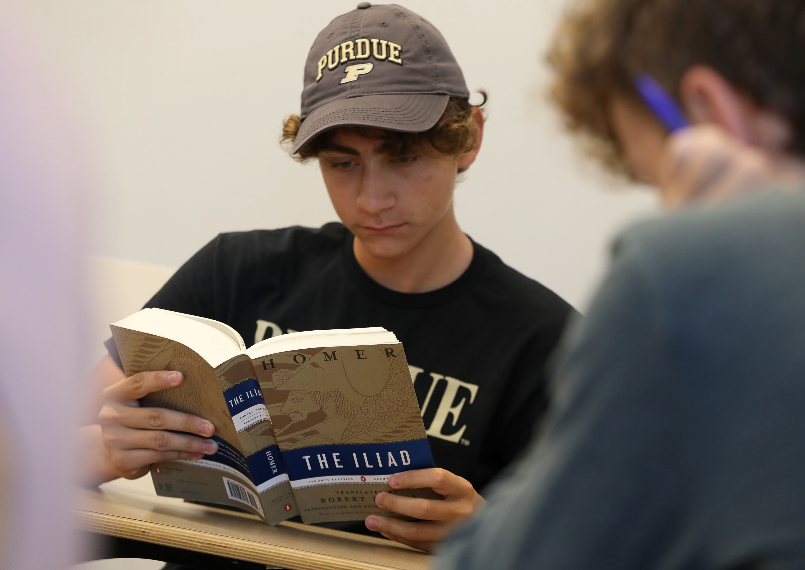

Cornerstone Integrated Liberal Arts

Melinda S. Zook,
Director, and Germaine Seelye Oesterle Professor of History
30 October 2025

12000

Enrollments in “Transformative Texts” by Academic Year 2017-2025

10000
10170

8000
7830
6943
7212
4197
3498
1956
154

6000

4000

2000

0
AY 17/18 AY 18/19 AY 19/20 AY 20/21 AY 21/22 AY 22/23 AY 23/24 AY 24/25

New Students by College, West Lafayette and Indianapolis, 2025

College of Education
139

164

230
414

519
644
916

925
1,060
1,755
College of Veterinary Medicine
College of Pharmacy
College of Liberal Arts
College of Agriculture
Exploratory Studies
College of Health and Human Sciences
Daniels School of Business
Polytechnic Institute
College of Science

College of Engineering
3,211

0 500 1,000 1,500 2,000 2,500 3,000 3,500

First-Year Students this Fall

Transformative Texts in West Lafayette
We are currently teaching 4,080 students this fall (1,649 are First-Year Engineering).

Transformative Texts in Indianapolis
Serving our Indianapolis campus, currently teaching 510 first-year students

Transformative Texts: Daniels Business School
Teaching first-year Business students the fundamentals of Political Economy, currently teaching 750 students this fall.

Total number of students in Transformative Texts this fall = 5,340

Transformative Texts I & II

First-year students enroll in two foundational courses in the College of Liberal Arts:
Transformative Texts (SCLA 101).

Critical Thinking and Communication I, from Antiquity to Modernity.
Fulfills the Written Communication and Information Literacy requirements of the University Core.

Transformative Texts (SCLA 102).

Critical Thinking and Communication II, Modern World.
Fulfills the Oral Communication requirement of the University Core.


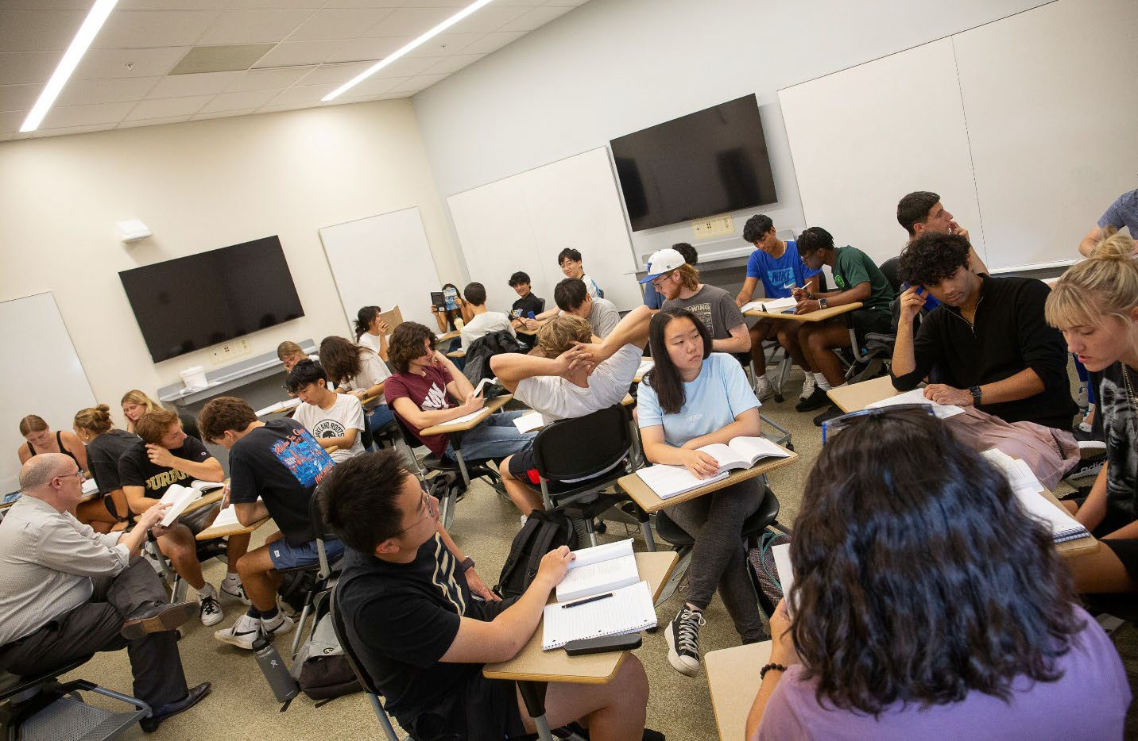
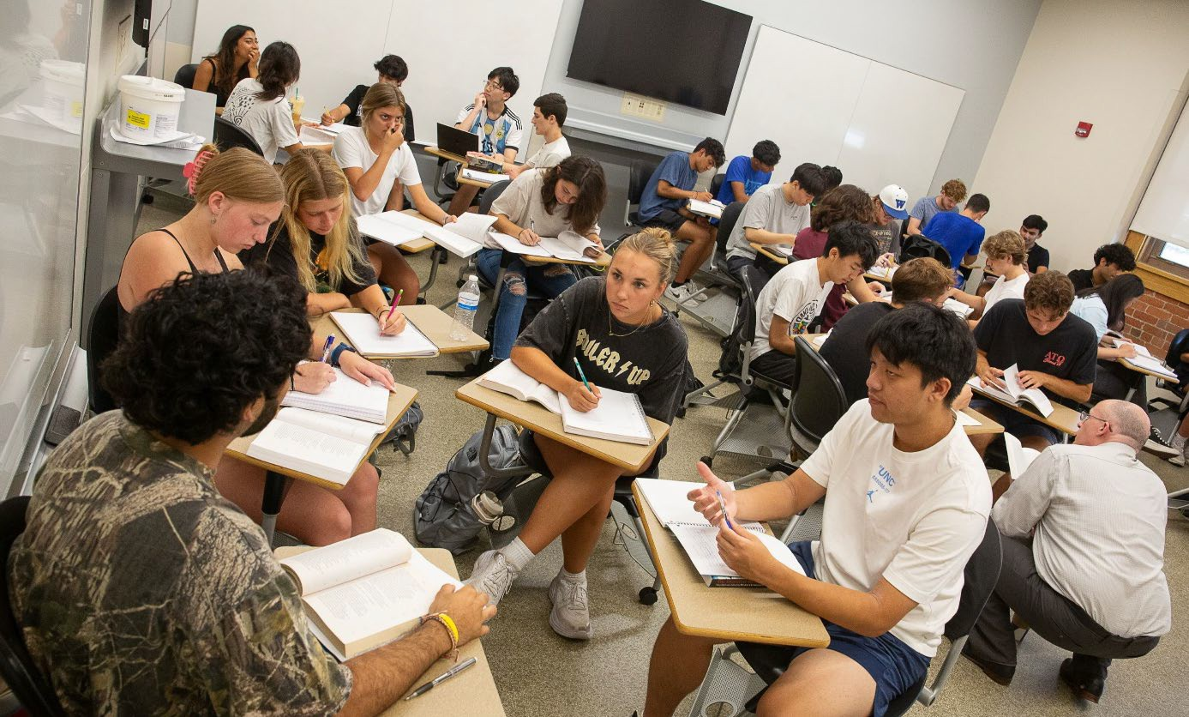

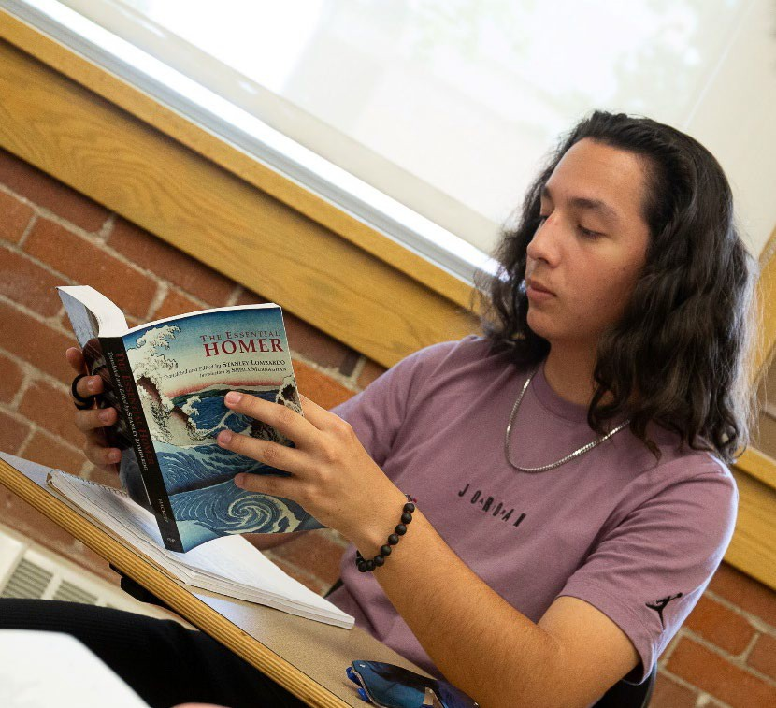
All Active Learning.
Professor David Riesbeck’s class reads Homer’s Iliad, and breaks into small groups.

Experiential Learning: Darwin & Worms

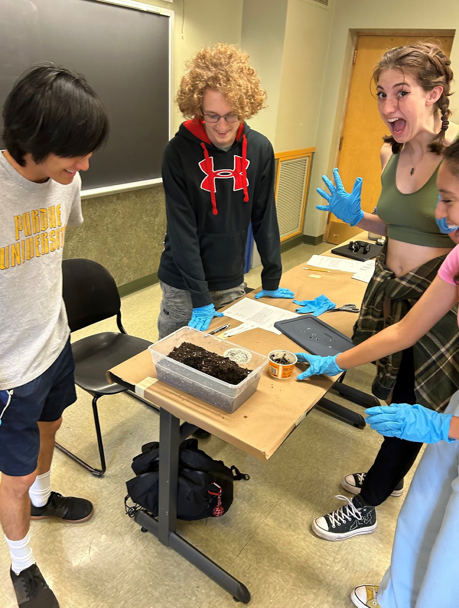
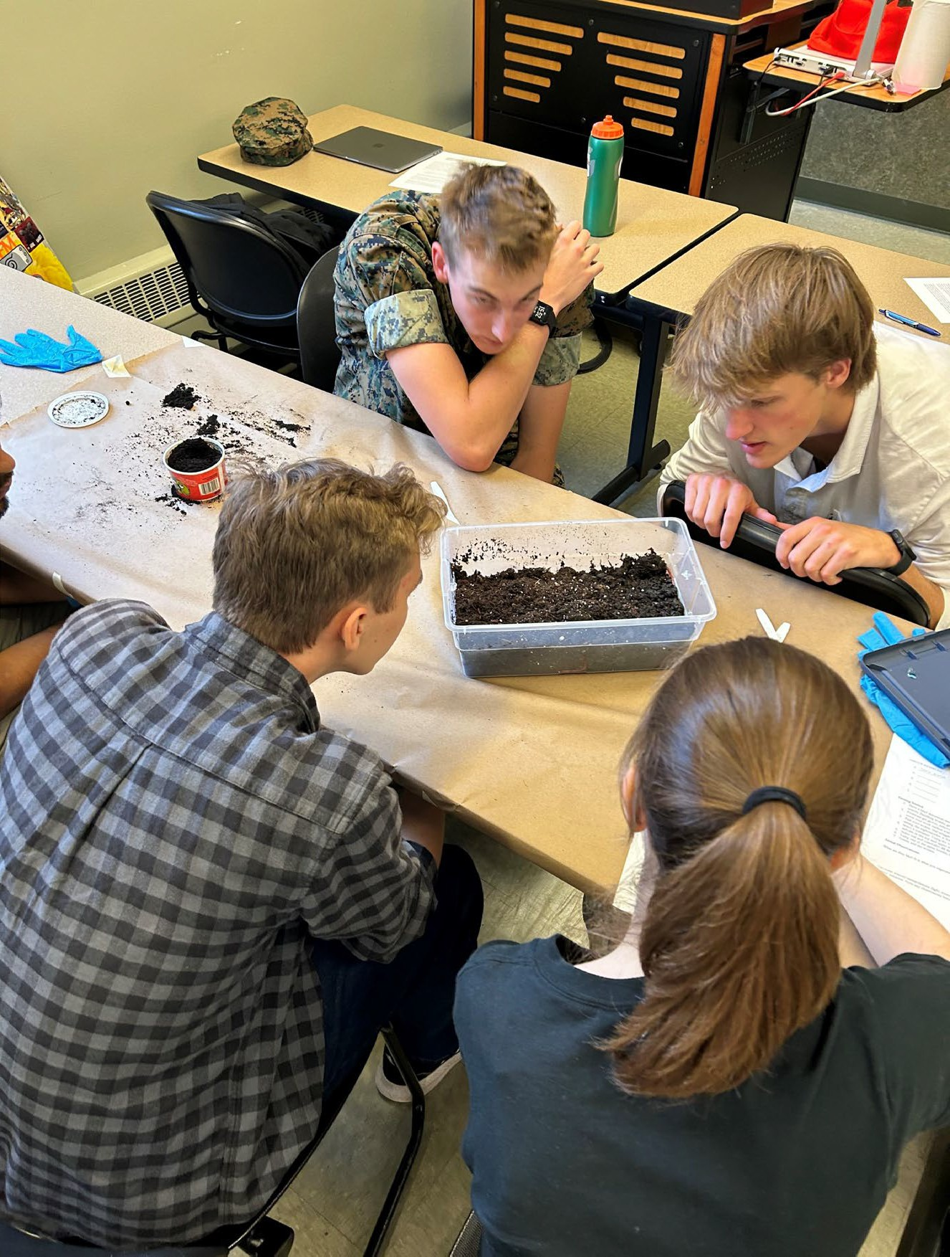
Sometimes the worms are very quiet

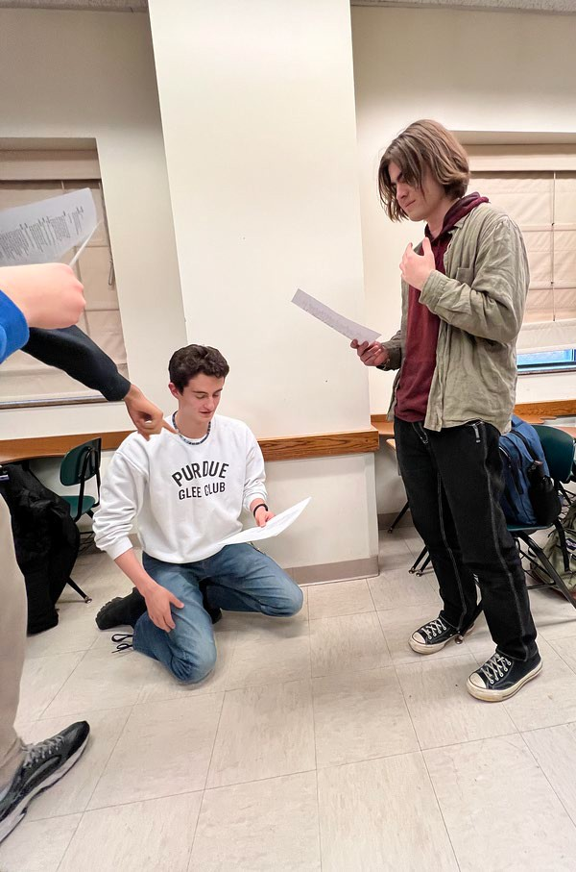
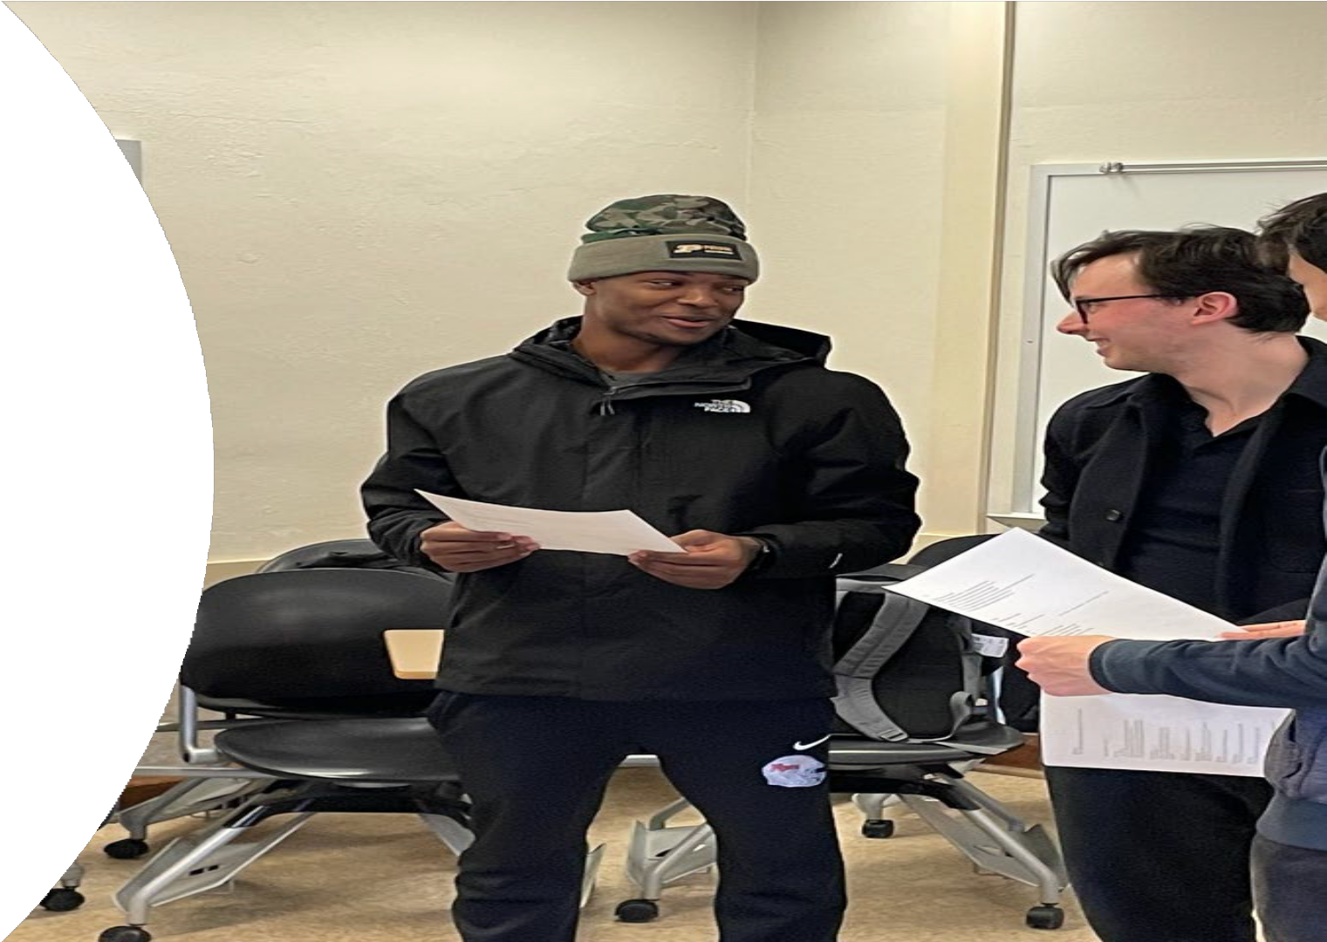
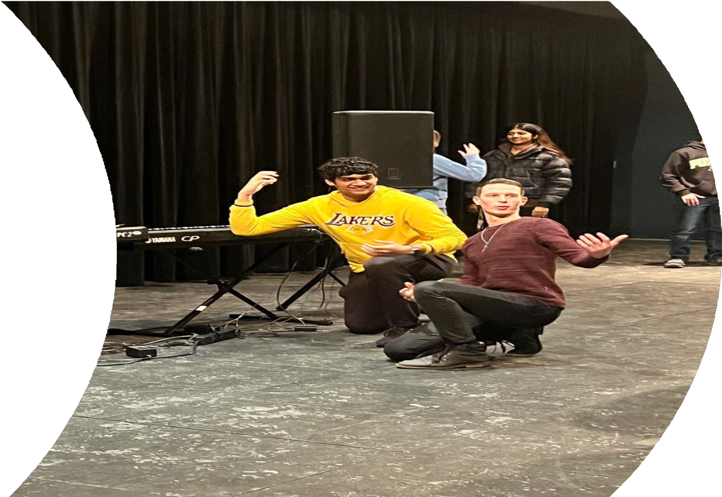
Reading & performing Hamlet with “Actors of the London Stage”

Some Special Topics in Transformative Texts this Fall:

Artificial Intelligence in the Loop: Humans in Charge Wealth, Society, and the Future
The Good Society
The Quest: Physical, Mental, and Spiritual Human versus Non-Human
Health, Disease, and Medicine
Utopian and Dystopian Narratives of Technology across Media Science, Society, and Imagination
Technology’s Help and Hindrance to Humankind’s Growth

The Cornerstone Integrated Liberal Arts Certificate
Students take three more Liberal Arts courses in a theme:

Science and Technology Environment and Sustainability Healthcare and Medicine Business and Management Democracy and Citizenship

The Growth of STEM & Business Double Majors in the Liberal Arts

700

600
552
474
368
249
102
112
Cornerstone
launched

611 624

500

400

300

200

100

0
2017 2018 2019 2020 2021 2022 2023 2024

Adapting to AI: Learning AI Literacy & Ethics

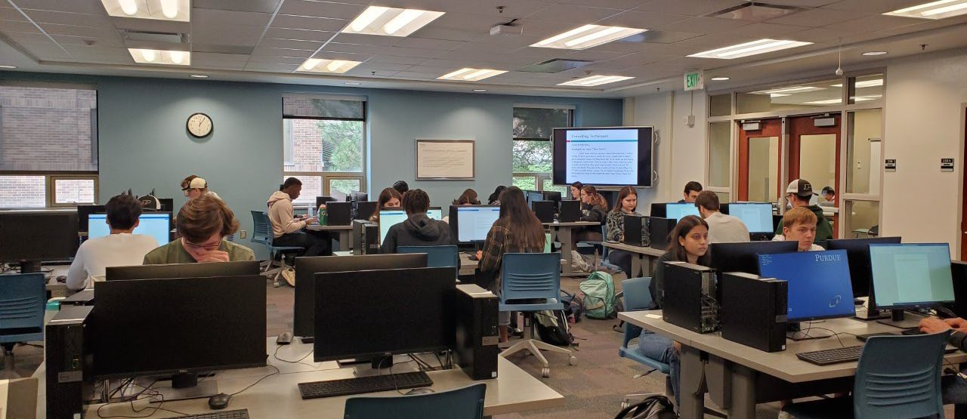

THE TEAGLE
FOUNDATION
ACTA
AMERICAN COUNCIL OF
TRUSTEES AND ALUMNI






ASSOCIATION OF PUBLIC & •
LAND-GRANT
UNIVERSITIES
NATIONAL ENDOWMENT FOR THE HUMANITIES
()PBS

NEWS

Universities and Colleges Implementing Cornerstone

American University, DC
Anne Arundel Community College, MD Augustana College, IL
Austin Community College, TX Bard College, NY
California State Polytechnic University, CA Catawba College, NC
Catholic University of America, DC Clark Atlanta University, GA Clemson University, SC
Colorado State University, CO Cooper Union for Science and Art, NY
CSU Maritime Academy, CA CUNY Baruch, NY
Dillard University, LA Drexel University, PA
East Carolina University, NC Emory University, GA Fort Lewis College, CO
Georgetown University, DC Houston Community College, TX Howard University, DC
Indiana University of Pennsylvania, PA Lehman College, NY
Linn-Benton Community College, OR Lyon College, AK
Marshall University, WV Mercer County Community College, NJ
Norfolk State University, VA North Carolina State University, NC Northern Kentucky University, KY
Pennsylvania State University system, PA Pepperdine, CA
Rhodes College, TN Rochester Institute of Technology, NY
Rose State, OK
Saint Louis University, NC Seminole State, OK Sonoma State, CA Stanford University, CA SUNY Cortland, NY
SUNY Erie Community College, NY SUNY Onondaga Community College, NY Tennessee Board of Regents system, TN Texas A&M University system, TX Thomas Jefferson University, PA Transylvania University, KY
Trinity Washington University, DC
Tulsa Community College, OK Tuskegee University, AL
UC Santa Cruz, CA UConn, CT
University of Georgia, GA University of Massachusetts Amherst, MO
University of Michigan Flint, MI University of Montana, MT University of Nevada, Las Vegas, NV University of Nevada-Reno, NV University of North Dakota, ND University of Notre Dame, IN University of Puerto Rico, PR
University of Wisconsin Platteville, WI Ursinus College, PA
Ursuline College, OH Vanderbilt University, TN Victoria College, TX
Virginia Union University, VA

85 campuses in all

We teach the fundamentals of the learning process:

Reading: to read closely and critically with one’s full attention, valuing learning for its own sake.
Writing: to articulate one’s thoughts in an organized and clear manner that engages and values the reader.
Speaking: to speak with clarity and eloquence in a manner that engages and values the listener.
Listening: to listen with appreciation and curiosity to others and value their conversation.
Understanding: to appreciate the wisdom, feelings, and life experiences of others, seeking to learn from them.

And what else does Cornerstone do …
Student contests: two every semester based on essays, fiction, poetry, artwork, and videos in Transformative Texts (with cash awards).
Film screenings: two every semester, like Pride and Prejudice and Into the Wild,
modern adaptations of classic novels.
The Cornerstone Review and The Exchange: Literature, Art & Business. Two annual publications of student work.
Reading Allowed: Storytime with Cornerstone. Monthly story readings for students by our faculty in the Cornerstone Reading Room, HSSE Library.
Socrates Strategic Initiative. Cornerstone Award ($1000) for an Outstanding Student in Transformative Texts.
How I Teach this Text, collaborative faculty workshops several times a year on how to teach reading, writing, speaking, and listening.
Text & the City. A faculty book club, bringing Indianapolis and West Lafayette faculty together.

