

Fourth Meeting
Monday, 27 January 2025, 2:30 p.m.
Zoom Meeting

AGENDA

1. Call to order | Professor Susan South
2. Statement of Land Use Acknowledgement | Professor Susan South
3. Approval of Minutes of 18 November 2024
4. Acceptance of Agenda
5. Remarks of the Senate Chair | Professor Susan South
6. Remarks of the President | President Mung Chiang
- Question Time
- Memorial Resolutions
- Résumé of Items Under Consideration by Various Committees  - Senate Document 24-05 Educational Policy Committee Faculty Committee (Subcommittee) Name Change | For Information Professor Elizabeth A. Richards  For Action Educational Policy Committee
11. Senate Document 24-06 Modifications to Streamline and Clarify the Readmission Policy and Add the Readmission Policy to the Purdue University Academic Regulations | For Action Educational Policy Committee
- Senate Document 24-08 Nomination for the Educational Policy Committee  - Senate Document 24-07 Creating a University Senate Listserv | For Action Nominating Committee  For Discussion Faculty Affairs Committee

- Athletics and Name, Image, Likeness (NIL) For Information Mike Bobinski, Executive Vice President & Director of Intercollegiate Athletics
Ken Halpin, Deputy Athletics Director

- Mental Health Resources, Purdue Psychology Treatment and Research Clinics
For Information Heather Ciesielski, Director

- Supporting Student Well-Being and Mental Health, Well-Being Unit and Counseling and Psychological Services

- New Business

- Adjournment
For Information Christopher Hanes, Ph.D. HSPP Assistant Vice Provost for Student Well-
Being, Student Life Senior Director, CAPS

Fourth Meeting
Monday, 27 January 2025, 2:30 p.m.
Zoom Meeting

Present: Joseph W. Camp Jr. (Secretary of Faculties and Parliamentarian), President Mung Chiang, Susan South (Chair of the Senate), Mark Zimpfer (Vice-Chair of the Senate), Patrick Wolfe (Provost), Se’Andra Johnson (Sergeant-at-Arms), Dulcy Abraham, Ryan Alan Altman, Arezoo Ardekani, Santokh Badesha, Saurabh Bagchi, Jonathan Bauchet, Ximena Bernal, Afsan Bhadelia, David Blon, Ali Bramson, Françoise Brosseau-Lapré, Tom Brush, Stephen Cameron, Julia Chester, Alejandro Cuza, Dan Cziczo, Brian Dilkes, Vince Duffy, Ben Dunford, Jim Dworkin, Ulrike Dydak, Abigail Engelberth, Yi Gao, Abrar Hammoud, Lori Hoagland, Sarah Huber, Whitney (Yu) Huidan, Morgan Hynes, Katie Jarriel, Hyunyoung (Young) Jeong, Alice Johnson, Nastasha Johnson, Bhagyashree Katare, Kee-Hong Kim, Cheng-kok Koh, Sarah LaRose, Kiseop Lee, Brian Leung, Stacy Lindshield, Damon Lisch, David Liu, Ryan Manuel, Stephen Martin, Stephanie Masta, Seema Mattoo, Byung-Cheol (BC) Min, Somosmita Mitra, Patricia (Trish) Morita-Mullaney, Paul Mort, Robert Nawrocki, Abdelfattah Nour, Tae Hong Park, Li Qiao, Darryl Ragland, Padinjaremadhom (PV) Ramachandran, Sebastian Murgueitio Ramirez, Elizabeth Richards, Brian Richert, Torbert Rocheford, Gustavo Rodriguez-Rivera, Chris Ruhl, Antônio Sá Barreto, Jennifer Scheuer, Steven Scott, Marisol Sepulveda, John Sheffield, Michael Smith, Kevin Stainback, John Sundquist, Mohit Tawarmalani, Monica Torres, Sasha Tsymbaliuk, Kim Updegraff, Anish Vanaik, Rua Williams, Christina Wilson-Frank, Bowei Xi, Howard (Howie) Zelaznik, Patrick Zollner Advisors: Eric Adams, Michael Cline, Cherise Hall, Sheila Hurt, Carl Krieger, Lisa Mauer, Beth McCuskey, Sunil Prabhakar, Alysa Rollock Guests: Mike Bobinski, Heather Ciesielski, Megan Dorton, Jason Doty, Kathi Ferrero, John Gipson, Ken Halpin, Chris Hanes, Ian Hyatt, Kim Pearson, Dimitrios Peroulis, Karen Plaut, Steven Schultz, Diane Spoljoric

Absent: Andy Baker, Lisa Bosman, Charles Bouman, Sabine Brunswicker, Min Chen, Xingshan (Shawn) Cui, Eugenio Culurciello, Mara Faccio, Alex Francis, Geraldine Friedman, Brent Jesiek, Yuli Lyanda-Geller, Loring (Larry) Nies, Jason Packard, Julio Ramirez, Joseph (Paul) Robinson, Chris Rogers, Dennis Savaiano, Ganesh Subbarayan-Shastri, Dengfeng Sun, Rusi Taleyarkhan.
Advisors: Heather Beasley, Chad Cahoon, Melissa Franks, Lowell Kane, Jenna Rickus, Katherine Sermersheim
Advisors: Eric Adams, Chad Cahoon.

- Quorum being established; the meeting was called to order at 2:40 p.m.
- Chair Susan South read the following Statement of Land Use Acknowledgement, as required by Senate Document 20-55:
The Purdue University Senate acknowledges the traditional homelands of the Indigenous People which Purdue University is built upon. We honor and appreciate the Bodéwadmik (Potawatomi), Lenape (Delaware), Myaamia (Miami), and Shawnee People who are the original Indigenous caretakers.

- The minutes of the 18 November 2024 Senate meeting were entered as read.

- The agenda was accepted by general consent.

- Chair South began her remarks [Appendix A].

“Today I want to talk to you a phenomenon you might have been encountering in the Chronicle of Higher Education or other news stories called the Enrollment Cliff and the possible implications for us here at Purdue. The percentage of high school graduates who go right onto college peaked at 70% in 2016. In 2022, that dropped to 62%. And the consensus view is that America will hit a peak of about 3.4 to 3.5 million high school graduates sometime in 2025. After that, the college age population is expected to shrink in the next five to 10 years by as much as 15% or more.

This is driven in large part by the drop in births around 2008 when the economy basically cratered in this country. Many of the data on this enrollment cliff come from the Western Interstate Commission for Higher Education, which provided this figure. High school graduates, as you can see, will decline in the state of Indiana. And you might be asking, "Wait, don't many of Purdue's undergraduates come from out of state and about 50%?" However, a majority, 56.2% of students at public four-year colleges attend an institution less than an hour's drive from home, and nearly 70% attend within two hours. And if you look near US, Illinois, and Ohio, where the majority of undergraduates from Indiana come, if they're not from Indiana, they're also facing a decline in enrollment. Next slide, please. So you might say, "Well, Purdue's enrollment has gone up for the last 10 years. Do we really need to worry?"
Certainly, there are many things that we have done over the last 10 years that make us very attractive as an institute of higher education. But again, it makes sense even for us here at Purdue to be vigilant to declining enrollment of high school graduates. So what does Purdue do to respond to the enrollment cliff? Well, Nathan Grawe, author of Demographics and the Demand for Higher Education argues that some institutions will likely be able to weather the enrollment cliff through some combination of spending reductions and investments in student retention until the nation's birth rates rebound. So things like removing barriers to enrollment, perhaps admitting students to enroll without a major, increasing support for students who are enrolled, particularly those who change majors, and focusing on students most likely to apply for, enroll, and graduate from college.

Who goes to college and who graduates? Well, one of the biggest demographics that you can look at is gender. And these slides show the percentage of men and women with a bachelor's degree over the course of the last 50 years. Now nationally, the six-year graduation rate in 2022 was 64.9%. But the graduation rate for first-time degree-seeking students at a four-year institution was six points higher for women than men. And interestingly, when they asked a sample of individuals who had never
been to college why they did not go, 34% of men and 25% of women said they did not want to.

How is Purdue doing? In 2024, almost 60% of our undergraduates, 58.7% were male, and 41.3% were female. And the best comparison data I could get from the Big 10 is closer to roughly 50/50. Why are there these gender differences? This chart is from the National Center for Education Statistics and shows the female and male college

entrance by major (presentation slide #8). Here women are less likely to enter college with the intent to major in engineering, computer science or business. So there is probably a larger conversation here about higher education and the proportion of majors across academic disciplines, but I will save that for another day. I will focus here on Women in STEM. Women now earn 37% of undergraduate STEM degrees in the US according to the National Science Foundation, but that obscures an important observation. Large differences in women's participation across STEM fields. Women's participation in STEM is concentrated in biology, chemistry, and math, more so than in computer science, engineering and physics. And gender gaps in computer science, engineering and physics are problematic because the US is not training enough computer scientists and engineers to keep up with demand. One way to remedy that is to make the fields more appealing to a broader audience.

What is going on here? This is from a large meta-analysis of stereotypes across STEM fields (presentation slide 10). On the right side of the figure are stereotypes about mathematics. On the left-hand side, stereotypes about computer science, engineering and physics. Graphing towards the top means the stereotype favors male ability, and graphing towards the bottom favors female ability. So, the stereotypes about math are incorrect. The stereotype is really about computer science, engineering and physics. The data show that stereotypes related to those STEM fields begin early. As early as age six, boys and girls already believe that boys are better at engineering and computer science than girls. A recent model suggests that women's under-representation in these STEM fields, particularly computer science, engineering and physics, is a function of a masculine culture that signals to women a lower sense of belonging (presentation slide 11). There is also a possibility of insufficient early educational experience and larger gender gaps and self-efficacy in computer science, engineering and physics.

We must also welcome open and honest communication where faculty can voice concerns and promote transparency in decision-making processes. We need to increase equity and transparency by making criteria for promotion clear. We should enact family-friendly policies, in addition to improving access to affordable childcare. We should improve leadership development and training for all faculty interested in moving to leadership positions. And we should also foster a culture of collaboration and encourage interdisciplinary teaching programs, research projects and opportunities for academics to share their work and support each other.
We have colleagues at Purdue, including our colleagues in the College of Education, who are doing incredible work on insufficient early experience, and I hope they can come back and talk to us about the work that they are doing. I want to focus here on this masculine culture of the fields. The research is clear on what is important.
Experiences that provide girls and women with learning opportunities and necessary support as they progress, that diversify current stereotypes that do not discriminate or devalue women, and that allow women to know they can achieve success in the field are likely interventions to make the biggest impact.

What are some things that we can do here at Purdue? Again, reducing barriers to majoring in STEM fields, perhaps admitting more students as exploratory or making it easy to CODO into engineering or computer science. Equalizing university core curriculum across colleges. Again, perhaps to make it easier to CODO into these STEM fields. Finally, bringing a smaller community feel to these larger departments. In fact, engineering and computer science, first year engineering and computer science are the largest majors at Purdue. We can also increase outreach to high schools in Indiana and our neighboring states, including social media outreach to highlight the work of particularly our female faculty and students at Purdue. We can encourage all STEM faculty to be allies, mentors and role models to female students at all levels of matriculation. And I know I am saying what we already do, but there is a real focus here that can be made on female-oriented interests and making computer science, engineering and other STEM fields relevant to what women want to do when they leave college.

Finally, we can increase the number of female faculty and graduate students who can serve as mentors for due undergraduates of the future. Whereas there is really important research that shows that higher levels of gender diversity in STEM classrooms or workplaces reduce the identity threat concerns of women, but only if it is considered sincere and authentic. In summary, attending to reducing barriers to entry and graduation from men's STEM disciplines can ensure that Purdue is well positioned to handle the challenges of the enrollment cliff and to be a leader in higher education of women the rest of the 21st century. Thank you, and I will move on now to recognize President Chiang for his remarks.”
- President Chiang presented his remarks.

“Well, thank you so much and great to see all of you virtually here. I know it is a very busy time of the year. It is also a cold time of the year. Today feels like it is already spring, 40 degrees sunny as I was walking around a little bit earlier this morning. So thank you for all the hard work by our faculty, staff, colleagues, and want to quickly highlight the three aspects. There is a community aspect and athletic aspect and academic on the community side. There are a lot of wonderful things going on, including quite a bit of construction in West Lafayette and Lafayette. I am also happy to say that we have thanks to many of you for your support, an outstanding season for the United Way with Purdue University participation in the Greater Lafayette United Way in particular, we had an elevated target from last year and this year and we again exceeded even the elevated target. This means a lot to our local communities and neighbors.

Speaking of neighbors, we have the Ascension St. Vincent Hospital project that some of you have heard for a while now and led to a report that we have made further progress, and hopefully this year will be the year when we can see some groundbreaking activities and a timetable for construction. And this is a great partnership with Ascension Group and we appreciate the opportunity to bring more healthcare delivery to West Lafayette. And I noticed that in the written questions last week, there were a couple of questions about the regional campuses and the

relationship with their local communities. I have to say, having visited both Fort Wayne and Northwest of our state, I've been very impressed with how our university regional campuses have been working alongside their own neighbors to increase economic vibrancy, to create more jobs and talent at the same time, and also to be very agile in response to their specific local needs.
We continue to further strengthen the relationship and the partnership of best practice sharing between main campus in West Lafayette, Indianapolis on the one hand, and the regionals on the other. Now secondly, I noticed that later in today's meeting, the Athletic Director Mike Bobinski will be speaking, and indeed as mentioned at the beginning of this academic year, each time I hope to bring along with me some colleagues who are direct reports to the President at Purdue University and they have important thing they would like to share with the rest of the Senate.
And you all know the tremendous changes coming to intercollegiate athletics these days. And there are also a lot of games that went on last semester, this semester. Some have more TV coverage than others, but they are all very important and we appreciate all 500 plus student athletes, as well as the entire coaching staff and other staff in the athletic department. I believe that my dear colleague Mike Bobinski is going to give an update to all of you, answer questions in particular relative to what the Senate is interested in, the NIL and its evolution.

I will turn to Provost Wolfe in a couple of minutes on the academic updates front. We continue to hear so much about AI, particularly generative AI using large language models and how that's further accelerating people's changes in how they learn, how they live, and how they work. And I have heard in a recent luncheon meeting with 45 distinguished professors, about their concerns relative to AI usage code of conduct. Now we do have two majors at undergrad level, one master’s degree, and multiple certificates in teaching AI. We have great researchers in AI foundational elements, as well as applications to the physical domain, including the Institute for Physical AI.
We have been deploying and using AI particularly in reducing signatures, enhancing efficiency and faculty productivity. But there is another aspect of AI complementary to all the above, and that is the usage of AI in teaching and learning. I appreciate Chair Leung when he was the Chair of Senate last year, an ad hoc committee that he put together working closely with Provost office, particularly with Jenna Rickus, in creating now a little over a year ago, the first AI usage guideline in teaching and learning. But one year is a long time in the evolution of AI these days. And AI's power has enhanced even further over the past 12 months. And perhaps with Chair South's consideration, this is again another time for us to review and revisit the guidelines that were provided a year ago. And that connects me to a relatable topic of student success, including retention rates, including graduation four-, five- and six-year graduation rates.

I have had, along with Provost Wolfe, some very thought-provoking in-depth discussions with part of the Senate in our committee conversations relative to how we think about a four-year, five-year or six-year graduation rate, where right now around the average, maybe a little bit below average among the Big Ten universities,

these are 18 good universities, two private, 16 public many land-grant universities. So we hope that we are not going to stay below average, and we hope to be at or above average. At the same time, it is not everything. And these are different institutions with different background and scale, and we recognize that there are also a lot of students who want to do things such as global exchange or industry internship and co-op, or research as an undergrad. And finishing as fast as possible can be a great choice for many, not necessarily for every one of the 40 plus thousand undergrads on our main campus. So, we want to also recognize their needs and at the end of the day it is the success of every Purdue student that matters most.

There is a lot of ongoing conversation both on further enhancing our graduation rates whenever appropriate, and enhancing our offering of individualized help, maybe AI can help generate some recommendations and individualized experiences for students when it comes to co-curricular and extracurricular activities. Now you might also wonder how many undergrad students we may have come August. Well, we do not know the full answer yet because this is only January in the undergraduate admissions cycle, but we do know in the early action round and that the deadline was November 1, and the results were released January 15th. We had yet another record year by a long stretch, frankly. And the Provost Wolfe can go into some details and data if you would like to, and it reflects this non-stoppable and frankly accelerating scale of demand for education at Purdue across different degrees.
At the same time, we must be very careful in knowing that once you admit students, you could never take that back. And therefore you must make sure we have the physical facilities and capacity to take care of every single one of the students who might choose to come to us. That yield rate can be very different from one's expectation. It used to be very steady across many, many years with almost no fluctuation beyond 1%. And last year the yield rate dramatically jumped by 4% or 5% and that's huge. For every 1%, we are talking about many hundreds of students. So this year we are being very careful, and therefore you may have heard that some students more so than before got a deferral. I just want to clarify here with all of you that deferral for early action application does not mean waitlist, certainly not rejection. It is simply a statement that this university has not been able to make up our mind, admissions office mind, about a particular application, and therefore I will be part of the regular, normal admissions cycle, if you will. So deferral simply means we have not decided; it means nothing more than that. I want to clarify that. And again, we have heard loud and clear from all of you and many, many others, students, parents, neighbors, on the need to make sure that we do not end up with enrollment that is surprising or larger than the capacity we can readily provide. We can always in the end provide perhaps to some degree, but we want to be very careful. And then I'm going to turn now to perhaps Provost Wolfe per usual and then see if there's any questions. Back to you, Chair South.”

Chair South thanked President Chiang and invited Provost Wolfe to provide remarks.

Provost Patrick Wolfe: “To continue President Chiang’s themes, if you look back just a few years to attract an incoming class of about 9,000, we, Purdue would typically

release as many as 36,000 offers of admission. And so to the point that was made earlier, you can imagine that any small fluctuation in the likelihood of a student saying yes can result in a large absolute perturbation in the number of students on campus, which is great, but you can feel the fact that it is a little bit like working with one hand tied behind your back if you have put 36,000 offers out to try to land at 9,000, it is a tricky matter. So, looking back a year ago at this time, we actually gave just about the smallest number of offers we have ever given, and we still saw, as was indicated, a pretty big bump in yield, which is the jargon for the likelihood of students accepting an offer.

That is good news for the long-term future of Purdue. And it speaks to a point that Chair South made at the beginning of the presentation, which is as demographics change throughout the United States, there are winners and losers in student enrollment. And so far, Purdue and many of its brethren have been firmly on the side of the winners. That is we tend to see increased demand, record demand every year. We saw again this year that a record number of people applied for early action, which is to apply before November 1st. And so I am very excited about helping our departments and colleges continue to increase yield. And as we continue to increase yield more consistently, we will have better ability to calibrate that fine precision of winding up with an incoming class of the size that we are hoping for.
Indianapolis is another very exciting front. We finished our first semester of academic operations with both new and beginning students, so freshmen as well as continuing students who came to us from what was IUPUI. And there is more happening than ever before this semester, which is just great. I would encourage you to spend some time there if you can. We have buses running back and forth and plenty of events taking advantage of the city, whether it is music or sports or other entertainment. And then of course we will see another crop of new beginners starting at Indianapolis next fall, and we are all very excited about that.
Maybe the last thing I will say just to round things out is AI was mentioned a few times. This connects to a couple of topics we have talked about. I was at a long meeting last week to talk about the rates of Indiana high school students going to college in the state of Indiana. Those rates have been on the decline over the past decade, and I think there is enormous opportunity for us as a university, not just to help ourselves as it were, by recruiting even more Indiana students, but also to help the broader Indiana public university ecosystem help our state, help our region to understand student pathways and opportunities near the end of high school. And how do you match students with the right opportunities and pathways that might or might not be a four-year degree, at least right up front. But I think we all stand to benefit from helping our state think about how to tackle this problem of getting more and a higher proportion of high school graduates to pursue higher education. So that ties into AI in the sense that we were just brainstorming a little earlier today about how we can use some more sophisticated AI tools to help give students and high school counselors the information they really need at their fingertips to make informed decisions about the myriad choices that our young people in the state face when they finish up with high school.

If anybody is interested in hearing more about that, I am happy to chat with folks offline, but it is a very big concern for the state and it is also a big concern for us. I know we started a little bit late, so in the interest of time, let me sort of stop there and hand it back to Chair South. But again, I think we heard from her earlier, like many of us are thinking about similar things here and excited to be in a position where we can really make some progress on some of these thorny issues. So thank you.”

- The answers to pre-submitted questions were posted to the Senate website [Appendix B]. Chair South opened Question Time.

Senator Anish Vanaik noted that there have been concerns and complaints coming to the Faculty Affairs Committee from parents with children at the Early Childcare Learning Center (ECLC). The parents’ concerns include poor communication and constant personnel turnover among other issues. A major cause of frustration is the lack of responsiveness of Purdue. He mentioned that there had been a response from Purdue just this afternoon, but he was unsure if it addressed the parents’ concerns. The parents also wondered if statewide efforts are needed to address their concerns. Senator Vanaik asked if the President could comment on these concerns and if there were opportunities for working with our contacts in Indianapolis to address the concerns.

President Chiang said that this was also important to him when his own children were young and required childcare. Although he was not familiar with the concerns, he will pursue the matter after this meeting. He mentioned we work with both mayors because childcare is a common community concern that must be addressed collectively. President Chiang asked for clarification about the involvement of Indianapolis.
Senator Vanaik suggested it would add considerable heft to the matter if Purdue’s lobbyists in Indianapolis could ask the state government to take up this important issue and provide statewide support.

President Chiang agreed that statewide support would be useful. He noted that the Purdue-led CCC grant to the Lilly Foundation, a statewide program, was funded in 2024 and that childcare was at the top of the list for that grant. The grant provided funding for Tippecanoe County and six surrounding counties. He will be happy to receive, offline, ideas to advocate for more resources. He will work with his colleagues to make sure that the parents feel their children are being well taken care of.
Senator Stephen Cameron asked what were the University’s lobbying efforts for Senate Bill 235, which would criminalize DEI efforts, and House Bill 1170, which removes the capacity for gun-free zones (Purdue is currently a gun-free zone). He also asked about President Trump’s executive order (America First Trade Policy) which will double the tax rate for foreign nationals of select countries with which we

are having trade wars. This could include many of our faculty and permanent residents.

President Chiang plans to review these many issues and meet with his team this week for discussions about these matters. He noted that thousands of bills have been proposed at the state level and there is no way to know how many will eventually pass and be signed into law. His team will review the many bills and seek input, including from those on the Senate, before determining the next steps.
Currently, there are thousands of pages to review.

Chair South mentioned that a question came via chat about monitoring executive orders at the state and federal levels and the impacts on grant activity at Purdue.
President Chiang agreed it is an important, timely question. He mentioned that a new Q&A website from the AVP for Research Office (in conjunction with the Office of the Provost and the CFO’s Office) was just launched. The website has the status for each agency and will be updated as new information becomes available. Any further questions may be directed to Sponsored Program Services
at spsopers@groups.purdue.edu

Chair South emphasized that it is important for Senators to pass this information along to their constituents.

Senator Kimberly Updegraff said that her constituents would like to know when they can expect some guidance on the Governor’s executive order concerning DEI programming, its impact on her constituents, and what steps they need to take.
President Chiang noted that Purdue has a capable team of state liaisons. These liaisons have been meeting with Purdue’s General Counsel and the Vice President for Ethics and Compliance. He will meet with them later in the week after reading their drafts on the topics. After these meetings and draft reviews, Purdue will be better positioned and equipped to provide guidance.

- Memorial Resolutions (None received for January)
- Senator Elizabeth Richards, Chair of the Steering Committee, presented the Résumé of Items (ROI) under consideration by the various Senate Standing Committees [Appendix C].

As Senator Richard’s Zoom audio was not working, Chair South asked the Chairs to present their ROIs. The Standing Committee Chairs presented their respective ROIs to the Senate. Of note, Nominating Committee Co-Chair Seema Mattoo mentioned that nominees are sought for the slate of Vice Chair candidates. The Vice Chair will be elected at the March Senate meeting. Senator Vincent Duffy mentioned that he is now the Chair of the Educational Policy Committee (EPC) and they are considering documents from PSG and/or PGSG were not listed in the ROI for the EPC. These documents concern voting on campus and the Mental Health Days Initiative. A third

item under review is Purdue’s winter session and winter programs. Senator Brian Dilkes noted that he is now the sole Chair of the Equity, Diversity, and Inclusion Committee. They will review SB 235 (mentioned above) and the Bronze Executive Action that has been signed into law. Given these State laws and bills, the Committee members will formulate questions about what it should and should not do moving forward.

- Senator Vincent Duffy, Chair of the Educational Policy Committee (EPC), presented for Action Senate Document 24-05 Educational Policy Committee Faculty Committee (Subcommittee) Name Change. He made a motion for the Senate to adopt the document. His motion was seconded by Senator Lindshield. Senator Duffy and Senior Assistant Admissions Director Kathleen Ferrero provided background on the proposed name change from the current Committee on Scholastic Delinquencies and Readmissions to the proposed Readmission and Academic Renewal Committee. The committee’s name change will reflect the tone and policies being implemented across Purdue with a focus on assets as opposed to deficits. It is also a reflection of the activities of the committee and has been approved by the committee members.
No discussion occurred.

The question was put, and the document was adopted by general consent.
- Senator Duffy, presented for Action Senate Document 24-06 Modifications to Streamline and Clarify Readmission Policy and Add the Readmissions Policy to the Purdue University Academic Regulations. He made a motion for the Senate to adopt the document. His motion was seconded by Senator Lindshield. Senator Duffy and Senior Associate Admissions Director Megan Dorton provided background on the document. The purpose of this document is to update and clarify as well as streamline the readmission policy. This policy does not determine the rules that surround how a student is academically separated, but rather it determines the process surrounding their return to Purdue. This would include allowing readmission applicants to apply solely for the fall and spring semester due to the ease with which a semester index can dip below a 2.0 in the summer. In the past, this policy has lived on the Office of Admissions webpage, and despite the role the Office of Admissions plays in the readmission process, the Educational Policy Committee finds that the policy would be more appropriately housed within the Purdue University academic regulations under the section entitled Academic Notice and Separation.
Additionally, the policy clearly delineates when a student would be eligible to file an appeal to the stopout period required after being academically separated. This policy was also discussed with the Committee on Scholastic Delinquencies and Readmission at two different points in the process as well as the Office of Admissions, Office of Financial Aid, Office of the Registrar, academic advisors across campus, and the Academic Notice and Separation Committee. They were all consulted as part of the process for coming up with this new policy. These discussions occurred over the course of three semesters and had the support of the above-named offices.

Chair South called for discussion of the document.

Past Chair Brian Leung reminded the Senate that the kinds of changes under discussion that then pass do not automatically come into effect. When the chairs do their end-of-year reports, the Chairs of the committees need to see whether things that the Senate passed were implemented, and if not, why not. Sometimes that carries over into the fall when the previous chair is no longer there, so follow-up is very important.

Senator Duffy noted that, in terms of follow-up, the EPC discussed making information available and tracking clicks on the web page. The intention was for a student-centered effort to try to make information about the process more accessible. The EPC will continue to monitor the web page.

Chair South commented that she had presented the document to the Board of Trustees and the board members discussed it positively.
No additional discussion occurred. The question was put and was adopted by general consent.
- Senator Seema Mattoo presented for Action Senate Document 24-08 Nomination for the Educational Policy Committee. Chair South noted that there were two additional openings on the EPC and that Senators can self-nominate for the openings. No additional nominations were made from the floor and the question was put. Chair South asked if there were any objections to accepting Senate Document 24-08 as presented. No objections were heard, and the document was accepted by general consent.
- Senator Anish Vanaik, Co-Chair of the Faculty Affairs Committee, presented for Discussion, Senate Document 24-07 Creating a University Senate Listserv. Senator Vanaik noted that the document has been several years in preparation and initially began when Senate leadership realized there was no access to a listserv or any way to communicate directly with the faculty of Purdue University. This contrasts with the fact that the leadership groups of the PSG and the PGSG have access to email listservs and can reach their respective constituents. This lack of access to the faculty violates an important principle of academic freedom championed by the AAUP that faculty leadership should have the right to email constituents without mediation by university administration. The document proposed the creation of an avenue of communication over time. The document asks:
  - That relevant university authorities create an opt-in/opt-out listserv where three clearly designated members of the Senate leadership would be able to send emails without needing express consent of the Vice Provost for Faculty Affairs, as is currently required.
  - The Senate Chairperson, Secretary of Faculties, and Sergeant-at-Arms the right to send emails to the listserv and decide what is appropriate content for posting on the listserv.

  - Once created, the university administration facilitates dissemination of knowledge about the listserv including instructions on how to access it through available channels, including (but not limited to):
    - One university-wide email annually.
    - A monthly reminder in Purdue Today during the academic year of the creation of the listserv.
    - Inclusion in the orientation materials sent to all new faculty hired at Purdue University.
    - Inclusion in orientation workshops for new faculty at Purdue University.
Objections made by members of the FAC during creation of the drafts of the document include:
  - Questions of abuse of the listserv.
  - The possibility that the listserv would replace the relationship between Senators and their constituents.
  - The principle that the Senate represents the will of the Senators rather than representing the faculty at-large.
  - The possibility that the already slim Senate leadership might get overwhelmed by requests for communications to be sent out via the listserv.
  - Disputations about who is Senate leadership and what differences among might result in.
  - The possibility that the proposed design falls between stools and is likely to be ineffective.
The FAC concluded that the current design backed by determined action and its potential for growing out to embrace the majority, if not all, faculty represents a desired step forward towards greater academic freedom at the University.

Chair South called for discussion of the document.

Past Chair Leung opened the discussion with comments and questions that will, hopefully, make it a stronger document.
  - He noted a discrepancy between the Rationale and the Proposal sections of the document. The Rationale section mentions that we do not have a way to reach faculty directly. However, in the Proposal section, faculty, staff, and students are all mentioned. He would like to see the Rationale section also mention faculty, staff, and students so it does not appear to be exclusive.
  - He emphasized that the Sergeant-at-Arms does not play a role in communications with the Senate. Se’Andra Johnson serves as the Sergeant-at-Arms but communicates with the Senate in her role as Executive Assistant to the Secretary of Faculties. This requires clarification.
  - He acknowledged that the Senate Chair and the Secretary of Faculties will have deliberations over communications, and he wants to know how the FAC members worked that out. What happens if there is disagreement about sending out a communication?

  - The Secretary of Faculties is part of the Provost’s Office as that individual is selected by the Provost. It is not clear to him how those dynamics will work.
Senator Vanaik noted that the rationale for mentioning the faculty in the first instance and then the other constituents is that we are a University Senate. Our main ambit, and the place where we have relative control, is the realm of academics and the academic function of the university. The faculty are the primary constituency there. That is why it mentions that as an opt-in. Given that the design of the listserv happens to be one that is open, it could be open to others much as our documents in general are on the Senate website. That is the rationale. We can tweak the document to reflect your suggestions.
Senator Vanaik mentioned that Past Chair Leung brought up a nuance that we were not aware of that the Sergeant-at-Arms from whom we receive communications about the Senate constantly writes those communications in the capacity of Executive Assistant rather than in the capacity of Sergeant-at-Arms. This was unclear to the FAC members, but the document can be amended accordingly.

Senator Vanaik acknowledged that the FAC members discussed at length the issue of Senate leadership which raised the following questions:
  - Who constitutes the Senate leadership as there is no official designation?
  - Who constitutes the set of people who would be authorized to send out communications via the listserv?
  - How would decisions be made on these questions?
There was reluctance among the FAC members to assign the responsibilities to the Senate Chair. The FAC members thought it best to let the set of responsible leaders work out among themselves how to resolve disagreements.
Senator Vanaik asked that suggestions for specific revisions be sent to him and the discussion period ended.

Chair South noted that SD 24-07 will be up for Action at the February Senate meeting. She encouraged the Senators to solicit responses from their constituents and that they pass any feedback to the Co-Chairs of the FAC.

- Executive Vice President and Director of Athletics, Mike Bobinski, and Deputy Director of Athletics, Ken Halpin, presented an update on Athletics and Name, Image, and Likeness.
Vice President Bobinski: “We are glad to be with you all today, and hopefully we will give you a little bit of perspective and background on a topic that has been the source of lots of news in and around college athletics over the last several years.

Name, image, likeness began in earnest back in July of 2021 following some rules adjustments by the NCAA in the month prior which allowed student athletes to receive compensation in exchange for the use of their name, their image, their likeness, or, in fact, their particular and unique skills by virtue of teaching lessons

and or conducting camps, clinics, and similar things, which were prohibited until July of 2021.

Once that began, we, like others, enabled and empowered our athletes to participate in this world. The basis of our presentation today will really be around questions that one of your colleagues, Libby Richards had sent us, so I will stay focused on those topics. The first question was, who is eligible to participate or profit from NIL activities? And in our world, it is truly any student athlete. If you look at the experience that we have had since 2021, it has been across all sports, period, several hundred student athletes have had name, image and likeness activities over the course of three and a half years, all different scopes, different magnitudes, different nature of activities. But lots of people have had ability to profit or receive compensation at some level, which has been interesting, and I think enlightening for our young people. It has created some entrepreneurial spirit in some of our athletes, which is not the worst thing in the world.

The arrangements that are allowed are any form of endorsement. One of the great visible examples that you see is the famous women's basketball player now with the Indiana Fever, Caitlin Clark doing State Farm commercials. That is sort of name, image and likeness at its highest and most evolved level where you have a national corporation engaged with a student athlete for advertising purposes. She receives compensation directly from State Farm, as in all NIL deals now, they are all funded by outside entities. None of this runs through the university. It is all done through direct relationships with outside entities.
The only thing that is prohibited at this point from a name, image and likeness perspective is true pay for play, and you cannot be compensated just for participating in college athletics. The other thing that we have done with our student athletes as part of our education and getting them understanding what this is all about, we have given them some guidance on prohibited categories of endorsement, things that they should not engage in, and tried to be careful not to conflict with any existing sponsorship agreements that the university may have in other ways. So we do have the ability to monitor and sort of veto things that step across a line that we've deemed inappropriate. And we have had very, very few of those things. Our student athletes have been very responsible and done a really good job of managing through these changes.

Compliance with NIL guidelines is managed by us, we have a fully staffed compliance operation in Purdue Athletics that has always worked on our behalf to make sure that we stay in line with University, NCAA, and any other guidelines. They have been tasked with making sure that we also stay compliant with NIL guidelines. And they do a great job of educating, monitoring, and updating our student athletes as things change. And we have been, again, very fortunate to not have any negative issues to this point in time in and around this issue. There is a disclosure requirement that our compliance folks monitor. Any NIL arrangement above $600 is required to be disclosed, and then obviously there are tax consequences, there are all those things that relate to our student athletes that make this a brave new world for them. But we

also have taken great pains to try to educate them on all of that to make sure that they understand what their responsibilities are in relation to any of this compensation that they may receive.

The impact of NIL on recruiting varies from school to school. Some schools make a very concerted effort to make it a primary thing or a primary decision point in trying to attract young people to their school. At Purdue, it is a secondary discussion. It is not the primary reason that anybody has come to Purdue. I think I can very safely say that no one has come here because we have offered them the best NIL arrangements or the most favorable opportunities. We participate in that world, we make those opportunities available, we encourage, we educate, we do not stand in the way. But the reality is, we are not advantaged by the NIL world as it exists today. We do not have a large corporate base, obviously, where we are located here in the greater Lafayette area, as opposed to, for instance, at Ohio State that has the Columbus community where there are multiple and numerous rabid Ohio State fans and organizations and companies that are just willing to participate very seriously in the NIL world. That is not our reality.
Our coaches continue to maintain the strengths of being a Purdue student and all that comes with that, the academic experience, the personal growth experience, the development for life after Purdue is still the number one reason to come to Purdue and not for NIL reasons. And I think that we have proven to this point in time that that can still be a very successful formula for us, and we intend to stay in that direction as time moves on.
We had employees in the past whose sole purpose has been to help work with our student athletes to help point them in the direction of opportunities and connect them with, in some cases businesses that are interested in using student athletes. Some of our local car dealers, some local restaurants, some local companies have wanted to partner with our student athletes to help advance their business. And so we have helped to make those connections. We do not actually put them together in any way other than just, "Hey, here's the contact person. You guys go ahead and connect with each other and see what business opportunities might be." And that has worked out just fine, to be honest with you. We have a website, the Boilermaker Marketplace, that is run on a platform that many colleges and universities use in their athletic programs. And that is sort of the place where all these connections are made, where all the actual business transactions occur, where the disclosures happen as to any NIL deals that are made.

What are the potential ethical concerns or what are some potential ethical concerns related to NIL deals? I think like anything, when there are rules, people, if they are so inclined, will look for ways to bend the rules or circumvent the rules or to operate outside of the guidelines. I think there's no shortage of headlines that you've all read where you hear these outrageous numbers that have been claimed, and in some cases claimed and not lived up to. I can honestly say that one of the things that we're probably most proud of at Purdue, and I think it is a very Purdue thing, that we have made zero representations about what someone may or may not be able to do and

then have that not be lived up to. So we are very conservative with what we portray in terms of opportunity because we don't ever want to be in that position of saying, "Well, Purdue said I could potentially profit or be compensated at this level, and that didn't happen." We have had none of that here. And so again, we are very fortunate that that is not the way things are done here.
In addition, I would tell you that the NIL world has been used in other places in what looks very much like a pay-for-play world, and that is prohibited by NCAA guidelines. We have stayed clear in our interpretation of that, and we are not going to do that. So far that has been worked out to our advantage in, first, staying out of the headlines, and second, knowing that we are doing things the right way, which is the way that we have always endeavored to do them here at Purdue.

Can NIL be fixed in a way that we do not see athletes moving from school-to-school year after year? And I think that is a phenomenon that, while NIL emerged as an opportunity, the transfer world was opened as a result of lawsuits and challenges formed or guidelines offered by state legislatures, or in some cases random judges that struck down transfer regulations. So they all came together at the same time and then sort of created a little bit of an unholy alliance of things that encouraged more movement among student athletes than we had seen in years gone by.

Anyone who watches games, will hear a young person identified as a participant and say, "Well, they were at school X, then they were at school Y, and now they are at school Z." That is, I think, a very unfortunate situation. I do not know if NIL can be fixed to eliminate that. I think what will hopefully happen as time goes by, and as I think the world will evolve here, there will be a natural leveling of that because I think it has become obvious that everybody that enters the transfer world does not always find a home. And that is a very unfortunate occurrence, but it has happened more often than not.
I think eventually there will be a settling of that, and people will hopefully revert to the way that we try to do it here where we value all the things that a college education is supposed to be about. That is persistence, that is pursuing a major and sticking to that major and seeing it through to completion and ultimately to graduation. That is obviously the focus that we have maintained here at Purdue. And while we are not trying to render ourselves uncompetitive, we are participating in the NIL world and we will continue to do so, but we do not ever believe that needs to be the main focus of how we go about our business.

I think in general it has been positive for us. We have not suffered the negative downsides that you have read about at other places. There have been no negative impacts within team dynamics. Nobody is jealous of another athlete having opportunities. They recognize that this is the free market at work and those that are so inclined to pursue these things typically are the ones that benefit from them. I will give you a good example, a couple of years ago, in the first year of NIL, Jaden Ivey was on our men's basketball team. Jaden Ivey was obviously a tremendous player; was a lottery pick in the NBA Draft. He chose not to participate in NIL at all because

he said, "I don't want to distract from the other things that are important to me as I think about my future." And so each individual athlete can make those choices and some very much do decide, "I don't want to devote time and energy to that. It's just not worth it in terms of the big picture of what I want to accomplish."

We have had no instances where a coach has come forward and said, "You know, this athlete has really suffered academically, athletically and otherwise because they're spending too much time on NIL." That has not happened a single time here at Purdue, and I am glad to say that. I think our young people have kept this in a good direction and managed it responsibly to this point. So all in all, not negative for us, but certainly we are aware of the pitfalls that could happen if things ever go in the wrong direction. I am happy to take any questions.”

Following the presentation, Vice President Bobinski entertained questions from the virtual floor.

Senator Zelaznik thanked Vice President Bobinski for his presentation. He inquired if the visas of international students prevented them from working more than a set number of hours per week and if anyone monitors that relative to NIL.

Mr. Bobinski stated that “We do have a fair number of international student athletes. A very high profile one that departed last year was Zach Edey. Zach was a Canadian citizen, obviously he had a lot of NIL value because of his stature as a player, his uniqueness in every way. And so there was a lot of careful thought put into how he might participate in that. He could only do basically what is referred to as passive income type of opportunities. He could not take an opportunity that conceivably could be filled by a citizen or somebody holding a different type of visa status. So yes, we are very aware of that and work closely with our international student athletes to make sure that they do not step in a wrong direction on any of that.”
Senator David Blon: “I was just curious relative to the Department of Education's memo recently regarding revenue sharing and school provided NIL information about the split regarding Title IX, getting funds equally between female and male athletes. Has your team given that any further consideration? Are you waiting to see how the DOE works out relative to the coming months with the transition with the new administration, or has that always been something that you have taken into account?”

Mr. Bobinski: “That is a great question, David. And we are, like everybody, monitoring how that progresses through the system, particularly with the change in administration. That guidance, and it was strict that it was guidance, it was not law or legislation, was issued at the 11th hour of the outgoing administration. And so we are all sort of standing by to see how that will be enacted in the months ahead, which really do not take effect until much later this year or the middle of this year.

Our position has been to try to be fair and equitable in any plans that we might have in terms of funds that are distributed through the university. To this point, there have

been no funds distributed that have run through the university, so we do not have any concern as to anything that has occurred to this point in time. We operate our program and have always operated it in compliance with Title IX guidelines, and we will do that, or with actual regulations and requirements of Title IX, we will continue to do so. The revenue share world is a brand-new thing and that will evolve as we all work through that in the months ahead, but we are not there yet.”

Chair South: “What percentage of your athletes have an NIL deal right now?”
Mr. Bobinski called on Deputy Athletic Director Ken Halpin to answer Chair South’s question.

Mr. Halpin: “It is not a hundred percent, and it has grown. We have, as Mike mentioned, our compliance office through that marketplace. The beauty of that marketplace is it allows us to track and keep statistics on that. We have not dusted them off recently. It is more than half of our student-athletes. But the other thing that has stood out is a higher percentage of our female student-athletes have benefited from third-party NIL agreements. So even though a small number of male student-athletes have had larger paying agreements, it has from the get-go led to a higher percentage of our female student-athletes having agreements. I would have to go dig up the specific number, which I can do as soon as we get off the call.”
Chair South: “So other schools have started these collectives in terms of NILs, but it sounds like Purdue does not have one. Is that correct?”
Mr. Bobinski: “No, that is not correct. We do have one. It is called the Boilermaker Alliance. It was formed by a group of Purdue graduates down in the Indianapolis area. Mainly a bunch of attorneys got together, and that was sort of the basis of all this.
And being attorneys and being Purdue folks, they were as complete and cautious as possible, and they really created a model set up in terms of having a collective available to help support our student-athletes in certain programs.
And I would tell you that athletes in football, men's and women's basketball, volleyball, baseball, golf, have all benefited at some level over the course of time from some of the activities of the collective. I would tell you that ours is not at the high end in terms of scope and scale. We are not operating in the upper echelons of dollars available. But our activities have been very much in accordance with all guidelines and we're very grateful to that group of people down in India that have helped us participate, at least in that world. My guess is that that will probably wind down in months ahead, but it has operated now for a couple of years and been helpful to us in several ways.”

Senator James Dworkin: “I wanted to know, are these NIL earnings for players, are they public data or are they private data?”
Mr. Bobinski: “They are private data only because they are not administered through the university. We do not make any of those payments. They are all made at this

point through third-party agreements, and those companies do not have any public reporting requirements. So they are all private data at this point.”

Chair South thanked Vice President Bobinski and Deputy Director Halpin and moved on to the next presentations which concern mental health resources at Purdue.
- Heather Ciesielski, Director of the Psychological Sciences Clinical Science Program, presented an update on the program [Appendix D].
Director Ciesielski: “Thank you all so much for the opportunity to present this to you. I am Dr. Heather Ciesielski. I am the Director of the Purdue Psychology Treatment and Research Clinics or what we call the PPTRC. So this is through the Clinical Psychology program and Psychological Sciences at Purdue.

We are a unique clinic on campus, I believe, in my understanding from other clinics, that rather than being primarily student-facing, we are a primarily community facing clinic. We offer three separate service clinics through the PPTRC. The first of which, and probably our most popular, is what is called the Testing and Assessment Clinic or TAC. Through this clinic, we provide comprehensive psychological evaluations, and we do almost all ages, so beginning at about age five and up. So we see both children and adults. Through this clinic, we provide evidence-based evaluation, diagnosis, and then treatment recommendations. So this could include primarily for treatment if that's appropriate for the client. For children, we will include recommendations for school and school services or work services, different things like that. We do a number of evaluations for students. It's a bit of a unique role on campus that sometimes we will go then through the Disability Resources Center or places like that as well.

We then offer a Child and Family Treatment Clinic or CFT. And in the past, if you've heard of the PPTRC Child Clinic, it used to only be focused on child behavior management skills. And we've expanded that clinic to pretty broad child and family treatment over the past couple of years. So we provide individual and family treatment for common childhood disorders. The most common thing that we likely see in the clinic will be ADHD, followed by anxiety and then depression. We do training for our doctoral clinical graduate students and evidence-based protocols and practice. So we use a number of different protocols depending on the diagnosis that's presenting.
We also offer, typically every semester, a behavioral caregiver training group. This is behavioral parent training for parents of children with behavioral difficulties. This group, we began to do as a remote telehealth group in the pandemic and have maintained that format only because we are the only organization in the greater area of West Lafayette that provides such a training group, which is the evidence-based treatment for ADHD. So maintaining it in a telehealth format has really helped our students get that experience, but then also to serve a much broader part of the community for that service.

Our final clinic is the Adult Services Clinic. And so this provides individual treatment for adult clients with a broad range of diagnoses or symptoms that we see. Similarly to the other clinics, our students have training in their evidence-based protocols and practice for adult treatment. This can include cognitive behavioral therapy, acceptance and commitment therapy, motivational interviewing. And then this semester we began an ADHD skills group program for university students or students at the college level.

So the PPTRC is in Lyles-Porter Hall. We provide supervision and training for our graduate-level student clinicians in the clinical psychology program. They do year-long clinic practicum rotations through the clinic, and these begin in the spring of their first year. So they'll begin with the assessment clinic, they will do that the spring of their first year and the fall of their second year in our program. And then in the second year, they can choose whether they want to begin with the Child Services Clinic or the Adult Services Clinic. And then in their third year, they will swap.
Students are also able to take an advanced clinic over the summer, and so once they've done one of our other clinics, they're able to see more advanced clients, things like that in an advanced clinical rotation for the summer, which is completely optional for them. And they can also continue in clinics a second time where they can see either more advanced cases or they can do peer supervision for students who are beginning the program for their first time.
All our student clinicians are supervised by licensed psychologists. So our two primary supervisors are me and Dr. James Noll. We are both new to the program, so we have been working on the clinic for the past couple of years and just adjusting some of the things and maintaining the strong base that we came into. I began in 2022, and my background was clinical practice as a clinical faculty member in academic medicine. And then Dr. Noll comes to us with many years of experience as both a practitioner and an administrator in community mental health. And so we have a pretty solid background of in field training that we can bring to our students.

One of the things I was asked to speak about related to the clinic are our clinic census and wait times. So as I mentioned, we are primarily community facing. This year we shifted to an application-based process for our clients. So if someone is seeking services at the PPTRC, they can go to our website, there is a secure link to a Qualtrics application that they complete. And this essentially just allows us to do a quick screening of clients that may be coming to our clinic. Given that we are a training clinic for students early in their training, we have some exceptions to what we're able to see. So any clients who may be very high risk or require emergency services, more in-depth substance abuse treatment, any type of court ordered treatment or evaluations, including custody evaluations, we do not have the capacity to do emergency or walk-in services, so we will provide referrals to people for all those things. That is essentially what we are screening for when we look at that initial application.
We do provide low-cost services to the community. Our current price range for services is from $4 to $45 per session. The typical individual sessions run from $6 to

$45. We are in the process of updating our fee schedule, so these are based on the federal poverty guidelines. However, our system has not been updated for quite a while, so we are using the guidelines from 2017, currently. To update to the current guidelines, we ran into a couple of obstacles of not being able to grandfather in current clients or to provide lower cost services for families who cannot afford even our baseline of costs. We have put that on hold for the moment just given that that would exempt some of our current clients from services, and we do not want to deny them that based on payment.
We are working on improving that. Now, we have an option for if a family has documented financial hardship. So if they are on our fee schedule at a higher rate, say they are expected to pay $40 per session, but if they have had some financial hardship such as loss of job, things like that, they are able to send a document that allows them then to go to the lowest fee on the table. So, we have some options for that.
Our census is really driven by the student cohort each semester, and we can increase it somewhat with that summer term, but we're typically limited by the number of students that we have in each clinic at each time. It really depends primarily on our class size. Typically we have about four students in each clinic. Right now we have seven in assessment, we have three in our child team and five I believe on our adult team. We have a little bit of a wait for all our services. Unfortunately, because of this and because of a cohort-based system, we do have lengthy waiting times. Our waiting list for assessment can be a year or more. Currently, I would say we are about five months out, so we are doing well, but we had a lot of applications from August, and so I think our wait will be longer for some of those clients to come in. And then for our therapy clinics, our wait is typically about three to six months. Again, that will fluctuate with the cohort.

Concerning our wait list, when clients do the application, regardless of whether they're approved for services, we always send them other opportunities for the same treatment that they are requesting. So if they get a note that they are being placed onto our wait list, we will send them other places that they might contact who can see them more quickly. If we are not able to see them, we will provide resources to them for other places that they may go.
The final question that came through were for students in distress. And this is not something that, as I mentioned, our clinic is able to do just given our nature and sort of the cohort size and things like that. So if we do see students, or really any client who's coming to us who may be in distress, there are several places that we do referrals to. If they are a Purdue student, we will send them to CAPS. They have a 24-hour crisis service, and so we'll typically have them go there first, that's one of our main referral sources for our clients. Other resources that we will share with our clients are the Indiana Suicide Prevention, the Suicide and Crisis Lifeline, which is also active in Indiana, if you've seen ads for the 988.

I believe shortly after I started in 2022, the National Alliance on Mental Illness chapter of Lafayette opened what is called the Lafayette Living Room. This is

essentially a bridge program so people in crisis can go to this space in Lafayette, they can meet with a counselor immediately, and that person will help bridge them into other services within the community.

If we see youth through our child team, and this also would include young adults, so some of our younger students, we have the Indiana Center for Prevention of Youth Abuse and Suicide. There are different resources and things that we share with them through that. Specifically for LGBTQ+ youth, there is the Indiana Youth Group that also offers services. Both are housed in Indianapolis but offer some online things as well that our students and clients can do.
I really appreciate the time to present about our clinic. I think I'm able to take questions, or you can also find our website, and feel free to email me if you have them as well.”

Following the presentation, Dr. Ciesielski entertained questions from the virtual floor.
Vice Chair Mark Zimpfer: “Doctor, we really appreciate your presentation. I know it is important to a lot of us here to hear about your work. A question or multi-part question, if you do not mind, could you discuss a little bit more about your funding sources? And then could you speak a little bit more about some of the obstacles to your pricing? Just any clarification you could provide. Thank you.”

Director Ciesielski: “I am learning a little bit more about the funding sources as we go, but primarily we are self-funded through the fees that we charge through the clinic. And so for things that we use for assessment measures, different things like that are entirely through our own clinic funds, so what we generate from billing for our clients. I am learning a lot as the incoming director, but I do not believe we have any source of external funding. We really are just internally funded through our fee for services.
The primary challenges for billing have been, I think there were some obstacles as we were working through this on ways to increase the fee agreement but not have it necessarily universally applied. For similar clinics, there has been a way to sort of grandfather in current clients, so we are not significantly increasing their fees.
Essentially what we are looking to do to update to the current poverty guidelines is to increase every level by $10. But we do have clients, and this primarily does affect our student clients because they are typically at that lowest fee level for our student clients, because they are typically at that lowest fee level for the clinic. So for many of them, that is just not a feasible option. To go from even $4 or $6 per session to $14 or $16 per session is just not feasible for them. So we are going to redo our proposal and see if there is a way that we can either begin to offer lower cost services or have some sort of exception for those who cannot pay. If we stay at our typical rates to help our clients move forward, it is a bit of a challenge, because all the other costs are increasing. So we are trying to find a way to balance our patients being able to

get the services that they need, and us to be able to supply the clinic with the things that we need.”

Vice Chair Zimpfer: “Thanks for expanding on that, and a quick follow-up. If you had additional sources of funding outside of just raising fees, and you were exploring that, what would that funding be spent for? What would you recommend?”

Director Ciesielski: “There are a couple of major areas. The primary thing would be to increase our training opportunities for our students. For example, there is a possibility that we are looking into with a grant to increase some substance abuse treatment options and being able to coordinate with community providers as well to do some of those types of things. Really increasing the exposure of our students through our clinic. Part of my role is also looking at our external practicum opportunities for our students. They do the clinic for their first couple of years, and then they go onsite to community clinics either here or in Indianapolis.
Those funding opportunities would help us do a little bit more in-house, but then also work with other people to give our students increased training in those areas. I think particularly things that are a little bit riskier, such as substance abuse. And then more specific testing opportunities for our students as well, so increasing our ability to do training in like neuropsychological testing, as well as more general psychological measures and those types of things.”

Past Chair Leung: “Thank you for taking time out in your afternoon to share with us. If you are at a restaurant, a waitlist is a positive thing. But in this case, I know that a waitlist probably is a frustration. I wonder just for context, in your field how does the waitlist time that you're experiencing here comparable to other areas that you are aware of in the field?”
Director Ciesielski: “It is a pretty consistent problem for training clinics across the board. I am part of an organization that is training clinic directors in psychology, and the waitlist is a pretty universal problem. Clinics have various ways of handling it. I would say ours is comparable to others. Some of the areas where we run into the most difficulty are things particularly for like child assessment, where there is just extremely limited opportunities to get those services elsewhere. So sometimes people will have other opportunities and get on multiple waitlists, like Riley Hospital or places like that, but then stay on ours because they're seeking those services.
There is a little flexibility, but we are comparable overall. I will say that other clinics handle it in different ways. For some clinics, when their waitlist hits a certain point of maybe six months, then they will just close it until they see those clients, and then they will reopen it. Ours has typically worked well as it is rolling, and we are usually able to get it a little bit shorter, but it varies semester-by-semester. I think if you ask either myself or Dr. Noll, our responses to whether it is comparable to other clinics is a little bit different.

My background in academic medicine was psychological evaluations for a pretty specific population, so to have a year-long waitlist for assessment was not uncommon for me. That was standard. But I know Dr. Noll coming from community mental health, one of their major efforts in the community mental health facilities is to decrease wait times. Because those clients do tend to be a little bit more severe, need quicker services, and so it is much different than what he was used to when he was working in community mental health facilities. I think it was typically like a month or less.”
Chair South thanked Dr. Ciesielski and moved on to the next by CAPS Director Christopher Hanes.

- Christopher Hanes, Assistant Vice Provost for Student Well-Being and CAPS Student Life Senior Director, provided an update on CAPS and other mental health services [Appendix E].
Vice Provost Hanes: “Thank you for the opportunity to come speak to the group and share about all the work we have been doing and some of the updates. To start off the frame of well-being, we think about Purdue as a special place. For students, it's a time of growth, engagement and discovery. But it also takes place within a community that creates the conditions for experience, for learning and all the things that support it. So it is not only the individual student, but also the community. When we think about that, when we think about well-being, student life provides the programs and services that support and cultivate and promote holistic well-being. We also think about Steps to Leaps, which is a program that provides knowledge, skills and resources. We work with and support both students, but also faculty and staff in helping, as I mentioned, create and support that community that takes place here at Purdue in this special place.

Recently, we have developed a new unit, a Well-Being Unit, which is led by a new role. The Well-Being Unit encompasses PUSH, Purdue University Student Health, Recreation and Wellness, as well as CAPS, Counseling and Psychological Services.
The idea behind this is really creating and cultivating a one-team approach to well-being at Purdue. With that, you think about being intentional, strategic, and comprehensive on how you kind of build out support and resources for students, but also the experience, the one-team experience for the student. Whenever they interact with all these services, hearing similar language, hearing similar ways to connect, really thinking across how we support the comprehensive student experience here.

I really want to mention the Action Council on Student Housing and Well-Being. They've really played a significant role in this, not only providing the resources that has helped us build out our staffing, as well as really promoting that campus-wide culture that we have talked about. Something else I want to say about the well-being initiative is we also have leaders across student life that are working together on a committee to further understand and support this comprehensive kind of view of approaching students. So it's involved a lot of people.

Some things about CAPS specifically, we have a large multidisciplinary team. I am a licensed psychologist. We have psychologists. We have mental health counselors, marriage and family therapists, social workers, psychiatrists, a nurse practitioner, nurses, all working collectively to support these students. We are specifically built out. It is not a one-size-fits-all system. We're built out to meet the continuum of needs. We follow a stepped care model, which allows us to really match and tailor the service recommendations to what the student needs in that space. Since I have been here, we have really built out so many options within every level. We continue to expand the creative and innovative ways of supporting students. As was mentioned earlier, we do have 24/7 access to crisis services here. At all times, we have two therapists. During the day, we have two therapists on duty available to support walk-ins, as well as 24/7 access to support.

We do obviously individual therapy. We have a large robust groups program, up to 22 to 23 weekly groups. We also developed drop-in services both within CAPS and across campus, where a student can participate in a workshop. They can self-enroll in a workshop, building some skills and not have to be a client too. We have been creative getting these services, and helping students get connected to it. We have also implemented and doubled our care management team, which provides high-risk support for students that need more intensive services, to help them kind of navigate their challenges in the moment. We have also really built out a peer support program, which I will mention in a minute, really excited about it, as well as some specialty services and treatment teams. Services are available both at the CAPS locations, as well as across campus. We have three different “Let's Talk” sites that we provide services weekly.

We are also available online for students. We can do telehealth, but we also can support a student at any location across the country and internationally with treatment, with the new resource that we have. There are no predefined session limits. Treatment services are brief in nature, but they are dependent on the student's need. We really tailor the support for that student, and we have been able to really build out that system. We have embedded clinicians in multiple spaces. We have two clinicians at Indianapolis, as well as a psychiatric provider who provides care in Indianapolis on a weekly basis. We have two clinicians in the graduate student center, as well as embedded clinicians in the College of Engineering and the College of Veterinary Medicine.

So think about wait time. There is no wait to get started at CAPS. We offer same-day and next-day access for any student wanting to get services. I want to emphasize that part, that you do not have to be in crisis to be seen same-day, next-day. For us, we have really built out a system to provide accessible support for students, and the messaging has been incredibly important to let students know it is same-day, next-day access. That is an important component. We want to be there at the opportunity of the moment whenever the student wants to be able to get some support. Another thing that we added this year, which has had impressive impact, is we provide online scheduling for the first contact. Within the first semester, we were up most of the

semester about 80% in those appointments after we turned it on to online scheduling.

So it really had a significant impact on how students connect with us. Now they can connect with us by scheduling online. They can walk in, in person, to schedule the appointment, or they can call us. We have really enhanced our staffing in specialties. Currently, we're at 39 staff therapists, which is a significant increase from what it was in the past. It has allowed us to really, really meet the demands that we're seeing. We also have a large interdisciplinary and diverse staff. We have a number of bilingual clinicians, and a range of specialties. We have our staff directory available, and we encourage the community and students to look at it. It allows the students to get to know us, connect with us, and they can request to work with certain people. We do encourage that opportunity to have that interaction. As I mentioned, we have expanded access.

We offer QPR, Question, Persuade, and Refer, which is the suicide prevention training. In the fall, I think we trained over 1,100 faculty, staff and students, both within CAPS and our relationships with UR. There is a very robust QR system and training across campus. We also have our CAPS Ambassadors program, which is exciting. It is students, student leaders creating programming for other students around how to have conversations around mental health. Really cultivate and support that community of care that we've talked about. There was an article yesterday or a couple of days ago that highlighted that program, and it's been very impressive. We also have Let's Talk, as I mentioned before. Thinking about an opportunity to talk with a counselor on campus, we have three locations, for 15 minutes for a student where they do not have to be a client.
They can just literally come in and talk to a clinician, ask some questions, get some tips, learn a little bit about resources. These are those no-barrier, high-access opportunities, engagement opportunities for students. We found that program to be very impressive and helpful in connecting students. We continue to see high demand. As I mentioned, we really managed... We saw a 35% increase in students seeking care in the fall compared to the prior fall. We actually are trending above the prior peak period of utilization, which is about 18-19, which was common nationally across universities. We are trending above that. It was about a 6% increase. We have been able to maintain that same-day, next-day, which I am very happy about. That has to do with increased staffing and really building out the systems before we built it out.
Nationally, there certainly is a growing trend toward being open to help seeking and creating improved perception of help seeking. Students are continuously interested in their own well-being, but also the well-being of others. We found that to be a wonderful development, I guess I would say in terms of the culture and the community. They do want to help each other, which is one of the reasons why the peer-to-peer programs are incredibly helpful. There is a certain percentage of students that would rather seek out a peer as the initial entry point into saying, "Hey, I want to have a conversation around mental health." Mental health continues to be prevalent in terms of challenges.

Depending on statistics, one sees it is one-in-three or two-in-five students report that mental health has had an impact on their ability to focus, their ability to complete their academic responsibilities. It is something that we are continuing to see and support. Consistently, anxiety and depression are the most prevalent issues that we work with and support, but social anxiety is certainly something we are seeing more. Loneliness is something that we are noticing. Depending on what numbers you look at, between 60 to 70% of students report feeling lonely at times. And loneliness is associated with a greater increase in possibly having distress, so figuring out and identifying ways of doing that. Which is one of the reasons we emphasize talking about community, creating access for students in new and creative ways, supporting communities. That factors in our strategy. We think about some of the opportunities for the next steps, right? Because it's really thinking about cultivating and supporting this community of care we have at Purdue. We really want to see everybody and support everybody as partners in this work, and how we can work together collectively to do this. A lot of the resources that we have built into CAPS for the Well-Being Unit have been about providing an opportunity for faculty and staff to utilize and engage in it. We have trainings available, like QPR.

TAO, which is Therapy Assistance Online, which is our self-help program, is open and free to all faculty, staff and students. Part of the reason behind that is we wanted the faculty and staff to be able to use it for themselves but also help connect students to it. One also can request workshops both from CAPS, but also other well-being resources within wellness, the Steps to Leaps. There are a number of resources that you can request to bring to your students and connect with them, if you can work with us to promote awareness of the different resources available as well as the messaging.
The well-being initiative committee has been taking this approach of creating highlighted practices for well-being. The first one we created was sleep. We recognized sleep was the most prominent. When it came to students talking about behavior, a health behavior that they struggled with, it was sleep. So we created highlighted practices which talked about data points. What are some interesting data points that would catch a student's attention? We also created opportunities to learn some skills around it, as well as connect students to the available resources within student life to support sleep. I'm more than happy to share that, the handout and the resources we've done about that. That is part of our framework, we are going to continue to put out these well-being highlighted practices.
The next one is going to be about community and belonging for awareness purposes. So sleep, and then the next one's community, which are the ones that are right in front of us. Also, “Steps to Leaps” has a number of wonderful resources. Within the classroom or these academic spaces as well as student life spaces, just thinking about, are there opportunities to create experiences for learning around aspects of well-being? Normalizing well-being struggles, self-compassion, capacity building when it comes to skill development and problem solving. This is part of that student's successful academic journey.

Being able to have spaces where they see that, they learn about it, because we know they are already thinking about it, really helps create that experience for students, which goes an awful long way. Also thinking about peer-to-peer support within your spaces. It is absolutely where we're continuing to grow within Steps to Leaps. We have a peer advisory group. Like I said, we have the CAPS Ambassadors. They have ideas. They have ways of creating these informal supports and really creating and cultivating that sense of belonging to the community within these spaces. Thank you.”
Chair South: “Thank you so much. That was such a thorough presentation, and I really appreciate this holistic view that you are taking of health and wellness. It is great to catch up with CAPS, and to see what's changed and what is different that you have incorporated in the last few years.”

Following the presentation, Vice Provost Hanes entertained questions from the virtual floor.
Senator Abdelfattah Nour: “Thank you very much for the opportunity. Also thank you, Chris, for this important presentation. I have a question regarding peer-to-peer support and ambassadors. One, how do you match peers together? Secondly, as you know, there is now tremendous interest in peer instruction, and team-based learning where students work together in groups. Taking that into consideration, do you think the involvement proactively of the support that you can give to structure these teams in such a way that the outcome will not be only on the academic side, but also on the psychological side? The final note or the final question is that when you match peer-to-peer or ambassadors, do you consider pre-professional program matching them with a student from professional programs, pre-vet, pre-pharmacy with vet pharmacy and things like that?”

Vice Provost Hanes: ”Absolutely. I will start to talk a little bit about the strategy. If I am missing a piece, please feel free to ask me for follow-up, because I want to make sure I talk through it. You used the word that I really, I think is helpful to bring. We want to try to get upstream. We want to be proactive in the way we support campus. The way we build out our programming peer-to-peer is absolutely part of that strategy. How do we create these non-clinical, yet very supportive, empowering, and effective resources and experiences for students? We think about them as communities of support. How do we cultivate those within the colleges as well as within the service areas, to really help support that?

CAPS Ambassadors specifically, have been doing a lot of messaging and tabling and supporting events. We have an exciting event coming up for Mental Health Action Week. I am the advisor for Mental Health Action Week for the university, and we have a wonderful plan coming up. The CAPS Ambassadors are going to be highlighted as one of the resources for that. They come up with events. It is called Mental Health Around the World, is the name of that specific event we are doing, but we're doing a Well-Being Wednesday as well, and a number of things. They go out into different spaces to provide that support. When we built the CAPS Ambassadors program, one

of the foundations of it is we wanted a student from every college to be part of the CAPS Ambassadors.

That way, we could support and infuse the message within every college but also hear about the needs of all the colleges from the students' perspective. There are 35 CAPS Ambassadors at this point. We tried to get all the colleges. That was our way of really getting comprehensive and getting out there to understand the unique needs of each area as we were building out our program. The CAPS Ambassadors also will be providing support spaces, where we will train them on how to facilitate non-clinical peer-to-peer support spaces. We purchase pizza and stuff like that to help do some engagement activities but also help inform them and equip them with how to support a student if they need to connect them to more care.”

Past Chair Leung: “I want to thank you for this presentation, and I want you to hear a thing that I heard that was so important to me. That is, in your presentation in one of the lines, you shared that there is an increased awareness about wellness, seeking wellness. I love that... I just want to tell you; I love that framing. Because a lot of times we are like, "Oh, this generation is fragile and frail, and what's different about them?" The framing that you have just makes so much sense to me, which is like, "Oh, well, when do you create awareness and create services, you make services available and people become aware of them, of course, they seek them out." I just really, really loved that. You've said many smart things, but I love that portion of this presentation.”

Vice Provost Hanes: “I really appreciate that. I cannot speak enough about the partnership all around, and how we support our community. It takes a community.”
Senator Afsan Bhadelia: “Thank you so much for this incredible presentation. I do not think I can express enough, so much gratitude for what you are doing. I know you came to public health, presenting what you have been doing. I had a question regarding reflecting our student populace, and the fact that particularly graduate students, we have 40% that are international. Thinking about the different cultures and languages. And opportunities to express any psychological distress they might be experiencing in a way that maybe the match considers opportunities for services in another language, or some more cultural context incorporated. I imagine you're thinking about it but just wondering just how that is playing into all the wonderful work that you're doing. Thank you again.”
Vice Provost Chris Hanes: “I very much appreciate it. Intentionally, we have approached that in a few different ways. With the staff directory, I wanted the students to be able to see representation, see the ability to connect with us. I really think that helps go a long way. We have increased the number of international students that we see over time. Upwards of 30% of the students that we see at CAPS are international students. We have a very large international staff. There's about, for example, I think we have about seven providers that can provide therapy in Mandarin. We have a pretty diverse team. That was part of the goal, was for students to be able to kind of connect with us, and we know how powerful that can be.

We also have a group called International Circle. It's a space to talk about and provide support and community for students that want to talk about the challenges of being an international student, and all the different things along those lines. We're also visible in the different spaces on campus that support students and communities. We might have a therapist to go out and be a liaison to different aspects of campus to provide that support. We certainly have seen a lot of international students seek us out and find that support, and we have seen that increase. We also have a large number of graduate students that seek us out. It is our most heavily utilized population, I would say, would be graduate students. I hope I answered that, but I appreciate that.”

Chair South: “I think there's a follow-up question from Senator Bhadelia.”

Senator Bhadelia: “You did address that. I was just thinking, because another point that you noted in terms of increasing awareness and participation with the faculty and staff, one of the things that is very commonly documented is male students do not seek services as much. Then there is different stigma, right, whether it be related to sex or gender or culture, et cetera. I am just wondering in terms of messaging, if there are ways that you're targeting to I think reaching some outreach populations, or in need populations that we might be able to perhaps increase our efforts and awareness building around.”
Vice Provost Hanes: “I very much appreciate that. I think one other thing I was going to say, which kind of speaks to the prior one, is Mental Health Action Week gives us an opportunity to have some intentional programming. Thursday of Mental Health, we are going to have something called Mental Health Around the World, where we're going to invite all the different communities on campus to come participate in an event. Just increasing awareness and connection around resources is one of the things that we do, that I am looking forward to seeing the impact of that. We also, as I mentioned, have liaisons within different areas of campus, and then also making sure we pay attention to opportunities around messaging. We have groups and different resources focused on men's issues and men's challenges to kind of create a conversation. A space where a student might be able to say, "Hey, that could be a place I could benefit from some support.

As you mentioned, I think it is so important to think about how we are proactively kind of talking about what we are seeing in terms of trends, and how are we messaging? I am a big proponent of theory of planned behavior. It is about not only awareness but also perceived social norms and attitudes around mental health. How can we build those concepts into our work, which is so important? Which is partially that CAPS Ambassadors, that peer-to-peer kind of messaging, inviting students to come in. They just did a tabling, and they are doing an event around seasonal depression to say, "Hey, this is something that impacts us as people and communities. How can they be visible out there?" I like what you're saying, and I appreciate it. We are continually trying to do those things.”

Chair South thanked Vice Provost Hanes and moved on to the next Agenda Item, New Business.

- New Business

There was no New Business from the floor.

- There being no further business, the meeting adjourned at 4:40 p.m.


Résumé of Items 27 January 2025

To: | The University Senate
From: | Libby Richards, Chairperson of the Steering Committee
Subject: | Résumé of Items under Consideration by the Various Standing Committees

Steering Committee
Libby Richards, erichards@purdue.edu
- Soliciting reports and informational sessions in response to faculty and committee requests

Advisory Committee
Susan South, senate-chair@purdue.edu

Nominating Committee
Damon Lisch, dlisch@purdue.edu and Seema Mattoo, smattoo@purdue.edu
- Managing committee vacancies
- Evaluating and balancing numbers, disposition and experience of Senators for equitable representation and task assignments

Educational Policy Committee
Vincent Duffy, duffy@purdue.edu
- Assessing the need for AI regulations
- Improving the percentage of students returning teaching evaluations
- Considering ways to improve the Grade Appeal Process
- Updating MEAPS language as per SB22-08
- Proposal for Readmission Policy Committee changes and Re-naming of that committee

Equity, Diversity, and Inclusion Committee
Brian Dilkes, bdilkes@purdue.edu / Geraldine Friedman, friedman@purdue.edu

Faculty Affairs Committee
Françoise Brosseau-Lapré, fbrossea@purdue.edu / Anish Vanaik, avanaik@purdue.edu
- Lecturers Advisory Committee
- Assessment of recent changes in P and T process.
- Ability of Senate leadership to directly email faculty [SD passed and sent to Senate for discussion and adoption]
- Implementation of SEA 202
- Impact of Indiana SB1 on Purdue Healthcare practices and follow up on measures laid out in SD 22-08
- Working of Elements software
- Input to OVPFA on recent changes to various standards, policies and procedures:
  - changes to eAPR

  - Guidelines for Establishing Intergovernmental Personnel Act agreements (IPAs)
  - Process and procedures for Purdue Faculty and Staff Participation in Intergovernmental Personnel Act Agreements.
  - Presentation about Purdue transition to Elements for Annual Activity Reports.
  - Courtesy Faculty Appointment Standard
  - Revised R/I/E Leave request procedures
  - Reportable Outside Activities leave request procedures

Student Affairs Committee
Abigail S. Engelberth, aengelbe@purdue.edu
- Class Size
- Equitable Parking
- Move-in Package

University Resources Policy Committee
Lori Hoagland, lhoaglan@purdue.edu
- Parking regulations and appeals process
- Issues around Bicycle Parking

REMARKS OF THE SENATE CHAIR


1


Enrollment Cliff: Declining Population of College-age Students

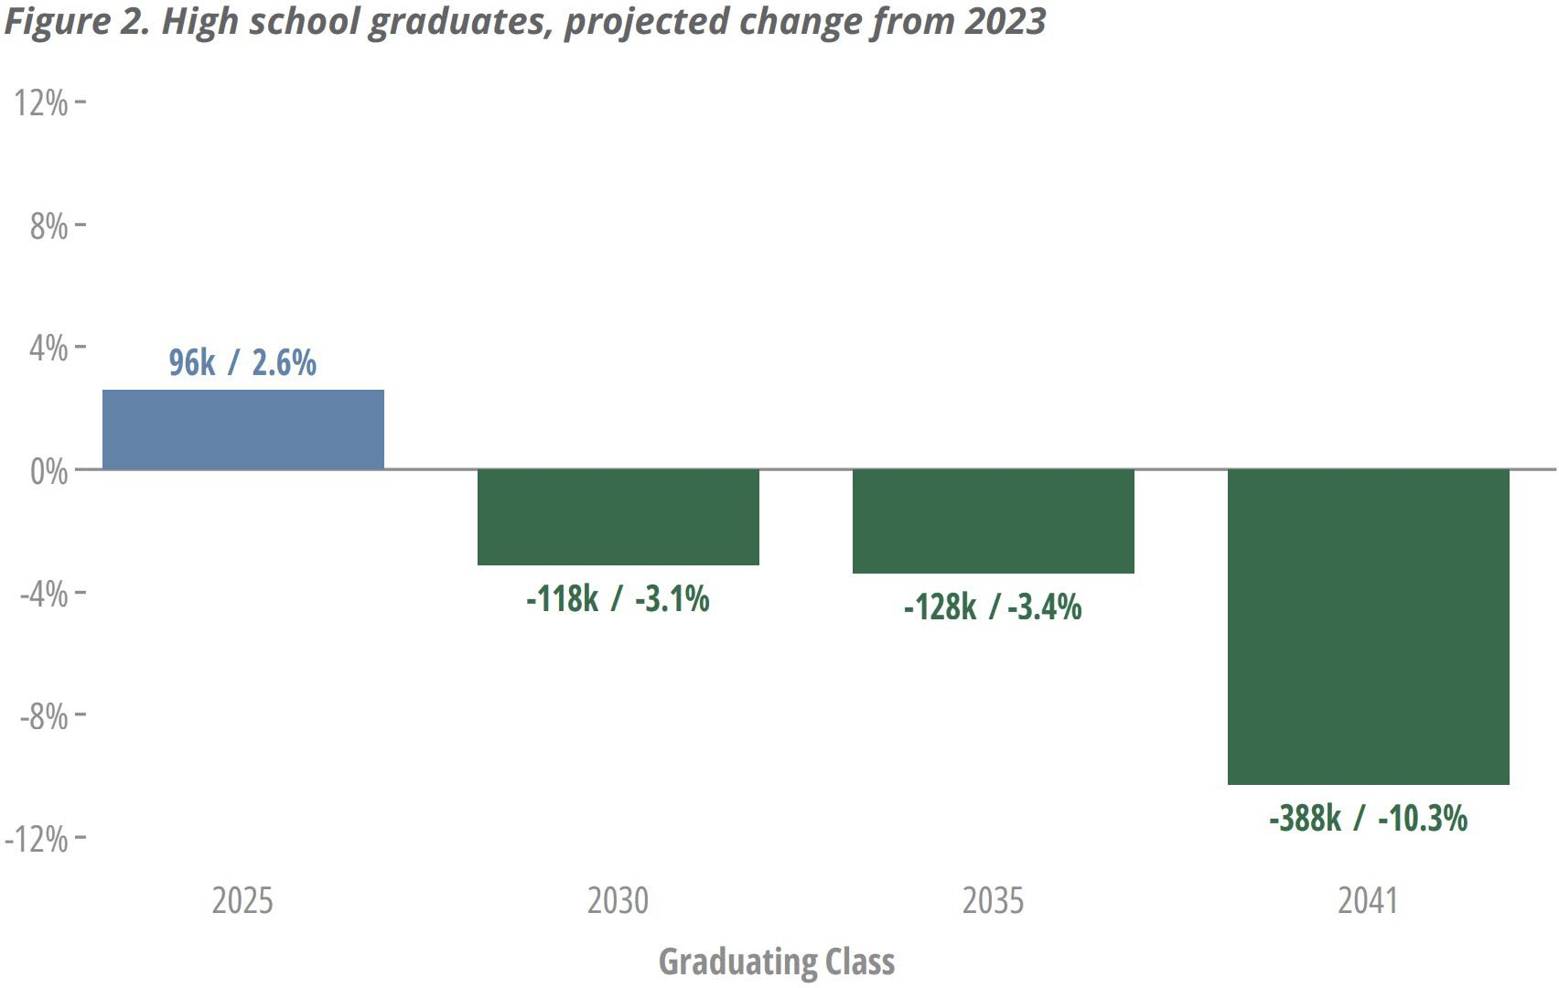

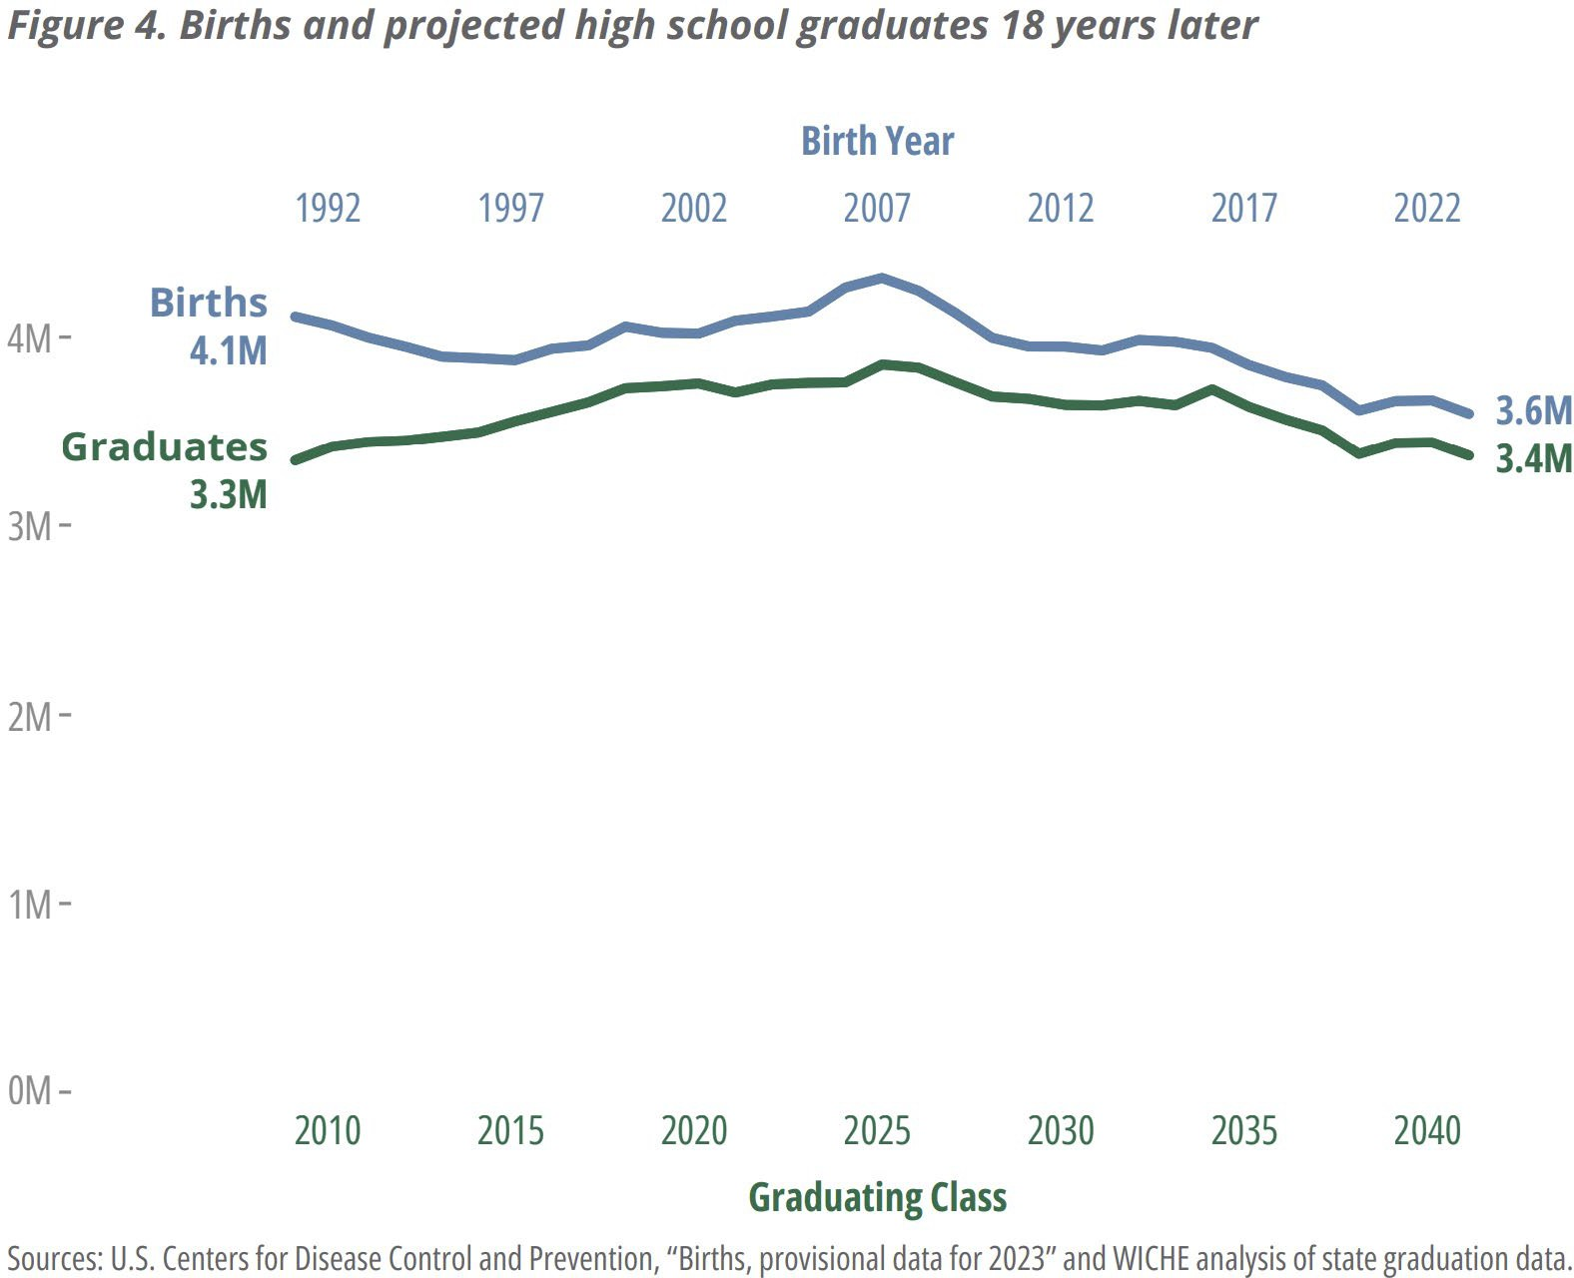
Knocking at the College Door, 2024

Declining High School Graduates in U.S.
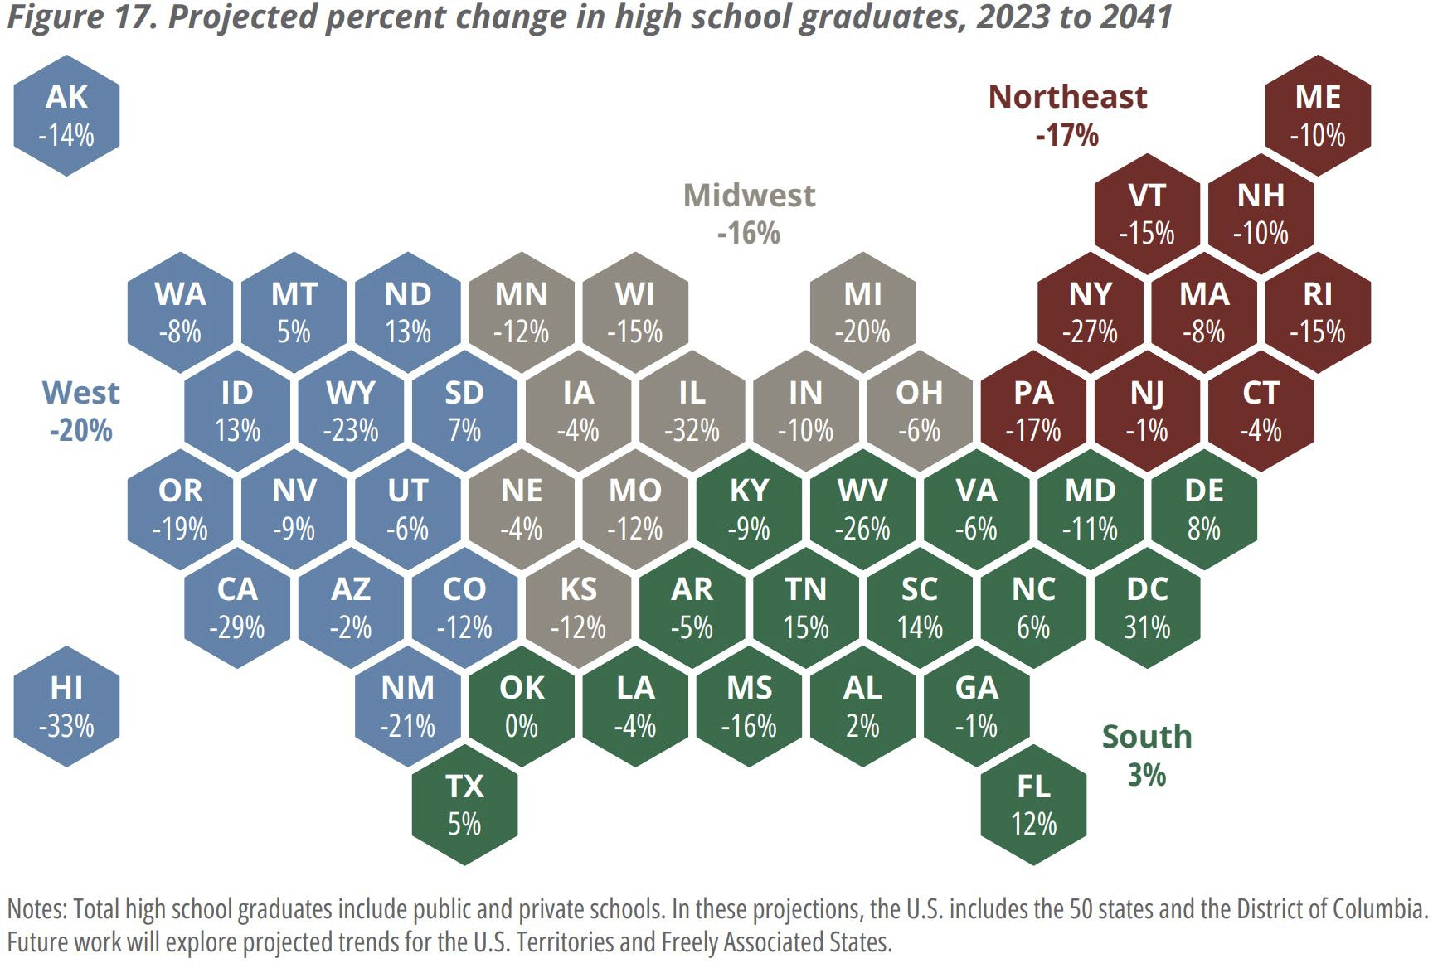

Knocking at the College Door, 2024

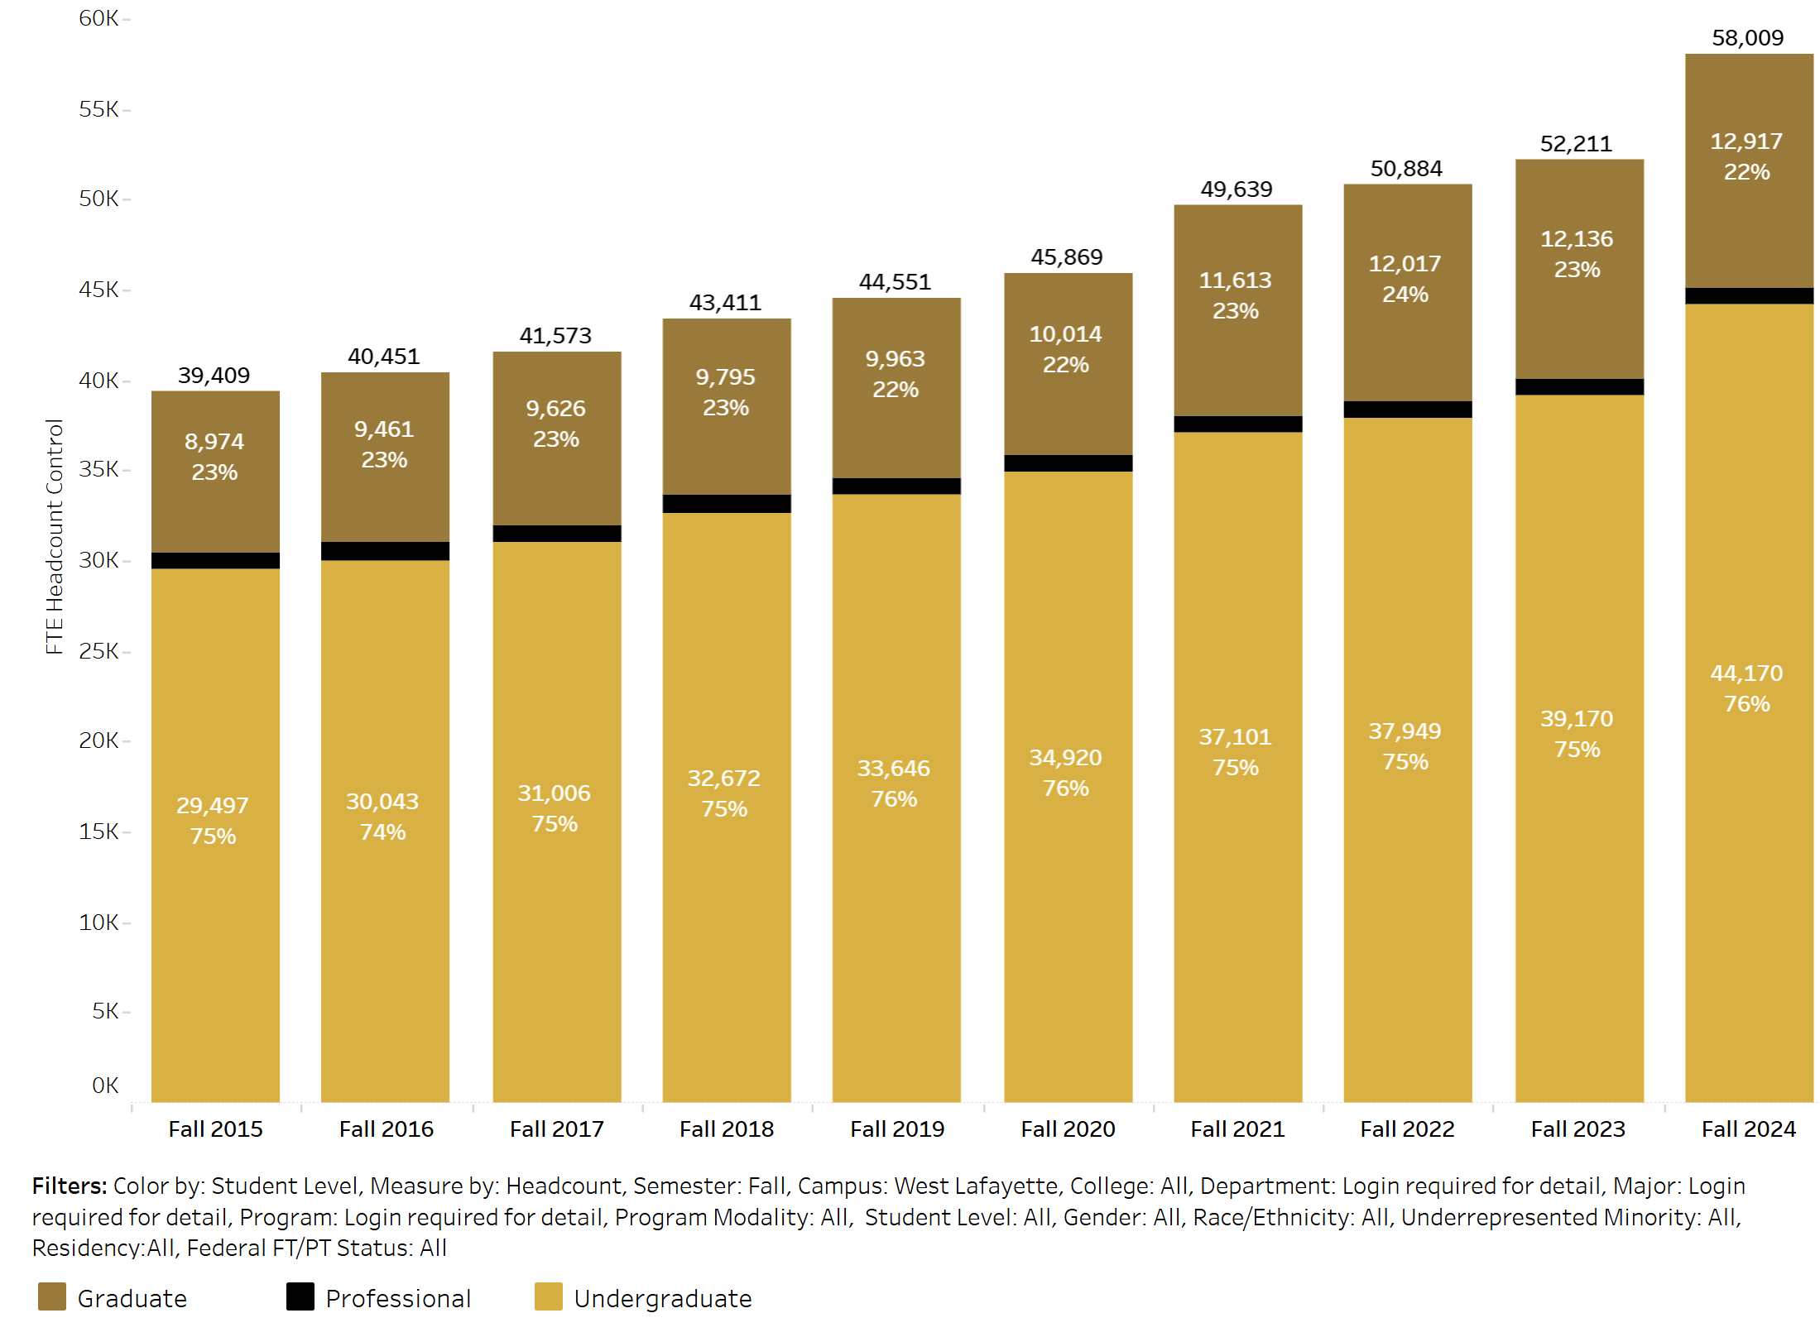
Purdue Enrollment 2015-2024

How does Purdue respond to the enrollment cliff?
- Remove barriers

- Increase support, advising and other programming designed to increase the success and retention of currently enrolled students

- Admit and enroll students who want to go to college and are more likely to finish

Who goes to college? Who graduates?

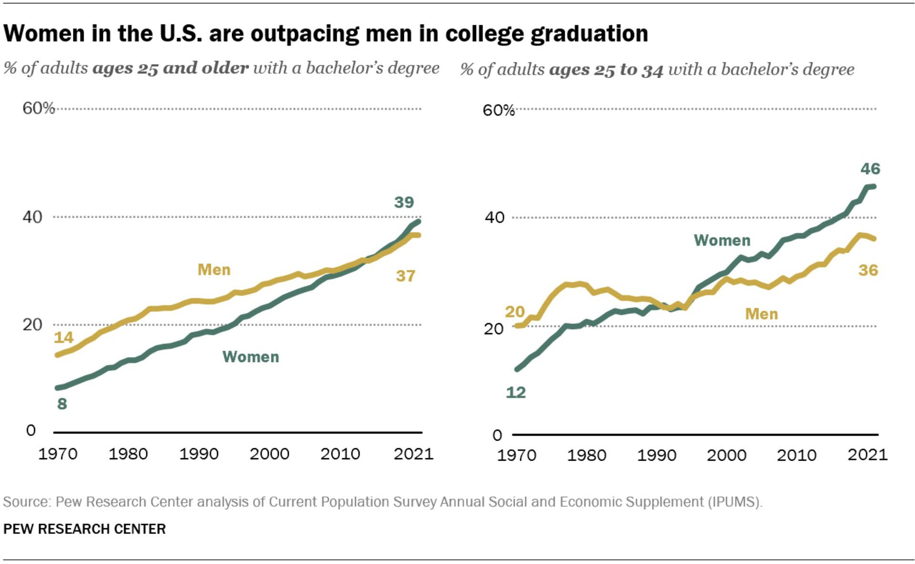

Source: PEW Research Center

Purdue Enrollment: Gender Differences

  - 2024: Purdue undergraduates 44, 166
    - Male undergraduates: 25, 904 (58.7%)
    - Female undergraduates: 18, 262 (41.3%)

  - Big 10
    - By gender, there are 323,711 female students (50.61%) and 315,875 male students (49.39%) at B1G schools. The female to male ratio is 1 to 0.98.

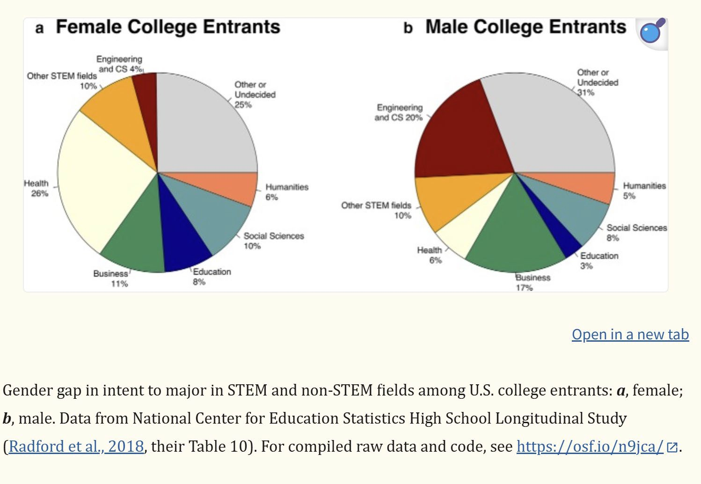

Gender Differences in College Majors

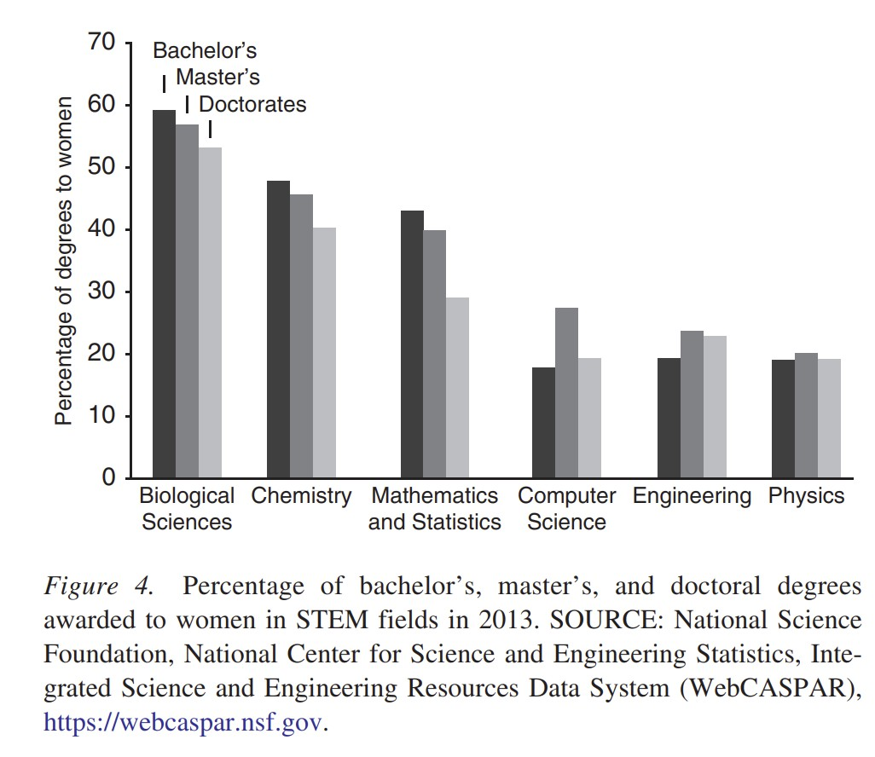
Women in STEM

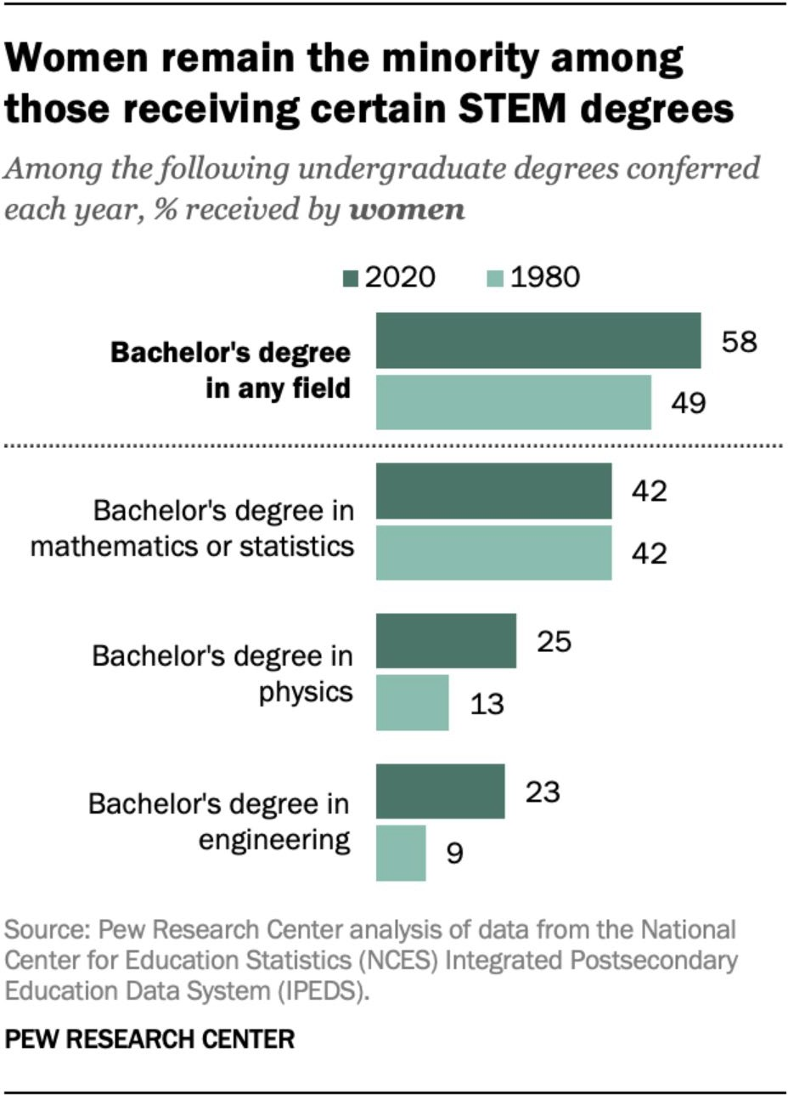

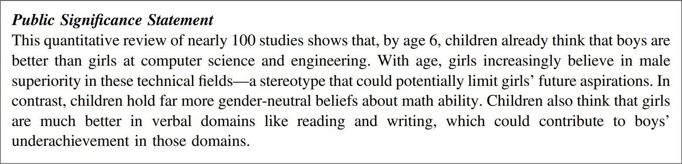
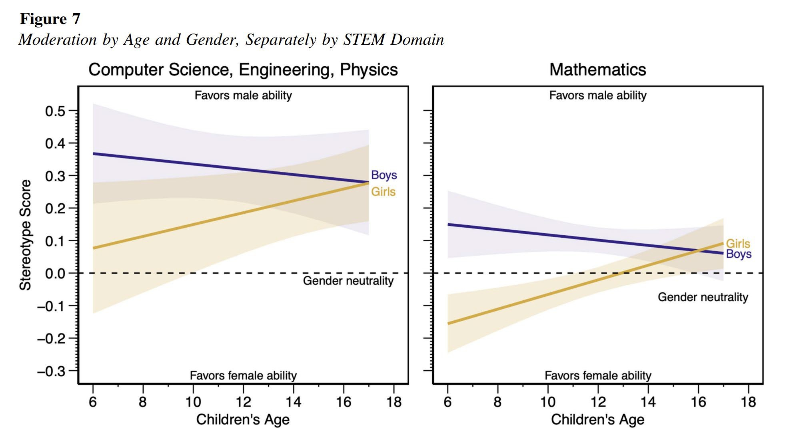
STEM Stereotypes Begin Early in Life


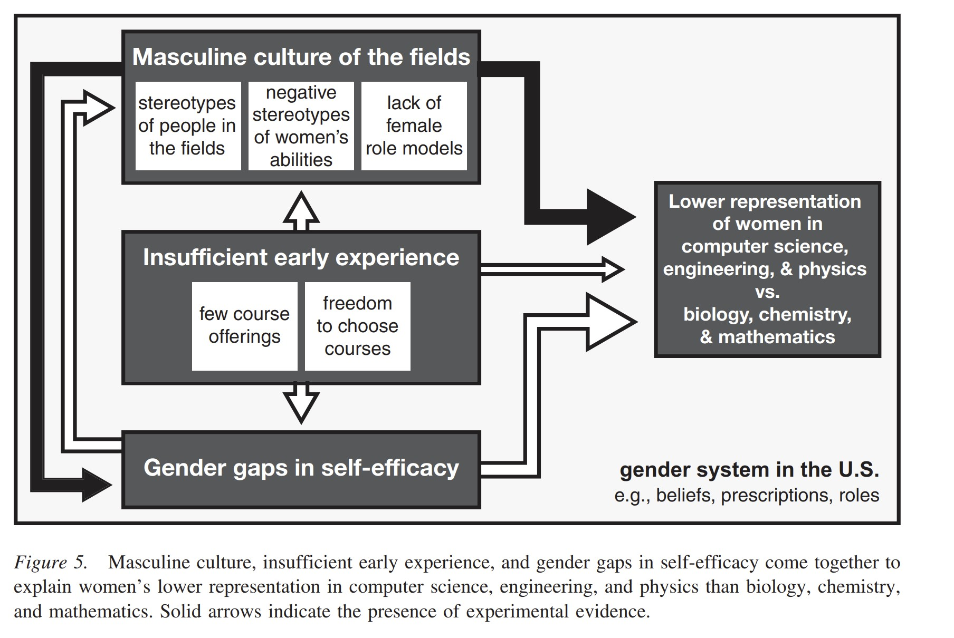
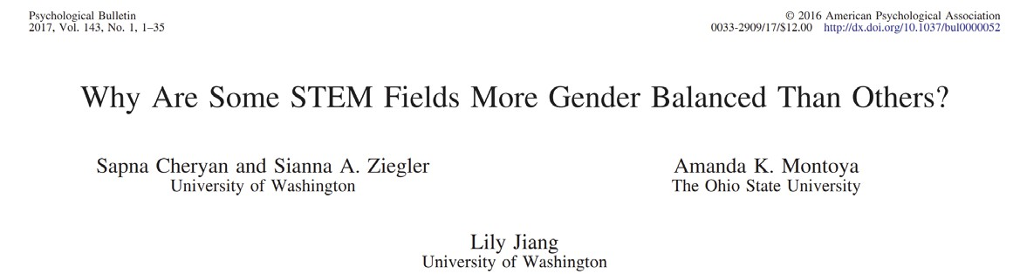
Women in STEM: Barriers
- A masculine culture signals to women a lower sense of belonging than to men

Increasing Women in all STEM Fields: Recommendations for Purdue

Reduce barriers to majoring in STEM fields
  - More students admitted as “exploratory”
  - Equalize university core curriculum across colleges
  - Bring small community feel to larger departments

Increase outreach to high schools in Indiana and neighboring states

  - Social media outreach to highlight the work and accomplishments of female faculty and students at Purdue

Encourage all STEM faculty to be allies, mentors, and role models to female students at all levels of matriculation
  - Make the topic relevant to female-oriented interests

Increase the number of female faculty and female graduate students who can serve as mentors to the Purdue undergraduates of the future

  - High levels of gender diversity in STEM classrooms or workplaces reduces identity threat concerns of women (Hall et al., 2018;Inzlicht & Ben-Zeev, 2000; Murphy et al., 2007)but only if it is sincere (Kroper et al., 2020)

Summary

- Attending to reducing barriers to entry and graduation for women in STEM disciplines can ensure that Purdue is well positioned to handle the challenges of the enrollment cliff AND to be a leader in the higher education of women in the rest of the 21st century

THANK YOU!
senate-chair@purdue.edu

14

 | University Senate Questions and Administrative Responses  27 January 2025

Questions
PWL and Regional Campuses……………………………………………………………………………………………………………………………………
What do you envision as the best possible relationship between Purdue WL and a regional campus, like PFW? What is the proper balance that PFW should seek to strike between planning for its own continued growth as a university in its own right and the support that it might expect both to give to and also receive from Purdue WL? How do we coexist and prosper together without trying simply to outcompete each other? By the way, I have posed only one question but in three different ways.
  - The relationship across the Purdue University System is one built on collaboration, mutual respect, and a shared commitment to advancing Purdue's land-grant mission of serving Indiana residents. Together, we can enhance educational opportunities and economic development across the state by leveraging our unique strengths—the main campus as a flagship research institution and both Fort Wayne and Northwest as vital regional hubs for accessible, high-quality education.

Grant Opportunities……………………………………………………………………………………………………………………………………………….
I started as an Assistant Professor of History at IPFW in 2000. When we were IPFW (before the 2018 split), Indiana University provided many system-wide grant opportunities that extended to faculty at regional campuses (e.g., IU New Frontiers grants) that provided generous support for research, conferences, etc. However, when we became PFW in 2018 those sources of support vanished. Unfortunately, PWL has not provided us (here at PFW) the same level of support for research that IUB provided. To be frank, it isn’t
even close. That’s why I was so excited to hear about the Purdue University Books Initiative, which provides substantial support for faculty who publish books. However, after I investigated the details, I learned that this support is limited to PWL faculty (faculty from other campuses are only eligible if they coauthor with a PWL faculty member). I was told that the Purdue Books Initiative is only open to PWL faculty because it is only budgeted for PWL faculty. Here’s my question: would it be possible to add more funds and make the Purdue Books Initiative available to faculty at regional campuses too (without the requirement of coauthoring with a PWL faculty)?
  - The Purdue University Books Initiative was launched to recognize the significant time and effort involved in academic book publishing. While the initiative is currently budgeted for main campus faculty, staff, and graduate students, faculty from Purdue Fort Wayne and Purdue Northwest are eligible if they coauthor with a faculty member from the main campus, encouraging greater systemwide collaboration. Launching a similar initiative is a decision for campus leadership, as demonstrated by Purdue Northwest’s creation of a seed funding program last year to support faculty working on book proposals or existing book contracts.

Voting on Campus…………………………………………………..………………………………………………………………………………………………..
Going forward, what specific procedures will the Administration follow to assure that planning and coordination with the County Board of Election for early and election-day voting happens well in advance of the BOE’s deadlines?

  - Early voting sites and on campus voting sites are selected at the sole discretion of the Tippecanoe County Board of Elections & Registration. Purdue fully supports the selection of voting sites that serve the best interests of the full Tippecanoe County community, as determined by the Board. When campus sites meet the necessary requirements, Purdue will propose suitable locations to the Tippecanoe County Board of Elections & Registration for consideration during each election
cycle. Purdue’s Auxiliary Services Conferences and Events team has integrated voting site planning
and selection into its recurring calendar of events, to aid timely planning and coordination with the Board.


Senate Document 24-05
18 November 2024

To: | The University Senate
From: | Educational Policy Committee
Subject: | Educational Policy Committee Faculty Committee Name Change
Reference: | - Purdue University Student Conduct Regulations: Grades and Grade Reports K. Academic Renewal  - Office of Admissions
Disposition: | University Senate for Discussions and Adoption
Rationale: | With the changes in language surrounding academic notice and academic separation, the Committee on Scholastic Delinquencies and Readmission would like to request a name change to reflect the more accurate and attuned tone that is being modeled elsewhere  across Purdue University.
Proposal: | The University Senate modifies the Academic Regulations within the Grade and Grade Reports, Section K Academic Renewal to reflect the committee’s new name:  Readmission and Academic Renewal Committee  Additionally, this name change would be reflected within the  Readmission Policy currently located within the Office of Admissions.

Committee Votes: Educational Policy Committee

For: | Against: | Abstained: | Absent:
Howard Sypher (Chair) Thomas Brush  Julie Chester Vincent Duffy Abdelfattah Nour PV Ramachandran Mark Russell Steven Scott  John Sheffield | N/A | N/A | Patricia Davies Stacy Lindshield Antonio Sa Barreto Monica Torres
Advisors Lesa Beals Sheila Hurt Jenna Rickus Jeff Stafancic |  |  | Advisors Jeff Elliott Cara Wetzel
Students  Ali Holmes |  |  | Students Bryanne Garcia Eden Wolfe

Senate Document 24-06
18 November 2024

To: | The University Senate
From: | Educational Policy Committee
Subject: | Modifications to Streamline and Clarify the Readmission Policy and  Add the Readmission Policy to the Purdue University Academic Regulations: Academic Notice and Separation C: Readmission
Reference: | - Office of Admissions  - Purdue University Academic Regulations: Academic Notice and Separation C: Readmission
Disposition: | University Senate for Discussion and Adoption
Rationale: | Purdue University’s current readmission policy needs updating, clarification and streamlining. Some of the policies and language date back to 1969 and no longer address the needs of the current student body at Purdue University. The current state of the policy causes confusion for students and staff trying to understand the details and includes redundancies throughout.  The current policy does not accurately reflect how Purdue University interacts with Purdue Fort Wayne and Purdue Northwest as students navigate academic separation from these institutions.  Nor does the current policy include clear language indicating that Purdue Polytechnic Statewide and Purdue in Indianapolis students should follow this readmission policy.  The current policy allows students to apply for Spring, Summer, and Fall readmission. There are a number of students who in the past have applied for readmission to Summer and then are separated again immediately at the end of the summer due to the ease with which a semester indices can dip below 2.0.  The current policy includes vague language regarding the required stop out period for students. This vagueness has resulted in dozens of students each semester spending many hours gathering medical information, notes from professionals across many fields, and compiling a genuine appeal as they reshare the traumatic events  which often played a large role in their eventual academic

separation. Yet the Committee on Scholastic Delinquencies and Readmission rarely granted these appeals because when students shared their stories it ultimately reinforced the belief that a stop out period was required.

The current policy lives on the website of the Office of Admissions and is linked to from the Academic Regulations. Although the Office of Admissions plays a role in shepherding students through the process and administering the readmission application, the Educational Policy Committee finds this policy would be more appropriately housed within the Purdue University Academic Regulations under the Academic Notice and Separation section.
Proposal: | The University Senate modifies the Readmission Policy according to the table that follows in order to:  - use more consistent and direct language regarding the readmission policy;  - reorganize the order of the policy to group like topics together and have the policy framed in a logical, progressive set of steps;  - ensure the readmission application process is aligned with all other application processes to Purdue;  - eliminate the ability for students to apply for readmission during the summer;  - clarify terminology regarding how the regional campuses and regional campus policies interact with this policy;  - delineate the instances where a student may file an appeal to the required stop out period;  - shift the placement of the policy from the Office of  Admissions website to the Academic Regulations

ORIGINAL LANGUAGE AND LOCATION | MODIFIED LANGUAGE AND  LOCATION
Office of Admissions Website  Readmission Policy | Academic Regulations  Academic Notice and Separation

 | C. Readmission
Readmission Policy  - The University Senate establishes academic notice and separation status levels. The current levels can be found  in University Regulations, Part 2, Section VIII.  - The University Senate establishes academic notice and separation status levels. The current levels can be found  in University Regulations, Part 2, Section VIII  (There is no corresponding statement.)  5. Students who are separated from the University for the first time are required to stay out at least one semester. Students who are separated for the second time are required to stay out for at least one year (two full semesters; summer session (modules 1, 2, 3) and other short-term programs do not count as a semester). The CSDR can make exceptions to this policy for seniors who can complete degree requirements in one semester with 15 or fewer credit hours, as long as they have the support of their school. Also, students who have suffered unusual extenuating  circumstances may petition for an | - The University Senate establishes academic notice and separation status levels. The current levels can be found in University Regulations, Part 2, Section VIII.  - A student may not be academically separated from Purdue unless they have been on academic notice the previous semester or was admitted on academic notice the previous semester. Throughout this policy, Purdue includes Purdue West Lafayette, Purdue in Indianapolis and Purdue Polytechnic Statewide.  (This is a new addition to the policy.)  - Students may only apply for Readmission in the fall and spring semesters.  - Students academically separated from Purdue for the first time must stop out for at least one semester. Students academically separated for a second time must stop out for at least one year (two full semesters; summer session (modules 1,2,3) and other short-term programs do not count as a semester). During that stop out period, students must enroll in at least 12 credit hours during one of the semesters. The exception is if the department requirement for readmission indicates that no classes should be taken during the stop out period.

exception. The CSDR must first review and approve valid pertinent information submitted by the student  with unusual extenuating circumstances before an application is given to the student for completion. Students seeking an exception must submit an application no later than the Thursday before classes begin for the next semester or academic term. (7/14/03)  The CSDR also must first review and approve any request from a school/department at Purdue University to make an exception to the layout period for a student with more than 15 credit hours to graduate. (7/14/03)  - The Readmissions Committee has authorized the committee chair to act on behalf of the committee under the following circumstances:  - When a student has a semester average of C or better the first semester after readmission and is separated again because of graduation index.  - When a senior has been separated and needs no more than nine credit hours for summer sessions to graduate or no more than 15 credit hours for fall or spring to graduate, and has a favorable recommendation from the school from which she/he has been separated. It is understood that in any instance in which a school recommendation for readmission is not favorable, the application | - The exceptions to the required stop out period are:  - Seniors who can complete degree requirements in one semester with 15 or fewer credit hours, if they have the support of their school/department  - The school/department may petition on behalf of a student with more than 15 credit hours remaining to reach degree completion  - Students who satisfy an incomplete grade within 15 days of the end of term  All exception requests must be filed no later than 15 days after the receipt of an academic separation notice. These exceptions are reviewed by the Readmission and Academic Renewal Committee.

will not be acted upon by the CSDR.  - When a student has been separated and has an incomplete grade from her/his last semester or academic session of enrollment that she/he can complete in a timely fashion - normally, before the beginning of the next semester or session. The course instructor must provide verification of the final grade in a timely fashion and the grade must raise the index (University graduation index and/or readmission semester stipulation) to the level where the student would be eligible to continue.  4. A student on academic separation status is not eligible to enroll in any course at Purdue University in West Lafayette, Purdue University in Indianapolis, any Purdue University regional campus, or the Statewide Technology Program.  - Students who are separated from the West Lafayette location may choose, after one semester lay-out, to apply for readmission at a Purdue regional campus and must adhere to the procedures established at that particular campus.  - A separated student from the West Lafayette campus who is readmitted as described in item 8 above in a Purdue program at a regional campus is eligible to  apply for transfer to the West Lafayette | - A student on academic separation status is not eligible to enroll in any course at Purdue, Purdue Fort Wayne, or Purdue Northwest.  - Students who are academically separated from Purdue may choose, after a one semester stop out, to apply for readmission at Purdue Fort Wayne or Purdue Northwest and must adhere to the procedures established at that particular campus.  - A student academically separated from Purdue who is readmitted as described in item 7 above is eligible to apply for transfer to Purdue under normal Purdue Fort Wayne  or Purdue Northwest transfer procedures

under normal regional campus transfer procedures after she/he has successfully completed 12 credit hours with grades of C or better.  - Students applying for readmission are required to pay a $100.00 readmission fee, which is non-refundable. Beginning with spring 2005 and thereafter, the readmission application fee will be  $100.00 (also non-refundable).* Refunds will be considered for students who will be registered after readmission for eight or fewer credit hours to complete their degree on the regional campuses and students who will be registered after readmission for six or fewer credit hours to complete their degree on the West Lafayette campus. The Office of Admissions may also waive the readmission fee if there is sufficient evidence of economic hardship  - Students must remove all University encumbrances by the application deadline of the semester or summer session for which they are seeking readmission and must pay the readmission fee by the application deadline.  14. The chair of the Committee on Scholastic Delinquencies and Readmissions may extend the readmission approval for a student. A newly readmitted student must enroll within one calendar year of committee action. Beyond that time the student shall file a new application for readmission. Another fee will be charged. (Reviewed and approved by the | after they have successfully completed 12 credit hours with grades of C or better.  - Students must remove all University holds and pay the non-refundable application fee by the deadline of the academic session for which they are seeking readmission. The Office of Admissions may waive the application fee if there is sufficient evidence of economic hardship.  - A newly readmitted student may request a change of term for up to one year from the date of original application. This request will be reviewed by the chair of the Readmission and Academic Renewal Committee. Beyond one year the student must file a new readmission application and will be charged the application fee.

Educational Policy Committee, 10/30/89).  (This was simply a statement listed above the policy.  Right of Review  A student who has been denied readmission by the committee may request that the committee review its decision. This review must be on the basis of additional relevant information not previously considered by the committee. The review can take one of two forms: (1) a review of written information submitted to the committee for further evaluation, or  (2) a personal appearance of the student at a committee meeting.  10. All students readmitted are readmitted on academic notice, with the stipulations to register for no more than 15 credit hours (nine credit hours total for all summer modules) and earn no less than a 2.0 semester index.  15. All readmitted students enrolled in more than 15 credit hours fall or spring semesters (nine credits for summer session) will be notified by letter within the first four weeks of the semester (two weeks of summer session) that their registration exceeds the credit hour limit and will lead to academic separation status if it is not reduced. Readmitted students who, based on their grade report, exceed the 15 credit hour maximum stipulation will be separated again. On the basis of unusual circumstances,  exceptions to the credit hour limitation | (This was not previously part of the policy.)  - A student who has been denied readmission by the academic department may request an appeal to the Readmission and Academic Renewal Committee from their application portal. This Readmission and Academic Renewal Committee review must be based on additional relevant information not previously considered by the academic department.  - All students readmitted are readmitted on academic notice, with the stipulations to register for no more than 15 credit hours and earn no less than a 2.0 semester index.  - Exceptions to the credit hours limitation for a readmitted student’s first semester back can be made for extenuating circumstances by petitioning the chair of the Readmission and Academic Renewal Committee.

can be made for extenuating circumstances by petitioning the chair of the committee.  3. Summer session grades do not immediately affect the academic notice or separation status of a student, except if the student has been readmitted for the summer session and does not meet the CSDR's stipulations. The student is separated again at the end of summer session if he/she fails to meet the stipulations placed on his/her readmission to summer session.  (There is no corresponding statement.)  - The Dean of Students was granted approval by the Committee on Scholastic Delinquencies and Readmissions in 1969 to reclassify and permit register as temporary students former students who have been separated provided:  - The Office of Admissions staff is convinced that the objective is for adult education only - no further degree objective.  - The student is at least 21 years old.  - The student will have been separated for at least a full year prior to registration. | - Summer session grades do not immediately affect the academic notice or separation status of a student. However, the summer term grades are included in the cumulative GPA of the next semester of enrollment.  (This is a new addition to the policy.)  - An academically separated student from Purdue Fort Wayne or Purdue Northwest must complete the campus’ readmission policy and complete 12 or more hours with grades of C or better at Purdue Fort Wayne or Purdue Northwest prior to being eligible to transfer to Purdue.  - An academically separated student is eligible to register as a non-degree student provided:  - The course load is limited to 7 hours or fewer  - The student will have been separated for at least 5 years prior to registration

- The course load is limited to six hours or less.  - The student is employed full-time or is a homemaker.  - The student is a commuter.  13. The Committee on Scholastic Delinquencies and Readmissions will review applications for students who graduated on academic separation status and want to enroll in  additional undergraduate course work. The Graduate School will decide whether a student who graduated on academic separation status may enroll  in graduate courses. (2/11/86)  - Members of the Committee on Scholastic Delinquencies and Readmissions voted to assign the readmission processing for non-degree students to the Office of Admissions. The director of admissions indicated that the following policies and procedures will be followed:  - All non-degree students who are separated for the first time must observe a one semester layout;  - A second readmission will not be considered;  - No readmission application fee will be assessed for non-degree seeking students | - The Readmission and Academic Renewal Committee will review post-baccalaureate reentry applications for students who graduated on academic separation status and want to enroll in additional undergraduate course work. The Office of Graduate Studies will decide whether a student who graduated on academic separation may enroll in graduate courses.  - Readmission processing for non-degree students is handled by the Office of Admissions. The following guidelines are used in instances of a non-degree student’s Academic Separation:  - All non-degree students who are academically separated for the first time must observe a one semester stop out  - A second readmission will not be considered  - Any high school student academically separated from Purdue must observe a one semester stop out before becoming eligible to reapply to Purdue

Committee Votes:
For: Against: Abstained: Absent:
Howard Sypher (Chair) Thomas Brush
Julie Chester Vincent Duffy Abdelfattah Nour PV Ramachandran Mark Russell Steven Scott
John Sheffield Patricia Davies Stacy Lindshield Antonio Sa Barreto Monica Torres
Advisors Lesa Beals Sheila Hurt Jenna Rickus Jeff Stafancic Jeff Elliott Cara Wetzel
Students
Ali Holmes Bryanne Garcia Eden Wolfe

Senate Document 24-07
27 January 2025

To: | The University Senate
From: | Senate Faculty Affairs Committee
Subject: | Creating a University Senate Listserv to enable unmoderated  communication between senate leadership and faculty
References: | See Footnotes
Disposition: | The University Senate for discussion and adoption
Rationale: | The University Senate is the governing body of the faculty, and it exercises the legislative and policy-making powers assigned to the faculty, subject to review and check only by the faculty by established procedures. [1]  The University Senate does not have direct access to the use of university-wide mailing lists. For the University Senate leadership to email the Faculty directly, it must send a request to the Vice Provost of Faculty Affairs that justifies how the proposed email content is “official University business of broad interest.” [2] The VPFA must provide advance approval for the Senate leadership to email the faculty directly.  The above policy was put in place to address concerns about misuse of university-wide listservs for unimportant items.[2]  The AAUP Report on Academic Freedom and Electronic Communications [3] states:  “[S]enate officers and other faculty representatives engaged in institutional governance activities should have free and unfettered access to university-controlled lists of faculty members they represent, and all faculty members should be able to comment electronically on governance issues without restriction or fear of disciplinary action.”  Purdue Student Government (PSG) and Purdue Graduate Student Government (PGSG), MaPSAC leadership, and CSSAC leadership currently enjoy the right to directly email their constituents without  mediation by administration. Additionally, the Senate leadership at

Purdue-Northwest and Purdue-Fort Wayne have the power to email their faculties without asking permission from the administration.

The University Senate Chairperson is the elected representative of the Senate, which represents the faculty at Purdue-West Lafayette; the chair serves a one-year term. [4] The Secretary of the Faculties is a faculty member who assists the Senate across multiple academic years, thereby providing organizational continuity and consistency.[5] The Sergeant-at-Arms is a staff member assigned by the Office of the Provost to support the work of the Senate.[6] These are Senate officers entrusted with ensuring the business of the Senate is carried on expeditiously, and that the will of the Senate is clearly expressed to various constituencies.

In pursuit of this charge, they might have need to communicate with the faculty body at large from time to time.

Proposal: The Vice Provost for Faculty Affairs authorize IT at Purdue to create a University Senate listserv with the following stipulations and take supportive measures to disseminate knowledge about the existence of the University Senate listserv.

- The Senate Chairperson, Secretary of Faculties and Sergeant-at-Arms have the right to send emails on the University Senate listserv without needing advance approval by any member of the University administration. Deliberation among these three parties will be the sole basis for deciding what is appropriate content for posting on this listserv.
- The listserv be created such as to allow any member of faculty, staff and students of Purdue University to:
  - Opt-in to receive emails sent on this listserv.
  - Once admitted, opt-out of this listserv if they wish.
- That, once created, the university administration facilitate dissemination of knowledge about the University Senate listserv and instructions on how to access it through all available channels including (but not limited to):
  - One university-wide email annually
  - A monthly reminder in Purdue Today during the first academic year of the creation of the listserv.
  - Inclusion in the orientation materials sent to all new faculty hired at Purdue University.

 | d. Inclusion in orientation workshops to new faculty at Purdue University.
References | - Bylaws of the University Senate, Article 1: Purpose and Powers https://www.purdue.edu/senate/about/bylaws.php  - Discussion during Question Time of University Senate meeting of 27 January 2020. Minutes available at https://www.purdue.edu/senate/documents/meetings/Jan-27-2020-Minutes-Complete.pdf  - AAUP report on Academic Freedom and Electronic Communication, 2013, p. 48. https://www.aaup.org/report/academic-freedom-and-electronic-communications-2014  - Bylaws of the University Senate, Article 3.20: Chairperson and Vice Chairperson of the University Senate. https://www.purdue.edu/senate/about/bylaws.php  - Bylaws of the University Senate, Article 3.30: Secretary of Faculties. https://www.purdue.edu/senate/about/bylaws.php  - Bylaws of the University Senate, Article 3.40: Sergeant-at-Arms.  https://www.purdue.edu/senate/about/bylaws.php

Committee Votes:

For: | Against: | Abstained: | Absent:
Françoise Brousseau-Lapré*  Stephen Cameron Patricia Davies Alice Johnson Bhagyashree Katare Robert Nawrocki Anish Vanaik*  *FAC Co-Chairs |  | Ali Bramson  Advisors  Sunil Prabhakar Lisa Mauer | Arezoo Ardekani Alexander Francis Nastasha Johnson  J. Paul Robinson Jennifer Scheuer

Committee Votes:
To: | The University Senate
From: | University Senate Nominating Committee
Subject:  Reference: | Nominee for the Educational Policy Committee  Bylaws of the University Senate
Disposition: | Election by the University Senate
Proposal: | For the opening on the Educational Policy Committee, the Nominating Committee proposes the following nominee:

Name | Term Years | Department/School
Yuli Lyanda-Geller | 2.5 | Physics & Astronomy

Senate Document 24-08
27 January 2025

For: | Against: | Abstained: | Absent:
Dulcy Abraham Damon Lisch Seema Mattoo  B.C. Min  Sebastian M. Ramirez Abdelfattah Nour Mohit Tawarmalani  Christina Wilson-Frank | N/A | N/A | Sabine Brunswicker

Purdue Psychology Treatment and Research Clinics (PPTRC)
College of Health and Human Sciences, Department of Psychological Sciences Clinical Program
Director: Heather Ciesielski, PhD, ABPP, HSPP

Services Offered

Testing and Assessment Clinic (TAC)
  - Comprehensive psychological evaluations for ages 5+
  - Evidence-based evaluation, diagnosis, and recommendations

Child and Family Treatment Clinic (CFT)
  - Individual and family treatment for common childhood disorders (ADHD, anxiety, depression)
  - Training in evidence-based protocols and practice
  - Behavioral caregiver training group program for parents of children with behavioral difficulties

Adult Services Clinic (ASC)
  - Individual treatment for adult clients
  - Training in evidence-based protocols and practice
  - Cognitive-behavioral therapy, acceptance and commitment therapy, motivational interviewing, and ADHD skills for college students (group program)

About Us
- Lyles-Porter Hall
- PPTRC provides supervision and training for graduate level student clinicians enrolled in the Clinical Psychological Sciences Program
- Year-long internal clinic practicum rotations begin Spring of Year 1
- Clinicians are supervised by licensed Clinical Associate Professors clinical program
  - Heather Ciesielski, PhD, ABPP, HSPP: TAC, CFT
    - Began 2022, background as clinical faculty in academic medicine (Cincinnati Children’s Hospital)
  - James Noll, PhD, HSPP: ASC
    - Began 2023, background in practice and administration in community mental health (4C Health)

Census and Wait Times

Primarily community-facing clinic
  - Application based process
  - Exceptions: Court-ordered treatment or evaluation (including custody), emergency or walk-in services, high-risk clients (referrals provided)
  - Services in all clinics are available to students (and anyone in the community)
- Low-cost services (current range $4 - $45/session)
  - Fees based on federal poverty guidelines (currently 2017)
  - Option for reduced fee if documented financial hardhip

Census is driven by each student cohort each semester
  - Advanced clinical training option over the M23 summer term
- Wait times = lengthy
  - TAC can be 1 year or more
  - CFT and ASC range about 3 – 6 months, depending on cohort


Students in Distress

- Purdue CAPS (24/7 crisis services)
- Other Resources:
  - Indiana Suicide Prevention: https://www.in.gov/issp/
  - Suicide & Crisis Lifeline (988): https://988indiana.org
  - NAMI: https://nami-wci.org/living-room
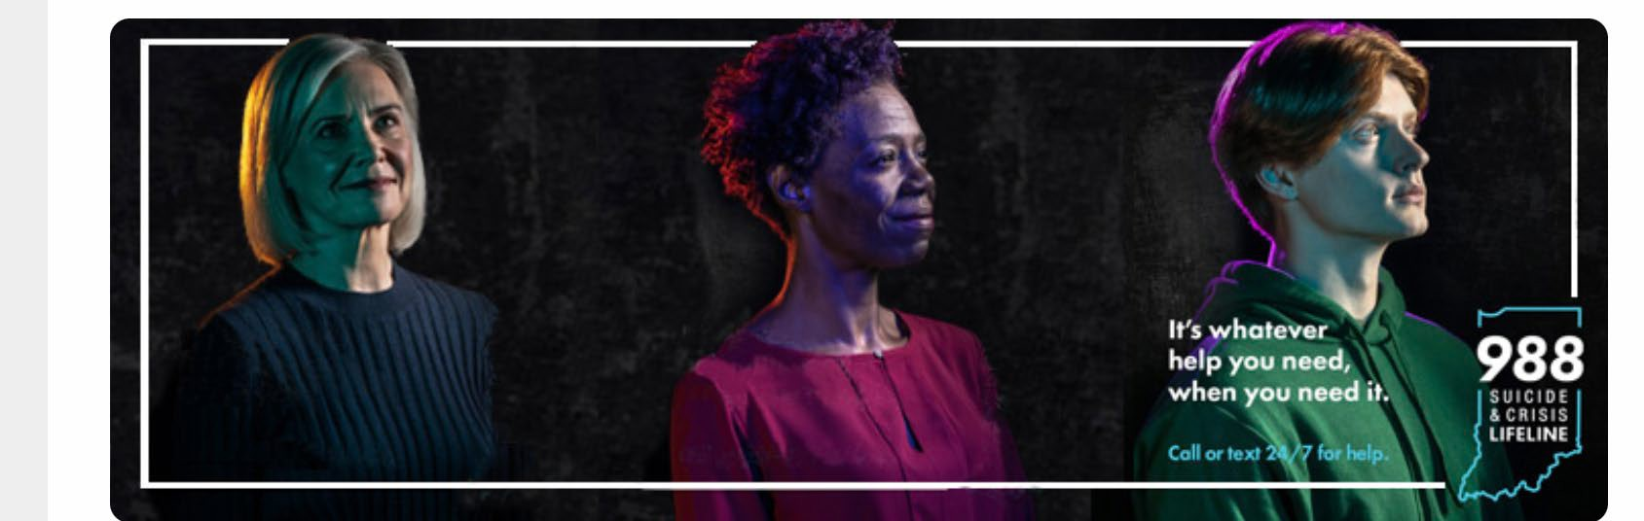
- Youth Resources:
  - Indiana Center for Prevention of Youth Abuse & Suicide (Education/resources; www.indianaprevention.org)
  - IYG: Specific Resources for LGBTQ+ youth; www.indianayouthgroup.org

Thank you!
Questions?

SUPPORTING STUDENT WELL-BEING AND MENTAL HEALTH

Well-Being Unit and Counseling and Psychological Services

1

Well-Being at Purdue University

    - Supported by Steps to Leaps, Student Life provides programs, services, and experiences focused on enhancing and improving holistic well-being.

    - A Well-Being Unit has been developed, led by a new role, As sistant Vice Provost for Student Well-being
      - Purdue University Student Health (PUSH), Recreation and Wellnes s (RecWell), and Counseling and Psychological Services (CAPS).
      - Promotes a “one team” approach and experience for well-being at Purdue University.

    - The Action Council on Student Housing and Well-Being has played a significant role in these initiatives including advancing e fforts toward a campus-wide culture of well-being and providing resources to enhance staffing and services.

Counseling and Psychological Services (CAPS)

    - CAPS is comprised of a multidisciplinary team of mental health providers that specialize in college mental health.

    - CAPS provides mental health services to meet the continuum of mental health needs of Purdue students.
      - Services are tailored to students needs and include group, individual, psychiatry, crisis services, drop-in, care management, peer support, and specialty services.
        - Provided at CAPS locations, across campus, and online.
        - No predefined session limits. Treatment services are brief in nature and based upon need.

    - CAPS has embedded counselors onsite in Indianapolis, Graduate Student Center, College of Engineering, and College of Veterinary Medicine.



Counseling and Psychological Services (CAPS) - Service Updates

- There is no wait to get started
  - CAPS offers same day/next day access appointments for any student
seeking care. Appointments are scheduled online, in person, or by phone.

- CAPS has enhanced staffing and specialties
  - Check out our staff directory for more information about the team.

- Expanded access to support through campus engagement programs
  - Now offering Question, Persuade, and Refer (QPR) training for campus, CAPS Ambas sadors peer to peer program, Let’s Talk, and other innovative services.

Student Trends

- CAPS continues to see a high demand for services. CAPS managed a 35% increase in total students seeking services during Fall 2024 compared to the prior year.

CAPS utilization is trending above the prior peak period of utilization in 2018-2019.
  - Additional staffing resources from the University has helped meet the increase in demand.

- Reflects greater trends with an improved perception of help-seeking and mental
health treatment among college students likely contributing to an increase in students seeking services .

- Students are increasingly interested in well-being and the well-being of others.

- Mental health challenges continue to be prevalent among college students with
anxiety and depression to be the most frequent issues. Social anxiety is increasingly common. Lonelines s is a big factor in well-being.

Next Steps for a Campus Wide Approach

- Engage and Partner with Resources
  - Attend a Training, Use TAO, or bring we-lbl

eing resources to your students.

- Promote Awareness of Resources andMessaging
  - Resources across Student Life, Academic Programs, and Campus
  - Share positive messages around importance of wel-lbeing. Steps to Leaps and Wel-lbeing highlighted practices (i.e. Sleep) are examples of available resources.

- Create Experiences for Learning and Engagement on aspects of Wel-lbeing
  - Incorporate concepts to develop skills, normalize wel-l being discussions, and capacity building activities as part of a student’s successful academic journey.

- Empower Peer to Peer Support
  - Students care about their mental health and the mental health of others.
  - Provide formal and informal experiences to create a sense of belonging and community.

THANK YOU
Counseling and Psychological Services 765-494-6995
www.purdue.edu/caps


CAPSATPURDUE  PURDUECAPS Purdue University CAPS

7

