
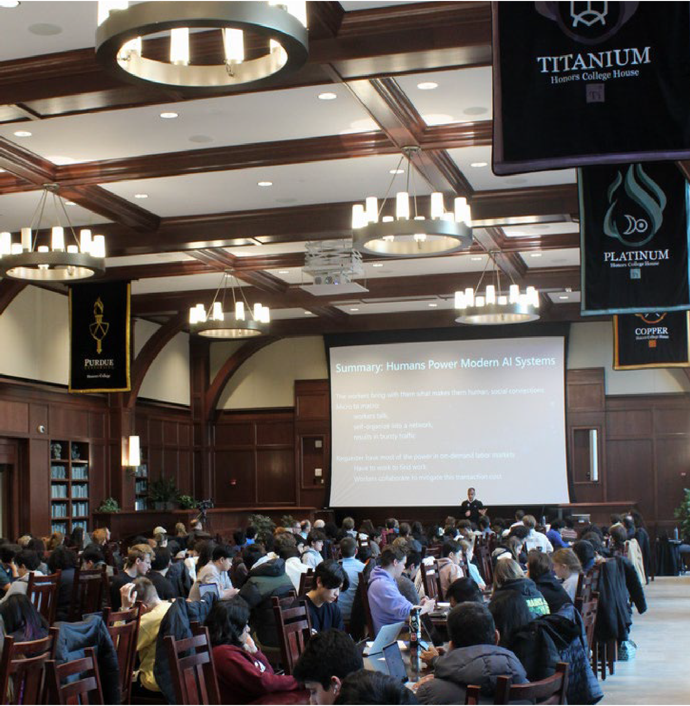


OVERVIEW OF THE JOHN MARTINSON HONORS COLLEGE
UNIVERSITY SENATE NOV 17, 2025 MEETING

Felisa Preciado Higgins, Ph.D. Associate Vice Provost and Dean of the John Martinson Honors College
Clinical Professor, Mitch Daniels School of Business
Professor of Practice (by courtesy), School of Industrial Engineering
1

JMHC is Purdue’s only academic residential college for highly motivated students from all colleges and majors






- Support highly motivated students in achieving their academic and personal goals.

Offer opportunities for leadership development, global and community engagement, undergraduate research, and interdisciplinary academics.
- Empower students to complete a 24-credit interdisciplinary honors curriculum.
- Guide students to produce scholarly projects that contribute new and original research or other scholarly/creative work to their field.
Named #8 Honors College in the
U.S. by College Transitions in
2024

Average SAT score of 1409,

ACT 32, and high school GPA 3.90
Garnered more than $8 Million in philanthropic support during FY25

>10,200
admission applications for Fall 2025

Intentional Pathways – Students design purposeful, self-directed journeys.

Rooted in Purdue's land-grant mission

“At the John Martinson Honors College, we challenge and empower students to contribute to society in meaningful ways and excel in their careers. We are an interdisciplinary community where highly motivated students build strong relationships, develop multiple dimensions of themselves, and collaborate to innovate for a better world.”

Scaffolded Development – The structure supports growing challenge, confidence, and impact
Integrated
academic and co-curricular experiences
A vehicle for
interdisciplinary, transformative learning






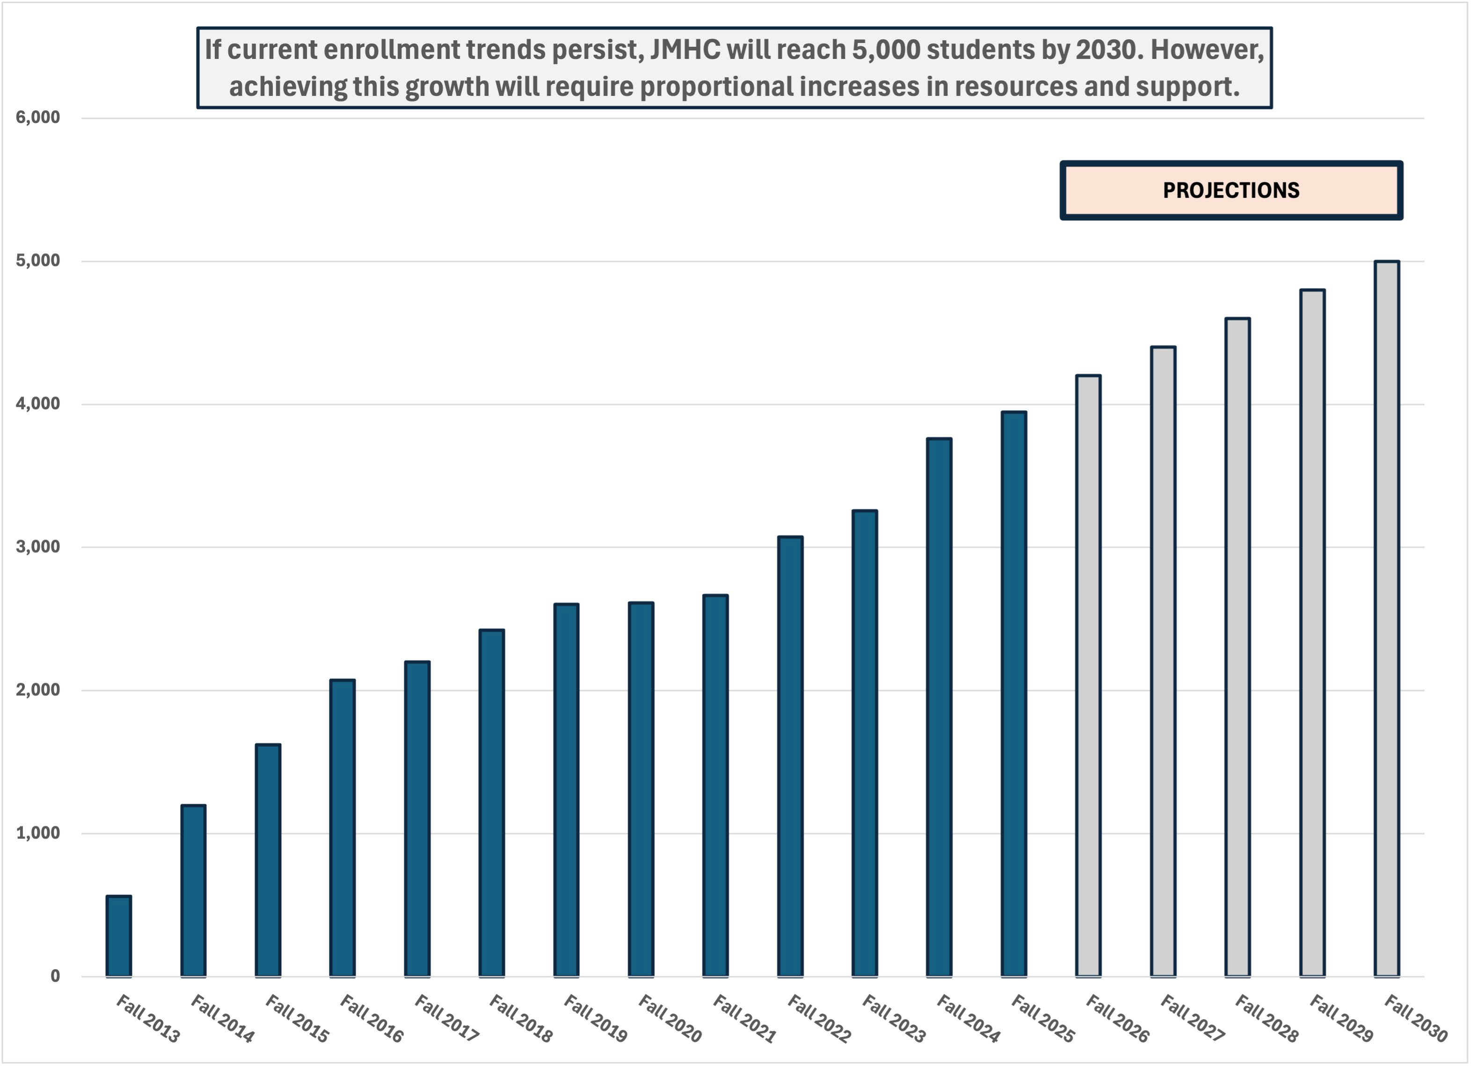
JMHC’s
enrollment tripled over 10
years: from 1200
(2014) to 3760
(2024):

% Fall 2024 JMHC Enrollment by College
College of Veterinary Medicine
College of Science
Polytechnic Institute
College of Pharmacy
College of Liberal Arts
College of Health and Human Sciences
Exploratory Studies
College of Engineering
College of Education
Daniels School of Business
College of Agriculture
0% 5% 10% 15% 20% 25% 30% 35% 40%

Four-Year Graduation, Honors vs. Non-Honors
100.0%

90.0%
80.0%
78.3%
78.4%
73.4%
74.6%
74.3%
70.9%
72.3%
70.0%
64.1%
64.7%
65.4%
66.1%
60.0%
59.4%
59.5%
61.4%
50.0%

40.0%

30.0%

20.0%

10.0%

0.0%
Fall 2014
Fall 2015
Fall 2016
Fall 2017
Student Co hort
Fall 2018
Fall 2019
Fall 2020
Honors 4-year Graduation Non-Honors 4-year Graduation
Six Year Graduation Graduation, Honors vs. Non-Honors
100.0%
92.6%
93.6%
91.1%
91.9%
90.0%
89.3%
82.5%
82.1%
82.8%
83.1%
82.7%
80.0%

70.0%

60.0%

50.0%

40.0%

30.0%

20.0%

10.0%

0.0%
Fall 2014
Fall 2015
Fall 2016
Student Co hort
Fall 2017
Fall 2018
Honors 6-year Graduation Non-Honors 6-year Graduation
% Students Graduated
% Students Graduated
JMHC ADMITS HAVE HIGHER SIX- AND FOUR-YEAR GRADUATION RATES THAN NON-HONORS STUDENTS

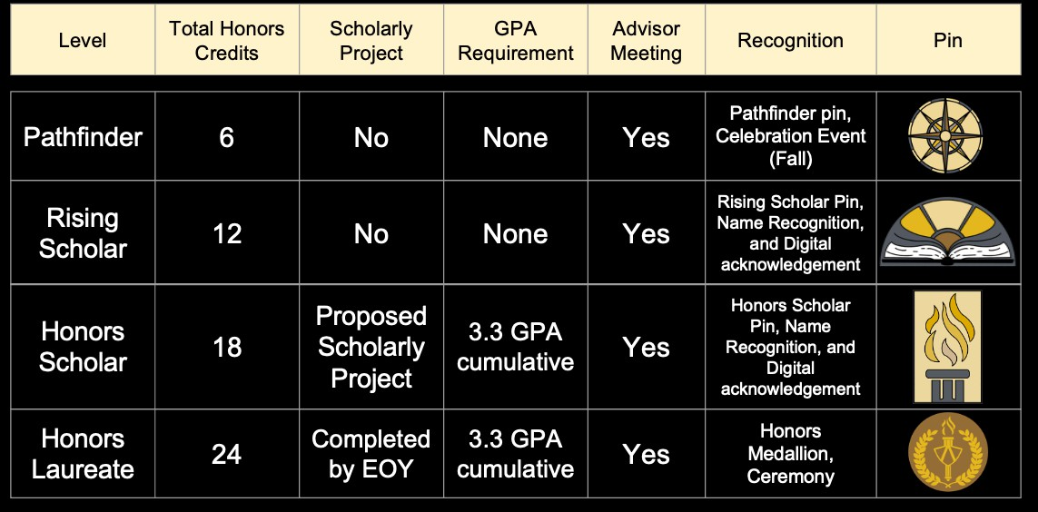
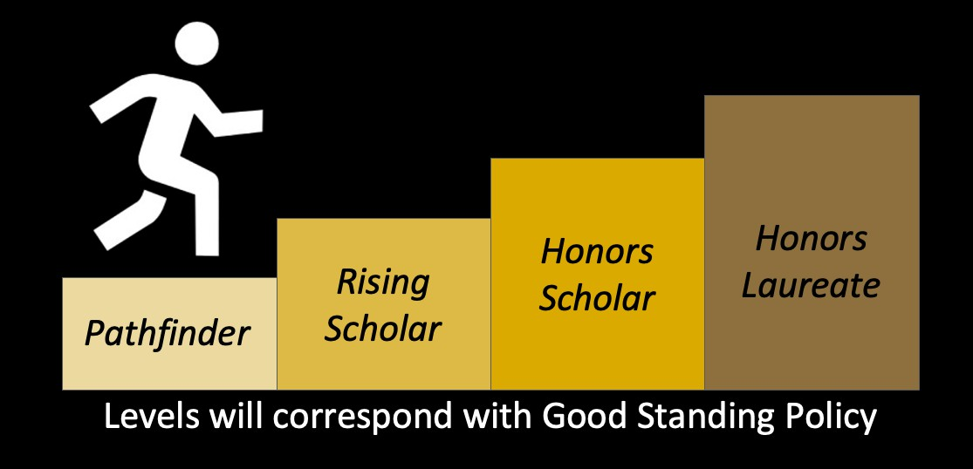


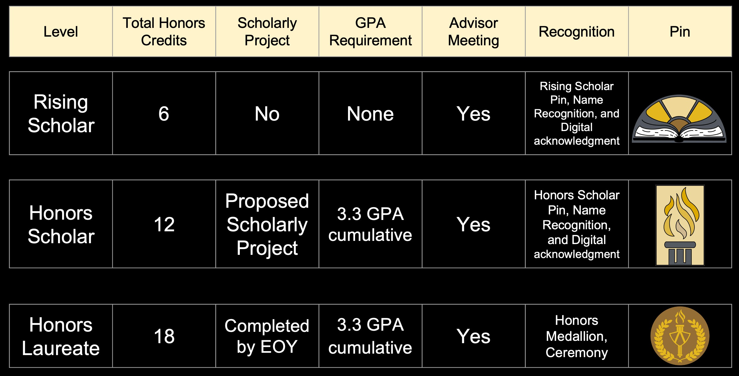


HONORS CURRICULUM: Ways to Earn Honors Credit

HONR courses – courses currently offered by the Honors College (HONR prefix)

Honors section courses (H designation) – sections of major, general education, or elective courses designated as honors (e.g. COM 11400-H) and offer by degree-granting colleges
H-Ready courses – beginning Fall 2025, some courses will be “H-Ready,” meaning the honors option is embedded in every section (no contract paperwork required)
Honors contracts (H contracts) – a student and instructor agree to enriched work in a standard course to convert it to honors credit

Selective:
- Graduate-level courses (500-level) – when not required for your major, such courses may count toward honors credit
- Supervised research / independent study / scholarly projects – research credit courses, honors thesis, or independent study courses count toward honors credit

All H Sections and contract Honors credits are provided by the academic degree-granting colleges as well as most of the research and selective credits

14,000

12,000

10,000
Credit Hours Produced

8,000

6,000

4,000

2,000

0
Honors Credit Hour Production by Academic Year, 2013-2024

H Section HONR Contract Enrollment

4,000

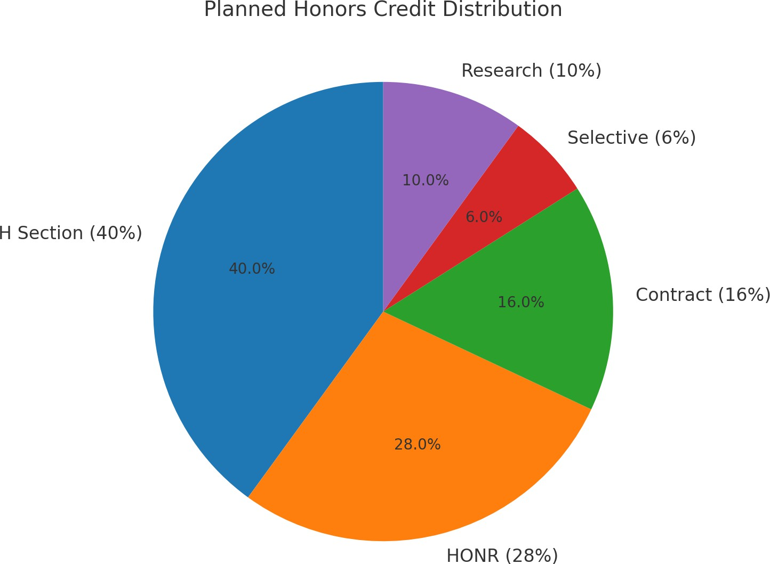
3,500

3,000

2,500
# Students in JMHC

2,000

1,500

1,000

500

0

Honors Section Credit Production by Disciplinary College, AY '22- AY '25
0 500 1,000 1,500 2,000 2,500 3,000 3,500 4,000

Agriculture

Business
129
142
168
165

61,021
94

1,363 1,481

Education

Engineering

HHS

Liberal Arts

Pharmacy

Polytechnic

Science

Vet. Med.
104
89
75
63

6
20
22

92
109
138
148

1

430
491
493
455

783

975
1,028

1,191

2,064
2,059
2,154

2,552

2,712

2,901

3,130

3,609

AY 2022 AY 2023 AY 2024 AY 2025

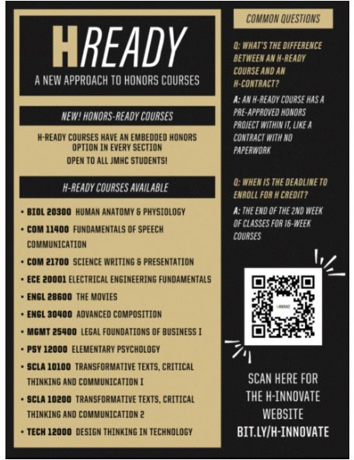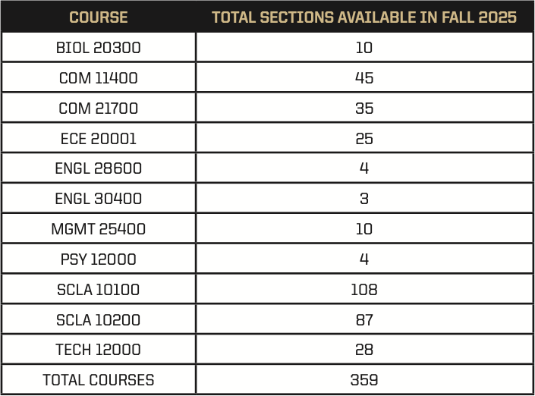

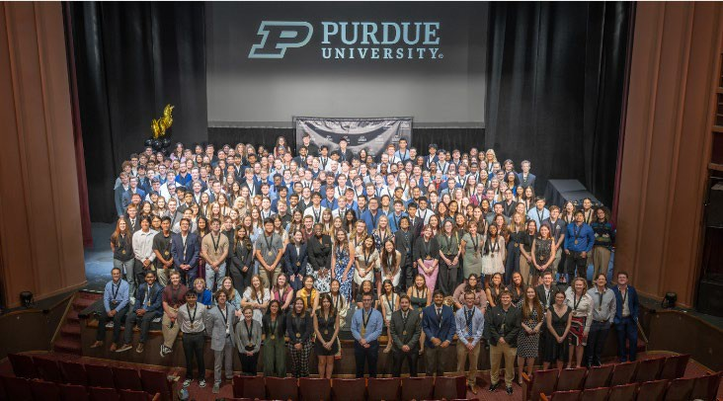
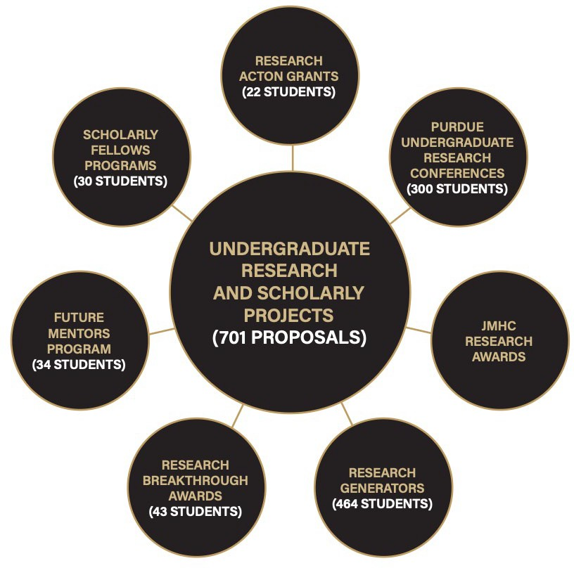
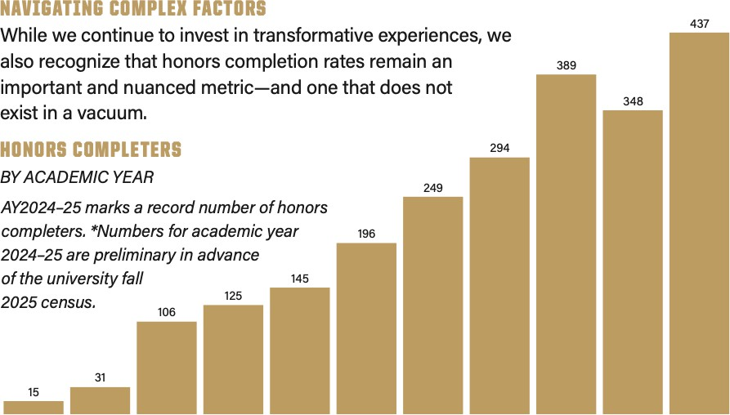

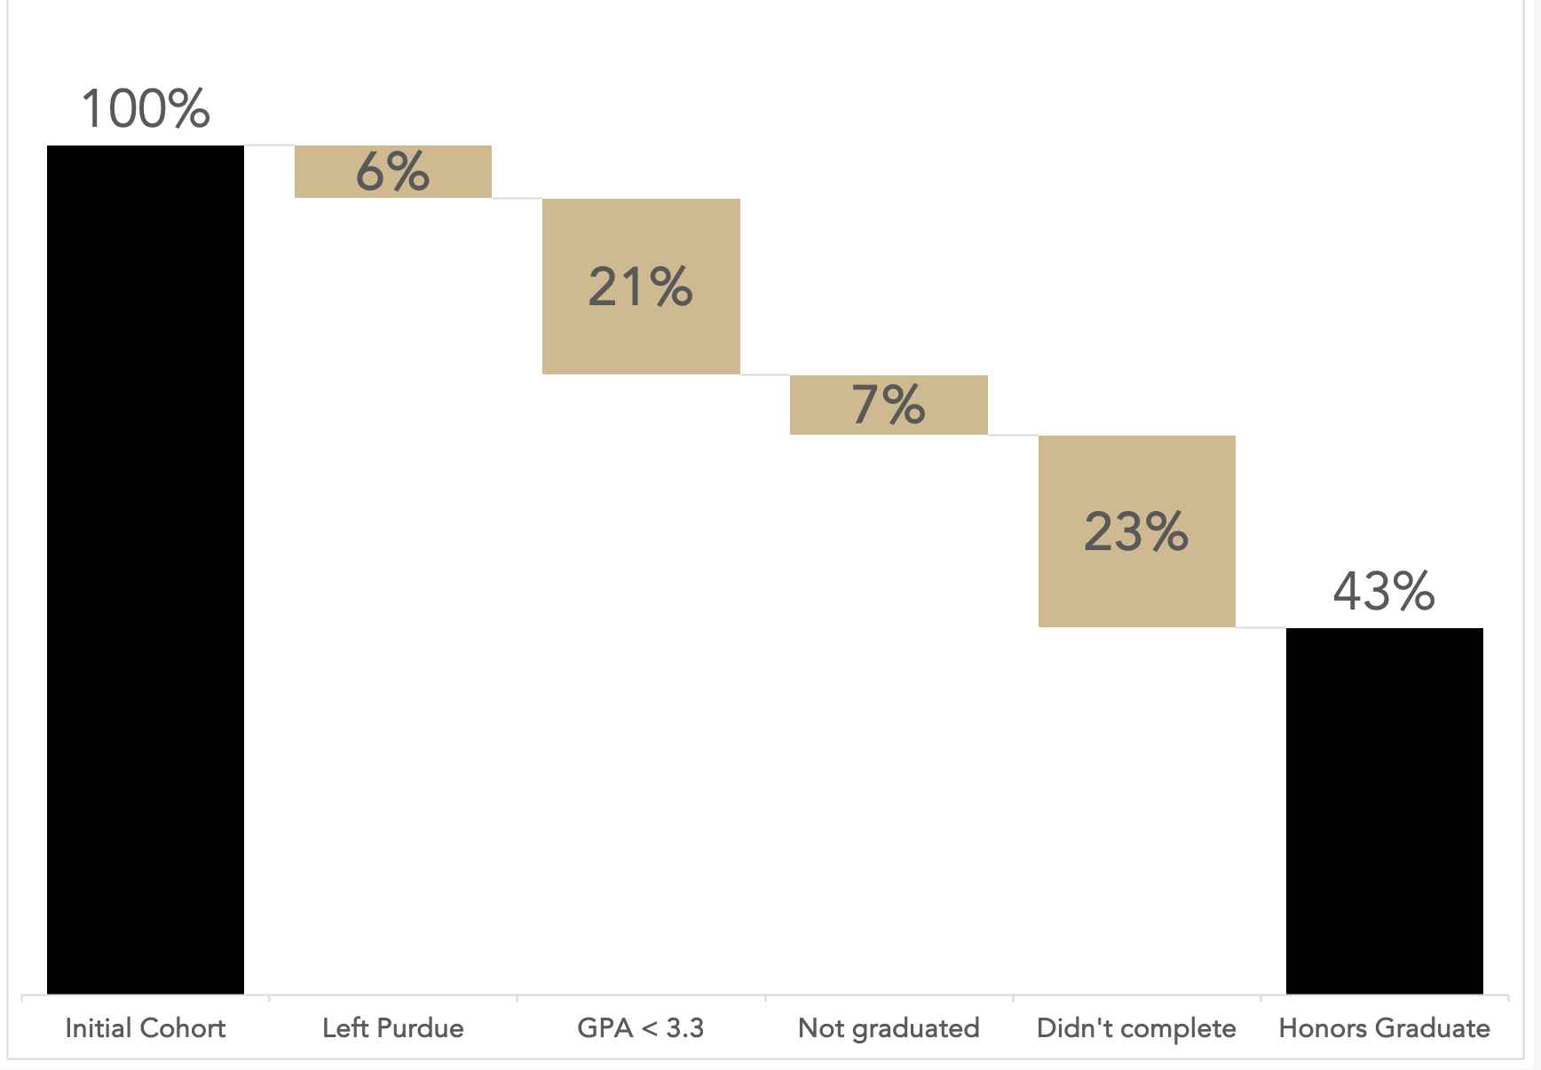
2021 FY Cohort 4-year Completion Factors

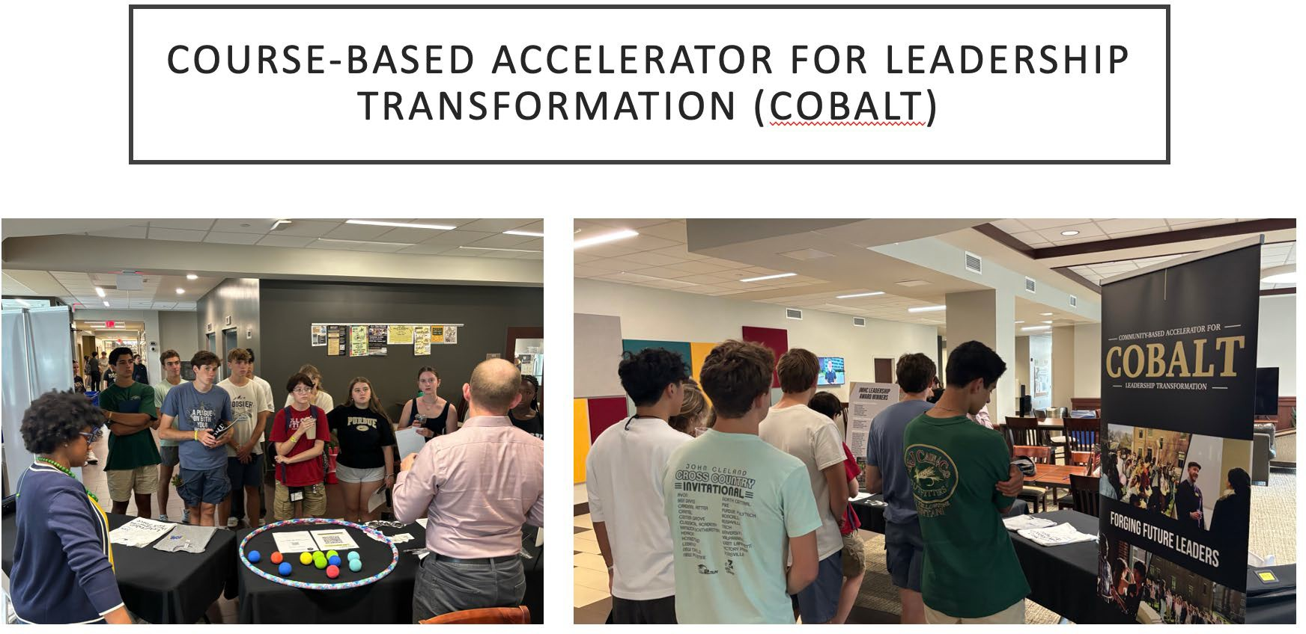

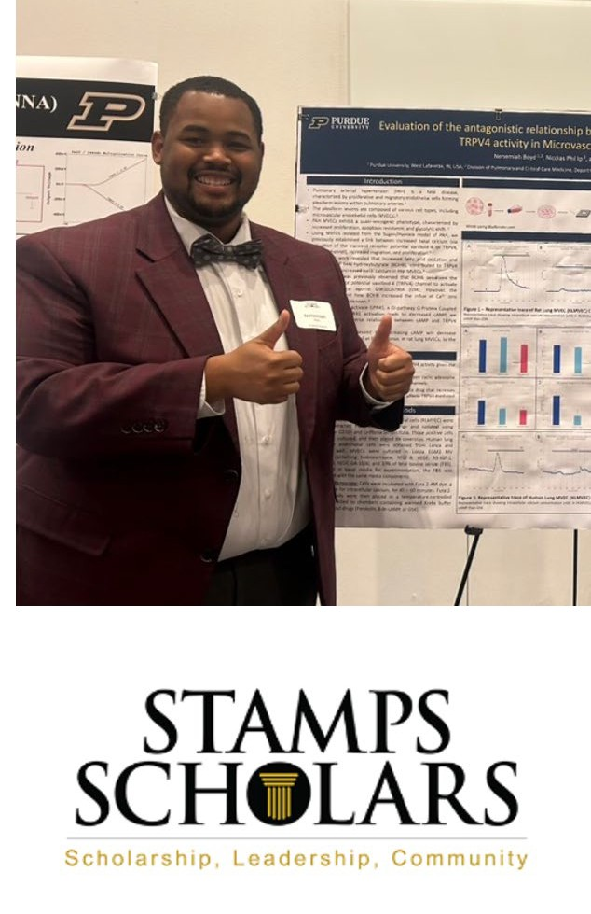
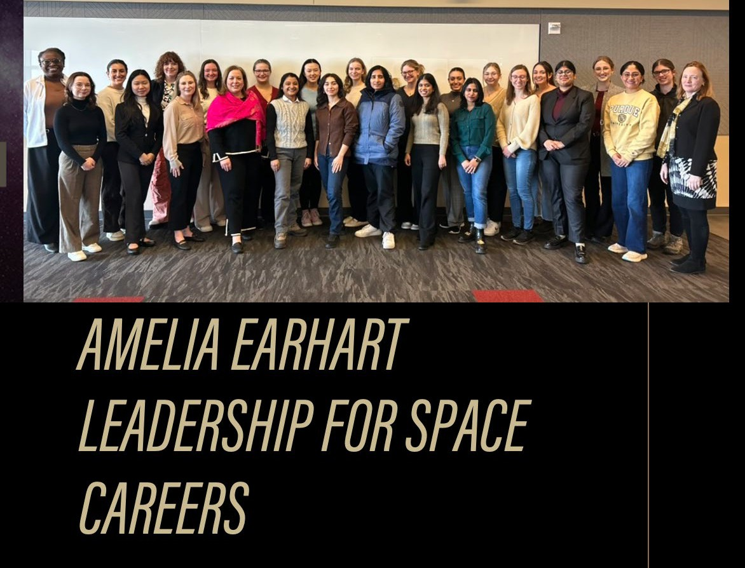

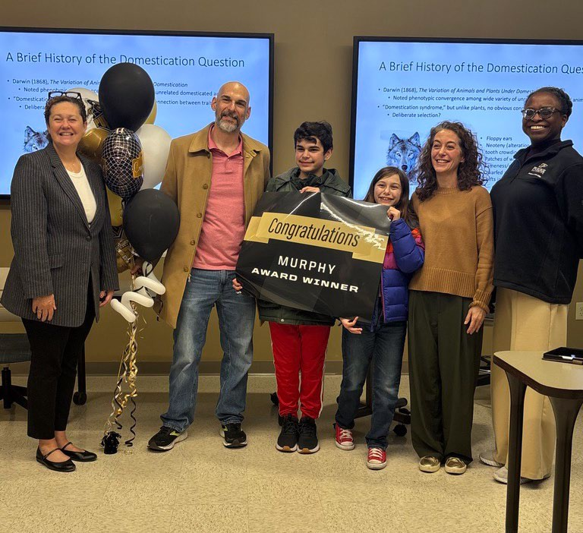
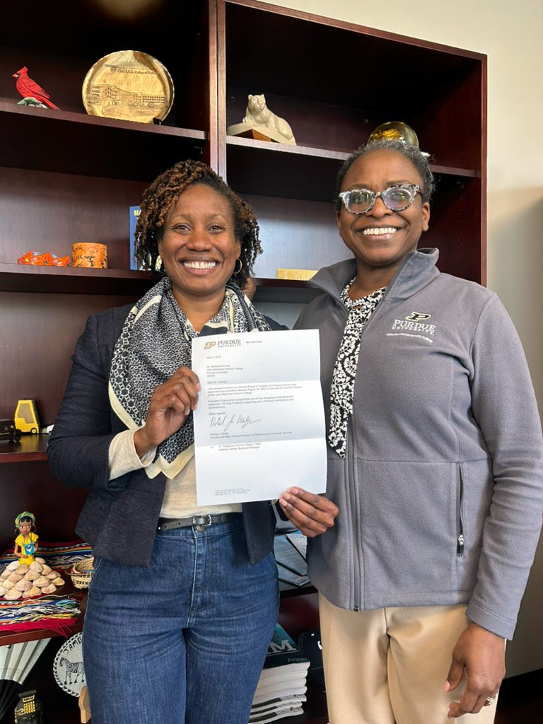
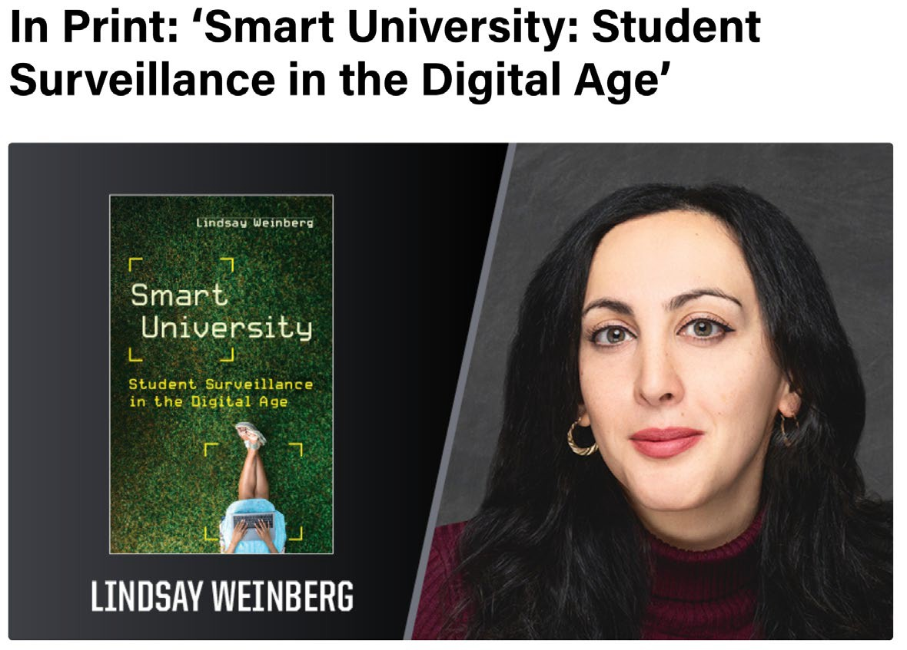


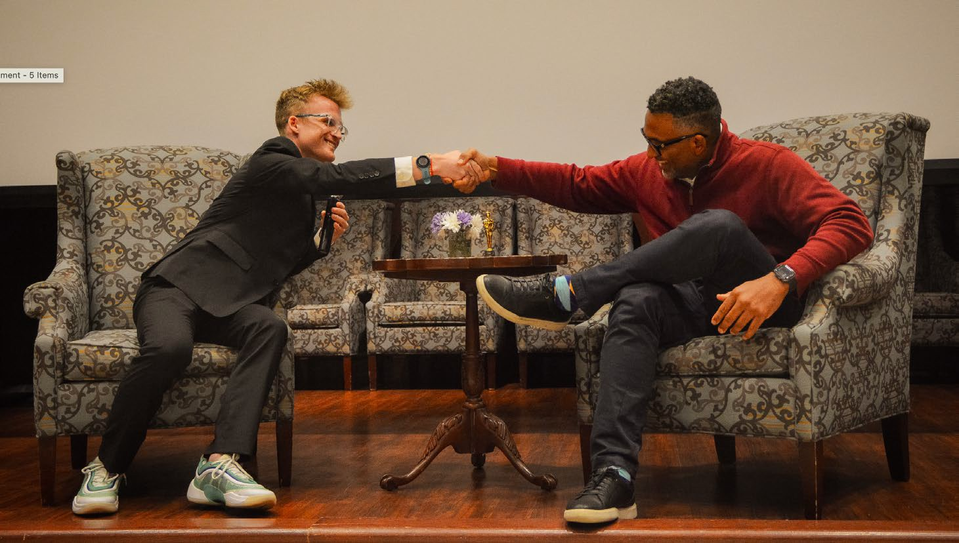

We partner with faculty across campus to further the work of faculty and promote undergraduate research
The Research Breakthrough Award offers $50-75K to Purdue faculty members prepared to conduct high-impact research or creative projects with a team of JMHC students.
- 2024 Breakthrough Award Recipients came from Agriculture, Health and Human Sciences, Honors College, and the Polytechnic Institute.
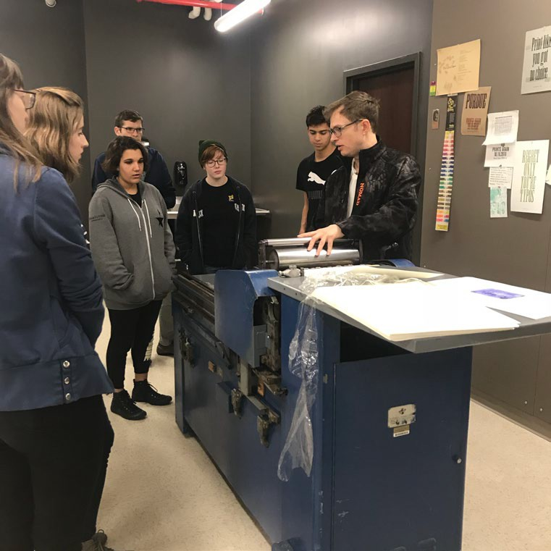
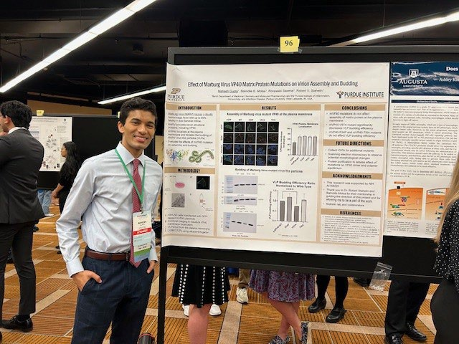
- Seed grants went to faculty from Engineering, Polytechnic Institute, and Veterinary Medicine
Our seven Research Generators bring together faculty from across campus to
collaborate on interdisciplinary themes: sports, sound, community engagement, computing, printmaking, technology, and health.
All JMHC students conduct research with a faculty supervisor, contributing to
ongoing research in every college. We train on research and teamwork skills, pair students with faculty researchers, and offer research grants and conference funding.




Current JMHC faculty members must seek to become departmental hires, with full financial responsibility assumed by the respective departments.
JMHC FACULTY REALIGNMENT: ACADEMIC AND INSTITUTIONAL CONSIDERATIONS

Honors funding will shift toward course buyouts rather than permanent faculty support.

Departments will determine if and how faculty contribute to honors teaching, scholarship, engagement, and mentoring.

JMHC faculty who do not secure a new position in a degree-granting unit will receive a notice of non-renewal of their contract.

Within these constraints, Purdue must ensure:
- Academic continuity for honors students.
- Transparent and fair faculty treatment.
- Sustained interdisciplinary engagement.
- Preservation of Purdue’s standing as a destination for high-achieving students.

Advantages
FOR ADDED CONTEXT: AAU INSTITUTIONS IN TOP 10 HONORS RANKINGS: FACULTY APPOINTMENT COMPARISON
:
Guaranteed honors teaching capacity.

Stable interdisciplinary curriculum planning.
High-impact mentorship and research opportunities.
A strong foundation for strategic student success outcomes.
Challenges: Faculty structural separation from the departments and loss of influence in department-level scholarly communities.

Tension when disciplinary norms differ from interdisciplinary expectations.
AAU Schools WITH Full-Time Honors Faculty | AAU Schools WITHOUT Full-Time Honors Faculty
Arizona State University (Barrett) | University of Georgia (Morehead)
University of Oregon (Clark) | Penn State University (Schreyer)
Purdue University (JMHC) | UNC Chapel Hill (Honors Carolina)

Growth limitations tied to funding allocations.

According to the 2025 CoHE Data Project, 46 percent of honors colleges nationwide report having their own faculty, while 78 percent of very large R1/R2 institutions (Purdue’s peer group) maintain dedicated honors faculty.

THE JMHC FACULTY NEXUS: A NETWORK FOR HONORS INNOVATION AT PURDUE

Shared Goals
- Support student and faculty success.
- Sustain robust honors teaching and mentorship.
- Strengthen Purdue’s academic mission and student outcomes.

Focused impact
+

Distinguished Fellows
Renowned faculty leading honors courses & research.

Core Honors Faculty
Dedicated faculty with interdisciplinary teaching & mentoring roles.
Long-term structural support
+
Distributed engagement through teaching, advising, and research

High-visibility innovation and mentorship
Affiliate Faculty
Faculty engaging in honors education through mentoring & instruction.








NExUS = Nurturing Exceptional Undergraduate Scholars

Key Questions for Thoughtful Transition

A careful, collaborative, and institutionally grounded approach will be essential to ensuring that Purdue students, faculty, departments, and the honors mission all remain well served:
- How will the continuity of dedicated faculty contributions to honors education at Purdue be ensured?
- How will faculty contributions to honors be recognized in departmental workloads?
- What mechanisms must be established to continue offering ongoing interdisciplinary engagement opportunities?
- How will we as an institution address the multiple concerns shared by current JMHC students and safeguard their experiences, as well as those of future cohorts?
- How can Purdue fulfill its duty of care toward the faculty members impacted by the transition, all of whom have been facing an uncertain future since February 2025?

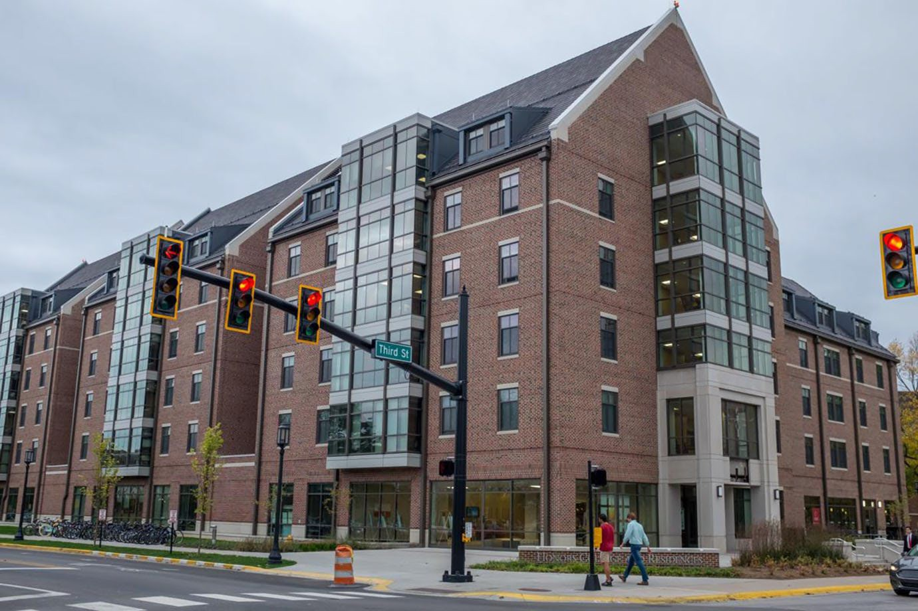

COME SEE US!
( FELISAPH@ PURDUE. EDU)

APPENDIX

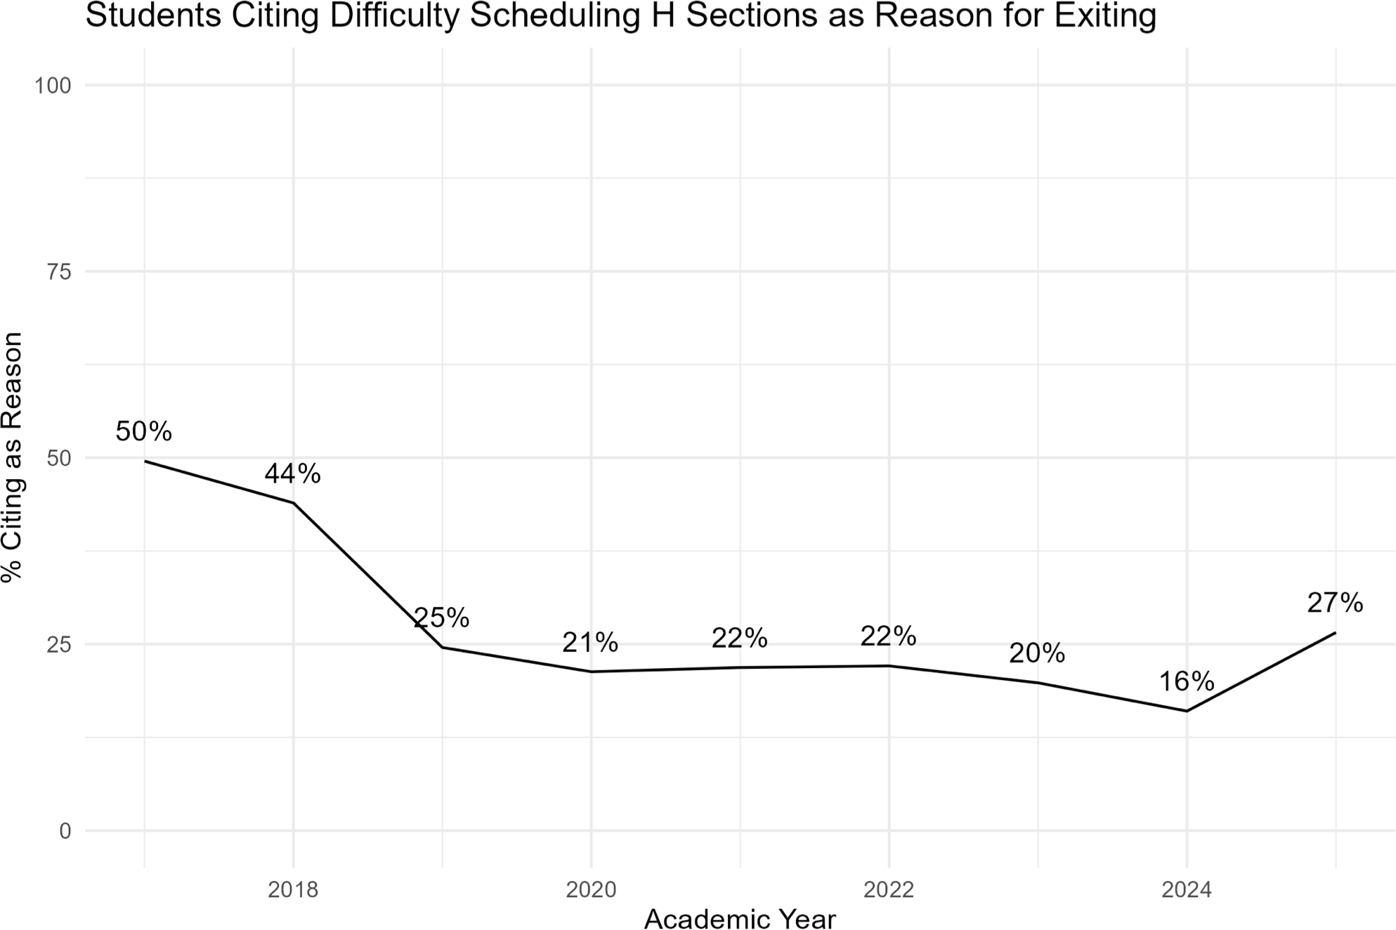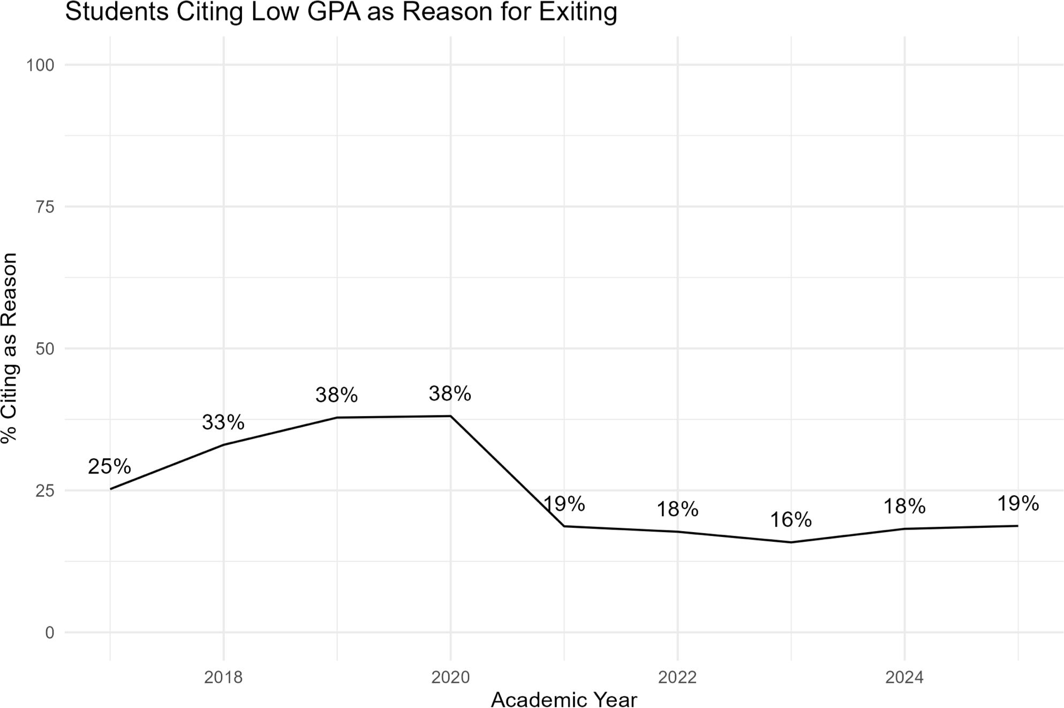
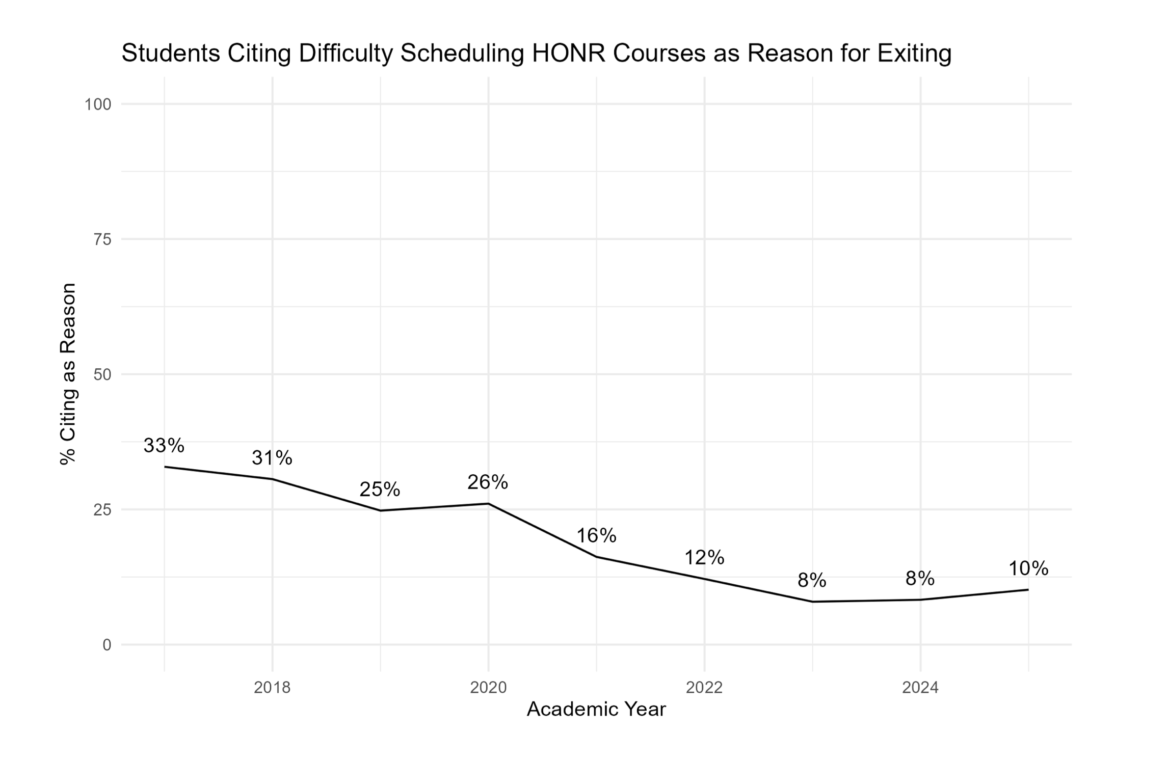
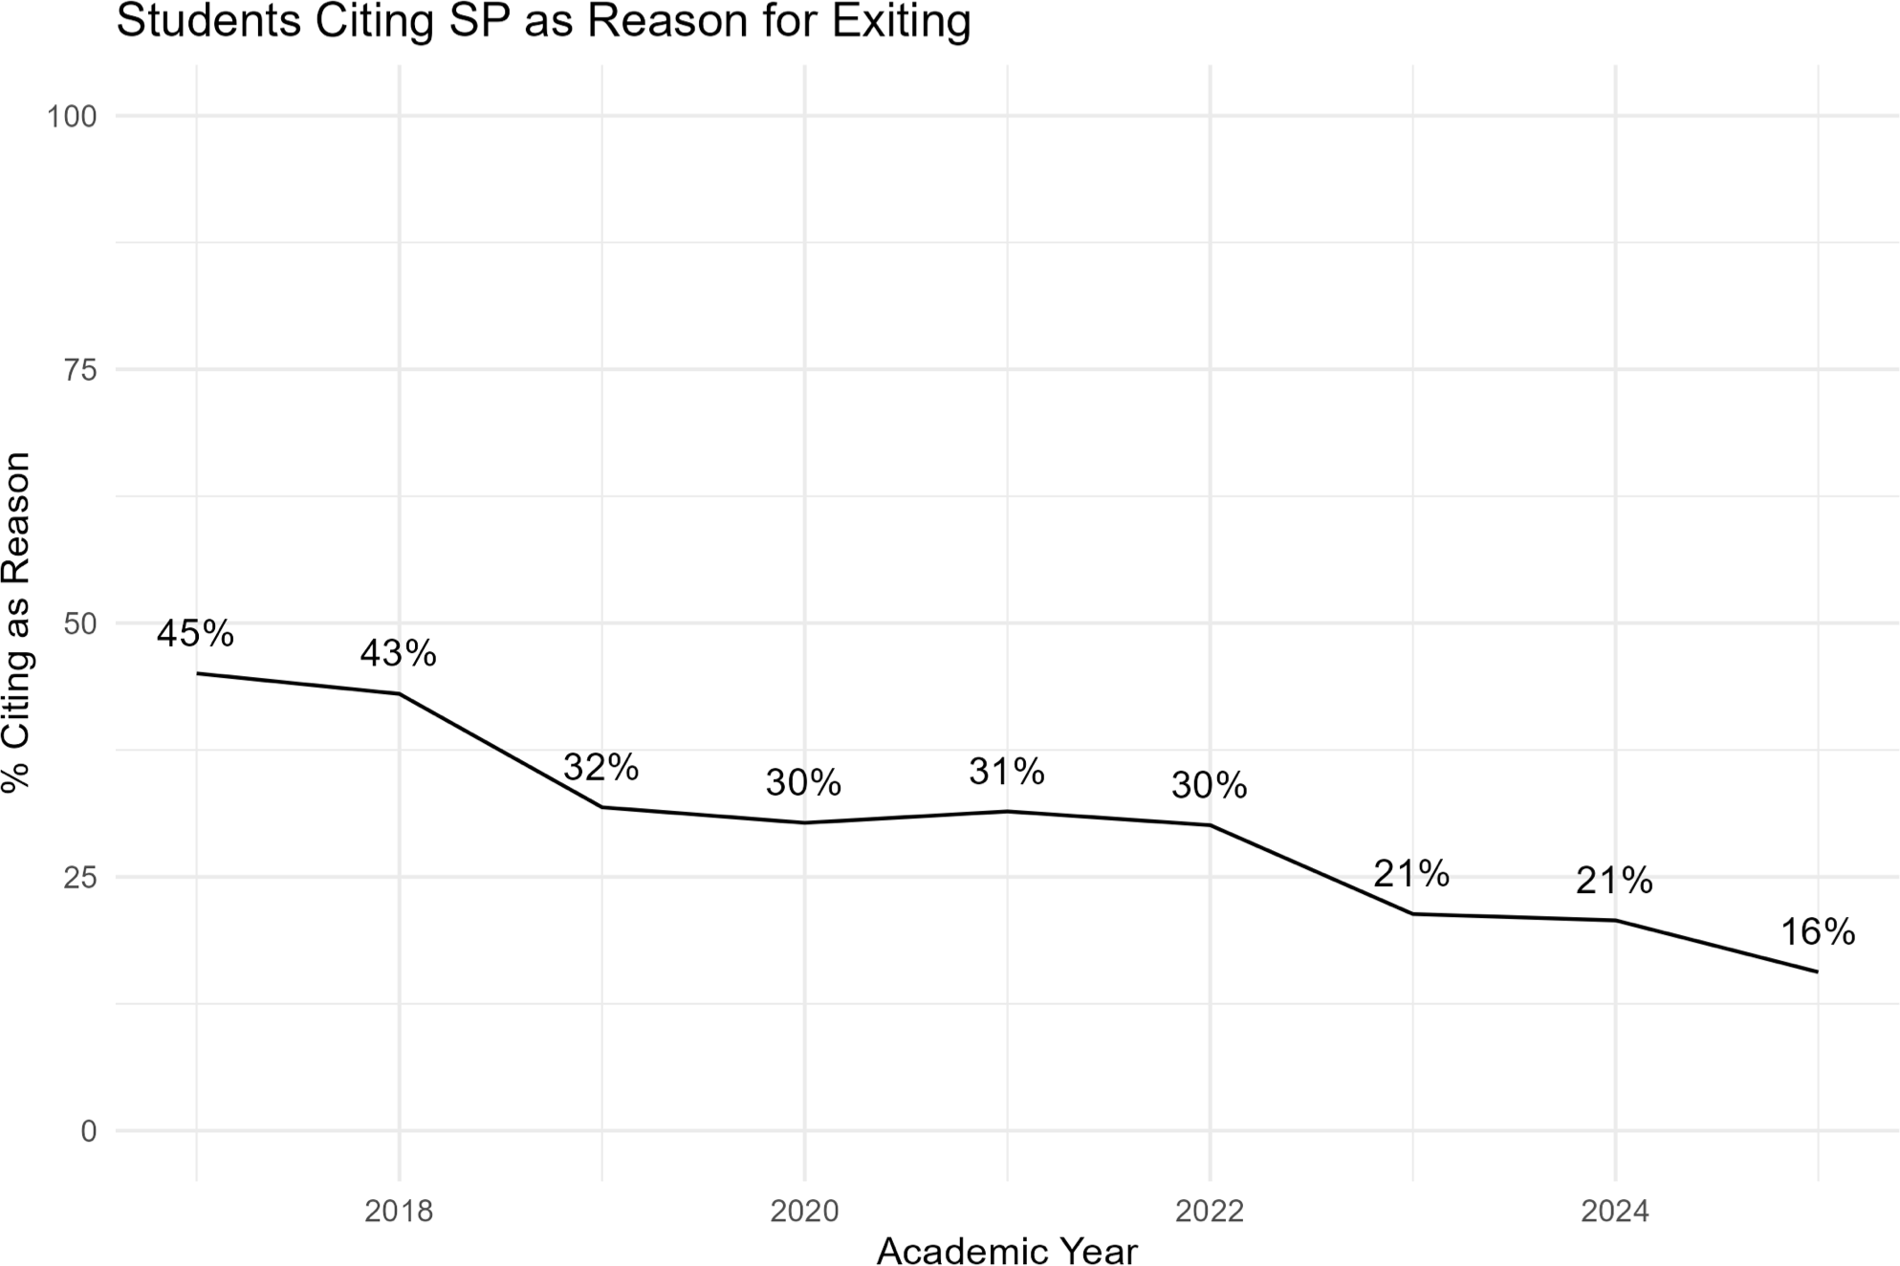

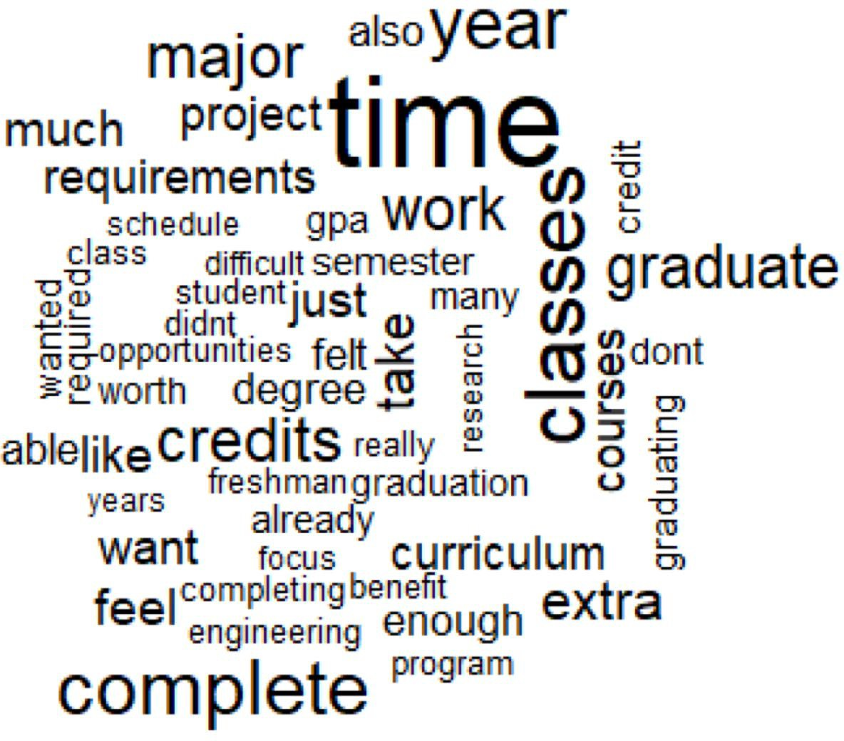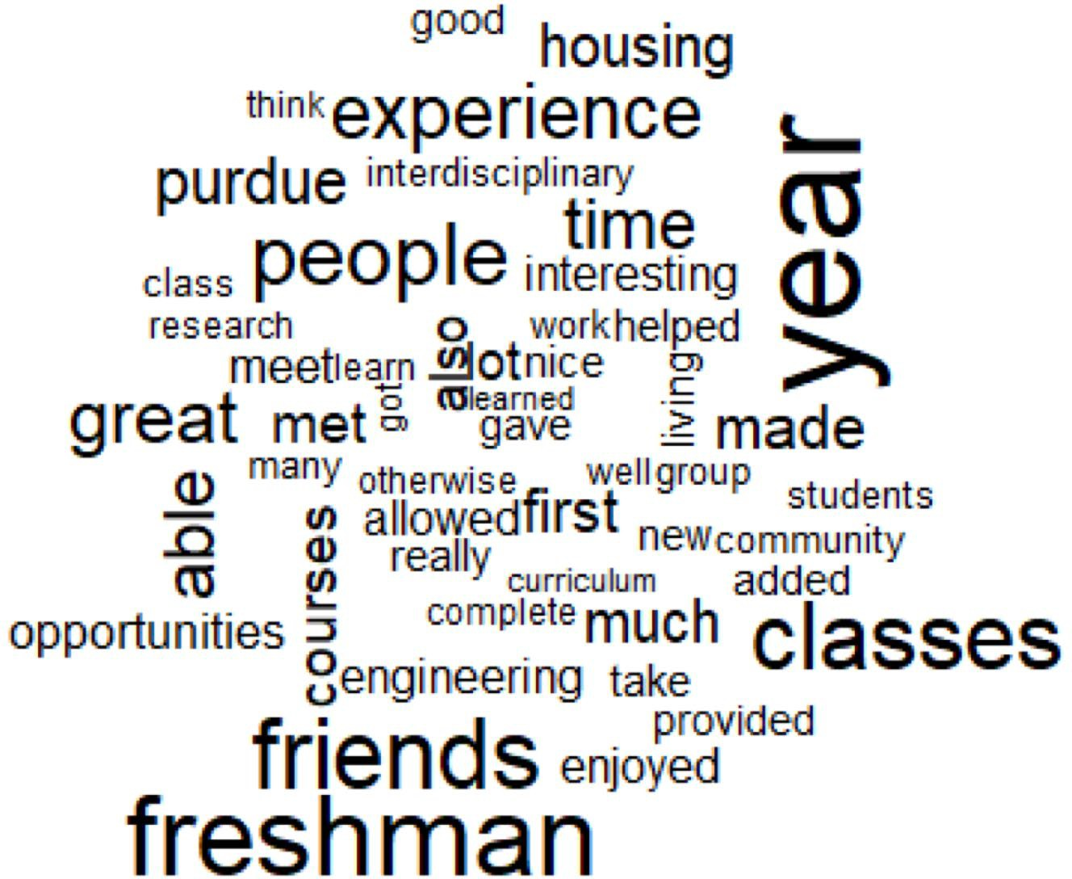

Why they left Why they stayed

35.0%
Side-by-Side Distribution of Fall 2019 Initial FY Enrollment and 6-Year Completion Outcomes (% by College)

30.0%

25.0%

20.0%

15.0%

10.0%

5.0%

0.0%

College of Agriculture

College of Education

College of Engineering

Exploratory Studies College of Health
and Human Sciences

College of Liberal Arts

School of Management (Daniels)

College of Pharmacy Polytechnic
Institute

College of Science College of
Veterinary Medicine

JMHC Fall 2019 Initial FY Cohort (dist by college) Honors Cohort 6-Year Completion (dist by college) Honors 6-Year Completion at Graduation (dist by college)

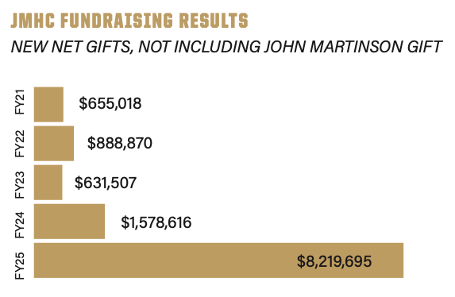
JMHC’s ability to attract
external support underscores its reputation as a high-impact academic community. With over
$8 million in philanthropic contributions in FY25 alone, the college has become a trusted partner for donors who value innovation, interdisciplinary learning, and student success.

NEXUS 2030 GOAL: REIMAGINING HONORS FACULTY ENGAGEMENT AT PURDUE

Impact Area | Key Objectives
Student Impact | - More honors sections and access across majors  - Stronger mentorship and student-faculty collaboration  - Deeper experiential learning (research, industry)  - Higher retention and interdisciplinary engagement
Faculty Impact | - Recognizes and retains top-tier educators  - Expands faculty roles in mentorship and teaching  - Increases engagement across departments
Institutional Impact | - Aligns with Purdue’s instructional innovation goals  - Scales high-impact, interdisciplinary teaching  - Strengthens JMHC’s leadership and visibility

Different Ways to Engage with Honors Students
Teach an HONR course
- Courses offered in the JMHC that are interdisciplinary and involve experiential learning
Offer an Honors contract
- An agreement between a student and an instructor that turns a standard course into an Honors course
Make your course H-Ready
- Adapting high-demand courses to allow for honors enrollment.
- Funding and support provided to transform an existing course during a (re)design institute.
- Requires departmental commitment
Offer an H section
- Course sections with an H designation that are taken in students' majors, minors, or core classes
Offer credit for research
- This can be a directed study, independent research, or an Honors thesis

