



Purdue Books Initiative From Idea to ISBN
Cristina Farmus VP Special Projects
cfarmus@purdue.edu
https://purdue.link/books

February 16, 2026

Purdue Books Initiative Overview
- Trends in Academic Publishing
Purdue Books Initiative
“Books enhance our scholarly understanding and generate impact both inside and outside the academy. They serve to summarize long-term research contributions, introduce innovative insights into quickly evolving areas, and crystallize years of teaching experience
into a mature course design.”
- Scope of Purdue Books Initiative
- Idea to ISBN Steps
- Other Types of Books
- Statistics

Trends in Academic Publishing

- Publisher consolidation, maintaining imprint names
- Significant decrease in sales of adult non fiction and academic books
- Several university presses closed
- Pdfs and faculty websites work as substitutes for traditional publishing

- E-books and self-publishing on the rise

Fewer academic books are published overall

Scope of Books Initiative Program

Book Classes
- Monograph
- Textbook
- Edited Volume
- Encyclopedia
- Casebook

Author Classes
- (Co) Author
- (Co) Editor
- (Co) Translator

Other Considerations
- Publisher pre-approved
- Must be a printed book
- Project completion in finite timeline



Purdue Books Initiative – Idea to ISBN Overview

Publisher Contract

Incentive

Support Services

Publicity and Impact

Connection with Academic Publishers

- Goal is to lower publishing barriers for new authors
- Books Team meeting with authors one on one to discuss best publisher
- Purdue webinar series connects authors with many publishers such as CRC, Elsevier, Emerald, Kendall Hunt, Oxford, Routledge, Springer, Taylor & Francis, Wiley, World Scientific
- Recordings available at https://purdue.link/books

Book Incentive Process
Finish Manuscript
Production
ISBN

Idea
Proposal
Connect with the Purdue
Books Team early to
discuss eligibility.
Contract

https://purdue.link/books

First part of the incentive disbursed after obtaining a publisher contract.

Remaining incentive disbursed when a completed manuscript is accepted by the publisher by an agreed-upon date.

Book Support Services

What the Books Initiative Team Can Do

- Graphics
- Formatting
- Alt-text
- Permissions
- Art log
- Proofreading
Billie Johnson billiejohnson@purdue.edu Shelby Nealley svibber@purdue.edu

What Freelancers Can Do
(to be paid by author)
- Developmental copy editing
- Copy editing
- Indexing

Author Recognition, Book Visibility Ideas

Author
- Display in email signature
- Ask publisher for press kit
- Submit for book awards
- Organize book launch
- Include in conference presentations
- Produce book commercial
- Social media: like and repost!

Institution
- In Print series in Purdue Today – twice/week
- University website https://purdue.link/books
- Collection of Purdue authored books in HSEE
- Giveaways for events – promote books
- Author recognition events by Purdue Libraries
- College and school newsletters, events
- Social media: like and repost!

Other Types of Books - Ideas

Lecture notes
  - Edited volumes with faculty co-authors – from Purdue and other institutions
  - Edited volumes based on Purdue student work
  - Concise series – Cambridge Elements, Cambridge Concise Histories, Norton
Shorts, Springer Briefs, Taylor and Francis Shortcuts, Routledge Basics
  - Dissertations to books: partnership graduate student and advisor


  - Casebooks
  - Translations
  - Program monographs


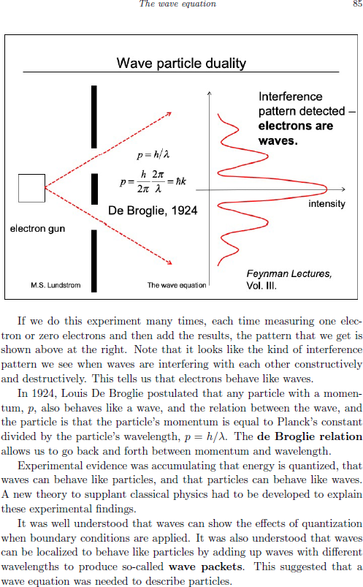
Lecture Notes to Books

Example from
Essential Semiconductor Physics

Mark Lundstrom
Published Fall 2025 by World Scientific
https://www.worldscientific.com/worldscibooks/10.1142/14454#t=aboutBook

Other Types of Books – Example


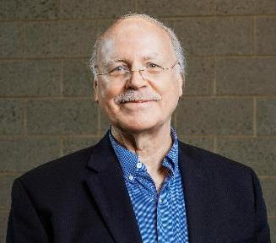
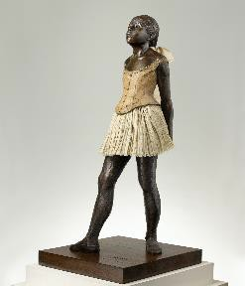

Professor and writer Michael Shelden
Purdue English CLA 304
Advanced Composition Class

Degas Monograph to be co-authored by students, in the works

Purdue Published Books – as of Feb 2026

140
120
100
80
60
40
20
0

80 74

68 70 77

80
68 71
51

120

65
Potential 2026

25

2015 2016 2017 2018 2019 2020 2021 2022 2023 2024 2025 2026

Discussion
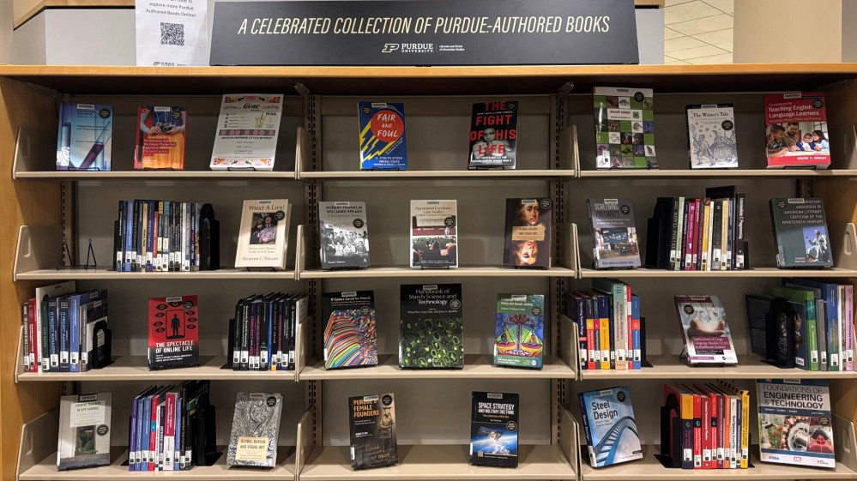

Purdue authored book collection in the HSSE Library, Stewart Hall

