

Fifth Meeting
Monday, 17 February 2025, 2:30 p.m.
Zoom Meeting

AGENDA (As amended)

1. Call to order | Professor Susan South
2. Statement of Land Use Acknowledgement | Professor Susan South
3. Approval of Minutes of 27 January 2025
4. Acceptance of Agenda
5. Remarks of the Senate Chair | Professor Susan South
6. Remarks of the President | President Mung Chiang
- Question Time
- Memorial Resolutions
- Résumé of Items Under Consideration by Various Committees  - Consent Agenda  - Senate Document 24-10 Nominees for Advisors to the Senate  - Senate Document 24-11 Nominees for Advisors to the Senate Standing Committees | For Information Professor Elizabeth A. Richards  For Action Nominating Committee
11. Senate Document 24-09 Nominees for Vice Chairperson of the Senate | For Discussion Nominating Committee
- Purdue Global and Purdue University’s Online and Residential Graduate Programs Report  - Update from the Senior Vice President for Administrative Operations | For Information Senator Libby Richards  For Discussion Senior Vice President Administrative  Operations Michael Cline

- Sustainability Presentation For Information
Chair of the Sustainability Committee
Michael Johnston
- New Business

- Adjournment

Fifth Meeting
Monday, 17 February 2025, 2:30 p.m.
Zoom Meeting
Present: Joseph W. Camp Jr. (Secretary of Faculties and Parliamentarian), President Mung Chiang, Susan South (Chair of the Senate), Mark Zimpfer (Vice-Chair of the Senate), Patrick Wolfe (Provost), Se’Andra Johnson (Sergeant-at-Arms), Dulcy Abraham, Ryan Alan Altman, Santokh Badesha, Andy Baker, Jonathan Bauchet, Ximena Bernal, Afsan Bhadelia, David Blon, Lisa Bosman, Ali Bramson, Françoise Brosseau-Lapré, Tom Brush, Stephen Cameron, Julia Chester, Joseph Coates, Alejandro Cuza, Dan Cziczo, Brian Dilkes, Vince Duffy, Ben Dunford, Jim Dworkin, Ulrike Dydak, Abigail Engelberth, Geraldine Friedman, Yi Gao, Lori Hoagland, Sarah Huber, Whitney (Yu) Huidan, Morgan Hynes, Katie Jarriel, Hyunyoung (Young) Jeong, Brent Jesiek, Nastasha Johnson, Bhagyashree Katare, Kee-Hong Kim, Cheng-kok Koh, Sarah LaRose, Seungyoon Lee, Kiseop Lee, Brian Leung, Damon Lisch, David Liu, Yuli Lyanda-Geller, Stephen Martin, Stephanie Masta, Seema Mattoo, Byung-Cheol (BC) Min, Somosmita Mitra, Patricia (Trish) Morita-Mullaney, Paul Mort, Robert Nawrocki, Tae Hong Park, Li Qiao, Darryl Ragland, Padinjaremadhom (PV) Ramachandran, Julio Ramirez, Sebastian Murgueitio Ramirez, Elizabeth Richards, Brian Richert, Torbert Rocheford, Gustavo Rodriguez-Rivera, Chris Ruhl, Antônio Sá Barreto, Dennis Savaiano, Marisol Sepulveda, Greg Shaver, John Sheffield, Michael Smith, Kevin Stainback, John Sundquist, Mohit Tawarmalani, Monica Torres, Sasha Tsymbaliuk, Kim Updegraff, Anish Vanaik, Rua Williams, Bowei Xi, Howard (Howie) Zelaznik, Patrick Zollner. Advisors: Eric Adams, Heather Beasley, Michael Cline, Melissa Franks, Cherise Hall, Carl Krieger, Lisa Mauer, Beth McCuskey, Sunil Prabhakar, Jenna Rickus, Alysa Rollock, Katherine Sermersheim. Guests: Lynne Dahmen, Jason Doty, John Gipson, Ian Hyatt, Michael Johnston, Valentina Negri, Km Pearson, Dimitrios Peroulis, Karen Plaut, Jurgen Ivan Rochin Gomez, Steven Schultz.

Absent: Arezoo Ardekani, Saurabh Bagchi, Charles Bouman, Sabine Brunswicker, Min Chen, Xingshan (Shawn) Cui, Eugenio Culurciello, Mara Faccio, Alex Francis, Abrar Hammoud, Alice Johnson, Stacy Lindshield, Ryan Manuel, Loring (Larry) Nies, Abdelfattah Nour, Jason Packard, Joseph (Paul) Robinson, Chris Rogers, Jennifer Scheuer, Steven Scott, Ganesh Subbarayan-Shastri, Dengfeng Sun, Rusi Taleyarkhan, Christina Wilson-Frank.
Advisors: Chad Cahoon, Sheila Hurt, Lowell Kane.

- Quorum being established; the meeting was called to order at 2:30 p.m.

- Chair Susan South read the following Statement of Land Use Acknowledgement, as required by Senate Document 20-55:

The Purdue University Senate acknowledges the traditional homelands of the Indigenous People which Purdue University is built upon. We honor and appreciate the Bodéwadmik (Potawatomi), Lenape (Delaware), Myaamia (Miami), and Shawnee People who are the original Indigenous caretakers.

- The minutes of the 27 January 2025 Senate meeting were entered as read.

- Vice Chair, Mark Zimpfer, made a motion to modify the Agenda by reversing items 12 and 13. His motion was seconded. There was no discussion, and the amended Agenda was accepted by general consent.

- Chair South began her remarks [Appendix A].
“Good afternoon, Senators, Advisors, invitees, and those who will be attending by live stream. I want to simply acknowledge the winter doldrums we might be feeling. The weather today I think reflects how cold it has been. It has been rather brutal. This semester has been long and actions out of our nation's capital have come fast and furious. I just hope everyone is finding a way to connect with loved ones and finding a time to take care of themselves.

I will not take long today. I only have two slides with figures, I promise. I just wanted to share a few thoughts with everyone that I have been percolating on during these very cold winter days. During our last meeting, I talked about women in STEM. After that I got interested in, what are the most common majors awarded in U.S. institutions of higher education?

As shown in this slide (1st presentation slide), you can see that, top line you might not be able to see very well, but that top line are business degrees awarded at U.S. institutions approximately the last 10 years. So far and away the most awarded undergraduate degree is in business, confirming that the business of America is business. But those three lines at the very bottom running neck and neck are biomed, engineering and psychology. Now, this was news to me, but it did get me thinking of how majors track with career needs in this country. Should a forward-looking university be attending to current needs in the labor market and those projected for the future?

I investigated the rising trends. Not surprisingly, there was a huge increase in degrees awarded for engineers and computer scientists. Liberal arts and sciences, humanities and English, were on the decline between 2012 and 2022. The number of undergraduate degrees in History, English, languages, literature, philosophy, and related subjects, fell 24%, according to the American Academy of Arts and Sciences.

However, the death of humanities might be exaggerated. Several universities are seeing reverse in this trend. As just one example, Virginia Tech has a humanities-focused executive education program, in which enrollees study History, philosophy, religion, classics, literature, and the arts in order to think about leadership qualities and how what they learn can be applied to technology trends, including data privacy and artificial intelligence. In my opinion, the liberal arts and humanities represent the core of higher education. They foster critical thinking, deepen our ability to understand other points of view, and perhaps most relevant to our current challenges, engage with moral and ethical dilemmas that arise.

This is the very essence of developing a well-rounded citizen, which harkens back to the original mission of this land-grant institution. And some people might disagree. Next slide, please.

In my opinion, AI will be one of the defining challenges in the next 50 years. We will need engineers and computer scientists to continue developing this technology. We also need leaders who know how to use it. On this slide (5th presentation slide) is a picture of Daniela Amodei, the President of the AI company, Anthropic, founded by former members of OpenAI. Daniela was named one of Time's 100 Most Influential in 2023. She also graduated Summa Laude for the University of California, Santa Cruz, with a Bachelor of Arts in English literature.

Purdue was only growing in national, international claim. In our next giant leaps, we need to make sure we do not leave behind disciplines that are critical to teaching our students how to think and how to collaborate with others. What would it look like for Purdue to have a College of Liberal Arts and Sciences? Would it encourage interdisciplinary collaboration among faculty and students to the betterment of all? I believe it can ensure that Purdue undergraduates receive a holistic education, that prepares them for the complexities of the modern world. We risk becoming too specialized in our training. Purdue graduates must lead and innovate in a future that will change rapidly. What will be critical for us to impart is the ability to continue learning throughout the lifespan.
And then finally, a plea. Please stay for the report of the ad hoc committee on Purdue Global and Purdue University's online and residential graduate programs. This represents more than a year of incredibly hard work by the committee. Thank you.
And I will recognize the President for his remarks.”

- President Chiang presented his remarks [Appendix B].
“Well, good afternoon, everyone. And Chair South, thank you. It is important to have both private and public meetings of the Senate. This monthly meeting is a public meeting of town hall style, where anyone can join, including the media. At the January public meeting, one local media outlet misreported what I said. At a city council meeting last month another local media misreported what Mayor Aaron Easter said. Words that were not uttered got reported in print and online. When each misreporting was discovered by the speaker and then corrected by the media days later, unnecessary confusion had already been created. Therefore, to ensure accuracy, today I will be reading from written remarks that will be distributed to any inquiring media. In the allotted 10 minutes, I will cover four topics.

Topic 1, Undergraduate admissions:
As you all know, here's the equation describing the relationship between applications and enrollment: Two different concepts. Enrollment equals applications times admissions rate, times yield rate. As a hypothetical example with round numbers, if the number of applications is 80,000, the admissions rate is 40% and the yield rate

is, say 30%, then the enrollment of undergraduate freshmen would be 9,600. Clearly an admissions rate of 50% and a yield rate of 25%, would lead to the same enrollment through an admissions rate of 25%, and a yield rate of 50%.
Yield rate is the percentage of students among all those admitted, who choose to accept a university's admissions offer instead of those of other universities. Yield rate can only be predicted with imperfect accuracy. In the above hypothetical example, a slight fluctuation in the yield rate, say by 3%, would add almost 1,000 to the enrollment due to the large base numbers.
Purdue's yield rate last year jumped to around 30%. To put this in perspective, according to public data at the other large public university in our state, the yield rate was 18%.

The number of applications and yield rate are both reflections of a market demand by students and parents. One, before admissions decisions are made, and the other after. Admissions rate is the only variable directly under our admissions office’s control: reducing that rate means becoming more selective.

Over the past several years, Purdue's admissions rate has gone down from about 70%, to just under 50% last year. It will likely be 40% or less this year. To put this into perspective, according to public data, the other large public university in our state continues to hover just under 80% admissions rate, and slightly lower rate at 75% for in-state applicants.

As for Purdue, in light of both the record high number of applications, but also the anticipated yield rate, and given the physical facility resource, we must ensure for each student, we will lower the admissions rate to whatever point it takes to avoid over-enrollment, while ensuring as many qualified in-state applicants are admitted as possible: for example, last year our in-state admissions rate was 74%, while out-of-state was only 45%.
Topic 2: Childcare

As promised last time, here is the answer to the question about one of the childcare facilities used by some of our colleagues.

After concerns were raised by several parents at the early care and education center on the west side of our campus, Purdue engaged with the childcare partner and provider Early Learning Indiana (ELI), to discuss the concerns and to respond appropriately. ELI has provided an update on actions they are taking to address the issues, including the following:
- They held open office hours with their CEO on January 21st (where eight families showed up).
- They will establish a PUECEC advisory committee by the end of February.
- They commit to improving communication from the center to the families.
- They have launched a search for a new food vendor.

- Along with Purdue's Administrative Operations, they will assess the current playground equipment and will announce a plan and timeline for playground updates by the end of March.
Purdue human resources will continue to work closely with ELI, with regular check-ins and quarterly business reviews to ensure compliance with contracts and expectations.

Topic 3: Federal government directives and court orders
This has been a key point in many people's minds and impacts hundreds of public and private universities across all states. A communication was sent by our EVP for Research, CFO and Provost, last Thursday. Thank you for your continued focus on research. We are very proud of the scholarly quality and societal impact of our colleagues’ work. I would like to reiterate several points here.

First point: The situation consists of multiple parallel tracks and each changes continuously. We have a team that is closely tracking them in order to be compliant and are tabulating on a public website. Because of the government directives and court orders, we have received, as of last Friday, all concerned government sponsored research. The core team naturally consists of the following:
- Patrick Wolfe, Provost,
- Karen Plaut, EVP for Research
- Chris Ruhl, CFO
- Steve Schultz, General Counsel
- Ian Hyatt, Chief of Staff
- Alysa Rollock, VP of Ethics and Compliance
- Amy Boyle, VP of HR
- Julie Rosa, VP of Communications
- Ken Sandel, Associate VP for SPS

Along with deans, associate deans for research, heads and directors of institutes and centers, who are in constant conversation with each other. This team continues to work hard for you.

Second point: At any given moment, there are many questions that we do not know the answers to, just like you, and we cannot execute on hypothetical directives that have not been given to us.

We forward information which is, agency specific, to the relevant principal investigators whenever we receive it. These include stop or cease work orders, as well as NIH directive that would reduce the indirect cost rate for NIH funded grants. Right now the NIH guidance is under a court's temporary restraining order.

Third point: Purdue will continue to follow our principle of “people first,” and will continue our core support for research. We also have longer term strategies to

support and grow our research enterprise. These strategies include further growing our industry partnerships and funding, as well as philanthropic fundraising for research programs and facilities. These strategies have been consistently and actively pursued at Purdue. In fact, the largest five-year capital campaign in Purdue history was announced two days ago.
Topic 4: Freedom of expression

Per long-standing practice and the Board of Trustees official policy at Purdue University. Unless directly requested by the government, we do not make public comments on behalf of the entire institution on any social-political topic, including court proceedings and state legislations covering such topics. While perhaps not always the most expedient, this practice and policy have proven to be a positive one for the university in the long run.
Such institutional neutrality maximizes the freedom for all the individuals at the university, more than 110,000 of them in our system, to exercise their individual freedom of expression on any topic they choose.

We do welcome and carefully listen to input from members of the university community and may find useful channels of communication to relay such input to decision-makers. And that is the completion of my prepared remarks. Back to you Chair South”

- The answers to pre-submitted questions were posted to the Senate website [Appendix C]. Chair South opened Question Time.
Senator Howie Zelaznik: “I received a request from my department head, which I've been informed came from the Provost Office, which made me attest that I had not inappropriately given a position on some topic without showing all the other sides. The question is, I often explain some aspects of human performance by turning to evolutionary principles that might explain some of these things. Am I obligated to present a creation science viewpoint on this? Which of course I will not do, but then I would be in violation of the request. Thank you.”

Provost Patrick Wolfe: “Howie, I am happy to talk that through with you. And you can imagine we have talked this through with colleagues from across the university, everybody from Susan and others all the way through to department heads as you mentioned. I think what you are referring to, the only thing I would know of that you are referring to is, with the implementation of 202 last year, which became state law last July 1st, 202 requires that as part of annual performance reviews, that all Indiana public institutions of higher education ask the questions of their employees. The two questions you will remember from 202, one of them was, have you exposed students to a variety of intellectual viewpoints in your work? And the other one being, have you not brought material totally unrelated to the course content into the classroom in an ongoing way? I am paraphrasing of course,

because I do not have the text in front of me, but you will find it in our policies and Senate leadership is certainly aware.
Let me sort of emphasize here. The faculty is responsible for the curriculum. That is true at Purdue. That is true at every university. Because a body of faculty that comprises a department are the people who are intellectually best placed to determine the appropriate curriculum for a certain degree path, right? A group of economists comprise an economics department. The notion of an economics degree is duly accredited by an accrediting body, and it is the group of economics faculty, for example, who are responsible for determining that curriculum. You have control over your own curriculum. If your faculty has approved your curriculum, and I would certainly expect that if you're teaching about anything related to biology or physiology, that evolution would come into play. I would expect that at any university, and I would certainly expect it here. If your faculty has duly decided that that is the curriculum that you are going to present as a faculty, as a team, then you are 100% in compliance with that.

Now, if your faculty had decided that that was appropriate and you had gone and done something completely the opposite, then I think by now probably your faculty colleagues or students, or department head, would have asked you about that. So absolutely not. You were obligated only to follow the curriculum that you and your faculty colleagues have designated as appropriate for the discipline. Once again, the determination of appropriate content lays with the faculty, and that is one of the underpinning principles of academic freedom.

I hope that helps. I am happy to follow up offline. But yes, it is certainly true that the law that was passed last year stipulates that every faculty member and staff member must have those two questions answered as part of annual performance review. That is true here, it is true at Ball State, et cetera, et cetera. But once again, the mechanism by which you answer those questions comes back to the fact that the curriculum is approved and modified and overseen by the faculty. And that is one of the essences of academic freedom. Let me stop there in case there are more questions, but I also see other hands up. So back to you Susan.”

Past Chair Brian Leung: “Good afternoon, Provost and President. It is important that you as voting Senate members feel comfortable and open coming to the Senate and providing your remarks and your responses to various questions. And I am a little rattled that something has happened that has disturbed the balance. And I would ask President Chiang and the Provost, if you would, at an appropriate moment communicate with the Senate leadership, and perhaps you have, what disturbed the balance and if there is something on our end that we can do to preserve this as a space where you feel comfortable speaking in open ways as you have so generously in the past. I would appreciate that communication with Senate leadership.”
Provost Wolfe: “I will just say quickly, we continue to do our best. President Chiang referenced a couple of cases of confusion on the part of reports of various meetings including this one the last time. And so, I think we are trying to be very exact and

making sure that there is no misreporting. We do not want student applicant numbers, for example, confused with student attendance numbers or anything like that. That would not be helpful for any of us. We will continue to do our absolute best to be clear and direct and at the same time trying to figure out to help make sure that accuracy gets maintained even as we live stream out into the ether as it were.
Thanks, Brian.”
Senator Stephanie Masta: “Thanks Susan. I do want to just say or make a comment that silence is not always neutrality, nor is it interpreted as neutrality. Silence often can be complicity. And so I understand that Purdue's position is to not make statements, that also sends a very strong message.”

Provost Wolfe: “Again, your point is totally taken, Stephanie. I think we all have watched as several changes and potential changes and potential impacts have impinged upon, not just us as a land grant public university in the State of Indiana, but more broadly across the country. From federal executive orders and other mechanisms, all the way through to a general assembly session that is continuing as we speak. I would respond to that by saying, I do not think there is anything to be imputed from or implied by a public silence on a particular matter. We had this level of discussion last year around this time, and I think I am sure we will have more of it in future senate meetings. But again, this is without prejudice as it were, there is nothing to be, again, inferred from or implied by or imputed from a lack of any public commentary on several situations that are developing and ongoing and changing from one day to the next or sometimes even one hour to the next.

I know everyone on this call will understand that, and you will not be surprised to imagine that groups of Big 10 and APLU and other colleagues are getting together at all levels from department heads and deans through to provosts and presidents to understand and assess and talk through all these potential impacts. Again, as I mentioned at a couple of meetings last week and the week before, there is an awful lot going on as we try to assess our position and assess potential impacts. And again, nothing to be inferred from lack of a public statement at this time. Thank you.”
President Chiang: “First I want to quickly respond to Past Chair Leung's comment. I want to clarify, there is nothing wrong that the Senate leadership has done, nothing whatsoever. And back to the most recent response that Provost Wolfe just provided. I simply would highlight the freedom for all individuals at the university. And there are more than 110,000 of us in this system to exercise their individual freedom of expression on any topic that they choose. And the institutional neutrality official policy voted upon and approved by the Board of Trustees, is meant to maximize those individual freedoms.”

Senator Rua Williams: “I wanted to follow on with what Stephanie Masta was saying and say that I think that what faculty are looking for is some kind of confirmation that, if in the future when one of us becomes targeted by these policies, will the university do anything in support of us or will you be neutral and simply let it happen?”

Provost Wolfe: “Again, I think there will not be commentary forthcoming about hypotheticals. We could discuss a whole number of hypotheticals all day long. Hopefully, again, you will have heard from department heads and your department head and your Dean, as we have talked over the past couple of weeks, a couple of different times about the changing federal funding landscape. The message is very clear. We will stay the course. We are preparing and working with anybody who is directly impacted, for example, in the case of federal grants. And we are preparing for a wide range of scenarios. But again, I do not think it is helpful to comment publicly or even internally to message around any number of hypotheticals. We just do not know what will or will not come to pass. Anybody who could have predicted the last month and a half would have made a fortune in the betting markets. I am going to bet that the next month or two are also going to be pretty unpredictable.
We are here to make decisions in the best interest of Purdue. We will continue to do that, and you will continue to hear from Deans and heads and people like Ken Sandel and the research office and others of us on an as needed basis. But I just think it is too difficult right now to prognosticate what will or will not happen. And again, if you think of last year at this time, it took some months, for example, for 202 to bottom out, it changed a whole bunch of times. If you followed the NIH Federal funding case, you know that there were three lawsuits filed, which resulted in two and a half temporary restraining orders and all kinds of other action within the space of about four business days.

We are certainly watching and working, and you've got a senior team that is entirely focused on this and will continue to be. And we will certainly issue all the reassurance that we can muster and that we will need to muster if any different event comes to pass. But right now, I just think it is impossible to prognosticate as to what might or might not be coming next. Again, looking at the past six weeks, given how unpredictable that has been, I would not be placing any bets on what might be coming around the next corner. But we are on top of it. We all realize that it is going to take quite a lot of work to stay on top of it, and that is what we are focused on right now.

President Chiang: “Will the Provost please post in the comment section a link to the communication that you, along with EVP for Research Karen Plaut and CFO Chris Ruhl, sent to faculty and staff last Thursday please?”

Provost Wolfe agreed to send it to Chair South to ensure she can repeat it for everyone. Chair South agreed to this suggestion.
Senator Morgan Hynes: “I wanted to extend outside of the kind of more technical relationship of the executive orders to a more personal response to the 110,000 people under your leadership and what kind of reassurances do you have that the rhetoric and actual actions that have taken place around DEIA rhetoric have on their personal and mental health and just understanding that they are included here at

Purdue and welcome. And how do you plan to move forward to assure students, faculty, staff, have that sense of community here at Purdue?”
Provost Wolfe: “Once again, happy to speak to this. And I think Susan just forwarded the URL that I sent to her. I will give you a very specific example. The concrete impacts to date have been relatively limited in focus and scope. So I will give you an example. We had a small handful of PhD students, fewer than five, who were impacted by potential changes to USAID funding. I say potential because again, none of us knows quite how this is going to work out. But our first principle, and it is both in the note that went out and that Susan just recirculated, and was implicit in Mung's, and explicit really in Mung's remarks earlier this afternoon. Our first principle is to take care of our people. If you were with us during COVID, we were all in it together.
We got through COVID without a single furlough.
And so, our people are our first priority. And we have, and we recognize that we have a fundamental duty of care to our PhD students. Anybody that we brought here with a PhD offer of admission, we are going to do our absolute best to make sure that their studies are minimally interrupted and as unimpeded as possible. So I mentioned a small handful of students, PhD students, who might be impacted by changes, potential changes again, to USAID funding. We will not know until the dust settles on everything, but for the moment, we have plans in place. Whether they are domestic students or international students, we have clear plans in place to adjust their funding sources if and as necessary, in a way that does not sort of take their thesis path and divert it by 90 degrees or anything like that. So again, the first principle is we are here to take care of and look after our people.

And the second principle is we really recognize our duty of care to students, for example, who would stand to be impacted if things like funding changes continue. So I would say again, that is the kind of response that you can and should expect from us if other changes come to pass. But again, if you look at the actual changes that have landed right now, it is hard to see which ones are even likely to stick. And we are just waiting and assessing and trying to again be planful but also emphasize that we stay the course unless specifically directed otherwise by a government agency.
And as we stay on the course, we plan and prepare for different eventualities. But with those two principles I mentioned, first and foremost taking care of our people and making sure that we follow through on our duty of care to our students, especially PhD students. I will stop there. Mung, I do not know if you wanted to add anything or not. I just wanted to make sure we made that part clear.”
Chair South: “If there is no more in that vein, I will end question time here. I think this is important and I appreciate everyone's willingness to share how they feel. And always feel free to bring back comments from your constituents. You can email me at senate-chair@purdue.edu as a place to share your thoughts. And of course, this meeting I think is very useful for this type of communication among the faculty, the staff, the students, and administration. So thank you for that. We are moving on. I recognize Senator Richards to deliver the Résumé of Items under consideration.”

- Memorial Resolutions (None received for February)
- Senator Elizabeth Richards, Chair of the Steering Committee, presented the Résumé of Items (ROI) under consideration by the various Senate Standing Committees [Appendix D].

Senator Richards asked the Standing Committee Chairs for any updates to the items under consideration by their respective Committees. She noted that the Steering Committee is working with the PSG and the PGSG to ensure that we are helping facilitate their documents for presentation to the Senate

Senator Brian Dilkes said the EDIC considered changing their name, but postponed the discussion until more information and guidance are forthcoming from the administration.

- Senator Seema Mattoo, Chair of the Nominating Committee, presented for Action a Consent Agenda consisting of Senate Documents 24-10, Nominees for Advisors to the Senate and Senate Document 24-11, Nominees for Advisors to the Senate Standing Committees. As this document is a routine matter from the Nominating Committee, no second is required.

No discussion occurred. The question was put, and the Consent Agenda was adopted by general consent.
- Senator Seema Mattoo presented for Discussion Senate Document 24-09, Nominees for Vice Chairperson of the Senate. Chair Mattoo noted that the Senate Bylaws require a slate of at least two candidates for the Vice Chairperson position. Currently, there is only one nominee, Senator Julio Ramirez. She encouraged the Senators to consider nominating a fellow Senator or to self-nominate. Nominations can be sent to the Co-Chairs of the Nominating Committee herself and Senator Damon Lisch. Finally, she mentioned that additional nominations will be accepted from the floor at any time before the election.

Past Chair Leung emphasized that his experiences as Senator, Vice Chairperson, and Chairperson of the Senate are among the best professional experiences he has had at Purdue. To quote: “Search yourself and think about yourself in this service role. I guarantee you, in three years, you and I will have a conversation, and you will say, ‘Wow, that was an amazing experience.’" As he will be leaving Senate service at the end of this term, he stressed that he has no agenda other than to encourage Senators to serve and to express what an amazing experience serving in the Senate leadership roles has been.”

Chair South solicited additional discussion. Current Senator and former Senate Chairperson Howie Zelaznik echoed Past Chair Leung’s comments. He stated that serving as Chairperson was a wonderful experience and he would have stayed in the role if he had been re-elected for any number of years.

Chair South observed that several current Senate members have served in the roles and can be contacted for more information.
- Senator Libby Richards, Chair of the ad hoc Committee on Purdue graduate programs, presented a report on the graduate programs offered by Purdue Global, Purdue University Online, and Purdue Residential Graduate Programs [Appendix E].

Senator Richards: “Thank you so much. it is my pleasure to have the opportunity to share this report with you. I would like you to know that there is a written report that if it is not available yet, will be shortly available on the Senate website, and this presentation is just a snippet of the work that we have done. So I encourage you to also look at the report with questions that I am unable to address. So as previously alluded to, this has been a yearlong endeavor, and I would like to highlight that it
truly has been a team effort. So I want to recognize my committee members who were outstanding (presentation slide #2). Truly one of the most pleasant and functioning committees I have had the pleasure of working on since my near 20 years at Purdue. And I would also like to draw attention to the fact that we did have representatives from Purdue University Online and Purdue Global to ensure that we were all speaking the same language, that we could have clear communication, and ease in data collection and transparency. And I do genuinely believe we accomplished those things.

In the Spring semester of 2024, the Senate had been hearing some concerns from our faculty about graduate programs. Some confusion, some misconceptions, some perceptions about Purdue Global and Purdue West Lafayette Online and Residential programs. And so at the time, then Senate Chair Brian Leung established this ad hoc committee, which brought together representatives from the Senate, as well as Purdue Global and Purdue University Online. Our mission was to understand how these three entities work together, complement one another, if there is overlap, what those issues may be and how we can all continue to work together better in the most cohesive way. Next slide please. So for context, when you hear me say Purdue University West Lafayette, I will be referring to the residential graduate programs and the online graduate programs. Purdue West Lafayette online graduate programs are owned by the colleges and departments that oversee them.

They are marketed and managed by Purdue University Online, and their aims are to expand access to a high-quality Purdue education beyond the boundaries of main campus. When we refer to Purdue Global, this is the establishment that occurred in April of 2017 when the university acquired the academic assets of the private for-profit online Kaplan University. Purdue Global is now a public university within the Purdue system. Administration considers this as a priority and a strategic opportunity to accomplish the educational part of our land-grant mission. And Purdue Global's goal is to focus on serving working adult learners to further their careers. So I want to be transparent with you with what our process has been over the past year. So we started by gathering and understanding all the existing accessible information. And where there was information that we could not find, we found it, and everyone worked well together.

In the document itself, there are many clickable links to these things that I am referring to. And so for time, we are not going to go through those. But we started by really understanding what the vision for online learning was. And the April 2023 Trustees meeting had a lot of information for us to digest. And so we would also like to refer you to looking at these documents for any clarity that you would like on the university's priorities. We also thought it was important for us to understand the accreditation of the programs offered through Purdue West Lafayette Residential and Online and Purdue Global. And so in our report, there is a detailed table that goes through the accredited programs. But in summary, most of the graduate programs are accredited across locations. They are not always accredited by the same accrediting bodies, but they are accredited.

There are a few programs at Purdue Global that are not accredited that I felt were worth drawing attention to. So, MS in Business Analytics, MS in Educational Studies, and the Master’s in Public Health program. After looking at accreditation programs, we wanted to understand what the faculty composition was. And so I think it is important to make sure we all know that when we are looking at faculty that are teaching online through Purdue West Lafayette with Purdue University Online, these are Purdue employees, Purdue West Lafayette employees. They are employed and directed by the respective unit or college that is overseeing the graduate program.
And we currently have the equivalent because they are not all full-time, 235 faculty and 80 part-time instructors. Purdue Global faculty, they have 278 full-time faculty, and just over 2000 part-time faculty. We also explored retention rates. And so we are sharing the retention rates with you.
These are one-year retention rates (presentation slide #5), which is how IDATA collects most of the data. In our report, there are some caveats because we did want to explore what some of the rationale might be for some of the lower retention rates. And so I think it is important to highlight. For example, at Purdue Global, one of the programs is a Master's in Public Safety, and first responders and military personnel often are enrolled in that program. And for a variety of reasons, you could see why individuals in those fields might have to start and restart later. We wanted to make sure that we understood the student composition. And so for reference, Purdue West Lafayette graduate students are younger. We have a higher majority of international students and a higher percentage of male students. When looking at the demographics of Purdue University Online students, they are truly right in the middle of Purdue Residential and Purdue Global. When looking at the composition of Purdue Global students, it was striking that 63% of Purdue global graduate students are female, and that is much higher than both Residential and Online programs through Purdue West Lafayette.

As you may recall, we also sent out a survey because we wanted to make sure we understood what the Senate knew, what our constituents knew, what the concerns were. So we launched this survey in April. We had 265 responses, and these are a summary of the themes that emerged from the responses (presentation slide #6). So we wanted to know about where our faculty saw opportunities or synergies across the

programs. Some things that emerged were there might be opportunities for more certificate or non-degree programs. There were also several mentions of the need to explore additional degree programs, which are specifically mentioned as they appeared.

There was a theme about trying to enhance interdisciplinary networking among graduate students. There was also a theme of responses looking to put some distance between Purdue West Lafayette and Purdue Global. And along with that, themes that viewed Purdue Global as a competitor, which would impair the ability to have synergy. And some are concerned that Purdue Global was in the online education realm. Where there was overlap, there were some suggestions provided for how we could avoid overlap, such as differentiating among specialties, or having a certificate that leads into a full degree program or a feeder program.
We also asked our constituents to identify their view of strengths and weaknesses (presentation slide #7). And so we saw academic rigor and faculty as a strength for the Purdue West Lafayette Online and Residential programs, as well as opportunities for connections with our graduate students. And it was also recognized several times that Purdue Global is flexible and accessible for non-traditional students and career focused. Weaknesses were identified. One of those being that public and some students, faculty, and staff have difficulty distinguishing between Purdue West Lafayette, Purdue Online, and Purdue Global, viewed competition between the institutions with some lack of consistency, and not clearly understanding the governance or administration structures across the institutions. Some concerns with rigor of programs, problems with transferring credits. And then some misconceptions. So as I stated earlier, Purdue Global is now a public entity, but there are some misconceptions that it is still private or a for-profit, which is not how they describe themselves.

Also, some concerns about the financial models for Purdue University Online. It can be hard for smaller programs to thrive with the cost recovery model. So then we had meetings and meetings, meetings, meetings, and more meetings. And it was a delightful process. Everyone was very willing to meet with us, transparent and generous with their time. So we started off with meeting with the administrators for Purdue graduate programs, Purdue Global and Purdue Online. And so our report provides more detailed information, but it is clear that Purdue Global is viewed as a way of meeting the land-grant mission of the Purdue University system, and that their goal is to provide an accessible college education. And it is also viewed that having Purdue Residential, Purdue Online, and Purdue Global can be a way to set the Purdue University system apart from other peer institutions.
We wanted to also gain a better understanding of marketing because that is where a lot of, I think, confusion stems from, is seeing the different marketing that is happening with Purdue Global. So we did meet with marketing teams to try to understand that process. It was shared with us that at the beginning of the acquisition of and the start of Purdue Global, a big marketing campaign was needed to just let people know who Purdue Global is, that they are here and that they are in

the Purdue portfolio. There was some discussion that less of a push needed to be made for Purdue West Lafayette Residential and Online, because the Purdue name is well known. There is now some transition with marketing to be more program specific and to be tailored to reach specific audiences, but we will likely continue to see Purdue Global as a sponsor of major athletic events, which is strategic for them.
It is worth noting that both Purdue Global and Purdue University Online have been challenged to more than double their enrollments, and so marketing is a priority for achieving that goal. We also wanted to understand how the course development process worked for Purdue Global and Purdue University Online. And so their instructional design team came and met with us. There is a lot of great resources provided in the report. But when it comes down to course development, Purdue Global and Purdue University Online do function in different ways. So Purdue Global, the process is more centralized. It remains collaborative, where a subject matter expert meets with the curriculum design team and develops the course and the course content. And once the course is then designed, it is delivered to the instructor that will be teaching that course. Whereas with Purdue University Online, the faculty has the lead role in designing a course. They may choose to work with the instructional design team, or they may develop the course on their own, but Purdue University Online has, and Purdue University West Lafayette has every resource available to faculty and staff who are looking to develop a course.
But there is more. We also met with the Office of Industry Partnerships, specifically wanting to know... "If I am a company, how will you tell me about Purdue Global or Purdue Online?" Because we wanted to make sure that all the entities had the same chance of getting industry partners and industry contact. And the Office of Industry Partnerships laid that out very nicely. They talked through the process of how they get to know the industry, client, what their needs are, and then share the different Purdue portfolio options with them. Of course, we had questions about finances. So we met with our financial team at the university. The specific questions that we had related to tuition. And so you likely have heard that Purdue Global provides tuition support to faculty, staff, and families through the gift of knowledge policy that it is linked to. However, Purdue University Online currently is unable to do that due to the cost reimbursement model that they use.

So right now, Purdue University can recoup the cost that they have in marketing and managing programs and so forth, but any revenue is shared to the units and colleges. So tuition reimbursement remains an issue. So we have, based on all of this, four global recommendations and specific strategies that we are recommending. The first one is to continue to clarify and market the differences between Purdue University Online programs and Purdue Global. And one of our rationales for this is it just was very clear that there's misunderstandings about what each entity is. And we know that we have very talented and strategic marketers that are working for us. And so we need to continue to try to figure out how to clarify relationships. And so we have a few suggestions. One being that we should talk about Purdue University West Lafayette Residential and Online and Purdue Global.

We do orientations, right? At least once a year. We should just be talking about this to try to change the culture, so folks know what we are talking about. But we also need to do some work outside of our university walls, because there are employers that are hiring students across these different entities, and they do not understand what the difference is among Purdue West Lafayette, Purdue Online, and Purdue Global. And we want them to, because there are unique differences. And so we do have some work to do in that area. And so we would like to encourage Purdue Global and Purdue Online and our Purdue West Lafayette marketing team, I think it is Brand Studio now, to look at their strategic plan and to be very mindful in looking for opportunities to update that, to eliminate those misconceptions.
We also think that Purdue University Online might need some more help with marketing, because there are some programs that are struggling that could be lifted. So we are recommending that the university consider increasing the marketing capacity and resources for Purdue University Online, with everyone's favorite caveat, without passing those costs onto the colleges or units that are working on those programs, because it just does not work. We also had a conversation about considering changing the tagline for Purdue Global. Currently, Purdue Global's tagline is "Purdue Global, Purdue's online university for working adults." Well, if I were working for Purdue Online, I would be like, "Hey, wait a second." Purdue West Lafayette also has online programs. Where do we fall in that arena?" And so I think this can be massaged, but calling Purdue Global, Purdue Systems, online university for working adults, but we think the tagline is problematic. We would also like to encourage some other revisions with marketing strategies, especially ones that combine messaging about Purdue University West Lafayette with overall Purdue system messaging. And so this recommendation comes out of a few things.

Over the past two to three years, there have been some mix-ups with popular press and ranking systems, confusing or mixing up Purdue Global and Purdue West Lafayette online and Purdue West Lafayette residential. So that in and of itself, I think shows that we need to do a better job of explaining who these entities are and what they do and what their differences are. And so the snippet that we have on the slide here is what is currently included in most of our university press release statements. And so we are serving a great number of students, but that is lumping together our students across campuses and modalities and that starts to get confusing. I am a nurse, people. So I am not a marketer, but I think there are ways to be clearer with this statement, so we do not see people like Newsweek and Forbes mixing up the difference between these entities.

We also recommend streamlining the processes and interfaces between Purdue West Lafayette residential and Purdue University's online programs. Specifically, we would like to explore opportunities to offset tuition costs for faculty and staff who would like to attend Purdue University online. There are great programs through Purdue University online, and some of those programs are also offered at Purdue Global. And so if we are asking people to choose, they are going to choose where they do not have to pay tuition, but that might not necessarily be the best choice for that person, but currently, they do not have a choice. So we would like to figure out a

solution to give each Purdue employee an opportunity to make a choice when it comes to continuing education.
There are also inconsistencies with how departments and colleges calculate teaching loads for Purdue online courses, whether they are in load or out of load, and how much faculty get paid for teaching out of load. It is very vast. That may not change, but it is worth exploring. And then also, Purdue University online has some new programs that are coming out, including one that is out is the Master's of Science and Artificial Intelligence and Master's of Science in Data Science. It would be great if we could identify ways for our residential students to also take some of these core online courses. They are really good courses. And so right now, you must be enrolled as a major in these courses, but we would like to see down the line, especially since these are some of the core pillars of the university right now, that our residential students can also reap these opportunities.

We also want to ensure that our faculty and staff know that there are resources available that they have access to and that they utilize these resources, and this is going to take some champions. So we would like to ask unit leaders to encourage staff and faculty to apply for CoPILOT, which is Purdue West Lafayette's training program. it is like IMPACT, if you have taken IMPACT, but specifically for online courses. Currently, we would like to see more. It is not always resources, right? More university resources allocated to the CoPILOT program because currently, faculty in the CoPILOT program are mostly those from that new Master's in Data Science and that new Master's in AI. And we would like to be able to see all our faculty be able to enroll in the CoPILOT program if they would like to.

We also would like to highlight more of the resources that are available at the Purdue West Lafayette campus for best practices in online education. So we currently get, and we should all be reading it because it is very good, teaching and learning update email from the Senior Vice Provost for Teaching and Learning, and there might be opportunities to include and highlight some resources we have for online education and best practices for that as well.
And last but not least, we are asking, our committee is asking that the President and Provost do study our report. We would be happy to meet with you and we would like you to report back by August 15th, to about what parts will be either adapted or adapted or what questions that you have because we do think the way things currently are that there is room for improvement to help everyone elevate. And that is it. It was a good committee, and we needed to share all of this with you. Chair South.”

Following the presentation, Senator Richards entertained questions from the virtual floor.

Chair South: “Thank you so much, Senator Richards. I think that your presentation reflects the just sheer amount of work that the committee did under your leadership, and I encourage everyone to read the report. It is important, it is good information, it

is an easy read and has a lot of links to where we got the data.” Past Chair Leung was recognized.
Past Chair Leung: “I want to say two things. One is that this Senate body, I would hope that you would recognize that our colleague, Libby Richards, was incredible in leading this ad hoc committee. There was lots of participation, but Libby was our coach, our captain, and I want everyone to know, it is important to know how much time and effort she spent on this important matter. It is the best Senate Report I have seen in my time in the Senate. So there you go, Libby. And then I have a question for Chair South. So Libby asked the President and the Provost to address the report. I think that there is a component where we also wanted to share the report with the Board of Trustees and is it your intention to do that through the Academic Affairs Committee? Probably we should hear that part of it.”

Chair South: “Excellent question. So I believe the Board of Trustees meets next in April. So I would like to get this report to them as soon as possible so they have time to digest it and then work with Senator Richards to incorporate this into my report because as a non-voting member of the Academic Affairs Committee, the Board of Trustees, I do get to present at the Board in April and this will be number one important issue to discuss with the Board at that time. Thank you for the question.”

Chair South recognized President Chiang.
President Chiang: “First of all, I try not to put myself back non-stop into the flow of conversation knowing that I already had my dedicated time and Q&A time already. However, hard to refrain from thanking and congratulating Libby, in particular, and her team and ad hoc committee. I am not sure whether it was the longest report or not. It was certainly an outstanding report. So thank you for your effort. I just have a quite simple response right away since you mentioned the President and the Provost. The two should be asked to read the report and engage and the answer is certainly yes. I look forward to reading it along with the Provost, but also with SVP for Partnership and Online, Professor Dimitrios Peroulis, and the Interim CEO and the Chancellor for Purdue Global, Chris Ruhl, and Jon Harbor as well.

There are two Boards, I want to clarify, as Vice-Chair Leung just alluded to. One is the Board of Trustees for Purdue University, and there is a separate and distinct Board for Purdue Global. Clearly, both should be engaged in the ensuing conversation as well. Again, thank you.”

Senator Richards: ”You are welcome. I also just wanted to be very transparent that we did work closely with Frank Dooley and Jon Harbor and Dimitrios and Eva and Chris. So there should be no surprises from anything that was reported and all of those folks and more were very gracious with their time.”
Senator Afsan Bhadelia: “Thank you so much, Senator Richards, for your work and the committee's work. A quick question in terms of longer-term plans. Apologies if I missed it. Is there an idea or thought that eventually some of the incredible findings that you have identified, and recommendations might be part of what faculty might

use to share as information with students as they make decisions on graduate degrees and otherwise and consistent messaging around that? Because I can see this as being of great value and important information we would want to share with our student body in the most effective way, an evidence-based way.”

Senator Richards: “I think that is up to each faculty member to decide what they want to communicate with their students, but I do think this is just the beginning of creating a clear and consistent communication plan. And so if we look at trying to start with different orientations and so forth, it is just the start. Hopefully this will get the ball rolling on all those things and more.”
Chair South thanked Senator Richards and moved on to the next Agenda item, a presentation by Senior Vice President for Administrative Operations, Michael Cline.

- Michael Cline, Senior Vice President for Administrative Operations, presented an update on his office’s operations [Appendix F].

Vice President Cline: “Thank you, Chair South. Pleasure to have a few minutes with you today. I have about ten slides to give you an introduction to administrative operations. Sometimes we call it AO as the Purdue way to create acronyms at speed, and we will not cover everything today, but I look forward to the opportunity to do so. I have a little introduction about myself. I am a 1988 civil engineering graduate of Purdue University. I have been working at Purdue since 2013 and I have, let us say 35 years of public and private sector experience in infrastructure and leading large organizations. I am credentialed as a licensed professional engineer in Indiana. I am a Board-certified professional traffic operations engineer. Much of my career before working at Purdue was in the transportation industry.
So I want to introduce our team (presentation slide #2). I will spend a little bit of time on this slide to let you see the people that work directly for me, and I just want to share that maybe on a scaling standpoint, AO has a $200 million annual operating budget. We have roughly, and this fluctuates somewhat, but a $300 million capital program. So that is new infrastructure investment of roughly 1,300 people that work in AO, and we take care of, in West Lafayette, roughly 20 million gross square feet of facilities and we have over 2,500 acres of land. So it is a big operation that we work on every day 24/7, 365. So I have a great team
.
I will say, by profiling my team, we are as an organization of those 1,300 people, about 75% are service personnel. So if you think about management, professional, administrators, whatever, police and fire, but mostly, it is the front-line people you see every day working on campus. Let me talk a little bit about my team that you see pictured, and we will start with left to right. It is alphabetical, but Kim Pearson is my Chief of Staff. She takes care of the functions that are listed there, collaborates very closely with the Provost's office and President's office on coordinating things with my group, which is very, very frequently. And next is Jessica Robertson, and she is overall Auxiliary Services. Jessica has a wide range of services. I do not know if you can hear

the sirens. I am in Indianapolis, so there are sirens here all the time, but that is because we are close to the hospitals. There are many ambulances going by.
In any case, Jessica takes care of a lot of services that we contract out for. So if you think about procurement in general, but things that are listed there that we have with the Purdue Union. And the things that are not listed, I noticed that we have seen come up before today already, some childcare contracts with ELI, and also our contract with CityBus all run through Jessica's talented group. Ryan Gallagher runs our facilities operations and environmental health and safety. A big part of his operation is energy utilities, which we all count daily. They have a stellar reliability in their service for delivery of electricity, and last year was 99.997 uptime for our power system. So better than private sector in many instances and we work closely with Duke Energy, providing power for the campus.

Jay Wasson has been active in our Capital Program, manages that, and has all our public safety. Purdue has its own police and fire units and that is unique for higher ed, but it becomes quite a benefit. And Jay's a skilled administrator in public safety. Evan Hawkins is our Senior Director over our operations in Indianapolis, and Evan comes from Marin University and very, very active in working on how we establish service delivery here on a new campus, working closely with IUI as we are launching, and then we have a lot of relationships with them even though we are independent. We still have to have these relationships, and also with our neighborhood because we have plopped down in downtown Indianapolis and Evan's been integral in that, getting us started. Lastly is Nathan Mangus, and Nathan oversees our real estate program and our leases for space. And when I mentioned 20,000,000 square feet of space, that is a lot to tackle and keep inventory and be able to assign and leverage to the best value for the university.

A couple of slides (presentation slides #4, #5, and #6) that I will go through that just demonstrate a little bit of our scale and breadth of activities and note that you might be familiar with some of these capital projects that we have highlighted in the photos of University Hall, which will open later this summer, a complete renovation of that building. We recently opened the Data Science NAI facility, which was the former Schleman Hall, and even the retail dining at the Purdue Union. These are all major renovations of existing buildings and one of the things that we have really focused in on over the years is how can we best leverage existing facilities versus just expanding the footprint, and then building new? And sometimes we must build new, but the renovations become especially important, and we believe we have been successful with that. The Union Club Hotel is another renovation completed just a few years ago. So that is particularly important.

Our guiding principles, not shown on this slide, but we talk about an AO being... Thinking about safe, reliable and transformative things, and all these things tie into that with our public safety efforts, just our energy and utilities service delivery, and then also this transformative effect we have when we invest new money for infrastructure on campus.

We power Purdue. That is something we get to think about every day as an organization and just a few more examples of the different types of work that you see with us every day with our people, whether it is tree planting, police and fire service delivery, helping campus remain safe. It is cold, it is going to be cold this week. I wish we did not have that, but our team is out 24/7, preparing for cold weather, doing all the necessary work with our utilities and our grounds and shoveling snow and clearing lots and everything else. So we must be respectful of the effort that they put in, and we have very good operations and proud of our ground’s crews that work in there, and our building services crews that do the same.
Our airport terminal project is coming along, Amelia Earhart, and that will be open later this year, helps us grow our commercial service program that we have for our commercial air service. And across the street from the union, we have done a lot of demolition, but soon, the new Daniels School of Business will be coming out of the ground, which will open in a couple of years. So that will be another significant investment for one of the priority initiatives of the university.

I think coupling with the four initiatives that President Chiang has broadcast with respect to Purdue Computes, One Health, Daniels School of Business and Purdue University in Indianapolis, our team, as we think about our strategy and how we want to look at what we can do every year from a strategic focus, but that every day in our operations, we came up with a very little creative, maybe liberty on the acronym, but it spells, "Power," if you follow the first letters of each number. But these things are vitally important to us and if we think about our efforts to create a place to implement operational processes, to be effective with the data that we have and get the best value for our investments, we provide this welcoming and safe environment. We are managing our energy utilities to be not only efficient and effective in our delivery of that but always looking forward to clean energy. And like many other organizations on campus and industries, our people, being able to recruit and retain is so vitally important.
That roughly 1,300 people that we have in AO is, from when I started in 2013, down about 200. So we are lean. We are trying to make sure we are right size. We have learned we gained quite a bit of efficiencies, but if you think about the growth in the campus and our ability to recruit and retain, to draw people into Purdue and this kind of career is a challenge. So we are focused on that as a leadership team and spend a lot of time on how we can do that, the best conceivable way to continue to deliver services to the university.

Briefly on the Capital Program: The Capital Program, $1.5 billion of major projects that we have on our radar, some of these were recently completed, but if we took this snapshot last summer, here are projects, some are underway, some are just being planned or have not gotten started yet, but it has a massive impact on West Lafayette and now Indianapolis investments. And this is an important part as a reminder that the university has been extremely focused on affordability, but the affordability still allows us to deliver this kind of investment to create transformative facilities to drive our business. So we are pleased to be part of that, and when you

put it all on a map, it has been impressive on the scale of what we are doing to help, again, push the university forward. So this document is online and available on our website, like many of the other pieces of information I have provided and encourage you to get to the AO link to look at this if you have more questions or are interested in more detail.
On April 2nd, we will have a groundbreaking event in Indianapolis. This is the Academic Success Building which the Trustees approved last summer. We have some state funding that has been authorized for the previous biennium. And as we go forward, this will be Purdue’s largest project we have ever done from a dollar standpoint, and it is a mixed-use facility that will have an academic and student infrastructure on the first four floors that will allow for a gateway into our first volley of activity in Indianapolis, and then a residential hall in what I would call a tower in Downtown Indianapolis. So this will be very, very high-profile. This view is looking east on Michigan Street. So it is the Indianapolis skyline, if you will, on the right, as you look east on Michigan Street (presentation slide #7). So we are on the north side of Michigan there and that is right at California Street, just west of West Street. I am extremely excited about this project, and it will be open and ready for occupancy for student housing in the fall semester in July 2027.

Ryan Gallagher also has our sustainability group a very important component of what we do in administrative operations. I will obviously declare that many of the things that we do for the university and what we manage and operate complement all the sustainability and other efforts that go into some of these rankings that are listed.
And so faculty, researchers, staff, others, students are involved in some of these achievements, but we play our part, and I think that if you think about us having this ranking with QS as number 12 in the US and 74 globally, that is a good sign.
Sometimes rankings do not declare all the nuances of things that are important, but we feel incredibly good about it. The Indiana Office of Energy Development has hired us to do a small modular reactor study, which we delivered with some researchers from our Nuclear Engineering School in December.

We are convinced that going forward, these small modular reactors that will provide nuclear energy to the world soon are a viable future energy source for the State of Indiana, including Purdue University. So a lot of hurdles to get over between where we are today and when that becomes manifest in our energy portfolio, but it is exciting to see that come about over the past few years. And I think that sometimes there is some information out there about our efforts towards greenhouse gas emissions and how we've been doing, and I just want to point out, this is the information we track. And not trying to qualify it, this is all factual, but Purdue University, since 2000, fiscal year 11 has grown. I talked about the 20,000,000 gross square feet. We have gotten bigger, and at the same time, our greenhouse gas emissions have gone down and there is a variety of things we have done, but a lot of it we have gotten out of coal, but we have worked on our systems and tried to reduce consumption, even though we've gotten bigger.

So the 37% is significant and provides the demonstration of the work of so many people across campus working on that. I think combined with the growth in square footage is we have a lot more people that are taking up space and using energy and all sorts of things. So some of the demographics of measuring how well we are doing in reducing is coupled or at least challenged by the scale of our growth that we've experienced over the past years. All factual, something we got to keep working on and we look forward to moving forward on our efforts with sustainability.
So, small modular reactors, I referenced that before, we did a study with Duke Energy a couple of years ago. It led to us working with the Office of Energy Development and we believe that those two things together, along with all the great work that is going on in our College of Engineering and other schools, areas of campus, we have been able to get grants from the Department of Energy to continue our nuclear energy research.
I put this slide (presentation slide #9) in here because I do believe and I believe in the connection between the future of nuclear energy and carbon-free energy, and that is what nuclear energy provides. I am not necessarily an energy expert, but what I would say is from a utility operator, I can see how nuclear energy in the future, safe, reliable, and scalable, will be a very, very good option for Purdue and others across Indiana, across the country, to dramatically reduce our greenhouse gas emissions.
And we see that as a strong component of future thoughts and efforts related to what we would maybe more globally discuss as sustainability. That concludes my formal remarks. Thank you.”

Following the presentation, Vice President Cline entertained questions from the virtual floor.
Senator Zelaznik: “Thanks so much for the report. I have a very selfish question coming from our faculty. I am in the Health and Kinesiology Department. We've had a building called Lambert Gymnasium that was built during the Depression in the 1930s. it is basically had zero structural renovations; it does not have any air conditioning. After years of complaining, we finally got an elevator. Any plans so I can retire happy and knowing we have a new building?”
Vice President Cline: “So thank you for your question. And currently, we are doing assessments on buildings, but as I see the next couple of years of planned investment, we do not have any major investments planned for Lambert. Duly noted. I will circle back with my team and we can provide maybe a more robust status on opportunities and things we see. When I do walk by Lambert and maybe a few other buildings and I see window air conditioning units, I get it. It does not seem quite right that this high-tech STEM university is still relying on that kind of technology to keep places cool. And we've made some progress, but we haven't gotten to every building. So thanks for your request for us looking at that and be able to circle back with you with a little bit more detail offline.”

Senator Brent Jesiek: “Thank you, Michael. I am just wondering, Michael, if you are in any conversations with the administration about developing a climate action plan? So I understand it is great to see Purdue being recognized for sustainability, but it is the only Big 10 school without a climate action plan. Thanks.”

Vice President Cline: “So I report to President Chang and as we look at the work of the AO, and as I referenced, so many other parts of the university that are involved and interested in climate, we are on a good trajectory for reducing our greenhouse gas emissions. We see a future of, as I referenced, the small modular reactors. And I think that there is a bright future for us with being able to continue to see how Purdue can be a leader in being able to reduce greenhouse gas emissions across the board.”

Senator Anish Vanaik: “Two quick questions for context on some of the things you presented. One, are the reductions in greenhouse gases scope one or scope two or scope three. Well, I assume they are not scope three emissions. Which of these are you reporting? And second, have you run any studies about the viability of non-nuclear forms of green energy supplying campus reliably and the comparative cost and time savings that might be involved in something like that? Renewables specifically, if there's been any comparative generated while doing viability studies?”
Vice President Cline: “So I am going to yield to Ryan Gallagher, and I will have to circle back with you. I believe that those numbers that I referenced were one and two, scope one and scope two, but I will have to circle back with you on that. And there are other types of projects that are potentially being considered for other types of clean energy. For example, rooftop solar would be one, and some other things we have looked at. And so we are not eliminating any of those from consideration of future investment. And again, I am not going to claim myself as a utility or an energy expert per se, but I recognize the scale at which we operate at for Purdue and our requirements. And so I think we want to be pragmatic about what is a solution that scales to what we currently are doing with our fossil fuels. And so we are going to focus in on those I believe going forward and we will see where we land.”
Senator Robert Nawrocki: “I have a question about the small nuclear reactor. If you can provide a little more details as to the timeline when it might become available, if it is going to be also used for research or just for energy generation or electricity generation. Thank you.”

Vice President Cline: “I think we are striking a chord. There is a lot of interest in clean energy and small modular reactors and sustainability. So I think best guesses on that, not mine, but just when you think about the industry and the scale of it, within the next 10 years, that seems to be the window of time for the ability for small modular reactors would be coming online. There are various drivers for that. And we are very interested in expediting that. I believe Purdue University and our power plant at the end of the day is not a big enough utility to wholesale drive industry in Indiana, but I do believe we can be a catalyst for change, and we are working for that. And so I

would estimate in the next 10 years, that is a round number, but that seems about right for small modular reactors in Indiana and across the country.”
Chair South: “Going back to your first slide on the sort of org chart of the folks under you, you had one individual, was it Evan, who was in charge of Purdue, Indianapolis?”

Vice President Cline: “Yes“

Chair South: “I am just wondering how much overlap there is, like how many new folks you are having to hire in Indianapolis to duplicate positions up here simply because it is an hour away. And I am just thinking of police, for instance. Have you had to hire new police officers for down there?”

Vice President Cline: “That is a great question. And I've been involved in the planning and the work to launch Indianapolis for several years now myself, personally involved in it. And as we launch our operations to support the university, we've had to figure out, well, what makes sense and when and how do we leverage the 1,300 people in West Lafayette to get started? And so that is what we did. And right now I think our headcount in Indianapolis full-time is about 10. That is about 10 people for AO. And so we still have quite a little bit of reliance on the rest of the organization and we work with the CFO, we work with the provost office and people like David Umulis down here that are driving our business to sort through what are the expectations, what are the needs, and then how I have to map what makes sense as far as having new people versus people that we can extend and leverage services at both campuses.
So we will go forward and figure that out. The police department in Indianapolis is not Purdue University police. We have MOUs, we have arrangements or agreements with them, and so we know how they are going to operate. Our police and public safety people have been down there, worked actively in setting this up, but it is the local plus IUI police. There is IMPD police, and so it is a different model for public safety service delivery in Indianapolis. We are comfortable as we have launched and as we go forward and learn and grow, we will continue to monitor how to best provide a safe campus for our students, faculty and staff in Indianapolis.“

Chair South: “I can only imagine how much of an added load to the position that you already had that adding a brand-new campus has been.“

Vice President Cline: “Can you talk to President Chiang about that? it is for all of us. All of us at Purdue are tackling this and it is such a wonderful opportunity for Purdue, and I live in Indianapolis, as I will just confess. it is a wonderful opportunity for Indianapolis and the business community and the local community. And this could be a marvelous win-win, and I am glad to be part of it right at the beginning. “
Chair South thanked Vice President Cline and moved on to the next presentation by the Chair of the Sustainability Committee, Michael Johnston.

- Professor Michael Johnston, Chair of the Sustainability Committee, provided an update on the Campus Sustainability Self-Study Project [Appendix G].
Professor Johnston: “So, thank you very much for this chance to update everyone in the Senate about what the sustainability committee has been doing this year. As you can see on the opening slide here, I am Mike Johnston, I am faculty in the English department, and I will also be referencing the role of Lynne Dahmen, who is the managing director at the Institute for Sustainable Future. So our work as a committee, the Senate Sustainability Committee, working with the Institute for Sustainable Future in a kind of collaboration that will become clear in a moment here, really was motivated by the last AASHE STARS report. AASHE is an acronym that I will be referring to, but it is the Association for the Advancement of Sustainability in Higher Education. it is kind of the gold standard for monitoring sustainability on campuses across the country, a self-reporting system. So in the last set of reporting, Purdue finished, as you can see there, second from the bottom in the Big 10.
Now, that is the complicated set of data that goes into this. And as you will see, there's some areas for improvement in areas where we think we were not quite catching the things that Purdue was doing, but also some places we do need to improve. That is kind of what started us on this journey. This time we are really trying to see what we did not capture. This rating was from the 2023 report that we submitted as a university. We are trying to see what we did not catch last time that we can attend to going forward.

So to that end, the Institute for Sustainable Future, which is a research institute under the aegis of the Office of Research, and it brings together faculty from across the university who are working on issues related to sustainability. So they called on me to represent the Sustainability Committee on the Senate here. And we have this group, as you can see there, meets regularly, and is working on understanding the place of sustainability on campus. So we meet regularly, and we have some committees working on, for example, education of the place of sustainability within the curriculum. We are creating some sustainable living guides for on campus for students, and some training materials for staff and orientation materials for them.

So this is the overall roadmap of what we are doing during the academic year. You can see objective one, we have established a working group. Objective two, we are really digging into the data from the last reporting to the STARS, which is again, the campus self-assessment of the role of sustainability and how sustainable campus is. As you can see on objective three, we are trying to assess the knowledge and behavior of students and faculty, which I will get into in a moment here. Promoting awareness of opportunities that are available and trying to create new opportunities on campus.

And then the ultimate goal of this committee's work is to create a five-year roadmap that we can share with stakeholders and administration, share with the whole campus community to identify sort of what is the state of sustainability on our campus, where are these areas for improvement, where are these things we are doing well, et cetera, just so that the whole campus community we are hoping can

get a sense of where things are. This will be a set of recommendations. It does not have any sort of actionable teeth to it, although we are hoping to introduce it so that people can take up our recommendations and that will ideally be ready to be shared by fall of 2025.

So, big picture, some of the things we are doing as part of this working group, we have the, as you can see on the left-hand side, the STARS. That is again, the AASHE STARS, our self-report, the STARS performance assessment. So we are looking at what we reported in 2023, getting ready for the next report in 2026 and seeing kind of really digging into the data and then also producing a campus sustainability self-study. So those are the two main things. Kind of along the way, things we are doing. We are gathering lots of data. We have events, which I will talk about here in just a moment. And some others, as I mentioned before, sustainable living guide for students that we are working on putting together as well.
So the STARS performance assessment in terms of what it is that we are looking at with this part of the sustainability committees or the sustainability working groups work this year, we are looking at self-reporting from the last STARS report in 2023, thinking about what we did well and obviously what we want us to then continue to do. How do we compare with our peers across the Big 10? What is the information that we have not been able to capture just because it is a large institution, and you are self-reporting the data. So we are sort of helping to figure out how we can help gather some of the data. And then what are the things, the kind of low hanging fruit that we can immediately target for improving our scores and the metrics, but even more importantly, improving the state of sustainability on campus.

So just a little quick overview. When the reporting for the scores on campus sustainability gets broken down into five categories, you can see them all listed there. We get scored on academics, on engagement, on operations, on planning and administration, and on innovation and leadership. And there are lots of subcategories there. If you are interested, you can go to AASHE's website, just Google AASHE, Association for the Advancement of Sustainability and Higher Education. And you can find Purdue's 2023 report on there and broken down into each category.

So one of the things we are doing, one big place where we had a lot of room for improvement was in the role of sustainability in the curriculum. So we are approaching this in both a student focused and a faculty focused way. For students, the committee has spent a lot of time really trying to figure out what courses there are out there that relate to sustainability. So we are trying to gather that together to create a sort of resource hub for students who, say I want to take one of my electives on sustainability or whatever. They can go to this place, go to this resource hub and find out. And as far as faculty, we are really trying to build networking opportunities for faculty, really trying to create a community of practice for faculty who teach in any area related to sustainability, to give them a chance to have resources at their fingertips and have abilities to talk to other faculty to kind of create, as it says, their interdisciplinary connections and partnerships.

Some events that have been put on by the Institute for a Sustainable Future thus far, which we as the Senate Committee are helping to facilitate. You can see already in January we had an event called Let's Talk About Sustainability Education in Purdue. That was in networking event, getting people in a room, starting to talk. We have two more events coming up that I would like to let everyone here know about. At the end of this month, in 10 days, we are going to have a workshop with Dr. Lynne Bryan from our own College of Ed, who will be talking about the K-12 standards and how sustainability factors into that. So we can kind of be aware of what our students are coming to Purdue with if they are in-state students, in-state high school students.
And then on March 24th, we are going to have an all-day workshop about teaching sustainability and bringing sustainability into your own classroom. So we will be hearing from Dr. Rebecca Walz-Hall, an expert on this from Georgia Tech. And there will also be lots of breakout sessions and individual kind of group work to talk about and network around this idea of sustainability in the curriculum here at Purdue. I should also add one of the other things we have done as a committee this year is trying to survey the whole faculty to figure out which courses are currently on offer that relate to sustainability. And the results of that survey, that survey closed about 10 days ago, but the results of that we are currently processing now.

And then this is kind of one of our big information gathering things. We are currently just launching or just about launching a survey for undergrads, for the whole undergrad population to really assess students' knowledge and behavior around sustainability. And then later in the semester we will be trying to assess faculty and staff and graduate students' behavior around sustainability. And we will be pushing out a whole survey. it is already gone through IRB approval and all of that. We will be pushing out a survey to the whole faculty. So that is something I really hope that can draw your attention to and that you all can help us to get this survey out to the colleagues in your department. We do not quite have the exact target date launch, but probably it will be in April that we will be circulating that.

All right, so as I wrap up here and leave some time for questions. You can see this is the group; this is the people who constitute the core working group that have been doing some of these various projects. So couple members from the Institute for a Sustainable Future. Kayla Gurganus is a Ph.D. candidate in poli sci. She has been the real workhorse, kind of digging into the data. Representatives from, we just heard from my client from administrative operations, working with this, myself on behalf of the Senate, a couple faculty members who work in sustainability, a staff member from the Department of Statistics, a graduate student who works with the ISF, and then three undergraduates as well.

So I think the next slide is just a thank you slide. Yes, so here is the contact information for Lynne Dahmen who is the director (presentation slide #12), the executive director of the Institute for Sustainable Future. If you want to get on the email list for the ISF and find more information about sustainability and their curriculum, et cetera, you can go to their website and sign up as well. And Lynne Dahmen and Valentina Negri. Valentina is the research scientist at the ISF. They have

both kindly joined. So we are all here for Q&A. So they told us we had 15 minutes. I have tried to get through quickly. I think it has been about 10 or 11. So I will stop here and just want to take the chance to fill everyone in and yeah, time for questions and answer. And I will say, I think Valentina and Lynne are here, so if there are a little more in the weeds than I am able to answer, I can also throw over to them.”
Following the presentation, Professor Johnston entertained questions from the virtual floor.

Senator Lisa Bosman: “Michael, thank you so much. This is so informative, and I am glad to see this new institute at Purdue with a focus on sustainable futures. I currently serve on the board or serve on a group for engineering for one planet in which they try or strive to incorporate sustainability into engineering courses. And one of the things we have been struggling with is this definition of sustainability going from the business curriculum, it is people, planet, and profits versus all the way to the UN sustainability goals, which kind of encompasses pretty much everything that we do. Can you kind of talk about what the scope or definition of sustainability is, at least from the Institute's perspective? Thank you.”
Professor Johnston: ”I throw to Lynne because I do not want to speak for the ISF.”

Senior Managing Director of the ISF, Lynne Dahmen: “Well, Lisa, I also think you should join our faculty committee and come to our workshop and present on our workshop to meet and agree with other people. So please, let's connect. So from a research perspective, we are very broad, and we just say that the sustainability development goals is kind of our sandbox and it's up to faculty to really figure out what that means for them. And our role is to help communicate across colleges and make some of those connections to integrate people across different campuses. For this tool, I totally agree. And then when you get in the weeds for sustainable education and you're talking about sustainable focus, sustainable support and all this stuff, it is really a nightmare. And how the STARS report does it, it gives us 170 keywords and it tells us to run the algorithm against the course catalog. Not very efficient, but that is the way that most campuses do it in terms of getting credit and establishing curriculum for the STARS report.
But Valentina is really looking into this more in depth as kind of a sub-research project. And that was the purpose of our campus survey of faculty, seeing how faculty are thinking about it. What we have found is that a good amount of faculty might be really teaching some of these topics either in units or in the focus of a class, but it may not be even considering themselves teaching sustainability. So it is a good question and hard to answer. But I will say that we are looking into it to go beyond the 190 and looking to see how a kind of faculty led approach, which has been interesting, and hopefully we'll get some better results as we go into the data
.
So that is my non-answer, but at least for our institute, we do not implement a definite version. We just say, here's our sandbox. And our goal is to help you, team, get your research funded. So there is a plug for ISF in general that I encourage you

guys to. I know there's a couple of senators who are also in our institute if you have additional questions, but I would really like to talk more because we are trying to get more faculty programs involved in our one-day conference.
Can I just add one quick thing? I just want to point out here, I mean, Michael and his team have been great, but I do want to say we are trying to flip this narrative instead of always asking about the climate action plan. We hope that we can have all of Purdue's support, every faculty, staff and student to make a change in sustainability by their own actions. So that really encouraging all the units and on campus to really do our job is to help everyone participate. It is not waiting for one person to decide or one person to investigate the magic globe but really providing information and support for everyone to be able to make those decisions.

And as I think Libby was saying, for her report, everyone across the university that we've talked to, they are often willing to participate, like providing information to students, providing information to staff, encouraging better signage. We have people lower than the president helping us to help communicate and engage everyone on campus. So I am hoping that that is a real good takeaway of trying to flip that narrative to enable everyone to participate. Thank you”
Chair South: “Thank you. I mean, that is a great message. We are a very large group of people once students are on campus. And so being able to impact students, faculty, staff, and everyone's behavior, that is a really important message. Thank you. I am going to recognize myself. Just ask the question, what do you need next? What does the sustainability committee need, what does the institute need for their next steps? What support would you ideally want?”
Professor Johnston: “I mean, just off the top of my head, I think really the big thing, the next big step this semester is really pushing out that survey, and Lynne, please add if you have more to say about this. But I think getting the survey out to as many faculty as possible is a logistical challenge. So I am hoping that we can work with the Senate as one mechanism to push that survey out because we really want to assess what faculty behaviors are. And that has never been done here on campus before. So I think it is a really great opportunity for us. I do not know if that reflects your priorities, Lynne, but that is kind of how I see it as a committee member.”
Director Dahmen: “Yeah, absolutely. And yes, once you hear things, communication is a gap. And so trying to encourage us to communicate what we see and can do.”

Professor Johnston: “And I think also, if I can think of a second thing, it is getting the word out about the efforts that we are undertaking to just have a centralized idea of the role of administration, of sustainability in our curriculum. Because again, that is
a kind of thing that is diffuse across campus, but there are lots of students who want to tailor their coursework around sustainability, and we just ought to be able to offer them that set of options. So helping to get involved with that and encouraging any of your colleagues to teach in sustainability who do not know about the ISF, to just sort of push them to get in touch.”

Senator Dilkes: “I wanted to thank you all for all the work and really appreciate trying to build a sort of centralized clearinghouse on multiple levels. So I just wanted to say that some efforts in the past to get sensible changes to our energy use have been stymied by the calculation on the part of the university. And this comes back to this climate action plan. The calculations on the part of the university that its energy costs are just the cost of coal to fire the plant. So things that would be in the long-term, good sense of researchers, good sense of the university and good sense of the climate have not been implementable because of the way costs are calculated here. And I wanted to just raise that up as something that has blocked myself, and I know several other people from reducing our energy costs here on campus, and I know that yes, we could all do things personally, but I spent the better part of three months slowing down my lab to try and do something that was more energy sustainable and got to know. So I do think that what you are doing here with the ISF is important because it gives us a place in which to have that sort of thing taking place. Thanks.”
Professor Johnston: “Well, no, and I think that the five-year roadmap that we're going to develop is obviously not creating policy for the university, but in the context of that survey, there will hopefully be a place to sort of raise issues like that that can then loop back into, and if we hear that from enough people, those kind of recommendations of rethinking the costing of energy in particular labs, et cetera. I know labs is something that have come up in some of our meetings. I do not know exactly the extent.”

Senator Dilkes: “We do not pay the energy bill. The university pays the energy bill.”

Professor Johnston: “Right, right.”
Director Dahmen: “On that issue, if I may, there is a program called Safe and Sustainable Labs on campus that was rolled out last August. And it will help individual researchers go through their labs and identify opportunities. Energy is just one of those. I think one of the other big things right now is how many labs use potable water instead of recycled water, which has not been an issue to date because we've had so much water. But in recent discussions about such things as the LEAP District and growing our own manufacturing in the region, we need to really rethink that and have a process for where it makes sense to not use potable water running through our labs as much. But we are working on how we can incentivize labs to go through that process. How do we have enough professional staff to help with that process?

How can we look at other processes? So I think the labs are something that we really are looking at. The energy being purchased from Duke Energy is hard. And I think that another issue there is just we are research, I'm sorry, resource stressed to say the least. And so I think that is a real problem for big initiatives or even initiatives that require more time to do. And that is the message that we've heard a lot from different units, especially in the office of the Provost, like they're worried about hiring enough people to clean a bathroom. And that comes before making sure that the recycling is properly separated or enough people to wash the dishes coming before putting back China plates and in the dining hall. But it is well heard.”

Chair South: “Thank you. Any final questions? If not, I will thank Mike for his presentation and thanks, Lynne, for also attending and giving us more information.”
Chair South Called for any New Business.
- New Business

Past Chair Leung: “I was waiting for somebody else to bring this up. I was waiting for somebody else to bring this up, it is February 17th. This is our birthday. On February 17th, 1964, this Senate was established. And Mr. Brian Leung, the cheerleader of the Senate, who is fading away in a couple of months, has to leave reminding all of us and say, a Happy Birthday, Senate. That is my new business, which I guess ironically old business.”
Chair South: “Thank you so much for reminding us. Happy Birthday to the Senate! Yay. Yes, Happy Birthday to the Senate. Is there any other new old business? And hearing none, this meeting is adjourned. Thank you everyone.”
- There being no further business, the meeting adjourned at 4:40 p.m.

REMARKS OF THE SENATE CHAIR

1

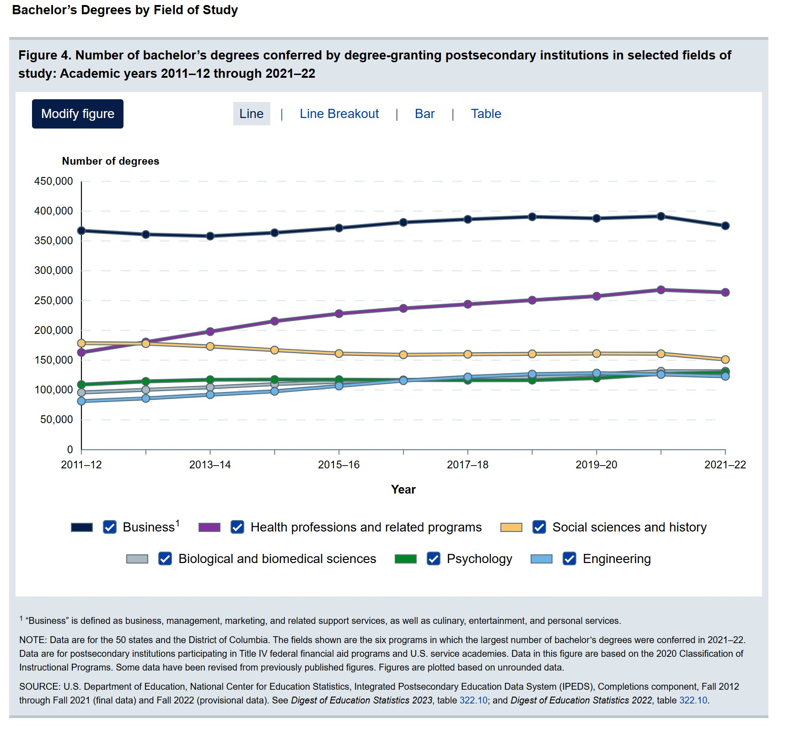

Most popular majors in higher education

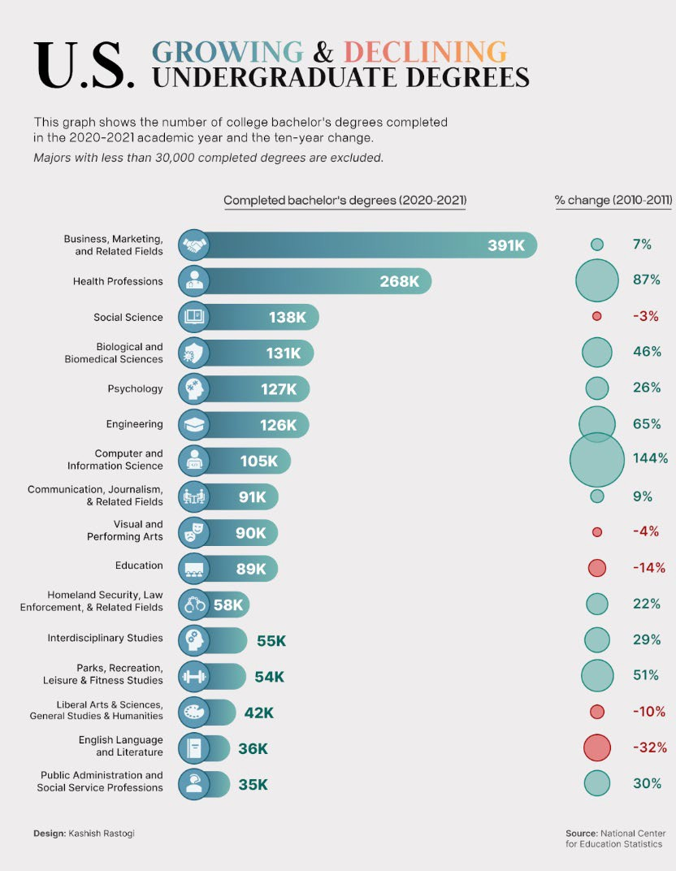
Growing and declining majors

Education

Death of Humanities—Greatly Exaggerated?

- In 2023, first-year Berkeley students majoring in the arts and humanities — English, history, languages, philosophy and media studies — was up 121% over the previous year
- University of Arizona: 76% increase in humanities majors since 2018
  - "applied humanities“: a new, fast-growing department that includes programs in business administration, fashion studies, game studies and public health.
- Virginia Tech: executive education program that imparts leadership skills to mid-career managers using humanities
Axios, 2023; Hechniger Report 2025

- Value: critical thinking, communication, analysis of complex data and ideas

Axios, Feb 2023 ₄

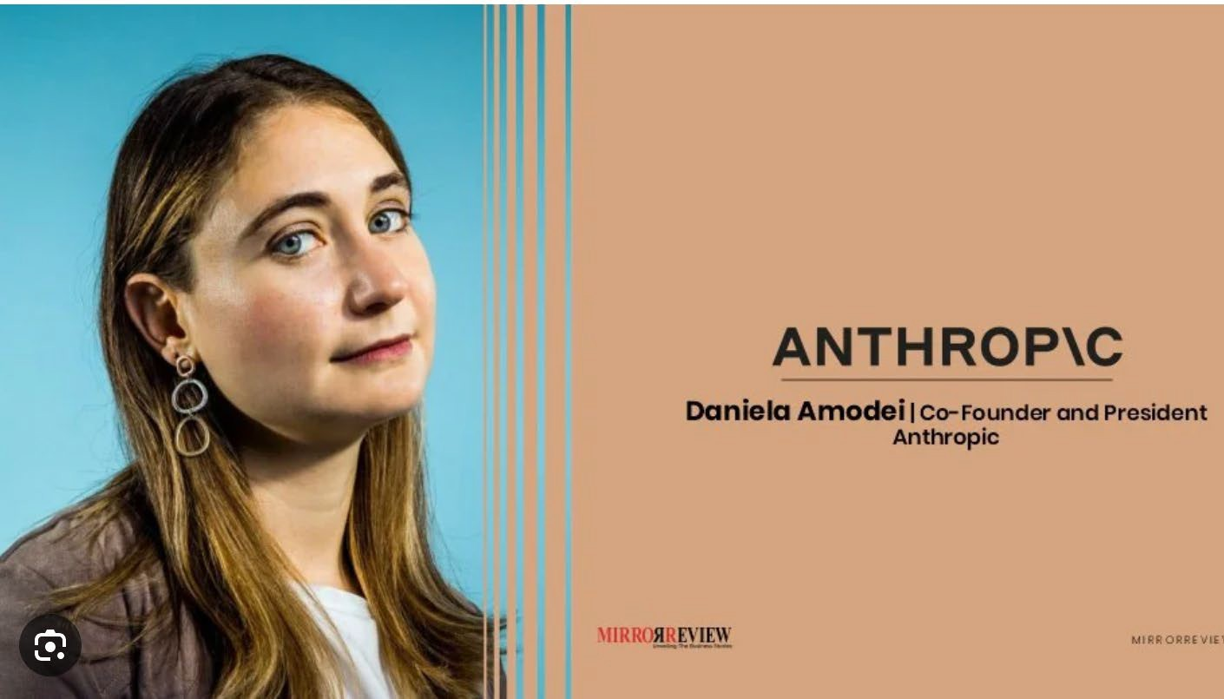

STEM and the Humanities: A False Dichotomy

- “We should be careful not to let interdisciplinary jockeying make us cling to what we know best. Everything looks like a nail when you have a hammer, as the saying goes. Similarly, at how great a disadvantage might we put ourselves—and the world—if we force our minds to approach all problems the same way?”
  - JM Olejarz

Finally, a request

- Please stay for the report of the Ad-Hoc Committee:
  - Purdue Global and Purdue University’s Online and Residential Graduate Programs Report

THANK YOU!
senate-chair@purdue.edu

8

Prepared Remarks for February 17, 2025, Purdue University Senate Public Meeting
It is important to have both private and public meetings of the Senate. This monthly meeting is a public meeting of town hall style, where anyone can join, including the media. At the January public meeting, one local media outlet misreported what I said. At a city council meeting last month, another local media misreported what Mayor Erin Easter said. Words that were not uttered got reported in print and online. When each misreporting was discovered by the speaker and then corrected by the media days later, unnecessary confusion had already been created. Therefore, to ensure accuracy, today I will be reading from written remarks that will be distributed to any inquiring media. In the allotted 10 minutes, I will cover four topics.

Topic 1: Undergraduate admissions:
As you all know, here’s the equation describing the relationship between applications and enrollment: two different concepts. Enrollment equals applications times admissions rate times yield rate. As a hypothetical example with round numbers, if the number of applications is 80,000, the admissions rate is 40%, and the yield rate is 30%, the enrollment of undergraduate freshman would be 9,600. Clearly, an admissions rate of 50% and a yield rate of 25% would lead to the same enrollment through an admission rate of 25% and a yield rate of 50%.
Yield rate is the percentage of students among all those admitted who choose to accept a university’s admission offer instead of those of other universities. Yield rate can only be predicted with imperfect accuracy. In the above hypothetical example, a slight fluctuation of
yield rate, say by 3%, would add almost 1,000 to the enrollment due to the large base numbers.

Purdue’s yield rate last year jumped to around 30%. To put this in perspective, according to public data, at the other large public university in our state the yield rate was 18%.

The number of applications and yield rate are both reflections of market demand by students and parents, one before admissions decisions are made and the other after. Admissions rate is the only variable directly under our admissions office’s control: reducing that rate means becoming more selective.
Over the past several years, Purdue’s admissions rate has gone down from about 70% to just under 50% last year. It will likely be 40% or less this year. To put this into perspective: according to public data, the other large public university in our state continues to hover just under 80% admissions rate, and slightly lower rate at 75% for in-state applicants.

As for Purdue, in light of both the record high number of applications but also the anticipated yield rate, and given the physical facility resource we must ensure for each student, we will lower the admissions rate to whatever point it takes to avoid over-enrollment, while ensuring as many qualified in-state applicants are admitted as possible: for example, last year our in-state admissions rate was 74% while out-of-state was only 45%.

Topic 2: Childcare
As promised last time, here is the answer to the question about one of the child care facilities used by some of our colleagues.
After concerns were raised by several parents at the Early Care and Education Center on the west side of our campus, Purdue engaged with the childcare partner and provider, Early Learning Indiana (ELI), to discuss the concerns and to respond appropriately. ELI has provided an update on actions they are taking to address the issues, including the following:
- They held open office hours with the CEO on Jan. 21 (where eight families showed up).
- They will establish a PUECEC advisory committee by the end of February.
- They commit to improved communication from the center to the families.
- They have launched a search for a new food vendor.
- Along with Purdue’s Administrative Operations, they will assess the current playground equipment and will announce a plan and timeline for playground updates by the end of March.
Purdue Human Resources will continue to work closely with ELI with regular check-ins and quarterly business reviews to ensure compliance with contracts and expectations.
Topic 3: Federal government directives and court orders
This has been a key point in many people’s minds, and impacts hundreds of public and private universities across all states. A communication was sent by our EVP for Research, CFO and Provost last Thursday. Thank you for your continued focus on research. We are very proud of the scholarly quality and societal impact of our colleagues’ work. I’d like to reiterate several points here.

First point: The situation consists of multiple parallel tracks and each changes continuously. We have a team that is closely tracking them in order to be compliant and are tabulating on a public website. Because the government directives and court orders we have received as of last Friday all concerned government sponsored research, the core team naturally consists of the following:
- Patrick Wolfe, Provost
- Karen Plaut, EVP for Research
- Chris Ruhl, CFO
- Steve Schultz, General Counsel
- Ian Hyatt, Chief of Staff
- Alysa Rollock, VP of Ethics and Compliance
- Amy Boyle, VP of HR
- Julie Rosa, VP of Communications
- Ken Sandel, Associate VP for SPS
along with Deans, Associate Deans for Research, Heads, and Directors of Institutes and Centers, who are in constant conversation with each other. This team continues to work hard for you.

Second point: At any given moment, there are many questions that we don’t know the answers to, just like you. And we cannot execute on hypothetical directives that have not been given to us.
We forward information, which is agency specific, to the relevant Principal Investigators whenever we receive it. These include stop or cease work orders as well as an NIH directive that would reduce the indirect cost rate for NIH funded grants. Right now, the NIH guidance is under a court’s temporary restraining order.

Third point, Purdue will continue to follow our principle of “people first,” and will continue our core support for research. We also have longer-term strategies to support and grow our research enterprise. These strategies include further growing our industry partnerships and funding as well as philanthropic fundraising for research programs and facilities. These strategies have been consistently and actively pursued at Purdue. In fact, the largest 5-year capital campaign in Purdue history was announced two days ago.

Topic 4: Freedom of expression
Per long-standing practice and the Board of Trustees’ official policy at Purdue University, unless directly requested by the government, we do not make public comments on behalf of the entire institution on any social-political topic, including court proceedings and state legislations covering such topics. While perhaps not always the most expedient, this practice and policy have proven to be a positive one for the university in the long-run.

Such institutional neutrality maximizes the freedom for all the individuals at the university, more than 110,000 of them in our system, to exercise their individual freedom of expression on any topic they choose.

We do welcome and carefully listen to input from members of the university community, and may find useful channels of communication to relay such input to decision-makers.

Applicants x Admissions Rate x Yield Rate
= Enrollment

1

Child Care

  - Response by Early Learning Indiana (child care partner and provider):
    - Letter to families on Jan. 16 addressing concerns
    - Held open office hours with CEO on Jan. 21
    - Will establish PUECEC advisory committee by the end of February
    - Is committed to improved communication from the center to families
    - Is seeking new food vendor
    - Will begin assessing playground equipment alongside Purdue with a plan and timeline to be communicated by the end of March

Thank You

 | University Senate Questions and Administrative Responses  17 February 2025

Questions
Purdue Graduate Student Concerns…………………………………………………………………………………………
What are the university’s plans regarding the provision of free CityBus transportation tokens for graduate students during the Summer and Fall 2025 semesters? Will the program be expanded or adjusted? Additionally, will graduate students be required to purchase their own tokens for Summer or Fall 2025?
- Campus transportation services are under review for Summer and Fall 2025. Summer transportation plans are currently being evaluated, while Fall 2025 services are under review through an open RFP process. We appreciate that many students depend on reliable transportation options and will share updates with the campus community as soon as more information becomes available.

Are there plans to increase the minimum stipend for graduate students for the 2025-26 academic year to account for inflation and rising costs of living?
- Over the past three years, the average graduate student salary has increased by 23% due to additional institutional investments. We are currently reviewing the option of returning to the practice of adjusting the minimum stipend by the same percentage as the faculty and staff merit pool, as was the case prior to recent major increases to the minimum stipend. Colleges and departments will continue to have the flexibility to set higher minima to support competitive recruitment efforts. Most of the Ph.D. students have stipends much higher than the minimum.

Since graduate students are not eligible to live on campus, they do not have access to non-commuter dining court passes. Would the university consider a pilot program to offer subsidized dining court passes for graduate students on assistantships in Spring 2025? Given the significant time demands of assistantships, access to affordable dining options would reduce challenges faced by graduate students who spend considerable time on campus due to classes and meetings. The lack of affordable housing makes them stay far away from campus and not be able to access their homes for mid day meals. Could this option be integrated into assistantship offers if increasing stipends proves challenging?
- Graduate students can purchase a commuter meal plan from Purdue Dining & Culinary, subject to availability based on demand from residence hall students. Additionally, Purdue Food Co. offers meal plans with reduced rates at retail dining locations.

The cost of health insurance for graduate students on 1/4-time appointments is significantly higher than for those on 1/2-time appointments. Would the university consider adjusting health insurance premiums to be proportionally fractional based on employment status to address this disparity?
- Currently, the university provides premium contributions for graduate students whose total appointments equate to 0.5 FTE or higher, similar to the university’s approach to medical premium support for employees at 0.5 FTE or greater.

Affordable childcare remains a challenge for graduate students with families. Are there plans to expand affordable childcare options on or near campus or to provide subsidies for graduate student parents to help with these costs?
- Information about childcare efforts can be found here. Through a Lilly grant, the university continues working with the Greater Lafayette community to expand childcare options for families.

Additionally, each of the three childcare programs affiliated with the West Lafayette campus accepts CCDF vouchers for eligible families. Human Resources also provides online resources, including childcare referral services, community childcare options, and information on the au pair program.
Access to A parking passes is currently limited. Would the university consider making A parking passes available for purchase by all graduate students, particularly those with time-sensitive commitments like teaching or research assistantships?
- Parking adjustments are made throughout the year to accommodate campus needs and address parking pressures. In Fall 2024, the parking team implemented changes that increased parking capacity for C permit holders and activated underutilized spaces through the South Campus shuttle. Additionally, 100 more permits were released in January 2025 to help meet demand while balancing overall parking availability.

The university continues to evaluate parking needs and explore potential adjustments. More information on future parking plans will be shared with the campus community as it becomes available.

As housing costs continue to rise, how is the university addressing the availability of affordable housing near campus for graduate students in the year 2025?
- While housing costs in the Greater Lafayette area have risen in recent years, there are indications that they may stabilize. Purdue is contributing to this effort by opening two new residence halls—one in Fall 2025 and another in Fall 2026—adding housing for approximately 1,900 residents.

Additionally, the community has seen a nearly 4% increase in available beds over the past year, with more major projects underway. This growing housing supply, combined with the University's efforts to limit enrollment growth in West Lafayette, is expected to help moderate rental increases.

Graduate students significantly contribute to teaching and research. Are there plans to introduce additional recognition, awards, or incentives to acknowledge their contributions and improve retention?
- The Office of the Vice Provost for Graduate Students and Postdoctoral Schools (OGSPS) is actively exploring new ways to recognize and reward graduate student excellence in research and teaching. While OGSPS has historically celebrated contributions to teaching, we recognize the need to highlight broader scholarly achievements.

To support this, graduate students are eligible for the Purdue University Books Initiative, and we encourage participation in this opportunity where appropriate. The Presidential Doctoral Excellence Awards were also recently launched to help recruit and retain outstanding PhD students. Looking ahead, OGSPS will collaborate with the Colleges in Spring 2025 to identify strategies that further elevate scholarly excellence. These discussions will shape the development of new

competitive awards, set to launch in Spring 2026, to recognize and support graduate student contributions.

Graduate students at Purdue Indianapolis note that 4 - 6 departments are currently housed in a single building. Are there plans to expand infrastructure, and if so, when can students expect the unveiling of the first building with research labs and classrooms?
- Purdue Trustees approved the construction of the Academic Success Building in June 2024. Construction on the 248,000 square foot facility is scheduled to begin in April 2025 and be completed by May 2027.

Purdue Indianapolis students have raised concerns about IU students gaining access to IU exclusive career fairs, while PIN students must travel to West Lafayette for events such as the Industrial Round Table. Could the university negotiate with IU to allow Purdue Indianapolis students access to IU career fairs? Additionally, what are the university’s immediate plans for hosting career fairs tailored to Purdue Indianapolis students?
- Purdue University provides career services and career fairs in Indianapolis, along with opportunities in West Lafayette and virtual options. The 2024 Indianapolis Career Fair hosted 79 companies and over 500 students, with additional events such as the Co-Op Fair (Jan 27), the Construction Industry Fair (Feb 4), and the upcoming Indianapolis Career Fair (Feb 24). To support access to West Lafayette’s Industrial Roundtable, additional buses were provided for Indianapolis students. Purdue remains committed to expanding career opportunities for all students.

Purdue Indianapolis graduate students receive an additional $1,500 per semester in housing allowances to offset the cost of living in Indianapolis. However, apartment costs in Indianapolis are comparable to, or even less than, those in West Lafayette. Why is this allowance provided only to Indianapolis students and not extended to West Lafayette students?
- The process for determining the cost of attendance (including housing) is determined by the Department of Education and the Division of Financial Aid calculates Purdue’s cost of attendance based on those guidelines. When the Division of Financial Aid calculated cost of attendance at Indianapolis, the rates were significantly higher than in West Lafayette because the housing estimates were based on two on-campus housing options (Lux and North Hall), both of which were higher price than some on-campus housing in West Lafayette.

For international students, the I-20 document previously listed the cost of living in West Lafayette as approximately $17,000 per year. The current figure from Purdue ISS shows this cost has risen to around
$22,000. If Purdue recognizes a $5,000 increase in the cost of living, why haven’t graduate student stipends
been adjusted accordingly to reflect this change?
- Over the past three years, the average graduate student salary has increased by 23% as a result of additional institutional investments. Purdue also raised the minimum graduate student stipend to
$26,000 on July 1, 2023, and it increased again to $28,000 on July 1, 2024. Additionally, individual colleges and departments have the flexibility to establish higher minimum stipends to support competitive recruitment and retention efforts.

Returning one hour a day to faculty ……………………………………………………………………………………….
Many of our colleagues still feel swamped. Can you please provide updates regarding the “returning one hour a day to faculty” initiative?
- Over the past several months, Sponsored Program and Business Office staff have worked diligently to enhance pre- and post-award management, launching key initiatives aimed at streamlining research administration. In October, we introduced the PERA (Purdue Excellence in Research Administration) system, a faculty-requested tool that centralizes research-related processes. Faculty feedback has been largely positive. Additionally, the Research Account Dashboard (RAD) was developed to provide researchers with real-time account insights. Its adoption has exceeded expectations, reflecting its value to faculty.

Our teams continue to reduce unnecessary approval steps by minimizing the number of signatures required whenever possible – our ongoing “One Signature Fewer” initiative. We welcome further improvement suggestions at finprocess@purdue.edu.

Purdue IT continues to expand AI resources to save faculty and staff time. For example, the recent launch of Proofig AI, an automated image proofing tool, helps ensure research integrity in scientific publications.

As we continue refining these systems, we recognize that both faculty and staff are managing significant demands. Ensuring an efficient research environment depends not only on process improvements but also on retaining skilled administrative staff. A culture of mutual appreciation and collaboration will be key to sustaining these efforts and driving future success.
Federal Executive Orders – impact on research funding……………………………………………………………….
How will Purdue administration support faculty, especially pre-tenure faculty, whose research agendas in social justice, equity, and inclusion have been criminalized by the federal government? Will you give these faculty time to reform their research agendas or will you use their sudden inability to be funded under their previous agenda as a reason to deny them tenure?
- The university values academic freedom and is committed to supporting faculty as they navigate changes in the research landscape. Led by deans and department heads, we will continue to work with affected faculty to explore viable pathways for continued scholarly excellence in an evolving environment. A research update email was distributed to faculty and staff across the Purdue system on Thursday.

Also, will you support the students who had been funded under canceled grants to complete their degrees? PhD students should not be punished for the government's choice to end their funding streams.
- Our top priority is our duty of care to students. We are actively assessing the impact of federal funding changes and committed to identifying viable solutions to assist affected PhD students in continuing their academic progress.

State Chemists….…………………………………………………………………………………………………………….
The state legislature is considering moving the State Chemist from Purdue to IU: https://legiscan.com/IN/bill/HB1184/2025. This would be a bad decision on the merits: the responsibilities of the State Chemist include administering agricultural laws regarding fertilizers and such (https://inplants.oisc.purdue.edu/USAPlantsIN/Index.aspx), and this is well in line with Purdue’s land-

grant mission, not to mention the technical expertise of Purdue’s STEM and Ag operations. It would also
be an unfortunate precedent for this kind of micro-managing to go through unopposed. How will Purdue respond to this legislative initiative?
- We are aware of the legislation and will continue to monitor its consideration.

COACHE survey……………………………………………………………………………………………………………….
What efforts were implemented based on the results from the last COACHE survey? As Purdue is getting ready to launch another COACHE survey, it would be useful to know what initiatives were taken in response to the results from the survey from three years ago.
- Several improvements were implemented in response to the last COACHE survey, including updating promotion and tenure criteria in partnership with colleges and departments, enhancing the annual review process, and creating a promotion pathway for lecturers. C/P and lecturer advisory boards were established, and leadership programs were tailored to address COACHE feedback. As we prepare for the next survey, we continue assessing these initiatives to enhance faculty success and engagement.
DEI Executive Order - impact on Purdue………………………………………………………………………………….
What is President Chiang’s take on the Trump ban on DEI (also referred to as DEIA in the executive order referenced below) initiatives, which the executive order of January 21st intends to apply through “civil compliance investigations” to “institutions of higher education that have endowments over 1 billion
dollars.” Purdue falls into that category with a 3-billion-plus endowment. Going forward, will Purdue continue to support DEIA?
If not, doesn’t our history of institutional support for DEIA run counter to the ban?
If so, how will Purdue address the legal issues if and when they arise?
- As a public university and State Education Institution (SEI), we are committed to our core mission and responsibilities while ensuring compliance with applicable laws. We are continuously monitoring a complex array of legal developments that are emerging at a rapid pace, including agency guidance and court proceedings related to this executive order and others.

Purdue Climate Action Plan………………………………………………………………………………………………….
When can we expect Purdue to commit to a climate action plan, with targets for decarbonization? When will the administration officially respond to SD 22-22, calling on the university to commit to carbon neutrality?
- Purdue University was recently ranked by QS (Quacquarelli Symonds) World University as the No. 12 institution in the United States for sustainability and our climate action plan consists of two parts:
  - 2020 Sustainability Master Plan
  - 2022 SMR to Zero Plan

Résumé of Items 17 February 2025


To: | The University Senate
From: | Libby Richards, Chairperson of the Steering Committee
Subject: | Résumé of Items under Consideration by the Various Standing Committees

Steering Committee
Libby Richards, erichards@purdue.edu
- Soliciting reports and informational sessions in response to faculty and committee requests
- Collaborating with PSG and PGSG to facilitate resolution review

Advisory Committee
Susan South, senate-chair@purdue.edu

Nominating Committee
Damon Lisch, dlisch@purdue.edu and Seema Mattoo, smattoo@purdue.edu
- Identify candidates for Senate Vice Chair
- Managing committee vacancies
- Evaluating and balancing numbers, disposition and experience of Senators for equitable representation and task assignments

Educational Policy Committee
Vincent Duffy, duffy@purdue.edu
- Winter Programs review
- Assessing the need for AI regulations, the nature of AI use, available training
- Updating of academic withdrawal language in academic regulations
- PSG PGSG Joint Resolution: Purdue University Voter Accessibility Policy
- Well-being and stress management; including PSG Mental Health Days Initiative
- Practice of departments requiring certain grades in specific courses
- Student Success, including communications re: brief DRC status update
- Expected communication with Faculty Committees reporting to EPC

Equity, Diversity, and Inclusion Committee
Brian Dilkes, bdilkes@purdue.edu
- Possible committee name change
- Compliance

Faculty Affairs Committee
Françoise Brosseau-Lapré, fbrossea@purdue.edu / Anish Vanaik, avanaik@purdue.edu
- Lecturers Advisory Committee
- Assessment of recent changes in P and T process.
- Ability of Senate leadership to directly email faculty [SD passed and sent to Senate for discussion and adoption]

- Implementation of SEA 202
- Impact of Indiana SB1 on Purdue Healthcare practices and follow up on measures laid out in SD 22-08
- Working of Elements software
- Input to OVPFA on recent changes to various standards, policies and procedures:
  - changes to eAPR
  - Guidelines for Establishing Intergovernmental Personnel Act agreements (IPAs)
  - Process and procedures for Purdue Faculty and Staff Participation in Intergovernmental Personnel Act Agreements.
  - Presentation about Purdue transition to Elements for Annual Activity Reports.
  - Courtesy Faculty Appointment Standard
  - Revised R/I/E Leave request procedures
  - Reportable Outside Activities leave request procedures

Student Affairs Committee
Abigail S. Engelberth, aengelbe@purdue.edu
- Class Size
- Equitable Parking
- Move-in Package

University Resources Policy Committee
Lori Hoagland, lhoaglan@purdue.edu
- Parking regulations and appeals process
- Issues around parking at bicycle racks
- PSG/PGSG resolutions around voting, move-in packages and equitable parking

Committee Votes:
To: | The University Senate
From: | Senate Nominating Committee
Subject: | Nominees for Vice Chairperson of the University Senate
Reference: | Bylaws, Section 3.20b, c
Disposition: | Election by the University Senate
Proposal: | The Nominating Committee proposes the following slate to serve as candidates for Vice Chairperson of the University Senate during the academic year 2025-2026:  Julio Ramirez, Civil Engineering TBD  Please see the following pages for their biographical statements.

Senate Document 24-09
17 February 2025

For: | Against: | Abstained: | Absent:
Dulcy Abraham Seema Mattoo Byung-Cheol Min Abdelfattah Nour Mohit Tawarmalani  Christina Wilson-Frank |  |  | Sabine Brunswicker Damon Lisch Sebastian Murgueitio  Ramirez

Julio A. Ramirez, Ph.D. Dist. M. ASCE Karl H. Kettelhut Professor in Civil Engineering
NHERI-NCO Center Director
Lyles School of Civil and Construction Engineering

Dr. Julio A. Ramirez was appointed to the faculty at Purdue University with the rank of Assistant Professor in 1985 and promoted to the rank of Full Professor in 1996. In 2018 he was appointed as Karl H. Kettelhut Professor of Civil Engineering in the Lyles School of Civil and Construction Engineering to this date. During more than 30 years as Purdue University professor, he has served in a variety of school, college, and university-level committees, including the University Senate.

Dr. Ramirez is a full voting member of the technical Joint Committees of the American Concrete Institute (ACI) and the American Society of Civil Engineers (ASCE) 445- Shear and Torsion; and Committee 408- Bond and Development of Reinforcement and has been invited to serve as a full voting member of the ACI 318 Building Code Committee. This is the standard that regulates all structural concrete building design and construction in the United States. Since 2016, he has been the Principal Investigator and Center Director of the Network Coordination Office (NCO) of the NSF funded Natural Hazards Engineering Research Infrastructure (NHERI). Previously he served as the chief officer for the NSF funded large-scale research infrastructure George E. Brown Jr. Network for Earthquake Engineering Simulation (NEES) from October 2009 to September 2015. On July 29, 2014, while serving as the Chief Officer of NEES, Prof. Ramirez testified before Congress as it debated reauthorizing legislation to reinstate federal research funding devoted to mitigating earthquake damage to the nation's infrastructure.

He has served as an Associate Editor for the Committee on Concrete and Masonry Structures (CCMS) Division of the American Society of Civil Engineers (ASCE) Structural Journal and has been a member of several National Cooperative Highway Research Program (NCHRP) research panels. Prof. Ramirez has served in NSF proposal review panels for several directorates. In 2017 Dr. Ramirez was inducted to the Purdue Innovator Hall of Fame.

In 2021 he was elected Distinguished Member of the American Society of Civil Engineers. Prof. Ramirez is a Fellow of the American Concrete Institute and the recipient of the 2000 Delmar Bloem Award and the 2006 Joe W. Kelly Award of the American Concrete Institute. Currently, Dr. Ramirez serves a two-year term on the Advisory Committee on Structural Safety of Department of Veteran Affairs Facilities providing advice to the Secretary of Veterans Affairs on matters of structural safety and remodeling of VA facilities.

Senate Document 24-10

17 February 2025

To: | The University Senate
From: | University Senate Nominating Committee
Subject: | Nominees for Advisors to the Senate
Reference: | Bylaws of the University Senate
Disposition: | Election by the University Senate
Proposal: | The Nominating Committee proposes the following slate of nominees for service on the Senate. The Advisors selected are to serve for three-year terms as specified in the Senate Bylaws. The terms will begin on 1 June 2025 and end 31 May 2028.  - Eric Adams, MaPSAC*  - Heather Beasley, Senior Director of Operations, Office of the Vice Provost for Student Life  - Michael Cline, Senior Vice President for Administrative Operations  - Melissa Franks, Director of Graduate Studies  - Cherise Hall, Vice Provost for Enrollment Management  - Sheila Hurt, University Registrar  - Lowell Kane, LGBTQ Center Director  - Carl Krieger, Director of Residential Life  - Lisa Mauer, Associate Vice Provost for Faculty Affairs  - Beth McCuskey, Vice Provost for Student Life  - Sunil Prabhakar, Vice Provost for Faculty Affairs  - Jenna Rickus, Vice Provost for Teaching and Learning  - Jurgen Rochin-Gomez, CSSAC**  - Alysa Rollock, Vice President for Ethics and Compliance  - Katherine Sermersheim, Dean of Students

Senate Advisors not assigned to committees:
Cherise Hall (Vice Provost for Enrollment Management) Katherine Sermersheim (Dean of Students)
MaPSAC Chair (see below)

* MaPSAC representatives serve one-year terms (the Vice-Chair serves on the Senate Advisory Committee and the Chair serves on the Senate)
** CSSAC representatives serve one-year terms

Committee Votes:

For: | Against: | Abstained: | Absent:
Dulcy Abraham Damon Lisch Seema Mattoo Byung-Cheol Min Abdelfattah Nour
Sebastian Murgueitio Ramirez
Mohit Tawarmalani Christina Wilson-
Frank

Senate Document 24-11

17 February 2025

To: | The University Senate
From: | University Senate Nominating Committee
Subject: | Nominees for Advisors to the Senate Standing Committees
Reference: | Bylaws of the University Senate
Disposition: | Election by the University Senate
Proposal: | On the recommendations from the Chairs of the University Senate Standing Committees, the Nominating Committee proposes the following slate of nominees for service on the Senate Standing Committees listed below. The Advisors selected are to serve for three-year terms as specified in the Senate Bylaws. The terms will begin on 1 June 2025 and end 31 May 2028.  - Advisory Committee  - Jurgen Rochin-Gomez, CSSAC*  - TBD, MaPSAC**  - University Senate Educational Policy Committee  - Jeff Elliott, Executive Director, Undergraduate Advising***  - Sheila Hurt, University Registrar  - Jenna Rickus, Vice Provost for Teaching and Learning  - Jeff Stefancic, Associate Dean of Students***  - University Senate Equity, Diversity, and Inclusion Committee  - Lisa Mauer, Associate Vice Provost for Faculty Affairs  - Lowell Kane, LGBTQ Center Director  - Alysa Rollock, Vice President for Ethics and Compliance  - University Senate Faculty Affairs Committee  - Sunil Prabhakar, Vice Provost for Faculty Affairs  - Lisa Mauer, Associate Vice Provost for Faculty Affairs  - University Senate Student Affairs Committee  - Heather Beasley, Senior Director of Operations, (Office of Vice Provost for Student Life)  - Beth McCuskey, Vice Provost for Student Life  - Melissa Franks, Director of Graduate Studies  - University Senate Resources Policy Committee  - Kim Pearson, Office of the Vice President for Administrative Operations***  - Carl Krieger, Director of Residential Life

* CSSAC Advisor serves a one-year term
** MaPSAC representatives serve one-year terms (the Vice-Chair serves on the Senate Advisory Committee and the Chair serves on the Senate)
*** Committee advisor, but not Advisor to Senate

Committee Votes:

For: | Against: | Abstained: | Absent:
Dulcy Abraham Damon Lisch Seema Mattoo Byung-Cheol Min Abdelfattah Nour
Sebastian Murgueitio Ramirez
Mohit Tawarmalani Christina Wilson-
Frank

1

Senate Ad Hoc Committee 2024-2025 Report:
Graduate Programs: Purdue Global and Purdue University’s Online and Residential Programs


Libby Richards, Committee Chair, Purdue West Lafayette, School of Nursing

Susan South, University Senate Chair, Purdue West Lafayette, Psychological Sciences Brian Leung, University Senate Immediate Past Chair, Purdue West Lafayette, English Maricel Lawrence, Representative of Purdue Global, Innovation Catalyst
Ellen Gundlach, Representative of Purdue University Online, Senior Managing Director for One Health

Eric P Kvam, Representative of the University Senate Educational Policy Committee, Materials Engineering

Ajay Malshe, Representative of the University Senate Faculty Affairs Committee, Mechanical
Engineering (Spring 2024 involvement only)



The committee will look at the ways Purdue West Lafayette's residential and online graduate programs and Purdue Global's online graduate programs complement one another and overlap, as well as how to enhance their independent and unified missions.







- Residential graduate programs
- Online graduate programs
  - ‘Owned’ by colleges/departments
  - Marketed/ managed by Purdue University Online
  - Aims to expand access to a high-quality Purdue education to a broader audience beyond the main campus
- Established in April 2017 through acquisition of the academic assets of the private, for-profit online Kaplan University
- Now a public university within the
Purdue system
- Considered a strategy to accomplish the land-grant mission
- Focuses on serving working, adult
learners to achieve their career goals

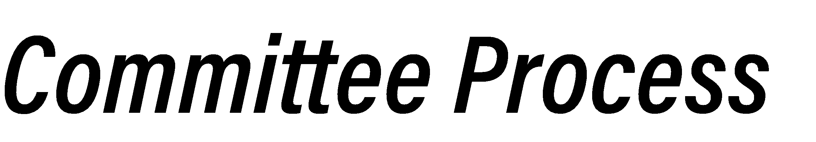


Reviewed Existing, Accessible Information

Vision for Online Learning 2.0 | Accreditation of Programs | Faculty Composition | 1 Year Retention Rates | Students
April 2023 Trustees meeting presented the Vision for Online Learning  2.0 and clarified the role between Purdue University Online and Purdue Global. | Most of the graduate programs offered from both schools are accredited but they are not necessarily accredited by the same bodies.  Purdue Global non-accredited programs include MS in Data Analytics, MS in Education, and MPH. | Purdue University Online Faculty:  employed and directed by their respective Purdue West Lafayette departments and colleges, equivalent of 235 faculty and 80 part-time instructors  Purdue Global Faculty: 278 full-time faculty, 2046 part-time faculty | PWL residential: 86-100%  PWL online: 72-100%  Purdue Global: 54-77% | PWL residential graduate students are younger, a majority international, and have a higher % of male students.  PWL online graduate students are in the middle  Purdue Global’s graduate  students are 63% female.

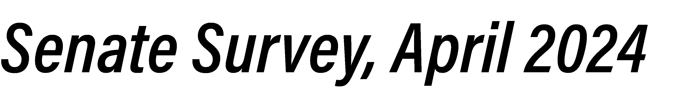

PG= Purdue Global
PWL= Purdue West Lafayette
PUO= online programs of PWL

Opportunities/synergies across PWL residential, online, and Purdue Global:
- Consider more certificate or non-degree programs
- Consider more degree programs
  - Early childhood education, Addiction specialist, Masters in social work, Nursing, Digital forestry
- Need more interdisciplinary networking among graduate students
- Prefer to put distance between PWL/PUO and PG instead of synergies
- PG is viewed as a competition which makes synergy hard/impossible
- PG should not offer graduate online education
- Where overlap exists, there could be opportunities to avoid
  - Differentiate programs with specialties
  - Offer a certificate at one location and a full degree program at the other
  - Have one program feed into the other

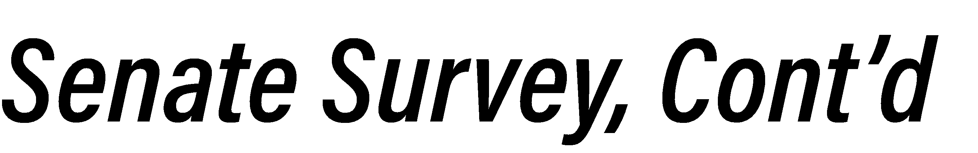

Strengths:
- PWL and PUO- Academic rigor, strong faculty
- PWL provides numerous opportunities and
meaningful connections for students
- PG is flexible, accessible for non-traditional students
- PG is career-focused

PG= Purdue Global
PWL= Purdue West Lafayette
Weaknesses:
- Public (and some students/faculty/staff) cannot distinguish between PWL, PUO, and PG
- Competition between institutions
- Lack of consistency between institutions
- Lack of clear governance/administration across institutions
- PG tarnishes Purdue’s reputation
- PG has less rigorous programs
- Credits do not transfer (easily)
- Land grant university should not have a for-profit entity
- PUO financial model does not work for all
programs, especially smaller programs












Purdue Global’s goal is to offer an accessible college education to working U.S. adults. Administration sees Purdue Global as one of the main components at the heart of Purdue University’s land grant mission.
Purdue University West Lafayette offers residential and online graduate education opportunities to selective audiences, meaning generally not all applicants who meet minimum requirements are accepted.
Having both Purdue Global and Purdue University Online has the potential to clearly distinguish Purdue from other institutions.
Purdue Global started with a huge focus on brand awareness- it was important for people to know who they were and that they are part of the Purdue portfolio. Now, they are starting to shift marketing towards programs and more tailored messages.

Purdue West Lafayette, which includes Purdue University Online, needs less brand awareness- people know who Purdue is and what they do.

Both Purdue University Online and Purdue Global are being challenged to more than double their enrollments.
The course design process follows online education best practices at both institutions.

Purdue Global: the process is centralized and collaborative. Subject matter expert works closely with the curriculum design and operations team to develop the course, providing consistency in course content as well as student experience. Once a course is designed, instructors teaching those courses are provided with the syllabus, content, and materials.

Purdue University Online’s TLT will work with faculty to design course and program-specific pedagogical material.
Two offices of specific interest are Educational Partnerships and Military Partnerships.
When determining if an industry/employer should partner with Purdue University Online or Purdue Global, OIP shares Purdue’s capabilities at a high-level, listens to the customer’s needs, and then discusses with them how to fill their gaps in workforce development. Once OIP understands their needs, they share programs with the appropriate learning outcomes from across the portfolio.
Purdue Global supports Purdue West Lafayette faculty/staff and family members’ tuition benefits through the Gift of Knowledge policy.

Purdue West Lafayette’s online programs operate on a cost-reimbursement budget model, meaning costs are recovered, but profits are passed onto the units. Due to this cost-reimbursement model, in order for tuition discounts to be offered to faculty, staff, and families, money must come from the units, colleges, or central administration.

Continue to clarify and market the differences between Purdue University’s online programs and Purdue Global
Strategy:
  - Provide information about Purdue University Online and Purdue Global at all new university-level
faculty and staff orientations.
  - Increase the marketing capacity and resources of Purdue University Online, without passing these costs to the colleges/units.
  - Change the tag line for Purdue Global, which currently states, “Purdue Global, Purdue’s online university for working adults” TO “Purdue Global, the Purdue system’s online university for working adults”
  - Purdue Global, Purdue University Online, and Purdue West Lafayette marketing should revise/update their strategic plan to more clearly distinguish the differences between these entities.
  - To ensure a comprehensive understanding of online offerings, future work should include the regional
campuses.

Revise marketing strategies which combine messaging about Purdue University West Lafayette with overall Purdue System messaging
Strategy:
  - Revise the press release statements to only include statements and data regarding Purdue University West Lafayette.
  - Add a specific statement on press releases mentioning Purdue University’s online programs and certificates.
Current press release statement:
“Purdue University is a public research institution demonstrating excellence at scale. Ranked among top 10 public universities and with two colleges in the top four in the United States, Purdue discovers and disseminates knowledge with a quality and at a scale second to none. More than 105,000 students study at Purdue across modalities and locations, including nearly 50,000 in person on the West Lafayette campus. Committed to affordability and accessibility, Purdue’s main campus has frozen tuition 13 years in a row. See how Purdue never stops in the persistent pursuit of the next giant leap — including its first comprehensive urban campus in Indianapolis, the Mitch Daniels School of Business, Purdue Computes and the One Health initiative.”

Streamline processes and interfaces between Purdue West Lafayette residential and Purdue University online programs.
Strategy:
  - Strategize how to offset tuition costs for faculty/staff to attend Purdue University Online.
  - Clearly articulate and review options for standardizing how colleges/departments calculate Purdue University Online courses into faculty compensation and/or teaching loads.
  - Reduce the financial and administrative barriers to allow access to courses between Purdue West Lafayette residential and online. For example, explore options for Purdue West Lafayette residential students to enroll in Masters of Science in Artificial Intelligence and Masters of Science in Data Science core courses.

Ensure all faculty have access to AND utilize best practices in online education to maintain rigorous online courses.

Strategy:
  - Unit leaders should encourage faculty and staff to apply for CoPILOT: Cohort Program for Innovation and Leadership in Online Training to facilitate development of accessible online courses using research-based online course pedagogy.
  - Purdue University administration will allocate additional resources to the CoPILOT program to allow more
faculty and staff to be able to enroll in this program.
  - Faculty, staff, and graduate students creating or teaching in an online environment should consult with the Center for Instructional Excellence and Teaching & Learning Technologies.
  - Dedicate a specific section for online education resources in each Teaching and Learning Updates email from the Senior Vice Provost for Teaching and Learning
  - The University should prioritize more faculty and staff working with the course production team to enhance and develop online courses and go through the Quality Matters-correlated Course Design Evaluation Rubric upon creation and then every three years. Release time for participation should be considered.

13


This Ad Hoc committee requests that the President and Provost report back by August 15th to the Senate as to which parts of this report will be adopted/adapted.



Ad Hoc Committee
Purdue Global and


Purdue University’s Online and Residential Graduate Programs
2024-2045 Report

Table of Contents
Executive Summary 3
Committee Charge 6
Description and History of Purdue University Online and Purdue Global 6
Review of existing, relevant information 6
Information obtained from current administration at Purdue West Lafayette, Purdue University Online, and Purdue Global 8
Structure of Purdue Global and Purdue University Online Student Support 10
Current interaction and relationship between Purdue Global and Purdue University Online on program development 10
Initial marketing discussions with senior administration 11
Comparison of programs across entities 11
Review of accreditation across programs* 12
Review of one-year retention rates 17
Purdue Global 17
Purdue West Lafayette Residential 18
Purdue University Online 18
Role of instructional design and learning technologies in online education 20
Role of Office of Industry Partnerships 21
Financial aspects 22
Tuition discounts 22
What are the current financial barriers that have thus far recommended against Purdue employee tuition discounts for Purdue University Online? 22
Is Purdue Global financially considered a separate ‘company’ or affiliated under Purdue’s incorporation? 23
Marketing of programs 24
How can communication be improved to help Purdue West Lafayette faculty, staff, students, and alumni understand and gain a better appreciation of the role of Purdue Global and Purdue University Online? 24
Is there a common story that can be told about all Purdue affiliated programs? Or is it better to separate Purdue Global and Purdue University (residential and online) for the public? 26
How are these Purdue branded educational opportunities marketing course sizes and instructor contact, and how are the instructors of record supported in delivering the marketed promises? 27
Q&A follow-up for Purdue University Online 28
Q&A follow-up for Purdue Global 29

Ad Hoc Committee Recommendations 30
Appendix 1: University Senate Survey circulated April 2024 33
What opportunities/synergies do you see for Purdue West Lafayette's residential and online graduate programs and Purdue Global's online graduate programs? 33
What do you see as the inherent strengths and weakness of graduate program offerings through Purdue Global, Purdue West Lafayette residential, and Purdue West Lafayette online? 33
Is there anything else you would like to share regarding graduate programs at Purdue Global and/or Purdue West Lafayette (residential and/or online) that would inform the committee's work? 34
What questions would you like the Ad Hoc Committee to look into regarding Purdue Global's online graduate program and Purdue West Lafayette's residential and online graduate programs? 34
Appendix 2: Committee member bios 35

Executive Summary
The Ad Hoc Committee, established by the Purdue University Senate in Spring 2024, conducted a comprehensive review of Purdue’s online and residential graduate education programs. This included Purdue Global and Purdue West Lafayette’s residential and online (offered through Purdue University Online) graduate programs. The committee’s primary objective was to evaluate synergies, overlaps, and opportunities to enhance their independent and unified missions while addressing concerns about branding, governance, financial health, and program differentiation.
Key Findings
    - Program Missions and Structures
      - Purdue Global focuses on serving working adults through accessible, flexible, career-oriented education, aligning with the land-grant mission.
      - Purdue University Online aims to provide scalable, high-quality education to a broad audience, leveraging the expertise of West Lafayette faculty. Programs are primarily graduate and non-credit professional development.
      - Purdue University West Lafayette’s residential graduate programs are designed to provide advanced education and foster research excellence in a wide range of disciplines.
      - Purdue Global operates independently with distinct student demographics and accreditation requirements.
    - Financial and Marketing Challenges
      - Purdue Global operates as a self-sustaining entity with financial health bolstered by partnerships and targeted marketing efforts. It does not receive state-level support and provides tuition-free education to Purdue University employees. Moreover, Purdue Global operates in a very competitive space.
      - Purdue University Online relies on a cost-recovery model, limiting tuition discounts for employees. Marketing challenges include distinguishing Purdue University Online from Purdue Global and competitors.
    - Student Demographics
      - Purdue Global serves older, primarily female, working adults.
      - Purdue University Online caters to younger, professional students.
      - One difference between student types is that Purdue University Online students are generally already in a professional career, and Purdue Global students are trying to get into one.

    - Faculty and Course Design
      - Purdue Global employs centralized instructional design processes to ensure consistency with research and best practices in adult online learning, and to track program outcomes.
      - Purdue University Online collaborates with faculty to develop discipline-specific materials and innovative course designs.
    - Branding and Communication Issues
      - There is confusion among some faculty, staff, students, and external stakeholders regarding the distinctions between Purdue Global and Purdue University’s online programs.
      - Inconsistent messaging in public relations materials influences brand confusion and perceptions of program reputation.
Recommendations
- Clarify and Market Program Distinctions
  - Clearly, consistently, and through multiple platforms, communicate the missions and target audiences of Purdue Global and Purdue University’s online programs in internal and external materials.
  - Update marketing strategies to highlight unique program strengths and reduce overlap confusion.
  - Provide joint- bi-annual updates to the University Senate
- Streamline Processes and Access
  - Reduce barriers for faculty and staff to access Purdue West Lafayette’s online programs.
  - Enhance integration between Purdue West Lafayette residential and online programs to improve flexibility for students.
- Invest in Faculty Development
  - Encourage faculty to engage in training on best practices for online education, fostering program rigor and quality.
- Revise Branding Strategies
  - Differentiate Purdue West Lafayette’s residential and online messaging from system-wide branding to preserve its reputation while aligning shared goals.
- Monitor Financial Models and Retention

  - Regularly evaluate financial health, tuition models, and retention rates to ensure long-term sustainability and competitiveness.
Conclusion
The committee recognizes the potential for Purdue Global and Purdue West Lafayette’s residential and online programs to complement one another while advancing Purdue’s land-grant mission. However, significant effort is required to address branding confusion, enhance faculty support, and improve access and affordability for students and staff. The outlined recommendations aim to strengthen Purdue’s position as a leader in residential and online graduate education while fostering synergies across the rest of the Purdue system, including Purdue Global’s offerings.

Committee Charge
In Spring Semester 2024 members of the University Senate expressed interest in better understanding the graduate programs offered under the Purdue brand, specifically Purdue West Lafayette residential and online as well as Purdue Global (Note: Purdue University Indianapolis and Purdue Polytechnic Institute are within Purdue West Lafayette. In addition, Purdue University has regional campuses which were not included in this report). Then Senate Chair, Professor Brian Leung, established an ad hoc committee which brought together Senate representatives as well as representatives from Purdue Global and Purdue University Online. The charge of the committee was codified as the following: The committee will look at the ways Purdue West Lafayette's residential and online graduate programs and Purdue Global's online graduate programs complement one another and overlap, as well as how to enhance their independent and unified missions.

Description and History of Purdue University Online and Purdue Global
Purdue University’s history with distance-learning and continuing education began in the late 20th century with the utilization of technologies like WBAA radio broadcasts and televised courses. As technology advanced, Purdue embraced satellite transmission and the internet for course delivery. By the early 2000s, Purdue started to actively develop online courses and partnering with other institutions to support students in Indiana. Between 2011 and 2015, distance education was led by the Purdue Extended Campus team, which evolved into Digital Education, and today as Purdue University Online. On April 27, 2017, Purdue announced the acquisition of the academic assets of the private, for-profit online Kaplan University, which converted to Purdue Global, a public university within the Purdue system. Purdue’s leadership identified this strategy as a move to accomplish the land-grant mission in the 21st century supporting working adults (Robertson & Eddy, 2023). While Purdue Global focuses on serving adult learners to achieve their career goals, Purdue University Online aims to expand access to a high-quality Purdue education to a broader audience beyond the main campus, contributing to advancements in various fields and the development of future leaders.

Review of existing, relevant information
- April 2023 Trustees meeting, which reviews the Vision for Online Learning 2.0 and clarifies the role between Purdue University Online and Purdue Global.

- Purdue Global: Top 4 FAQs Video (approx. 1 min)---Quick capture of common questions.

- Why Students Choose Purdue Global

- Purdue University Online Rankings:
  - Online master’s degrees in engineering and education from Purdue again rank among the nation’s finest - News
  - Online Programs Rankings - US News
- Purdue University Online Faculty
  - All faculty, instructors, and teaching assistants who teach in online and/or hybrid credit programs are employed and directed by their respective Purdue West Lafayette departments and colleges. Academic content and the delivery of the content is owned by academic departments. The equivalent of 235 faculty and 80 part-time instructors on the West Lafayette campus develop and teach online courses.

- Purdue Global Faculty
  - 278 full-time faculty, 2046 part-time faculty

- Organizational structure:

  - The university president reports to the Board of Trustees
  - Purdue Global also has a Board of Trustees with some but not all Purdue Global trustees also serving as Purdue West Lafayette trustees.
  - Purdue University Online:
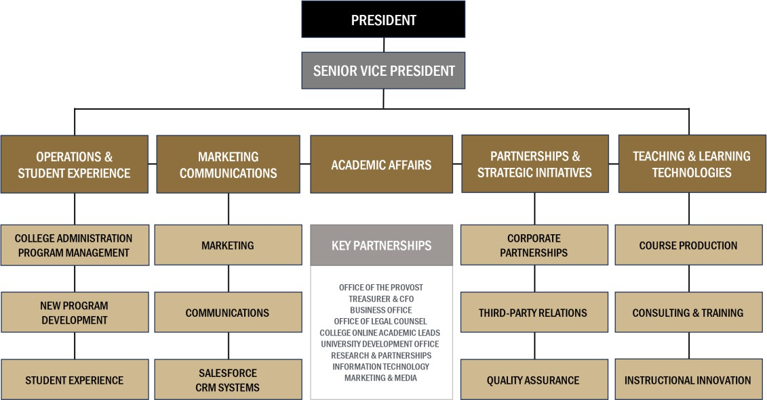

  - Purdue Global Leadership Structure (Organizational chart not available)

    - School of Business and Information Technology
    - School of Nursing
    - School of Multidisciplinary and Professional Studies
    - Purdue Global Law School
    - College of Social & Behavioral Sciences
    - School of Education
    - School of Health Sciences
  - Effective January 1, 2025 Chancellor Frank Dooley completed his term as chancellor and Jon Harbor was designated interim chancellor.

Information obtained from current administration at Purdue West Lafayette, Purdue University Online, and Purdue Global
The Ad Hoc committee met with senior leadership on 5.15.24. Attendance included: Eric Barker, Interim Vice Provost for Graduate Students and Postdoctoral Scholars; Frank Dooley, then Chancellor of Purdue Global; Dimitri Peroulis, Senior Vice President for Partnerships and Purdue University Online; and Jon Harbor, Senior Advisor to the Provost. The following talking points were addressed, and responses were summarized by the Ad Hoc committee:
How the administration of Purdue Global and Purdue University Online view their roles:
- Purdue Global offers accessible education. They are currently working with Guild, the Gardner Institute, and the Gates Foundation to increase the accessibility of a college education to working U.S. adults. Former Chancellor Dooley sees Purdue Global as one of the main components at the heart of Purdue University’s land grant mission.
- Purdue University West Lafayette offers residential and online graduate education opportunities to selective audiences, meaning generally not all applicants who meet minimum requirements are accepted. There is an admissions process used to select applicants.
- Having both Purdue Global and Purdue University Online has the potential to clearly distinguish Purdue from other institutions.

Additionally, the ad hoc committee met with Jon Harbor, interim chancellor on 1.10.25. The following is a summary of the meeting:
Dr. Harbor emphasized that Purdue Global is focused on the land grant education mission of the Purdue University system. He also indicated that the university is putting

in even more effort to identify opportunities to streamline processes and operations between Purdue Global, Purdue University Online, and Purdue West Lafayette. For example, Purdue’s Human Resources function as a vendor for benefits and retirement for Purdue Global.
Moreover, previous and current examples of collaboration between Purdue Global and Purdue West Lafayette academics were provided. In 2020, Purdue Global launched a Bachelor’s degree in Professional Flight, which was developed in collaboration with Purdue’s School of Aviation and Transportation Technology. In 2021, Krannert School of Management launched a Foundations of Quantitative Methods for Business course for the purpose of supporting new graduate students. This course was developed by Purdue Global’s faculty. In 2022, a partnership was established between PWL Graduate School and Purdue Global’s Law School to offer law courses, which count as electives in their Purdue degrees (to date seven West Lafayette students have participated). In 2023, Purdue Pharmacy and Purdue Global initiated a collaboration to support the Academic Model Providing Access to Healthcare (AMPATH) partnership in Kenya. As of today, a cohort of ten students from Kenya have graduated from the MPH program at Purdue Global, and a new group is participating in the same offering. Further, Dr.
Harbor stated that while Purdue Global does not have a research mission, Purdue Global could potentially be a productive site for research in online learning.
In support of Purdue Global’ s educational mission, the institution has secured external funding through the Gates Foundation. In March 2023, Purdue Global received
$480,000 to assess the current student experience and develop a comprehensive plan for growth and student success. In July 2024, the Gates Foundation provided $750,000 to support the plan through a series of interventions. Preliminary results will be available in June 2025.
Additional media about this funding is available at these sites:
- https://www.purdue.edu/newsroom/2023/Q2/purdue-global-looks-to-expand-education-opportunities-for-working-adults/
- https://www.gatesfoundation.org/about/committed-grants/2023/03/inv-053059
- https://www.purdue.edu/newsroom/2023/Q4/purdue-global-selected-by-gardner-institute-to-join-inaugural-cohort-of-transforming-the-foundational-postsecondary-experience/
- https://www.gatesfoundation.org/about/committed-grants/2024/07/inv-069466
The ad hoc committee also asked Dr. Harbor to address misconceptions and the view of overlap between Purdue Global and Purdue University’s residential and online graduate programs. It was reinforced that marketing done for the three different entities is meant to attract students rather than explain the nuances between the entities. It was also stated that while both Purdue Global and Purdue University West Lafayette have their own Board of Trustees, there are several trustees who serve on both boards (i.e., M. Berghoff, J. Brouillette, T. Carter, M., Dekryger, M., Klipsch).

Structure of Purdue Global and Purdue University Online Student Support
- Both Purdue Global and Purdue University Online have advisors and success coaches. Purdue Global’s advisors are contracted through Kaplan because Purdue only purchased the academic side of Kaplan. Purdue Global’s success coaches work within the Purdue Global academic structure, primarily supporting a subset of the Purdue Global student body that are more at-risk for attrition. Purdue University Online’s advisors and coaches are mostly Purdue staff. Purdue University Online is phasing out the advisors/coaches who are affiliated with Wiley/Risepoint and Kaplan as contracts expire.
Current interaction and relationship between Purdue Global and Purdue University Online on program development
- Research & Development Committee: This committee evaluates online program development in the Purdue System in two ways:
  - Proactively builds a framework for all the educational needs within an industry segment (data, manufacturing, business), maps existing programs, and highlights gaps. This committee identifies which gaps have enough market demand for a feasible new program and recommends to senior leadership at both Purdue University Online and Purdue Global which new programs should be offered at either entity based on the degree level and applicability to the university and its students.
  - Shares new program ideas under consideration by each entity and identifies any concerns or overlaps during the initial program development stages. If a potential for overlap exists, the team builds a framework and conducts market research to better understand the program and student demand. They then recommend to senior leadership at both Purdue University Online and Purdue Global a path to move forward in the space without creating overlap. This can include shared development, naming changes, curricular focus changes, or no concerns.
Research and Development Committee Members as of January 2025: TBD, Industry Partnerships, Office of Industry Partnerships
Maricel Lawrence, Innovation Catalyst for Purdue Global
Jennifer Lasater, Vice President for Student and Career Advancement for Purdue Global
Chris Martin, Executive Director for Student Operations and Student Experience, Purdue University Online

Marty Gustafson, Executive Director of Marketing and Communications, Purdue University Online

- Notices of Intent are sent by Purdue University Online to all departments regarding new program development among all entities.
- Graduate Council: a faculty-led body which reviews and ensures concerns are resolved.

Initial marketing discussions with senior administration
- Purdue Global:
  - Chancellor Dooley mentioned that there is not a common application system for working adults to identify educational opportunities, and this plays into the large marketing budget needs.
  - Purdue Athletics was chosen as a marketing avenue due to the large national coverage provided.
  - Local online marketing efforts are being diminished, but without clearing the browser cache, people will still see Purdue Global ads.
  - Prior to 2023, Kaplan led the marketing. Currently, the marketing strategy is led by Purdue Marketing and executed by Kaplan.
  - Southern New Hampshire University, University of Maryland Global Campus, and Arizona State University are some of the competitors for Purdue Global.
- Purdue University Online does market research to determine what programs are needed and could be self-sustaining. They investigate how to reach potential students for each program individually or in industry. Purdue University Online is also doing a brand campaign. Purdue West Lafayette’s online graduate program competition is discipline-specific. Indiana University, Georgia Tech, Johns Hopkins, Penn State, and University of Illinois are considered competitors for online graduate education. Purdue University Online lost the most admitted students to these competitors. Purdue Global remains a competitor for a small number of programs such as Education and Public Health (MHA, MPH) which are in very price-sensitive fields.
Comparison of programs across entities
Enrollment as of Spring 2024 among similar programs *details in link below

Program | PWL Residential | PWL Online | Purdue Global
MBA | 7 | 244 | 1533
MS in IT | 54 | 33 | 414
MHA | -- | 40 | 503
MPH | 30 | 77 | 212
MS Education- ABA | -- | 23 | 1156
MS Education- IDT | -- | 70 | 68
- IDATA report on student enrollment across similar/same programs

- Any current overlap between Purdue Global and Purdue University Online is with legacy programs. Purdue Global has a 30-year contract with Kaplan (ending 2048), and there are financial implications if Purdue Global closes these programs before the contract expires. While a non-compete agreement does not exist, there are processes in place to reduce the likelihood for future overlap.
- Based on Spring 2024 data:
  - Purdue West Lafayette residential graduate students tend to be younger (33% are age 20-24, and close to 80% are age 29 or younger) than online students at Purdue University Online and Purdue Global
    - Purdue West Lafayette residential graduate student average age:
27.2 Years (78% between 20-29)
    - Purdue University Online graduate student average age: 32.5 years (49% between 20-29)
    - Purdue Global graduate student average age: 37.3 Years (33% between 30-39; 28% between 20-29; 39% 40 or above)
  - Purdue West Lafayette residential graduate students are majority international
    - Purdue West Lafayette residential graduate students – 60%
International
    - Purdue University Online graduate students – 8% International
    - Purdue Global graduate students – 5.5% International
  - Purdue West Lafayette residential and Purdue University Online graduate students are majority male, whereas Purdue Global’ s students are over 70% female.
    - Purdue West Lafayette residential graduate students – 62% Male
    - Purdue University online graduate students – 62% Male
    - Purdue Global graduate students – 27% Male

Review of accreditation across programs*
*This table is not a complete list of every program offered, these are only the programs with accreditations.

University |  | Purdue Global |  | Purdue University West Lafayette
Modality |  | Online |  | Online | Residential
COLLEGE | Program
BUSINESS
 | MBA | Accreditation Council for Business Schools |  | Association to Advanced Collegiate | AACSB

 |  | and Programs (ACBSP) |  | Schools of Business (AACSB)  *Considered gold standard
 | MS Accounting | ACBSP |  | N/O =Not offered | AACSB
 | MS Finance | ACBSP |  | N/O | AACSB
 | MS Finance-Financial Planning | Certified Financial Planner |  | Certified Financial Planner (offered through MS in Consumer science)
 | MS Mgmt and Leadership | ACBSP |  | N/O | N/O
 | MS Mgmt and Leadership- HR | Society for HR Mgmt |  | AACSB | AACSB
 | MS Data Analytics | Not accredited |  | AACSB | AACSB
EDUCATION
 | MS Applied Behavior Analysis | Program completion prepares students to sit for the Board-Certified Behavior Analyst exam (via Pathway 2- will need additional course and field work). |  | Program completion prepares students to sit for the Board-Certified Behavior Analyst exam (via Pathway 1) | Program completion prepares students to sit for the Board-Certified Behavior Analyst exam (via Pathway 1)
 | MS Educational Studies – Educational Leadership and Policy Studies with licensure and  Building Level Administrator Licensure | N/O |  | National Policy Board for Education Administration Council for the Accreditation of Educator Preparation (CAEP) | National Policy Board for Education Administration

 | MS in Education | Not accredited (1) |  | N/O | N/O
Licensure Programs | English Language Learning  High Ability  Career and Technical Education Directorship  Transition to Teaching | N/O |  | CAEP | CAEP
 | MS Educational Studies – with Special Education initial and additional licensure for mild and intense intervention | N/O |  | CAEP | N/O
 | PhD-  Counseling | N/O (2) |  | N/O | American Psychological Association
 | PhD-  Educational Studies: Educational Leadership and Policy Studies Leads to Superintendent licensure | N/O |  | National Policy Board for Education Administration  CAEP | National Policy Board for Education Administration  CAEP
HEALTH/PUBLIC HEALTH
 | MPH | Not accredited (3) |  | Council on Education for Public Health (CEPH) | Council on Education for Public Health (CEPH)

 | MHA | Commission on Accreditation of Healthcare Administration Education  *Candidacy status |  | Commission on Accreditation of Healthcare Management Education (CAHME)  candidate | N/O
 | MS Health Informatics | Healthcare Information and Management Systems Society (4) |  | N/O | N/O
 | MS Homeland Security | International Fire Service Accreditation |  | N/O | N/O
 | MS  Occupational and Environmental Health | N/O |  | N/O | Applied and Natural Science Accreditation Commission
 | MS- Speech, Hearing, Language | N/O |  | N/O | American Speech-Language-Hearing Association
 | Audiology Doctorate | N/O |  | N/O | American Speech-Language-Hearing Association
 | MS-Medical Physics | N/O |  | N/O | Commission on Accreditation of Medical Physics Education Programs (CAMPEP)
 | PhD- Medical Physics | N/O |  | N/O | Commission on Accreditation of Medical Physics Education Programs (CAMPEP)

LAW
 | JD | California Bar (5) |  | N/O | N/O
 |  | Indiana Bar (6)
 |  | Connecticut Bar (7)
LIBERAL ARTS
 | MFA- Visual Performing Arts | N/O |  | N/O | National Association of Schools of Theatre
NURSING
 | MSN | Commission on Collegiate Nursing Education (CCNE) |  | N/O | Commission on Collegiate Nursing Education (CCNE)
 | DNP | CCNE |  | N/O | CCNE
PHARMACY
 | PharmD | N/O |  | N/O | Accreditation Council for Pharmacy Education
VETERINARY MEDICINE
 | DVM | N/O |  | N/O | American Veterinary Medical Association
N/O= Not offered Notes:
- The NPBEA is not a fit for the Purdue Global program. The Purdue Global programs do not focus on school system leaders (assistant principals, principals, superintendents). They also do not focus on educational policies and laws that guide licensure programs. Purdue Global MS Education focuses on developing classroom teachers and educators in areas such as classroom management, assessment, teaching practices, literacy, special needs, etc. Those in Purdue Global’s MSE-Ed Leadership program take two additional courses in leadership, but it really is for educators to gain those additional skills if they want to move into staff development, department leads, or curriculum development.

- APA only accredits doctoral programs.
- Students from this program can also sit for the same exam as CEPH-accredited grads. They would need a relevant graduate-level degree and at least three years of public health work experience.
- Purdue Global also offers an MHI with a Health Information Management concentration. The MHIM concentration of the MHI incorporates the Digital Health Leader (DHL) certificate into the core courses. The DHL is accredited by CAHIIM (Commission on Accreditation for Health Informatics and Information Management Education). If MHI students take one elective course, they will also qualify for the DHL. The MHI is an HIMSS (Healthcare Information and Management Systems Society) Approved Education Partner and HIMSS Academic Organizational Affiliate.
- 70% of Concord’s enrollments come from outside California. There are many reasons why students might select to participate in this program without passing the California bar. For example, in many jurisdictions, there are relaxed rules for in-house counsel, such that they may not need to be licensed in the state in which they are located. Another example is that some PG students plan to use their legal training to go into fields that don’t require a bar license at all, let alone an in-state license.
- Effective July 1, 2024, the Indiana Supreme Court amended its bar admission rules so that graduates of a non-ABA law school who are eligible to sit for the bar in another state upon graduation can petition the Indiana Board of Law Examiners for a waiver of the ABA educational requirement. This change was made as a direct result of PGLS’s advocacy. So far, all such waiver petitions have been granted.
- On October 4, 2024, the Connecticut Bar Examining Committee approved PGLS graduates who graduated in 2024 or later to sit for Connecticut’s bar exam immediately upon graduation, at least through 2027 (at which point PGLS will seek renewal).

Review of one-year retention rates
Purdue Global

SCHOOL | PROGRAM MODALITY | AY 2021-2022 | AY 2022-2023 | AY 2023-2024
Arts and Sciences | Online | 68% | 63% | 67%
Business | Online | 62% | 64% | 66%
Education | Online | 74% | 70% | 70%
Health Sciences | Online | 68% | 70% | 73%
Information Technology | Online | 69% | 67% | 63%
Legal Studies | Online | 58% | 64% | 67%
Nursing | Online | 71% | 74% | 77%
Public Safety (1) | Online | 60% | 59% | 54%
Notes:

  - AY (Academic Year): The period beginning July 1 and ending June 30 in the subsequent Calendar Year.
  - AY Cohort: Matriculated students are included in an AY cohort when they begin their enrollment in the enrollment AY, and their enrollment is the first at the Academic Degree level for the student at PG. Students in an academic year cohort may have previously attended another college or university prior to enrolling with Purdue Global.
  - (1) Public Safety programs have a large military, and first responders learners which requires stops and starts.
Purdue West Lafayette Residential

COLLEGE | PROGRAM MODALITY | Fall 2021 | Spring 2022 | Fall 2022 | Spring 2023 | Fall 2023
Agriculture | Residential | 89.6% | 93.8% | 95.5% | 100.0% | 100.0%
Business | Residential | 98.5% | 89.5% | 100.0% | 90.9% | 98.6%
College of Pharmacy | Residential | 0.0%
Education | Residential | 93.8% | 66.7% | 94.1% | 100.0% | 100.0%
Engineering | Residential | 96.6% | 92.6% | 97.8% | 97.8% | 98.4%
Health and Human Sciences | Residential | 100.0% | 100.0% | 95.4% | 66.7% | 98.3%
Joint and Special Programs | Residential | 91.7% |  | 80.0% |  | 100.0%
Liberal Arts | Residential | 100.0% | 100.0% | 91.2% | 0.0% | 96.0%
Polytechnic Institute | Residential | 93.5% | 88.5% | 97.6% | 100.0% | 95.3%
Science | Residential | 95.8% | 92.9% | 100.0% | 94.1% | 96.3%
Veterinary Medicine | Residential | 95.2% |  | 88.9% | 100.0% | 86.4%

Purdue University Online
Purdue University Online looks at “New to Purdue at the Graduate Level” when calculating retention. This means they only look at those students who are pursuing their first master’s degree at Purdue. If a student already earned a master’s degree from Purdue and is now working on their second, they are excluded. Students may begin at three different times during the year but are only put into two cohorts per year. Students who start in Summer or Fall are put into one cohort. Students who start in Spring are put into a separate cohort. One year later (either Fall or Spring depending on when the student first enrolled) they check to see if that student is either enrolled, graduated, or left with no degree. Retention is calculated as the % of the cohort that either is enrolled

in the following Fall or has since graduated divided by the total initial cohort. Example: 2 students start Summer 2022, and 8 students start in Fall 2022 = 10 students in this cohort. In Fall 2023, 1 student has already graduated, 8 students are enrolled, and 1 student is not enrolled. The 1-year retention is Retention = (1 + 8)/ 10 = 90%. Note: working professionals often need to take a semester off due to work or family demands, so we expect lower retention term to term.

COLLEGE | PROGRAM MODALITY | Fall 2021 | Spring 2022 | Fall 2022 | Spring 2023 | Fall 2023
Agriculture* | Hybrid | 29.8% | 88.9% | 100.0% |  | 90.9%
Agriculture** | Online |  |  |  |  | 0.0%
Business | Hybrid | 85.9% |  | 89.8% |  | 100.0%
Business | Online | 81.2% | 78.4% | 77.7% | 81.9% | 84.9%
Education | Hybrid | 75.0%
Education | Online | 86.7% | 82.6% | 86.3% | 87.2% | 79.5%
Engineering | Online | 76.8% | 80.5% | 79.4% | 77.6% | 79.0%
Health and Human Sciences | Hybrid | 100.0%
Health and Human Sciences | Online | 82.6% | 82.8% | 71.7% | 69.0% | 87.5%
Joint and Special Programs | Hybrid |  |  | 0.0%
Joint and Special Programs | Online | 88.9% | 80.0% | 70.0% | 50.0% | 75.0%
Liberal Arts | Online | 91.2% | 90.0% | 89.3% | 78.3% | 79.4%
Polytechnic Institute | Online | 72.6% | 80.4% | 78.7% | 78.3% | 79.7%
Science | Online | 100.0% | 83.3% | 85.7% | 50.0% | 71.9%
*Agriculture’s hybrid program retention appears low only because one of the programs has a special grant-funded opportunity for a large cohort only in particular years.
**Agriculture’s online retention rate is low in 2023 due to the launch of a new program that had only one student in that cohort and who needed to drop due to work commitments.

Role of instructional design and learning technologies in online education
The Ad Hoc committee met with Jason Fish, Executive Director of Teaching and Learning Technologies (TLT) for Purdue University Online; Cody Connor, Director of Instructional Design for Purdue University Online; and Judy Lewandowski, Vice Provost for Adult Teaching and Learning for Purdue Global on 7.11.24.
The committee sought to understand how the course design process worked for both Purdue University Online and Purdue Global. In addition, the committee sought to understand the services and tools available/needed to create effective online courses.
The course design process follows online education best practices at both institutions. At Purdue Global, the process is centralized and collaborative, where the subject matter expert works closely with the curriculum design and operations team to develop the course, providing consistency in course content as well as student experience. Once a course is designed, instructors teaching those courses are provided with the syllabus, content, and materials. Whereas Purdue University Online’s TLT will work with faculty to design course and program-specific pedagogical material.
These materials were provided by the Teaching, Learning, and Technology staff:
- Teaching and Learning Technologies presentation
- Course Design Process for Purdue Global
- Purdue Global Teaching and Learning Model White Paper
- Purdue Global Course Overview Video (approx. 6 min)--- This provides an overview of Purdue Global course layout
- Purdue Global Virtual Campus Tour Video (approx. 4 min)---This was designed for students to showcase the virtual resources.
The Ad Hoc committee met with Dave Nelson, Associate Director of the Center for Instructional Excellence on 11.26.24. The committee was referred to the Innovative Learning website for available tools and resources for residential and online education.
The Innovative Learning team is composed of members from the Center for Instructional Excellence, Libraries and the School of Information Studies, Purdue University Online, and Teaching and Learning Technologies. Currently, Innovative Learning is fully resourced to meet the needs of faculty teaching in online environments.
The following resources are available at Innovative Learning:
Online and Hybrid Resources: This site provides content aimed to increase Purdue instructors’ knowledge, skills, and abilities in both designing and delivering an effective online or hybrid course.
PoRTAL (Purdue Repository for Online Teaching and Learning): Topics include: instructor strategies, course enhancement, pedagogy, active learning, sample tools, and policies to help online instructors and online courses be engaging.

CoPILOT (Cohort Program for Innovation and Leadership in Online Teaching): CoPILOT is a semester-long, online instructor development program. The goal of CoPILOT is to enable Purdue University instructors to both develop and deliver high quality (asynchronous, accessible, active-learning) online courses in a scalable, collaborative, and community environment. Specifically, CoPILOT creates cohorts of Purdue faculty in which participants, both individually and collaboratively, enhance their understanding and ability to:
  - develop course outcomes and learning objectives;
  - design assessments and activities aligned to outcomes and objectives, appropriate for online delivery;
  - determine and design course content that incorporates research-based practices for online teaching into course design;
  - familiarize themselves with Purdue University Online functional areas; and
  - identify and determine best practices for online courses delivery.

Role of Office of Industry Partnerships
The Ad Hoc committee met with the Office of Industry Partnerships (OIP) on 9.13.24. OIP works with businesses, faculty, staff, and students to create mutually beneficial partnerships. Two offices of specific interest to this Ad Hoc committee are Educational Partnerships and Military Partnerships. When determining if an industry/employer should partner with Purdue University Online or Purdue Global, OIP shares Purdue’s capabilities at a high-level, listens to the customer’s needs, and then discusses with them how to fill their gaps in workforce development. Once OIP understands their needs, they share programs with the appropriate learning outcomes from across the portfolio. At the date of the meeting, 9.13.24, this was the structure of OIP:
  - Diana Hancock, Associate Vice President of Educational Partnerships who is charged with all Business to Business (B2B) sales and coordination for both Purdue Global and Purdue University Online. She manages both an internal team focused on business development as well as manages external third-party partnerships with Kaplan North America, Guild, and others.
  - Matthew Wagner, Senior Director of Educational Partnerships
  - Kelvin Gumbs, Executive Director of Military Educational and Strategic Partnerships. Kelvin manages the online education military strategy for both Purdue University Online and Purdue Global. His goal is to position the Purdue brand as the leading online university provider to advance career readiness and professional development of military servicemembers, veterans, and eligible dependents.
- OIP Education Partnerships Presentation

In January 2025, OIP was restructured, and most of the team is currently working under the leadership of Purdue Global's VP of Enrollment Management. Diana Hancock has since retired. Dimitrious Peroulis is the Senior Vice President for Partnerships and Online. Luna Lu is the Vice President for the Office of Industry Partnerships.

Financial aspects
Tuition discounts
Tuition discounts for Purdue Global:
Purdue Global supports Purdue West Lafayette faculty/staff and family members’ benefits through the Gift of Knowledge policy.
Tuition discounts for Purdue University Online:
Purdue West Lafayette’s online programs operate on a cost-reimbursement budget model, meaning costs are recovered, but profits are passed onto the units. Due to this cost-reimbursement model, for tuition discounts to be offered to faculty, staff, and families, money must come from the units, colleges, or central administration.
Tuition discounts for Purdue University West Lafayette:
Purdue employees, spouses, and dependents are eligible for fee remissions for eligible residential programs, although this excludes professional and online programs. These fee remissions are funded through fringe benefit rates.
The Ad Hoc committee met on October 9, 2024 with:
  - Eva Nodine, Vice President and Deputy CFO for Purdue University and Financial Officer and Chief Operating Officer for Purdue Global
  - Jason Dietz, Senior Director of Finance (emphasis area includes Purdue University Online)
The committee asked the following questions, and written responses were provided by Ms. Nodine and Mr. Dietz.
What are the current financial barriers that have thus far recommended against Purdue employee tuition discounts for Purdue University Online?
Purdue employee, spouse, and dependent fee remissions for currently eligible residential programs (excluding Purdue University Online and residential professional MS programs) are funded through a fringe benefit rate charged in the payroll process to the funding sources of employee salaries. The current rates for staff and other (spouse/dependent) fee remissions are 0.10% and 0.28%, respectively, of total salary

excluding student and temporary staff salary. The other fee remissions are not chargeable to federal funds.
  - Can an argument be made that tuition discounts for Purdue employees (not children) are an investment rather than a pure outflow?
There would be costs associated with an expanded staff fee remission benefit. There would be foregone revenue associated with a staff tuition discount. Of course, there may be benefits of supporting continuing education for employees, such as job effectiveness, promotability, and/or retention. However, the impact of the various tuition discounts on retention and promotion have not been studied at Purdue.
  - Would tuition discounts force higher course caps to allow space to “recover” lost income?
If Purdue University Online and/or residential professional MS programs were to be incorporated into the fee remission structure, then it is likely that costs would increase, and the fringe benefit rate charged to university payroll would need to increase accordingly. This would act as a budget reduction to each college/unit’s operating budget expenditures. To address the reduction, it is possible that some colleges might consider higher online course caps.

Is Purdue Global financially considered a separate ‘company’ or affiliated under Purdue’s incorporation?
Purdue Global is a separate entity, wholly owned by Purdue University.
  - Is Purdue Global meant to be self-sustaining?
Yes, and is self-supporting.
  - What is the financial health of Purdue Global and how is it attached to Purdue as a whole?
We are currently wrapping up our FY24 Audit with Plante Moran, and our liabilities are similar to prior years. Current liabilities are approximately 83% of all liabilities and are payables due to Kaplan (KNA) and other vendors at year end. Long-term liabilities consist of the accrued fee payable to KNA, which is capped based on the current Terms of Operating Standard Agreement (TOSA) approved by the Department of Education.
Purdue Global remains in good financial standing and has an increase in Net Position again in FY24. Since FY20, Purdue Global’s Net Position has increased approximately $12M. The only deficit incurred was in FY23 and was due to strategic investments in student success and academic initiatives.
NOTE: 2023 Financial Audit Summary and Full Report Available Online

Marketing of programs
The Ad Hoc committee met with Marty Gustafson, Executive Director of Marketing for Purdue University Online, on 7.11.24.
The following information was provided by Purdue University Online Marketing:
  - Purdue Global started with a huge focus on brand awareness- it was important for people to know who they were and that they are part of the Purdue portfolio. Now, they are starting to shift marketing towards programs and more tailored messages.
  - Purdue Global helps students with prior learning assessment, giving credit for past life experience. Schools need a special accreditation to do this at scale, and Purdue Global has this special accreditation and is efficient at processing it, which adult learners appreciate and is hard to do well—big strength for Purdue Global.
  - Purdue West Lafayette, which includes Purdue University Online, needs less brand awareness- people know who Purdue is and what they do.
  - Purdue University Online targets alumni, current West Lafayette residential students, and future leaders in their fields looking for a challenging program. Strategies to communicate with the West Lafayette campus include electronic messages in Purdue’s Union and emails from registrar (3 times a year). Dimitri Peroulis is communicating to Deans about Purdue University Online, and at least 1 Purdue University Online article goes into Purdue Today each week for faculty/staff awareness. Purdue University Online senior managing directors (“admin leads”) are embedded in each college to help with faculty/staff contacts.
  - President Chiang wants Purdue University Online to go from current 5k students to 12k and for Purdue Global to go from current 36k students to 100k. Veterinary Nursing Distance Learning associate’s degree program is Purdue University Online’s largest at 700+ students. Purdue Global’s largest program has thousands of students.
The committee asked the following questions, and written responses were provided by Ms. Gustafson:
How can communication be improved to help Purdue West Lafayette faculty, staff, students, and alumni understand and gain a better appreciation of the role of Purdue Global and Purdue University Online?
Purdue University Online Marketing’s primary focus is to speak to prospective students, so the majority of our work is external. We do have a separate communications strategy (see below) for sharing information on the President’s vision for online learning with campus (see https://www.purdue.edu/onlinelearning/).
Websites
  - Purdue University’s online programs can be found at purdue.edu/online.

  - Purdue’s Central Marketing and Communications team (Brand Studio) is currently working with a user experience design company to study the Purdue.edu website experience for graduate and online students. Online option are available under “Become a Student” https://www.purdue.edu/home/become-a-student/ but not under “academics” or “Majors.” Brand Studio updated the purdue.edu site in December to make more options for graduate and online learning visible. We hope their recommendations will lead more students to quickly find what they are looking for.
  - We have also recently terminated the single website that was developed as a part of the Kaplan purchase and establishment of Purdue University Online in 2018. This web portal listed all online programs across all campuses in the Purdue system but with little explanation, differentiation, or support for students to find the right campus and program for their educational needs. It created confusion for the market, and on June 30, 2024, President Chiang terminated the contract that required this site. Each campus in the Purdue system now maintains a separate website to serve its target students and showcases their own offerings. Separate websites make it much clearer to students which campus they are investigating and what it offers.

Communications Strategies
  - Purdue University and Purdue Global Brand Guidelines is provided for campus communicators (https://marcom.purdue.edu/our-brand/purdue-brand-guides/) to ensure everyone is using the same messaging on the President’s vision for Online Learning.
  - Significant effort was made by Purdue’s Central marketing team in 2021-23 to communicate the Purdue Global rebrand. This effort showcased Purdue Global as Purdue’s online campus for working adults and embraced it as part of the Purdue family. The prominent placement of Purdue Global in West Lafayette athletics and Purdue Today was intended to raise awareness on campus of Purdue Global as the entity serving working adults, primarily with degree completion programs. The origin video for this effort is here: https://youtu.be/a9_q1GoLAlw?si=-VyRR-vZdr7u8ynq .
  - Purdue University Online communicates regularly with faculty on a schedule set by the Provost’s Office:
    - Twice per term Faculty Newsletter from Purdue University Online, detailing faculty training opportunities, new online teaching tools, funding available from Purdue University Online, new program launches, student successes, and college online admin/academic lead contact information.
    - Purdue University Online Senior Vice President Dimitrios Peroulis meets twice per term with each Dean to discuss existing performance and new online opportunities.
    - Purdue University Online publishes a story/news article twice per week in Purdue Today.

For alumni, Purdue University Online runs the following with the support/oversight of Purdue for Life (PFL):
  - Up to four times year emails to alumni on Purdue University Online programs and student successes (sent by PFL)
  - Up to four times year placements in the PFL Lifelong Learning Newsletter (sent by PFL)
  - Link on the PFL Lifelong Learning website
  - In 2024, a new MOU with PFL provides Purdue University Online access to alumni profiles that can be targeted with social media Purdue University Online posts on various social media platforms.

For on-campus students, Purdue University Online communicates through:
  - Two term announcements in the enrollment management-driven newsletter to all students
  - Four Winds digital signs in select campus buildings/union
  - Printed signage in select campus buildings (Engineering, Liberal Arts, Young Hall)
  - Purdue University Online is a Grand Prix sponsor (signage, tent, website)
  - Purdue University Online is a graduation sponsor (program, digital advertising, tent)
  - Purdue University Online encourages program faculty and staff to connect directly with their undergraduates on continuing education online after graduation
For off-campus prospective students, Purdue University Online communicates through paid marketing efforts, including search engines (Google, Bing), social media (Meta, LinkedIn, Quora, Reddit), video (YouTube, Connected TV ads), industry association conferences and newsletters, along with email campaigns, in-person events and earned organic media.

Is there a common story that can be told about all Purdue affiliated programs? Or is it better to separate Purdue Global and Purdue University (residential and online) for the public?
Purdue’s land-grant mission drives all Purdue system schools to serve the students of our state and beyond with quality educational opportunities. This theme is shared in many of our materials across campuses and campaigns as our common purpose. This message is in the shared language across many of our press releases:
Purdue University is a public research institution demonstrating excellence at scale. Ranked among the top 10 public universities and with two colleges in the top four in the United States, Purdue discovers and disseminates knowledge with a quality and at a scale second to none. More than 105,000 students study at Purdue across modalities and locations, including nearly 50,000 in person on the West Lafayette campus.
Committed to affordability and accessibility, Purdue’s main campus has frozen tuition for 13 years in a row. See how Purdue never stops in the persistent pursuit of the next

giant leap — including its first comprehensive urban campus in Indianapolis, the new Mitchell E. Daniels, Jr. School of Business, the One Health initiative, and Purdue Computes — at https://www.purdue.edu/president/strategic-initiatives.
Purdue’s Origin Video: https://youtu.be/a9_q1GoLAlw?si=-VyRR-vZdr7u8ynq
Modified Origin Video for Purdue University Online: https://youtu.be/I0G8ly-qCuM?si=esqXOg_gCEjrAtOV
Each Purdue entity targets outreach to the students they best serve through individual marketing campaigns. These campaigns focus on sharing the needs and benefits of the program, location, or initiative that may be of most interest to a particular population.
Targeting these campaigns as closely as possible to the right audience helps the message stay relevant and drive appropriate action. This is why we speak separately to alumni, 16–18-year-old high school students, donors, working professionals or adult degree completers for example.
Sample Purdue University Online Video: https://youtu.be/qjZyCOujC10?si=R8Btl36SMXZapEbO
Some campaigns will be seen by multiple audiences, often when the goal of the campaign is to increase overall brand awareness. Generally speaking, lifting the brand has benefits for all entities in the system, as it makes Purdue’s name top-of-mind.
In 2022, during the launch and rebrand of the Purdue Global brand marketing campaign, there was much joint market research which resulted in two separate brand guidelines being developed.
How are these Purdue branded educational opportunities marketing course sizes and instructor contact, and how are the instructors of record supported in delivering the marketed promises?
Program level details are generally not included in marketing messaging for either Purdue University Online or Purdue Global. These are shared via website content that is approved by academic directors and departmental teams.
Purdue University Online does emphasize that graduate degrees and certificates earned online are from Purdue University, just like those earned in residence on the West Lafayette campus, with instruction from the same innovative campus faculty. The academics of all Purdue University Online programs are owned and managed by Purdue West Lafayette departments, and they are involved in review of marketing materials from Purdue University Online to ensure accuracy and consistency.

Q&A follow-up for Purdue University Online
After the initial fact-finding of the Ad Hoc committee, follow-up questions were posed to Purdue University Online. The responses are summarized by the Ad Hoc committee.

- Why is there a "firewall" between PUO and PWL programs? Why cannot students move back and forth between modalities as needed? For example, why cannot a student in the residential MPH program take classes from the online MPH program?
-There is a Graduate School policy around not mixing modalities. In spring 2023, conversations were held across campus regarding how this policy affects growth and revenue opportunities. Relevant offices include ISS, the Graduate School, Enrollment Management (Bursar, Registrar, Financial Aid).

-Visa requirements for international students and online course limits

-Pricing – Online programs are self-supporting and pricing is market based. Residential programs operate based on an incremental base budget model. An online program is only sustainable with revenue flowing as part of a self-supporting model. There is dedicated support for marketing, recruiting, student support, instruction, instructional support, and infrastructure that is unique to the online programs.

- Who writes the academic regulations for a degree in Purdue University Online?
The Purdue college/department determines academic regulations for both residential and online degrees. Online and residential programs go through the same approval processes, including Graduate Council, Board of Trustees, and Indiana Higher Education Commission.

- How does (or does not) teaching Purdue University Online courses impact the course load for Purdue West Lafayette residential faculty? Are these above and beyond the expected course load? Are these “overload”?
This is college/department specific. There is not a standard definition of load. The Purdue University Online financial model is flexible enough to allow for either in-load or overload compensation, as determined by the department head and dean for each program.

- Who are the academic and admin leads for each college? What do they do? When do you talk to them?
This was included on page 3 of Senior Vice President Peroulis’ Fall 2024 newsletter: PUO News for Faculty 10-16-2024.pdf or on the website at https://www.purdue.edu/online/leadership/.

You can consider your administrative lead as your single point of contact for all things online and professional education. They are your connection to the broader Purdue University Online team.
- Why has Engineering been so successful with online graduate programs? What lessons can other colleges learn from them?
Purdue’s reputation as a top 10 engineering school and leader in STEM education makes it a well-known and in-demand location for graduate school. From a marketing perspective, it means a large number of potential
students seek out Purdue or respond to our proactive advertising. The success of the programs in national rankings also provides exposure. They also offer broad in-demand degrees (Mechanical, Electrical, Civil, Interdisciplinary, etc.) and let students specialize through curricular options.

- Why do students choose Purdue University Online?
Purdue University Online’s Spring 2023 pre-coursework survey found:
  - 93% of students listed increased opportunities as their biggest motivator to become a learner
  - 91.7% also listed personal fulfillment as a motivating factor
  - 76.5% also listed increased salary as a motivating factor

Q&A follow-up for Purdue Global
After the initial fact-finding of the Ad Hoc committee, follow-up questions were posed to Purdue Global. The responses are summarized by the Ad Hoc committee.
Purdue Global fact sheet describes Purdue Global’s overall student population and our program outcomes.

- How does accreditation work for Purdue University Online and Purdue Global?
Purdue University and Purdue Global are separately accredited by the Higher Learning Commission (HLC).

- Why is there a "firewall" between Purdue Global and Purdue West Lafayette programs?
Purdue Global and Purdue West Lafayette are two separate universities, just like any other two entities. A student must apply to each university separately and use transfer credit policies to apply credits from one to the other. This separation into two different universities was a requirement for accreditation by HLC as well.

Ad Hoc Committee Recommendations
Based on the fact-finding and discussions the Ad Hoc Committee has completed over the past year; we propose the following recommendations and specific strategies:
Recommendation 1) Continue to clarify and market the differences between Purdue University’s online programs and Purdue Global:
RATIONALE: The committee recognizes that Purdue Global and Purdue University Online programs support different demographics and student types. However, it is evident from talking with our colleagues, both within and outside of the Purdue system, that the differences between Purdue University’s online programs and Purdue Global are not clear to them. In addition, many hiring employers also do not know the differences between these two online entities. Further, some online opportunities at Purdue University are a lesser-known entity compared to Purdue Global which limits the potential for further growth. The University should be investing additional resources into marketing Purdue University’s online programs. However, marketing costs, including the university-wide brand campaign, are passed onto the Colleges, which contributes to Purdue University Online services becoming cost-prohibitive for smaller online programs.
Strategies:
- Provide information about Purdue University Online and Purdue Global at all new university-level faculty and staff orientations.
- Increase the marketing capacity and resources of Purdue University Online, without passing these costs to the colleges/units.
  - Stop passing the expense of the Purdue University Online Brand Campaign onto the Colleges.
  - Consider specific/additional Purdue University Online marketing resources for programs which also exist within Purdue Global
    - Master of Health Administration, College of Health and Human Sciences
    - Master of Public Health, College of Health and Human Sciences
    - Master of Business Administration, Daniels School of Business
    - Master of Science in Information Technology, Polytechnic
    - Master of Science in Educational Studies (MSED): Applied Behavior Analysis, College of Education
    - Master of Science in Educational Studies (MSED): Learning Design and Technology, College of Education

- Change the tag line for Purdue Global, which currently states, “Purdue Global, Purdue’s online university for working adults” TO “Purdue Global, the Purdue system’s online university for working adults”
- Purdue Global, Purdue University Online, and Purdue West Lafayette marketing should revise/update their strategic plan to more clearly distinguish the differences between these entities.
- To ensure a comprehensive understanding of online offerings, future work should include the regional campuses.

Recommendation 2) Revise marketing strategies which combine messaging about Purdue University West Lafayette with overall Purdue System messaging:
RATIONALE: Popular press and ranking systems have confused/mixed-up Purdue Global and the Purdue West Lafayette campus (i.e., Newsweek 2022 article, Forbes best online colleges for military article). Purdue press releases include this messaging at the end: “Purdue University is a public research institution demonstrating excellence at scale. Ranked among top 10 public universities and with two colleges in the top four in the United States, Purdue discovers and disseminates knowledge with a quality and at a scale second to none. More than 105,000 students study at Purdue across modalities and locations, including nearly 50,000 in person on the West Lafayette campus. Committed to affordability and accessibility, Purdue’s main campus has frozen tuition 13 years in a row. See how Purdue never stops in the persistent pursuit of the next giant leap — including its first comprehensive urban campus in Indianapolis, the Mitch Daniels School of Business, Purdue Computes, and the One Health initiative.”
Given that Purdue Global is considered a separate entity under separate accreditations, messaging from Purdue West Lafayette should be revised to maintain the focus on Purdue West Lafayette.
Strategy:
- Revise the press release statements to only include statements and data regarding Purdue University West Lafayette.

- Add a specific statement on press releases mentioning Purdue University’s online programs and certificates.

Recommendation 3) Streamline processes and interfaces between Purdue West Lafayette residential and Purdue University online programs.
RATIONALE: There is confusion among Purdue West Lafayette faculty, staff, and students regarding how Purdue West Lafayette residential interfaces with Purdue University Online. Given that both the residential and online programs are under the West Lafayette campus, there should be more integration of processes. Purdue

University Online offers courses that would be desirable to residential graduate students. Further, Purdue West Lafayette faculty and staff would be interested in attending Purdue University Online programs if tuition assistance was available.
Strategies:
  - Strategize how to offset tuition costs for faculty/staff to attend Purdue University Online.
  - Clearly articulate and review options for standardizing how colleges/departments calculate Purdue University Online courses into faculty compensation and/or teaching loads.
  - Reduce the financial and administrative barriers to allow access to courses between Purdue West Lafayette residential and online For example, explore options for Purdue West Lafayette residential students to enroll in Masters of Science in Artificial Intelligence and Masters of Science in Data Science core courses.

Recommendation 4) Ensure all faculty have access to AND utilize best practices in online education to maintain rigorous online courses.
RATIONALE: The Senate survey revealed that many faculty believe online courses are not as rigorous as residential instruction. Further, many faculty, staff, and graduate students are not aware of the University resources available to facilitate best practices in online education.
Strategies:
- Unit leaders should encourage faculty and staff to apply for CoPILOT: Cohort Program for Innovation and Leadership in Online Training to facilitate development of accessible online courses using research-based online course pedagogy.
- Purdue University administration will allocate additional resources to the CoPILOT program to allow more faculty and staff to be able to enroll in this program.
- Faculty, staff, and graduate students creating or teaching in an online environment should consult with the Center for Instructional Excellence and Teaching & Learning Technologies.
- Dedicate a specific section for online education resources in each Teaching and Learning Updates email from the Senior Vice Provost for Teaching and Learning
- The University should prioritize more faculty and staff working with the course production team to enhance and develop online courses and go through the Quality Matters-correlated Course Design Evaluation Rubric upon creation and then every three years. Release time for participation should be considered.

Appendix 1: University Senate Survey circulated April 2024
In April 2024, the Ad Hoc committee created and disseminated an online survey seeking input from University Senators regarding graduate programs across Purdue West Lafayette, Purdue University Online, and Purdue Global. The following are the questions asked with a summary of themes identified in the 265 responses.
Abbreviations:
PG= Purdue Global
PUO= Purdue University Online PWL= Purdue West Lafayette campus OIP= Office of Industry Partnerships
What opportunities/synergies do you see for Purdue West Lafayette's residential and online graduate programs and Purdue Global's online graduate programs?
- Consider more certificate or non-degree programs
- Consider wider degree offerings
  - Early childhood education
  - Addiction specialist
  - Master’s in social work
  - Nursing
  - Digital forestry
- Provision of flexibility for students and staff
- Could develop more interdisciplinary networking among graduate students
- Prefer to put distance between PWL/PUO and PG instead of synergies
- PG is viewed as a competition which makes synergy hard/impossible
- PG should not offer graduate online education
- Where overlap exists, there could be opportunities to avoid
  - Differentiate programs with specialties
  - Offer a certificate at one location and a full degree program at the other
  - Have one program feed into the other
What do you see as the inherent strengths and weakness of graduate program offerings through Purdue Global, Purdue West Lafayette residential, and Purdue West Lafayette online?
STRENGTHS:
- Academic rigor of PWL
- PWL has strong faculty
- PWL provides numerous opportunities and meaningful connections for students

- PG is flexible
- PG provides accessibility for non-traditional students
- PG is career focused
- PUO has academic rigor and strong faculty WEAKNESSES:
- Public (and many students/faculty/staff) cannot distinguish between PWL, PUO, and PG
- Competition between institutions
- Lack of consistency between institutions
- Lack of clear governance/administration across institutions
- PG tarnishes Purdue’s reputation
- PG has less rigorous programs
- Credits do not transfer (easily)
- Land grant university should not have a for-profit entity
- PUO financial model does not work for all programs, especially smaller programs
Is there anything else you would like to share regarding graduate programs at Purdue Global and/or Purdue West Lafayette (residential and/or online) that would inform the committee's work?
- Need to better distinguish between entities
- Students need to clearly identify which institution they went to, diplomas are too similar
- The financial models are not clear
What questions would you like the Ad Hoc Committee to look into regarding Purdue Global's online graduate program and Purdue West Lafayette's residential and online graduate programs?
- What is the funding model for faculty and instructors?
- Transparency on financial health of entities
- How could credits transfer?
- What are the graduation rates?
- Where do students work after graduation?
- How can prospective students distinguish between accredited and non-accredited PG programs?
- Clear faculty and instructor profiles/qualifications of PG

Appendix 2: Committee member bios
Libby Richards, Committee Chair, Purdue West Lafayette, School of Nursing
Libby Richards, PhD, RN, is a professor at Purdue University’s School of Nursing. She received her PhD in public health promotion from Purdue University, her MSN in community health nursing from Indiana University, and her BSN from University of Saint Francis in Fort Wayne, IN. She is the Director of the PhD program in the School of Nursing. In addition, she is a faculty associate for Purdue’s Center for Aging and the Life Course and a faculty partner for Purdue’s Center for Families. Her research explores individual and interpersonal influences of physical activity. She is currently the co-chair for the Ageing Special Interest Group for the International Society of Behavioral Nutrition and Physical Activity and the past chair and founding member of the Physical Activity Section of the American Public Health Association.
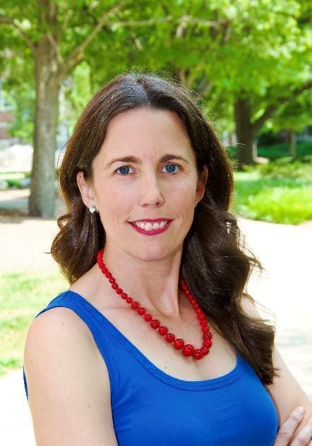

Dr. Richards’ research informs health promotion interventions that positively impact community health by improving physical activity across populations. As a public health nurse, Dr. Richards widely disseminates health education about the importance of vaccinations, flu prevention, and physical activity promotion. She has reached audiences through print sources such as The Wall Street Journal, the Washington Post, the Chicago Tribune, Newsweek, AARP, and Readers’ Digest. Her online presence has wide public reach with articles regarding the importance of vaccination and physical activity promotion in The Conversation surpassing over 2 million readers.

Brian Leung, University Senate Immediate Past Chair, Purdue West Lafayette, English

Brian is the Immediate Past Chair of the University Senate and the convener of this ad hoc committee. He is a Professor in the Department of English, and the author of several novels. His forthcoming fiction collection, A Terrifying Brush with Optimism, will be published in spring, 2024. He joined Purdue University in 2014. Prior to joining Purdue, he worked with the


U.S. Department of State Institute on Contemporary
U.S. Literature where, in his final year, he served as Principal Investigator and Director. He is a recipient of the University of Louisville's President’s Award for Outstanding Scholarship, Research, and Creative Activity, and a College of Arts and Sciences Outstanding Research and Creative Activity Award at
that same institution. Currently, he serves as Director of Creative Writing at Purdue

University. A native of California, he received his M.F.A. in Creative Writing from Indiana University. He has teaching experience in fiction, creative nonfiction, poetry, drama, literary genre, and special topics in contemporary American literature. His writing interests include writing within difference and diversity including concerns surrounding race, class, gender, and sexuality.

Susan South, University Senate Chair, Purdue West Lafayette, Psychological Sciences
Dr. South received her undergraduate degree in psychology and graduate degrees (M.A., Ph.D.) in clinical psychology from the University of Virginia. She completed her clinical psychology internship at the Medical University of South Carolina. After a postdoctoral fellowship at the University of Minnesota, Susan came to Purdue for her first faculty position. Susan South began her academic career at Purdue University in 2008. She was promoted to Associate Professor in 2014 and Full Professor in 2021. She currently serves as the Director of Clinical Training for the doctoral program in clinical psychology. She is the vice-chair of the Purdue University Senate. Past service includes serving on and chairing several search committees and chairing the College of Health and Human Sciences Faculty Affairs Committee.


Susan is an internationally recognized researcher who
investigates the links between romantic relationship functioning, personality, and psychopathology. She has published over 100 peer-reviewed empirical publications on the assessment of relationship satisfaction, the links between mental illness and relationship distress, gene-environment interplay between relationship distress and mental illness, and gender differences in personality. Her current, NIH-funded researcher examines the links between interpersonal relationships and mild cognitive impairment.

Maricel Lawrence, Representative of Purdue Global, Innovation Catalyst
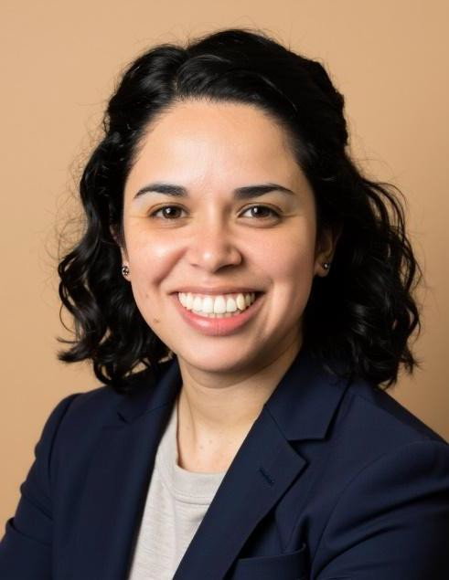

Maricel Lawrence, EdD, is the Innovation Catalyst at Purdue Global, where she plays a key role in shaping the future of education and work. She earned her Doctor of Education in Leadership & Innovation from Arizona State University, her master's in adult education and training from Colorado State University, and her bachelor's degree in Spanish from Indiana University. Maricel's career in higher education began at Purdue University, where she contributed to the development and launch of online courses and programs.
Before joining Purdue Global, she served as the executive director of UMOnline at the University of Montana, where she worked closely with the university's colleges to identify growth opportunities based on learner needs, workforce demands, and industry trends.

Dr. Lawrence is actively involved in research focused on integrating futures capacities within higher education institutions. Her interest in strategic foresight began during her time at the University of Montana, where she engaged in foresight practices to envision the university's future. In 2021, she further pursued her passion for strategic foresight by establishing a strategic foresight team at Purdue Global, collaborating with practitioners and researchers worldwide to shape a visionary path forward.
https://www.linkedin.com/in/maricel-lawrence-05181721/

Ellen Gundlach, Representative of Purdue University Online,
Senior Managing Director for One Health Online and Professional Education, Colleges of Agriculture | Health & Human Sciences | Pharmacy | Veterinary Medicine
Ellen has a M.S. in Physical Chemistry from The Ohio State University, with a Master of Public Health (Health Statistics concentration) and a Graduate Certificate in Applied Statistics from Purdue University. She taught in the Purdue Departments of Mathematics and Statistics. She is a member of the Teaching Academy, a former associate editor of the Journal of Statistics and Data Science Education, and an IMPACT participant. Her awards include the UPCEA Midwest Regional Excellence in (Online) Teaching, Indiana Council for Continuing Education’s Course of the Year, and the American Statistical Association’s Journal of Statistics Education Best Paper for research comparing the effectiveness of residential, online, and hybrid modalities of a coordinated


course. She was the inaugural Managing Director of The Data Mine and then became the Senior Managing Director (“admin lead”) for Purdue University Online for the online education portfolios for the Colleges of Agriculture and Veterinary Medicine 2021 and adding the Colleges of Liberal Arts and Science in August 2023. In September 2024 she became the Senior Managing Director for One Health Online and Professional Education. https://www.linkedin.com/in/ellen-gundlach-9ba42943/
Eric P Kvam, Representative of the University Senate Educational Policy Committee, Materials Engineering


Eric P Kvam is a long-standing member of the faculty in Materials Engineering. He is acting as a correspondent for, and is past chair of, the Senate’s Educational Policy Committee. He has taught twenty different courses in Materials Engineering and one in Archaeology, and served on several other committees at department, college, and university levels. His undergraduate work was at Iowa State, graduate degrees from the Massachusetts Institute of Technology, and held postdoctoral positions at University of Liverpool and Lawrence Berkeley National Laboratory before arriving at Purdue.

Ajay Malshe Representative of the University Senate Faculty Affairs Committee, Mechanical Engineering (Spring 2024 involvement only)
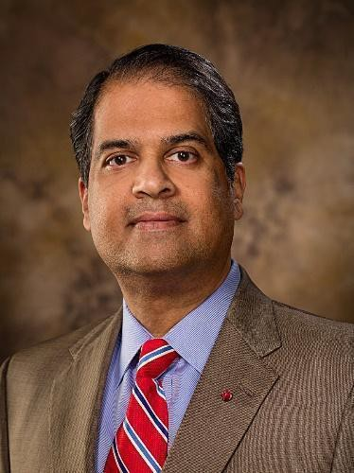

Ajay joined Purdue in 2020. He is the R. Eugene and Susie E. Gordon Distinguished Professor of Mechanical Engineering and currently serves as a Purdue University President’s Fellow. Aja co-directs the eXcellence in Manufacturing and Operations Purdue Engineering Initiative (XMO PEI). He has gained a national and international reputation in academia, entrepreneurship and industries for advanced manufacturing, bio-inspired designing, functional multi-materials, and system integration and productization. Over the decades, application areas of his interest and contributions have included heterogeneous microelectronics for high-density systems;
nanomanufacturing for extreme machines; in-space servicing, assembly and manufacturing (ISAM) at the point of need; and biomanufacturing for future foods and farms for equity.

ADMINISTRATIVE OPERATIONS OVERVIEW
Michael B. Cline, senior vice president
02/17/25



ADMINISTRATIVE OPERATIONS
LEADERSHIP TEAM

ADMINISTRATIVE OPERATIONS IS COMPRISED OF THE FOLLOWING SIX UNITS:

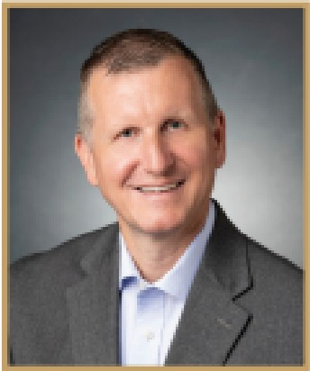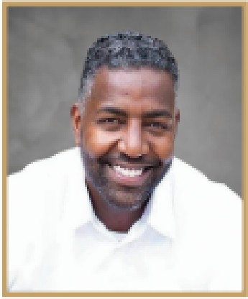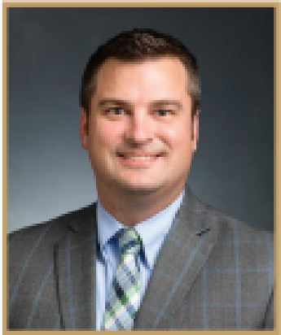

SERVICES
ADMINISTRATIVE

AUXILIARY SERVICES
FACILITIES OPERATIONS
AND ENVIRONMENTAL
HEALTH AND SAFETY
PHYSICAL FACILITIES
AND PUBLIC SAFETY
PURDUE UNIVERSITY
INDIANAPOLIS
REAL ESTATE AND SPACE
ADMINISTRATION

Kim Pearson, Associate Vice President and Chief of Staff
- Executive Office Operations
- Communications.
- Facilities Information Services
- Integrated Analytics
- Talent Development and Acquisition
Jessica Robertson, Associate Vice President
- Airport Operations and Commercial Air Service
- Materials Management and Distribution
- Parking Operations
- Procurement Services
- Purdue Memorial Union and Conferences Operations
- Purdue Travel
Ryan Gallagher, Associate Vice President
- Building Services
- Energy and Utilities
- Environmental Health and Safety
- Grounds
- Operations and Maintenance
- Sustainability
Jay Wasson, Vice President and Chief Public Safety Officer
- Campus Planning and Architecture
- Capital Asset Management
- Emergency Preparedness and Planning
- Purdue University Fire Department
- Purdue University Police Department
Evan Hawkins, Senior Director
- Planning and Programming
- Service Delivery and Operat,ions
- Community Engagement
Nathan Manges, Senior Director
- Real Estate and Space Inventory Management
- Property Purchases, Sales and Leases
- Space Requests, Utilization and Tracking
- Occupancy Planning

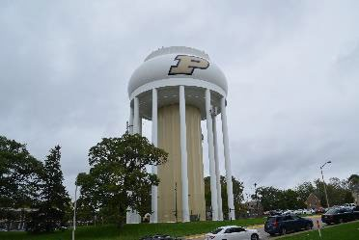
We Power Purdue
ENERGY AND UTILITIES

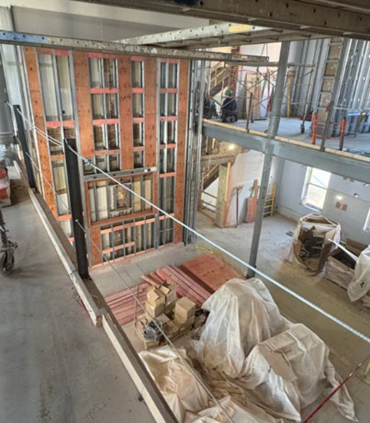


RETAIL DINING

UNIVERSITY HALL
PUBLIC SAFETY


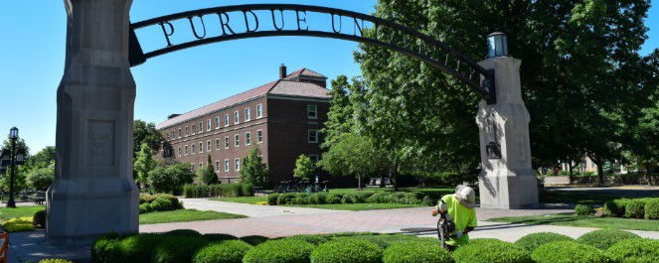
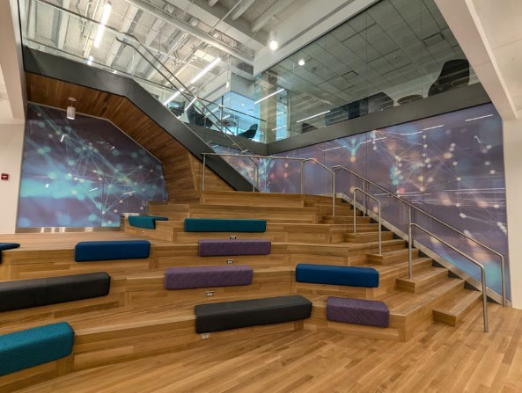

3
GROUNDS

DATA SCIENCE AND AI

UNION CLUB HOTEL

We Power Purdue
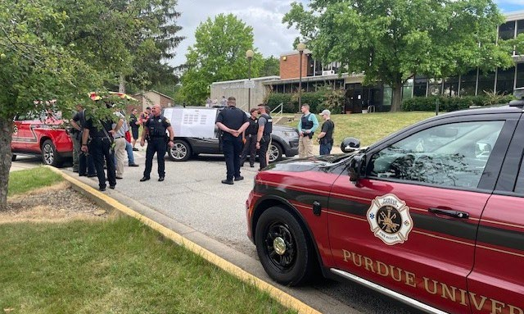
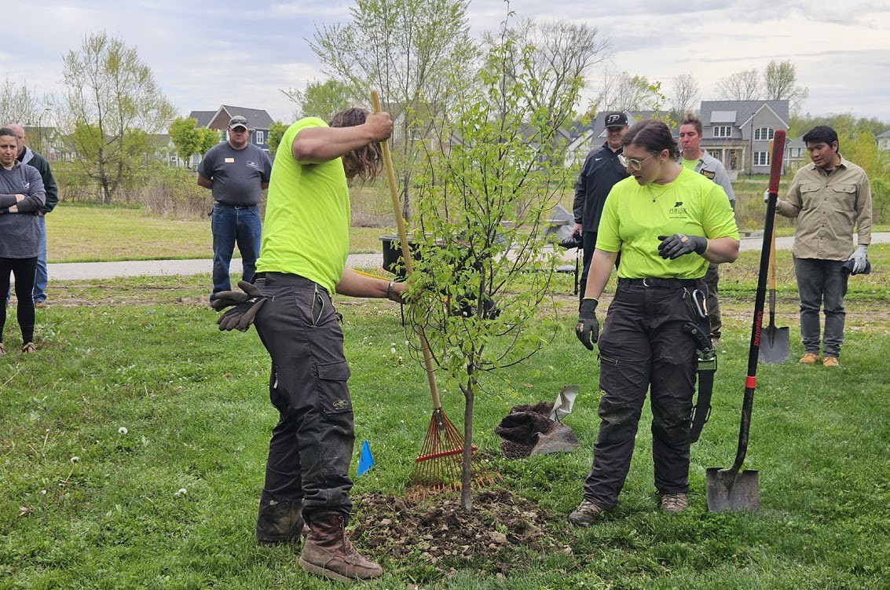


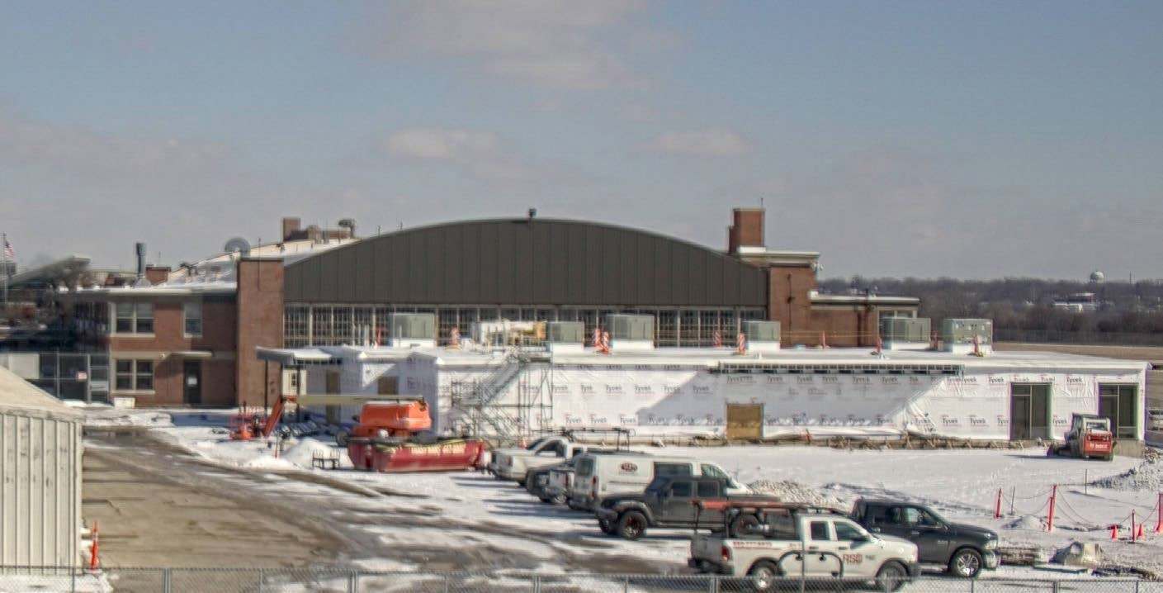
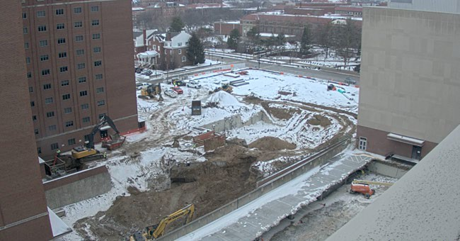

PUPD AND PUFD

TREE PLANTING
PUPD
SNOW REMOVAL
AMELIA EARHART TERMINAL
DANIELS SCHOOL OF BUSINESS

AO Initiatives
Driving performance in alignment with Purdue’s strategic initiatives

PLACE
We plan, construct, and operate a top-tier campus environment providing the necessities that enable Purdue to meet its academic, research and service missions.

OPERATIONAL PROCESSES
We develop, maintain, and improve processes and data utilization to better our operational performance, maintain student affordability and reduce enterprise risk.
- WELCOMING + SAFE
We provide a hospitable, safe, and secure campus experience that includes amenities tailored to the needs of our customers.

ENERGY
We deliver reliable and affordable utility services to Purdue while pursuing innovative technologies for long-term clean energy solutions.
- RECRUIT + RETAIN
We provide a culture that attracts, develops, and retains a quality workforce.

Academic Success Building


Presenter Notes
2025-02-14 18:18:18
--------------------------------------------
Confirm if rendering will be updated before 2/6 to shower larger ‘P’ on the building? If there is a rendering for construction fencing, add to appendix
Scope
- A new 248,000 GSF student-focused hub near West and Michigan Streets. Includes classrooms, teaching labs, 500 beds, and a 400-seat dining area that will engage prospective students and the community.
Budget
- $187M
  - Non-Fee Replaced Debt – Aux Housing Dining & University Reserves:
$105M
  - Capital Cash State Appropriation: $60M
  - Gift Funds: $22M
Schedule
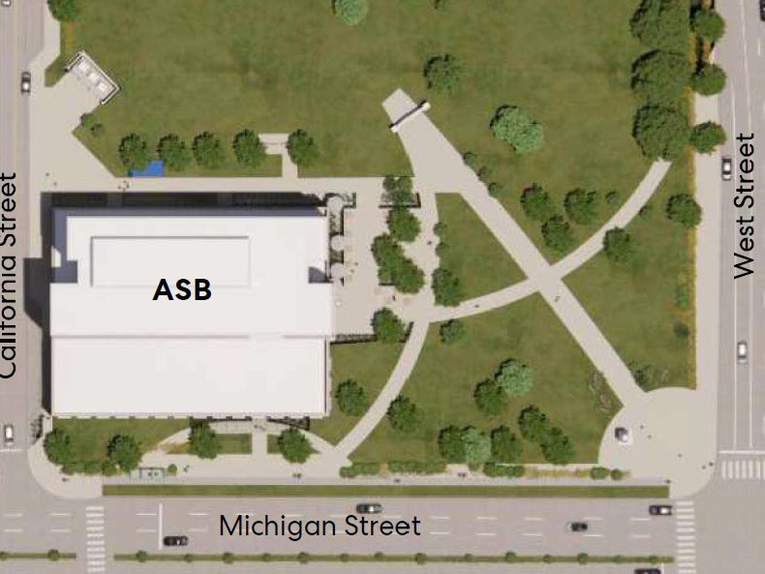

GROUNDBREAKING EVENT
- April 2, 2025
- Coordinated by Purdue for Life
- High visibility Purdue project branding
- Board of Trustees Approval June 7, 2024
- Construction Start April 2025
- Construction Complete May 2027
- Occupancy July 2027
AE: Browning Day/Perkins & Will CM: Shiel Sexton
AO Project Manager: Rick Emery

Sustainability
Recent Achievements
Current Activities
- Working with Institute for a Sustainable Future on campus sustainability self assessment
- Developing 2030 AO Sustainability Plan
#5 in the Big Ten, #12 in the U.S and #74 globally for sustainability in higher education
(2025 QS World University Ranking)
Indiana Office of Energy Development Small Modular Reactor Study
- Study concluded that SMRs present a viable opportunity for Indiana to transition to a cleaner, resilient and diversified energy future.

GHG Emissions Reduction (FY11-24)

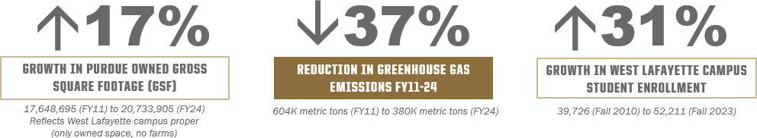

Small Modular Reactor
Advances in understanding around SMR and advanced reactor technologies

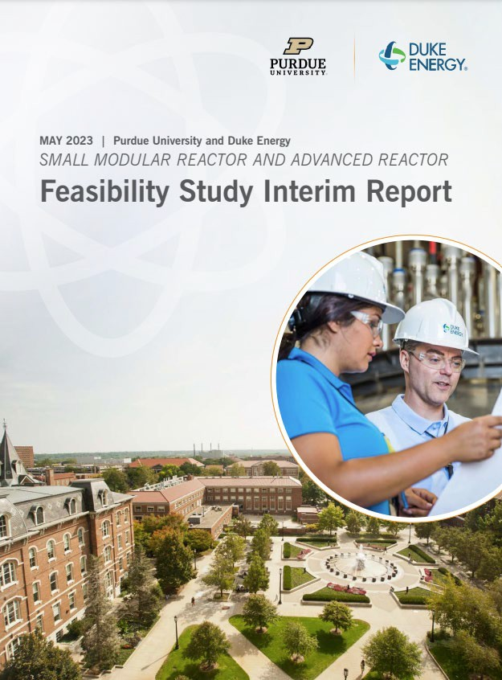

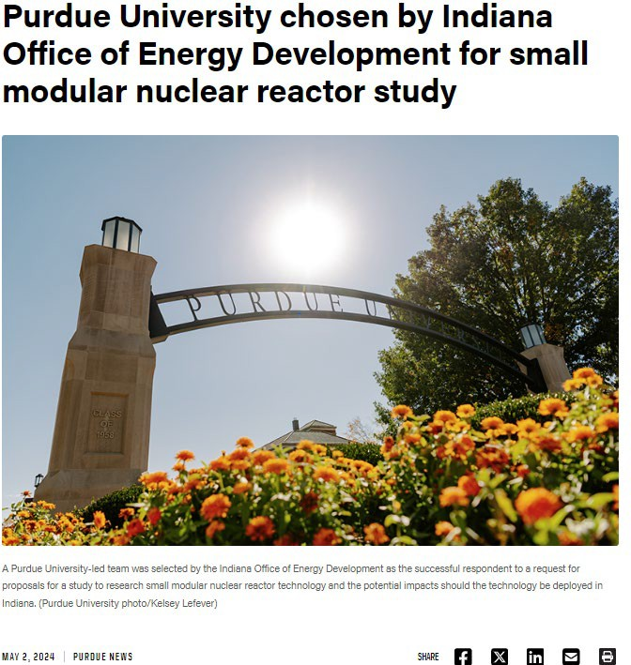

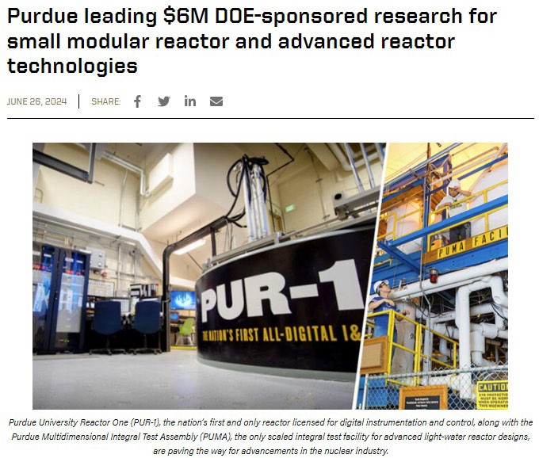

Committee Votes:
To: | The University Senate
From: | Senate Nominating Committee
Subject: | Nominees for Vice Chairperson of the University Senate
Reference: | Bylaws, Section 3.20b, c
Disposition: | Election by the University Senate
Proposal: | The Nominating Committee proposes the following slate to serve as candidates for Vice Chairperson of the University Senate during the academic year 2025-2026:  Julio Ramirez, Civil Engineering TBD  Please see the following pages for their biographical statements.

Senate Document 24-09
17 February 2025

For: | Against: | Abstained: | Absent:
Dulcy Abraham Seema Mattoo Byung-Cheol Min Abdelfattah Nour Mohit Tawarmalani  Christina Wilson-Frank |  |  | Sabine Brunswicker Damon Lisch Sebastian Murgueitio  Ramirez

Julio A. Ramirez, Ph.D. Dist. M. ASCE Karl H. Kettelhut Professor in Civil Engineering
NHERI-NCO Center Director
Lyles School of Civil and Construction Engineering

Dr. Julio A. Ramirez was appointed to the faculty at Purdue University with the rank of Assistant Professor in 1985 and promoted to the rank of Full Professor in 1996. In 2018 he was appointed as Karl H. Kettelhut Professor of Civil Engineering in the Lyles School of Civil and Construction Engineering to this date. During more than 30 years as Purdue University professor, he has served in a variety of school, college, and university-level committees, including the University Senate.

Dr. Ramirez is a full voting member of the technical Joint Committees of the American Concrete Institute (ACI) and the American Society of Civil Engineers (ASCE) 445- Shear and Torsion; and Committee 408- Bond and Development of Reinforcement and has been invited to serve as a full voting member of the ACI 318 Building Code Committee. This is the standard that regulates all structural concrete building design and construction in the United States. Since 2016, he has been the Principal Investigator and Center Director of the Network Coordination Office (NCO) of the NSF funded Natural Hazards Engineering Research Infrastructure (NHERI). Previously he served as the chief officer for the NSF funded large-scale research infrastructure George E. Brown Jr. Network for Earthquake Engineering Simulation (NEES) from October 2009 to September 2015. On July 29, 2014, while serving as the Chief Officer of NEES, Prof. Ramirez testified before Congress as it debated reauthorizing legislation to reinstate federal research funding devoted to mitigating earthquake damage to the nation's infrastructure.

He has served as an Associate Editor for the Committee on Concrete and Masonry Structures (CCMS) Division of the American Society of Civil Engineers (ASCE) Structural Journal and has been a member of several National Cooperative Highway Research Program (NCHRP) research panels. Prof. Ramirez has served in NSF proposal review panels for several directorates. In 2017 Dr. Ramirez was inducted to the Purdue Innovator Hall of Fame.

In 2021 he was elected Distinguished Member of the American Society of Civil Engineers. Prof. Ramirez is a Fellow of the American Concrete Institute and the recipient of the 2000 Delmar Bloem Award and the 2006 Joe W. Kelly Award of the American Concrete Institute. Currently, Dr. Ramirez serves a two-year term on the Advisory Committee on Structural Safety of Department of Veteran Affairs Facilities providing advice to the Secretary of Veterans Affairs on matters of structural safety and remodeling of VA facilities.

Senate Document 24-10

17 February 2025

To: | The University Senate
From: | University Senate Nominating Committee
Subject: | Nominees for Advisors to the Senate
Reference: | Bylaws of the University Senate
Disposition: | Election by the University Senate
Proposal: | The Nominating Committee proposes the following slate of nominees for service on the Senate. The Advisors selected are to serve for three-year terms as specified in the Senate Bylaws. The terms will begin on 1 June 2025 and end 31 May 2028.  - Eric Adams, MaPSAC*  - Heather Beasley, Senior Director of Operations, Office of the Vice Provost for Student Life  - Michael Cline, Senior Vice President for Administrative Operations  - Melissa Franks, Director of Graduate Studies  - Cherise Hall, Vice Provost for Enrollment Management  - Sheila Hurt, University Registrar  - Lowell Kane, LGBTQ Center Director  - Carl Krieger, Director of Residential Life  - Lisa Mauer, Associate Vice Provost for Faculty Affairs  - Beth McCuskey, Vice Provost for Student Life  - Sunil Prabhakar, Vice Provost for Faculty Affairs  - Jenna Rickus, Vice Provost for Teaching and Learning  - Jurgen Rochin-Gomez, CSSAC**  - Alysa Rollock, Vice President for Ethics and Compliance  - Katherine Sermersheim, Dean of Students

Senate Advisors not assigned to committees:
Cherise Hall (Vice Provost for Enrollment Management) Katherine Sermersheim (Dean of Students)
MaPSAC Chair (see below)

* MaPSAC representatives serve one-year terms (the Vice-Chair serves on the Senate Advisory Committee and the Chair serves on the Senate)
** CSSAC representatives serve one-year terms

Committee Votes:

For: | Against: | Abstained: | Absent:
Dulcy Abraham Damon Lisch Seema Mattoo Byung-Cheol Min Abdelfattah Nour
Sebastian Murgueitio Ramirez
Mohit Tawarmalani Christina Wilson-
Frank

Senate Document 24-11

17 February 2025

To: | The University Senate
From: | University Senate Nominating Committee
Subject: | Nominees for Advisors to the Senate Standing Committees
Reference: | Bylaws of the University Senate
Disposition: | Election by the University Senate
Proposal: | On the recommendations from the Chairs of the University Senate Standing Committees, the Nominating Committee proposes the following slate of nominees for service on the Senate Standing Committees listed below. The Advisors selected are to serve for three-year terms as specified in the Senate Bylaws. The terms will begin on 1 June 2025 and end 31 May 2028.  - Advisory Committee  - Jurgen Rochin-Gomez, CSSAC*  - TBD, MaPSAC**  - University Senate Educational Policy Committee  - Jeff Elliott, Executive Director, Undergraduate Advising***  - Sheila Hurt, University Registrar  - Jenna Rickus, Vice Provost for Teaching and Learning  - Jeff Stefancic, Associate Dean of Students***  - University Senate Equity, Diversity, and Inclusion Committee  - Lisa Mauer, Associate Vice Provost for Faculty Affairs  - Lowell Kane, LGBTQ Center Director  - Alysa Rollock, Vice President for Ethics and Compliance  - University Senate Faculty Affairs Committee  - Sunil Prabhakar, Vice Provost for Faculty Affairs  - Lisa Mauer, Associate Vice Provost for Faculty Affairs  - University Senate Student Affairs Committee  - Heather Beasley, Senior Director of Operations, (Office of Vice Provost for Student Life)  - Beth McCuskey, Vice Provost for Student Life  - Melissa Franks, Director of Graduate Studies  - University Senate Resources Policy Committee  - Kim Pearson, Office of the Vice President for Administrative Operations***  - Carl Krieger, Director of Residential Life

* CSSAC Advisor serves a one-year term
** MaPSAC representatives serve one-year terms (the Vice-Chair serves on the Senate Advisory Committee and the Chair serves on the Senate)
*** Committee advisor, but not Advisor to Senate

Committee Votes:

For: | Against: | Abstained: | Absent:
Dulcy Abraham Damon Lisch Seema Mattoo Byung-Cheol Min Abdelfattah Nour
Sebastian Murgueitio Ramirez
Mohit Tawarmalani Christina Wilson-
Frank

Updates on Campus Sustainability Self-Study Project
Michael Johnston, University Senate Sustainability Committee
Lynne Dahmen, Senior Managing Director, Institute for a Sustainable Future
2/17/2025



Motivation

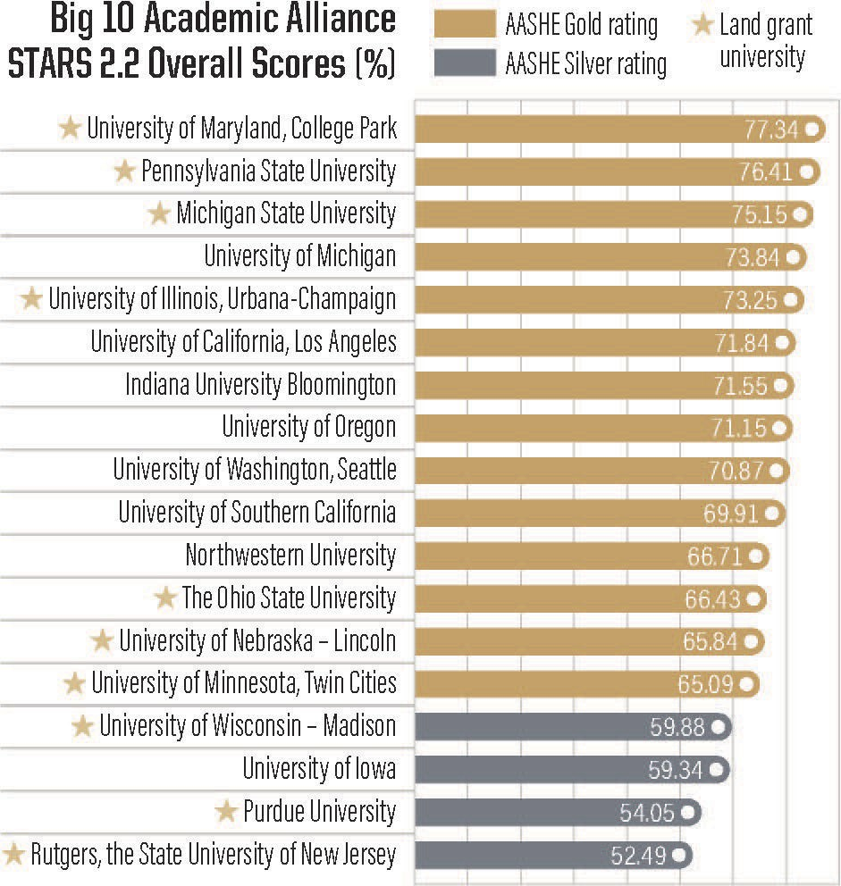
- Improve ranking among peers;
- Explore opportunities and challenges;
- Address campus concerns.
- Research campus performance.

Sustainability Working Group


Core group: 13 representatives from various faculty, student, and staff groups
  - Meet regularly
  - Assess progress
  - Assign and accomplish tasks
  - Sub-committees:
    - Faculty/sustainability education
    - Student/sustainable living guide/events
    - Staff/survey & training contents

SWG Webpage

Academic year 2024 - 2025

Obj. 1
Obj. 2
Obj. 3
Obj. 4
Obj. 5
Obj. 6



Establish a core Sustainability Working Group
Campus Sustainability Self-Study
Define protocols to collect and analyze data related to AASHE STARS 3.0
categories
Conduct a sustainability literacy and culture (SLAC) assessment
Promote awareness of efforts and opportunities
Conduct cost-benefit analysis of recommendations and research funding opportunities
Draft a 5-year roadmap


Parts of the Project


Large Outputs/Divisions:
- Purdue’s STARS Performance Assessment (SPA)
- Campus Sustainability Self-Study (CASS)


Additional “Along the Way” Outputs
  - Surveys & datasets
  - Events/activities for sustainable education
  - Updated course listing for students
  - Sustainable Living Guide
  - Presentation for new hires
  - “Getting to Gold” short report

Goals of SPA

Purdue’s STAR Performance Assessment
- What do we well?
- How do we compare to peers?
- What information is not being captured?


- What are the ‘low hanging fruit’
for rapid improvement?

Understanding AASHE’S Structure

Category | Subcategory
Academics (AC) | Curriculum, Research
Engagement (EN) | Campus Engagement, Public Engagement
Operations (OP) | Buildings & Grounds, Energy & Climate, Food & Dining, Procurement & Waste, Transportation
Planning & Administration (PA) | Coordination & Planning, Investment Social Equity, Wellbeing & Work
Innovation & Leadership

Sustainability Education

Academics (curriculum): biggest gap and potential to increase Purdue score

Student focused

- Identify courses and programs
students attend
  - Identify additional courses or modules and programs students
are interested in
  - Provide resources to identify offerings at Purdue more easily
Faculty focused

- Support faculty to integrate sustainability in the curriculum
- Develop a plan and a community
tailored to faculty need and interest
- Facilitate interdisciplinary
connections and partnerships

Sustainability Education Events

Let's Talk Sustainability Education at Purdue

January 23, 2025
K-12 Teaching of Sustainability aligned with Indiana Academic Standards in Science
Dr. Lynn Bryan (Purdue)

February 27, 2025
One-day workshop about teaching sustainability with keynote speaker Dr. Rebecca Watts Hull
(Georgia Tech) Presentations by faculty Workshop breakouts March 24, 2025

Goal: Familiarize faculty with concepts related to teaching sustainability and enable development of a plan supported by their interest.

Sustainability Literacy and Culture Assessment

Assess current state of campus sustainability behavior and knowledge at Purdue; establish a template to track progress over time

- Undergraduate students (February 2025)
  - Focus: knowledge and behavior
  - Goal: Identify strengths and gaps in students’ understanding to inform curriculum development and student engagement strategies; inform current sustainability efforts on campus

- Faculty, staff and graduate students (March/April 2025)
  - Focus: behavior
  - Goal: Understand perceptions, values, and practices to guide cultural initiatives on campus

Core working group
Presenter Notes
2025-02-17 20:50:38
--------------------------------------------

Member name | Member title | Department
Valentina Negri | Research Scientist | ISF
Lynne Dahmen | Senior Managing Director | ISF
Kayla Gurganus | PhD candidate | Poli Sci
Anthony Gillund | Director of Sustainability | AO
Patrick Brown | Sustainability Manager | AO
Michael Johnston | Professor | English
Lindsey Payne | Assistant Professor of Practice | EEE
Jonathon G. Day | Associate Professor | Hospitality and Tourism Management
Amanda Taylor | Executive Assistant to the Head | Statistics
Kuang Xin | PhD candidate | Energy Development and Sustainability
Marley White | Undergraduate Student | Natural Resources and Environmental Science (NRES) and Political Science
Sophia Maria D'Isabella | Undergraduate Student | Pharmacy
Olivia Williams | Undergraduate Student | Agriculture Economics (BS) and Spanish (BA)

Thank you!
Contact: Lynne Dahmen
ldahmen@purdue.edu

