Separation of Mixtures and Density
Teacher Notes

 | STUDENT HANDOUT/MATERIALS | TIPS FOR USE and/or ANSWER KEYS
PRE-UNIT QUIZ | ICP.separation.pre.test  Student handout:  ICP.separation.pre.student.answer.sheet.(doc) | Key:  ICP.separation.pre.key
MIXTURE CARDS - “macroscopic solutions” | White envelope  Student handout:  card_sort_activity_page.(doc or pdf) | Key:  Card_sort_activity_page_key.(doc or pdf)
MIXTURE CARDS -  atom/molecule diagram cards | White envelope  Student handout:  card_sort_molecular_level.(doc or pdf) | Key:  card_sort_molecular_level_key.(doc or pdf)
SEPARATION -  containers with simple mixtures | 12 samples in a single container  Student handout:  Classification Activity.(doc or pdf) | Key:  Classification Activity.(doc or pdf)
ACTIVITY  The Recycling Factory | Student Handout:  The Recycling Factory Lab.doc | Materials: Plastic, salt, sand, and nuts/bolts in a box to make the mixture. Other supplies - magnet, filter paper, and tweezers also in a box. Please return materials to baggies and notify Science Express if sodium chloride is needed.
DENSITY LAB | Density Lab - Sugar Content of Common Beverages.doc | SEE TEACHER PAGE (first page in file) TO MAKE SUGAR SOLUTIONS
ELECTROLYSIS DEMO | Hoffman Apparatus | Flinn directions included  Materials:  Ring stand, two clamps, and a 9 V battery.
FINAL ASSESSMENT | File Available | File Available

Indiana State Standards
Teacher Notes (Indiana 2016)

ICP.6.1 Distinguish between elements, mixtures, and compounds based on their composition and bonds and be able to construct or sketch particle models to represent them
ICP.6.2 Develop graphical and mathematical representations to show that mixtures can be made in any proportion and separated based on properties of the components of the mixture and apply those representations to quantitatively determine the ratio of components.
ICP.6.3 Cite evidence that supports the idea that some pure substances are combined of elements in a definite ratio, as for example seen in the electrolysis of water.
ICP.6.4 Given the periodic table, determine the atomic mass, atomic number, and charges for any element.
ICP.6.5 Given a periodic table, understand and describe the significance of column location for elements by calculation of molar ratios of known compounds.
ICP.6.6 Develop graphical and mathematical representations that describe the relationship between volume and mass of an object, describe the slope in terms of the object’s density, and apply those representations to qualitatively and quantitatively determine the mass or volume of any object.
ICP.6.7 Describe how both density and molecular structure are applicable in distinguishing the properties of gases from those of liquids and solids.

Science Express – Separation of Mixtures PRE-TEST

1. Look at the eight pictures shown. Check the box by the four images that float on water.
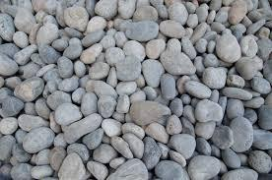 |  | 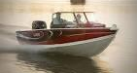 | 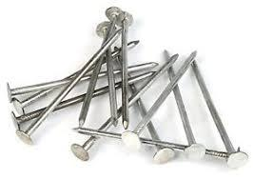

2. The density of an object is found by dividing the mass of an object by its volume. What is the density of a metal sample that had a mass of 400 g block of metal that has a volume of 50 cubic centimeters?
2000 g/cm³ | 800 g/cm³ | 8 g/cm³ | 0.125 g/cm³

3. Check the box by the substances that are elements.
oxygen | copper | water | potassium | salt | sugar

4. The word “homogeneous” is defined as a substance that is the same throughout a sample. Select the two types of substances that would always be homogeneous.
an element | a compound | a mixture

5. The word "heterogeneous" is defined as a substance that is different throughout a sample. Which of the following beverages is a heterogeneous substance?
a cup of tea

a glass of milk

a glass of orange juice with no pulp

a glass of carbonated soda with ice and a straw

6. Mixtures can be classified as either homogeneous or heterogeneous. Which of the following mixture descriptions indicate that the sample is heterogeneous.
The air in our environment that is made up of nitrogen and oxygen.

A piece of jewelry that is made up of silver and gold.

A pan of salt water on the stove BEFORE you add the pasta.

An ice cream sundae with whipped cream, nuts, and a cherry.

7. Which of the following treats would you describe as a homogeneous treat?
chocolate chip cookie | sugar cookie | Hershey’s chocolate bar | Reese’s peanut butter cup | Snickers Bar

8. You accidentally spill a box of nails from your workbench into a pile of sawdust on the floor. Which of the following would be the best way to pick up the nails quickly?
Use a pair of tweezers to gather the nails.

Use a magnet to gather the nails.

Use scotch tape to gather the nails.

Use a leaf blower to try to move just the sawdust and leave the nails.

9. You are given a mixture of sand, sugar, and water. You use a coffee filter to separate the sand, so now you have the sugar and water. If you boil the mixture, the sugar
would stay dissolved in the water when it turns to steam.

end up as a crystalline solid after the water boiled off.

cannot be separated from the water.

10. Water is a sample of a compound. It can be chemically decomposed using electricity. The products of the decomposition would be
the elements hydrogen and oxygen.

water and air.

different each time the experiment was run.

Classifying Matter Flowchart

Use this flowchart to help you classify an unknown sample of matter.
Unknown Sample of Matter

Heterogeneous
(does it look different)?
Homogeneous
(does it look the same)?

Heterogeneous
Mixture
Homogeneous

EX: concrete; river water; Caesar salad
One substance?
More than one substance?

OR

Called a “solution” or “homogeneous mixture”
EX: salt water; sports drinks; cool-aid

Multiple substances
Single substance

More than one element?
One element?

OR

Compound
Element

Look for a formula with symbols
EX: water (H₂O); table salt (NaCl); rust (Fe₂O₃)
Look for symbols on the periodic table
EX: oxygen gas; helium, iron

These are called “pure substances”

Classifying Matter Flowchart

Use this flowchart to help you classify an unknown sample of matter.

Unknown Sample of Matter

c

Can it be separated “physically”?
EX: tweezers, filter, distillation, etc.
NO
YES

Pure Substance
Mixture

Uniform Composition?
(does it look the same)?
NO
NO
Can it be chemically decomposed?
EX: electricity; acid
YES
YES

Homogeneous Mixture
(also called a “solution”)
EX: salt water, sports drinks; cool-aid

Heterogeneous Mixture
EX: concrete; river water; Caesar salad

Element
EX: O₂; He; Fe
Compound
EX: H₂O; NaCl; Fe₂O₃

Classification of Matter Activity

We classify matter into several categories such as elements, mixtures, compounds, etc. In column 1, write the definition from your textbook. In column 2, rewrite the definition in your own words. Simplify the definition. In column 3 draw a picture or graphic that will help you remember each of the terms.

Chapter Definition | Your Definition | Graphic Reminder
Substance:

Mixture:
Element:
Compound:
Heterogeneous Mixture:
Homogeneous Mixture:

On the lab tables you will see 12 different samples of matter that need to be classified. Your job is to classify each of the 12 samples of matter. First decide whether each type of matter is a “pure substance” or a “mixture” in column 1. If you decide “substance” then in column two you decide between “compound/element” in column 2. If you decide “mixture” in column 1, then you choose between “homogeneous/heterogeneous” in column 2. BE CAREFUL TO NOT MIX-UP THE OPTIONS! When you have decided, be sure you explain your choices in column 3.

 | Substance or Mixture | Compound/Element or Homogeneous/Heterogeneous | Explain your choices!
#1
#2
#3
#4
#5
#6
#7
#8
#9
#10
#11
#12

The Recycling Factory Activity

Suppose you are the new owner of the Indiana Recycling Factory and you are looking for business.

The Governor has just arrived with a dump truck full of recyclable materials that must be separated and they will give your company a lifetime contract if you can do it. Unfortunately, the job was made more difficult by the fact that someone has ground all of the materials into small pieces, making it impossible to separate all of them by hand.

Fortunately, the Governor knows what the materials in the truck are, as well as some of their properties:

Material | Soluble in water | Magnetic | Color
Steel nuts/bolts | No | Yes | Shiny gray
Plastic pieces | No | No | Off-White
Salt | Yes | No | White
Sand | No | No | Light brown

As a group, write up a procedure for separating all of the materials so they can either be recycled or reused. Be sure you pay attention to what order you do things in as some of your tools CAN’T get wet.

Fill in the boxes on the back of this page with your ideas.

We will then go through each group’s procedure and decide as a whole class which procedure we will try out to see if it works, meaning we would win the recycling contract.

Materials Available for Use:
Water
Tweezers/forceps
Filter paper
Magnetic wand
Strainer
Matches
Distillation Apparatus

Materials We Will Use:

Order We Will Use Materials:

Why We Chose Our Materials/Order:

Density Lab
TEACHER’S PAGE
Standard Sugar Solutions:

Students will make a graph with the following sugar solutions prepared in advance. Each lab group, needs 1 mL of each solution. The directions are written to make approximately 100 mL of each solution.

PART A
SAMPLE | MASS OF SUGAR  (g) | MASS OF WATER  (g)
0%  sugar  (no color) | 0 | 100
5%  sugar  (yellow) | 5.26 | 100
10% sugar  (blue) | 11.11 | 100
15% sugar  (green) | 17.65 | 100
20% sugar  (purple) | 25.00 | 100

Beverages to evaluate:
Have four or five beverage samples (1 mL per lab group) including soda (diet and regular), fruit juice (grape, orange (no pulp), apple), energy drink, sports drink, etc. Students can bring in samples that they may be curious about the sugar content. If a sample is carbonated, let it become “flat” before weighing.

Density Lab
Sugar Content of Common Beverages
PRE-LAB QUESTIONS: Circle what you think is the correct answer.
- Which of the following items would float on water?
  - inflated pool raft
  - ping-pong ball
  - basketball
  - baseball
  - beach ball

- Which of the following is the best explanation of why the items selected in #1 float?
  - An item will float on water if it is in the shape of a sphere (ball).
  - An item will float on water if it is used in athletic contests.
  - An item will float on water if its density is less than the density of water.
  - An item will float on water if it is white.
  - None of the items in #1 will float on water.

- Density, measured in grams per cubic centimeter,$\left(\frac{g}{{cm}^{3}}\right)$, calculated with the equation
$density = \frac{mass}{volume}$

An aluminum block with a mass of 54 g has a volume of 20 cm³. What is the density of aluminum in g/cm³ ?
a. 0.37 g/cm³ b. 2.7 g/cm³ c. 27 g/cm³ d. 37 g/cm³ e. 270 g/cm³

- A sample of cooking oil has a mass of 19.4 g and a volume of 20.8 cm³. What is the density of cooking oil in g/cm³?
a. 0.271 g/cm³ b. 0.933 g/cm³ c. 1.07 g/cm³ d. 9.33 g/cm³ e. 10.7 g/cm³

- The density of water is 1.00 g/cm³. Which of the substances in the two previous samples will float on water?
  - only the cooking oil
  - only the aluminum block
  - both the cooking oil and the aluminum block
  - neither the aluminum block nor the cooking oil

PROCEDURE AND DATA:

PART A:
- Turn on the balance and make sure that it is zeroed.
- Place the disposable cup on your balance and press the zero (or tare) button.
- Using a graduated pipette, obtain 1 cm³ of water and place it in the cup. Record the mass of 1 cm³ of water in the data table below.
- Repeat step 3 for each of the samples of sugar water rinsing the pipette with water between each sample.
- Since each sample was 1 cm³, the density is equal to the mass for each sample
(density in g/cm³ = mass in grams / 1.00 cm³). Using the graph grid on the next page, plot the points for the five samples.
- Using a straight-edge, draw a best-fit line through your data points.

PART A |  |  |  | PART B
SAMPLE | MASS  (g) | DENSITY$\left(\frac{g}{{cm}^{3}}\right)$ |  | BEVERAGE  SAMPLE | MASS  (g) | DENSITY  $$\left(\frac{g}{{cm}^{3}}\right)$$ | PERCENT  SUGAR
0%  sugar  (no color) |  |  |  | 1
5%  sugar  (yellow) |  |  |  | 2
10% sugar  (blue) |  |  |  | 3
15% sugar  (green) |  |  |  | 4
20% sugar  (purple) |  |  |  | 5

PART B:
- List the beverages that will be tested in the data table above.
- Predict the sugar content in these beverages by ranking them from the one with the lowest sugar content to the one with the highest sugar content.

lowest sugar content |  |  |  | highest sugar content

- Repeat step 3 from Part A for each of the beverages recording the mass of 1.00 cm³ in the above data table.
- For each of the beverages, add a data point to the graph and record the percent sugar.

GRAPH:
Label the x-axis as Percent Sugar (%) ranging from 0 to 20% and the y-axis Density $\left(\frac{g}{{cm}^{3}}\right)$. Use scales that fill the graph completely. Include a key to identify data points on the graph. Draw a best fit straight line through the data points using a ruler.

Density as a Function of Percent Sugar

ANALYSIS:
- Complete the chart below by finding the percent sugar using your graph. For each beverage tested, go from the vertical axis at that beverage’s density to the right until you hit the line. From that point, go down to the horizontal axis to determine the sugar content. Record your percent sugar values in the final column of the Part B data table.

lowest sugar content |  |  |  | highest sugar content

- Compare your predictions with your results. Explain any differences between your prediction and the data. Did you put the beverages in the correct order before you tested them? What may have caused you to place things in a different order than how they tested?

- Review your data and comment on the following assumption made to complete this lab:

The difference in the density of a beverage is directly related to the percent of sugar in the beverage.

CONCLUSION:

Name ____________________________ Period _____
Assessment – Separation of Mixtures (each answer blank is 1 point – 35 points total)
Vocabulary Matching
____1. A mixture in which there are differences in the composition throughout the  substance (jello with fruit). |  | a) elements
____2. A mixture with a uniform composition throughout (jello). |  | b) compound
____3. There are 118 of these found on the periodic table. |  | c) homogeneous
____4. A combination of elements that can only be separated by chemical reactions. |  | d) heterogeneous
____5. A combination of substances that can be separated without changing the identity  of any of the components. |  | e) mixture
____6. A sample that contains a single element or a single compound. |  | f) pure substance

____7. Select the list which contains only elements.
a) copper, carbon, water, and dust
b) sodium, chlorine, air, and lead
c) hydrogen, copper, oxygen, and neon
d) aluminum, helium, wood, and mercury
____8. A silver chloride precipitate forms when silver nitrate and sodium chloride are mixed. How would the precipitate be recovered?
a) filter the products and dry the filter paper to recover the solid
b) remove the solid from the container with an eye dropper and then dry it
c) use a magnet to separate the product components
d) It is not possible to separate the products.

____9. Electrolysis is a process that will separate a compound into its elemental components. Water samples are gathered from the classroom sink, a local stream, a bottled-water from the vending machine. Each of these samples is separated into hydrogen and oxygen using electrolysis.
a) The water sample from the stream would have more oxygen because that sample has been open to the air.
b) All three water samples would produce hydrogen and oxygen in a 2:1 mole ratio.
c) The bottled-water would give the best results because that water was purchased.
d) The water from the sink would not separate into hydrogen and oxygen.

____10. Which of the following substances is not a compound?
a) air (approximately 20% oxygen and 80% nitrogen) b) water (11% hydrogen and 89% oxygen)
c) table salt d) carbon dioxide

____11. Which of the following is a homogenous mixture?
a) a sample of chlorinated pool water b) chocolate chip cookies
c) tossed salad d) ice cream sundae with hot fudge, nuts, and a cherry

____12. A chef has a sample of cooking oil that he thinks is olive oil. The density of olive oil is 0.91 - 0.93 g/mL. You measure the mass of 1.0 mL to be 0.85 g. Do you think the sample is oil olive?

a) Yes, the densities are the same, so the substances are the same.
b) No, the sample density is 0.85 g/mL which does not match olive oil.
c) Yes, the density of the sample is lower than olive oil’s density.
d) No, density cannot be used to check if the sample is olive oil.

____13. The mass and volume of five samples of plastic were measured in lab. The data was used to make the graph shown. Using the provided graph, calculate the density of the plastic in g/cm³?
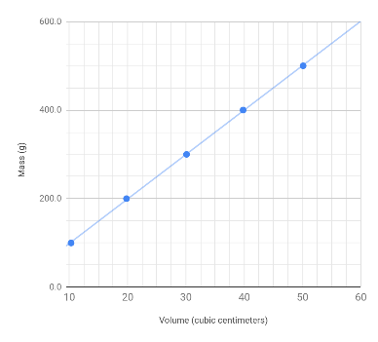
a) 100 g/cm³ b) 50 g/cm³ c) 20 g/cm³ d) 10 g/cm³

Use this space to show your calculation for the density of the plastic:

14. (14 points) You will make TWO X’s in each row. Select “pure substance” or “mixture” by placing an “X” in one of the first two grayed columns. Then, classify each substance as an element, a compound, a homogeneous mixture, or a heterogeneous by placing an “X” in one of the four columns to the right (no fill color). An example is completed for you.

Substance | Pure Substance | Mixture |  | Element | Compound | Homogeneous Mixture | Heterogeneous Mixture
Carbon dioxide | X |  |  |  | X
Pure NaCl
Tap water
Water and oil
Salt and pepper
Pure water
Vegetable soup
copper

15. Complete the flowchart used to classify matter by selecting the correct term to fill-in the four lettered blanks labeled A, B, C and D. (4 points)
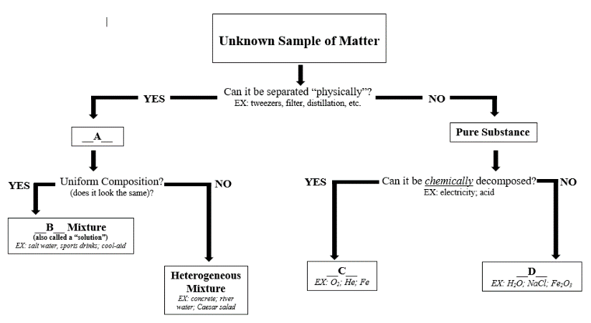

____ element ____ compound ____ homogeneous ____ heterogeneous

16. (4 points) You are given a container with a mixture of four common substances - sand, salt, small pieces of Styrofoam, and aluminum paper clips. Write a procedure (a numbered list of steps) to separate this mixture into the four components. For each of the four substances, make sure to include whether the substance is an element or a compound.

