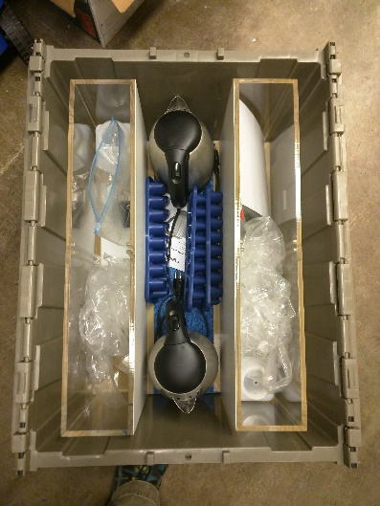
Convection Currents

Supplies that come with the kits:
- (2) Convection Current tanks with dividers
- (2) Cordless tea kettles
- (2) 1 gallon sized plastic baggie with 2 clips
- (2) Square bottle with weights and stopper
- (2) Ice cube trays

Procedures for method 1:
- Prelab Setup
- Make or get ice (1 gallon bag per experiment).
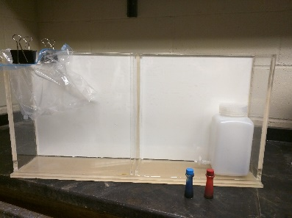
- Gather food coloring.
- Plug in tea kettles to heat up water.
- Set up Current tank*.
*It is a good idea to have extra water containers to fill tank.
- Clip gallon baggie on one side of the tank.
- Fill clipped baggie with ice.
- Fill tank with room temperature water.
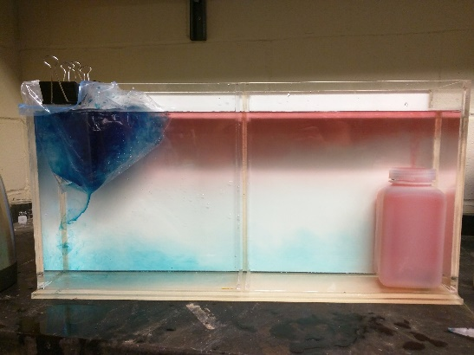
- Put weights in the square bottle.
- Put the stopcock in the hole at the bottom.
- Fill square bottle completely with hot water.
- Add 4 or 5 drops of red food coloring to bottle.
- Put 8 drops of blue food coloring in ice.
- Lower square bottle into opposite corner of baggie.
- Carefully remove stopcock so that water is not disturbed.
- If the cold blue water is not coming out, gently raise the baggie a small amount and clip.
- Throughout the experiment you might have to pour about 50 ml of cold water into the baggie several times.
Trouble shooting:
- The blue overpowers the tank:
  - You added too much food coloring.
- The square bottle does not want to sink:
  - Not enough weight in the container OR square bottle was not completely filled with hot water.
- I forgot to make ice:
  - With a large temperature difference, the demo should still work: cold tap water will produce similar results.
- Classroom blew a fuse/breaker:
- Make sure tea kettles are plugged into different circuits (each tea kettle pulls a lot of amperage).
Guiding Questions:
- What happens to the hot water when the experiment begins?
- What happens to the cold water when the experiment begins?
- When the hot water reaches the cold bag of ice, what happens, and why?
- Does something similar happen to the cold water? Explain.
- What happens to the area in the middle of the tank?
- Define a convection current.

Procedures for method 2:
- Prelab Setup
- Make or get ice (1 gallon bag per experiment).
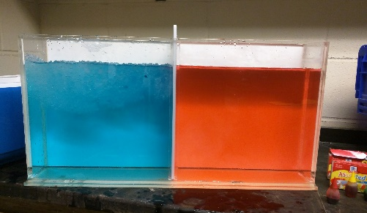
- Gather food coloring.
- Plug in tea kettles to heat up water.
- Set up Current tank with divider*.
*It is a good idea to have extra water containers to fill tank.
- Fill the tank halfway with lukewarm water.
- Add ice to one side of tank.
- Quickly match water with hot water on the other side of the tank.
- Add 5 drops of blue good coloring to cold side. Mix.
- Add 5 drops of red food coloring to hot side. Mix (not with your hand!).
- Ask predictions from class, what will happen when the divider is pulled?
- Quickly remove the divider, and set aside.
- Gently add a compact ball of ice.
- Quickly add 2 drops of food coloring to the ice ball.

Trouble shooting:
- The blue overpowers the tank:
  - You added too much food coloring OR you used too much ice/too little hot water.
- I forgot to make ice:
  - With a large temperature difference, the demo should still work: cold tap water will produce similar results.
- Green food coloring did not make a nice layer in the middle:
- Not all of the food coloring landed on the ice ball.
- Classroom blew a fuse/breaker:
- Make sure tea kettles are plugged into different circuits (each tea kettle pulls a lot of amperage).
Guiding Questions:
- Describe what happens when the divider is removed.
- What happens to the area in the middle of the tank?
- Describe what happens to the green and explain why.
- Define a convection current.

Lab Hints:
- Make sure you know how to work the tea kettles before you start your lab.
- Tea kettles get very hot and can cause burns.
- The bigger the temperature difference, the more dramatic and faster the demo is.
- Between classes, make sure to have tea kettles warming up.
- If working in student groups, make sure you have plenty of ice.
- Don’t overuse food coloring.

Lesson extensions:
- Use FLIR cameras to observe heat transfer.
- Have groups run experiment to demonstrate various processes:
- Melting polar ice caps
- Thermal pollution
- El Niño/La Niña
- Land/sea breeze
- Energy released from Earth’s core
- Convection vs. conduction

