Stream Table Activity 1: Teachers Guide
Time: approximately 90 minutes
Supplies:
- Stream table set up
- Concerned intriguing

Stream Table Activity 1

Vocabulary

Deposition
Discharge
Entrainment
Ephemeral
Erosion
Flood
Gravity
Meandering stream or river
Morphology
Oxbow Lake
Perennial
Slope
Velocity
Watershed

Where does a river begin?
Rivers generally originate at high elevations, and they always flow to points of lower elevation. It is the energy of this flowing water that shapes the landscape of the Midlands.
When an object falls, it loses potential energy. At the same time, it picks up speed and gains kinetic energy. The water in a river that starts high in the mountains behaves much like any falling object as it flows to the sea.

When does a river have its greatest kinetic or potential energy?
The water at the top of a waterfall has kinetic energy of the sort just discussed. It also has a great deal of potential energy because its height is well above the base of the falls. As the water plunges over the falls, its kinetic energy increases. At the same time, its potential energy decreases. When the water reaches the bottom of the falls, it crashes into the rocks and slows down again.

THE STREAM TABLE

In order to study the work of rivers in the classroom, it will be necessary for you to use a stream table. In order to do many of your activities, you will set up an artificial stream using the table.
One of the problems in interpreting the natural landscape is that many important variables act at the same time. The stream table will allow you to control some of the important variables that are uncontrollable in nature. For example, you'll be able to do such things as create a river, speed it up or slow it down, or make it flow through different types of material that you select. Modeling these possibilities can help in describing how real rivers behave on their pathway to the sea.

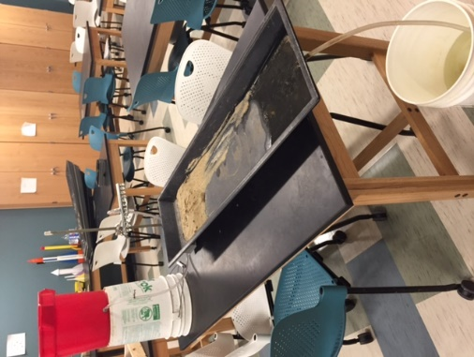
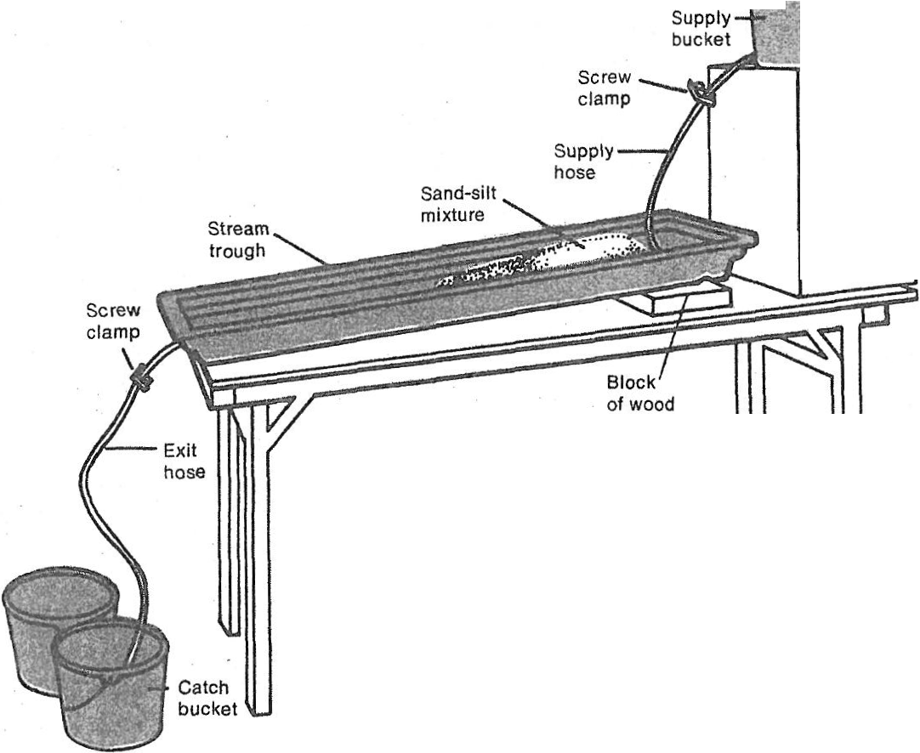
Below is the set up for our stream table.

The flow of water in and out can be controlled by opening and closing screw clamps. The slope can be changed by moving a support (such as a brick or a wooden block) back and forth under the trough.

Activity 1: Setting the flow rate.
If the stream table is not set up, set it up like the diagram seen previously.
Flow is measured in volume / time. For our activities the units will be ^{ml}/_{sec}.
- Fill the supply bucket with water.

- Adjust the screw clamp from the supply bucket to allow water to flow slowly out of the hose.

- Time how long it takes (in seconds) for the supply hose to fill a 100-ml graduated beaker.
If it takes five seconds to fill the beaker. Then the rate of flow is as follows:

100 ml (volume of water)
-—————————- = 20 ^{ml}/_{sec} (rate of flow)
5 sec (time)

- Adjust the clamp so that you get a rate of flow of 10 ml/sec. (Tighten the clamp to reduce the flow and open it to increase the flow.)

- Leave the flow rate at 10 ^{ml}/_{sec} for the next activity. Do not tighten or loosen the clamp screw at this time.
Question 1: What would the flow rate of the supply be if it took 25 seconds to fill the 100ml beaker?

Activity 2: Determining variables affect the speed at which water flows
For this activity you will use the smaller trough. You can just set it in the stream table tray.
- With a wax pencil, mark a starting line 8 cm from the upper end of the trough. Elevate the upper end of the trough 4 cm.
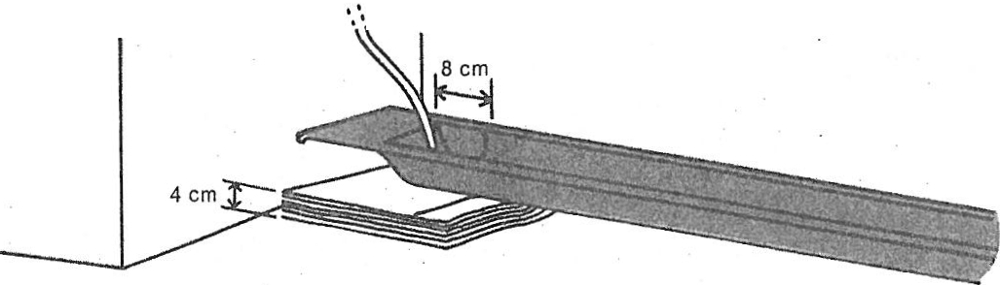
- Add a shallow layer of sediment to the trough.
- With the flow rate at 10 ^{ml}/_{sec,} add a drop of food coloring to the water as it flows past the starting line. Time how long it takes the dye to reach the end of the trough. Calculate the speed in centimeters per second. (Speed= distance traveled / time).
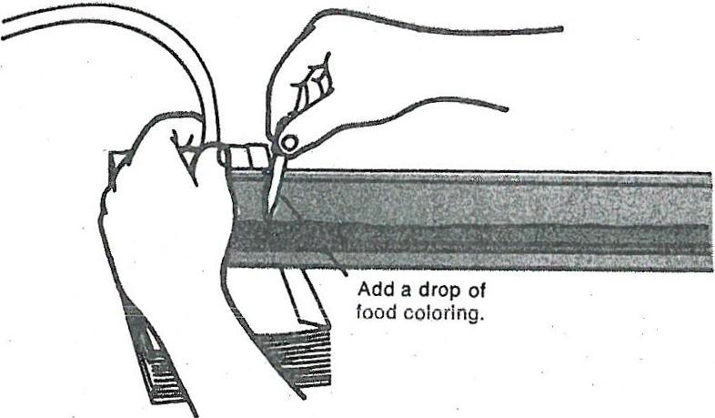
- Do trials 2-5 changing the slope, flow rate, or surface covering as noted.

 | Slope  (in cm) | Rate of flow  into trough | Trough bed | Speed (in cm/sec)
Trial I | 4 | 10 | Sand-silt
Trial 2 | 8 | 10 | Sand-silt
Trial 3 | 12 | 10 | Sand-silt ·
Trial 4 | 4 | 20 | Sand-silt
Trial 5 | 4 | 10 | Gravel over  Sand-silt
CAUTION: Watch the catch bucket. Don't let it overflow!

Question 2: What happens to the kinetic energy of river water as slope increases?

Question 3: What happens to the kinetic energy of river water as it encounters gravel or rocks?

Question 4: What are some variables that affect how fast water flows in a stream or river?

Activity 3: Modeling geomorphology of streams.
- Arrange the sand on the stream table as shown. Be sure that the sand is wet and piled fairly deep. It should be rounded off, as shown.
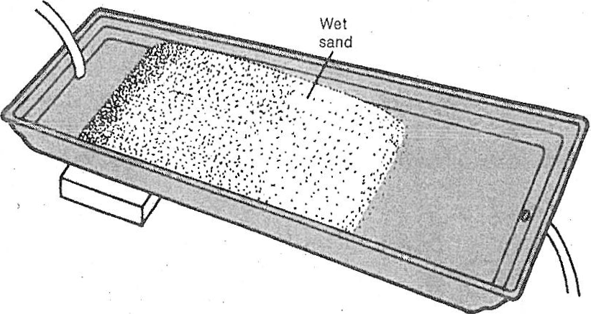

- Trace a meandering path through the sand with your finger as shown.
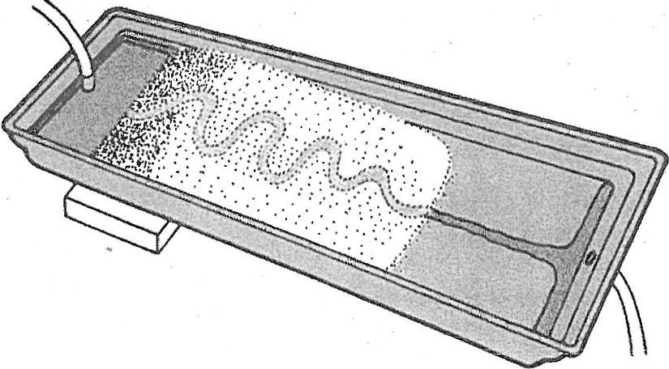
- Adjust the flow of water into the reservoir to about 5 mi/sec.
- Allow-the water to flow down the path for 20 minutes. Then turn off the water, but leave the sand in place. You can do activity 4 while you are waiting for the 20 minutes to expire. CAUTION: Watch the catch bucket. Don't let it overflow!
Question 5: In your stream table, on which side of the bend does the water move faster? How do you know?

Question 6: Where and how will an oxbow form?
Activity 4: Modeling deposition on a curved path.
- Place 1 teaspoon of sand in a beaker three-fourths full of water.
- Stir the water until it swirls around in the beaker. Observe what happens to the sand
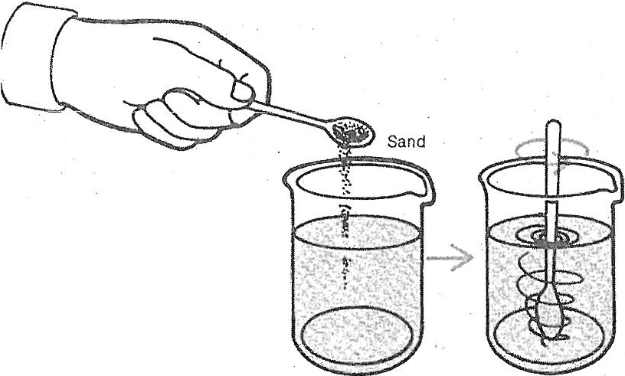
Question 7: Where in the beaker did the sand pile up? Why did this happen?

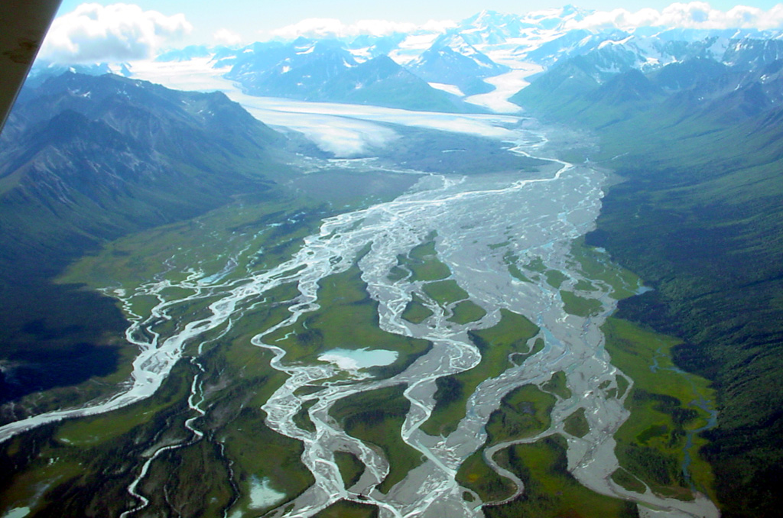
http://sageography.myschoolstuff.co.za/wp-content/uploads/sites/2/2013/08/braidedstream.jpg
Notice in the image above, the sand deposits that cause the braiding are located where the land begins to level off. The sand is carried down from the mountains by the river. Then, when the land flattens out, the river loses speed (kinetic energy), and it drops the sand particles. It is at points like this that one most often finds braided streams.

